Monitoring Land Use Land Cover Dynamics using Geospatial Techniques: A Multi-temporal Analysis Approach

Pothu Siva Kumar Reddy¹, Raghu Babu Kottala^{1*}, Badapalli Pradeep Kumar¹
¹Dept of Geology, Yogi Vemana University, Kadapa, Andhra Pradesh, India, 516005.
*Corresponding: dr.raghukottala@gmail.com

Abstract:
This research emphasizes the utilization of Landsat 7 ETM+ and Landsat 8 OLI/TIRS satellite data to analyze the dynamic changes in Land Use and Land Cover (LULC) from 2012 to 2022. The supervised classification technique is employed to prepare a comprehensive LULC map. Results show significant shifts in LULC categories. Water bodies increase by 10.01%, reflecting changes in precipitation patterns and land management practices. Fallow lands decrease by -26.69%, indicating reduced uncultivated areas. Moisture soils decline by -15.28%, affecting water regulation and biodiversity. Vegetation increases by 3.87%, highlighting the expansion of green cover. Cultivated lands see a significant increase of 28.09%, driven by population growth and agricultural demands. These findings provide valuable insights into the dynamic nature of LULC changes, aiding land management and environmental planning. Understanding these LULC changes is essential for making well-informed decisions, managing land sustainably, and achieving a balance between environmental protection and economic growth. Effective policies are required to reduce negative effects, preserve biodiversity, safeguard water supplies, protect ecosystems, and encourage sustainable agriculture. This work adds to our understanding of LULC dynamics and will help future land management and conservation initiatives in the study region.
Keywords: LULC, Landsat 7ETM+, Landsat 8 OLI/TIRS, Supervised classification, Remote Sensing and GIS.

- Introduction:
The physical and functional qualities of a piece of land, such as its natural features and the human activities that take place there, are referred to as land usage. While land cover refers to the surface cover, such as woods, wetlands, croplands, or built-up areas, land use refers to how the land is used, such as for agricultural, residential, industrial, or recreational reasons. Understanding land use and land cover dynamics and changes through time has been emphasised in previous writing on these topics. Researchers have evaluated and tracked trends of land use and land cover at local, regional, and global scales using a variety of geospatial approaches, including remote sensing and GIS. Studies have examined the drivers and impacts of land use changes, the accuracy of classification methods, and the integration of socioeconomic factors in land use modeling. Additionally, research has emphasized the significance of accurate and up-to-date land use and land cover data for effective land management, natural resource planning, and sustainable development strategies (Sharma et al., 2016; Adhikary et al., 2019).
Understanding the intricate connections between human activities and the environment depends heavily on the proper measurement and monitoring of land use and land cover changes. Significant implications for sustainable development, urban planning, biodiversity protection, and natural resource management result from the ongoing changes in land use and land cover patterns (Badapalli et al., 2022; Ganem et al., 2022). Geospatial techniques, such as remote sensing and Geographic Information Systems (GIS), have emerged as powerful tools for monitoring and analyzing land use and land cover changes over time. In this study, we present a comprehensive approach for monitoring land use and land cover dynamics using a multi-temporal analysis approach, leveraging the capabilities of geospatial technologies (Singh et al., 2016; Jamali et al., 2020).
The objective of the multi-temporal analysis technique is to identify trends, patterns, and change-causing factors by examining land use and land cover changes throughout a variety of time periods. It is feasible to identify and quantify changes that have taken place through time by analysing historical data and contrasting it with current land use and land cover data. This method facilitates informed decision-making and efficient land management methods by offering insightful information on the dynamics of land use and land cover (MohanRajan et al., 2020; Roy et al., 2021).
Using imagery from satellites and aerial photography, remote sensing is essential for gathering the spatial data needed for monitoring land use and land cover (Singh, 2016). These remotely sensed data provide a synoptic view of the Earth's surface, allowing for the identification and classification of different land cover types. By acquiring imagery at regular intervals, it becomes possible to generate time-series data, which serve as the foundation for multi-temporal analysis. Additionally, the integration of GIS techniques enables the spatial analysis and visualization of land use and land cover changes, enhancing our understanding of the dynamic nature of landscapes (Rwanga et al., 2017; Kumar et al., 2023).
One of the key compensations of the multi-temporal examination approach is its ability to differentiate between natural and human-induced land use and land cover changes. By analyzing the temporal patterns of alteration, it becomes possible to distinguish between gradual changes that occur due to natural processes, such as succession or climate variations, and rapid changes driven by human activities, such as urban expansion or deforestation. This information is invaluable for policymakers, land managers, and researchers, as it helps identify areas of concern and prioritize conservation or intervention efforts (Xiuwan, 2002; Vivekananda et al., 2021; Pasham et al., 2022).
In this study, we aim to deliver a complete overview of the multi-temporal analysis method for monitoring land use and land cover dynamics using geospatial techniques. We will explore various methods for data acquisition, preprocessing, and analysis, highlighting the strengths and limitations of each approach. Furthermore, we will showcase case studies and examples of successful applications of this approach in different regions, demonstrating its potential for updating land management decisions and endorsing sustainable development practices. By understanding the dynamics of land use and land cover, we can work towards a more sustainable and resilient future for our planet.
- Study area:
In the Indian state of Andhra Pradesh, in the YSR Kadapa district, is the town of Kondapuram. It is governed by the Kondapuram mandal, which is a subdivision of the Jammalamadugu revenue division. The town is situated in the Rayalaseema area, which is distinguished by its unique geological and cultural features. As the administrative centre for the Mandal, Kondapuram is located around 89 kilometres west of Kadapa, the district seat. As per the 2011 Census, the local language spoken in Kondapuram is Telugu. The town has a total population of 6,433 individuals, residing in 1,551 households. The female population constitutes 52.0% of the total population. The literacy rate in Kondapuram is recorded at 67.3%, with a significantly lower female literacy rate of 31.7%.
Due to its distinctive geographic location, Kondapuram Mandal is impacted by a variety of climatic and geological elements. The area has a distinct climate with particular trends in temperature, precipitation, and other meteorological factors. The availability of water and the productivity of the land's agriculture as well as the vegetation cover are all impacted by the rainfall in Kondapuram and the places around. The landforms and underlying substrate are shaped by geological forces, which also have an impact on the patterns of land use and land cover in the region.
Understanding the land use and land cover dynamics in Kondapuram mandal is essential for effective planning and sustainable development initiatives. Geospatial techniques, including remote sensing and GIS, can provide valuable insights into the changes occurring in land use and land cover over time, helping policy makers and land managers make informed decisions. By analyzing the climate, rainfall, and geological factors in conjunction with land use and land cover data, we can gain a comprehensive understanding of the dynamics shaping the landscape of Kondapuram mandal.
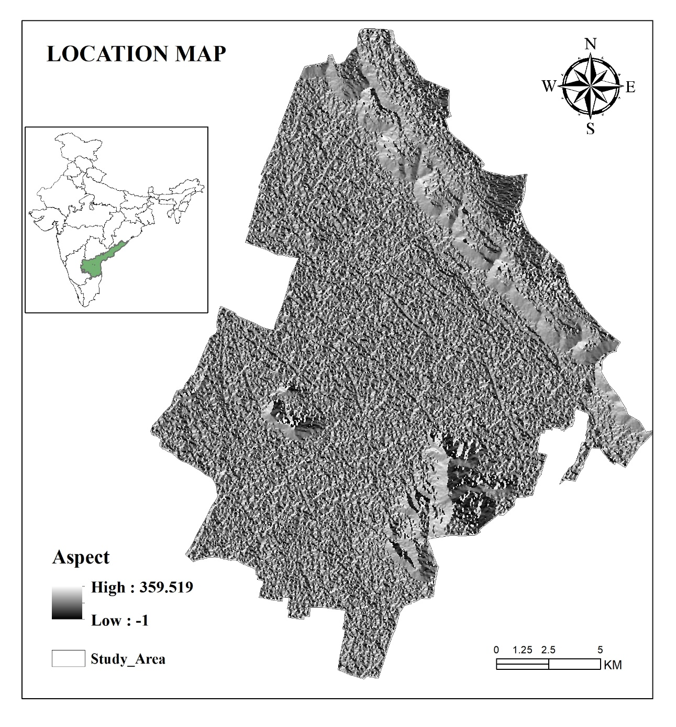
Figure.1: Location Map
- Methodology:
The following steps involved in the LULC mapping of the study area:
  - Data Acquisition:
- Obtain Landsat 7 ETM+ imagery for the year 2012 and Landsat 8 OLI/TIRS imagery for the year 2022. These satellite images can be acquired from reliable sources such as the USGS Earth Explorer or any other authorized data providers.
  - Preprocessing:
- Conduct necessary preprocessing steps for the Landsat imagery, including radiometric calibration, atmospheric correction, and geometric correction, to ensure accurate and consistent data.
  - Training Data Collection:
- Select representative sample points or polygons across the study area, covering various land cover classes of interest.
- Collect ground truth data for these sample points, either through field surveys or using high-resolution imagery or existing land cover maps.
- Identify and assign appropriate land cover class labels to each training sample.
  - Supervised Classification:
- Utilize the ArcGIS software for supervised classification. Create a new classification project and load the preprocessed Landsat imagery for both years.
- Implement a supervised classification algorithm, such as Maximum Likelihood or Support Vector Machines (SVM), using the training samples to classify the imagery into different land cover classes.
- Repeat the classification process for both the Landsat 7 ETM+ imagery (2012) and Landsat 8 OLI/TIRS imagery (2022) separately.
  - Accuracy Assessment:
- Validate the accuracy of the classified land use land cover maps. Select a subset of sample points or polygons that were not used for training and compare the classified results with the corresponding ground truth data.
  - Post-Classification Analysis:
- Conduct post-classification analysis to analyze the land use and land cover changes between 2012 and 2022.
- Compare and quantify the changes in land cover classes, such as urban expansion, deforestation, agricultural land conversion, etc.
- Results and Discussions:
4.1. Waterbodies:
Waterbodies are a significant category in Land Use and Land Cover (LULC) analysis, representing areas covered by various types of water, such as lakes, rivers, ponds, and reservoirs. Waterbodies are vital components of ecosystems, providing habitats for aquatic plants and animals, as well as serving various human needs, including drinking water supply, irrigation, transportation, and recreation.
The extent of waterbodies in 2012 was reported as 6.25 km² (Table 2 & Figure. 2). However, by 2022, the area covered by waterbodies increased significantly to 43.78 km² (Table 2 & Figure. 3). This increase indicates the expansion or creation of new waterbodies within the study area during that period. The resultant changes in waterbodies are calculated by subtracting the 2012 value from the 2022 value, which yields 37.53 km². These resultant changes represent the net increase in the area covered by waterbodies during the specified time frame. It is important to note that these changes are presented as positive values, indicating an overall increase in waterbodies.
Waterbodies are essential to the hydrological cycle because they control water flow, recharge groundwater, and affect a region's general climatic patterns. Additionally, they sustain a variety of ecosystems that serve as homes for several plant and animal species. Waterbodies also add to the visual value of a landscape and are frequently important for recreation and tourism.
The notable increase in waterbodies from 2012 to 2022 (Figure 4 & Figure 5) suggests changes in land use and environmental conditions within the study area. Factors such as increased precipitation, land management practices, and human interventions can contribute to the expansion or creation of waterbodies. These changes may have significant implications for both the natural environment and human activities dependent on water resources.
4.2. Fallow lands:
Fallow lands are a category in Land Use and Land Cover (LULC) analysis that refers to agricultural lands that are temporarily left uncultivated or fallow. Following is a common agricultural practice employed to allow the land to rest and recover fertility before being cultivated again. It helps reduce soil erosion, improve soil quality, and manage pests and diseases. In the year 2012, the extent of fallow lands was reported as 244.54 km² (Table 2 & Figure. 2). However, by 2022, the area of fallow lands decreased to 144.46 km² (Table 2 & Figure. 3). This decline suggests a significant reduction in the amount of agricultural land left uncultivated during the specified period.
The resultant changes in fallow lands are calculated by subtracting the 2012 value from the 2022 value, resulting in a value of 100.08 km². These resultant changes represent the net decrease in the area of fallow lands during the specified time frame. In this case, the negative value (-26.69%) indicates a reduction in fallow lands (Figure 4 & Figure 5). Various reasons, including increasing agricultural activity, a rise in the amount of cultivated land, modifications to the way land is managed, and agricultural intensification, may be responsible for the decline in fallow lands. To satisfy the rising need for food production or to take advantage of agricultural technology improvements, farmers may have cut the length of fallowing or abandoned the practise entirely.
Both good and negative effects may result from the decline in fallow lands. On the plus side, a decrease in fallow land might perhaps boost total agricultural productivity and assist in meeting the demands of a rising population for food. As fallowing is essential to preserving soil health, saving water resources, and preventing the deterioration of agricultural land, it is critical to evaluate the environmental effects of such changes.
4.3. Moisture Soils:
Moisture soils, also known as wetlands or marshlands, are a crucial component of Land Use and Land Cover (LULC) analysis. These areas are characterized by high soil moisture content and are often associated with unique ecosystems and biodiversity. Moisture soils play a vital role in water regulation, nutrient cycling, flood control, and providing habitats for a variety of plant and animal species.
In the year 2012, an area of 76.73 km2 was classified as moisture soils (Table 2 & Figure. 2). However, by 2022, this area decreased to 19.44 km² (Table 2 & Figure. 3). This reduction suggests a substantial decline in the extent of moisture soils within the study area during the specified time period. The resultant changes in moisture soils are calculated by subtracting the 2012 value from the 2022 value, resulting in a negative value of -57.29 km². These resultant changes indicate a significant decrease in the area of moisture soils during the specified time frame. It's important to note that the negative value (-15.28%) represents a reduction in the moisture soils category (Figure 4 & Figure 5). Numerous reasons, including changes in land use, urbanisation, drainage operations, and modifications to hydrological patterns, may be responsible for this drop. Wetlands frequently disappear or deteriorate as a result of these changes, which has an adverse effect on the ecology and biodiversity.
Water filtration, carbon sequestration, and habitat supply are just a few of the beneficial ecological services moisture soils offer. These ecological processes may be disrupted by soil moisture loss, which may also hasten the extinction of species that depend on wetlands for their existence.
4.4. Vegetation:
Vegetation is a fundamental category in Land Use and Land Cover (LULC) analysis, representing areas covered by various types of plants, including forests, grasslands, shrublands, and other forms of natural or cultivated vegetation. Vegetation plays a crucial role in the environment, providing numerous benefits such as carbon sequestration, habitat provision, soil stabilization, and the regulation of local climate and water cycles.
In the year 2012, an area of 32.25 km² was identified as vegetation (Table 2 & Figure. 2). However, by 2022, this area increased to 46.75 km² (Table 2 & Figure. 3), indicating a significant expansion in the extent of vegetation within the study area during the specified time frame. The resultant changes in vegetation are calculated by subtracting the 2012 value from the 2022 value, resulting in a positive value of 14.50 km². These resultant changes represent the net increase in the area covered by vegetation during the specified time period. The increase in vegetation can be influenced by multiple factors, including natural regeneration, afforestation efforts, reforestation projects, and changes in land use practices (Figure 4 & Figure 5). It is worth noting that the mentioned increase in waterbodies, as well as the decrease in fallow lands, can contribute to the expansion of vegetation. Waterbodies can provide favorable conditions for plant growth, supporting riparian vegetation and wetland ecosystems. Conversely, the reduction in fallow lands may have allowed for increased cultivation or afforestation activities, leading to the expansion of vegetation.
The growth and preservation of vegetation have numerous benefits for both the environment and human well-being. Vegetation helps to regulate the climate by absorbing carbon dioxide, releasing oxygen, and influencing local temperature and rainfall patterns. It also provides habitats for diverse plant and animal species, contributing to biodiversity conservation. Moreover, vegetation can mitigate soil erosion, improve water quality, and offer recreational and aesthetic value to communities.
4.5. Cultivated lands:
Cultivated lands are a significant category in Land Use and Land Cover (LULC) analysis, representing areas that are actively used for agricultural purposes, including the cultivation of crops, horticulture, and other forms of managed cultivation. Cultivated lands play a crucial role in food production, rural livelihoods, and the overall agricultural economy.
In the year 2012, an area of 15.08 km² was identified as cultivated lands (Table 2 & Figure. 2). However, by 2022, this area significantly increased to 120.39 km² (Table 2 & Figure. 3), indicating a substantial expansion in the extent of cultivated lands within the study area during the specified time frame. The resultant changes in cultivated lands are calculated by subtracting the 2012 value from the 2022 value, resulting in a positive value of 105.31 km². These resultant changes represent the net increase in the area covered by cultivated lands during the specified time period. It is important to note that the mentioned increase in waterbodies and the decrease in fallow lands can contribute to the expansion of cultivated lands (Figure 4 & Figure 5). The increase in waterbodies can provide water resources for irrigation, enabling farmers to expand their cultivation areas. Additionally, the decrease in fallow lands may indicate a reduction in the land left uncultivated, thus increasing the overall area under cultivation. The expansion of cultivated lands can have several implications, both positive and negative. On the positive side, an increase in cultivated lands can contribute to higher agricultural production, thereby addressing food security concerns and supporting rural livelihoods. It can also lead to economic growth in the agricultural sector.
However, the expansion of cultivated lands can also have adverse effects on the environment. It may lead to deforestation, habitat loss, soil degradation, and increased use of fertilizers and pesticides, which can have negative impacts on biodiversity and water quality. Balancing the need for agricultural expansion with sustainable land management practices is crucial for mitigating these environmental risks.

Table 2: LULC Changes from 2012 to 2022.
LULC Categories | 2012 |  | 2022 |  | Resultant LULC
 | in Km2 | in % | in Km2 | in % | in Km2 | in %
Waterbodies | 6.25 | 1.67 | 43.78 | 11.67 | 37.53 | 10.01
Fallow lands | 244.51 | 65.23 | 144.46 | 38.54 | -100.05 | -26.69
moisture Soils | 76.73 | 20.47 | 19.44 | 5.18 | -57.29 | -15.28
Vegetation | 32.25 | 8.60 | 46.75 | 12.47 | 14.50 | 3.87
Cultivated lands | 15.08 | 4.02 | 120.39 | 32.11 | 105.31 | 28.09
Total | 374.84 | 100.00 | 374.84 | 100.00

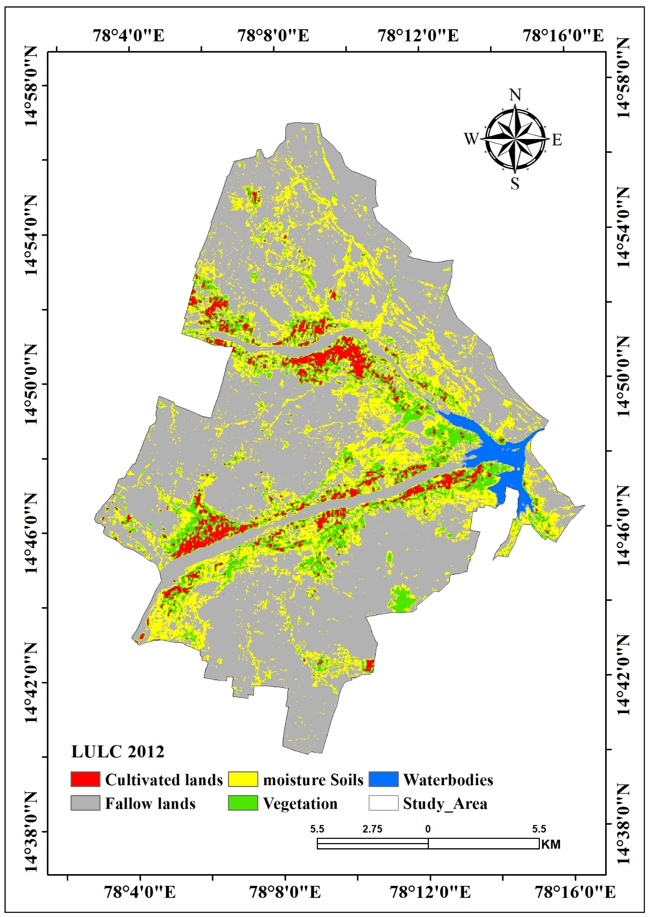
Figure 2: LULC changes in the year 2012.
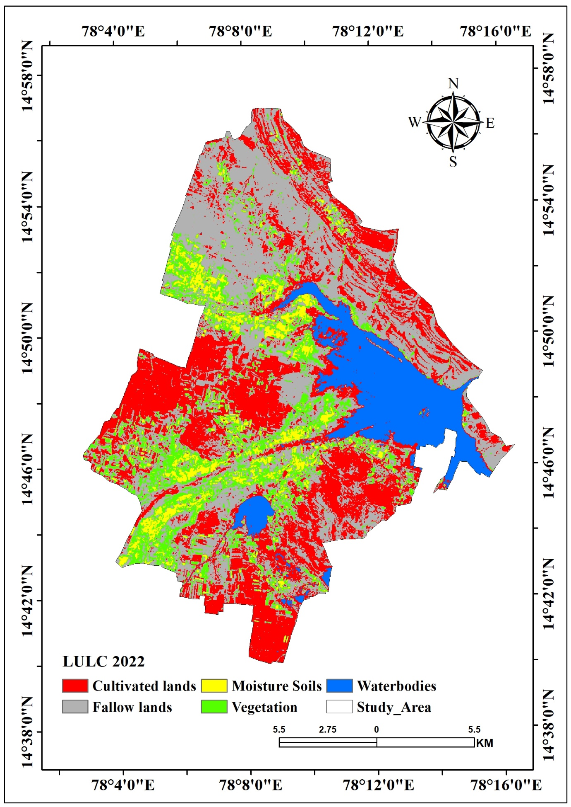
Figure 3: LULC changes in the year 2022.

Figure. 4: LULC changes from 2012 to 2022.

Figure. 5: Resultant Changes from 2012 to 2022.

- Accuracy Assessment:
During the grouping procedure, Accuracy Assessment (AA) plays a crucial role in ensuring the reliability of the results. To emphasize the accuracy evaluation, pixel selection was based on areas that could be clearly identified using high-resolution images from Landsat, Google Earth, and Google Maps. A total of 50 points were defined, and topographic maps and Google Earth were utilized as reference sources to assign the selected features to specific classes (Dewan and Yamaguchi, 2016).
To determine the accuracy, KAPPA analysis, a discrete multivariate technique commonly used in accuracy assessments, was performed. The analysis yielded a Khat statistic, which serves as an estimate of KAPPA and measures the agreement or accuracy of the classification. The computation of KAPPA was carried out using the appropriate formulae available in ArcGIS. The accuracy assessment results revealed an overall accuracy of approximately 80% based on a random sampling process applied to the image.
- Conclusions:
Significant variations in the research region throughout the given time frame are shown by an examination of the resulting changes in LULC categories. These changes have an impact on human activity, biodiversity, and the environment. The significant rise in waterbodies (10.01%) is one noticeable shift. The growth or development of new waterbodies indicates modifications to precipitation patterns, methods of land management, and human activities. Waterbody expansion affects regional climate patterns and water supplies by creating crucial homes for aquatic animals and contributing to the entire hydrological cycle.
On the other hand, there has been a decrease in fallow lands (-26.69 %), indicating a reduction in the amount of agricultural land left uncultivated. This decline is likely due to increased agricultural activity, changes in land management practices, and agricultural intensification. Another significant change is the reduction in moisture soils (-15.28 %). Factors such as land use changes, urbanization, drainage activities, and alterations in hydrological patterns have contributed to this decline. The loss of moisture soils negatively impacts water regulation, biodiversity, and ecosystem services. Therefore, conservation and restoration efforts are necessary to preserve these valuable ecosystems. Conversely, there has been an increase in vegetation (3.87 %), indicating the expansion of natural or cultivated vegetation within the study area. Afforestation, reforestation, and changes in land use practices may have contributed to this growth. Lastly, there has been a substantial increase in cultivated lands (28.09 %), reflecting the expansion of areas used for agricultural purposes. This expansion can be attributed to factors such as population growth, changes in land tenure systems, agricultural policies, and market demands. Overall, the resultant changes in LULC categories emphasize the dynamic nature of land use and its impact on the environment. It is essential to understand these changes for informed decision-making, promoting sustainable land management practices, and maintaining a balance between economic development and environmental conservation.

References:
- Adhikary, P. P., Barman, D., Madhu, M., Dash, C. J., Jakhar, P., Hombegowda, H. C., ... & Beer, K. (2019). Land use and land cover dynamics with special emphasis on shifting cultivation in Eastern Ghats Highlands of India using remote sensing data and GIS. Environmental monitoring and assessment, 191, 1-15. https://doi.org/10.1007/s10661-019-7447-7
- Badapalli, P. K., Nakkala, A. B., Kottala, R. B., & Gugulothu, S. (2022). Geo environmental green growth towards sustainable development in semi-arid regions using physicochemical and geospatial approaches. Environmental Science and Pollution Research, 1-18. https://doi.org/10.1007/s11356-022-24588-z
- Ganem, K. A., Xue, Y., Rodrigues, A. D. A., Franca-Rocha, W., Oliveira, M. T. D., Carvalho, N. S. D., ... & Shimabukuro, Y. E. (2022). Mapping South America’s Drylands through Remote Sensing—A Review of the Methodological Trends and Current Challenges. Remote Sensing, 14(3), 736. https://doi.org/10.3390/rs14030736
- Jamali, A. A., Naeeni, M. A. M., & Zarei, G. (2020). Assessing the expansion of saline lands through vegetation and wetland loss using remote sensing and GIS. Remote Sensing Applications: Society and Environment, 20, 100428. https://doi.org/10.1016/j.rsase.2020.100428
- Kumar, B. P., Anusha, B. N., Babu, K. R., & Sree, P. P. (2023). Identification of climate change impact and thermal comfort zones in semi-arid regions of AP, India using LST and NDBI techniques. Journal of Cleaner Production, 407, 137175. https://doi.org/10.1016/j.jclepro.2023.137175
- MohanRajan, S. N., Loganathan, A., & Manoharan, P. (2020). Survey on Land Use/Land Cover (LU/LC) change analysis in remote sensing and GIS environment: Techniques and Challenges. Environmental Science and Pollution Research, 27, 29900-29926. https://doi.org/10.1007/s11356-020-09091-7
- Pasham, H., Gugulothu, S., Badapalli, P. K., Dhakate, R., & Kottala, R. B. (2022). Geospatial approaches of TGSI and morphometric analysis in the Mahi River basin using Landsat 8 OLI/TIRS and SRTM-DEM. Environmental Science and Pollution Research, 1-18. https://doi.org/10.1007/s11356-022-24863-z
- Roy, Bhaswati, and Nuruzzaman Kasemi. "Monitoring urban growth dynamics using remote sensing and GIS techniques of Raiganj Urban Agglomeration, India." The Egyptian Journal of Remote Sensing and Space Science 24, no. 2 (2021): 221-230. https://doi.org/10.1016/j.ejrs.2021.02.001
- Roy, P. S., Behera, M. D., & Srivastav, S. K. (2017). Satellite remote sensing: sensors, applications and techniques. Proceedings of the National Academy of Sciences, India Section A: Physical Sciences, 87, 465-472. https://doi.org/10.1007/s40010-017-0428-8
- Rwanga, S. S., & Ndambuki, J. M. (2017). Accuracy assessment of land use/land cover classification using remote sensing and GIS. International Journal of Geosciences, 8(04), 611.
- Sharma, R., & Joshi, P. K. (2016). Mapping environmental impacts of rapid urbanization in the National Capital Region of India using remote sensing inputs. Urban Climate, 15, 70-82. https://doi.org/10.1016/j.uclim.2016.01.004
- Singh, R. K., Singh, P., Drews, M., Kumar, P., Singh, H., Gupta, A. K., ... & Kumar, M. (2021). A machine learning-based classification of LANDSAT images to map land use and land cover of India. Remote Sensing Applications: Society and Environment, 24, 100624. https://doi.org/10.1016/j.rsase.2021.100624
- Singh, S. K. (2016). Geospatial technique for land use/land cover mapping using multi-temporal satellite images: A case study of Samastipur District (India). Environment & We An International Journal of Science & Technology, 11(4), 75-85. https://doi.org/10.1016/j.jenvman.2020.110355
- Vivekananda, G. N., Swathi, R., & Sujith, A. V. L. N. (2021). Multi-temporal image analysis for LULC classification and change detection. European journal of remote sensing, 54(sup2), 189-199.
- Xiuwan, C. (2002). Using remote sensing and GIS to analyse land cover change and its impacts on regional sustainable development. International journal of remote sensing, 23(1), 107-124. https://doi.org/10.1080/01431160010007051

