Application of 3D Printing in Food Processing Industry
1. P Babu  Subject Matter Specialist(Agril Engg)  Krishi Vigyan Kendra Kondempudi,Anakapalli  ANGRAU, Lam Guntur,India.  babucae002@gmail.com | 2. E Mounika  Ph. D Scholar  Department of Processing and Food Engg  CIAE, Bhopal, M.P.  mounikareddy26516@gmail.com
3. Jinukala Srinivas  Assistant Professor  Department of Agril. Engg  CUTM, Paralakhemundi, Odisha.  jsrinivas.527@gmail.com | 4. G Vani  Ph. D Scholar  Department of Processing and Food Engg  CIAE,Bhopal,M.P.  vani14027@gmail.com
5. Sivamma P
Scientist
Indian Institute of Seed Science,
Mau, U.P.
psm9604@gmail.com

ABSTRACT
Digital fabrication technology, also referred to as 3D printing or additive manufacturing, creates physical objects from a geometrical representation by successive addition of materials. 3D printing technology is a fast-emerging technology. Nowadays, 3D Printing is widely used in the world . 3D printing technology can print an object layer by layer deposition of material directly from a computer aided design (CAD) model. Different from robotics based food manufacturing technologies designed to automate manual processes for mass production, 3D food printing integrates 3DP and digital gastronomy technique to manufacture food products with customization in shape, colour, flavor, texture and even nutrition. The selected prototypes are reviewed based on fabrication platforms and printing materials. A detailed discussion on specific 3DP technologies and their associate dispensing/printing process for 3D customized food fabrication are reported for single and multi-material applications. Eventually, impacts of food printing on personalized nutrition, on-demand food fabrication, food processing technologies and process design are reported. This book chapter presents the overview of the types of 3D printing technologies, the application of 3D printing technology and lastly, the materials used for 3D printing technology in manufacturing industry.
Keywords: customized food fabrication, 3D food printing, platform design, multi-material
I. INTRODUCTION
There is an increasing market need for customized food products, most of which are currently designed and made by specially trained artisans. The cost for such a limited number of pieces is relatively high. Three-dimensional (3D) food printing, also known as Food Layered Manufacture (sun et al., 2015), can be one of potential alternatives to bridge this gap. It aims to produce 3D custom-designed food objects in a layer-by-layer manner, without object-specific tooling, molding, or human intervention. Thus, this technology can increase production efficiency and reduce manufacturing cost for customized food products fabrication.
Three-dimensional (3D) printing, also known as additive manufacturing, is a technique allowing to build computer-aided designed objects on a platform through layer-by-layer deposition. 3D printing (3DP) is a process for producing physical, three-dimensional objects based on a computer model. The model is created in the program for graphic engineering (CAD) in the form of STL (stereolithography) files. Initially, 3D printing was applied for rapid prototyping, but now with the development of technology it is also used for manufacturing final objects. In the printing process of food, it is important that the layer has sufficient strength to maintain its own weight as well as another layer without significant deformation and change of shape.3D printing is to convert food in a semi-liquid, pure or powder form to normal food form. Part of the food after the printing process requires further processing such as cooking, baking or frying.
Many studies explored formulation ﬂexibility for 3D food printing. Wang et al., (2018) investigated printing of ﬁsh surimi gel, where it was observed that surimi gels made with 1.5g NaCl/100g surimi mixture are most appropriate for 3D printing when considering geometrical accuracy and object dimensions. Yang et al., (2018) printed lemon juice gels with added potato starch and concluded that lemon juice gel with 15g/100 g potato starch was most suitable for 3D printing of cylinders and some other deﬁned objects. Only a few studies describe the relation between rheological properties (e.g. viscosity) of formulations and the printing behaviour. Zhang et al., (2018) successfully 3D printed doughs with prebiotics. They found dynamic rheology measurements could be correlated to the printability of the dough in a qualitative but not a quantitative manner.
A. HISTORY OF 3D FOOD PRINTING
The ﬁrst working 3D printer was developed in the 1980's and used photo polymer and plastic as printing material. The ﬁrst generation of 3D printers printed materials like metals, ceramics and polymers and were not meant for printing foods. The ﬁrst 3D food printer was developed around 10 years ago employing a syringe-based extruder to deposit food pastes on a platform. The syringe-based extrusion printer typically uses food pastes of high viscosity. Different types of 3d food printers are developed in recent which are (Fuh et al., (2015)) :
- 2006 Fab@Home Paste extrusion by fex. frostings, Nutella, chocolate (Cornell Univ.)
- 2006-2009 CandyFab, Sugar printing (EvilMad Scientist Lab)
- 2012-2015 FP7-performance, easy to chew and swallow senior food printing from pastes (Biozoon).
- 2013, printing of advanced shapes by sugar (sugar sculptures) (3D Systems)
- 2013, in vitro meat by bioprinter (Modern Meadow)
- 2014, printing of chocolate, (Hershey’s & 3D Systems)
- 2015, printed pasta, (Barilla & TNO)
II. TYPES OF MANUFACTURING IN 3D PRINTING
1. Additive manufacturing
2. Subtractive manufacturing
- Additive Manufacturing (AM) also known as Solid Freeform Fabrication (SFF) or 3D Printing can be used in food printing, as well as in other three-dimensional objects printing. AM (Marga et al., 2012) is a technology that build objects by adding layer-upon-layer of materials. It reduces down time, the capacity utilisation and overall operation costs. This manufacturing concept is usually suitable for materials having low melting point, such as plastic. No material wastage takes place in these processes. Complex shapes can be easily fabricated using additive manufacturing techniques.
- In subtractive manufacturing (SM), layer by layer material is gradually removed from a solid block to fabricate 3D product. This manufacturing concept can be applied to all solid materials irrespective of melting point. These processes are associated with material wastage in the form of chips, scraps, dissolved ions, vapours, etc. SM processes have limited capability in fabrication of complex shapes.
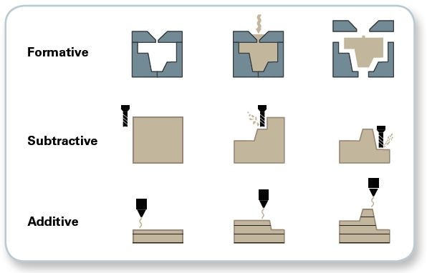
Plate 1 : Difference between the subtractive and additive manufacturing
III. CONCEPT OF EXTRUSION BASED 3D FOOD PRINTING
The extrusion process in food printing is a digitally-controlled, robotic construction process which can build up complex 3D food products layer by layer. It starts with loading of material, pushing the material out of the nozzle in a controlled manner, moving the material stream according to a predeﬁned path, and eventually bonding the deposited layer to form a coherent solid structure.
The extrusion-based food printer consists of a multi-axis stage and one or more extrusion units. It has a compact size and low maintenance cost but is criticized due to its limited material choices and long fabrication time (Sun et al., 2015). With the aid of computer control, such printers can manipulate food fabrication in real time.
3D printing of foods follows a well-defined sequential process (Plate. 2). This begins with designing a 3D CAD model of the required geometry either the model is created or a geometry is scanned to get maximum information of its surface features. Then, using suitable slicing software, it is sliced into individual layers. During this process, machine codes are generated for each sliced layer. Following this, generated G-codes and M-codes are transferred to the printer for printing a preferred recipe (Plate 2.1). G-codes refer to the numerical control language generated by the CAD software to guide motors regarding printing region, printing speed, and printing axis. M-codes refer to auxiliary commands that assist machine functioning. Being complex matrices, food systems require an adaptive slicing software for printing. This is associated with challenges in creating G-codes as these imply high memory space requirements, posing difficulties to process owing to the complexity involved in processing vast data (STL files). This has implications on the quality of the fabricated food and process time requirements. Different software are available for scanning, model development, and printing applications; their selection depends on user expertise and features required.
Plate 3 (Peng (2015)) shows a typical 3D printer consists of (1) control circuit for integrating the computer and the printer; (2) motor, filament, and drive system for guiding the motors; (3) mixing chamber into store and mix the material supply; (4) feed rollers; (5) flow sensors;(6) pressure regulators; (7) nozzles; and (8) a printing platform over which the food is printed (plate 2). The printing platform consists of a three-axis stage (Cartesian coordinate), a dispensing/sintering unit, and a user interface. With digital control over the material feeding system, one can manipulate the fabrication process to meet customer expectations. Foods can be printed in commercial platforms or using self developed platforms. There are no standard printers available for 3D printing of foods; printers can be customized to meet specific printing requirements. A commercial platform is a changed version of an existing platform (available open source). This involves replacing the print head with one which can control flow rates or one that has the capability to use a food grade material as a binder for the process. Classic examples include Fab@home™ and Frostruder MK2™ systems. We design self-developed platforms to fabricate a particular food. Some examples include cheese- and chocolate-based 3D objects printed from edible ingredients, and 3D sugar structures fabricated using computer-controlled laser machines. Fabrication in self-developed platforms is flexible owing to the capability to include wide variations in the material supply.

Plate 2: Schematic flow diagram of a typical extrusion based food 3D printing process

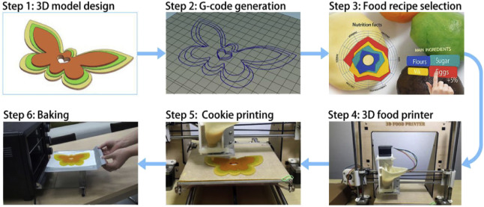
Plate 2.1 : Schematic diagram of Extrusion-based 3D Food Printing Process

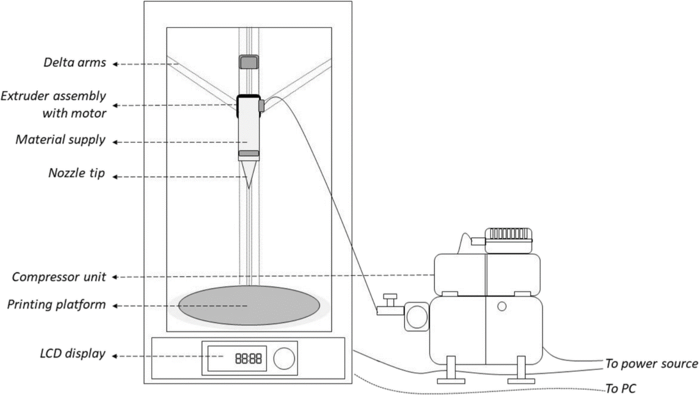

Plate 3 : Schematic diagram of a typical extrusion type 3D food printer
IV. FOOD PRINTER CONﬁGURATION (Dalbhagat et al., 2019)
The multi-axis stages used in food printing include Cartesian, Delta, Polar and Scara conﬁgurations.
A. Cartesian conﬁguration
As shown in plate 4(a), the Cartesian conﬁguration has X, Y, and Z axes for left to right, front to back and up and down motion, respectively. It may have a square stage moving along Z-axis and a printhead sitting on X-Y axis or a printhead moving along X-Z axis and a square stage sitting on Y-axis. Examples of Cartesian conﬁguration include Choc Creator, Foodini, BeeHex Robot pizza printer. This conﬁguration requires a large space for printing operation, thus it is not practical as a consumer end device. The moving printhead loaded with food material is also heavy, which compromises printing speed and results in a constant jerking motion when printing direction changes. This may result in collapse of 3D printed food pieces with large height. Last but not least, relatively slow printing speed in the Cartesian conﬁguration is always a bottleneck to limit its application in commercial machine designs.
B. Delta conﬁguration
In Delta conﬁguration as shown in plate 4(b), a circular print stage is ﬁxed, and the print head is suspended above it by three arms in a triangular conﬁguration. The number of components in this conﬁguration is less, thus reducing maintenance and machine costs. Machines with Delta conﬁguration such as Pinya3 food printer and Tytan 3D delta printer are currently being developed towards commercialization. Compared with the Cartesian conﬁguration, the Delta conﬁguration printers are cheaper and faster, and can fabricate larger volume food piece in a shorter time period. However, when the print head loaded with liquid material (such as melted chocolate) is moving under faster speed, the rapid acceleration/ deceleration may cause liquid vibration in the printing process. Thus, the extrusion process may become unstable. A modiﬁed Delta conﬁguration is suggested for liquid material extrusion applications, i.e. a ﬁxed print head with a moving print stage.
C. Polar conﬁguration
Different from the Cartesian conﬁguration, Polar conﬁguration uses polar coordinates to describe points on a circular grid rather than a square. As shown in plate 4(c), a Polar food printer usually has a spinning stage, plus a print head that can move up-down to cover Z axis, and left-right to cover X and Y tangentially. This conﬁguration can achieve a perfect circle, and equal performance for all the direction movement with minor mechanical errors and minimum calibration. Examples include the XOCO 3d- printer, consisting of a rotating build plate and a single pillar, and the TNO food printer.
D. SCARA conﬁguration
Selective Compliant Assembly Robot Arm (SCARA) has gained growing interest in food manufacturing industries greatly since the implementation of the FDA Food Safety Modernization Act (FSMA) in 2011. This conﬁguration is easy to build and has been repurposed for 3D printing. It consists of a robot arm moving along the X-Y plane and an additional actuator to move along the Z- Axis. “Sanna: the food printer of 2020”, a conceptual design from Columbia University, has applied this conﬁguration to convert unprocessed raw, frozen food purees into tasty, cooked and texturized dishes.
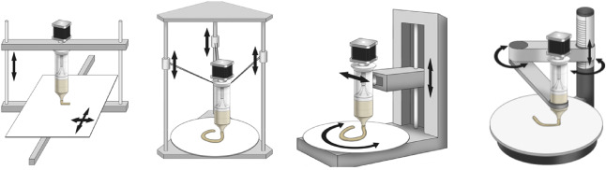
Plate 4 : Food printer conﬁguration: A. Cartesian, B. Delta, C. Polar D. Scara
V. EXTRUSION MECHANISM IN FOOD PRINTING
Three extrusion mechanisms(Sun et al., 2018) have been used to extrude liquid/ semisolid materials: syringe-based extrusion, air pressure driven extrusion and screw-based extrusion.
A. Syringe-based extrusion
As shown in Plate 5(a), the syringe-based extrusion unit includes a syringe to store food materials and a step motor to drive the extrusion process. The step motor is programmed to generate liner motion, control the position of the syringe plunger, and push the food material out of the nozzle. It has been applied in commercial machine designs such as Choc Creator and CocoJet 3D Printer. The extrusion rate (i.e. how quickly the material can be extruded out of the printhead) can be easily and rapidly adjusted by varying the motor speed, and more power is required to extrude high viscosity materials. This design requires one motor for each printhead, thus the printing payload for multi-material increases greatly
This type of extrusion unit is suitable to print semi-solid or solid food materials. The syringe unit should be selected carefully, otherwise it may require additional power due to increasing friction force caused by overloading.
B. Air pressure driven extrusion
An air pressure driven extrusion unit includes a pneumatic pump and an encapsulated food cartridge, and has been applied to design Barilla's pasta-making 3D printer (and BeeHex 3D printer . As shown in plate 5(b), air pressure produced by the pneumatic pump pushes the material in the encapsulated food cartridge out of the nozzle. The pump can drive multiple extrusion heads with varied extrusion rates at the same time through regulating valves. The response time is relatively long when changing the extrusion rate.
In the above two extrusion methods, mechanical components do not have a direct contact with the food materials, which reduces the risk of food contamination. While, to ﬁll/reﬁll high viscous material homogeneously into the syringe\cartridge without air bubbles may need additional devices if scaled up for industrial production.
The air pressure driven extrusion is more suitable to print liquid materials, while the solid and semi-solid material can easily attach on the inner wall of the food cartridge. To sterilize the air from the pneumatic pump, a ﬁltration system is necessary to be installed on the airway to minimize contamination of the printing material.
C. Screw-based extrusion
As shown in plate 5 (c), food materials are fed into the cartridge and transported to the nozzle by an auger screw for continuous printing. In this screw-based extrusion, the food cartridge is designed to have a wide opening on top for material loading, followed by the narrower tube structure and the extrusion nozzle. During the printing process, the screw driven by the motor continuously brings the materials downwards and passes through the extrusion nozzle with a minimum disturbance from air bubbles. Due to the direct contact to food materials, the screw and cartridge should use food-grade stainless steel for autoclave.
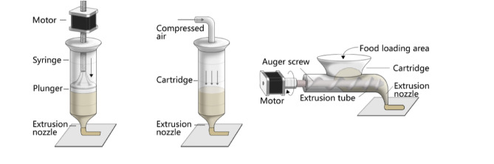
Plate 5 : Different types of Extrusion mechanism, A. Syringe Based. B. Air Pressure Driven C. Screw Based
VI. PRINTING VARIABLES AND PROCESS PARAMETERS
Design and process parameters involved in 3d printing are nozzle tip diameter, deposition rate, nozzle depth height, suck back time, push back time, the temperature of hot air, and the air gap between layers are key considerations.
- Researchers have used smaller diameter nozzle tips to print foods with smooth and fine resolution. Higher printing speeds reduce printing precision, and large tip diameters reduce printing resolution.
- While lower nozzle heights result in inadequate printing accuracy and poor product mechanical strength in chocolates, too high nozzle heights make it difficult for the material supply to reach the printing platform.
- In studies using lemon juice (as a gel), researchers confirmed nozzle height to be a significant printing parameter. They also developed a function to relate nozzle diameter, movement speed, and extrusion rate. Too high speeds (above 35 mm/s) resulted in dragging of filaments; at the lower speeds, continuous filaments can be obtained .
- The layer thickness is determined by the stage speed, extrusion rate and diameter of the nozzle. Smaller nozzles may lead to thinner layer thickness, better food surface, and vice versa.
- For the same extrusion rate, a faster stage moving speed may break the deposited stream or cause deformation, and a slow stage moving speed may result in the accumulation of the extruded stream, in turn increasing the layer thickness and sacriﬁcing the surface quality.
- In food printing, the extrusion rate should not be ﬁxed or simply proportional to the instant stage moving speed, but rather be increased or decreased slightly to compensate the stage speed change. For example, if the stage moving speed is nearly zero, i.e. the printing path is under a directional change, a small extrusion rate is recommended. A constant extrusion rate may cause swell in some regions of the printed food pieces, and void in others. It is suggested to implement an intelligent control algorithm to adjust the extrusion rate along the printing path..
VII. AVAILABLE PRINTING MATERIAL AND RECIPES
A. Classification of Printing Material (Martina et al., 2018)
Material supplies can be categorized as natively printable materials, non-printable materials, and alternative ingredients.
B. Non-Natively printable materials
Non-printable traditional food materials like rice, meat, fruit and vegetables, largely consumed by people every day, are not printable by nature. To enable their capability of extrusion, adding hydrocolloids in these solid materials has been approved and utilized in many culinary fields. Lipton et al., (2010) used simple additives to modify traditional food recipes and created complex geometries and novel formulations. Cohen et al., (2009) experimented food texture using two hydrocolloid systems, and explored structural requirements for post-processing materials such as protein pastes and cake mixtures.
C. Natively printable materials
Natively printable materials like hydrogel, cake frosting, cheese, hummus and chocolate can be extruded smoothly from syringe (Cohen et al., 2009). Some traditional foods were tested for printability study using Fabaroni machine and the most successful material was pasta dough, judged by viscosity, consistency and solidifying properties. Food products made by natively printable materials can be fully controlled on taste, nutritional value, and texture. Some of natively printable materials are stable enough to hold the shape after deposition, do not require further post processing and can be reserved for medical and space applications.
VIII. RATIONAL CHOICE OF 3D PRINTING TECHNIQUE BASED ON MATERIALS PROPERTIES
One of the critical challenges in the 3D food printing ﬁeld has been to align food grade materials with printing processes. Three food materials property related critical factors are suggested here for the rational design of 3D food structures:
- Printability: This feature relies on how the properties of the material enable handling and deposition by a 3D printer and hold its structure post-deposition. The printability of liquid- based AM technologies, such as, drop-on-demand techniques is inﬂuenced by the material viscosity or rheological properties. In addition to rheological properties, 3D printing based on extrusion techniques can be affected by speciﬁc gelation mechanisms (crosslinking) and thermal properties (melting point and glass transition temperature). Properties like particle size distribution, bulk density, wettability and ﬂowability can also exert inﬂuence on powder-based 3D printing
- Applicability: AM technologies can be attractive by their capability of building complexes structures and textures. In addition, AM becomes more interesting when nutritional value is incorporated to the unique designed structures. The applicability of AM technology is also ruled by the materials properties.
- Post-processing: Ideally, the 3D construct of food should resist to post-processing, such as, baking in an oven, being cooked by immersing in boiling water or deep frying. In the pursuit of a cooking-resistant structures, an accurate selection of materials with appropriate physical-chemical, rheological and mechanical properties are essential.
IX. IMPACTS FROM 3D FOOD PRINTING (Nachal et al., 2019)
Food printers introduce artistic capabilities to fine dining, and extend mass-customization capabilities to industrial culinary sector. This benefits a high-value, low volume customization food fabrication process that would be impossible to achieve currently. It also provides research tools to manipulate structure development of solid food materials at multiple scales. This technology is still under development stage; hence, it is important to understand its core value and potential applications in the market. At the same time it is also necessary to follow up with technology progress and relevant applications in order to investigate how this new technology will meet the customers’ needs and potentially change people’s lifestyle.
X. ADVANTAGES OF 3D FOOD PRINTING
Among the advantages of 3D food printing, the following may be mentioned:
- Food personalization,
- Meal composition adapted to individual diet,
- The use of new components, which are not used or are not popular among consumers,
- Ease and simplicity of preparation of meals,
- Both aesthetic and functional customization can be achieved at the same time,
- Novel food textures,
- Longer shelf life,
- Ease of transportation even to the most remote corners of the world or into space (NASA),
- New opportunities to create dishes, their artistic design - creating culinary works of art,
- The ability to design your own food – being a food designer,
- Economical and efficient technique of mass personalization.
XI DISADVANTAGES
- Limitations of size: 3D printing technology is currently limited by size constraints. Very large objects are still not feasible when built using 3D printers.
- Limitations of raw material: At present, 3D printers can work with approximately 100 different raw materials. This is insignificant when compared with the enormous range of raw materials used in traditional manufacturing. More research is required to devise methods to enable 3D printed products to be more durable and robust.
- Cost of printers: The cost of buying a 3D printer still does not make its purchase by the average householder feasible. Also, different 3D printers are required in order to print different types of objects. Also, printers that can manufacture in colour are costlier than those that print monochrome objects.
- Fewer Manufacturing Jobs: As with all new technologies, manufacturing jobs will decrease. This disadvantage can have a large impact to the economies of third world countries especially China, that depend on a large number of low skill jobs.
XII. CHALLENGES IN 3D PRINTING OF FOOD
The biggest challenges in 3D food printing are ingredient mix rheology, structure accuracy and shape-stability, compatibility with traditional food processing technologies (e.g. baking and drying) and printing speed. For example, traditional cookie recipes have been shown to be compatible with 3D printing but due to the presence of high amount of fats they don't retain their shape and structure after post-processing (e.g. baking) (Lipton et al., 2010). Thus, to enable 3D printing of cookie recipes the ingredients and their proportions need to be modiﬁed. For example, shape stability after printing reduced by increasing the amount of butter in butter- egg yolk-sugar mixture whereas increasing the egg yolk concentration increased width/length stability but decreased height stability.
A. Material science: 1.Shape stability 2.Additive and recipe control (need for: thickeners, enzymes, crosslinking agents with shape memory) 3. Replicate traditional foods 4. Compatible printing material with traditional cooking, i.e., baking and frying. 5. Rheology of food materials vary by time 6. Stable print materials needed
B. Manufacturing technology: 1. Safety 2. Easy to clean surfaces, cartridges 3.Throughput 4.High throughput or large reservoir needed for vast printing 5. Speed 6. Either fast or cheap enough to operate thousands (applies particularly for food industry).
XIII. THE FUTURE OF 3D PRINTING IN FOOD INDUSTRY
3D food printing is poised to have a massive impact on the global economy, closing the gap between small and large-scale businesses, while giving consumers a large degree of freedom in choosing the food they want to eat. Some of the ways in which 3D printing will affect the future of the food industry include -
- Management of inventory for food manufacturers will become easier and cheaper as they would be able to manufacture food based on demand
- Raw materials will represent a large fraction of the cost for a food manufacturer. 3D printed food will allow them to bring down costs allowing for cheaper and more sustainable food
- 3D food printing can radically change food production practices, ensuring better management of resources while reducing wastage of food products
- 3d food printing also promises an opportunity for FMCG food manufacturers to produce better, healthier food for e.g. PepsiCo, who recently announced that they are looking into leveraging 3D printing for healthier potato chips
- 3D printing can also boost food innovation and culinary creativity, with chefs and cooks around the world leveraging 3D printing to create beautiful looking food in a variety of shapes and colors.
XIV. REFERENCES
[1] Dalbhagat, C.G., Mahato, D.K., Mishra, H.N., 2019. Effect of extrusion processing on physicochemical, functional and nutritional characteristics of rice and rice-based products: A review. Trends of Food Science and Technology,85(1),pp.226–240.
[2] Fuh, J.Y.H., Hong, G.S., Zhou, W., Huang, D., Sun, J., 2015. An overview of 3D printing technologies for food fabrication. Food Bioprocess Technology, 8 (8),pp.1605–1615
[3] Nachal, N., Moses A., J., Karthik, K., Anandharamakrishnan, C., 2019. Applications of 3D printing in food industry: A review. Food Engineering Rev.
[4] Lipton, J., Arnold, D., Nigl, F., Lopez, N., Cohen, D.L., Nore´n, N., Lipson, H., 2010. Multi-material food printing with complex internal structure suitable for conventional post processing. Solid Free Fabrication symposium.809-815
[5] Martina, L., Nurmela, A., Nordlund, E., Kortelainen, Nesli Sozer. 2018. Applicability of protein and ﬁber-rich food materials in extrusion-based 3D printing. Journal of Food Engineering. 20-27.
[6] Peng, Z., 2015. 3D Food Printer: Development of Desk-top 3D Printing System for Food Processing (Master Thesis). National University of Singapore, Mechanic Engineering, Singapore.
[7] Sun J, Zhou, W., Yan L, Huang, D., Lin, L. 2018. Extrusion-based food printing for digitalized food design and nutrition control. Journal of Food Engineering..1-11
[8] Sun, J., Zhou, W., Huang, D., Fuh, J.Y., Hong, G.S., 2015. An overview of 3D printing technologies for food fabrication. Food Bioprocess Technol. 8(8), pp.1605-1615.
[9] Wang, Lin, Zhang, M., Bhandari, B., Yang, C., 2018. Investigation on fish surimi gel as promising food material for 3D printing. Journal of Food Enginering. pp.101–108.
[10] Yang, F., Zhang, M., Bhandari, B., Liu, Y., 2018. Investigation on lemon juice gel as food material for 3D printing and optimization of printing parameters. Food Sci. Technol.87, 67–76
[11] Zhang, Yimin Lou, Maarten A.I. Schutyser.,2018. 3D printing of cereal-based food structures containing probiotics. Food Structure. 14-22.

