SERICULTURE AND ITS PRODUCTION TECHNOLOGY WITH NATURAL ENEMIES
Rajesh Aarwe¹, Deependra Singh Rajput¹, Sachin Balpande², Abhishek Shukla², Amit Kumar Sharma² and Neelesh Raipuria²
¹Institute of Agricultural Sciences, RDVV, Jabalpur (M.P.) India
²Department of Entomology, College of Agriculture, JNKVV, Jabalpur (M.P.) India
Email - drrajeshaarwe@gmail.com

Abstract
The sericulture is an agriculture basis industry, the word which represents production of silk by means of silkworm rearing. The sericulture is a labour encouragement agriculture industry preferably eliminates joblessness. Further get better their economic standards of rural people. The “silk” is known as the queen of textiles has a huge importance ever before pre Vedic epoch. The term ‘silk’ was revealed in Rig-Veda, the Ramayana and the Mahabharata. It is expected that one of mulberry and its associated activates can provided employment to people either direct or indirect. The sericulture gets better regular returns all through the year with comparatively fewer expenses and some common inputs.
Keywords: Sericulture, mulberry silkworm, pests, diseases, rearing.
INTRODUCTION
The sericulture or silk production is the breeding as well as management of silkworms for the money-making production of silk or the practice of rearing silkworms for the production of silk is known as sericulture. The sericulture is an significant production in Japan, China, India, Italy, France and Spain. The “silk” is known as the queen of textiles has a huge importance ever before pre Vedic epoch. The term ‘silk’ was revealed in Rig-Veda, the Ramayana and the Mahabharata. The silk producing insects are usually known as serigenous insects. The silkworm is a general name for the silk-producing larvae of silk moths. The silk is a secretion from the salivary glands of silkworm which are found on both surface of the alimentary canal of silkworm larvae and this secretion harden into fine threads is termed as silk. The cocoons with which pupae are enclosed by the worms are utilized meant for silk production.

SILKWORM HISTORY IN THE WORLD
Nowadays there are more than 29 countries in the world are working on sericulture; the historical facts demonstrated that, silk was discovered in China and later this industry extend to further parts of the world. The previous reference to silk was found in the history of Chou – King (220 BC).
As per to the Chinese records, the discovery of silk production from Bombyx mori occurred about 2700 BC. It is thought that empress Si-lung-Chi was asked by emperor Huang-ti to find out the reason of injured mulberry leaves on trees in their backyard. The empress found white worms eating the leaves. The few days afterward she found the worms to have grown very large and the curious queen continuous to observe the process till the cocoons were spun by the worms. Subsequent to the formation of shiny cocoons, the queen collected them and preserved till moths have evolved. A cocoon one day accidentally she dropped into her hot cup of tea and silky threads separated from the cocoon, when she tried to get rid of them from the cup; a fine shiny thread exposed from the cocoons. The historical facts reveals that the silk industry began in China where the resource of silk was kept an undisclosed for more than 2000 years. Later than some time, China lost their monopoly in silk production, sericulture reached Japan via Korea and then to other countries. The sericulture has been rising in India as an agriculture basis industry playing a very important role in the enhancement of rural economy.

SERICULTURE HISTORY IN INDIA
In western historians revealed, mulberry cultivations increase to Indian about 140 BC from China to way through the Tibet.
The cultivation of mulberry and industry of silk first begin in the areas nearby the rivers Brahmaputra and Ganges, the Aryans revealed the silk worm in sub-Himalayan regions although mulberry cultivation may have come to India from the China.
The beginning of christen era, the silk from Kashmir became well-known. This may be the truth that, the Arabs acquired the silkworm eggs as well as mulberry seeds from India during the initial days of christen era.
At the time of 4th century AD, when the industry of sericulture established in India and central Asia, raw silk and silk goods were sell to other countries to Persia and Rome.
At the time during in 553 AD, the sericulture was increase to the Constantinople. Step by step, the industry of sericulture developed in venation Republic and was capable to meet the whole require of silk in European by eleventh century.
The silk obtained from Kashmir and Bengal was selling abroad to the European markets at the time during the 14th and 15th century, commencing 1761 to 1785 the sell to other countries of Bengal silk to the European markets. The East India Company started to bring up to date the rearing of silkworm and silk reeling techniques.
In 1771, the Chinese Silk was beginning with the purpose of the superiority of Cocoons. The Haitian methods of rearing were introduced by East India between 1717 and 1775.
The effort was made to change local breeds of silkworm by the new varieties of mulberry plant not including scientific study ultimately is the entire industry to disorder.
In 1870, Louis Pasteurs, discovered the method of mother moth examination might control pebrine disease.
At the Delhi, a silk conference was called by the British Govt. in 1942. The Government launched a determined project which known as ‘Silk Expansion scheme’.
In the year 1948, the Country was divided in to India and Pakistan. As result some silk producing regions have gone to Pakistan along with East Bengal.
At the time during 19th century when the industry of silk was at hit the highest point in France, the outbreak of pebrine wiped out the industry of sericulture not only in France but also in Europe and Middle East. In India this disease was reported in Bengal during the 19th century.

PRODUCTION OF SILK IN INDIA
India has the distinct feature of being the only country producing the entire five known commercial silks, which is, mulberry, tropical tasar, oak tasar, eri and muga, of which muga with its golden yellow shine is distinctive and choice of India.
In India, the total silk production during 2021-2022 was 34,903 MT (Anonymous, 2022). The share of mulberry production is the biggest among other types of silk produced in the country.
The cultivation of mulberry silk is mainly in states such as Karnataka, Andhra Pradesh, Assam, West Bengal, Jharkhand and Tamil Nadu, who are the major silk producing states in the country. The North East has the unique distinction of being the only area producing four varieties of silk viz., Mulberry, Oak Tasar, Muga and Eri. The overall, the NE area contributes 18% of India's total silk production.
The main silk-producing states in the country are Andhra Pradesh, Assam, Bihar, Gujarat, Jammu & Kashmir, Karnataka, Chhattisgarh, Maharashtra, Tamil Nadu, Uttar Pradesh and West Bengal (Anonymous, 2022).
The Indian state Karnataka contributed approximately 32% of the total silk production in the country during 2021-22. This was followed by Andhra Pradesh which had contributed to 25% in the overall silk production during 2021-22 (Anonymous, 2022).

MAJOR PROPERTIES OF SILK
1. The silk is shiny, soft and strong.
2. The silk is made of two proteins which are the inner core is fibroin and an outer cover is sericin.
3. The silk is hard wearing.
4. The silk can be painted into several colours silk moth Bombyx mori is at present completely cultivated.
5. The silk no longer exists in a wild state and it cannot survive without the human care.

GEOGRAPHICAL INDICATIONS OF INDIAN SILK
- Chanderi Fabric - Madhya Pradesh (M.P.)
- Orissa Ikat - Odisha
- Muga Silk - Assam
- Molakalmuru Sarees - Karnataka (K.N.)
- Ilkal Sarees – Karnataka (K.N.)
- Mysore Silk – Karnataka (K.N.)
- Baluchari Saree – West Bengal (W.B.)
- Kancheepuram Silk - Tamil nadu (T.N.)
- Salem Silk - Tamil Nadu (T.N.)
- Arani Silk - Tamil Nadu (T.N.)

KINDS OF SILKWORM, VOLTINISM WITH BIOLOGY OF SILKWORM

Kinds of silkworms
There are four types of natural silk, which are marketable known and produced. Amongst them, mulberry silk is the very important and contributes as much as 95% of globe production. The additionally non-mulberry silks are eri silk, tasar silk as well as muga silk.

Characters | Species | Family | Host plants | Cocoon | Domestication  feasibility in  India
Mulberry  Silkworm | Bombyx mori | Bombycidae | Mulberry | The colour is silvery white. Constant and uniform type with high silk production. | trouble-free and  inexpensive
Eri silkworm | Philosamia ricini  P. Cynthia | Saturniidae | Castor | The colour is white or brick red. Neither uniform not unbroken type with moderate silk production. | infrequent
Tassar silkworm | Antheraea pernyi  A. myliltta  A. yamamai | Saturniidae | Terminalia,  Dalbergia,  Shorea, Zizyphus,  Ficus, etc. | Colour is brown. Constant and uniform type with high silk production. | The moths do not mate and so cannot be cultivated
Muga silkworm | A. assama | Saturniidae | Som  (Machilus bombycina),  Soalu  (Litsaea polyantha) | Shiny golden yellow in colour.  constant and uniform type with less silk production. | Infrequent and confined to Assam

THE WILD SILKS OF INDIA
The Natural Silk
The natural silk is fiber of insect. It comes from the silkworm cocoon that the silkworm spins around itself to form its cocoon. A single filament from a cocoon can be as long as the 1600 meters. It is measured an animal fiber for the reason that it has a protein structure. Immediately like other animal fibers silk does not conduct heat, and acts as a superb insulator to keep our bodies hot in the cold weather and cool in the hot weather.
The silk has shine, adorn and strength. There are three grades of silk each is a product of the three dissimilar stages of silk processing. The unwound filament makes the best quality silk, and is referred to as reeled silk. It is satiny soft and pure white. The remaining silk from the reeling process becomes the raw material for carded or combed, spun silk thread. The short fibers left behind after the carding or combing process is used to make noil thread, a richly textured nubbly silk.
The India generate all three varieties of natural silks that is silk, Tasar silk, Muga silk and Eri silk.
The Tasar, Eri and Muga silk are non mulberry silks which are wild silks and also called Vanya Silks.

ERI SILK, TASAR SILK AND MUGA SILK
The vanya silks produce the creative excitement in designers for novelty, originality and exclusively naturally and spontaneously.
The vanya silks represent the rich crafts, ethnicity and tradition of the North Eastern and tribal zones of Central, eastern India and sub Himalayan region.
They are differentiate in looks and feel as they are acquired from the wild silkworms that feed on leaves of castor, kesseru, payam, som, sualu, oak, arjun, asan, sal etc. in the open jungles, absorbing the disproportion of nature, and sparkly it in the silks they produce.
In unparallel surfaces, with normal shine, easy resemblance for natural colorant, light in weight and high in moisture absorbency, and with impenetrable thermal properties warm in winter and cool in summer, products of rich, hygienic climate and nutritious to the vegetation, each of the vanya silks has its possess unique beauty and national culture.
They are renowned in four different forms like muga, tropical tasar, oak tasar and eri. They are the bravura gifts of natural world to genius of worldwide designers, to search and create various designs for outfits, life style products and home furnishings for difficult homes, haute (high class) fashion design as far as artistic imagination can stretch.

ERI SILK
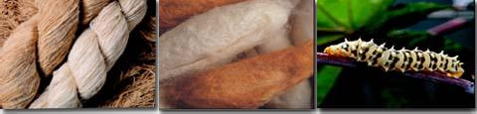
It is also called as endi or errandi, this silk is produced from the eri silkworm (Philosamia ricini).

These silkworms mainly feed on the Castor and Kesseru. The eri cocoons are open ended, the thread is spun. Fascinatingly, in many parts of the North-East, eri cocoons are produced for their edible pupae and silk is the outcome. Stylishly designed eri shawls and chaddars are quite trendy because of their thermal properties.
They can be blend with cotton, wool, jute or even mulberry silk to create foreign fabrics for use in jackets, or suiting material, or for producing a variety of furnishings, making it an inner decorator’s joy. It is also known as non violent silk as the pupa is allowable to grow and come out as moth because eri is spun and not reeled.

TASAR SILK
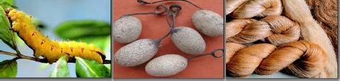
The tasar silk is formed by tasar silkworms (Antheraea mylitta and Antheraea proylei) that nourish mostly on the leaves of Asan, Arjun as well as Oak. The India is the second major producer of tasar silk and the exclusive manufacturer of Indian tasar also called as tropical tasar which is mostly tended by tribal’s in the Gondwana belt.

The oak tasar also called as temperate tasar is chiefly used for furnishing, dress materials and sarees.
The Bomkai, Paithani, Ikkat (tie & dye) and Katki are some well-liked fabrics produced by tasar silks. The Bafta is a well-liked blend of tasar along with cotton. The Shawls and mufflers are also formed using a blend of oak tasar and other natural fibers similar to wool, cotton, etc.
The tasar silk is best for making jackets for men and women or conventional costumes akin to the ‘salwar-kurta’. This silk can be styled into beautiful dresses, stoles and scarves. The tasar fabric can also be printed, hand-painted, or, even embroidered into conventional sarees and beautiful dress-materials. In fact, in India, it is said that a bride’s trousseau is never complete without a saree made of tasar silk.

MUGA SILK
The pride of India, muga silk is recognized for its natural shining golden colour.
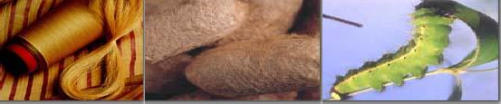
Its production is confined to Assam, border areas of adjoining North eastern states and Cooch Bihar in West Bengal. It is produced by the muga silkworms (Antheraea assamensis), which take to eat on Som and Sualu.
The major costly of silks, muga is essentially woven into the cultural background of the people of Assam.
The exciting Sualkuchi sarees and mekhla-chaddars are the conventional items made from muga silk.
In current times, fashion designers have created exciting prospects in using muga silk for developing new products and designs. The use of muga thread as a replacement for ‘zari’ in sarees is finding favor with reputed weavers.

CLASSIFICATION OF MULBERRY SILKWORM ON VARIOUS BASES
1. Based on geographical division
a. Japanese
The univoltine or bivoltine, produces green, yellow or colorless cocoon, larval phase is longer, silk is thick, small length and are better adapted in adverse conditions. They generally produce dual cocoons.
b. Chinese
The univoltine, bivoltine or multivoltine larval growth rate higher, feeding rate is higher, cocoon is egg-shaped, colorless or golden, yields much longer fine silk with less diameter.
c. European
The univoltine, eggs are bigger, cocoon is long, or egg-shaped, colorless or yellow coloured, yield much longer silk. Larvae are with higher feeding rate, larval phase is longer, it not endure higher temperature and humidity.
d. Indian
The multivoltine takes fewer time to complete life cycle, cocoon is small, egg-shaped, yellow or green coloured and yields silk of considerable length.
2. Based on Number of generation per year (Voltinism)
a. Univoltine
It means refers to insects having one brood or crop or generation per year. Their larvae are of stout size and eat much more food. These generate larger sized cocoons having 200–300 mg covering weight. In such cocoon yields 800 to 1200 m silk. They show diapause.
b. Bivoltine
It means refers to insects having two broods or crop or generations per year. Their larvae are somewhat of moderate size. The covering weight of the cocoon is 150 – 200 mg. They yield 600 – 800 m silk.
c. Multi or Polyvoltine
It means refers to insects having more than two broods or crop or generations per year. Their larvae are relatively of small size. The covering weight of the cocoon is 100 – 150 mg. They yield 300 – 400 m silk.
3. Based on Number of moults
a. Trimoulter
Their larvae moult three times in their larval phase. The weight of cocoon, shell ratio, the length of silk acquired from their cocoon is much less.
b. Tetramoulter
Their larvae moult four times in their larval phase. The weight of cocoon, shell ratio, the length of silk acquired from their cocoon is relatively better.
c. Pentamoulter
Their larvae moult five times in their larval phase. The weight of cocoon, shell ratio, the length of silk acquired from their cocoon is of superior quality.
4. Based on Genetic nature
The pure strain, hybrid strain, mono hybrid as well as poly hybrid.

BIOLOGY AND MORPHOLOGY OF MULBERRY SILKWORM
The silkworms go by a complete metamorphosis from egg to adults’ phase.
I. Egg
1. The eggs are laid in clusters on the underneath of mulberry leaves during night time.
2. A female lays concerning 300-400 eggs commonly known as silk-seeds measuring about 1 to 1.3 mm in length and 0.9 to 1.2 mm in breadth.
3. The eggs are tiny, ovoid, flat, ellipsoid or egg-shaped light, white or yellow and seed like in form.
4. At the time of egg emerging, it turns into black and hatch within 10-12 days in the period of summer and 30 days in the period of winter. In the univoltine race, the eggs do not hatch in the period of winter and endure the hibernation.
5. The one generation is completed in univoltine race per year, but 2-7 generations completed in multivoltine race per year.

II. Larva
1. The newly emerged larva is white to dark in colour along with measures about 3 mm long.
2. There are 3 pairs of thoracic and 5 pairs of abdominal legs which are located on the 3, 4, 5, 6 and 10th abdominal segments.
3. On the dorsal surface of the eighth abdominal segment, the larva carries the caudal horn.
4. The larva moults 4-5 times and turns into maturity in 30-35 days.
5. The full grown-up larva is creamy white in colour and measures about 75 mm long.
6. In the female, a pair of milky white spot is become visible on each of the eighth and ninth segments.
7. In male, a small milky white body becomes visible at the centre of the ventral side between the eighth and ninth segments.
8. Cocoons development takes place within 25 hours.

III. Pupa
1. The cocoon concerning 38 mm in length and 19 mm in breadth. It is egg-shaped and white or yellowish in colour.
2. The larva pupates within the cocoon which is made up of a single yarn.
3. The pupa within the cocoon is reddish-brown in colour and concerning about 25 mm x 7 mm in size.
4. The pupal period lasts for about 10-15 days.
5. At the time of coming out of adult, it emits an alkaline fluid which pierces the cocoon and adult comes out.

IV. Adult
1. The moth of silkworm is a creamy white colour concerning 30 mm in length and a wingspan of about the 40-50 mm in size.
2. The female is bigger and less active than male.
3. The head is smaller and bears a pair of black compound eyes and the appearance bipectinate antennae.
4. The mouth parts are vestigial (not well developed) hence the moth does not take food and lives only for about 2 to 3 days.
5. The frontal portion of thorax is narrower than the posterior.
6. The forewings are provided with dirty dark coloured lines and the body is covered by means of hairs.
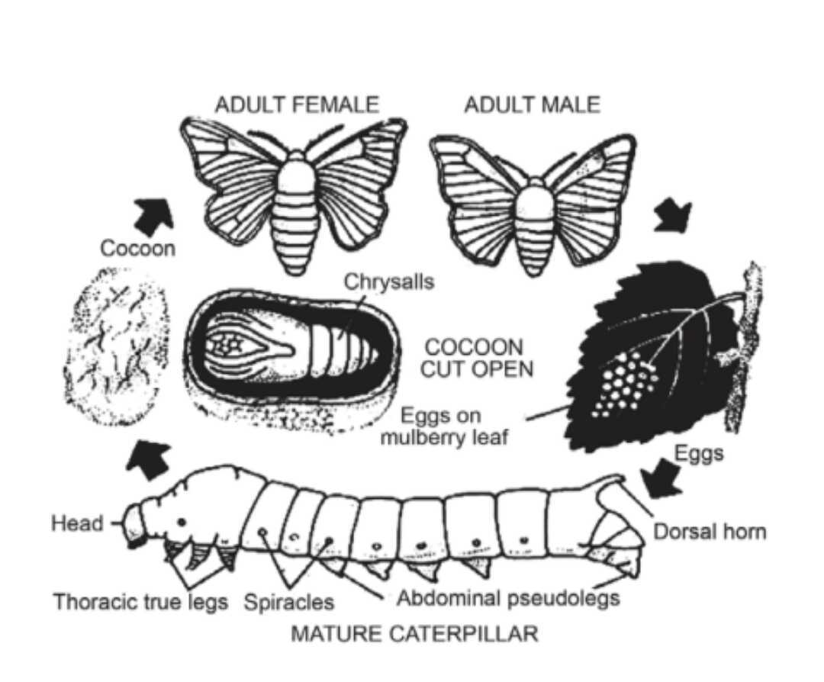

COCOON
- The cocoon is produced from a secretion of two large silk glands (truly the salivary glands), which expand along the within of the body and open by a general duct on the lower lip of the mouthparts.
- The larva moves the head from side to side extremely fast (about 65 times per minute) throwing out the secretion of the silk glands in the form of a yarn.
- The secretion is an obvious sticky liquefied, which on exposure to the air gets hardened into the superior silk fibre.
- The filament producing a cocoon is regularly and ranges in length from 700 to 1100 metres.
- The cocoons from which moths have come out are called pierced cocoons.
- These are of lower value because regular thread cannot be acquired. The pieces are removed by instruments and spun into a thread.

SILKWORMS REARING
The sericulture is the nurturing of silkworms for the making of raw silk. The most important actions of sericulture comprises of food-plant cultivation to give food to the silkworms which spin silk cocoons and reeling the cocoons for unwinding the silk thread for value added profit such as processing and weaving.

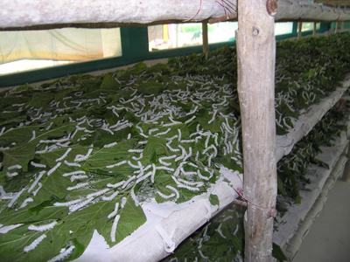
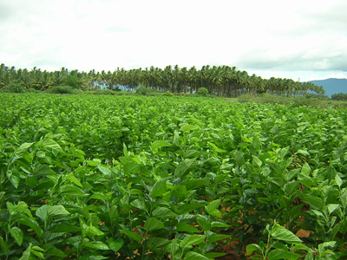
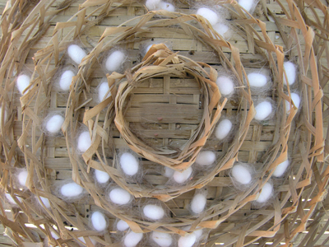
Even though there are a number of commercial species of silkworms, Bombyx mori is the most broadly used. The silk thread is a protein produced from the silk glands of silkworms.
The sericulture is an ideal world suited to get better the rural financial system of the country, as it is practiced as an additional trade to agriculture. The latest research has also shown that sericulture can be developed as an extremely returning agro based industry.

CULTIVATION OF MULBERRY
Mulberry (Morus spp., Family - Moraceae)
The significant character of the members of the family Moraceae (particularly Morus spp.) is the existence of idioblast, an enlarged epidermal cell into the leaf.
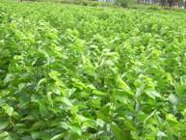
Ecological necessities
Climate
The mulberry can be grown up to 800 m Mean Sea Level. For the most advantageous growth of mulberry and good quality sprouting of the buds, the average atmospheric temperature must be in the range of 13ºC to 37.7ºC. The best temperature must be between 24 and 28ºC with relative humidity of 65 to 80 percent and sun shine period of 5 to 12 hours per day. The mulberry is able to be grown-up with a rainfall range of 600mm to 2500mm. Beneath the low rainwater conditions, the growth is inadequate and need supplemental irrigation. On an average, 50mm once in 10 days is measured best for mulberry.

Soil
The slightly acidic soils, pH ranges 6.2 to 6.8 are free from adverse salts are best for good growth of mulberry plant. The saline and alkaline soils are not ideal.
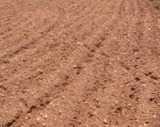
Varieties of mulberry
Irrigated - Kanva 2, MR 2, S 30, S 36, S 54, DD (Viswa), V1
Semi irrigated - Kanva 2, MR 2
Rainfed - S 13, S 34, RFS 135, RFS 175, S 1635

Propagation of mulberry plant
- The mulberry is mainly propagated by means of cuttings.
- The cuttings may be planted straight away in the main field itself or nursery may be raised as well as the sprouted and rooted seedlings may be planted in the main field.
- The later method is suitable because of its easy establishment in the main field.
Planting material selection
- Usually, the mulberry plants are raised from semi hardwood cuttings.
- The cuttings are chosen from fine established backyard of 8 to 12 months old.
- The only complete grown thick main stems, free from the insect along with disease damages having a diameter of 10 to 12 mm are preferred for preparation of cuttings.
- The cuttings should be of 15 to 20 cm with 3 to 4 lively buds and should have 45º slanting cut at the base end.
- The care should be taken to create a sharp dirt free cut at both the ends of cuttings without splitting the bark.
- The manually or power operated mulberry cutter or stem cutting machine is available for rapid cutting of propagation material.

Nursery
Preparation of nursery bed
- To select the 800 sq.m. area of red loamy soil close to water source for raising seedlings or plantlets for planting one hectare of the main area of field.
- Application of the 1600 kg of Farm Yard Manure (FYM) @ 20 t/ha and mix up fine with the soil.
- To raise the nursery beds of 4m x 1.5m in size.
- The length may be of suitable size depending upon the slope, irrigation source, etc.
- To provide a drainage channel and keep away from the shaded area.

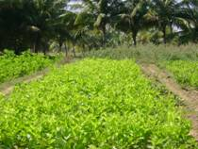

Pre treatment to the cuttings
- To mix up one kilogram of Azospirillum culture medium in water @ 40 liters.
- To keep the base end of the cuttings for the period of 30 minutes in it prior to the planting. Azospirillum is applied for the purpose of inducing the early rooting.
Planting of nursery
- To apply the VAM @ 100 g/m² of nursery area.
- To irrigate the nursery bed. Planting of the cuttings in the nursery at the spacing of 15 cm x 7 cm at an angle of 45 degree.
- To make sure the exposure of one active bud in every cutting.
Management of Nursery
- To irrigate the nursery one time in three days.
- Application of the dust one kg of any one of the following insecticide around the nursery bed to keep away from termite attack. e.g. Quinalphos 1.5D.
- To keep away from root rot and collar rot, drench the soil with carbendazim 50 WP (2 g per litre) or the application of Trichoderma viride 0.5 g per m² using rose can.
- After weeding, apply the 100 g of urea per m² among 55 and 60 days after planting at the time of weeding.

Age of seedling
- The seedlings are prepared for transplanting in the main area of the field after 90 to 120 days of planting.

Methods of planting
  - Paired row planting system
To keep the planting of cuttings or saplings at a spacing of 75 or 105 cm x 90 cm. To raise the intercrops in the wider inter row space which is willing for mechanization also.
Method of planting | Spacing ( in cm )
 | Irrigated | Rainfed
Ridges and furrows | 60 x 60 or 90 x 90 | 90 x 90
Pit system | 90 x 90 | 90 x 90

The number of cuttings per hectare are 27,780 (60 x 60 cm) and 12,345 (90 x 90 cm).

Planting time
- To plant the saplings during rainy season.
- To keep away from planting during winter and summer months.

Saplings planting
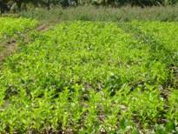
- To plant the saplings with the well rooted and sprouted at a depth of 15 to 20 cm.
- To earth up and level the area around the saplings.
- To fill the gap during monsoon months.

Management of nutrients
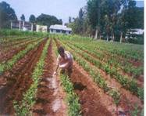

a) Irrigated or semi irrigated crop (kg/ha)
 | Row planting system |  |  | Pit planting system
 | N | P | K | N | P | K
Recommendation | 300 | 120 | 120 | 280 | 120 | 120
Split doses
First crop | 60 | 60 | 60 | 60 | 60 | 60
Second crop | 60 | - | - | 40 | - | -
Third crop | 60 | 60 | 60 | 40 | - | -
Fourth crop | 60 | - | - | 60 | 60 | 60
Fifth crop | 60 | - | - | 40 | - | -
Sixth crop | - | - | - | 40 | - | -

- The fertilizer schedule for the V1 variety is 375:140:140 kg NPK/ha.
- To apply fertilizers as per soil recommendation wherever doable.
- To apply the first dose of fertilizers within the three months after planting.
- To follow later dose of fertilizer after every leaf harvest and pruning.
- To apply straight fertilizers to reduce the cost.

b) Rainfed crop (Kg/ha)
 | N | P | K
Recommendation | 100 | 50 | 50
First dose | 50 | 50 | 50
Second dose | 50 | - | -

- To apply the first and second doses coinciding with south west and north east monsoons in that order.

Application of Biofertilizers
- To apply Azospirillum @ 20 kg per ha in the five split doses. To apply phosphobacterium @ 10 kg per ha in two equal splits.
- To mix up the bio-fertilizers with 50 kg of FYM for homogeneous supply.
- To make sure irrigation after application.
- Do not mix up bio-fertilizers with inorganic fertilizers.
- To grow and in situ incorporation of sunhemp.

Micro nutrients application
- To apply the recommended major or secondary nutrients based on the deficiency symptoms.
- According to the deficiency symptom of micro nutrients appeared then apply various kind of micronutrients as foliar spray such as zinc sulphate 5 g, ferrous sulphate 10 g, borax 2.5 g, copper sulphate 2.5 g, manganese 2.5 g and sodium molybdate 100 mg per liter of water using high volume sprayer (spray fluid 500 liter per ha).
- To add the wetting agent like Teepol @ 0.5 ml per lit. for better adherence on the foliage.

Irrigation Methods
  - Ridges and furrows method of irrigation
- This is the highly efficient method of irrigation.
- This requires comparatively less amount of water.
- The furrows serve up as drainage waterway during heavy rainfall.
  - Flat bed method of irrigation
- In this method formed the rectangular beds and channels.
- Relatively in this method low water runoff.
- The more land is wasted and need more labour for field preparation.
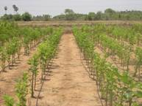
  - Drip method of irrigation
- The most efficient in water use.
- Huge saving in irrigation water.
- To better growth of crop.
- This is appropriate for undulating terrains.
- The fertilizers can also be applied together with irrigation water.
- The blockage of emitters by physical, chemical and biological impurities.
- The initial cost is very high.
Weed Flora in Cultivation of Mulberry
The general weed flora in the mulberry garden is given below.
Name of weeds
1. Monocotyledonous weeds (Grassy weeds) | 2. Dicotyledonous weeds (Broad leaves)
Cyperus rotundus (Nut grass) | Abutilon indicum (Velvet leaf)
Cynodon dactylon (Bermuda grass) | Amaranthus viridis (Pig weed)
 | Acalypha indica (Copper leaf)
 | Boerhaevia diffusa (Hog weed)
 | Croton sparsiflorus (Croton)
 | Parthenium hysterophorus (Carrot grass)
 | Trianthema portulacastrum (Carpet grass)
 | Tridax procumbens (Tridax)

Integrated Weed Management in Mulberry
Cultural method
- To eliminate the stubbles and roots of weeds while preparing the land.
- To use fine decomposed manure to avoid spreading of weeds.
- To clean the equipments prior to use.
Mechanical method
- To employ country plough after pruning in the inter space.
- To eliminate the weeds by hand hoe.
Chemical method
- To make use of Paraquat (Grammoxone) @ 2-3 litre per hectere area as post-emergence application.
- To spray of Glycel 7.5 ml with 10 grams of ammonium sulphate per litre of water as post-emergence application. A total of 600 litres of spray fluid is required per hectare area.
- To make use of flooding or deflector or fan type nozzle for spraying weedicides. Applications of weedicides apply instantly after pruning or within 2-3 days after pruning.
Intercropping
The intercropping through short duration pulse crop improves the soil, gives extra income and besides controls the weed growth. To grow crop as intercrop like black gram green gram as well as cowpea.
- Seed rate:-10 kg per ha.
- To sow the intercrop after pruning and earthing up.
Mulching
The mulching by means of pruned mulberry twigs and additional materials like straw and dried leaves will have the subsequent advantages
- To controls the weed growth.
- To conserves the soil moisture by reducing run-off.
- To enhance the infiltration of water.
- To decrease the soil temperature.
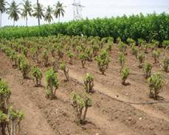

Methods of pruning
i) Bottom pruning
To cut the plants at ground level leaving 10 to 15 cm base, above the ground level. This type of pruning is done one time in a year.
ii) Middle pruning
To cut the branches are at 40 to 60 cm above the ground level. Later than bottom pruning, succeeding cuts are made at 45 to 50 cm height.
iii) Kolar / Strip system
In this type of pruning is done in area where plants are planted closely. The branches are cut at earth level every time. Therefore, it receives five pruning’s every year. This type of strict pruning requires heavy fertilization and irrigation.
Harvesting of Leaf
The harvesting method of leaf based on the type of rearing technique applied. It is desirable to harvest the leaves for the period of morning hours. There are three types of methods which are adopted for mulberry leaves harvesting.
Picking of Leaf
The individual leaves are harvested with or devoid of petiole. The leaf picking starts 10 weeks past bottom pruning and succeeding pickings are done at an interval of 7 to 8 weeks.
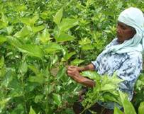

Cutting of branch
The whole branches are cut and fed to the worms. Prior to that, topping is done to make sure uniform maturity of the lower leaves.
Harvest of whole shoot
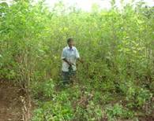
To cut the branches are at ground level by bottom pruning. The shoots are harvested at an interval of 10 to 12 weeks and hence 5 to 6 harvests are made in a year.
Harvesting time
It is desirable to harvest the leaves for the duration of morning hours.
Preservation of mulberry leaves
To use leaf preservation assembly room or wet gunny bags to store the leaves or cover the bamboo basket with wet gunny bags to keep it cool along with fresh.

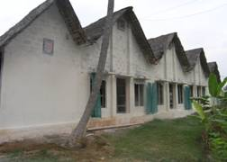
HOUSE FOR REARING
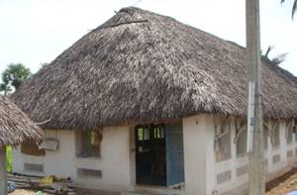

The rearing house
- A separate house is best for rearing of silkworm.
- The rearing house should have enough number of windows to allow cross ventilation.
- The prerequisite should be made to make it air tight for the proper disinfection.
- The rearing house has to be built in such a way to make available optimum temperature of 26 to 28ºc and RH of 60 to 70% for the growth of silkworm at lowest operational outlay.
Main principles
The most significant principles to be kept in mind in silkworm rearing house are:
To avoid
- Moist condition
- Stability of air
- Undeviating and strong drift of air
- Exposure to bright sun light with radiation
To ensure
- A similar temperature and humidity
- Good quality ventilation.
Characteristics
- The house of rearing should be built depending on the staining capacity and the method of rearing. The rearing area of 2 sq. ft per dfl for floor rearing and 3 sq. ft per dfl for shoot rearing is the common criteria.
- The house of rearing should have a chief rearing hall, an ante room (8 x 8 ft) and leaf preservation room. To maintain a best separate chawki room (a must for two- plot rearing system; rearing room of size 10’ x 14’ with a height of 9-10 ft for an acre of garden).
- The house of rearing should face east-west direction.
- The house of rearing should have facilities to maintain the required environmental conditions.
- The growing trees around the house of rearing assist to maintain favorable environment.
- The house of rearing should be constructed taking consideration he following points such as effective is disinfection as well as washable floor, etc.
- The house of rearing is required for 480 sq. ft areas for rearing 100 dfls.
Rearing house preparation
- The rearing room is to be kept ready after disinfection at least 3 to 4 days in advance of beginning of rearing.
- The preconditioning of the rearing house is necessary that is arrangement of rearing appliances and prerequisite of essential environmental conditions one day in advance.
Preparation in favor of brushing
- Prior to initiation of each rearing, the rearing equipments and rearing houses must be carefully washed and disinfected with chlorine dioxide.
- The chlorine dioxide is sprayed on equipments, walls, roof along with floor homogeneously to devastate the disease causing organisms.
- The rooms should be kept shut for about 24 hours after disinfection.
- The doors and windows should be kept open as at least for 24 hours before initiation of rearing to avoid traces of decontaminator.
- To disinfect the rearing room and rearing appliances, chlorine dioxide can be used. The 500 ml of chloride dioxide is mixed with 50 gram of activator and this is dissolved in 20 litres of water. To this, 100 gram of lime powder has to be mixed.
Appliances for rearing
Non recurring (As General)
1. Disinfection mask and protective gum shoes, 2. Sprayer required for disinfection, 3. Room heater, 4. Water air cooler, 5. Kerosene blow lap, 6. Wet and dry thermometer, and 7. Forceps 6”.
Non-recurring (As specific)
1. Egg transportation box, 2. Egg incubation chamber, 3. Loose egg incubation frame, 4. Black box, 5. Chawki rearing trays, 6. Rearing bottom stand, 7. Feeding Stand, 8. Ant wells, 9. Leaf chopping board, 10. Leaf chopping knife, 11. Leaf mat, 12. Bed cleaning nets, 13. Earthen pot, 14. Litter basket, 15. Late age rearing trays, 16. Rearing stand, 17. Shoot rearing rack, 18. Chandrike, 19. Plastic basin, 20. Buckets, 21. Mug, 22. Plastic box, 23. Foam pads, 24. Foot rugs, 25. Leaf chamber for late age, 26. Leaf basket, 27. Cleaning nets.
Recurring
1. Paraffin paper, 2. Formalin, 3. Bleaching powder, 4. Lime powder, 5. Bed disinfectants, 6. Slides and cover slips, 7. Gunny cloth, 8. Cora cloth.

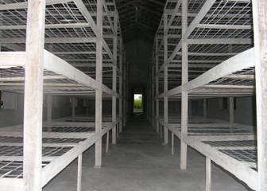 | 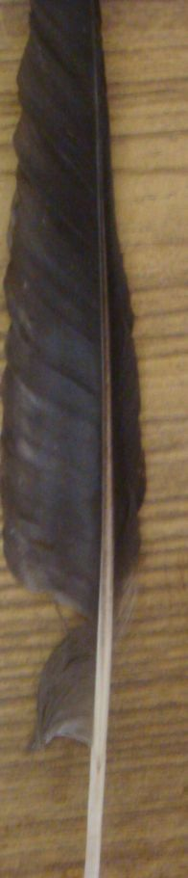 | 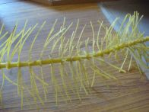 | 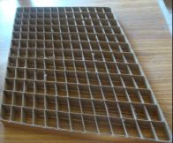
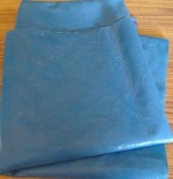 | 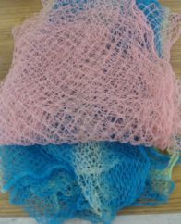 | 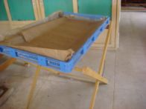 | 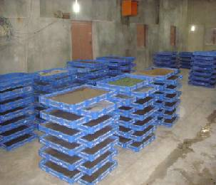

DISINFECTION
- Spray 2 % formalin with 0.3% slaked lime or 2.5 % chlorine dioxide with 0.5 % slaked lime @ 2 l/m2 area for disinfecting the rearing house immediately after completion of rearing and three days before brushing.
 | 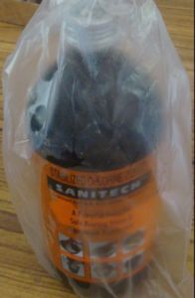 | 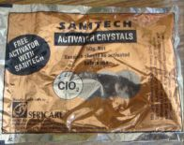
- Dip the rearing equipments in 2 % bleaching powder solution and sun dry before use.
- Dust 5% bleaching powder with slaked lime powder @ 200 g/m2 around the rearing house and passages and sprinkle water @ 1 lit / m2 floor area.
Incubation of egg and hatching
- The egg sheets should be spread out as a single layer in a chawki tray.
- Temperature of 25oC and humidity of 80 per cent are maintained. For this, paraffin papers and wet foam pads may be used.
- When the eggs come to head pigmentation stage (about 48 hours before hatching), they should be kept in dark condition by wrapping them in black paper or by keeping them in a box (black boxing). On the expected day of hatching, eggs are exposed to light, early in the morning to ensure uniform hatching. This facilitates uniform development of embryo.
- Most of the eggs (90 to 95 per cent) will hatch in about 2 to 3 hours.
Low cost method of preservation of eggs
- The eggs can be kept in an earthen incubation chamber.
- Draw the diagram and observe how humidity is maintained in the chamber.
Brushing
- The hatched larvae should not be starved and they must be brushed on a paraffin paper in a rearing tray or blue polythene sheet (Rearing bed).
- This is done by sprinkling chopped tender mulberry leaves of size 0.5 to 1 cm2 over the hatched larvae. The larvae crawl on to the leaves.
- After 8 to 10 minutes, the egg sheet is inverted over rearing tray and gently tapped.
- Worms that are still attached to the egg sheets should be gently removed to the tray with a feather.
- A rearing bed is prepared and some more chopped leaves, if necessary, are sprinkled.
- To prevent drying of leaves and to maintain the required humidity in the rearing bed, wet foam pads and paraffin paper covering are provided.

YOUNG AGE SILKWORM (CHAWKI) REARING
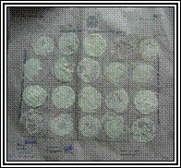
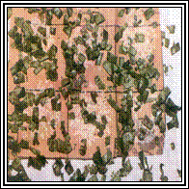 | 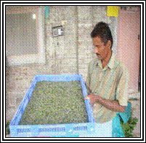
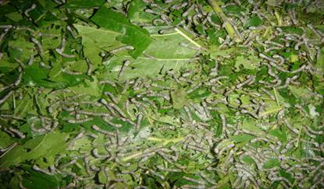

In a tray of 120 cm x 90 cm x 105 cm size, 20 dfls are brushed and reared upto second stage.
Selection of leaves
- From brushing to the end of second age, the larvae are fed with tender leaves.
- The leaves are selected from the largest glossy leaf, 3rd or 4th from the top.
- The next 6 to 8 leaves are used to rear the young age worms upto II moult.
- The size of the chopped leaf is around 0.5 to 1.0 sq.cm. during 2nd age.
- Illustrate with the help of a figure, the selection of leaves from a fully grown branch.
Leaf preservation
- Silkworm grows best when fed with succulent leaves which are rich in nutrients and moisture.
- The leaves, if not preserved properly, dry up and become unsuitable for feeding.
- The harvested leaves must be preserved in fresh condition in a wet gunny cloth.
- If the climate is too hot and dry, the leaves are preserved in a leaf chamber which is lined with gunny cloth.
- The cloth is kept wet by spraying water at frequent intervals.
Cleaning
- It is the process of removing the silkworm excreta and left over leaves in the rearing bed
- In the first age, one cleaning is given just a day before the worms settle for moulting.
- In the second age, two cleanings are given, one after resuming feeding and the other before second moult.
- A net with mesh size of 0.5 x 0.5 cm is spread over the rearing bed and feeding is given.
- The worms crawl through the net and come to fresh leaves.
- The net along with the worms and leaves are transferred to another tray.
- The left over leaves and litter are discarded.
Moulting
- At the time of moulting, care should be taken not to disturb the worms.
- Correct detection of moult and stopping or resuming feeds are very important for uniform growth of silkworms.
- During moult, the rearing bed should be kept thin and dry by applying lime @ 30 – 50 g/m2 and should have proper aeration.

LATE AGE SILKWORM REARING
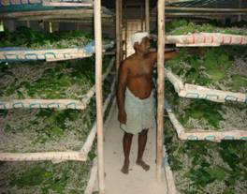 | 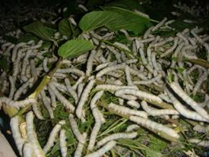

- The third, fourth and fifth instar larvae are considered as late age worms. They are reared in bamboo trays. Newspapers are spread over the trays to absorb excess moisture in leaves and faecal pellets.
- The temperature and humidity requirement gradually comes down as the stage advances.
- Leaves of medium maturity (6th leaf onwards) are fed in the third and fourth age and coarse leaves are fed in the fifth age.
- Over matured and yellow leaves should be rejected, since they may induce disease outbreak.
Bed disinfectants
Apply bed disinfectants like Resham Jyothi, Vijetha or Sajeevini @ 4 kgs/100 dfls.
Stage (before feeding) | Bed disinfectant (Qty/100 dfls) (g)
After 1st moult | 50
After 2nd moult | 150
After 3rd moult | 800
After 4th moult | 1000
On fourth day of final instar | 2000
Total | 4000

Moulting
- Remove the paraffin papers
- Evenly spread the larvae in the rearing bed 6-8 h before settling for moult.
- Provide air circulation to avoid excess humidity inside the room.
- Provide charcoal stove/heaters to raise the room temperature during winter.
- Apply lime powder at 60 minutes before resumption of feeding daily during rainy/winter seasons to reduce the dampness in bamboo trays.
Mounting
- Apply Sampoorna @ 20 ml (dissolved in 4 l of water) per 100 dfls over the leaves for early and uniform spinning of cocoons.
- After attaining full growth in the final instar, the worms cease to feed and are ready to spin.
- Such worms are slightly translucent and raise their heads to find a place for spinning.
- These worms have to be picked up and transferred to a mountage for spinning cocoons.
- Mounting of worms should not be delayed as the ripened worms will waste silk.
- About 800-900 worms per m2 are to be kept on a mountage. For 100 dfls, about 30 to 40 chandrakis are required.
- Mountages should be kept under shade in well ventilated place.

Care during spinning
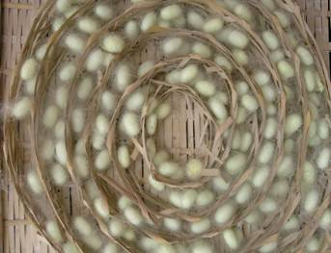

- Quality of silk depends on the care taken at the time of spinning.
- Mature worms are sensitive to temperature, humidity, light, etc., at the time of spinning.
- The ripe worm requires space equal in area to square of the length of its body for spinning.
- Proper spacing avoids wastage of silk for forming preliminary web and avoids double cocoons.
- To prevent staining of cocoons, keep mountage in an inclined position so that the urine may drop to the ground.

Maintenance of humidity
- Fluctuation of humidity causes abrupt thinning and thickening of silk filament.
- A relative humidity of 60-70% is ideal for spinning.
- Provide proper ventilation and straw mats below the mountage to quid excreta.
- Provide even and moderate lighting. Improper lighting (bright light or dark shadow) causes crowding of larvae to shaded area leading to double cocoons.
- Remove dead worms and non-spinners on the 2nd day of spinning.
- To protect the silkworm from predatory ants, apply lakshman rekha (repellent) at the base of mountage stand.

Harvesting
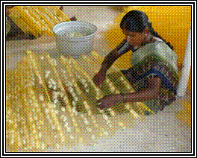 | 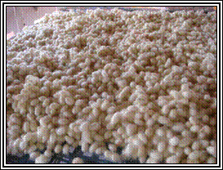

- The silk worms complete spinning in 2 to 3 days but the cocoons should not be harvested at this time as the worms inside are still in the prepupal stage.
- Harvesting should be done on the fifth day (7th day for bivoltine hybrids) when pupae are fully formed and hard.
- Do not harvest when the pupa is in amber colour.
- Dead and diseased worms on the mountages should be removed before harvest.
- Marketing of cocoons should be done on the sixth day (8th day for bivoltine hybrids).

Shoot rearing for late age worms
Silkworm larvae consume 85% of their food requirement during fifth instars. Fifty per cent of the labour input is utilized during the last seven days of rearing.
Rearing house
- Provide separate rearing house for shoot rearing in shady areas. Separate room should be provided for young age worm rearing, leaf storing and hall for late age worm rearing.
Shoot rearing rack
- A rearing rack of 1.2m x 11m size is sufficient to rear 50 dfls.
- Provide 15 cm border on all sides of the shelf to prevent the migration of the larvae.
- Arrange the shelves in three tier system with 50 cm space between the tiers.
- Fabricate the rack stand with wood, or steel and the rearing seat with wire mesh/bamboo mat.
Shoot harvesting
- Harvest the shoots at 1 m height from ground level at 60 to 70 days after pruning.
- Store the shoots vertically upwards in dark cooler room.
- Provide thin layer of water (3 cm) in one corner of storage room and place the cut of shoots in the water for moisture retention.
Feeding
- Provide a layer of newspaper in rearing shelf.
- Disinfect the bed; spread the shoot in perpendicular to width of the bed.
- Place top and bottom ends of the shoots alternatively to ensure equal mixing of different qualities of leaves.
- Transfer the third instars larvae to shoots immediately after moulting.
- Watch for feeding rate from 4th day of fourth instars. If 90% of larvae have not settled for moulting, provide one or two extra feedings.
- Provide 3 feedings during rainy/winter months and 4 feedings during summer rearing.
Spacing
- 18-36 m²/100 dfls.
Bed cleaning
- Bed cleaning is done once during second day of fifth instar following rope (or) net method.
- In rope method, spread 2 m length of rope (two numbers) at parallel row leaving 0.5m on other side.
- After 2 to 3 feedings, ends of the ropes are pulled to the centre to make it into a bundle.
- In net cleaning method, spread 1.5 cm2 size net across the bed.
- After 2 or 3 feedings, the nets are lifted and the old bed is cleaned and disinfected.
- Transfer the net to newer shelf, spread the net over the shoots; larvae will migrate to lower layer.
Advantages
- Labour saving upto 70% when compared on hour to hour basis with leaf feeding method.
- Leaf saving upto 15-20%. Hence, leaf cocoon ratio is less by 2-3 kg and extra cocoon production.
- Better cocoon characters and effective rate of rearing (ERR).
- Better preservation of leaf quality both during storing and on the bed.
- More organic matter production (upto 18 tonnes per ha per year).
- Better hygienic conditions can be maintained.
- Handling of silkworms minimised. Hence, contamination and spreading of disease reduced.
- Bed cleaning only once after IV moult.
- Worms and leaves are kept away from the litter. Hence, chances of secondary contamination are minimised.
- Labour dependent risk is reduced.
Disadvantages
- Required rearing room floor area is more (by 30%)
- Bed refusals will not be available as a cattle feed.
- Planting materials (cuttings) will not be available.

IMPORTANT SILKWORM PESTS AND THEIR MANAGEMENT
Pests | Nature of Damage | Management
Common Name- Uzi fly  Scientific Name- Exorista sorbillans  (Tachinidae: Diptera)  (Endo-parasitoid of silkworm) | - The flies lay their eggs on full-grown larvae of silkworm after that hatched eggs become maggots they feed the body contents of caterpillar.  - The matured maggot causes decrease in yield of cocoons and cocoon quality.  - Furthermore, causes death of silkworm larva.  - The occurrence of creamy white oval eggs on the skin of larvae in the early stage.  - Existence of black scratch mark on the larval skin.  - The silkworms larvae die prior to they reach the spinning stage (if they are attacked in the initial stage). In later on stage, pierced cocoon is noticed. | - To prevent fly's access to silkworms by mechanical way.  - To use the fly's proof rooms or doors or ventilators.  - All the cracks and crevices of the rooms should be closed to prevent maggots pupating in the soil.  - To dust the China clay @ 3g per 100 on spinning larvae before mounting.
Common Name- Beetles  Scientific Name-Dermestes cadeverinus)  (Dermestidae: Coleoptera) | - The attraction of adults beetle and grubs due to smell of the cocoons.  - They consume the cocoons, enclosed pupae and frequently the eggs of silkworms.  - The females beetle lay their eggs in the crevices, organic matter as well as wooden boards.  - The Grubs and adults beetle bore into the cocoons and consume the dried pupae, attack pierced and melted cocoons stored within the grainage.  - The existence of small holes (pierced cocoons) in the pupae and abdominal parts are damaged in the adult moths. | - To shutting down of cracks and crevices.  - To comprehensive cleaning of rearing room.  - To fumigate the rooms with methyl bromide.  - To store up the pierced cocoons in a separate room.  - To avoid long storage of pierced cocoons.  - To sun dry the pierced cocoons one time in a week.
Ants  (Formicidae: Hymenoptera) | - Ants attack silkworms in rearing trays. | - The legs of the rearing stands should be dipped in ant wells (water + kerosene).  - To use the ash or kerosene at the handles of the mountages at the time of spinning.
Squirrels, Rats, Birds and Lizards | - All this feed on silkworms.  - The mammals devour on pupae by biting open the cocoons. | - The rearing rooms should be kept liberated from lizards.  - To set the traps for rat as well as squirrel control.  - To scare the birds from the vicinity.

IMPORTANT SILKWORM DISEASES AND THEIR MANAGEMENT
Diseases and Causal organism | Susceptible stages/Mode  of infection | Damage symptoms | Management
Pebrine disease (Protozoa transmitted) (Nosema bombycis) | Eggs, Larvae, pupae, adults  Mode of infection: Ingestion of spores | - It is a chronic disease.  - Eggs laid by moth are fewer and do not firmly attach to the egg sheet.  - Peeper like black spots.  - Laying of unfertilized and dead eggs.  - Diseased larvae have poor appetite, retarded growth, undersized and flaccid.  - Larvae are comparatively paler,  - translucent and delays to moult.  - Silk gland will have white pustules on its surface.  - Dead larvae remain rubbery for some time and then turn black.  - Diseased pupa may develop black markings on the surface.  - Moth appears malformed.  - The wings are stunted and crippled  - The infection spreads to successive generation through eggs of diseased moth (TOT: Transovarial Transmission).  Responsible factor:  - Infected seeds (eggs) | - Mother moth examination.  - Use of disease free females.  - Sterilization of eggs with 2% formalin.  - Destruction of infected eggs and females.  - Bed disinfectant:  Vijetha powder
Flacherie disease (Bacteria transmitted) (Bacillus bombysepticus) | Larvae  Mode of infection: Ingestion of spores | - Loss of appetite, semisolid excreta, becomes lethargic.  - Skin becomes flaccid body purification and emission of foul smell.  - Larvae vomits gut juice and develop dysentery.  Responsible factor:  - Bad rearing condition (High temperature and humidity).  - Poor ventilation, over crowding  - Bad leaves and over feeding | - Proper incubation of eggs.  - Proper rearing conditions.  - Disinfectant: Slaked lime solution 0.3%  - Bed disinfectant:  Vijetha powder
Grasserie disease (Virus transmitted) (Nuclear Polyhedrosis Virus)  Milky disease | Larvae  Mode of infection: Ingestion of polyhedra (Chrystal virus particle) | - Swelling of inter segmental region and easy rupture of skin.  - The integument will be fragile and breaks easily oozing turbid milky fluid.  - Body fluid becomes thick and cloudy and they die.  - The larvae do not settle for moult and their integument become shining  Responsible factor:  - Bad rearing condition (High temperature and humidity).  - Poor ventilation, over crowding  - Bad leaves and over feeding | - Avoidance of injury.  - Disinfection of seed production unit, appliances, silkworm rearing house surroundings and silkworm egg surface.  - Disinfectant: Slaked lime solution 0.3%  - Bed disinfectant:  Vijetha powder
Muscardine  disease  (Fungal transmitted)  1. White Muscardine (Beauveria bassiana)  - Green Muscardine (Spicaria prasina)  3. Yellow Muscardine  (Iscaria farinosei) | Larvae/ pupae/ adults  Mode of  infection:  Penetration of  skin by  germinating  spores of conidia | - Larvae loose appetite, become inactive and flaccid on death.  - Hyphae come out from inter-segmental membranes.  - Body becomes too hard.  - Mummified larvae vomit and shows diarrhea like symptoms.  Responsible factor:  - Bad rearing condition (High temperature and humidity).  - Poor ventilation, over crowding  - Bad leaves and over feeding | - Proper rearing conditions.  - Sterilization.  - Formalin 3% or bleaching powder 2% or Slaked lime solution 0.3% as disinfectant.  - Bed disinfectant:  Vijetha powder

Research and Training Institutes on Sericulture in India
Central Silk Board (CSB), Bangalore, Karnataka under the ministry of textiles, Govt. of India, is nodal agency. The main Research & Training Institutes of the CSB provide scientific and technological support for enhancing production and productivity for sustainable sericulture through innovative approaches.
The main institutes working under CSB are as follows:
1. Central Sericultural Research & Training Institute (CSRTI), Mysore, Karnataka, deals with Mulberry sericulture.
2. Central Sericultural Research & Training Institute (CSRTI), Berhampore, West Bengal, deals with Mulberry sericulture.
3. Central Sericultural Research & Training Institute (CSRTI), Gallandar Pampore, Kashmir, J&K, deals with Mulberry sericulture.
4. Central Tasar Research and Training Institute (CTRTI), Piska-Nagri Ranchi, Jharkhand, deal with Tasar sericulture.
5. Central Muga Eri Research and Training Institute (CMER & TI), Lahdoigarh, Jorhat, Assam, deals with Muga and Eri sericulture.
In order to provide R&D support in post cocoon sector, the Board has established a Central Silk Technological Research Institute (CSTRI) at Bangalore. In addition, the CSB has also set up Silkworm Seed Technology Laboratory (SSTL) in Bangalore, Karnataka, Central Sericultural Germplasm Resource Centre (CSGRC) at Hosur, Tamil Nadu, and Seri-Biotech Research Laboratory (SBRL) at Bangalore, Karnataka.

Glossary of Silk or Silkworm
1. Antheraea mylitta, Antheraea pernyi and Bombyx croesi - Species of wild (undomesticated) moths that produce silk fibre. The silk filament is about three times heavier than that of the cultivated (domesticated) silkworm and is a coarser fibre. It is called tussah. 2. Artificial silk - Material that is similar in look to genuine silk, but is made from man-made fibres such as polyester, nylon or acetate.
3. Bombyx mori - The native (domesticated) variety of silkworm that produces Thai silk.
4. Cellule - A plastic black conical cup used to cover paired moths and female moth during oviposition.
5. Cocoon - The small, egg-shaped enclosure that a silkworm spins around itself, by creating silk filaments, to allow it to metamorphose inside to emerge as a moth.
6. De-gumming - The process of washing raw silk in warm soapy water to remove the sericin. This process can reduce the weight of the silk by as much as 25%. De-gummed silk is creamy white in colour and quite soft.
7. Denier - A unit of measurement of the fineness of silk and other fibres. One denier is equivalent to the weight of a single strand of silk thread of 9,000 meters in length, usually equal to one gram.
8. Dupion (or dupioni) - Yarn made from "double" cocoons that are spun by two silkworms simultaneously.
9. Fibroin - The protein that makes up the fibre of silk filaments.
10. Floss - Low-grade silk from the outer part of the cocoon. It can also refer to a soft silk yarn without any twist that is often used in embroidery.
11. Loom - A device for weaving threads together to make fabric. Hand-looms are usually made mostly of wood. Looms usually have a number of peddles to raise and lower alternate warp threads.
12. Mulberry - The tree whose leaves are the staple diet of silkworms. Approximately 200 kilograms of mulberry leaves will be eaten to produce one kilogram of raw silk.
13. Mulberry Silk - Another name for silk produced by Bombyx mori silkworms because they eat mulberry leaves.
14. Polyvoltine - The term used to describe silkworms that can be harvested several times a year. The native variety of silkworm in Thailand is polyvoltine.
15. Raw Silk - Silk thread that has been reeled from cocoons and is still in its natural state. It consists mainly of fibroin (the filament) with about 10-25% sericin (a gluey secretion). Raw silk is golden yellow in colour and somewhat stiff.
16. Reeling - The process of unwinding raw silk filaments from cocoons to produce a raw silk thread.
17. Sericin - A gluey protein secreted by silkworms that holds silk filaments together in a cocoon.
18. Sericulture - The process of rearing silkworms to the cocoon stage where they can then be reeled.
19. Silkworm - The larval stage of the Bombyx mori moth that produces silk fibres.
20. Skein - A coil of silk thread.
21. Slub - Tiny irregularities in the silk thread created by hand-making the thread.
22. Throwing - The process of taking raw silk threads and twisting them together to form skeins of silk yarn that will eventually be used for weaving. Different throwing techniques are used to produce warp and weft threads.
23. Tussah – Silk produced by wild silkworms; for example, Antheraea mylitta. Its silk filament is about three times heavier than that of the cultivated silkworm, Bombyx mori, and is a coarser fibre.
24. Weaving - The process of using a loom to interlace weft and warp threads to produce lengths of finished fabric.
25. Weighted silk - Silk that is coloured with dye and to which metallic substances have been added during the dying process. This adds back weight which is lost during de-gumming and also adds body to the fabric. If weighting is not done properly, it reduces the life of the fabric. Pure-dye silk is considered superior.
26. Wild Silk - Silk made by wild silkworms; for example, Antheraea mylitta and Antheraea pernyi, also called tussah.
27. Yarn - Silk thread that is ready to use for weaving.
28. Voltinism - It refers to number of life cycles per year. Depending upon eco race a typical silkworm may have one (Uni), two (Bi), three (Tri) or Multi(more than three) life cycles.
29. Disease free laying (DFL) - It is a defined as a group of eggs laid out by a moth which has been certified as disease free. Normally it consists of 200 healthy eggs. After emergence from the cocoon male moths immediately couple with female moths. After a period of 24-36 hours female moth lays eggs in about three batches. These eggs are cleaned washed and examined under the microscope for diseases specially pebrine. After a batch ic certified as disease free then only it is used for rearing in the field.
30. Chawkie rearing - Initially laid eggs when transferred in the field are hatched under supervision in few selected shrubs for a week. This natal stage rearing is called Chawkie rearing. After a week the one week old larvae are spread all over the forest areas.
31. Grainage - The process of Tasar egg making in lay mans term is called grainage. It involves storage of eggs, facilitating of male female coupling, washing cleaning of eggs and disease checking.
32. Ecorace - Due to agro climatic variations in the country various silkworm have adapted to local conditions and have evolved into distinct ecoraces. For example daba, modal, rally, laria are ecoraces of Tasar. Similarly in case of Mulberry ecoraces are developed by Central Silk Board to get maximum productivity for a particular area.
References
- Anonymous, 2022. https://www.ibef.org/exports/indian-silk-industry#:~:text=The%20total%20silk%20production%20in,previous%20year%20(33%2C770%20MT).

