Ion Transport Mechanism in MWCNT doped Nanocomposite Gel Polymer Electrolyte for Device Applications

Lovely Ranjta*, C.P. Singh

Department of Physics, AKS University, Satna (M.P.) 485001 INDIA
E-mail*: lovelyranjta@gmail.com

Abstract
The aim of the research work is focussed to study the impact of MWCNT on the performance of PVA based nanocomposite gel polymer electrolyte (NCGPE) membranes namely [(PVA-NH₄CH₃COO):MWCNT] system. These gel membranes are prepared by solution cast technique and characterized by various measurements viz. structural, electrical and electrochemical. SEM pictures confirm diminution in porosity of the system on increasing MWCNT contents. FTIR studies reveal the complexation of polymer with salt and filler only causing structural changes which results into minor shifting in the system. The NCGPEs exhibit highest ionic conductivity at 5.49x10⁻⁴Scm⁻¹ for 1.0wt% MWCNT doped gel membranes. The temperature dependence conductivity of (NCGPEs) membrane shows Vogel-Tammam-Fulcher (VTF) and Arrhenius behaviour which indicated hopping of ions in polymer matrix. The a.c. conductivity response follows the universal power law. LSV investigations on gel membranes have shown better electrochemical stability viz. ±4.29V. All these results indicate present system as an alternative to electrolyte materials for electrochemical device applications.
Keywords: Nanocomposite electrolyte, SEM, FTIR, conductivity and cyclic voltammetry

- Introduction
Past few decades have dominated polymer electrolytes as potential candidate for various electrochemical devices on account of achieving high ionic conductivity, better mechanical and thermal stability as well as to possess the ability to form suitable electrode-electrolyte contacts [1-4]. Among various electrolytes, polymer electrolytes possess excellent thermal stability, good flexibility, low flammability and high safety. A lot of researchers have keenly focussed on implementing polymer gel electrolytes due to their numerous properties. Chapter motivation is focused on the investigation of the role of polymer host, aspect ratio, shape and size of nanotubes in terms of boosting the electrochemical properties of nanocomposite gel polymer electrolyte (NCGPE). This will in turn help in order to widen new horizons towards the development of NCGPE with overall balancing property for enhancement of the fast ionic conductivity which can revolutionized the energy storage device technology.
This special class of polymer gel electrolytes are known to suffer from solvent exudation and mechanical degradation apart of their high ionic conductivity. Researchers now-a-days have dispersed non-interacting filler particles like TiO₂, Al₂O₃, SiO₂, BaFeO₃ etc. to over-come these drawbacks so as to create another emerged class of polymer electrolytes known to be nanocomposite polymer electrolytes (NCPEs) [5-8]. Despite of many favourable host polymer for the synthesis of nanocomposite gel electrolyte, Poly Vinyl Alcohol (PVA) is a semi crystalline and water soluble polymer with 1, 3-glycol structure wherein anion-cation mobility tends to occur in the amorphous phase and its diffusion occurs through a complex mechanism which involves segmental mobility of PVA. Moreover, this polymer also contains hydroxyl groups that are attached to methane carbons which act as active sites for complexation with different salts and acids. Because of achieving remarkably high ionic conduction with protons/NH₄⁺ ions in gel electrolyte systems, it has been considered as a host for development of proton conducting electrolytes [9]. Further, it exhibit relatively low glass transition temperature, high melting temperature and to dissolve even high concentration of a wide range of dopants. Prompted by these considerations, a proton/NH₄⁺ conducting nanocomposite polymer gel electrolyte which is based on host polymer PVA has been attempted [10]. Among the different dopants, ammonium acetate (NH₄CH₃COO) has been considered owing to small cationic/bigger anionic size which thereby allows greater mobility for transporting the ions. Nanofillers are attractive candidate for developing all components of the battery. Since nano materials have ability to fulfill the demand of the energy storage system with high energy density. Among various nanofillers available, multiwalled carbon nanotube (MWCNT) has been used for developing NCGPE membranes as they possess peculiar mechanical properties and mostly characterized by high thermal stability [11]. Nowadays, due to increased accessibility for the proton conducting batteries globally, it becomes important to develop new technologies which can provide the safe and advanced energy storage system. Keeping this in mind, the performance of PVA based electrolyte membranes through dispersal of MWCNT filler was undertaken and a free standing proton conducting nanocomposite gel membrane dispersed with multiwall carbon nanotubes (MWCNTs) has been synthesized. For the next generation energy storage system, the battery must be of a smaller size with better performances so that the void in the energy storage devices can be fulfilled [12].
- Materials and Methods
2.1 Preparation Methods
There are various synthesization approaches for nanocomposite gel polymer electrolytes and is done by various methods such as Solution Cast Technique, Spin Coating Technique, Dip Coating Technique, Hot Press Technique, In Situ Polymerization Technique etc. The properties of the nanocomposites gel polymer electrolytes are also affected by their preparation methods. This chapter focuses only Solution Cast technique for the development of NCGPE membranes.

The chapter covered the four different materials–polymer, salt, solvent and nanofillers chosen with main focus on their properties in view of their electrochemical and physical properties. The four different categories of material chosen result into the development of new class of NCGPE which possess entirely different characteristics, performance and modifications and behaviour making it an ideal candidate with the main focus on electrochemical and physical properties for the applications in proton conducting batteries.
The dissolution of polymer as host must be having an electron rich group called polar group and the salt dissolves in the solvent. The host polymer creates the coordinating sites for fast ion migration and also supported by the segmental motion of the polymeric chains. The segmental motion leads to the flexibility of the polymer chain as it pushes the ion from one site to another and therefore the mobility is sufficiently increased. For this, PVA with M_{w} 124000–186000 from Aldrich has been used.
Ammonium acetate (NH₄CH₃COO), aprotic solvent dimethyl sulphoxide (DMSO) was used for developing composite gel membranes. The incorporation of nanofillers was adopted as the most fascinating approach to develop the NCGPEs which contributes to the enhancement in the electrical as well as thermal and mechanical properties. Since the shape of nanofillers plays an important role because of the interconnection of the electrical properties of the nanofiller shape and surface group. So the main attention is to choose such a nanofiller that is beneficial for achieving fast ion transport. MWCNT from Aldrich having average diameter 50-80nm and length 2-4.5μm were taken.
2.2 Solution Cast Technique
PVA was dissolved in solution of NH₄CH₃COO in appropriate solvent (DMSO) by continuous stirring forming pristine gel electrolyte i.e. PVA-NH₄CH₃COO. A viscous solution of composite polymer gel electrolyte was prepared by admixing MWCNT in pristine solution in different weight proportions followed by constantly thorough mixing at higher temperatures with a magnetic stirrer for 8-10h. To obtain free standing NCGPE membranes were then poured in petri dishes. The obtained film is kept in a dessicator with silica gel for prevention from the moisture. After synthesis, these thin stable membranes were taken out carefully for further characterizations [13].
Thus nanocomposite polymer gel electrolyte membranes were developed with improved mechanical, thermal properties, electrochemical stability window and electrochemical properties. Table 1 shows the important characteristics for selection of appropriate materials for preparation of NCGPEs.
Table 1. Characteristics of constituents of polymer electrolytes.
Polymer | Solvent | Salt | Nanofiller
Provide fast segmental motion of polymer chain | Abundant in Nature | Low Lattice Energy for More Availability of Free Ions | High Polarity Low Melting and High Boiling Point
Low glass transition temperature | Non Aqueous in Nature | Broad Voltage Stability Window | Safe and Nontoxic
High molecular weight | Low Melting Point | Large Ion Transference Number | Environmental friendly and cost effective
High degradation temperature | High Dielectric Constant | High Thermal and Chemical Stability | High Dielectric Constant for better dissociation of salt
Low Viscosity | Low Viscosity | High Ionic Conductivity | Act as Lewis Acid for Interaction with Polymer
High Dielectric Constant | Good Solubility for Polymer and Salt | Small Cation size for fast migration between the electrodes | Inert to All Cell Components

2.3 Characterization Techniques
As we know that main components of a battery are anode, cathode and electrolyte. The NCGPE is sandwiched between the two electrodes and plays the dual role; one as an electrolyte for fast ion transport and other one as a separator for physical separation of electrodes to prevent any short-circuit. Hence, an electrolyte plays a key role during operation in any electrochemical device. Keeping in mind, these synthesized NCPE gel membranes were characterized for their practical applications. There are some parameters that need to be measured experimentally which give us the information about their performances and are discussed below.
2.3.1 Scanning Electron Microscopy (SEM)
Generally, nanofiller addition suppresses the crystallinity and crosslinking alters the polymer chain arrangement and completely changes the morphology of NCGPE membranes. The most critical requirement with the NCGPE is the formation of the amorphous content that will improve the electrode-electrolyte interface [14, 15]. The increased amorphicity also improves the use of full electrode material. A brittle coating of gold was applied to the NCPE membranes in a sputtering unit prior using the samples to study the surface morphology. The surface morphology of NCGPE membranes were obtained by using a JEOL-JSM-6390A scanning electron microscope.
2.3.2 Fourier Transform Infra-red (FTIR) Spectroscopy
The salt dissociation tendency of the polymer plays an important role in deciding the suitable polymer gel electrolyte with balanced properties. The polymer should be having high dissolution capability to enhance the salt dissociation as anions and cations and to increase the ionic conduction. Further, small tendency of the chain reorganization can appreciably contribute in separating the cations and anions in an effective way. Further the supportive role is done by the salt for the overall solvation ability. Apart from the polymer-salt, solvent also affects the dissolution ability of the overall participating species and changes the structural morphology of the synthesized polymer gel electrolytes. The IR traces were detected on Alpha platinum ATR Spectrophotometer (Bruker) ranging from 4000-600cm⁻¹ at room temperature to completely understand the interaction among various species. The complex-impedance measurements and Cyclic Voltammetry (CV) analysis were carried out by using an Electrochemical Analyzer (CHI608D) at the scan rate at 0.1Vs⁻¹ and in the voltage sweep range ±3V so as to ascertain electrochemical stability and electrochemical window of the prepared NCGPE membranes. Electrical conductivity measurements were performed at various temperatures ranging between 20˚C and 100˚C with frequency from 1Hz to10⁶Hz.
3. Results and Discussion
3.1 Scanning Electron Microscopy Studies
Fig. 1 (a-d) illustrates the surface morphology of pure MWCNTs and NCPEs containing 0.0wt%, 0.4wt%, 1.0wt% concentration of MWCNT contents. Image ‘a’ shows the SEM image of pure MWCNTs which confirms the nanometric dimensions of filler particles. Image ‘b’ shows a closed porous structure made up of PVA chains in PVA:NH₄CH₃COO electrolyte system.
Fig. 1 SEM Images: (a) pure MWCNT (b) DMSO casted PVA:NH₄CH₃COO electrolyte membrane (c) 0.6wt% MWCNT (d) 1.0wt% MWCNT.

Addition of 0.4wt% MWCNTs, vanishes the porosity of electrolyte system as MWCNTs are entrapped between polymer chains in the pores shown by image c, to indicate the attachment of MWCNTs on the surface of matrix electrolyte [16]. On further increase of MWCNT content upto 1.0wt% in polymer electrolyte, MWCNTs are completely covered by polymer chains which shows complete dispersion of nanofillers in polymer-electrolyte membrane shown in image d.
3.2 Infrared (IR) Spectroscopy Studies
Fig. 2 shows the FTIR spectra of pure PVA, NH₄CH₃COO and NCPE membranes of (PVA-NH₄CH₃COO) containing 0.0wt%, 0.2wt%, 0.4wt% & 1.0wt% concentration of MWCNTs. IR studies shows the characteristic broad peaks of pure NH₄CH₃COO with stretching vibration of C-O bond near 1046cm⁻¹ & 1244cm⁻¹ and the stretching vibration of C=O bond near 1734cm⁻¹ (table 2). These results confirmed well with earlier reportings of Agrawal et al. [17].
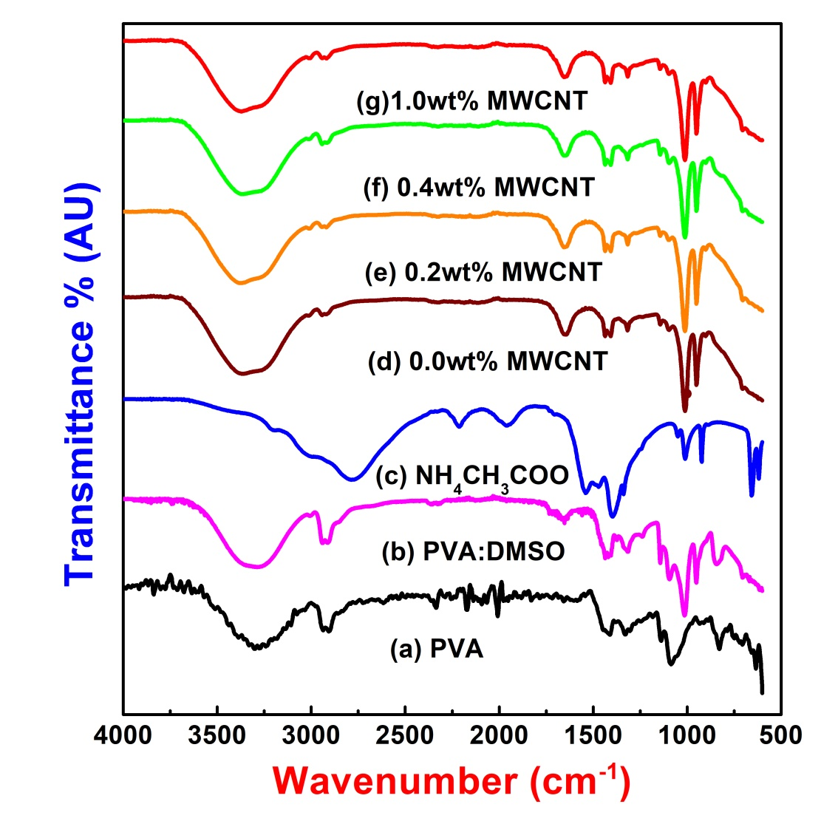
Fig. 2 Infrared spectra of Pure PVA and NCPE membranes of PVA:DMSO:NH₄CH₃COO with different wt% of MWCNT content.

Triplet peaks 1406cm⁻¹, 1418cm⁻¹ and 1436cm⁻¹ are seen in PVA-DMSO spectrogram and these peaks merged into double peaks at 1408cm⁻¹ and 1441cm⁻¹ in spectra of DMSO-PVA-NH₄CH₃COO and few shifting in peaks are also noticed in spectra from e to g on addition of nanofillers shown in table 1. C-H deformation related and C-O stretching related peaks at 1006cm⁻¹ and 1326cm⁻¹ indicating pure PVA related CH-OH bending and CH₃ in plane deformation are seen being shifted towards lower wave number. On increase of nanofillers contents peaks at 1244cm⁻¹ indicating C-O stretching mode and NH deformation vibration related peak of NH₄CH₃COO at 1401cm⁻¹ shows decrease in intensity. These modulations
result in improved salt-polymer interaction with MWCNT.

Table 2. IR transmittance bands of NCPE membranes (in wave numbers).

Description of Vibration Modes | Pure PVA | Pure  NH₄CH₃COO | [(PVA-NH₄CH₃COO) containing MWCNT (wt%)]
 |  |  | 0.0 | 0.2 | 0.4 |  | 1.0
C- H out of plane deformation | 714 | 618  657 | 619  706 | 615  711 | 618  702 | 614  703
O-H bending mode | 923 |  | 951 | 952 | 954 | 947
C-H wagging mode |  | 1014 | 1006 | 1010 | 1009 | 1014
C-O stretching mode | 1083 | 1046 | 1095 | 1093 | 1096 | 1097
C-C and C-O stretching mode | 1135 |  | 1139 | 1142 | 1140 | 1147
C-O stretching mode | 1236 | 1244
CH-OH bending mode CH₃ in plane deformation & C-H wagging | 1326 |  | 1317 | 1317 | 1315 | 1313
N-H deform. & asymmetric CH₃ bending mode |  | 1401
C-H deformation mode | 1410  1445 |  | 1406  1439 | 1408  1441 | 1403  1436 | 1412  1437
C-H stretching | 1643 |  | 1650 | 1649 | 1655 | 1653
-CONH- bending mode | 1661
C=O stretching mode |  | 1734
C-H symmetric stretching mode of CH₂ group | 2845  2906  2937  3059 | 2790  3006 | 2920  2942  3014 | 2911  2944  3010 | 2914  2947 | 2915  2948  3006
O-H stretch | 3295 | 3210 | 3372 | 3307 | 3352 | 3380

Decrease in intensity and broadening of peaks are due to the presence of MWCNT indicating it as passive in nature and only modifies the system morphology with stretching in polymer chains.. Further, peaks at 3372cm⁻¹, 3014cm⁻¹, 2942cm⁻¹, 2920cm⁻¹, 1139cm⁻¹ and 619cm⁻¹ which are related to C-H stretch (asym and submethyl), sym C-H stretch, C-H stretch and OH stretch, sym υ (SH) and acetal overtone, C≡N stretch, C-C and C-O stretch, O-H twisting respectively shifted to 3380cm⁻¹, 3006cm⁻¹, 2948cm⁻¹, 2915cm⁻¹, 1147cm⁻¹, 614cm⁻¹ respectively with increasing broadness. These shifting of peaks can also be correlated to physical attachment of MWCNT with ammonium acetate in composite polymer electrolyte. All these features unveils the prominent participation of MWCNT in improving better morphology of the system through polymer-salt interaction.
3.3 Cyclic Voltametry (CV) Studies
Fig. 3 shows the cyclic voltagrams of PVA-NH₄CH₃COO composite electrolytes system with nanofillers. On addition of 0.2wt% MWCNT (b), improved stability is observed. An oxidation peak noticed at 0.5V in (a) which is related to NH₄⁺/H⁺ ion clearly indicating protonic conduction in polymer gel electrolyte system [18]. On further increasing MWCNT, this oxidation peak tends to vanish and finally disappears completely in (c) & (d). This feature confirms the change in system morphology due to MWCNT addition in pristine electrolyte system. Voltagram (b) shows a peak at 1.6V which is due to oxidation of MWCNT. It is a significant feature reported earlier by Crooks and co-workers [19-20]. This oxidation peak gets reduced with increasing nano filler contents in polymer gel electrolyte systems (b & c). Comparing with PVA-NH₄SCN with Al₂O₃ fillers, the improved cyclic stabilities for [(PVA-NH₄CH₃COO):MWCNT] NCPE gel membrane system were noticed [21]. The cathodic and anodic peaks diminish in intensity and become broaden with slight shifting of cathodic peak towards lower potential and anodic peak towards higher potential which is due to the interaction of polymer with the NH₄CH₃COO with MWCNT as dispersoids.
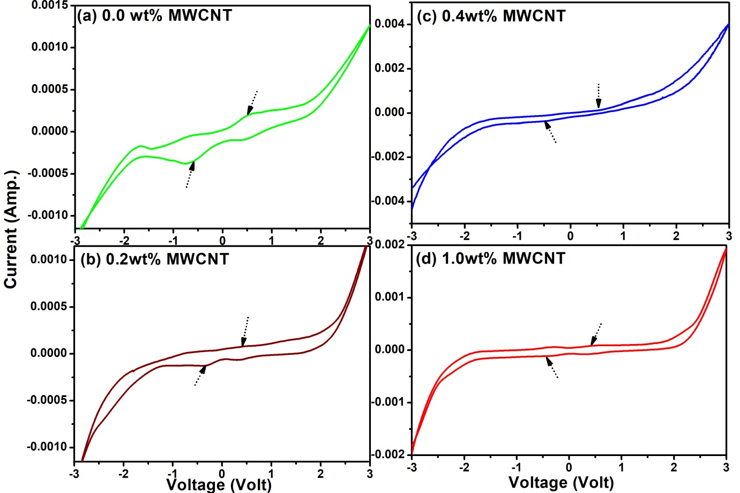
Fig. 3. Cyclic Voltagrams of PVA: NH₄CH₃COO gel membrane and 0.2wt%, 0.4wt% and 1.0wt% MWCNT.
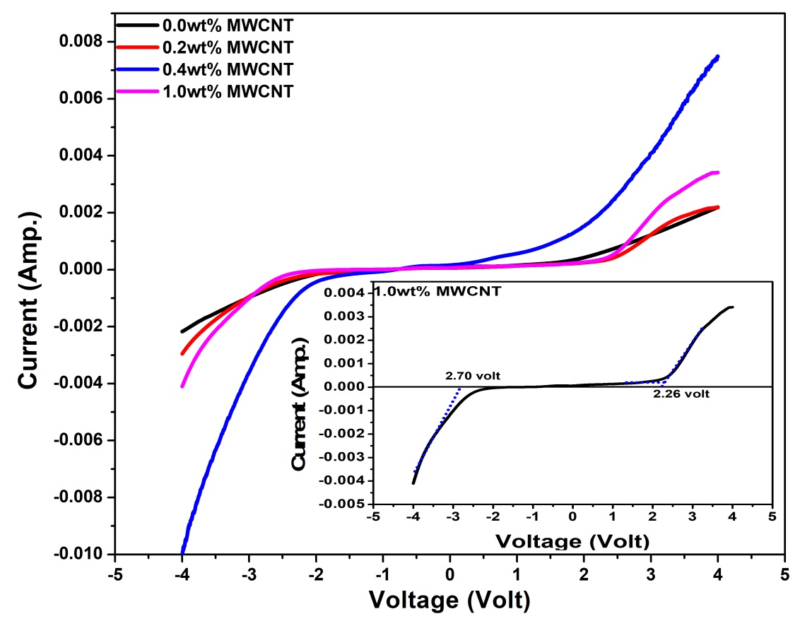
Fig. 4 LSV measurement of PVA-NH₄CH₃COO-MWCNT system containing 0.2wt%, 0.4wt% and 1.0wt% filler content.

Fig. 4 shows Linear Sweep Voltammetry (LSV) measurement. Upon addition of dispersoids in PVA-NH₄CH₃COO system, the electrochemical window stability is expanded and goes upto ±4.96V when 1.0wt% MWCNT is added (inset image). The anodic and cathodic potentials are noticed at +2.26V and -2.70V respectively signifying the electrochemical stability has been improved qualitatively on addition of MWCNT in the polymer-electrolyte system.
3.4 Impedance Spectroscopy
Fig. 5 shows the prominent role of MWCNT on ionic conductivity of polymer gel electrolyte membranes. In this case, the conductivity behaviour also shows two maximas; one at 0.5wt% and other one at 1.0wt% MWCNT which is said to be a typical feature of polymer nanocomposite gel electrolytes [22-24]. It is accompanied with the fact that the ammonium acetate salt has been completely dissociated and charge carrier concentration became limited. It has significantly changes the system morphology that leads to affect the ionic conductivity. Also, the rise in conductivity can be supported by the breathing chain model [17] and Tsagaropolous model which were reported earlier [24-25]. According to this model, ion dissociation takes place from folding and unfolding of the polymeric chains which creates free volume because of local pressure fluctuations for the ions in order to migrate smoothly. This reduces the trend of transporting ions and help in enhancing ionic conductivity as shown in fig. 5. Hence, maximum conductivity was observed at 5.49x10⁻⁴Scm⁻¹ for 1.0wt% of MWCNT content which shows that conductivity is enhanced by the promotion for ion mobility. However, Wagner’s polarization (t_{ion}) studies reveal that present system is ionic. Hence observed value of t_{ion} is found to be 0.99 and seen in fig. 6.
The temperature dependence conductivity of the polymer gel electrolyte in the presence of filler content is given in fig. 7. The increase in conductivity with temperature is associated to hopping mechanism between local structural relaxation, coordinated sites and segmental motion of the polymer. As the amorphousness increases continuously, which in turn, the polymer chain ascertains faster internal motion and bond rotations.
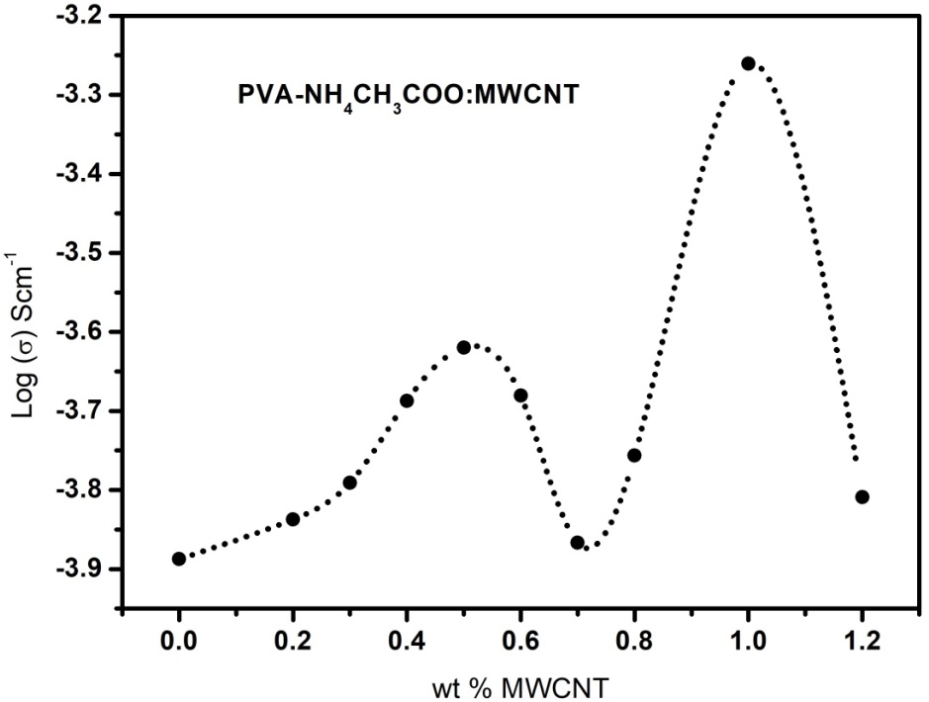
Fig. 5 Conductivity variations of NCGPE membranes with MWCNT at room temperature.
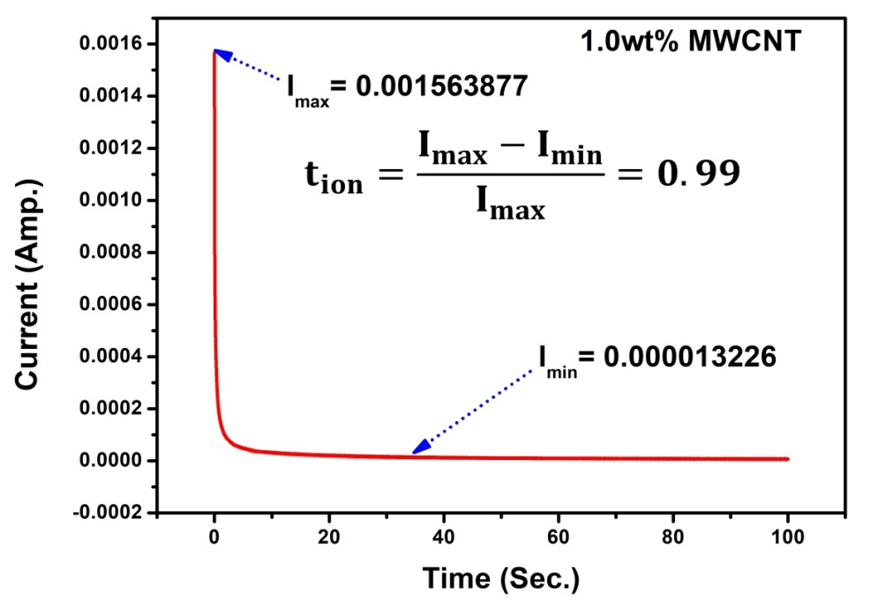
Fig. 6 Ion transference number of 1.0wt% MWCNT filled NCGPE membrane.

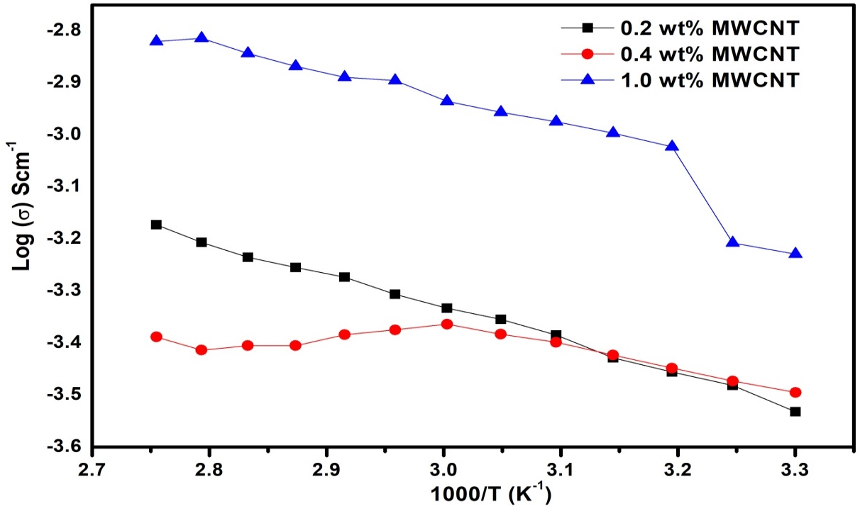
Fig. 7 Temperature dependence conductivity of NCGPE membrane with 0.2wt%, 0.4wt% and 1.0wt% concentrations of MWCNT.

As a result the hopping of intra and inter chain movement as well as ionic conductivity of NCGPE membrane increases. It is shown in fig.7 that conductivity behaviour shows two linear regions separated by a nonlinear behaviour. The linear region lies at the lower temperatures (25°C-40°C), thereby obeying Arrhenius nature as discussed earlier.^{[25]} The possibility lies in the fact because the liquid electrolyte gets encapsulated within the polymer matrix. The conductivity temperature regime (40°C-85°C) response is explained by VTF relationship. When the temperature becomes close to the T_{g} of the pure/complex PVA the matrix becomes quite flexible giving rise to VTF behaviour. These observations have already been observed by Srivastava et al. [26] and has given information about two regions which were separated by a small region corresponds to phase transition from crystalline to amorphous. At the interfaces, the reorganizations are more pronounced at glass transition temperature (T_{g}) of the composites. Owing to a modification of the polymer dynamics which is strongly interacting with the MWCNT [24,27-28]. Further, it has already been shown that addition of nanofillers can enhance the T_{g} in polymer gel electrolytes [29]. As a result with various MWCNT proportions in the composite polymer electrolyte system, the nonlinear region has been observed changing. As the temperature increases beyond 40°C, segmental motion in polymer composite plays a prominent role and starts affecting the conductivity. All these curves exhibit a similar behaviour as a combination of VTF and Arrhenius character.
The variation of a.c. conductivity for different proportions of MWCNTs doped NCPEs with frequency is shown in fig. 8. It is evident that a.c. conductivity goes on increasing with lower frequency and then followed a nearly frequency independent regime at higher frequencies. The increasing conductivity behaviour is connected to the electrode-electrolyte phenomena i.e. it results from electrode polarization effects [30]. This kind of behaviour has been reported for broad range of nanocomposite polymer electrolytes [31] and also for [(PVA-NH₄CH₃COO):MWCNT] system. It is seen that the increase in nanofillers enhance a.c. conductivity of polymer-electrolyte system. The power law exponent (p) value for ionic conductor is found to be in between 1.0 and 0.5 showing the long-range pathway diffusion limited hopping.
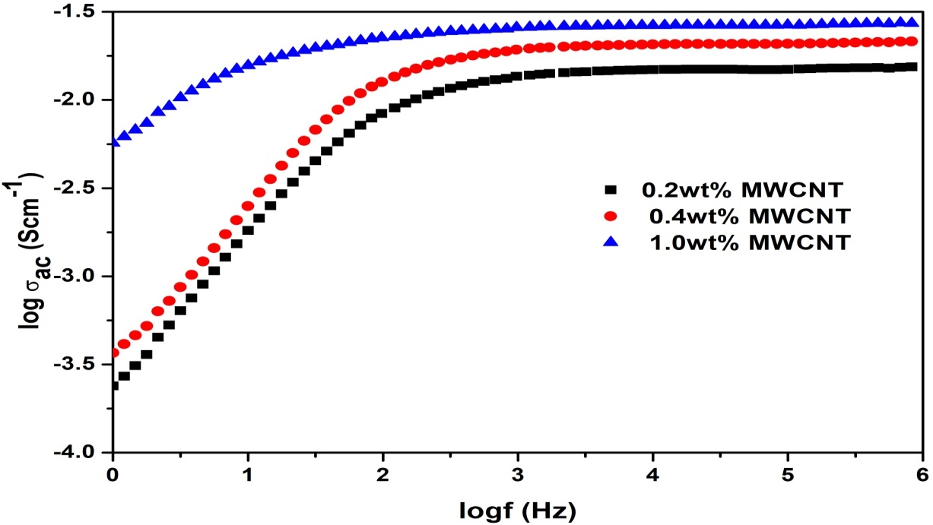
Fig. 8. a.c. conductivity with frequency for NCGPE containing (■) 0.2 wt.% (●) 0.4 wt.% and (▲) 1 wt.% MWCNT contents.

The frequency dispersion for different composite can be understood by jump relaxation model.^{[30-31]} According to jump relaxation model, an ion can be easily hop from a site to neighbouring vacant site successfully to result in conductivity. The probability for ions to hop back apparently increases due to short time periods at high frequencies. This forward-backward hopping together with relaxation of dynamic cage potential is quite responsible for high frequency plateau region.
Conclusion
This chapter highlighted the latest updates on the NCGPE system with different concentrations of nanotubes (MWCNT). The development of polymer gel electrolyte as a better alternative to solid/liquid polymer electrolytes has been carefully focused by researchers in past times all over the globe. From last few decades, the nanofillers have gained remarkable attention for synthesis of polymer gel electrolyte for electrochemical device applications. Amongst the various nanofillers available, nanotubes have been most extensively studied. The addition of nanofiller improves the overall properties of the polymer gel electrolytes. The nanofillers not only increase the electrical properties but mechanical properties also depending on the preparation method, interaction with polymer chains, dispersion and dielectric constant. The major drawback with nanofiller was that at higher concentration it is not effective in enhancing the various properties to a desired extent may be due to the possibility of aggregation. One remarkable advantage with the nanotube was that it provides a long continuous path for ion mobility. This provides smooth ion migration between the electrodes along with improved thermal and electrical properties. The larger electrochemical stability window proves that polymer gel electrolytes are the better option as far as device stability is concerned. These investigations ascertains that the nanotubes soaked NCGPE membranes are a suitable system of achieving thermally stable electrolytes and electrochemically stable with enhanced ionic conductivity. These properties are expected to widen the application areas particularly in electrochemical device applications.

References
[1] M. M. E. Jacob, E. Hackett, E. P. Giannelis, J. Mater. Chem. 2003, 13, 1.

[2] Y. Ma, L. B. Li, G. X. Gao, X. Y. Yang, J. You, P. X. Yang, Colloids and Surfaces:A Physicochemical and Engineering Aspects 2016, 502,130.
[3] X. Fan, J. Liu, Z. Song, X. Han, Y. Deng, C. Zhong, W. Hu, Nano Energy 2019, 56, 454.
[4] S. K. Tripathi, A. Gupta, A. Jain, M. Kumari, Indian J. Pure & App. Phy. 2013, 51, 358.
[5] S. Mallakpour, M. Naghdi, Progress in Mater. Sci. 2018, 97, 409.
[6] C. Cazan, A. Enesca, L. Andronic, Polymers 2021, 13, 2017.
[7] C. P. Singh, P. K. Shukla, S. L. Agrawal, Macromol. Symp. 2019, 388, 1900032.
[8] T. V. Rajendran and V. Jaisankar, Materials Today: Proceedings 2015, 2, 4421.
[9] G. R. Baymuratova, A. V. Chernyak, A. A. Slesarenko, G. Z. Tulibaeva, V. I. Volkov, O. V. Yarmolenko, Russian J. Electrochemistry 2019, 55, 529.
[10] A. P. Khandale, S. S. Bhoga, S. K. Gedam, Ionics 2013, 19, 1619.
[11] S. Manzetti, J. C. P. Gabriel, Inter. Nano letters 2019, 9, 31.
[12] D. Deng, Energy Science & Engineering 2015, 3, 385.
[13] K. Karuppasamy, R. Antony, S. Alwin, S. Balakumar, X. S. Shajan, Materials Science Forum 2015, 807, 41.
[14] A. Arya, A.L. Sharma, Ionics 2017, 23, 497.
[15] M. Bhattacharya, Materials 2016, 9, 262.
[16] J. M. Chun, M. S. Akhtar, K. J. Kim, O. B. Yang, Theories and Applications of Chem. Eng. 2007, 13, 2038.
[17] C. P. Singh, P. K. Shukla, S. L. Agrawal, High Performance Polymers 2020, 32, 208.
[18] S. Sharma, N. Dhiman, D. Pathak, R. Kumar, J. Mater. Sci. 2016, 3, 28.
[19] T. Ito, L. Sun, R. M. Crooks, Electrochem. & Solid-State Lett. 2003, 6, C4.
[20] B. J. Hinds, N. Chopra, T. Rantell, R. Andrews, V. Gavalas, L.G. Bachas, Science 2004, 62, 303.
[21] N. Chand, N. Rai, S. L. Agrawal, S. K. Patel, Bull. Mate. Sci. 2011, 34, 1297.
[22] R. Kumar, S. Sharma, D. Pathak, N. Dhiman, N. Arora, Solid State Ionics 2017, 305, 57.
[23] N. Lakshmi, S. Chandra, Physica Status Solidi 2001, 186, 383.
[24] S. L. Agrawal, N. Rai, J. Nanomaterials 2015, 435625.
[25] B. A. Shujahadeen, J. W. Thompson, M. A. Hameed, Journal of Science: Adv. Mater. & Devices 2018, 3, 1.
[26] N. Srivastava, A. Chandra, S. Chandra, Phys. Rev. B 1995, 52, 225.
[27] C. Bartholome, P. Miaudet, A. Derre, M. Maugey, O. Roubeau, C. Zakri, P. Poulin, Composites Sc. & Tech. 2009, 68, 2568.
[28] A. Sachdeva, B. Bhattacharya, V. Singh, A. Singh, S. K. Tomar, P. K. Singh, High Performance Polymers 2018, 30, 949.
[29] K. Pandey, M. M. Dwivedi, M. Tripathi, M. Singh, S. L. Agrawal, Ionics 2008, 14, 515.
[30] S. L. Agrawal, M. Singh, M. Tripathi, M. M. Dwivedi, K. Pandey, J. Mater. Sci. 2009, 44, 6060.
[31] A. Sachdeva, S. Singh, P. K. Singh, Materials Today: Proceedings 2021, 34, 697.

