Recombinant DNA Technology

Dr.Ramesh.D^{1*},Dr.Kumara Wodeyar D.S², Dr.Ananth Krishna.L.R³, Dr.Yathish.H.M⁴, Dr.Anil Gattani⁵

^{1*}Assistant Professor Department of Veterinary Physiology and Biochemistry, Veterinary College Hassan, KVAFSU, Karnataka-573202, India.

²Assistant Professor, Department of Veterinary Physiology and Biochemistry, Veterinary College Gadag, KVAFSU, Karnataka, India

³Associate Professor and Head Department of Veterinary Physiology and Biochemistry, Veterinary College Gadag, KVAFSU, Karnataka, India.

⁴Assistant Professor Department of Animal Genetics and Breeding, Veterinary College Bengaluru, KVAFSU, Karnataka, India

⁵Associate Professor Department of Veterinary Biochemistry, College of veterinary Science and Animal Husbandry, Jabalpur India.

*Corresponding Author

Assistant Professor Department of Veterinary Physiology and Biochemistry, Veterinary College Hassan, KVAFSU, Karnataka-573202, India. Email-drrameshd@gmail.com Mobile-8277522429.

Learning Objectives
- Comprehend the significance of recombinant DNA technology.
- Gain knowledge of isolation of DNA from cells and its partition on agarose gel.
- Understand restriction enzyme digestion and ligase enzymes and their application in rDNA Technology.
- Appreciate the different vectors and its function in gene cloning as well as expression.
- Safety concern of rDNA Technology
- Applications of rDNA Technology

Abbreviations Used
SL No | Abbreviations used | Expansion
1 | DNA | Deoxy ribonucleic acids
2 | dsDNA | Double stranded Deoxy ribonucleic acids
3 | gDNA | Genomic DNA
4 | rDNA | Recombinant DNA
5 | E. coli | Escherichia coli
6 | PCR | Polymerase Chain Reaction
7 | GMOs | Genetically modified organisms
8 | YACs | Yeast Artificial Chromosomes
9 | BACs | Bacterial Artificial Chromosomes
- Preface
Recombinant DNA technologies have effected in step forwards in crop along with animal biotechnology. The rDNA technology approaches from our ability to learn and change gene functions through controlling genes and transforms them into the interested cells of plant and animals. There are a number of tools of molecular biology are utilized including, DNA isolation and analysis, molecular cloning, determination of gene copy number, quantification of genetic material expression, transformation into the appropriate host intended for replication or transfer into crop and investigation of transgenic organisms etc.
- Definition of r-DNA Technology and Brief History
Recombinant DNA technology engages procedures for investigating or combining DNA pieces from one or many organism sources, including the introduction of the rDNA of interest into a host cell for duplication, or integration into the genome of the target cell (Figure 1).
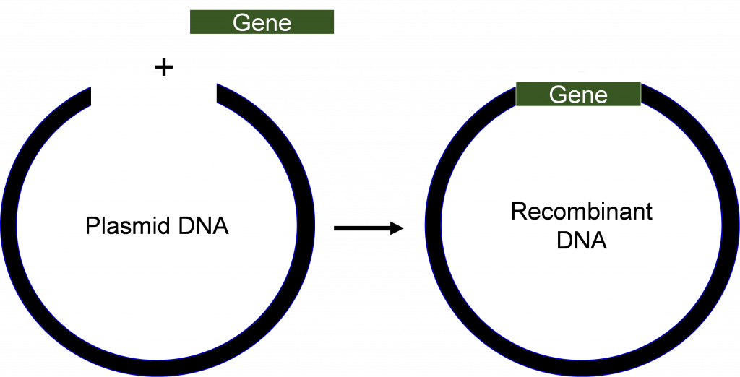

Figure 1. Recombinant DNA is completed from combining the DNA from two or more diverse sources [1].
Milestone in the molecular biology started in the early 1970s comprises of successful creation and transferring of DNA molecules into the host cells of interest has uprising in both science and several industries. The original GMOs are bacteria that are synthesize the simple pharmaceutical proteins of interest, like insulin. Because of the improvement in the technologies day by day, the other higher organisms like plants develop into acquiescent for enhancement by rDNA technology.

Table 1 Major milestones of development in the application of rDNA technology.
SL No | Major Research Findings of rDNA Technology | Year of Recognition
 | Mendel’s experimentations | 1866
 | Discovery of DNA in cell | 1869
 | Finding Mutation in genes by x-rays studies | 1927
 | One gene- responsible for one enzyme concept | 1941
 | DNA is recognized as the genetic material | 1944
 | Structure of double stranded DNA resolved | 1953
 | Ribosomes are protein synthesizing machineries | 1954
 | Function of mRNA elucidated | 1961
 | Genetic code is established | 1961-64
 | Isolation and identification of restriction enzyme | 1970
 | Recombinant DNA techniques generated | Early 1970s
 | Segregation of a single replica of gene from higher eukaryote | 1977
 | DNA sequencing method developed | 1977
 | Genetic transformation of Plant cell | 1983
 | Testing of transformed plants in Field | ca. 1986
 | Engineered plants Release to general public in the USA | 1995-96
Transformation of cells with rDNA generates new organisms known as bioengineered or genetically modified organisms (GMOs). The GMOs possess new traits from a new organism, the first GMOs generated was Escherichia coli cells that were transformed with the genes from higher eukaryotes to produce pharmaceutical proteins for various purposes.

- Isolation of genomic DNA, restriction enzyme digestions and its separation of DNA fragments on an agarose gel Electrophoresis
- Isolation of gDNA
Isolating the pure DNA is the prime criteria in rDNA technology, the practical difficulty is that plant cell and animal cells generate several other substances that regularly act as contaminants and further may restrain the cloning or sequencing of the DNA. Moreover, tissues as well as organs from the same plant or animals, and different plants or animals commonly contain a variety of metabolites or biomolecules like, proteins, lipids, and carbohydrates etc. These contaminants necessity be segregated from the gDNA during isolation procedures. To attain this, scientists utilize the various physicochemical characteristics of different bio molecules within the cell. For example, the negatively charged gDNA is, facilitating it is soluble in aqueous solution. On the other hand, the hydrophillc sugar phosphate groups of the DNA are repelled by non-polar solutions. Further in the last step in many DNA isolation protocols entails precipitation using 70% Ethanol. Other contaminants like, proteins can also be simply segregated from gDNA by changing the various concentration of salt incorporated in the extraction buffer or elution buffer (Figure.2).
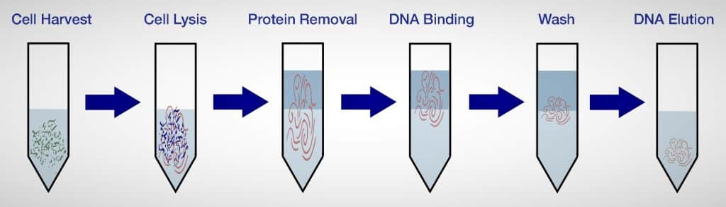
Fig.2 Graphical representation of Procedure for the Genomic DNA isolation
- Restriction enzyme Digestion of gDNA using restriction endonuclease enzymes
Restriction endonucleases are collection of enzymes derived (mainly) from bacterial or prokaryotic origion. Even though there are diverse categories of restriction enzymes are available commercially, which are most useful in rDNA technology would functions by recognize the specific short sequences (4-6bp) in the gDNA and cleave the dsDNA at site of recognition to produce either cohesive (sticky) or blunt-ended fragments as depicted (Figure 3).
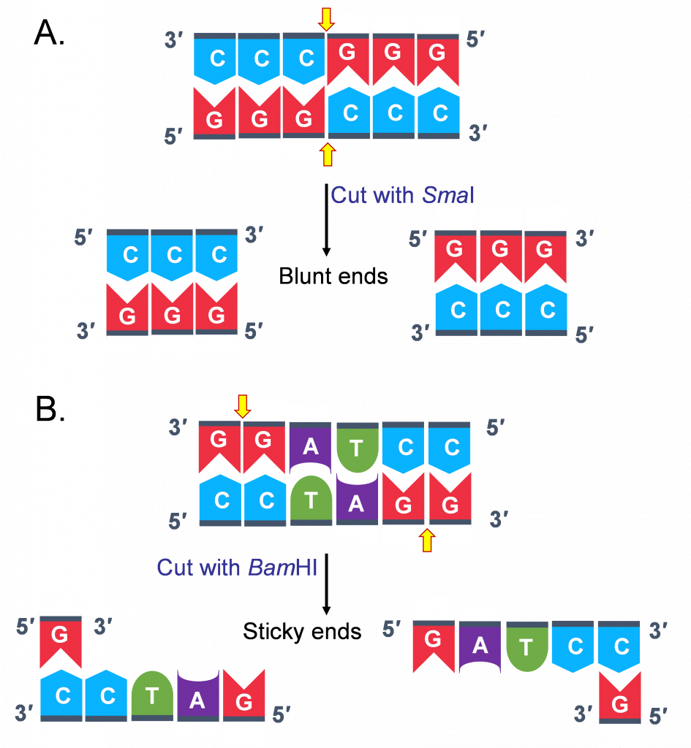

Figure 3. Restriction enzymes digestion on gDNA. (A) Subjecting the gDNA with SmaI restriction enzyme results in blunt ends fragments. (B) Digestion of gDNA with BamHI creates cohesive” or “sticky” ends fragments [1].
Additionally, there are more than 500 different restriction enzymes that might be bought commercially. So, one might question: How frequently does a restriction enzyme cut a DNA sequence? It is difficult to give an accurate response to this query. Let's assume that each DNA strand includes 4 bases, though. This suggests that there is a 1/4 chance of finding an A (adenine) at a specific site. Due to the fact that most restriction enzymes only recognize sequences that are 6 bases long, the likelihood of discovering such a site is (1/4)6 = 1 site in every 4,096 base pairs (bp). Assuming you want to digest isolated maize genomic DNA using a restriction enzyme that generates cuts every 4,096 (4,100) bp, what number of fragments will you get? You must be aware of the size of the genome of the plant or animal you are working with in order to respond to this question. For instance, the genome of maize is over 2,500,000,000 base pairs (bp) in size. As a result, one would anticipate obtaining 2,500,000,000 bp/4,100 bp, or roughly 610 000 fragments, when using a restriction enzyme that cuts every 4,100 nucleotides. Keep in mind that the distribution of nucleotides is not necessarily random; therefore the frequency may vary depending on the DNA. Additionally, methylation of certain nucleotides in DNA from the genome can stop cleavage at a particular place.

- Separation of Genomic DNA on Agarose gel
The size and genomic sequence of DNA fragments are the only physical characteristics that are frequently utilized to characterize them. DNA The most practical way to determine molecular weight is by electrophoresis in gels made of agarose. When cooling from the melting state, agarose formed hydrogen bonds that caused it to solidify into gel. The movement of DNA across this gel's intricate web of agarose chains is hampered. Agarose concentration changes the size of the pores, which in turn impacts how quickly DNA fragments of a particular size migrate. A sample is placed through wells on one end of the gel, which is then immersed in an electrolyte solution. Current is then applied to help DNA fragments travel around the gel (Figure.4).. Since DNA has a negative charge, it will move in an electrical field. According to separation, fragments to scale. Every time, the migration's distance is inversely proportionate to 1/log of the molecular weight of the DNA fragments. DNA can be seen after the electrophoresis procedure by staining with the dye ethidium bromide or any another DNA stain.

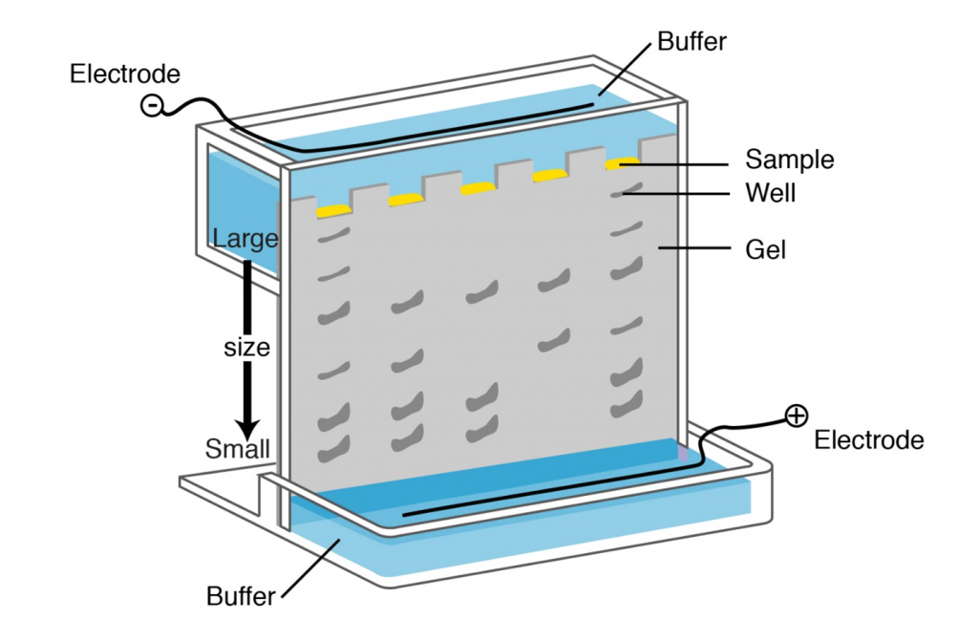

Figure 4. Protein or nucleic acid molecules are separated according to size using gel electrophoresis. In the case of DNA, an electric field is applied to the sample, causing DNA that is negatively charged to move toward the positive electrode. The size of the DNA segment influences the rate of migration. The DNA molecules can be separated more easily when a semisolid matrix, such as agarose or polyacrylamide gel, is used. [2]

Table.2. Recombinant DNA Technology Enzymes [4]
SL | Major group of Enzyme(s) | Specific Function of the enzymes
1 | Type II restriction endonucleases | dsDNA can be cut at certain nucleotide sequences.
 | Polynucleotide kinase | Adds a phosphate compound group to a linear duplex's 5' OH ends.
2 | DNA polymerase I (E. coli) | Fills gaps between DNA duplexes by adding nucleotides sequentially to the 3' ends
 | DNA ligase | Fuses two molecules of DNA or fragments together.
3 | Reverse transcriptase | Makes an RNA molecule's DNA copy
4 | Bacteriophage λ exonuclease | Exposes single-stranded 3' ends through eliminating nucleotides from a duplex's 5' ends.
5 | Terminal transferase | Adds homopolymer ends to a linear double stranded duplex's DNA 3'-OH ends.
6 | Exonuclease III | Removes residues of nucleotides from a double strand DNA 3’ends.
7 | Alkaline phosphatase | Eliminating terminal phosphates from the 5', 3', or both ends of the chain.

- PCR, or polymerase chain reaction

A single DNA fragment can be synthesized in a test tube in millions of copies over the course of a few hours using the polymerase chain reaction (PCR). A gene is made up of regulatory sequences, sequences that code, and non-coding sequences at the genomic level. Once the genetic makeup of a particular gene has been identified, it is possible to extract that gene using PCR from any DNA sample. Therefore, the strategy would be to start with DNA if the objective is to utilize PCR to separate both regulating and non-regulatory sequences of a gene.

To make it easier to clone PCR fragments when genes are cloned with PCR, restriction enzyme sites are added to the primers' 5′ ends. Approximately 6 nucleotides were inserted at the 5′-end of the restriction sites are designed to make it easier for PCR products to be digested by restriction enzymes before being cloned into a plasmid vector. Alternately, since the PCR product produced by the PCR reactions employing Taq polymerase has A overhangs, PCR products can be directly cloned into a T-A cloning vectors with no restriction digestions within E. coli. The fragment is first cloned into E. coli, sequenced, and finally sub-cloned into appropriate vectors for expression investigations. DNA synthesis via PCR is not an absolutely perfect process, like many other biochemical processes, and occasionally a polymerase enzyme will add a wrong base to the lengthening DNA strand. The process of "proofreading" occurs during the replication of DNA in a living organism, where errors are fixed by a distinct DNA polymerase. DNA polymerases those are available for purchase could have or could not have the ability to proofread. However, if the product of the PCR procedure is employed for the Expression analysis, we must employ a high fidelity DNA polymerase, such as Pfu or vent polymerase, in order to ensure proof reading in the PCR procedures.

- Contamination is a crucial factor in PCR analysis.
Even slight contamination of the raw material can have negative effects. Remember that PCR allows for the massive amplification of very little amounts of initial DNA. It will be impossible to tell the difference between lines if one mistakenly combines DNA from multiple sources. Guarantees that the right protocols are followed while setting up PCR experiments in this regard. The byproducts of earlier amplification procedures are a typical source of contamination in plant biology. Even a tiny droplet as well as aerosol leaving a pipette tip will include a huge number of amplifiable molecules since a successful PCR reaction would produce millions of identical copies of amplified fragments. Running negative controls is always necessary since they will show whether contaminated DNA was used in your PCR tests.
- Using mRNA as the precursor for rDNA technology

The process of transcription, which produces RNA from DNA. An essential stage in the expression of genes is transcription. Reverse transcription is a technique that allows the generated mRNA to be extracted and "copied" back to DNA (Figure 5). Reverse transcription's initial stage mimics a tactic utilized by retroviruses with RNA genomes. Reverse transcriptase, also known as RNA-dependent DNA polymerases, is a gene-transmission component found in retroviruses. The retrovirus utilizes an enzyme called reverse transcriptase to convert its single-stranded RNA genome onto a single-stranded of complementary DNA (cDNA) after infecting a host cell. The second DNA strand is then created by the reverse transcriptase from the first strand of cDNA to create a double-stranded copy of the DNA that can be integrated into the host genome. Isolating the genetic material using cDNAs would be considered the preferred method if only the coding sequence of a gene was needed. It is crucial that cDNAs are created from tissues that express the target gene. As a result, it's crucial to determine the gene's functional environment before creating the cDNA molecules needed to clone the desired gene.

Similar to chromosomal DNA, the in vitro generated cDNAs (Figure 5) can be employed for PCR analysis. A useful technique for gene cloning and mRNA quantification is the RT-PCR method, which combines reverse transcription and polymerase chain reaction.

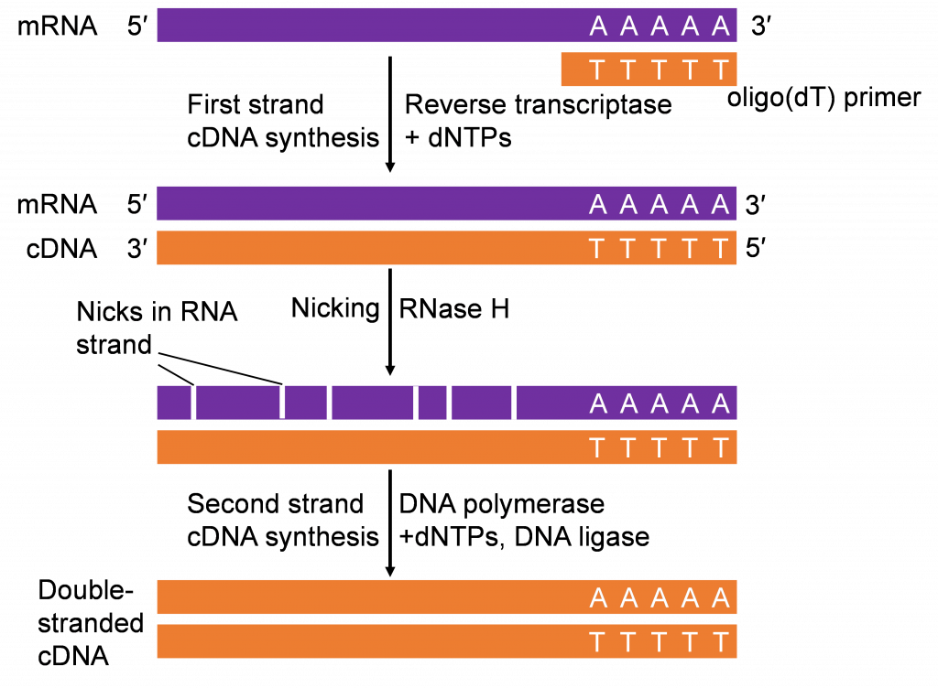Figure 5. To start the process of reverse transcription of cDNA from mRNA templates with dNTPs, a population of mRNA extracted from either animal or plant tissues is synthesized with oligo(dT) primers which anneal to the poly(A) tail of the mRNAs. Hybrid molecules (mRNA-DNA) are the end outcome. After being exposed to RNAse H, the mRNA is degraded, leaving the first strand of the single-stranded DNA intact. By incorporating complementary dNTPs into the expanding chain, DNA polymerase creates the second strand. The RT reagents often come in pre-mixed kits, making it simple to perform such an assay on a regular basis in most laboratories. The majority of mRNAs from the tissues that were examined are transformed to cDNAs. Therefore, a double-stranded cDNA can be replicated by PCR for multiple reasons, such as gene expression, by utilizing primers appropriate to a sequence cloning. [1]

- Definition and prerequisites for cloning vectors

A cloning vector comprises a unique DNA sequence that has the ability to enter a living cell, impart a selected property on the cell in question (for example, resistance to certain antibiotics), and have the ability to replicate itself. A vector additionally needs to possess easily discernible physical characteristics, like as size or shape, to enable for contamination-free purification away from the genome of the host cell.

- Types of cloning vectors
A plasmid (Figure 6) is an illustration of a cloning vector and is described as a construct that autonomously regenerating additional chromosomal circular DNA that is faithfully transmitted to offspring. Circular double-stranded DNA plasmids range in size anywhere from one kb to 200 kb. The best plasmid sizes for cloning are between 2 and 10 kb since they are simpler to work with and frequently yield more copies whenever cultivated into bacterial host cells.
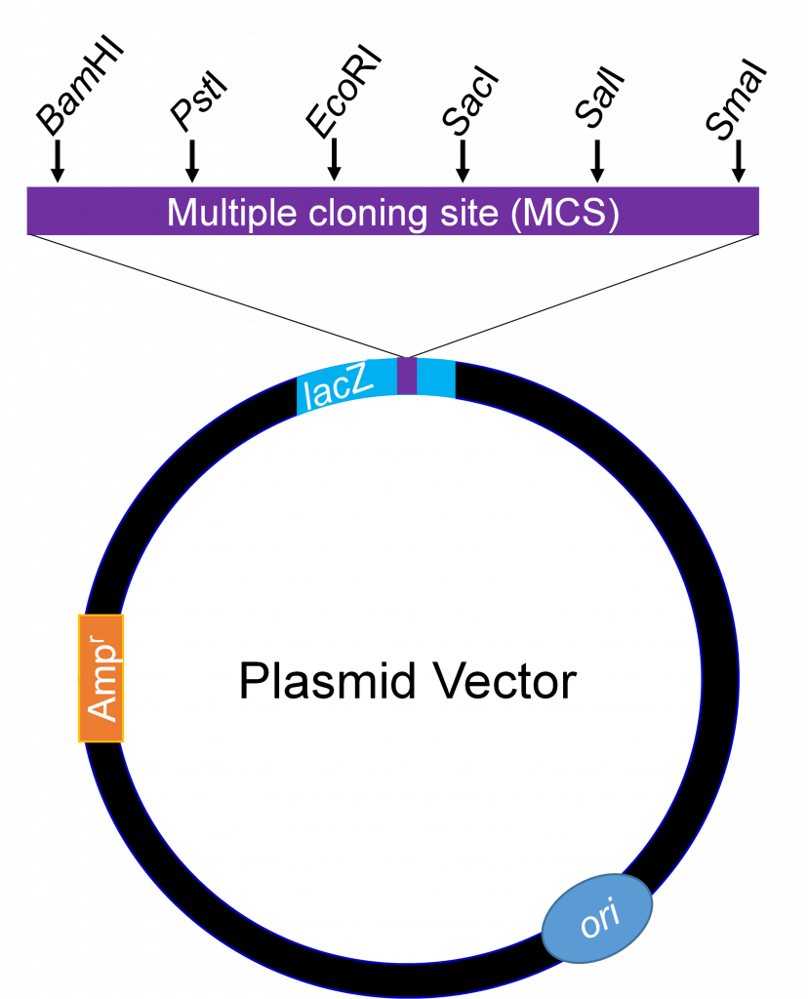

Figure 6. Plasmid vector's basic map. A couple of the restriction enzyme sites found in the MCS are illustrated here as examples. [1].
Usually, plasmids can hold a maximum of than 10 kb of DNA. A vector known as bacteriophage lambda is utilized to efficiently clone huge DNA segments. When inserted onto a lambda phage vector, substantial chromosomal DNA segments larger than 23 kb are stable.
Bacterial Artificial Chromosomes (BACs)
Simple plasmids created for the cloning of extremely lengthy DNA segments (100,000 to 300,000 bp) are what make up bacterial artificial chromosomes. They typically contain highly stable origins of replication (ori), which keep the genome of the plasmid at just one or two copies per cell, as well as selectable markers like immunity against the antibiotic chloramphenicol (CmR). The BAC vector is used to clone DNA segments with a few hundred thousand base pairs. The huge circular DNAs are subsequently electroporated into the host bacteria. These approaches make advantage of host bacteria that have cell wall modifications that make it possible for the big DNA molecules to be taken up [4].
Yeast Artificial Chromosomes (YACs)
There are many other hosts for genetic modification besides E. coli bacteria. For this work, yeasts are a particularly useful eukaryotic creature. The field of yeast genetics is equally well established as that of E. coli. Saccharomyces cerevisiae, the most widely used yeast, has a genome of about 14x106 bp, which is a small genome by eukaryotic standards and is less than four times the measurement of the chromosome in E. coli. Its full sequence is also known. In the laboratory, yeast is also incredibly simple to produce and maintain on a big scale. Yeast-specific plasmid vectors were created using the same guidelines as the application of E. coli vectors mentioned above.
Now that there are simple ways to transfer DNA between the inside and outside of yeast cells, many different topics can be studied in the biology of eukaryotic cells. Some recombinant plasmids contain numerous replication sources and other components that enable them to be employed in different species (like yeast or E. coli, for example). Shuttle vectors are plasmids that can multiply in cells from two or more distinct species. The creation of yeast artificial chromosomes was prompted by the emergence of huge genomes and the resulting requirement for high-capacity cloning vectors.A yeast origin of replication, two or more selectable markers, and specialized sequences required for stability and appropriate segregation of the chromosomes upon cell division are all components of YAC vectors that are required to preserve the eukaryotic chromosome in the yeast cell nucleus [4].

- Ligation Transformation and rDNA Screening
Recombinant DNA is created by cutting and connecting vector and fragmented DNA from various sources. Remember that DNA ligase is used to link dsDNA molecules together after restriction endonucleases (table-2) have further sliced the DNA. Restrictions fragments are joined together by the enzyme known as DNA ligase by creating fresh phosphodiester linkages. The altered host cell can now be used to replicate and express the DNA fragment and ligated vector. E. coli changes over a period of time in several stages. A selectable marker, typically encoding for antibiotic resistance, is first added to a plasmid that already has a gene of interest. Second, the ligated plasmid-DNA fragments (rDNA molecule) and the bacteria themselves are briefly exposed to both cold (0 oC) and heat (37–42 oC) in order to transform the plasmid construct encoding the gene of interest into bacterial cells.
The transformed cells are then grown on selection media containing a selective antibiotic (KAN-Kanamycin) in the following phase. Only the cells that have undergone transformation with the plasmids containing the desired gene and the marker for antibiotic resistance (KAN-kanamycin) will endure. Plasmid vector systems with the lacZ gene expressing -galactosidase make it simpler to choose positive colonies that might contain the target rDNA molecule, in addition to utilizing an antibiotic. This method is shown in Figure 7.
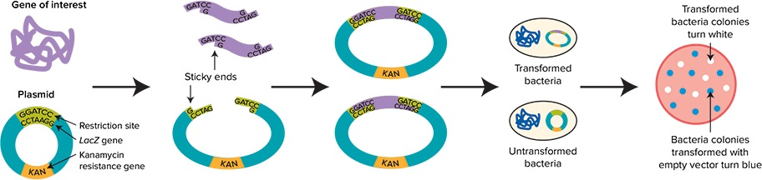
BLUE-White Screening of recombinant Transformed bacteria
Figure 7: Blue-white screening in its common form as seen in a schematic. Cloning a gene placed into a plasmid vector that contains antibiotic resistance and a LacZ reporter gene allows for the blue-white screening of colonies of bacteria. The LacZ gene is rendered inactive by ligating an insert into the vector's numerous cloning sites. Blue and white colonies are created when competent E. coli is transformed with the ligated mixtures in culture media while X-gal is present. [3].
- Applications of rDNA Technology
Today, rDNA plays a significant role for countless patients as well as in questions of how to provide sufficient food supply in developing countries like India and for environmental related issues.Major Application areas of rDNA technology includes Food industry, Agriculture, Environmental use, Medicine Research, Both in Animal and plant Biotechnology etc. Some of the examples are
- Insulin production with recombinant DNA technology
- Recombinant DNA for the synthesis of human growth hormone
- Recombinant vaccinations
- Recombinant DNA and gene treatments
- Enzyme production with recombinant DNA technology
- Recombinant DNA technology for protein production.

- Safety concern of rDNA technology
Considering the safety of recombinant DNA, rDNA and protein molecules are not observed as dangerous. The apprehensions remain about few organisms that express rDNA, particularly when they outside the laboratory invivio conditions and are introduced into the environment or food chain. The safety issues comprise antibiotic resistance and adverse immune reactions, in addition to the health sector includes the potential of gene pollution of the environment but also deleterious health effects of foods from genetically modified organisms. On the other hand, to make sure the greatest degree of safety possible, all rDNA work needs to be accommodating with high standards and guidelines set out by the respective regulatory institutions of the country. Despite safety issues, there is the ethical issue of genetically modified organisms, human genome editing as well as around genetic information in common.
- The future prospects in rDNA technology
Recombinant DNA technology has been increasingly significant in recent years for treating many plant diseases, particularly viral, bacterial, and fungal resistance, as well as for generating innovative gene therapy and vaccination products. The worldwide rDNA technology business is expected to increase at an average annual rate of 7.7% to a value of $223 billion by 2028, having one of the key drivers being the increasing prevalence of chronic diseases.
Lesson Summary
The progress of agricultural biotechnology has benefited greatly from recombinant DNA technology. Genetically modified organisms, often known as bioengineered creatures, are created when cells are transformed with rDNA. Technologies enabling plant rDNA technology include Agrobacterium as a vector to introduce foreign DNA into plants, restriction enzymes, ligation enzymes, microbial hosts, ways to separate and multiply nucleic acids, and methods to quantify nucleic acids.
Reference:
- WALTER SUZA; DONALD LEE; MARJORIE HANNEMAN; AND PATRICIA HAIN, https://iastate.pressbooks.pub/genagbiotech/chapter/recombinant-dna-technology/
- Electrophoresis (genome.gov)
- https://www.moleculardevices.com/en/assets/app-note/bpd/automated-colorimetric-colony-selection-blue-white-colony-screening-with-qpix-400-series .
- Lehninger Principles of Biochemistry 4th Ed, 2004

