ANDROGRAPHOLIDE AND ITS ANALOGUES IN LUNG CANCER

M. Alagusundaram¹, Mishra Namrata *¹, Bhattacharya Vijeta¹, Venketeshwarlu Goli ² G. Sai Sri Harsha³
Assistant professor school of Pharmacy, ITM University Gwalior, Madhya Pradesh
mishranamrata2710@gmail.com
Introduction
Single category of tumor that matures in the lungs is a lung growth. Your lungs, a binary elastic bodily component in your upper body, are where you can exhale out carbon dioxide and inhale oxygen. The leading cause of cancer-related deaths worldwide is lung cancer. Lung cancer can spread to people who have never smoked, but smokers are more at risk than nonsmokers. Because of how many and how regularly you smoked cigarettes, you have an unfairly high risk of developing lung cancer. Even after years of smoking, giving up burning can consciously reduce your risk of developing lung cancer. When the figure's cells proliferate without restriction, a condition known as cancer results. When it initially appeared, the illness was known as lung cancer..
Glandular cancer and squamous lockup carcinoma are two specimens of small and non-small lockup lung tumours that fall into these two main types. These frequent categories of lung tumours have distinctive patterns of development and satisfying responses. Non-small-cell lung cancer is more mutual than small-cell lung cancer. The foremost process of stoppage is to dodge risk factors plus soldering and air litter. Behaviours and long-standing products are influenced by the category of cancer, the stage (amount of banquet), and the patient's general condition. Record illnesses cannot be cured. Radiotherapy, chemotherapy, and surgery are often used treatments. Surgery is occasionally used to treat NSCLC, although chemotherapy and radiotherapy are typically more effective for treating SCLC.
Lung cancer will have killed 1.8 million people and impacted 2.2 million people globally in 2020. Designed for both men and women, it is the principal foundation of cancer-related passing. The average diagnosis age is 70. The five-year subsistence proportion is typically between 10 and 20%, however, it reaches 33% in Japan, 27% in Zion, and 25% in the Nation of Korea. Conclusions are normally of inferior quality in undersized nations.
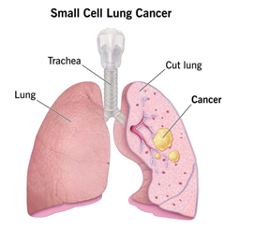

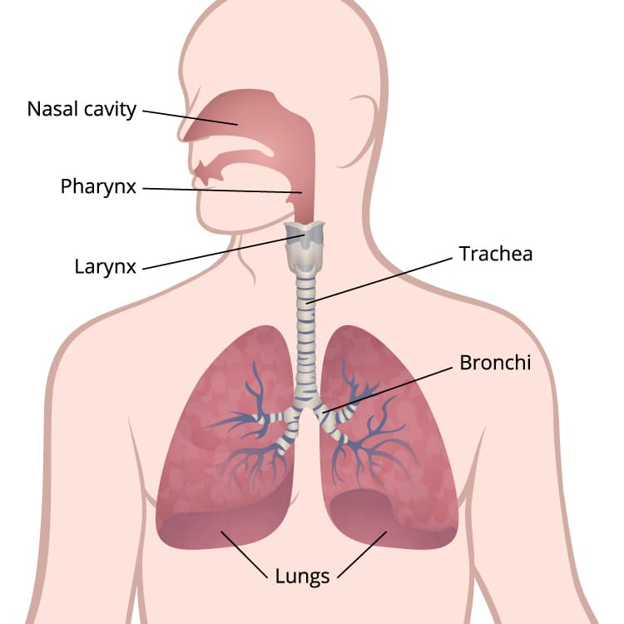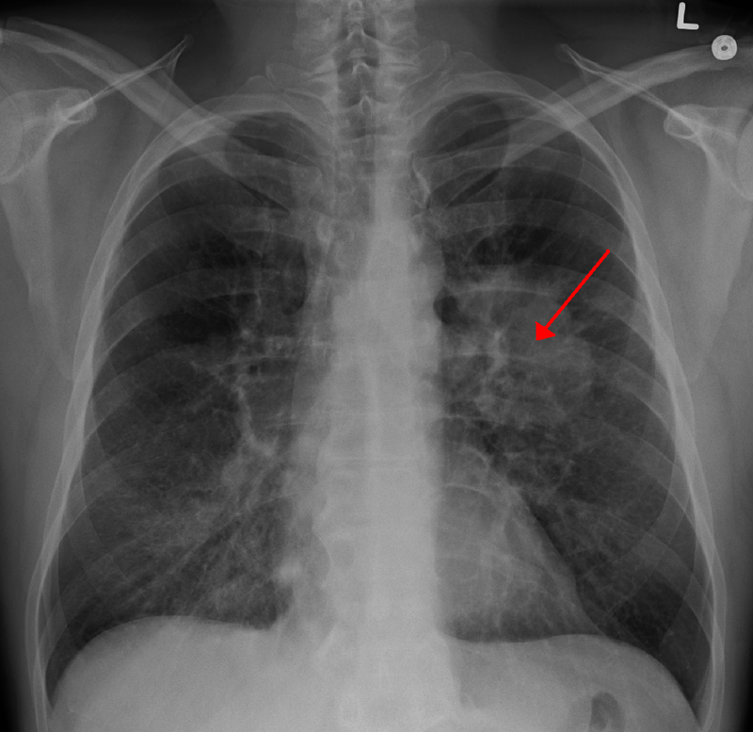
Lung’s cancer
Prevalence and Death Rates highlight the severity of the diseases
Number of Malignance Demises Anticipated In the United States, cancer-related fatalities are predicted to total 609,360 in 2022, or over 1700 each day. Male lung, prostate, and colorectal malignancies reason the most fatalities, while female lung, breast, and colorectal cancers cause the most fatalities (Fig. 1). Table 4 breaks out the projected mortality rate for these and other common malignancies by state. higher than 350 people will lose their breath to lung melanoma every day, which is 2.5 times higher than CRC, the second-leading cause of tumor death, and more than chest, prostate, and pancreatic growths combined. Of the 130,180 lung cancer fatalities in 2022, smoking-related causes will be responsible for roughly 105,840 (81%), while another 3650 deaths will be the result of another needle smoke. 26 If the other 20,700 non-smoking-related lung cancer deaths were included separately, they would rank as the ninth most common cancer death in both sexes.
The process for estimating current malignance belongings and diseases remained adjusted in 2021 and is covered in detail elsewhere. This modification was made to take use of numerical showing progresses and heightened cancer recordkeeping treatment. Using delay-adjusted, high-quality rate data (98% population coverage; data were not available for a few rare years for a small number of states), Using invasive cancer incidence data from the 50 states and the District of Columbia, complete counts for each state from 2004 to 2018 were approximated. To account for changes in sociodemographic and means variables, clinical sceneries, and growth-showing customs at the state level, a generalized linear mixed model was utilized.
The counts were then projected to 2022 based on the Employing SEER 21 delay factors for invasive disease (delay factors are not available for in situ cases), the joining point regression model's average APC was created and adjusted for reporting delays. Using the prior data-driven join point technique described for the case projection to report cancer fatalities from 2005 through 2019 at the state and national levels as reported to the NCHS allowed for the prediction of the anticipated number of cancer deaths in 2022.
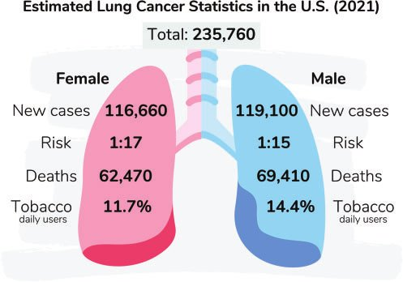
Ten Most Common Cancer Types by Assessed New-fangled Suitcases and Deaths from Cancer thru Sex in the United States in 2022 Except for bladder cancer, guesses are curved to the closest 10 and do not include basal cell, squamous cell, or in situ carcinomas. The ranking may not match the most current observed data because it is based on predicted projections..
Current treatment of lung cancer and their limits
Lung malignance can be frozen in a assortment of ways reliant on the type of malignance and how faraway it has gone. Hospital, chemotherapy, fallout therapy, embattled therapy, or a blend of these behaviors may be run to non-small-cell lung malignance affected role. Chemotherapy and radioactivity therapy are regularly used to treat small-cell lung cancer.
Surgery. is a process in which remedial authorities eradicate spiteful material.
Chemotherapy. exploits novel drugs to eradicate or decrease cancer The pills can occasionally be given intravenously and orally. therapy with radioactivity. engaging high-power beams that bear a resemblance to X-rays to finish cancer
Targeted treatment. blocking the growth and spread of cancer cells using medication Drugs might be administered intravenously or as pills that you ingest. You will undergo tests to see whether targeted therapy is appropriate for your particular cancer type before starting this treatment.
To treat lung cancer, many medical specialties typically work together. Medical doctors who specialize in lung conditions are referred to as pulmonologists. Surgeons are medical professionals who carry out operations. Thoracic surgeons specialize in surgeries of the chest, heart, and lungs. Medical doctors called oncologists utilize medication to treat cancer. Medical experts known as radiation oncologists utilize radiation to treat cancer..

Diagnosis
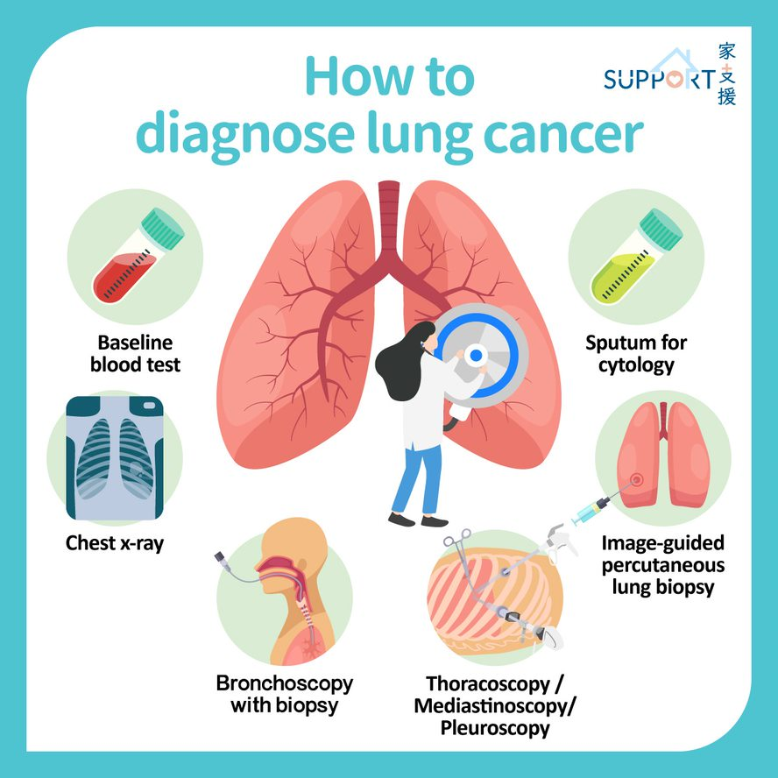

Testing healthy people for lung tumor
People who are more likely to develop lung cancer may consider receiving yearly low-dose CT scans to screen for the condition. The bronchoscopy pop-up dialog box is utilized to identify malignancy in the aforementioned Figure 4. Lung cancer screening is often given to older people who have smoked heavily for a long time or recently quit smoking.
Discuss your risk of lung cancer with your doctor. You can decide whether or not you should get screened for lung cancer with your partner.
Procedures for diagnosing lung cancer If there is reason to suspect that you may have lung cancer, your doctor may perform a series of tests to look for malignant cells and rule out other illnesses.
Testing might involve:
- Exams that use graphics. An X-ray may show an unusual lung tumor or nodule. Small lung lesions that might not be evident on an X-ray can be detected using a CT scan.
- Pneumonia cytology. Sometimes, when sputum is coughed up and examined under a microscope, lung cancer cells can be seen. This is especially true if you are producing sputum when coughing.
- Biopsy sample of tissue. It is possible to remove a sample of aberrant cells through a biopsy process. In order to examine for aberrant lung tissue, your doctor may do a biopsy using a variety of methods, such as bronchoscopy, which requires putting a lit tube down your neck and into your lungs.
- Mediastinoscopy is a different option that requires creating a tiny incision at the.
- Additional selection is a indicator biopsy, in which your doctor uses X-ray or CT descriptions to attendant a needle over your chest wall and into the lung material to collect questionable cells.
- A biopsy may also be performed on your liver or other organs where cancer has spread, such as your lymph nodes.
- A thorough examination of your cancer cells in a lab will reveal the type of lung cancer you have. The outcomes of complex tests can disclose the precise characteristics of your cells that can assist your doctor determine your prognosis and guide your treatment.
- Tests to regulate the level of the tumor
The extent (stage) of your cancer will be determined by your doctor when lung cancer has been detected. The stage of your cancer aids you and your doctor in selecting the best course of action. Imaging techniques may be used as part of staging testing so that your doctor may check for signs that cancer has moved outside of your lungs. These examinations consist of bone scans, positron emission tomography (PET), CT, and MRI. Discuss whether tests are acceptable for you with your doctor because not everyone needs them. The stages of lung cancer are denoted by Roman numerals ranging from 0 to IV, with the lowest stages signifying lung-specific malignancy. Stage IV signifies the cancer's advanced stage and the extent to which it has spread throughout the body. Your overall health, the type, and stage of your illness, as well as your preferences, all play a role in the cancer treatment plan that you and your doctor decide on. You might decide in some circumstances not to receive therapy. For instance, you might believe that the risks of the medication outweigh any potential advantages. If that is the case, your doctor might advise comfort care, which merely addresses cancer's associated symptoms like pain or shortness of breath.
Lung cancer surgery Open pop-up dialog box

During surgery, your surgeon strives to remove the lung cancer along with a margin of healthy tissue. The tumor-containing lung tissue and a piece of the surrounding healthy tissue are removed using the wedge resection technique.

More of the lung can be removed without removing a full lobe by using a segmented resection.

Perform a lobectomy to remove the entire lobe of one lung.

A pneumonectomy involves the removal of the entire lung.

In the event that you undergo surgery, your surgeon may also remove a few of your chest lymph nodes to check for any signs of cancer. Surgery may be an option if your cancer is restricted to your lungs. Before doing surgery, your doctor can suggest chemotherapy or radiation therapy to shrink a larger lung cancer. If there's a potential that cancer cells were left behind during surgery or if you could experience a cancer relapse, your doctor can recommend chemotherapy or radiation therapy.

Radiation therapy

In radiation therapy, powerful energy beams from sources like protons and X-rays are utilized to destroy cancer cells. During radiation therapy, a machine circles around you as you sit on a table and distributes radiation to particular parts of your body. Patients with locally advanced lung cancer may get radiation therapy either before or after surgery. In many cases, it takes place in conjunction with chemotherapy treatments. Chemotherapy and radiation therapy may be your main treatment options if surgery is not an option. Advanced lung cancers and those that have spread to other body parts may be treated with radiation therapy to alleviate symptoms like pain..

Chemotherapy
Chemotherapy employs drugs to eradicate cancer cells. One or more chemotherapy drugs may be administered intravenously or orally. Over the course of a few weeks or months, a number of treatments using a combination of medications are frequently given, with breaks in between to allow for recuperation. Chemotherapy is routinely used following surgery to eliminate any cancer cells that could have survived. It can be used with radiation therapy or used on its own. Chemotherapy is sometimes used to shrink malignancies before surgery so they are easier to remove. Patients with advanced lung cancer can use chemotherapy to address their symptoms, including discomfort..

Stereotactic body radiotherapy
Stereotactic body radiotherapy, sometimes referred to as radiosurgery, is a strenuous radiation therapy that directs several radiation beams toward cancer from various angles. Usually, stereotactic body radiation is finished in one or rare assemblies. For those with tiny lung malignancies who cannot have surgery, stereotactic body radioactivity may be a substitute. It can also be cast off to treat lung malignancy that has developed in the brain and other tissues.

Targeted drug therapy
Drug treatments that target specific defects in cancer cells are known as targeted therapies. Targeted pharmacological therapy can destroy cancer cells by stopping these anomalies. Although there are a number of targeted treatment medications available, the majority are exclusively administered to cancer patients with advanced or recurring diseases. Patients who can benefit from targeted therapy are the only ones who have specific genetic changes in cancer cells. Your cancer cells may be studied in a lab to determine whether these treatments would be helpful.
Immunotherapy
Your body's disease-fighting immune system may not attack your cancer because cancer cells may produce proteins that help them hide from immune system cells. Immunotherapy changes how well that process works. Only immunotherapy is typically used to treat patients with locally advanced lung cancer and tumors that have spread to other parts of the body.
Palliative medicine
The adverse effects of treatment as well as disease symptoms are frequently experienced by people with lung cancer. Salaried with a registrar to lessen your signs and indications is a key section of loyal care, occasionally referred to as palliative care. To make sure you're comfortable throughout and after your cancer treatment, your doctor might advise that you meet with a palliative care team immediately after your diagnosis.
A study found that people with advanced non-small cell lung cancer who began supportive care as soon as they were diagnosed lived longer than those who kept getting treatments including chemotherapy and radiation. People who received supportive care reported improvements in their emotions and quality of life. On average, they outlived those who received standard treatment by almost three months.
Importance of natural products and highlight the importance of medicinal plants in lung cancer

Natural goods are priceless presents from nature to humans. They comprise a variety of chemical substances that are produced naturally in humans and animals, as well as extracts from plants and animals, metabolites from insects, marine life, and microorganisms. Additionally, natural ingredients combined with TCM theory form the foundation of traditional Chinese medicine (TCM). Drug discovery has traditionally benefited from the use of natural products. Numerous prescription medications used for treatment are made from natural sources, according to the most recent information on medications approved by the Food and Drug Administration (FDA) in the United States. Over 50% of newly approved medications between 1946 and 2019 were natural small compounds. Chinese medicines and plant-based remedies are examples of multi-component, multi-channel, and multi-targeted products. Natural products continue to catch the attention of researchers due to their variety of structures and functions. The natural compounds that target and control the TME of lung cancer have not been systematically compiled, even though TME has been the subject of many studies. The anticancer effect of natural products on TME in lung cancer is discussed in this review. We list pertinent natural products together with explanations of how they modulate the TME in lung cancer when taken alone (Table 1), in combination with anticancer medications (Table 2), and combination with substances like nanomaterials (Table 3).

Table 1
The effects of natural products on modulation of the TME.
No. | Natural Products | Common Source | Cell Lines or Animal Models or Patients | Function or Molecular Mechanism | Ref.
Targeting angiogenesis
1 | Jolkinolide A (1) | Euphorbia  fischeriana | A549, HUVEC;  A549 cell xenograft mice | VEGF protein expression is decreased and the Akt-STAT3-mTOR signaling pathway is blocked, which also prevents HUVEC motility.
2 | Jolkinolide B (2)
3 | Parthenolide (3) | Tanacetum  parthenium | A549, H526 | Induction of apoptosis, suppression of angiogenesis, and inhibition of A549 and H526 cell growth in the presence and absence of nicotine. Bcl-2 expression is downregulated, while E2F1, p53, GADD45, Bax, Bim, and caspase 3, 7, 8, and 9 expressions are upregulated.

Bronchoscopy Open pop-up dialog box
Exploratory strong entities for lung malignancy
People who are more likely to develop lung cancer may consider receiving yearly low-dose CT scans to screen for the condition. Lung cancer screening is often given to older people who have smoked heavily for a long time or recently quit smoking. Discuss your risk of lung cancer with your doctor. You can decide whether or not you should get screened for lung cancer with your partner.
Tests to establish cancer's severity
The amount (stage) of your growth will be strong-minded by your registrar when lung cancer has been detected. The stage of your cancer aids you and your doctor in selecting the best course of action. Imaging techniques may be used as part of staging testing so that your doctor may check for signs that cancer has moved outside of your lungs. These examinations consist of bone X-rays, positron production tomography (PET), CT, and MRI. The stages of cancer are shown in Figure 5. Discuss whether tests are acceptable for you with your doctor because not everyone needs them.
The periods of lung cancer are represented by Classical numbers vacillating from 0 to IV, with the lowest stages signifying lung-specific malignancy. Stage IV signifies the cancer's advanced stage and the extent to which it has spread throughout the body.
Risk factors of colon cancer
As you stage, your jeopardy of emergent colorectal cancer growths. Other hazard reflections include:
- Crohn's disease and ulcerative colitis are examples of inflammatory bowel conditions
- A history of colorectal cancer or polyps in the family or personally.
- A genetic syndrome like Lynch syndrome or familial adenomatous polyposis (FAP), which are hereditary non-polyposis colorectal cancers.
These are a few instances of lifestyle factors that may increase the danger of colorectal malignancy.
• A diet lacking in capsules and taters.
• A lack of regular exercise.
• A diet that consumes a lot of processed meats or is heavy in fat and low in fiber.
• Overweight and obesity.
• Alcohol use.

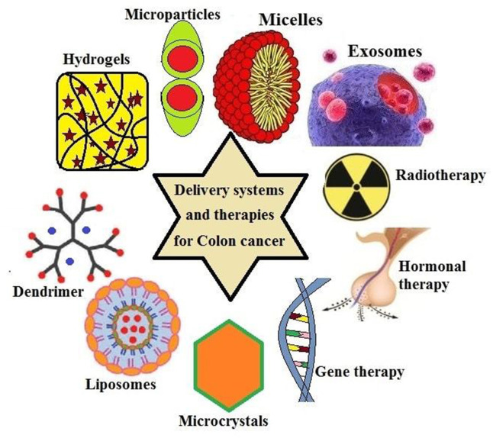
Drug targets in colon cancer
Researchers have created new kinds of medications that directly target the cell changes that lead to colon or rectal cancer as they learn more about these changes. Chemotherapy treatments function differently from targeted medications. They frequently have different adverse effects and occasionally are more effective than chemo medicines. If chemo is not an option, it can be used either alone or in conjunction with chemo. These drugs work against cancers that have spread to remote areas of the body because, like chemotherapy, they are taken into the bloodstream and reach almost every part of the body.
Current treatment strategies and side effects
Use a scope to do a colonoscopy to look into your colon. During a colonoscopy, your whole colon and rectum are seen thanks to a long, flexible, and thin tube that is connected to a video camera and monitor. If any suspicious areas are found, your doctor may introduce surgical instruments through the tube to take tissue samples (biopsies) for analysis and remove polyps.
blood testing. There is no blood test to detect colon cancer.. However, your doctor may perform blood tests to look for indicators of your general health, such as outdated kidney and liver function tests.
Your doctor may perform a blood test to check for a substance called a carcinoembryonic antigen, or CEA, which colon tumors occasionally generate. Your doctor may be able to determine your prognosis and whether your cancer is responding to therapy by monitoring the level of CEA in your blood over time.
Skin issues including an acne-like rash on the face and chest during therapy, which can occasionally result in infections, are the most frequent side effects of these medications. It might be necessary to use an antibiotic cream or ointment to help prevent the rash and associated illnesses. When this rash appears, the malignancy is frequently responding to therapy. The majority of those who have this rash live longer, and those who experience more severe rashes also appear to recover faster than those who get milder rashes. Other negative effects include: fatigue, fever, and Diarrhea, among other symptoms
An allergic reaction that occurs during the infusion of these medications is an uncommon but dangerous adverse effect that may result in breathing difficulties and low blood pressure. Before receiving therapy, you might receive medication to help avoid this. Importance of medicinal plants and phytocompounds in colon cancer
To improve a thorough examination, a methodical search approach was created. phrases like "The Mesh terms "anti-tumor," "anti-cancer," "bioactivity," "biological activity," "phytochemicals," and "pharmacological activities" were combined with one or more of the terms "colorectal cancer," "colon cancer," "adenomatous polyps," "colorectal tumor," and "colon tumor." These terms must be used in conjunction with the following plant or fungal terms: "banana," "pomegranate," "leguminous plant," "legumes," "hibiscus," "hibiscus sabdariffa," "cruciferous vegetables," or "cruciferous plants"."
The physiological effects of nutritional support treatments, such as different herbal, mineral, and vitamin supplements, are now better understood as a result of extensive research. Additionally, it is thought that a deeper comprehension of the biological makeup of cancer cells would help certain complementary treatments and cancer-fighting medications work more effectively over time. Yeşilada claims that 5-fluorouracil (5-FU), a chemotherapy drug used to treat colon cancer, has significant side effects that patients must tolerate in real-world situations. In a related study on the topic, the blood values of the experimental animals also significantly increased (red cell, neutrophil, and monocyte counts increased by 1,2 fold, 9 fold, and 6 fold, respectively). He mentioned that blueberries are useful in the treatment of colon cancer. The literature research has demonstrated the therapeutic and preventive effects of Rheum ribs, Nigella sativa, Echinacea purpurea, Lignum usitatissimum, Punica granatum, Cronus mas, and Vaccinium myrtillus on colon cancer.
Cancer and Rheum Ribes: It promotes the treatment of cancer kinds like stomach, intestinal, lung, brain, and lymphocyte lymphoma in Figure 6, in addition to its many other advantages. Many distinct recipes call for raw Rheum ribs along with olive oil, egg, ginger, and Rheum
Rheum ribes
Drugs for rheumatoid arthritis directly affect malignant cells and cause them to shrink; even after just two days, 50% of them are gone. Rheumatoid ribs are therefore often utilized in the pharmaceutical business.

The active component of Nigella sativa (black seed), Timokinone, is utilized as an antioxidant, anti-inflammatory, and antineoplastic (anti-tumor cells inhibit development) medicine. Nigella sativa and cancer. Figure 7 shows how to diagnose lung cancer with nigella sativa. Timokinone is used as a starting ingredient in medications for adenocarcinomas of the chest, colorectal, colon, pancreatic, uterine, neoplastic keratinocytes, human osteosarcoma, fibrosarcoma, and lung. Additionally, the androgen hormone receptor (non-responsive) timocino prevents prostate cancer by concentrating on the E2F-1 transcription factor and receptor.
Nigella sativa
Laboratory tests have demonstrated that the black seeds of Nigella sp. boost the immune system, increasing resistance to cancer as well as the body's ability to fight off viruses and other harmful bacteria.

Echinacea purpurea (L.) and cancer Moench: E. purpura is effective against pancreatic and colon cancer in Figure 8. E. purpura is taken in large quantities as an anti-aging agent in several countries due to its potent antioxidant capabilities.
Echinacea purpurea
E. purpurea is used to complement chemotherapy in many cancer therapies, particularly those for blood cancers because it lowers free radicals. Tea in particular helps to boost immunity and stave against other diseases by preventing immunological deficiencies brought on by chemotherapy.
Linum usitatissimum (L.) and cancer Figure 9 is utilized to treat lung cancer in the example below. Breast, colon, and pancreatic cancer are all prevented by consuming flax seeds. Omega 3 fatty acids alpha-linolenic acid (ALA), Omega 6 fatty acids linoleic acid (LA), Omega 9 fatty acids oleic acid (OA), lignans (SDG), mucilage, and vitamin A (beta-carotene) are all found in flax seed.
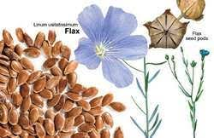
Linum usitatissimum
Usitatissimum has a high percentage of modest amounts of potassium, magnesium, iron, copper, zinc, and different vitamins, as well as a lot of fiber and highly polyunsaturated fatty acids.
Punica granatum (L.) and cancer: Punica granatum L. is useful in the treatment of prostate, breast, and colon cancer. Alkaloids with the names starch, manner, resin, triterpene acids, tannins, pellets, Impellitteri, and methylpelletieri can be found in the root and trunk shells. Figure 10 shows that the fruit peel and flowers—again, as previously mentioned—contain alkaloids and tannins. Pomegranate, Iron, potassium, calcium, phosphorus, and vitamins B1, B2, and C are also included (Ayaz and Alpsoy, 2007). High quantities of antioxidant tannin and flavonoid compounds are present in pomegranate juice. Pomegranate juice has potent anti-tumor properties that induce apoptosis, alter the cell cycle, and suppress androgen receptor expression.

High quantities of iron and vitamin C block the impacts that could result from boosting people's immune systems (Başgöl, 2007). As a result, frequent pomegranate juice consumption has been shown to have positive effects on avoiding prostate cancer and slowing the spread of the disease.
Cornu’s mas (L.) and cancer Lung, head and neck, colon, liver, breast, prostate, oesophageal, and soft tissue malignancies can all be successfully treated with C. mass. The hormone melatonin is secreted in the brain.
It is present in cranberry fruit, which improves our quality of life. Utilized in Figure 11. Due to this, it is also utilized to stop side effects including depression and sleep issues that patients may suffer while undergoing treatment. Because it is a potent diuretic, it also functions as an antioxidant. It effectively gets rid of toxic substances that have built up in the body. Additionally, C. mas contains a variety of organic plant compounds, vitamin K, manganese, and phytonutrients.

They defend the body from damaging free radicals, as evidenced by their anti-inflammatory and anti-cancer capabilities. Due to the vitamin C it contains, it is a potent natural antioxidant. It can decrease the body's susceptibility to pathogenic pathogens and reduce some damage caused by free radicals (Topuz, 2012). One prominent cause of urinary tract infections is urinary tract infections (UTIs). Cranberries should be consumed, especially by people who frequently get sick or who are in danger of getting sick. By preventing Helicobacter pylori bacteria from adhering to the lining of the stomach wall, cranberry juice also guards against stomach ulcers and stomach cancer (Topuz, 2012). The plant of C. mas can be used to make water, sherbet when boiled, or fruits. However, if sugar is added to the syrup, it loses its ability to prevent cancer and starts to cause it. Because of this, just like with any plant, how the cranberry plant is ingested is crucial.
Vaccinium myrtillus (L.) with cancer: Pterostilbene, ellagic acid, and vitamin C are all present in blueberries, which are also high in several cancers, particularly colon, uterine, and liver cancers. Cancer is being treated in Figure 12. A daily serving of fresh or dried blueberries greatly lowers the chance of developing cancer in people (HTML Access Date: May 1, 2013). Some proanthocyanidins, a type of dye called V. myrtillus, vitamins A and C, beneficial sugars, organic acids, tannins, pectin, and merlin give the fruit its color. V. myrtillus fruit can be eaten fresh, dried, or made into tea.
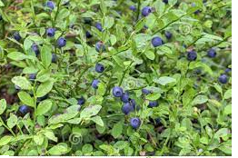

Andrographolide and its analogy role in colon cancer
Additionally, andrographolide has been demonstrated to inhibit colon cancer by way of the apoptotic route. Human HT-29 colon cancer cells experienced apoptosis as a result of it, which appears to be related to increased intracellular ROS levels and disturbance of the mitochondrial membrane potential via the regulation of caspase-3 activity.
- Analogy and andrographolide have traditionally been used to treat disorders like allergic responses, hemorrhagic lesions, and central nervous system malfunction. According to reports, andrographolide, and its derivatives have a strong therapeutic potential for treating human cancer, inflammation, common colds and coughs, and liver diseases. As antipyretic, anti-inflammatory, hepatoprotective, immunostimulant, and anti-neoplasm medicines, these metabolites have also been employed. Andrographolide has poor bioavailability due to its low aqueous solubility, which is then employed for oral administration in adequate tissue localization and for subpar therapeutic objectives. Because of their short half-lives and ease of excretion through the gastrointestinal system and urine, andrographolide and its derivatives have great qualities in that they do not stay in the body for a very long time.
- Hepatoprotection
- anti-aggregation of platelets
- Anti-inflammation Anticancer
- Cytotoxicity
- Induction of apoptosis
- Antitumor

CONCLUSION
Anticancer treatments have benefited significantly from the use of natural ingredients. All of the potent and effective anticancer medications including aspirin, vincristine, vinblastine, and paclitaxel are derived from bioactive compounds found in plants. In numerous nations, including India, Andrographis paniculate has been used medicinally in traditional medicine. In addition to having immunosuppressive, antipyretic, analgesic, hepatoprotective, antiviral, and anti-inflammatory effects, andrographolide is one of the key bioactive compounds. Figure 2 illustrates the cumulative effects and mechanism of action of andrographolide. Andrographolide and analog triggered cell cycle arrest, promoted apoptosis in a variety of cancer cells, and showed anticancer effects. In both animal and human cancer cells, andrographolide and analogs produced cell cycle arrest, apoptosis, and reduced metastasis and anti-angiogenesis. Because andrographolide can suppress the activity of v-Src, NF-B, STAT3, and PI3K/AKT as well as impede the advancement of the cell cycle, inflammation, metastasis, and the formation of new blood vessels, these effects are the outcome of the compound. For the development of anticancer drugs, substantial chemical-biological research has been conducted on analogy and andrographolide. In equally in vitro and in vivo representations, several andrographolide analogs consume demonstrated superior anticancer activity. To confirm the pharmacological, pharmaceutical, and toxicological effects of andrographolide, additional clinical and biological investigations are needed.

