Statistical Analysis of Gym Verses Yoga
Mrs. Sapna Atish Bhusare
Asst.prof.in Ashoka center for business and computer studies, Nashik.
Mr. Deven Avinash Sonawane
Student of Ashoka center for business and computer studies, Nashik.

Abstract
It is the subjective method of an individual which taking part in a physical activity. This paper represents the difference between Yoga exercise and Gym exercise on regular basis. The main objective of the paper is:
1) To determine and examine the difference between Gym and yoga exercise.
2) To examine the difference between males and females and their opinions.
There is a sample of 111 yoga as well as gym performers. There is no difference found between yoga and gym on the basis of gender. The paper is based on question answer pattern and peoples thinking on gym practice and yoga exercise. Both types of questions are asked based on the gym as well as yoga.
INTRODUCTION:-
Researches on Gym practice and yoga exercise have gained very much importance in last few years. Everyone is working hard for making their health better. There are many factors like family, surrounding, environment, effect of technology, poverty which affects the practice and exercise. This paper is attempted to throw a light on gym practice and yoga exercise across two groups. Various papers are there which provides the evidence regarding the gym practice and yoga exercise. Working on it will prevent the disease/causes like Blood-pressure, mental stress, anxiety, mood, stress tolerance, mental focus. Yoga has been used for stress management and Gym has been used for Physique management.
GYM:-
Now day’s gym becoming most commonly exercise preferred by youth for develop their strength and muscular gain. People prefer gym to gain body weight and it will more beneficial for the ones who want to gain body weight or muscular strength.
Youths are leaning toward yoga over different techniques to stay in shape like joining recreation centers

Figure 1.1 Gym Equipments.
or going to oxygen consuming classes. ... "Doing quick activities in exercise center could assist then with controlling their weight yet doesn't help in taking care of pressure which influences them because of the high speed life.
YOGA:-
Nowadays yoga is also becoming one of the common exercises preferred by house wives and elder ones. This influencing today’s youth to do yoga. Yoga is better for People who are suffering from Anxiety, Hypertension, Anger, Depression, Mental stress, etc. are overcome by the practice of Pranayama. Those who want to maintain their mental as well as physical health they can also perform or prefer to yoga. There are lot of benefits of performing yoga like by doing meditation we get mentally stable, our body gets flexible etc. It is a great way to stay limber and energetic. Yoga can help you feel great and function better in your daily life.

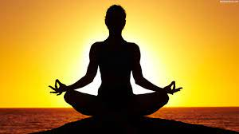
Figure 1.2
RESEARCH OBJECTIVE:-
1) To determine and examine the difference between Gym and yoga exercise.
2) To examine the difference between males and females and their opinions.
METHODOLOGY:-
Participants
There are 111 participants among them 64 were gym performers and 47 were yoga performers are randomly selected. Further two groups were divided on the basis of gender where 54 males and 10 female perform gym and 19 male and 47 female perform yoga. i.e there are total 73 males and 47 females in the data analysis.
Data Analysis:-
The data is analyzed by the help of Google form by collecting information from peoples.
Questions:-
- What do you prefer?
- How much time do you spend for gym or yoga?
- Which is more effective?
- What does your doctor suggest for your physical fitness?
- House wife prefer gym or yoga for their physical fitness?
- Which one detoxes your body?
- For flexible body what do you prefer?

RESULT AND DISCUSSION:-
Group |  |  | Total people
Gym |  |  | 64(Male+Female)
Yoga |  |  | 47(Male+Female)
Male |  |  | 73
Female |  |  | 38

From the data we get that there are 64 people (Male+Female) who prefer Gym and 47(Male+Female) people prefer Yoga. In that 73 are the male and 38 are females who prefer gym as well as yoga. There are some pie charts from which we have decided the final result.
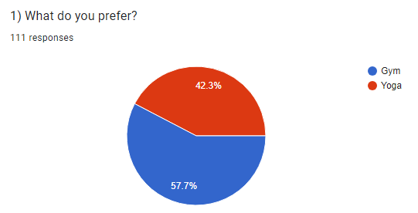
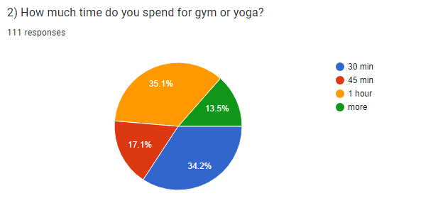
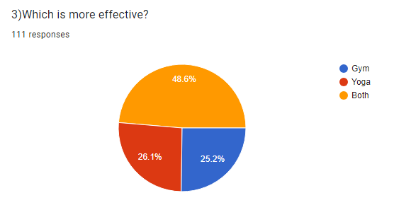

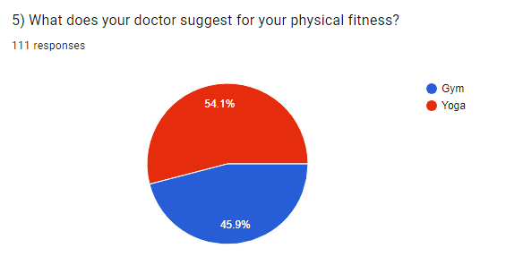

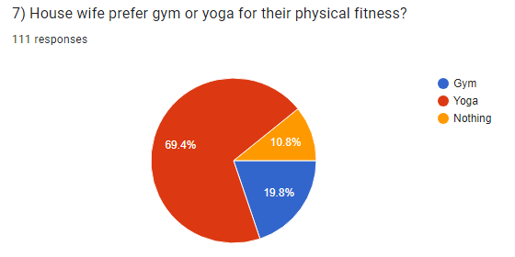
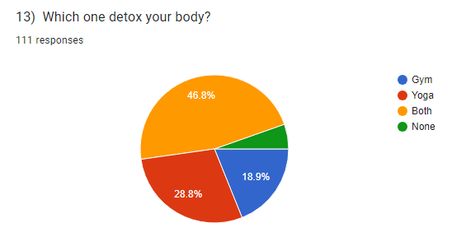
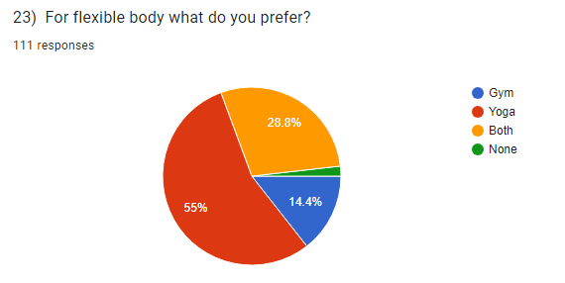
CONCLUSION:-
From the above data that we have analyzed we can conclude that people prefer Yoga exercise than gym exercise.

