Futuristic Trends in Renewable & Sustainable Energy
Aarti Maurya, Amit Kumar Chaurasia*
Amity Institute of Biotechnology, Amity University Uttar Pradesh, Noida, India
*Corresponding author: Tel: +91-120- 4392410, E-mail: akchaurasia@amity.edu

Keywords: Renewable energy, Sustainable development, The environment, The energy mix, Emerging trends, Strategies, Energy Management and Enabling technologies.

Abstract: The world's energy consumption is currently exceeding the limitations of installable generation capacity. As a result, future energy demands must be fulfilled and upgraded in an efficient and secure manner. Renewable energy sources should be used to assist energy solutions. At the moment, renewable energy's contribution to global primary energy is insufficient to meet primary energy and electricity demands. In the future decades, both industrialized and emerging countries will have to rely on fossil fuels. The situation in underdeveloped countries is more inconvenient than in developed countries. Many emerging countries appear to be attempting to reform their energy industries. It appears that realizing inventions is challenging. The main impediments to the development of renewable energy are cost, market share, and policy. Many countries' strategic plans encourage sustainable development in terms of economic, social, and industrial dimensions through their energy policies. Newer enabling technologies related to green power will also help to minimize environmental expenses, allowing energy systems to run securely and economically while avoiding environmental difficulties. New renewable energy markets are unquestionably required in both the wholesale and retail markets.

Abbreviations
RES | Renewable energy sources
CO2 | Carbon dioxide
SDGs | Sustainable Development Goals
ICTs | Information and Communication Technologies for environmental sustainability
B2B | Business to Business
Ref. | Reference

- Introduction
The need for electricity is skyrocketing. Industrial countries have 28% of the world's population and utilize 77% of global energy production. The current global population is anticipated to grow 1.26 times to 9.7 billion by 2050. The emerging countries account for the majority of the world's population, accounting for 90% of population growth. Although wealthy countries will implement more effective energy conservation policies by 2050, their energy consumption will remain constant. People in underdeveloped countries, on the other hand, generally want to build their own electricity-generating facilities.
fossil fuels will meet approximately 75% of final energy demand and 67% of power supply in 2016. Coal is an essential basic energy resource in the globe, and its use is predicted to expand by 27% over the next 20 years.
It is projected that fossil fuel stocks would deplete naturally. As a result, alternative and renewable energy sources will be the most important energy resources in the near future. This condition will provide an impetus to create new jobs and build future industries.
Because of rising industry and human labor, the environment is becoming increasingly contaminated. The utilization of renewable energy, energy security, energy pricing, energy policy, renewable energy applications, and smart grid technology are all part of sustainable development.

There are two ongoing trends relating to the utilization of fossil resources and global climate change. Renewable energy is quickly emerging as a solution to both of these issues. Energy consumption is one of the most dependable markers of a country's degree of development and life quality.
Data from dimensions such as economics, politics, and, to a lesser extent, the environment and human existence, are linked to current energy systems. The fundamental principles of most energy strategies are to save energy and use domestic energy sources. However, in the future, there will be a close relationship between energy usage and the environment.
All industrial plants' environmental consequences should be considered while planning and building them in order to improve the economy, support ecological, and save energy. Energy expenditures for environmental preservation will need significant financial resources. The success of each new technology will be determined by the cost-effectiveness metric that improves the environment. As a result, the world's expanding energy needs will be satisfied by clean power generation. It is a truth that clean and inexpensive energy will power progress towards the achievement of the SDGs.
Emerging trends and fresh insights open up major new business prospects for energy leaders and organizations to inform smarter decisions and enable new technologies. The results of a technology trends review can be identified and categorized as sustainable energy, advanced materials and nanotechnology, sophisticated manufacturing technologies, information society technologies, life science, aerospace technologies and biotechnology, global change, green energy, and ecosystem. Strategic sectors are also supported by these technologies in order to achieve high market growth and tackle societal concerns.
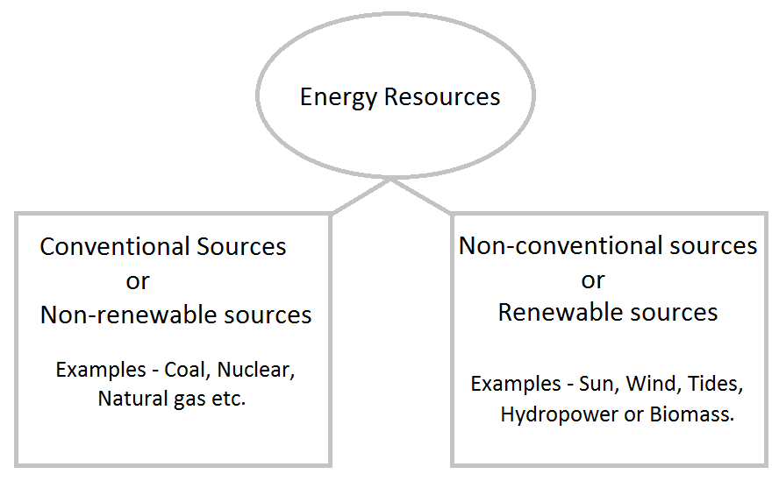

- Management of Smart Energy
Constant population expansion and increasing urbanization have raised worldwide energy consumption. As previously stated, different energy management concepts such as green energy, sustainable energy, renewable energy, and so on have been developed in recent decades to solve the issues associated with rising energy consumption. The primary purpose of the green energy idea was to reduce the negative environmental and socio economic repercussions of nonrenewable energy use. As a result, while satisfying clean energy demands, it minimizes carbon emissions, greenhouse gas emissions, human health concerns, and so on.
The idea of sustainable energy was created with the intention of maintaining and sustaining nonrenewable energy sources for the benefit of current and future generations. Sustainable energy, in general, combines renewable energy generation and energy conservation. Another popular concept that uses RESs to meet global energy needs is renewable energy. Some of the most extensively utilized RESs include solar energy, wind energy, and tidal energy. The cost of RES has decreased over time and continues to fall. Smart energy is a comprehensive strategy that incorporates green, sustainable, and renewable energy ideas.
Figure. Smart energy idea integration

Nonrenewable energy sources, such as petroleum, coal, natural gas, and nuclear, currently meet a large amount of global energy demand. Despite this, intensive efforts by domain specialists have significantly boosted the contribution of renewable energy sources to global energy demand. As a result, the traditional energy management paradigm is evolving into a hybrid model that incorporates both renewable and nonrenewable energy sources. Although technological advances have transformed traditional distribution networks into smart grids that intelligently coordinate the behavior of all connected customers and utility providers, hybrid energy generation requires certain additional capabilities. As a result, the smart grid paradigm is growing further to incorporate renewable energy generation, renewable energy storage, distributed energy storage, and other related technologies.

- Overall energy resource distribution
At the moment, renewable energy makes a little contribution to primary energy and electrical supplies. Appropriate cost reductions, growth of the renewable energy industry, and technological advancements are all linked to government policy accuracy, private sector ingenuity, and investment. The first level in [Table 1] is the share of oil in total primary energy supply, with fossil fuels accounting for around 81% of total. Renewable energy is intended to substitute fossil fuels as both ecologically safe and economically viable.

Resources | Properties | Share (%)
Oil | Oil is a finite resource. An oil is any nonpolar chemical compound that is hydrophobic and lipophilic and is made up largely of hydrocarbons. | 31.9
Coal | Resources that cannot be replenished. Coal is a flammable black or brownish-black sedimentary rock heavy in carbon and hydrocarbons. | 27.3
Natural gas | Natural gas is not a source of renewable energy. Natural gas is an energy source derived from fossil fuels. | 22.4
Biofuel & gas | Biofuels are a type of sustainable energy that is obtained from living matter. | 9.2
Nuclear | Nuclear energy is commonly regarded as a nonrenewable energy source. | 4.9
Solar, wind, geothermal & tidal | Wind power, solar power, bioenergy (organic matter used as a fuel), and hydropower (including tidal energy) are examples of renewable energy sources. | 1.9

Table 1. Fuel shares in world total primary energy supply (2017).
The largest renewable energy source of worldwide renewable supply, which includes solid, biofuels, and charcoal, is 60.7% in developing nations, owing to its use for home heating and cooking. According to Figure 1, hydropower is the second largest source, accounting for 18.5% of renewable energy. The remaining renewables account for a lower proportion.
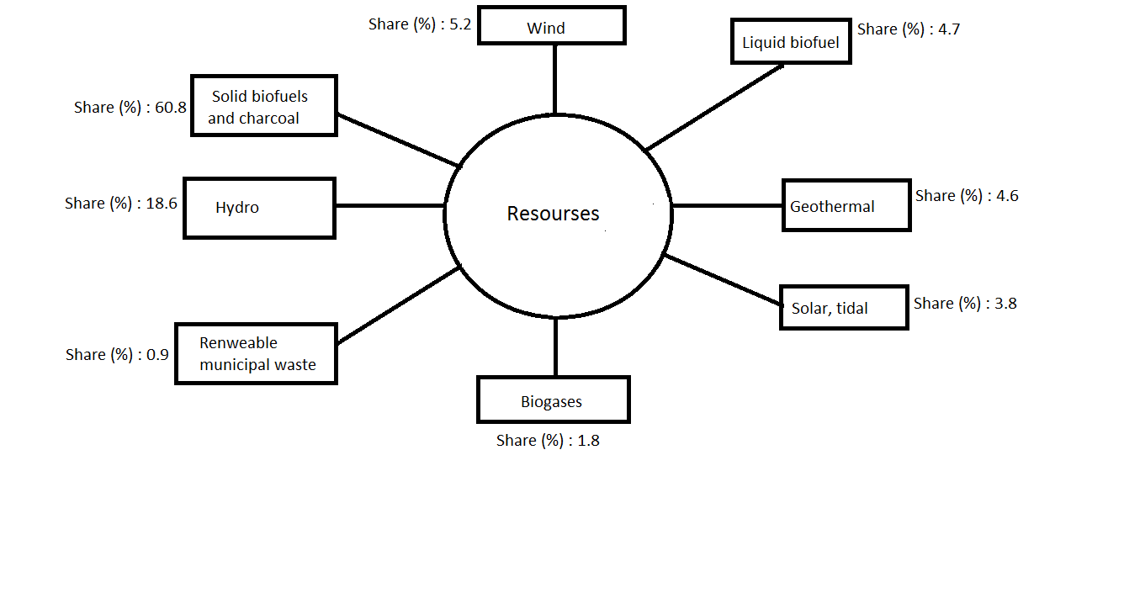
Figure 1 . Product shares in world renewable energy supply (2017).
The majority of renewables, on the other hand, are consumed in the residential, commercial, and public services sectors, as seen in figure 2.
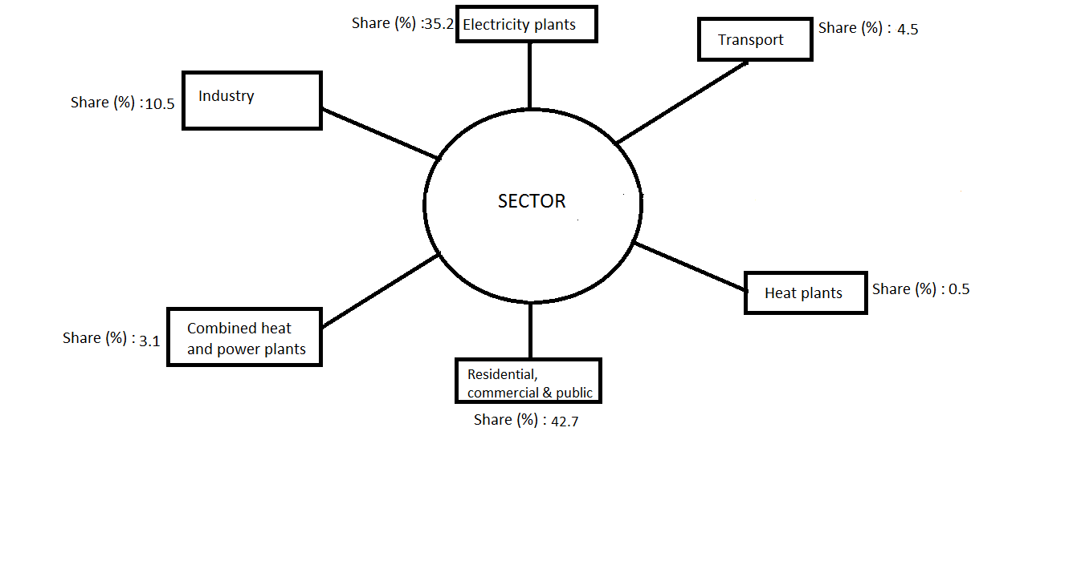
Figure 2 : shows the fuel shares of global power production in 2017.

Figure3. shows the average figures for global total final consumption by sector in 2017. Industrial, transportation, and residential energy use account for 37, 29, and 22% of total energy use, respectively.
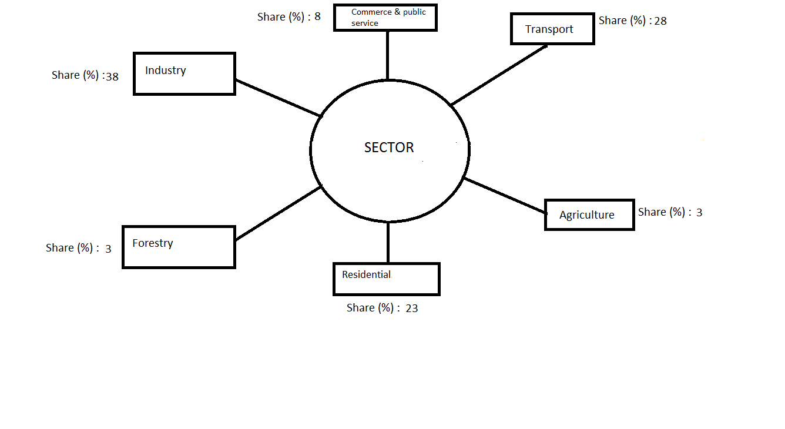

Figure 3: Total global final consumption by sector in 2017.

According to the figures, renewable energy will increase the quickest in the electrical sector, accounting for 29.4% of power consumption in 2023, up from 23.9% in 2017.
Table 2: Renewables share in 2017 and 2023.
Bio-energy (as solid, liquid, or gaseous fuels) will, nevertheless, account for 30% of the rise in renewable consumption from 2018 to 2023, owing to the use of bio-energy in heat and transportation. On the other hand, the remaining renewables, which account for 80% of total final energy consumption, have less effect on the sectors of heat and transportation. Although solar PV and wind energy continue to rise in the electrical industry, bio-energy will remain at the top. Renewables such as solar PV, wind, hydropower, and bioenergy are predicted to fulfill over 70% of global electricity generation increase from 2018 to 2023. Hydropower (16%), wind (6%), solar PV (4%), and bio-energy (3%), will meet world electricity demand by 2023. Biofuels in road transport have the lowest renewable proportion, with 3.4% in 2017 and 3.8% in 2023. Renewable heat use is predicted to account for 11.8% of total energy consumption by 2023. The rise of renewable usage in the transport and heat sectors is slowing due to reduced legislative support and higher impediments to implementation.

- Energy and long-term development
Energy systems may have a significant environmental impact in both developing and wealthy countries. As a result, a sustainable global energy system should optimize efficiency while limiting emissions. Technology and the global economy must also evolve in tandem with steady and sustainable growth.
Global environmental concerns are unavoidable as energy usage rises, particularly from fossil fuels. Both industrialized and developing nations intend to enable the most appropriate energy systems while also improving the human, economic, social, and environmental conditions for long-term growth. For the long-term sustainability of the global energy systems, numerous problems such as demographic, social, economic, and technical developments may exist at the moment.
To achieve sustainable energy systems, as concluded, vigorous action should be taken primarily in the areas of energy diversity and efficiency, supply reliability, public trust, market-sensitive interventions, market-based climate change responses, cost-reflective prices, technological innovation and development, and regional integration of energy systems.
Government policies should be properly prepared for energy production, replacement, transportation, distribution, and use. Because of the environmental concerns and challenges associated with energy, governments should strive to safeguard the climate system, strengthen legislation, and adopt relevant preventions. As a result, rules for minimizing local air pollution should be reinforced and applied effectively and efficiently.
The existing energy supply and consumption are extremely unsustainable due to reliance on traditional fossil fuels, which are mostly generated in politically unstable nations. To address current and future needs for improved circumstances, such as human, economic, social, and environmental, substantial improvements in technology will be necessary everywhere. Topics like innovation, investment, work, organization, and leadership should be considered.
The global political and economic condition, technology and energy policy, and market development are the three groupings of essential elements affecting the energy future. To meet a country's energy needs, the environment, cultural history, and abundant natural resources should be utilized. Energy generation, transmission, distribution, and trading, on the other hand, should be supported by the use of standardized equipment and materials.
Although the usage of coal raises the danger of local pollution and greenhouse gas emissions, it also provides energy security. Coal has substantial carbon dioxide emissions per unit electricity at the moment of usage. However, commodities like coal and gas will continue to be significant.
Diversification and use of the country's resources are always critical components in ensuring long-term sustainability and low-cost energy supply. The future industrial investments should go towards clean technology. The quality of a cleaner environment will be influenced by economic and political considerations, depending on technology improvements. Domestic renewable energy resources such as hydro, wind, solar, geothermal, and biomass should create more power to offer resource variety.
By 2040, however, the world's energy supply mix will include oil, gas, coal, and low-carbon sources. To combat pollution and minimize CO2 emissions, the usage of coal should be limited, as planned. When compared to fossil fuels, renewable energies are both ecologically safe and economically viable.
The use of hydropower can provide several benefits for water supply and agricultural irrigation, but also has drawbacks for aquatic ecosystems.
When compared to typical fossil fuel plants, geothermal power plants are more environmentally friendly. Pollutants emitted by the power plant might cause environmental damage. As a result, cooled geothermal fluids are pumped back into the soil, lowering the risk to the environment.
When compared to the environmental consequences of fossil fuels, wind power has a modest environmental impact. Depending on the conditions, the location and operation of wind turbines may have a negative impact on the health of those who reside nearby.

Solar energy is becoming increasingly popular across the world. There are, however, several arrangements on solar thermal and PV installed power, and the same is envisaged for concentrating solar power systems.

Bio-energy is derived from biomass, which is a clean energy resource in terms of the type of biomass and conversion technique employed.

- Energy security, problems, and aspirations in terms of sustainability
To summarize, energy is crucial to the problem of sustainability in terms of social, economic, and environmental aspects. As a result, the shift to sustainable energy resources and systems is coupled with a number of environmental, economic, and development requirements. Local renewable resources, installation costs, and policy framework will all be important considerations.

Although the environmental implications of energy production and consumption are local, considerable repercussions associated with pollution movement in the atmosphere can occur on regional, continental, and even transcontinental dimensions.
While global electricity demand and sustainable development are rapidly increasing, energy policy goals that take into account energy mix, efficiency, market and environmental standards should also be established in order to provide several rehabilitations on unlicensed electricity generation and renewable energy resources.

The following are some of the policies' primary components:
- Feed-in tariffs are used to secure higher free market pricing.

- To provide further incentives for sales of locally made parts of renewable energy power plants.

- When connecting to the grid, renewable energy should be prioritized.

Energy difficulties for developing countries are serious and growing. However, many developing nations have some benefits in striving to reform their energy sectors and may have an opportunity to establish cleaner and more efficient technology. It is apparent that the situation for emerging countries is more challenging than that of wealthy ones in many aspects. Due to resource limits, a considerable portion of the population may face problems accessing essential energy services. Many conventional technologies are anticipated to stay less expensive than sustainable energy alternatives.
Renewable energy sources should be supplied for any country's sustainable growth owing to dwindling fossil fuel levels, rising global fossil fuel prices, and reduced environmental repercussions. Solar, wind, hydro, and biomass are significant forms of renewable energy sources with enormous promise for meeting future energy concerns. As mentioned, there are various characteristics that must be met in order to have a sustainable energy supply, including climatic compatibility, resource sparing, minimal hazards, social equality, and public acceptability.
- Obstacles to renewable energy
There are several challenges and impediments to overcome while creating renewable energy. Some technologies have been commercialized and industrialized to some extent, and the scale and speed of development of industries in developing nations are unavoidable and have enormous gaps.
The following challenges to renewable energy production may be categorized into three categories:
- Cost-cutting measures: Traditional energy sources are less expensive and less expensive than renewable energies. Because the cost of producing renewable energy is higher than that of producing fossil fuels using the same technology, there are significant hurdles to commercialization and distribution of renewable energy. The major causes for renewable energy's high production costs are limited scale and low manufacturing technology.

- Obstacles to market share: The current advancement of renewable energy involves pricing constraints. A developed market, on the other hand, may provide system operating reliability while also lowering manufacturing costs.

- Policy constraints: Policy enactment and implementation are different parts of the policy process. Renewable energy should be developed to an industrial scale in the future. As a result, depending on policy assistance, renewable energy's market share must be raised.
Barriers associated with societal and cultural patterns must be avoided in order to have more sustainable lives, and hence appealing and more sustainable alternatives, as well as other incentives, will be necessary. Because of the prevailing assumption in endless natural resources and continuing economic expansion, the current economic system continues to be a barrier to change.
The present construction business, on the other hand, is a very conservative enterprise. It is widely acknowledged that new and more sustainable designs, building materials, and construction processes are just gradually appearing and being applied. Another difficulty for building energy efficiency is the high cost and extended payback period for upgrades.

- Renewable energy development strategies, policies, and metrics
Renewable energy has become a significant alternative for governments in adopting sustainable plans. It is unavoidable that energy will be the driving force behind social and economic progress. However, because fossil energy is widely used, the economy and environment's sustainability suffer.
Renewable energy are non polluting and pure. They encourage and promote the objective of sustainable development. As a result, the development of renewable energies is hastened by enacting laws and regulations that provide significant incentives. Renewable energy's strategic aims are essentially to increase energy competitiveness, secure supply, and safeguard the environment.
Renewable energy resources are also selected to replace fossil fuels in order to organize the energy structure and improve energy supply security. Because renewable resources are available locally, they may be converted directly or indirectly into energy or liquid fuels.

In rural regions, the development of renewable energy resources may tackle the problem of energy consumption while also combining with agricultural output, increasing farmer income. Renewable energy is expected to account for around 30% of global energy structure by 2050.
Renewable energy production is dependent on technological innovation and the advancement of new high technology levels associated with industrialisation and commercialization. It is true that the expense of developing renewable energy is somewhat expensive. Countries will not assist to cut costs, raise profits, maintain dependability, and improve the value of renewable energy if the government's support and policy presentation cannot assure large-scale development.
Renewable energy is the foundation of the future energy system, meeting pressing demands for its environmental benefits, sustainable development, and use. Due to present energy and environmental issues, it is vital to accelerate the growth and trends of renewable energies.

- Global Renewable Energy Future Trends
According to, global energy trends and their potential consequences are linked to issues such as supply and demand, energy access, the environment, and air pollution. Current policies are being developed to fulfill long-term climate targets under the Paris Agreement, and they will serve to reduce air pollution and provide universal energy access. Renewable technologies are the top choice in electricity markets due to lowering prices and favorable government regulations. It is likely that an ambitious utility will seek to deliver renewable energy at a cheap and set price in order to attract investment.
By 2040, renewables are predicted to account for more than 40% of worldwide electricity generation. However, coal and gas will continue to be the most important energy resources.
Future electricity markets will be flexible and adaptable due to fluctuation in supply and power systems. To be engaged in renewable energy sharing, market changes, grid investments, and new enabling technologies are necessary.
Energy technologies, as noted, have concentrated on the proliferation of clean energy technology in terms of possibilities and constraints. Global technological trends have an impact on industry competitiveness and future growth. By identifying difficulties for innovation and technology, industrial reliance on foreign technology may be lessened.
To improve technological growth at the moment, the following basic international trends may be identified:
- Technology collaboration

- ICT stands for information and communication technology.

- Digitisation

- The emphasis is on high-tech industries.

- Recognising the significance of multinational enterprises.

While it is preferable to use an appropriate energy source in the energy mix, variables such as technical innovation, cost savings, energy storage technology, and rising consumer demand are critical for the management of renewables and alternative resources. On the other hand, the expanding importance of offshore wind will attract new investors and may cause more onshore wind providers and developers to shift their focus to the sector.
The worldwide potential of algal biofuel
Globally, there is a push to utilize algal biofuel since it has enormous potential as a future green transportation fuel. The US government has begun to move its attention from food crops to algae-based biofuel production. Since 1982, the ASP (Aquatic Species Programme) has undertaken several studies on algae-based biofuel in Hawaii, California, and New Mexico, yielding a 100 times higher output than oil palm.
Algae-based biodiesel performance and emissions, Many scientists have successfully synthesized biodiesel from various Algae plant species and studied its performance and emission properties in CI engines. One of the easiest conversion processes is the transesterification of algal lipid content into biodiesel.
Geographically, India has a vast coastline and a tropical environment that are ideal for large-scale algae farming. Extensive research has been conducted in India on the use of microalgae for culinary and pharmaceutical purposes.

- Technologies and applications that make it possible
While global energy demand is increasing and new power plants are necessary, energy security and dependability should be enhanced, and alternative energy sources should be researched.
As stated, components such as high research and development intensity, quick innovation cycles, high capital investment, and highly trained employees are supplied to build enabling technologies. Enabling technologies that are interdisciplinary and supportive of technology leaders' research efforts meet the procedures for products and service innovation.
Enabling technologies are mostly chosen in the following manner:
- Addressing global issues such as low-carbon energy or resource efficiency
- to aid in the creation of new items
- to promote economic growth and employment creation

To reduce prices and increase integration, a mix of enabling and demand trends is required to realize global renewable energy trends. The following are current enabling technologies:
- High-tech materials
- Systems for advanced manufacturing
- Microelectronics and nanoelectronics
- Nanotechnology
- Biotechnology in the workplace
- Photonics
As stated, innovative materials, sophisticated manufacturing systems, and industrial biotechnology are required to meet social concerns and speed the growth of the economy and the energy transition. Digital technologies are being incorporated into process technologies, material development, and business model creation as a result of the present digital evolution and its great benefits. Enabling technology will also hasten the development of new markets, growth, and jobs.
The following are the key technological advances and initiatives that are required:
- Developing advanced materials for use in energy efficiency (e.g., light weight), renewable energy generation and storage (e.g., battery components), or smart features that respond to stimuli (e.g., self-repair). Materials for building, energy, mobility, food, health, and electronics are also created by advanced materials. Polymer materials for 3D printing are utilized in the automotive, lightweight design, medical, and 3D printing industries.

- Creating advanced process technologies and industrial biotechnology for more sustainable energy production and alternative energy resources.

- Using digital technology to provide better process control, business models, and innovative consumer experiences. Digital technologies facilitate the move from batch to continuous intensified operations that are adaptable and continuous.

On the other hand, the development of technology to convert CO2 into a valuable resource and to use it in the production of polymers can help minimize the consumption of petroleum. Process technologies allow raw materials to be transformed into products with a different chemical composition, structure, and qualities than the input raw materials. Advanced process technologies are a subset of enabling technologies that enable the chemical industry to supply materials (solid, gas, and liquid) and novel properties to all industrial value chains (e.g., construction, automotive, medical, electronics, and energy).
As described, solar energy may be transformed to both electricity and thermal energy at the same time by a hybrid photovoltaic/thermal (PV/T) system, which can also meet building energy demands. Performance study of PV/T systems is critical when developing them to fit the operational circumstances. Economic constraints and applications should be considered while conducting an energy flow study. Solar power, as predicted, offers various advantages and is more competitive than conventional energy sources. There may be a land adequacy issue for onshore wind turbine installation. As a result, if the place is suitable, an offshore wind turbine with greater economic expenses is an alternate option these days.
Wind energy has major technological, social, and environmental hurdles. Wind energy, on the other hand, has emerged as a viable option for both established and developing countries in sustaining a green environment.

The following are basic developing conceptions for future sustainable lifestyles:
- To transfer the focus of design, planning, and action away from the individual and towards the community, allowing communities to take ownership. For example, if a community is founded on equity, mutual assistance, and stakeholder engagement, it is possible to create more connected communities and sustainable neighborhoods.

- The sharing of products and services contributes to the development of collaborative infrastructure. As a result, community-based consumption has mitigated the negative effects of individual consumption. For example, smart renewable energy assistance for distributed renewable energy generation and consumption.

- Sustainable solutions must be normalized without reducing people's freedom of choice. Several options can make sustainable decisions easier and appealing, as well as changing the necessity for individual conduct. People will, for example, coordinate their conduct based on consumption levels and resource utilization.
There is a strong emphasis on innovation in enabling technologies that can aid in the integration of variable renewable resources into energy networks.

- Some considerations for promoting renewable energy
As the percentage of renewable energy sources grows, it appears that considerably greater flexibility in energy markets is necessary. Large electrical end users, such as merchants, manufacturers, and technology firms, are major consumers for purchasing renewable energy directly. There is a variable interplay between independent power providers, utilities, and commercial and industrial users. The function of utilities in each transaction varies as new models are developed.
It is stated that sustainable business models, which are becoming increasingly popular across a wide range of industries, include solutions such as building a market model to assure revenues for stakeholders. Energy, innovation, marketing, entrepreneurship, developing nations, engineering, building, mobility, and transportation are just a few of the applications of these concepts.
The feed-in tariff is the most commonly employed governmental mechanism to support the renewable energy industry. As a result, a set price per unit of power sold is guaranteed for the duration of the agreement. While feed-in tariffs reduce renewable costs quickly, there is a possibility that renewables may need to be subsidized by governments for a long time. On the other side, in recent years, there has been a shift away from government-managed feed-in tariffs and towards auction systems. It is hoped that by determining the price for renewable energy contracts, significant cost savings in renewable energy would be obtained. Financing is a critical component of the adoption of renewable energy technology. Public finance institutions, individual investors, and institutional investors are the primary sources of funding.
Industrial marketing refers to business-to-business marketing, and its goods are based on functional consumption values like price and quality. Businesses to businesses sell, rent, or offer things to other businesses. Local buyers do not just buy items from local vendors in a globalized economy. Due to rising worldwide rivalry, B2B enterprises must discover innovative strategies to stay relevant in the market. To meet their consumers' personal requirements, businesses must also treat them as persons with values. Business-to-consumer marketing, on the other hand, seeks to offer items or services directly to customers.
Business-to-business renewable energy firms might have a marketing edge when it comes to sustainable solutions. However, selling green energy is difficult. Purchasing a renewable energy product is an investment. Customers usually rely on assistance packages that are not set and might vary between nations to help finance their investment.
Companies investing in renewable energy are expected to leverage their environmental credentials to sell their usage of renewable energy. Governments that are interested in renewable energy and its advantages arrange various assistance packages such as tax credits and subsidies. Subsidies for fossil fuels, on the other hand, are being cut to make renewable energy more appealing.
The demands of power systems with larger proportions of variable renewable energy are reflected and reacted to in various energy markets by digitization, decentralization, and electrification movements. Imported is a gradual improvement in energy market pricing. In general, the package can comprise the temporal value of power, new dispatch regulations, flexibility, economic energy resources, self-consumption, and market connectivity. Appropriate electricity market designs for changing power system models are required to accelerate the energy transition. End customers of electricity now have more providers and new packages to select from, and they may quickly switch tariffs and suppliers. However, the retail sector cannot offer the intended outcomes for all end users.

- Conclusions
Fossil fuels continue to account for the majority of energy usage and are on the rise across the world. Environmental contamination is unavoidable in this circumstance, and renewable energy plants make no direct contribution.
It is hoped that in the future, the primary energy sources would be innovative and renewable energies. While fossil fuels will ultimately run out, renewables will become more essential. They are effective in a variety of areas, including continual cost savings, job creation, the development of new businesses, and fulfilling energy and environmental standards.
Renewable energy production and utilization will benefit energy security, the environment, the economy, mechanical manufacturing, construction, transportation, and industry, as well as serve to create new employment. Solar, wind, and biomass energies can fulfill local energy demands while also helping to enhance environmental protection. The current energy demand scenario fosters a big market for renewable energy. Renewable energy will account for 12.4% of global energy consumption by 2023, as expected.
Renewable energy has the potential to make major contributions to energy demands in the long future if investments in renewable technology continue. Furthermore, biofuels and fuel cells can contribute to the heat, transportation, and energy industries.
In 2023, the percentage of fossil fuels in total primary energy supply is predicted to be about 81%. Renewable energy will account for roughly 30% of global energy structure by 2050.
The share of domestic and renewable energy resources in the generating system may be expanded to the greatest degree possible by providing nations with balanced resource diversity for primary energy resources. Targets should be attained in time for supporting, developing, and encouraging new environmentally friendly practices in generation and services, as is also sought in many nations' existing strategic plans. The top industrialized nations, such as the United States, Japan, and Europe, have the highest market share and the most sophisticated renewable energy technology.
Many energy-efficient enabling technologies are used to utilize less and cleaner energy in power plants, buildings, industrial facilities, and transportation networks. These technologies have the potential to cut costs by up to 80%, save energy by up to 30%, and assist in halting global warming in the future. As a result, the countries could remain cost-effective while making long-term development. Marketing renewable energy may also be characterized as the skill of knowing consumers and their demands.
Energy management has arisen as a service in smart settings with the goal of using energy more effectively and sustainably. The benefits of energy management are diverse and apply to any smart environment. The purpose of this essay was to provide an outline of the connection between smart environments and energy management.

