Revolutionizing Farming: The Impact of Robotics in Agriculture
Anmol Giri ^{1, 2*,} Arijit Karmakar³ and Narendra Nath Hansda⁴
¹Assistant Professor, Department of Agricultural Economics, School of Agriculture, GIET University, Gunupur, Rayagada- 765022, Odisha, India.
²Research Scholar, Department of Agricultural Economics, Bidhan Chandra Krishi Viswavidyalaya, Mohanpur-741252, West Bengal, India.
³Research Scholar, Department of Agronomy, Bidhan Chandra Krishi Viswavidyalaya, Mohanpur-741252, West Bengal, India.
⁴Research Scholar, Department of Vegetable Science, Bidhan Chandra Krishi Viswavidyalaya, Mohanpur-741252, West Bengal, India.
*Corresponding author: anmolgiri20k@gmail.com
Abstract
The rise of agriculture and its allied sectors can be seen as a game changer in the history of mankind. The first significant change in the relationship between fully civilised creatures and the natural world was caused by humans' ability to artificially manipulate the environment to produce enough food to sustain a massive population boom. For 12,000 years, agriculture has advanced humanity, yet we are reaching a turning point. In order to meet nutritional trends, agricultural production would need to rise until a minimum of 70% from current levels by the year 2050, by which the population dynamics of the globe is expected to breach the 10 billion mark. More than ever, the well-being of our planet is under stress due to the demand from the agriculture sector to produce more nutrient-dense foods. Modern farming has been completely revolutionised by novel technological developments, such as robotics, drones used in various agricultural practices and computer vision softwares. Farmers today have access to tools that will allow them to cater to the expectations of the growing world population. Another aspect that has been paving way for humans to reduce their workload as well as perform hi-end tasks and laborious tasks with ease due to this technological advancement is automation.
Keywords: agricultural production, modern farming, robotics, agricultural drones, automation.
“There are an endless number of things to discover about robotics. A lot of it is just too fantastic for people to believe”.
¬ Daniel H. Wilson
History and Background:
The concept of robotic agriculture, or agricultural settings supported by intelligent equipment, is not new. The conceptualization of a mechanism that could carry out responsibilities automatically is considerably old, as evidenced by the over 4,000-year-old automatic toy dog made by the Egyptians, the gold mythological servants who helped the Greek God Hephesto (known as Vulcan to the Romans) in his blacksmithing works in the year 2000 BC, and Da Vinci's design and construction of a horse and "robotic" knight in the year 1500 AD. Although the concept is not new, Wiener's interest in researching the use of control theory in biological systems only led to its realization in the 1940s. Then came cybernetics, a branch of knowledge concerned with the mechanisms of communication, control, and operation of artificial systems built around biological systems. This branch of knowledge studies organisms from neuronal cells and synapses that connect them to the subjective behaviours of animals (including humans). Grey Walter created his 'turtles' in 1940, which were small, trainable machines that could be 'domesticated'. From these ideas, Devol created the first robot used in industry to manipulate objects in 1954. Additionally, the first industrial robot to be produced for commercial purposes, known as Unimate, emerged in 1961 and was used to manipulate fundamental parts of car chassis at the manufacturing facility of General Motors. The field of robotics has advanced dramatically since the first practical industrial robot was created in 1961. As a result, presently, we are able to describe a robot as any autonomous device that is capable of making decisions. For this to happen, the robot has to possess electronic "brains" that use artificial intelligence (AI) algorithms to think logically (Albiero, 2019).
In the past, several engineers have created driverless tractors, but they have not proved successful in real-world applications. The majority of them pretended to have an industrial aesthetic that could only function in predetermined ways, like a manufacturing line. The current strategy is to create machines that are smarter and clever enough to function in a natural or semi-natural world. These devices must act rationally in established situations. They should therefore be intelligent enough to perform well over a longer time frame in a semi-natural environment (Fountas et al., 2007).
Energy is used extensively in modern agriculture in the form of fuel, machinery, chemicals, and fertilizers. To increase effectiveness, the phytotechnology method aims at directing the imparted energy. According to Chamen (1994), switching from standard overcrowded techniques (255 MJ/ha) to an alternative system (79 MJ/ha) can result in 70% energy savings in agriculture. This did not involve any deep loosening and was only for superficial ploughing. This leads us to the conclusion that between 80 and 90 percent of the energy consumed for conventional farming goes towards repairing the damage done by large tractors. Since a small, light machine wouldn't initially induce compaction, it would be preferable to a large, heavy one (Bera and Dutta, 2021).
Introduction
Agriculture allowed for the growing of crops, the use of fire for cooking foods, and the creation of self-driving vehicles. With an ever-increasing population that is been seen around the globe, governments are now seen to be focusing on innovative ways to cater to the food requirement of their people. But that is not as simple as it may sound. As more and more people move into cities and no one stands up to lead next-generation farming, now is the ideal time to introduce disruptive technology such as artificial intelligence and robots into agriculture. Modern farming is not a contradiction. With applications that regulate irrigation, GPS systems that drive tractors, and RFID-chipped ear tags that monitor cattle, modern agricultural enterprises are more likely to make an everlasting impact and pave ways for breakthroughs in the coming days and a significant role in that direction will be paved by technological advancements and agricultural robots.
Agricultural robots remove weeds, harvest the greens, gather and pick the fruits making it ever so easy for the farming community. Drones collect airborne photographs that enable farmers to immediately evaluate the health of their crops. And in the backyards of densely populated metropolitan markets, robotic greenhouses are emerging thousands of kilometres from traditional farming zones, growing produce. All of this occurs while food consumption is predicted to increase dramatically by 2050 due to the projected increase in global population from 7.7 billion to 9.7 billion people (Velaquez, 2023) and an expensive, long-term labour scarcity for growers.
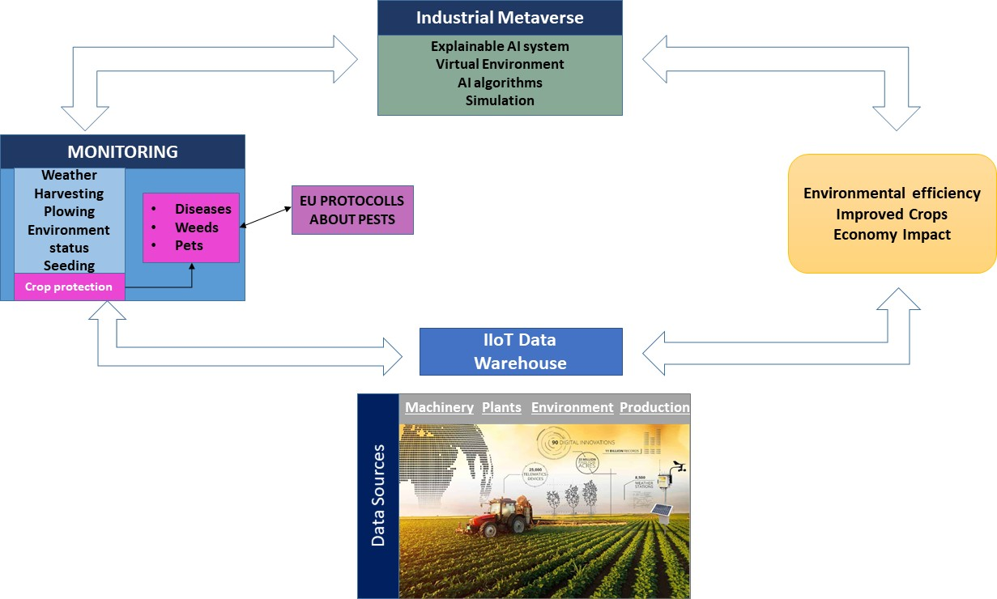

Fig. 1. High-level architecture of a crop protection system with AI and robotics techniques. (Balaska et. al., 2023)
Robotics is already penetrating many corporate sectors, including customer service, production, shipping, and transportation. Fortunately, the next sector to embrace technology and undergo a significant revolution is agriculture. But, the question which arises in the minds of traditional thinkers is, why robotics, out of all the technologies? The answer to this is very simple and precise. As it can fill the gap between the needs for labour and output. Agriculture is undergoing a high-tech change, and producers in general are increasingly looking to robots to tackle numerous problems. Robotics is already being employed in the European and American countries as well as some pan-Asia Pacific countries to address manufacturing-related issues. Robotics in agriculture is anticipated to become increasingly prevalent in the years to come (Das, 2022).
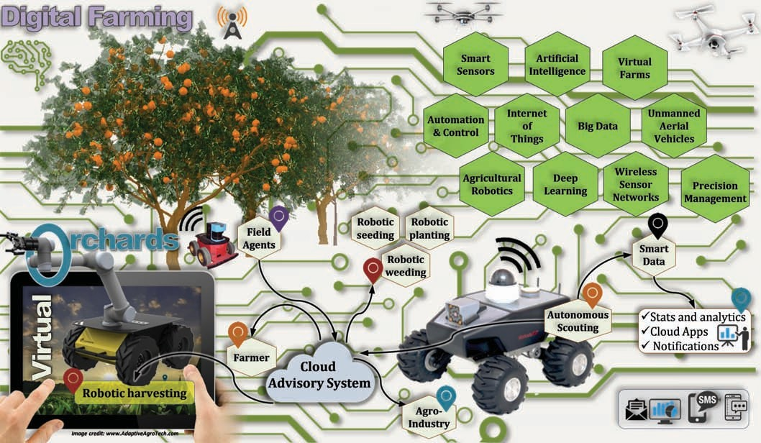
Fig. 2. An illustration emphasizing the use of agricultural robotics in digital farming and artificial orchards. Source: www.AdaptiveAgroTech.com
Importance of Artificial Intelligence in Agriculture
Artificial Intelligence (AI) is increasingly gaining significance in agriculture due to its potential to address key challenges faced by the industry, from increasing food demands to resource constraints. By leveraging AI technologies, farmers can make informed decisions and optimize various aspects of agricultural practices. Here are some key points on the importance of AI in agriculture:
- Precision Farming: AI-driven technologies, such as sensors, drones, and satellite imagery, enable farmers to monitor fields in real-time, assessing crop health, moisture levels, and nutrient deficiencies. This information empowers farmers to apply fertilizers and pesticides precisely where needed, reducing waste and increasing yields.
- Crop Disease Detection: AI-powered computer vision systems can swiftly detect early signs of crop diseases, pests, and infections. Timely identification enables farmers to implement targeted interventions, preventing the spread of diseases and minimizing crop losses.
- Climate Resilience: AI-based weather prediction models help farmers anticipate extreme weather events, such as droughts or floods, enabling them to implement precautionary measures and adapt their farming practices accordingly.
- Autonomous Farming: AI-driven autonomous machinery and robots can perform tasks like planting, harvesting, and weeding with precision and efficiency. This reduces the need for manual labor, lowers operational costs, and increases overall farm productivity.
- Data-Driven Decision Making: AI processes vast amounts of agricultural data, including soil composition, weather patterns, and historical crop performance. By analyzing this data, AI can generate valuable insights and recommendations, helping farmers make informed decisions and optimize their operations.
- Supply Chain Optimization: AI can enhance the entire agricultural supply chain by predicting demand, optimizing transportation routes, and reducing food wastage. This results in a more efficient and reliable distribution of agricultural products.

Some trending applications of Robotics in Agriculture
Autonomous application of seeds
The sowing process is exceedingly challenging and inconvenient to carry out using traditional methods. The agricultural sector of farming urgently needs the development of advanced technology, particularly when it comes to seed sowing and proving row-to-row and seed-to-seed spacing, resulting in greater yields and the positioning of seed depth that differs for various crops to crops depending on the weather conditions. When new machinery became available, farmers sprayed it with a "broadcast spreader" coupled with a tracker. Although the process was made simpler, a significant portion of the seeds were scattered across the field by the associated features, completely wasting them. Thankfully, automated precision seeding can be useful. Using a combination of robots and geomapping, the algorithm is capable of placing those seeds precisely where they're supposed to be for best results.
Due to a dearth of technical expertise, cutting-edge equipment, and technology, agriculture automation is still in its infancy. The majority of nations lack sufficient numbers of qualified workers in the agriculture sector, which has an impact on developing nations' economic development. Therefore, incorporating modern technology into farming operations may give farmers more help.
Interculture
Mechanical weeders or chemical spraying are used in cross-cultural operations like weeding in order to eradicate weeds. Field crop manual hand weeding is one of the most difficult farm tasks and requires a lot of human labour. Herbicide weed control not only has significant input costs but also harms the ecosystem and lowers productivity as a whole. Robotic weeding could provide a viable substitute for traditional hand-tool weeding techniques. Additionally, robotic weeding provides the finest substitute for manual weeding due to the stringent regulations and limitations on the use of herbicides. Vision-based systems are used by robotic weeders to mechanically uproot weeds and detect weeds (Melander et al., 2015). Gonzalez-de-Soto and colleagues (2016) designed a robotic system for precise herbicide application called the patch spraying system.
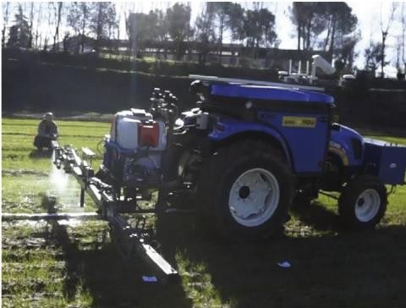

Fig. 3. Robotized patch sprayer (Gonzalez-de-Soto et al., 2016)
Harvesting Robots
Robots are renowned for replacing people in repetitive tasks. They carry out the necessary harvesting and plucking. It takes a lot of work to harvest important food, but it is necessary. For the benefit of people doing such arduous tasks, robots are assuming control over them. While fundamental cereals such as wheat and barley may be easily planted and harvested by robots, other tasks, like picking fruits and vegetables, call for more versatile robots.
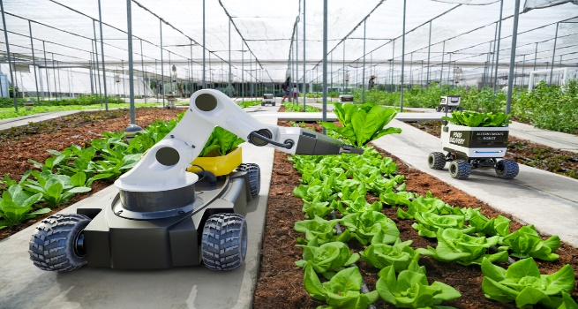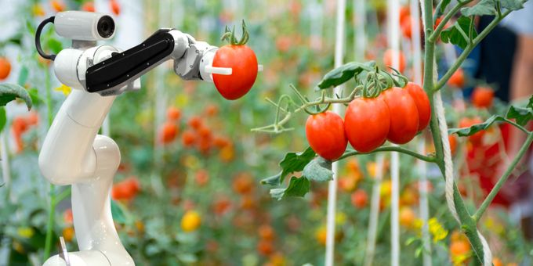
Fig. 4. Robots being used for Harvesting of different crops. (Source: howtorobot ;AgriTechTomorrow)
Crop scouting
Accurate and timely information gathering is one of the key functions of good management. Quantitative data has a history of being expensive, and the expenses of sampling can soon overshadow the advantages of managing space differently. If an automated device could remain in the crop carrying a variety of sensors to evaluate crop health and status, data collecting would be less expensive and quicker. In order to transport instruments above the crop canopy and make use of GPS, a high clearance platform is required. Student competitions have led to the development of smaller sub-canopy machines .
Spraying Robots
The soil is harmed by a great deal of chemical repellents sprayed on the plants. Subsequent sowing has a lower likelihood of avoiding the chemicals despite the ground being frequently churned to change its texture. According to Oberti et al. (2016), pesticides are commonly applied uniformly across fields, even though many pests and diseases show uneven spatial distributions and evolve around discrete foci. Effective site-specific application of pesticides can reduce the amount of agrochemicals used in precision horticulture (Maghsoudi et al., 2015). The ecosystem is also negatively impacted by it. As a result, farmers are utilising micro-spraying robots to mitigate the effects. Future advances in computer vision will enable weed detection and targeted pesticide spraying by micro-spraying robots.
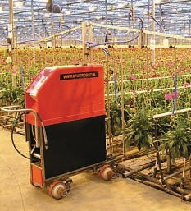 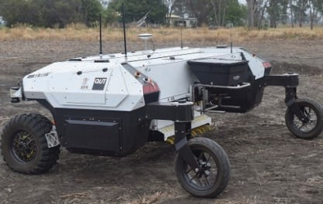 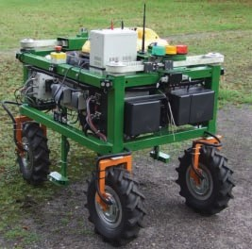Fig. 5 Spray robot; Fig. 6. Agbot-II and Fig. 7. Autonome Robotor
Source: Hollandgreenmachine; Queensland University of Technology; Osnabrück University
Aerial Imagery Drones and Seed-Planting Drones
Drones or unmanned aerial vehicles (UAVs) are the new way to carry out agricultural tasks like crop mapping, scouting, spraying, etc. when labour is scarce and to control agricultural inputs like pesticides and fertilizer precisely. In order to increase spatial resolution at a potentially reduced cost, UAVs, drones, and radio-controlled model aircraft can be flown at lower altitudes (Hunt et al., 2005). UAV platforms for agricultural management have several advantages over traditional satellite photography, including extremely high pixel resolution, independence from cloud cover during crucial growth periods, and fast information exchange
By providing farmers with a bird's-eye perspective of their crops, aerial imaging can save them a lot of time. In this method, they can swiftly assess the condition of the vegetation, bug problems, irrigation patterns, and weed growth. Even the amount of insecticide needed for the crops may be exactly calculated thanks to it. Farmers can obtain these priceless flypast photographs of their fields through a number of subscription services (such as thermal, infrared, and NDVI), but fewer businesses have fully embraced unmanned aerial vehicles. The FAA's regulations for autonomous drones, which call for pilots to be instantly prepared to assume control of a drone, are most likely to blame for this. Additionally, when in flight, small unmanned aircraft must be kept in the line of sight of any prospective pilot.
Robots for mitigation of weeds
If you've ever taken care of an individual garden, you know how crucial and challenging tasks like mowing and weeding are. Commercial farmers are aware of it as well but on a far larger scale. Many major operations remain entirely or somewhat dependent on the use of pesticides, regardless of whether crop rotation is an option. It's not a perfect solution, though, given that plants can develop weed-killer resistance and that customers are growing weary of food that has been chemically treated. In addition, maintaining large properties takes a lot of time. Robots that manage weeds and mow lawns are therefore a desirable choice, even those that use cutting-edge AI.
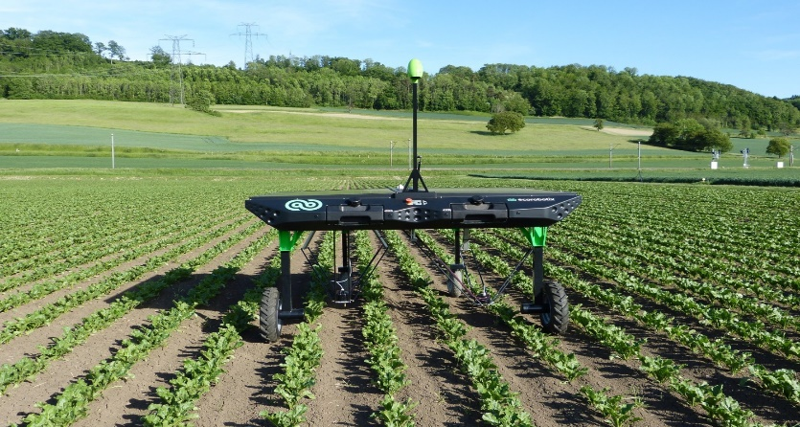
Fig. 8. Robots performing weeding activities. (Source: ecoRobotix)
Use of Robots in Greenhouses
One of the next major developments in agricultural automation will bring bots for agriculture to the field, not the other way around. The foundation for a future powered by robots and greenhouses is being laid by a number of entrepreneurs. While not all plants can be grown in this manner, the benefits are noticeable for some crops. These businesses advertise controlled indoor settings that do not require pesticides, as well as a huge reduction in water usage (between 90 to 95 percent less) for a comparable crop output.
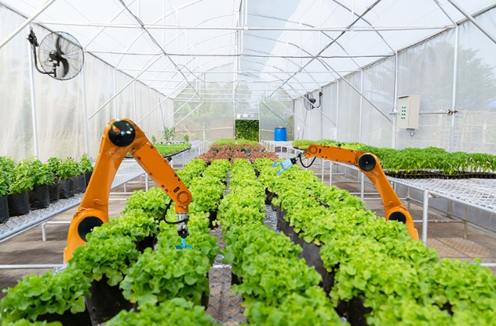
Fig. 9. Robots in Greenhouses. Source: (Foodunfolded)

Sorting and Packing Robots
Beyond the actual agricultural work, sorting and packaging require a large number of human workers. In today's hectic manufacturing environment, human labour for packing and wrapping is in high demand. As a result, many farming enterprises are adopting sorting and packing robots to help them finish tasks swiftly and effectively. Due to their coordination skills and line-tracking technologies, these robots can expedite the packing process.
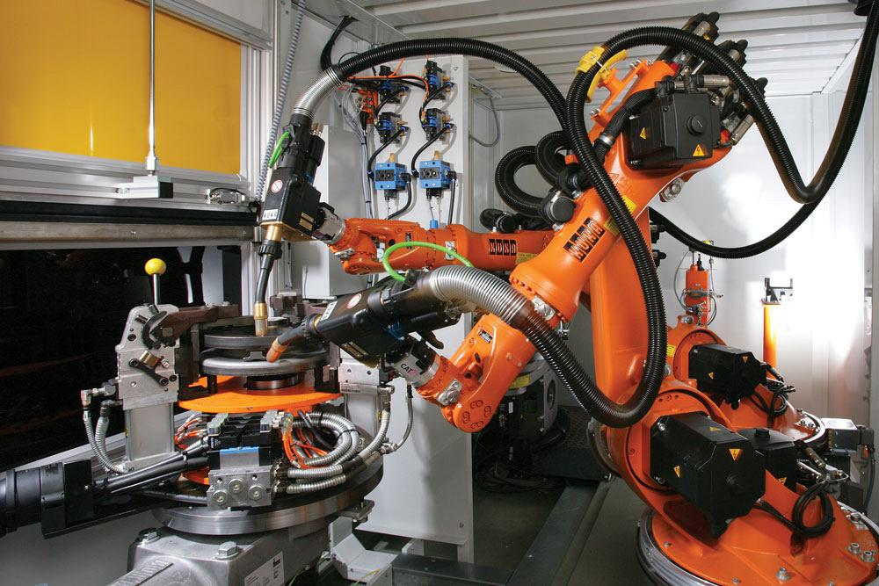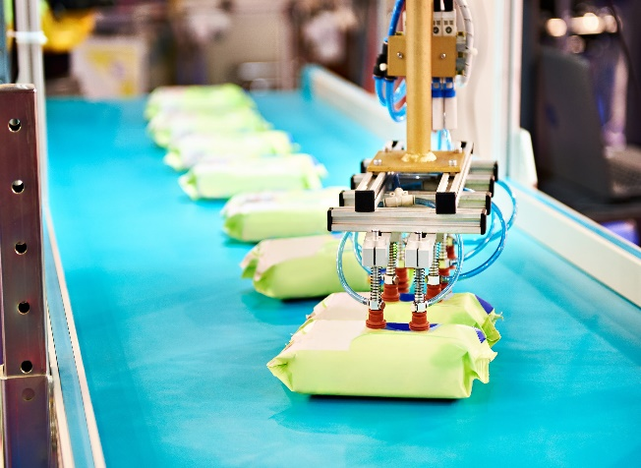
Fig. 10. Robots being used for sorting and packing of commodities.
Source: (howtorobot)
Robots for crop harvesting
Crop harvesting appears to be a prime candidate for automation. It's physically demanding and incredibly repetitious, the kinds of work that the robot revolution frequently targets most successfully. But it's not always the case.
Crop picking also calls for proficient hands and a light touch. In the summer, many fruits and green vegetables bruise easily. And the majority of robots simply aren't sophisticated enough to manage that level of accuracy. However, companies working on agricultural technologies are attempting to overcome that obstacle.
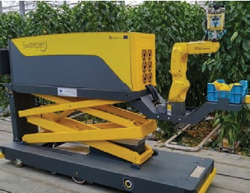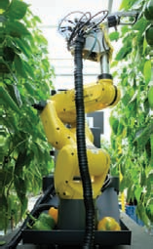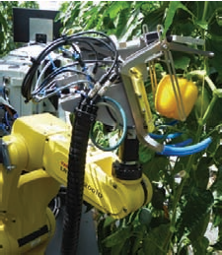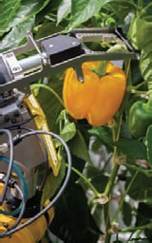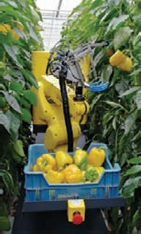
Fig. 11. SWEEPER robot: The first completely automated platform for harvesting sweet peppers in the world.
Source. Sweeper EU H2020 project consortium – www.sweeper-robot.eu.
While there is a consensus on the general structure of autonomous agents/robots nowadays, the implementation of this structure has been a subject of prolonged debate and is still under investigation. Agents, including robots, typically employ various sensing and acting devices. Data from sensors to actuators is processed by different modules, and the problem lies in building a high-level world model and generating a plan, which are time-consuming activities and make such systems unsuitable for agents operating in dynamic environments. Reactive architectures prioritize fundamental robot functionalities like navigation or sensor interpretation, proposing a direct connection between stimuli and responses (Nrip. et al., 2022).
Bottlenecks in the application of automation and robotics
Although it may initially seem impractical to utilize robots in agricultural operations, doing so is now essential to ensuring the global population's food security and addressing the labour deficit in the sector. There is a workforce shortage and rising food demand as a result of labour leaving agriculture for other industries. Robotic farm equipment has the potential to be used for labor-intensive repetitive farm tasks including planting, weeding, and harvesting. It also provides further benefits to get around labour shortages or unavailability for tasks like weeding, spraying, and harvesting fruits and vegetables.
Driverless tractors, laser land levellers, and robotic harvesters for fruits and vegetables in greenhouses are being developed, but face challenges in acceptance and commercialization due to geographical and climatic conditions, high costs, and training requirements. However, robotics solutions for fruit harvesters, sprayers, and autonomous combines or tractors are available for sale, aiming to alleviate future labour shortages. Enhancing, evaluating, and promoting these technologies with collaborative human-robot systems through multi-stakeholder initiatives could accelerate their adoption in agriculture.
Conclusion
Since we have a long way to go before creating totally autonomous robots, we have choices in which individuals can help the robot or the robot can help people. Another possibility is to employ remote control to aid robots moving around in the greenhouse. Employees can remotely control the robot in this fashion, allowing them to operate comfortably outside of the arid agricultural environment.
At the end of the day, we need to make sure that workers are helped and their working circumstances are improved by robotics rather than disrupting them. Furthermore, considering that many primary workers receive bonuses based on the amount of harvest and how quickly they are able to deliver their goods, robots and automation may potentially enable people to earn more substantial earnings. Robots and automation may be able to enable primary workers—who typically make less than minimum wage and much less than that—to achieve their bonus goals without subjecting themselves to intolerable physical strain.
Robots may just provide farmers with the safety net they need to continue feeding hundreds of millions of individuals across the world as crises like the coronavirus and its subsequent quarantines threaten the integrity of the supply chain for food by preventing workers from doing agricultural tasks. With the engagement of central authorities, robotics in agriculture and farming, is set to achieve new heights in the coming years.

References
- Chamen, W. C. T., Dowler, D., Leede, P. R., and Longstaff, D. J. (1994). Design, operation and performance of a gantry system: Experience in arable cropping, Journal of Agricultural Engineering Research. 59:145-60.
- Fountas, S., Blackmore, B. S., Vougioukas, S., Tang, L., Sørensen, C. G., & Jørgensen, R. (2007). Decomposition of agricultural tasks into robotic behaviours. Agricultural Engineering International: CIGR Journal.
- R Shamshiri, R., Weltzien, C., Hameed, I. A., J Yule, I., E Grift, T., Balasundram, S. K., & Chowdhary, G. (2018). Research and development in agricultural robotics: A perspective of digital farming. 11(4):1-14.
- Albiero, D. (2019). Agricultural robotics: a promising challenge. Current Agriculture Research Journal, 7(1). DOI:10.12944/CARJ.7.1.01
- Bera, A. and Dutta, D. (2021). Application of Robotics in Modern Agriculture. Just Agriculture. 1(11): 1-5. Available at. https://www.researchgate.net/publication/353321362_Application_of_Robotics_in_Modern_Agriculture
- Das, C. (2022). Digital Agriculture: Top 10 Robotic Applications in Modern Farming. KrishiJagran. Available at. https://krishijagran.com/farm-mechanization/digital-agriculture-top-10-robotic-applications-in-modern-farming/
- Velazques, R. (2023). 16 Agricultural Robots and Farm Robots You Should Know. Builtin. Available at. https://builtin.com/robotics/farming-agricultural-robots
- Hunt, E.R.Jr, Cavigelli, M., Walthall, C.S.T., McMurtrey, J.E.III, and Walthall, C.L., 2005. Evaluation of digital photography from model aircraft for remote sensing of crop biomass and nitrogen status. Precision Agriculture 6: 359–78. https://naldc.nal.usda.gov/download/59136/PDF
- Sinha, J.P., 2020. Aerial robot for smart farming and enhancing farmers’ net benefit. Indian Journal of Agricultural Sciences 90: 18-27. http://epubs.icar.org.in/ejournal/index.php/ IJAgS/article/view/98997
- Maghsoudi, H., Minaei, S., Ghobadian, B. and Masoudi, H. (2015). Ultrasonic sensing of pistachio canopy for low-volume precision Spraying. Computers and Electronics in Agriculture 112: 149–160. 10.1016/j.compag.2014.12.015
- Oberti, R., Marchi, M., Tirelli, P., Calcante, A., Iriti, M., Tona, E., Hocevar, M., Baur, J., Pfaff, J., Schutz, C., and Ulbrich, H. (2016). Selective spraying of grapevines for disease control using a modular agricultural robot, Biosystem Engineering 146: 203-215. https://doi.org/10.1016/j.biosystemseng.2015.12.004
- Gonzalez-de-Soto, M., Emmi, L., Perez-Ruiz, M., Aguera, J. and Gonzalez-de-Santos, P. (2016). Autonomous systems for precise spraying - Evaluation of a robotised patch sprayer. Biosystems Engineering 146: 165-182. https://doi.org/ 10.1016/j.biosystemseng.2015.12.018
- Nrip, N. K., Omkar, V., Shinde and Gaikwad, A. (2022). Applications of Artificial Intelligence and Robotics for Indian Agriculture Development. International Journal of Advances in Engineering and Management. 4(1);100-104
- Melander, B., Lattanzi, B. and Pannacci, E. (2015). Intelligent versus non-intelligent mechanical intra-row weed control in transplanted onion and cabbage. Crop Protection 72: 1-8. https://doi.org/10.1016/j.cropro.2015.02.017
- Balaska, V., Adamidou, Z., Vryzas, Z., & Gasteratos, A. (2023). Sustainable Crop Protection via Robotics and Artificial Intelligence Solutions. Machines, 11(8), 774.

