DESALINATION AND ADVANCED WATER TREATMENT

RADHIKA JAMWAL^{1*}, MONIKA PANCHANI², SANJAY NARANG³, MANOJ THAKUR⁴
^{1,2,3}Department of Zoology, Vallabh Govt. College, Mandi, Himachal Pradesh, India
⁴Department of Enviornment Sciences, Vallabh Govt. College, Mandi, Himachal Pradesh, India
^{1*}radhika.jamwal09@gmail.com , 9418080991

Abstract: The Earth's surface is covered with water to an approximate extent of 71%; the oceans retain 97.5% of that water, and the remaining 2.5% of fresh water is trapped in the atmosphere, the ground, glaciers, and ice caps. Only 1% this fresh water is drinkable. Out of that, only 0.014% is directly accessible for human beings and other forms of life. Consequently, there is persistent requirement of fresh water for both agricultural and drinking uses. Thus, water treatment techniques are of highest importance, with desalination of saltwater via desalination plants being the most popular one to be developed. The reduction of suspended impurities, colloids, solids and the treatment of biodegradable organic matter are accomplished by the use of standard or conventional wastewater treatment techniques. However, to eliminate out all nutrients, suspended solids, dissolved solids, and hazardous components from wastewater is the major goal of sophisticated wastewater treatment techniques. Hence, in this chapter we will discuss the crucial methods of water treatment and key techniques used in desalination.

Introduction: It is estimated that about one-third of the world's population resides in countries with scarce freshwater supplies. As a result, good drinking water is becoming increasingly difficult to find. As oceans are the greatest reservoirs in the world, therefore, desalination technology has proved to be an important tool enabling the use of sea water as an alternative water resource especially in many arid areas. Apart from seawater, brackish water is also important source of desalination technology. Nowadays, desalination is frequently employed globally, including major countries such as the India, China, Japan, Spain, Italy, Greece, Australia, some Middle East countries, and etc.

The desalination plant intends to purify sea water as well as brackish water. Brackish water are present in transitional areas between of sea and fresh water, eg. as in rivers, lakes, estuaries, and underground. Salinity in brackish water is halfway between that of fresh and seawater. Total dissolved solids (TDS) in seawater are about 35,000 mg/L in pure form, but TDS in brackish water ranges from 1,000 to 15,000 mg/L.
Water treatment and purification refers to the processes used to remove microorganisms, natural contaminants, suspended and dissolved solids, organic materials, unfavorable chemicals or toxic substances, and other hazardous industrial effluents from water. Water treatment not only intends to make water fit for consumption but also other applications including agricultural purposes, medical, pharmacological, or other industrial applications.
Water treatment technologies
Desalination is an emergent technique which involves vast array of technologies. The selection of preferred techniques to extract pure water from saline or brackish water depends upon the characteristics of the water to be treated, the capital cost required, and the expected usage of the treated water. Some of the frequently utilized techniques in water treatment and distillation plants are as follows:

I. Pretreatment methods

i. Pumping
By using pumps, drawn feed water is sent into the piping system or storage tanks. The piping system or storage tanks must be correctly installed with high-quality materials to prevent water contamination from nearby unintended water contaminant.
ii. Screening
It is the preliminary treatment employed when a water source contain relatively large particles, sticks, dirt, leaves, coarse and suspended debris debris such as rocks, gravel and sand and other enormous specks that needs to be screened out that may damage the subsequent purification/treatment procedures.
iii. pH adjustment
Natural water has a pH close to 7, while the moderately alkaline range of seawater's pH values ranges from 7.5 to 8.4. Based on the geology and topography of the water reservoir, effects of pollutants and environmental tenacious contaminants, water can have pH levels that vary greatly. The water having pH value lower than 7 (acidic water) can be adjusted by addition of NaOH, Ca(OH)₂, or NaHCO_{3,} These alkalies elevate the pH by causing rise in calcium ion concentration and hence increasing the water's level of hardness. Additionally, "Compelled draught degasifiers" are also used as a useful tool to raise the pH level in acidic waters as it removes dissolved CO₂ from the water. Alternatively, alkaline water may occasionally also be mixed with acid to lower pH, such as H₂SO₄sulfuric, HCl, or HCo₃⁻.
Alkaline water felicitates "coagulation and flocculation" processes. Moreover, appropriate alkalinity and also lowers the chance that lead may dissolve from pipes or from joints or welding used in pipe fittings and also the reduces water-borne corrosion of iron pipes.

iv. Presedimentation
Presedimentation is generally used to remove of settleable material. Silt, gravel and sand is filtered away in order to prevent it from impeding the coagulation and sedimentation processes. The excessively heavy silt loads can also immobilize machinery as well as result in rapid clogging of filters and pumps.
v. Microstaining
In order to minimise the suspended solids in water to be treated that have high levels of algae, other aquatic organisms, and microscopic debris that might clog filters microstainig is used. Typically, a drum is wrapped in a fine fabric or screen. Water flows from the inside of the drum to the outside as it rotates in a circle while being submerged. As the water flows through the drum, the thin fabric catches the particles. However, bacteria are not removed by this process.
vi. Coagulation and flocculation
It is one of the most important step in conventional water treatment methods as it influences turbidity and color. Both coagulation and flocculation are used to remove colloidal particles (biological and inorganic) and suspended compounds by the addition of specific chemicals.
In this process coagulant having positive charge is introduced that causes negatively charged colloidal particles particles to aggregate into larger flocs, that can be be settled or filtered out in subsequent processes. This is referred as "flocculation process."
Aluminum and iron salts are most commonly used coagulants. For example, inorganic coagulants like aluminium sulphate (or alum) and iron salts such as iron chloride are used to swiftly and efficiently neutralise the particles. In addition, as a result of chemical and physical reactions iron and aluminium ion-containing metal hydroxide precipitates also begin to form, which further aggregate into larger particles. Then suspended particles can easily be removed using processes like filtration and sedimentation.

vii.Clarification
Clarification aims to lower turbidity of water below 10 NTU. This technique is used to lower the suspended solids (both inorganic and organic particles) and floating particulate matter in water. Additionally, it is crucial process for getting rid of pathogens like Giardia and Cryptosporidium. There are the two most frequently utilised alternatives in clarification process viz. sedimentation and dissolved-air flotation.
- Sedimentation
Sedimentation is the removal of undesirable suspended and settleable particles like flocs under the action of gravity. Its rate depends upon the volume/area of the tank, the flow rate through the tank, properties of the particles and the settling velocity of the suspended particles. Retention duration or tank depth often has no effect on the effectiveness of a sedimentation tank. The tank should, however, be sufficient to prevent agitation of the sludge that the water currents have created. Sludge at the bottom of tank contain maximum sedimentants. Ordinary sedimentation retention time varies from 1.5 to 4 hours and tank depth varies from 10 to 15 ft. (3–4.5 m)
b. Dissolved air flotation (DAF)
DAF technique can be used as an alternative to sedimentation and frequently used to purify the water when floatable matter do not easily settle down through sedimentation. Diffusers of air on the DAF system tank’s base are created to produce bubbles of air that attach to floc particles resulting in suspended floating mass of the floc to rise. The suspended bubble-floc blanket is removed with a scraper and clear water is drawn from the base of the tank.
The advantage of DAF systems is that they have ability to eliminate tiny, low-density particles like algae that are hard to settle through conventional sedimentation. In addition to this DAF can lower coagulant dose and shorten flocculation time than those required for typical sedimentation.

viii. Filtration
Filteration removes microorganisms and floating particles that do not settle. It is advantageous technique as it can adjust turbidities in the range of 10-20 NTU. There are two sub categories of filtration technology: gravity and pressure filtration systems. Typically, rapid rate gravity filtration is the most commonly used technique employed in traditional water treatment.
The most popular gravity filter types are rapid sand filters. The "anthracite coal" or "activated carbon" layered sand bed are used for vertical flow of water through it. Natural components are removed by the top layer, which affects flavour and odour. Simple filtration is insufficient because the space between sand particles is typically larger that allows the small floating particles to pass through them . Meanwhile, few get stuck in the cracks or stick to the sand particles. The size of the sand filter affects how well it filters. The contaminated water may be directly disposed off, or it may be recycled. Apart from sand filters, pressure filters are also frequently utilized in water treatment. It operates on the same principle as rapid gravity filter. The filter medium is housed inside a vessel where water is forced through the filter medium under pressure.

ix. Storage
Water can be kept in the tanks on the rear for periods of time ranging from a few days to several months, allowing a biological cleaning process to take place naturally. This is especially important if the treatment is carried out using slow sand filters.
x.Disinfection
Disinfection is mainly used to inactivate pathogens, lessen the growth of microorganisms and making them incapable of reproducing and transmitting diseases. Commonly used disinfectants include Chlorine, Chloramine,Chlorine dioxide and Ozone etc.

xi. Other treatment methods
• Ion exchange: In these systems, zeolite-packed columns or ion exchange resin is employed to remove undesired ions. For softening water, Ca2+ and Mg2+ ions with are exchanged with Na+ or K+ ions. Ion exchange resins are also used to prevent the absorption of heavy metals like mercury, lead, and arsenic.
• Microfilteration: This technique can purge the water of contaminants and microorganisms. Microfilters can filter out big colloids and pathogens including bacteria, algae, and protozoa but not viruses since their pore diameters range from 0.1 to 10 microns. It is also frequently employed to eliminate of pathogens that are resistant to chlorine, like Giardia cysts and Cryptosporidium oocysts.
• Ultrafiltration membranes: Both microfilteration and ultrafiltration eliminate contaminants from the water through straining, or size exclusion. But in ultrafiltration membranes have smaller pore sizes ranging from 0.001 to 0.1 μm. The polymeric or ceramic membranes with microscopic pores is employed to eliminate most water turbidity including bacteria, viruses, toxins and pathogens.

II. Desalination technologies

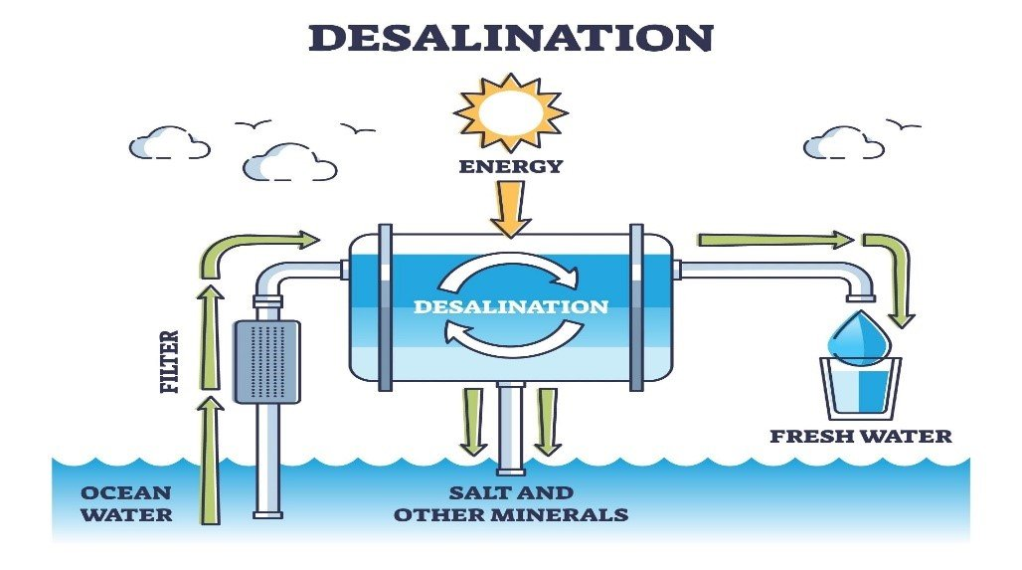

Fig. 1: Desalination process

Image Source:https://www.safewater.org/fact-sheets-1/2017/1/5/desalination

Desalination is the technique to extract salts and minerals from saline water to produce desalinated water suitable for human consumption or irrigation. The by-product of the desalination process is brine or concentrate (Fig. 1). It was earliest invented by Thomas Jefferson in the year 1791. Typically, sea water and brackish water both are purified using desalination. NaSO4, NaCl, MgCl2, LiCl, and MgSO4 are among the salts that are eliminated during the desalination process.

Broadly, desalination methods can be divided into thermal-based (e.g., multistage flash distillation)and membrane-based (e.g., reverse osmosis). Desalination techniques that have been in use for a very long period have been established using three traditional criteria: thermal, electrical, and pressure.

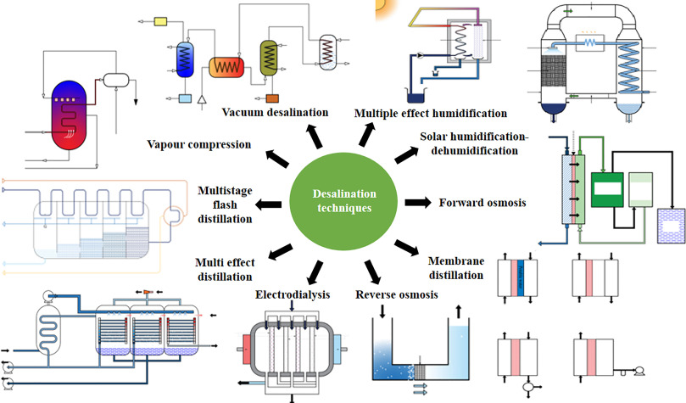

Fig. 2: Different types desalination techniques

Image source: Bhoj, et al. 2021: Recent advancements in practices related to desalination by means of nanotechnology,Chemical Physics Impact, 2, 100025, https://doi.org/10.1016/j.chphi.2021.100025

There are numerous desalination methods (Fig.2). The classic method is relied solely on large-scale thermal evaporation or distillation, which involves heating and then re-condensing seawater to remove salts and contaminants. Prior to the development of membrane technology, this strategy was primarily employed.The following one involves using electric current to remove salt. This strategy was primarily employed before the introduction of membrane technology, utilizing electric current to remove salt. A selectively permeable membrane is traversed by the ions as a result of the electric current, releasing salts along the way. Numerous natural contaminants, environmental tenacious pollutants and microorganisms can be removed using different membrane technologies. Additionally, membrane systems are more advantageous as they have reduced capital cost and energy requirements. But, thermal desalination systems stand out because they produce water with a lower salt content than membrane systems.

Another advanced technique is reverse osmosis, in which pressure and salt water are both transmitted transversely through a membrane. The pressure helps the water whip across the membrane, separating the salt in the process. The fundamental thermal, electrical, and pressure-placed processes outlined above have inspired a wide range of other processes. Each has merits and demerits but all are useful. Some of these techniques include:
- Solar Distillation
Solar desalination works on two scientific principles: evaporation of a saline water followed by condensation of the generated vapor. In conventional solar desalination units, solar irradiation penetrates the still through a transparent inclined condensing plate positioned over a feedwater basin filled with saline/brackish water.
Most solar stills are simple black bottomed vessels that house the distillation equipment. Radiation that strikes the basin is primarily absorbed by it. The transparent cover traps infrared electromagnetic waves that are emitted from the heated surface, raising the temperature inside the system. Saline/brackish water in feedwater basinevaporates, the water vapor is condensed onto a cool surface(Fig.3). Most pollutants do not evaporate, so they are left behind.
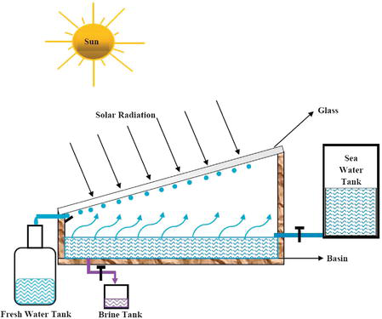
Fig. 3: Solar Distillation
(Image source:https://www.intechopen.com/chapters/61215)
2. Vacuum distillation
Distillation operated under reduced pressure or pressure below atmospheric pressure is known as Vacuum distillation. The vacuum desalination process causes the majority of the volatile liquid to evaporate by lowering the pressure above the liquid mixture to below its vapour pressure(Fig.4).
It is based on the principle that as pressure decrease, the boiling point of the compound also decrease or boiling occurs when vapor pressure of liquid exceeds ambient pressure. Vacuum desalinationis used with or without heating the liquid mixture. This is performed by lowering the pressures in the column or the reactor.

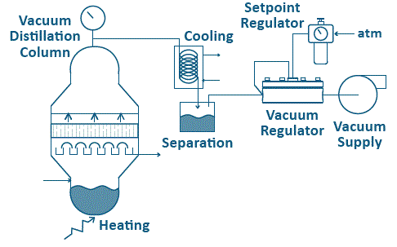
Fig.4: Vacuum distillation
Image source: https://www.equilibar.com/application/vacuum-distillation/

3.1 Multistage flash distillation (MSF)
3.Multistage flash distillation
It is the most frequent thermal desalination technology based on flashing process, producing distilled water from sea water. The water to be desalinated is heated at low pressure, which causes sudden, irreversible evaporation. This process is repeated in subsequent stages where the pressure decreases in accordance different conditions. In this process, preheated sea water is heated upto 90⁰- 120⁰ in brine heater under low pressure steam. Then, sucessively flashed in multiple stages comprising of countercurrent heat exchangersat decreasing pressure levels. The vaporsproduced ateach step each are condensed outside preheated condenser and collected as pure water (Fig. 5).
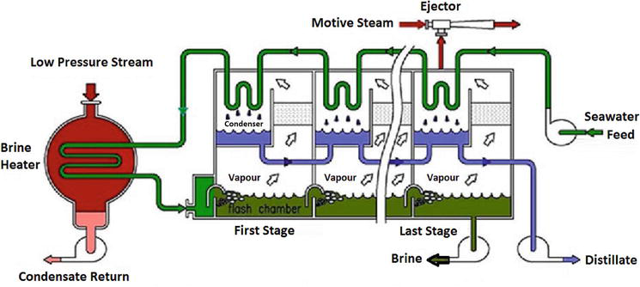

Fig. 5.Multistage flash distillation

(Image source: https://www.barc.gov.in/div/57_237_t403_406.pdf)

It is appropriate for waters with high salinities, higher temperatures and more pollutants. The high energy consumption of MSF plants is a key drawback.

4. Multiple-effect distillation (MED)
In multiple-effect distillation the treated water is passed progressively through a number of evaporators (varies from 8 to 16 stages) in series. It works on the same principle (i.e., evaporation and condensation at reduced pressure) same as that of MSF. In each step same process repeats but with susequent lower temperatures and pressures. However, the design of the plant is different and it is thermodynamically more efficient method compared to MSF. (Fig.6)

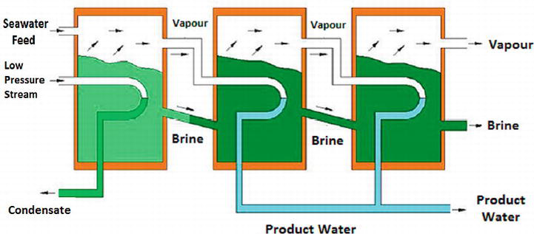
Fig. 6: Multiple-effect distillation
(Image source: https://www.intechopen.com/chapters/71348)

5. Vapor-compression (VCD)
In vapor-compression distillation technology, by reducing the pressure, the boiling point of saline water is lowered as with MSF and MED. The method is applied either alone or in conjunction with MED (Fig. 7). There are two methods of VCD: mechanical vapor-compression (MVC), which is usually electrically driven, or a thermal vapor-compression (TVC).
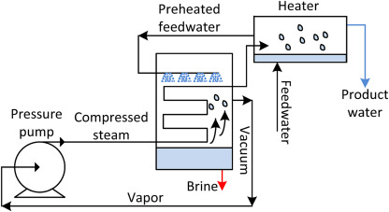
Fig. 7: Vapor-compression distillation (VCD)
(Image source: https://www.sciencedirect.com/topics/engineering/vapor-compression)

6. Electrodialysis and electrodialysis reversal (EDR)
Electrodialysis desalinationis electrically driven membraneprocess based on the principle of electrodialysis and works similarly to “ion exchange” treatment process.This technique employes both cation and anion selective membranes to separate charged ions (Fig.8).
In electrodialysis, suspended particulates with positive or negative electrical charges are deposited on the membrane surface, which significantly increases the membrane's resistance. However, this can be circumvented by switching the polarity of the applied electrical potential at predetermined intervals, which removes charged particles that have collected on the membranes. This technique is referred to as electrodialysis reversal (EDR

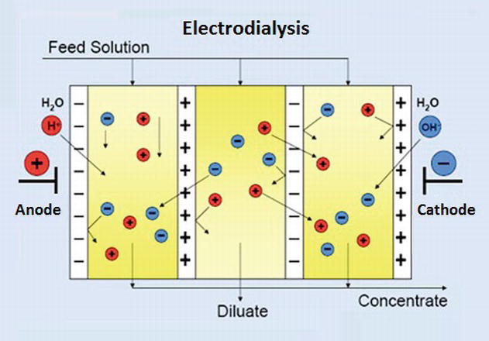

Fig.4:Electrodialysis and electrodialysis reversal
(Image source: https://www.intechopen.com/chapters/71348)

7. Reverse osmosis (RO)
The key technology in the desalination process is Reverse Osmosis. It is a purification process that works on the principle of osmosis and requires a selective pressure-driven partiallypermeable membrane to separate impurities by pushing water under pressure. Reverse osmosis is able to filter salts, small particles, dissolved organic matter, proteins, carbohydrates, dyes, bacteria, and majority of other contaminants.
Osmosis is used to separate two solvents, from region of low solute concentration to the high solute concentration. However, in the reverse osmosis , external pressure greater than the osmotic pressure applied to the saline water that cause the solutes (salts) to hold back on pressured side while allowing pure solvent (freshwater) to pass to the other side. Hence, by applying an external pressure on the higher concentration side, the flow could be stopped or reversed, the phenomenon is called “reverse osmosis.”(Fig.9)
Firstly, organic impurities such as oil, seaweed, rubbish etc. were removed from seawater, then it is subjected to reverse osmosis. Following filtering, two streams are obtained: one is reject stream or brine and the other is permeate or freshwater. The reject stream is introduced to dilution to reduce salt concentrations before disposal and he freshwater undergoes through a remineralization and chlorination process before consumption.
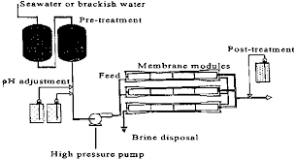
Fig. 9: Reverse Osmosis (Image source:https://www.oas.org/DSD/publications/Unit/oea59e/ch20.htm)

8. Nanofiltration (NF)
Nanofiltration is a membrane based filtration method. NF membranes have distinct nanometer-sized pores and properties in between reverse osmosis (RO) and ultrafiltration (UF) membranes. The nanofiltration (NF) membrane allows particles smaller than 10 nanometers pass through the membrane with operating pressures between 5 and 40 bars. It is frequently is used to treat solutions that contain organic molecules, sugars, and multivalent anion salts. Typically, polymers such as polyethylene terephthalate, poly-ether-sulfones, aromatic poly(acrylonitrile), polyamides, and poly(phenylene oxide), metals such as aluminum as well as other modifications of these, are used to create the membranes. Typically there are two types of NF membranes, charged and non-charged nanofiltration membrane. Charged nanofiltration membrane discards negative charged ions, such as phosphate or sulfate according to membrane charge and membrane fouling mechanism. On the other hand, non-charged nanofiltration membrane discards dissolved matter and uncharged ions based on the shape and size of the molecule (Fig. 10).

. 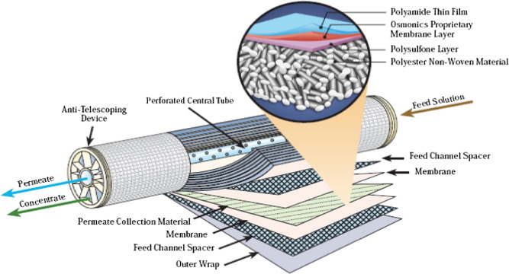
Fig. 10: Nanofilteration
Image Source Mona A. Abdel-Fatah. 2018Nanofiltration systems and applications in wastewater treatment: Review article, Ain Shams Engineering Journal, 9(4): 3077-3092,https://doi.org/10.1016/j.asej.2018.08.001)

9. Membrane distillation
Membrane distillation works on the principle of thermally driven separation based on phase change i.e partial vapour pressure difference. The separation is brought by differential temperature. Membrane distillation is a amalgam of distillation and RO technique that uses a synthetic hydrophobic membrane (acting as a barrier for the liquid phase) to allow water vapour to diffuse over the membrane pores and prevent the solution from passing through. With the help of membrane distillation, water from a brine solution is turned into vapour, which is then condensed into clear condensate on the cooled side of the membrane (Fig. 11).
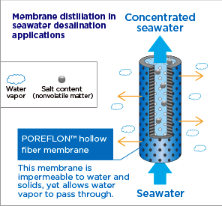
Fig. 11:Membrane distillation (Image Source: https://sumitomoelectric.com/id/topics/2021/09/002)
10. Forward osmosis(FO)
Forward osmosis is a relatively new industrial technique. It is an energy-efficient technology and extremely effective purification process that removes salt from seawater by driving a salt concentration gradient (osmotic pressure) through a semipermeable membrane. In other words FO based on simple principle of osmotic pressure, transporting water through the membrane and retaining all the dissolved solutes. Due to the transport of water across membrane concentrated effluent is created, the resultant solution becomes diluted, and the feed solution concentrated (Fig. 12).
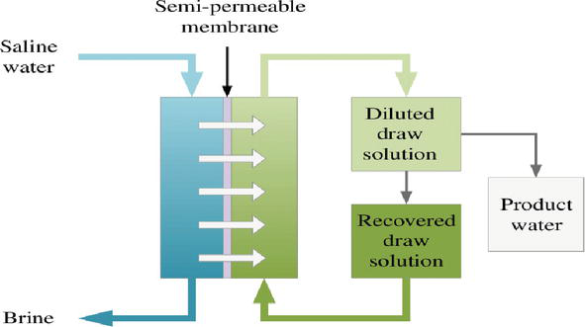
Fig. 12.Forward osmosis.
(Image Source: Jiaoet al. 2015. Osmosis and Its Applications. 10.1007/978-1-4614-5491-5_1741)

11. Adsorption desalination (AD)
Adsorption is advanced desalination method that may eventually replace of the existing thermally activated and membrane-based desalination systems. Beacause to its comparatively low cost, low energy requirements, excellent salt removal efficiency, and minimal environmental impact, adsorption is a promising desalination technique.
To assist and reject latent heat of evaporation, a silica gel adsorbent (desiccant) is utilised as a medium between an evaporator and a condenser ((Fig.13)). The silica gel is packed into beds and stacked around tubes where it can be cooled for adsorption or heated for desorption by water. The process temperature is within a range of 20°C and 85°C for the beds and condenser, respectively. To keep the feedwater temperature constant, the evaporator needs a heat source.

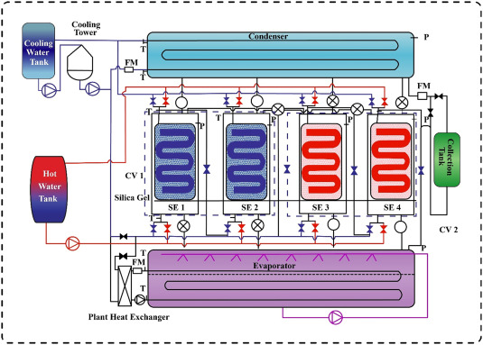
Fig.13: Adsorption desalination
(Image Source: https://www.sciencedirect.com/science/article/abs/pii/S0735193321004875)

12. Membrane Pervaporation
Membrane pervaporation is one of the effective membrane based separation process used to segregate two or more components (volatile compounds out of solutions) across a selective membrane employing differential rates of diffusion. An energy-efficient combination of permeation and evaporation is the foundation of this process. The downstream side of the membrane is provided with a vaccum while the upstream side of the membrane is with ambient pressure. The upstream side is in contact with the feed liquid that permits the evaporation as a result permeant vaporises and is obtained as vapour . Pervaporation can also be used to dehydrate organic solutions and remove organic impurities from aqueous solutions (Fig. 14).
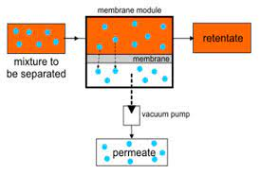
Fig.14: Membrane Pervaporation
(Image Source: Manshad et al. 2016. Membranes with Favorable Chemical Materials for Pervaporation Process: A Review Soheila Manshad et al. J. of membrane science and technology,6:4)
Summary
The World Health Organisation (WHO) recommendations state that the admissible amount of salt that can be ranges upto 500 parts per million (ppm) in consumable waters, with a special exception of 1000 ppm. Most of the water on Earth has a salinity of up to 10,000 ppm, while seawater typically has a salinity of between 35,000 and 45,000 ppm of total dissolved salts. With increasing population, drinking water of acceptable quality has become a scarce commodity. Therefore, desalination of seawater is an emergent technique facilitating fresh water for numerous communities specially which are residing in arid areas or near to saline water but still in critical scarcity of pure water. It is also conspicuous technology for the industrial sectors that are essential to socio-economic development in a number of developing nations.
However, the desalination plants run on fossil fuels, they are not cost effective, and the environmental pollution they generate is becoming more and more detrimental to the planet. Furthermore, even close to a coast where there is an abundance of seawater, such plants are not commercially feasible. In many of these places, there is frequently a lack of fossil fuels as well as insufficient power supply. But in remote areas, typical basin solar stills with a relatively large footprint is viable and simple technology of producing fresh water from salt water.

