Editor ID: IIPER1680083527
Green Synthesis of Silver Nanoparticles from Psidium guajava Leaf Extract and application
Anjali Dasari¹, Srikanth Rachakonda², Veluru Sridevi³,Husam Talib Hamzah⁴
¹Assistant Professor, Department of Chemical Engineering, ANITS, Sangivalasa, India.
² Professor, Department of Chemical Engineering, ANITS, Sangivalasa, India.
³Department of Chemical Engineering, AU College of Engineering, Andhra University, Visakhapatnam, India.
⁴Department of Chemical Engineering, AU College of Engineering, Andhra University, Visakhapatnam, India.

- Introduction
1.1Nanoparticles
Nanotechnology is an emerging and rapidly growing field that finds application in science and technology, primarily focused on manufacturing materials at the nanoscale level (Anjali et al., 2019). Nanoparticles, which are clusters of atoms within the size range of 1-100 nm, lie at the heart of this field. At the nanoscale, materials exhibit novel and enhanced properties that significantly differ from both individual atoms/molecules and bulk materials. These distinctive properties are a direct result of the limited size of their constituent components. Nanoparticles possess characteristics entirely distinct from those of conventional macroscopic materials, making them invaluable in a diverse range of industries. Nanotechnology's applications span across engineering, medicine, pharmaceuticals, food and beverages, agriculture, and more. A key advantage of nanoparticles lies in their high surface-to-volume ratio compared to bulk materials. In nanomaterials, a greater percentage of atoms reside on the surface, resulting in a significantly expanded specific surface area. Consequently, particle size distribution and shape assume pivotal roles in determining the properties of nanomaterials. The exceptional properties of nanoparticles have fueled their widespread adoption across various sectors, including food production, fertilizers, medical advancements, biotechnology, and numerous engineering disciplines. Among metallic nanoparticles, silver nanoparticles (AgNPs) have garnered substantial research attention owing to their diverse range of applications. AgNPs exhibit several characteristics that render them invaluable in scientific research, medical treatments, agricultural practices, and catalytic processes. Notably, silver nanoparticles demonstrate remarkable antimicrobial efficacy against bacteria, viruses, and other eukaryotic microorganisms. However, the extensive use of nanoparticles has raised environmental concerns. Therefore, a crucial aspect of nanotechnology involves the development of clean, nontoxic, and environmentally friendly "green chemistry" procedures. These procedures encompass a wide spectrum of organisms, ranging from bacteria and fungi to even plants, to mitigate the potential adverse environmental impacts. In the production of silver nanoparticles, a primary precursor employed is a silver nitrate solution. This solution is prepared through the reaction of silver, such as silver bullion or silver foil, with nitric acid. The resulting process yields silver nitrate, water, and various oxides of nitrogen as byproducts, with the specific byproducts being contingent upon the concentration of nitric acid used.
3Ag + 4 HNO₃ (cold and diluted) 3 AgNO₃ + 2 H₂O + NO (1)
Ag + 4 HNO₃ (hot and concentrated) AgNO₃+ H2O + NO₂ (2)
1.2 Sources of silver recovery
Silver, a precious and noble metal, holds immense significance in various human applications. Its demand continues to rise in tandem with the progress of industrialized societies. Regrettably, global reserves of high-grade silver ores are diminishing. Nevertheless, substantial deposits of low and lean-grade silver ores remain largely untapped (Syed, 2016). The worldwide appetite for silver has seen a consistent upsurge, driven by the increasing use of electronic and electrical equipment (EEE) (Vats and Singh, 2015; Cayumil et al., 2015). As these industries flourish, there has been a concerted effort to explore methods for silver recovery. This is imperative because the current market demand presents a pressing challenge for efficiently and environmentally responsibly extracting silver from spent sources (Goosey, 2003). The quest for silver recovery holds immense importance from both environmental and economic standpoints (Lee et al., 2005; Park and Fray, 2009). Secondary silver has been successfully reclaimed from diverse waste sources, such as the photographic industry, solar cell sector, anode slime, and electronic waste (Birloaga and Vegliò, 2018; Syed, 2016; Xing and Lee, 2019). Numerous techniques, including cementation, chemical precipitation, adsorption, biosorption, electro-coagulation, electro-winning, ion exchange, and solvent extraction, have proven to be cost-effective methods for recovering and extracting silver from various silver-containing sources (Syed, 2016). Photographic industries, in particular, generate substantial amounts of waste containing precious metals like silver, found in spent effluents and discarded radiographic films (Khunprasert et al., 2008). Silver halide, used for coating polyester sheets in X-ray and photographic film, contains an average of 15% silver (Khunprasert et al., 2008). These waste films serve as a valuable source of silver, which can be repurposed for various applications, including light-sensitive materials. Over an extended period, numerous studies have been conducted to recover precious silver from photographic waste, considering both environmental and economic considerations
There are several methods for recovering silver from waste X-ray films, primarily classified into three categories: direct burning of the films, oxidation of metallic silver followed by electrolysis, and stripping the gelatine-silver layer using various solutions. Among these methods, the second and third approaches have gained more widespread use than the first. Typically, silver recovery from X-ray films involves a two-step process. The first step is dedicated to stripping the silver from the film, and the second step focuses on recovering the stripped silver through either smelting or electrolysis. In many cases, the initial step involves leaching, which can take the form of either microbiological or chemical processes. However, the use of chemical reagents like sodium cyanide in leaching raises environmental concerns. On the other hand, microbiological processes are known to be relatively slow.An alternative and more environmentally friendly approach is plant-mediated green synthesis for the production of nanoparticles. Plants serve as excellent sources for this purpose because they are free from toxic chemicals, and they readily provide natural capping agents. Plants offer a wide range of metabolites that can effectively assist in reducing silver ions, and they tend to be faster than microbes in the synthesis process. Many studies have explored the synthesis of silver nanoparticles using broths derived from boiling fresh plant leaves. This method holds promise as a greener and more efficient alternative for silver nanoparticle synthesis.

1.3 Silver Recovery from X-ray Sheets
Silver recovery from X-ray and motion picture films presents a valuable opportunity, as these applications often contain a substantial amount of silver, comprising as much as 30-40% of the emulsion weight. Typically, one kilogram of developed X-ray film can yield between 14-17 grams of silver. In the hydrometallurgical process, the film undergoes shredding and treatment with various reagents such as sodium hypochlorite, sodium hydroxide, or sodium carbonate. This treatment liberates metallic silver from the emulsion. The resulting silver sludge is then subjected to a series of steps, including filtration, washing, drying, and dissolution in nitric acid or melting with fluxes. However, the pyrometallurgical methods, such as burning films, are not always satisfactory for silver recovery from photographic films. These techniques often yield lower results depending on the treatment system. In one method, silver is recovered from used photographic film by burning it and dissolving the silver present in the ashes with nitric acid. The resultant silver is then precipitated using sodium chloride, and the precipitate is subsequently filtered. Notably, X-ray film contains a considerable amount of silver compared to other types of film. Even used X-ray film retains a significant quantity of fine silver particles, typically ranging from 1.5 to 2.0% by weight in its emulsion layers. Therefore, recycling and reusing silver recovered from used X-ray film are practical endeavors. On a global scale, a considerable amount of silver remains unrecovered or unrecycled, primarily due to the cost-ineffectiveness of many existing methods. In industrial settings, there has been growing interest in the production of certain metals through cementation reactions due to their inherent simplicity.
To address these challenges and promote a cost-effective, environmentally friendly approach, the present study has explored innovative methods for silver recovery and recycling.
- Production of silver nitrate solution from Photographic sheets
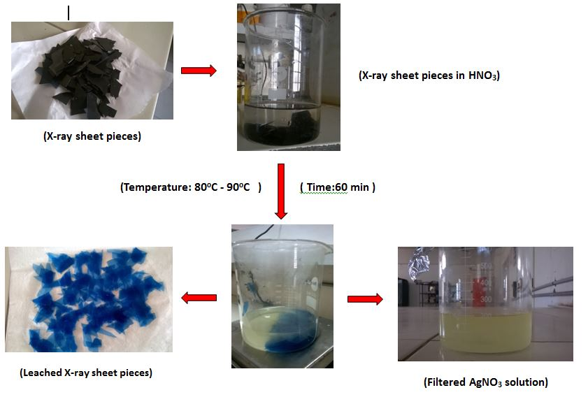
Waste photographic (X-ray) films, containing approximately 1.5% silver, were gathered from a local hospital in Visakhapatnam and subjected to a meticulous recovery process. Initially, these photographic films, sized at 297×420 mm, were carefully cut into smaller pieces measuring 50 × 50 mm. These smaller film sections were subsequently placed within a borosilicate beaker. To commence the silver recovery process, 15 grams of the waste films were dissolved in a solution consisting of 250 mL of 1M HNO₃, while being kept in a water bath for an hour at a controlled temperature range of 80°C to 90°C. The solution underwent continuous agitation at a rate of 300 rpm, with precise temperature control. Following this step, any excess water content was evaporated, and the optimal dissolution parameters were firmly established. This experiment was conducted within a fume cupboard to ensure safety. During the dissolution reaction, nitrogen oxide gases were generated, but these were effectively neutralized using the fume cupboard's washing unit before being safely released into the atmosphere.One notable challenge during this process was the extended leaching time due to the voluminous nature of the films, which often caused them to adhere together, making acid interaction more challenging. Once the silver had successfully dissolved in the nitric acid solution, the concentrations present in the resulting solutions were accurately measured through titration, using a 0.001M NaCl solution. The resultant solution was a 0.001M AgNO₃ solution, albeit with some excess HNO₃.To prepare the recovered AgNO₃ solution for further use, the excess HNO₃ was neutralized either using 1M NaOH or Na₂CO₃ solutions. This carefully processed 0.001M silver nitrate solution was then stored in a sterile environment at room temperature, ready for subsequent applications. The recovered AgNO₃ was further utilized in the synthesis of silver nanoparticles using a plant-mediated solution. This environmentally friendly approach harnessed the unique properties of plants and their metabolites to facilitate the formation of silver nanoparticles, opening up potential applications in various fields.

Figure 1. Efficient Silver Nitrate Solution Production from Photographic Films: A Step-by-Step Flowchart

- Plant Mediated Synthesis of Metal Nanoparticles
3.1 Green synthesis of silver nanoparticles
The development of biologically inspired processes for nanoparticle synthesis has become a pivotal branch within the realm of nanotechnology. Utilizing environmentally friendly materials like plant leaf extracts (Sasikala et al., 2012), bacteria (Saifuddin et al., 2009), fungi (Bhainsa and D’souza et al., 2006), and enzymes (Willner et al., 2007) for the synthesis of silver nanoparticles brings forth a multitude of advantages in terms of eco-friendliness and compatibility for pharmaceutical and other biochemical applications. Notably, these methods steer clear of toxic chemicals in their synthesis protocols. In the case of biosynthesis of silver nanoparticles using Calotropis gigantean leaf extract, the formation of silver nanoparticles has been meticulously observed at various time intervals. The resulting nanoparticles exhibited an absorption peak at 420nm, with sizes ranging from 83.7nm to 11.8nm (Backer et al., 2005; Elumalani et al., 2010). Furthermore, research has underscored the antibacterial and antioxidant properties of these silver nanoparticles. Similarly, silver nanoparticles synthesized from the leaf extract of Azhadiracta serve as both reducing and capping agents, displaying a peak at 351nm and an average size of 21.07nm (Begum et al., 2009). The leaf extract has also shown potent antioxidant activity, as evidenced by DPPH assay and hydrogen peroxide assay results (Raut Rajesh et al., 2009). Another study delved into the photosynthesis of silver nanoparticles using Gliricidia sepium. When the leaf broth was exposed to an aqueous AgNO3 solution, a noticeable color change occurred, shifting from yellowish-green to brown. The entire reaction mixture eventually turned brown after 12 hours of reaction time, with an absorbance peak around 440nm and particle sizes ranging from 10-50nm (Vikas et al., 2014). Furthermore, research efforts have focused on optimizing the biosynthesis of silver nanoparticles from Psidium guajava leaf extract and evaluating their antimicrobial activity against human pathogenic bacteria. Various parameters such as silver precursor concentration, reducing agent, pH, temperature, and synthesis duration were examined, resulting in strong absorption at 440nm and nanoparticle sizes ranging from 5-50nm (Raut Rajesh et al., 2009). Overall, plant-mediated synthesis methods are proving to be cost-effective, eco-friendly, and straightforward alternatives to conventional physical and chemical approaches for silver nanoparticle synthesis. These green synthesis methods hold promise for a wide range of applications in various fields.
Leela and Vivekandan (2008) directed their attention towards harnessing previously untapped resources for the synthesis of silver nanoparticles. They explored the bio-reduction capabilities of various plant leaf extracts, including Helianthus cannus (Asteraceae), Basella alba (Basellaceae), oryza sativa, Saccharum officinarum, Sorghum bicolor, and Zea mays (Poaceae). Among these, H. annus exhibited remarkable potential for rapidly reducing silver ions, leading to the formation of silver nanoparticles. These nanoparticles displayed a peak absorbance at 400-420 nm and sizes ranging from 139 to 595 nm.
Seema (2012) discovered that an aqueous solution of AgNO3, when combined with black pepper (Piper nigrum) corn extract and aided by microwave irradiation, efficiently reduced most of the silver ions into silver nanoparticles within a mere 120 seconds of reaction time. These nanoparticles took on a spherical shape and exhibited sizes ranging from 5 to 50 nm. Euphorbia hirta, a plant with shade-dried leaves, was employed by Elumalai et al. (2010) to yield silver nanoparticles with sizes ranging from 40 nm to 50 nm through an aqueous extract. In a different approach, Dattu et al. (2014) explored the extracellular biosynthesis of silver nanoparticles using an endophytic fungus, Penicillium, isolated from healthy leaves of Curcuma longa (turmeric). They evaluated the antimicrobial activity of these nanoparticles against MDR E. coli and S. aureus. The study involved parametric optimization, resulting in maximum absorbance at 420-425 nm under pH 7, at 25°C, using 1M AgNO3 concentration with wet biomass. The size of the silver nanoparticles ranged between 25 to 30 nm. Sohail et al. (2013) delved into the biosynthesis of silver nanoparticles using bamboo leaves extract.
Collectively, the literature review underscores the promise of plant-mediated green synthesis techniques as a valuable route for nanoparticle production. In this present study, Psidium guajava leaves have been selected as the source for producing silver nanoparticles from the extracted silver.

3.2 Preparation of Leaf Extract:
Matured Psidium guajava leaves were gathered from the ANITS college campus in Sangivalasa and subsequently cleaned by washing with tap and distilled water before being air-dried at room temperature. To create the leaf extract, 30 grams of these dried leaves were combined with 300 milliliters of distilled water and boiled gently in an Erlenmeyer flask for 20-30 minutes at a temperature ranging from 50°C to 60°C. After boiling, the leaf extract was carefully filtered to eliminate any solid residues, and the resulting solution was stored at 4°C for future use, ensuring its preservation and stability. This extract can be employed for various applications, including the synthesis of silver nanoparticles or other research endeavors.
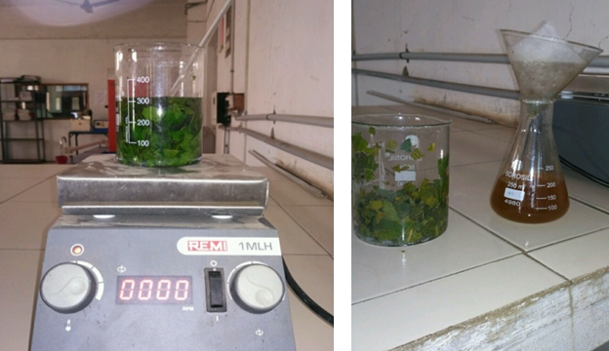

Figure 2. Leaf Extract Preparation: A Step-by-Step Guide
3.3 Synthesis of silver nanoparticles
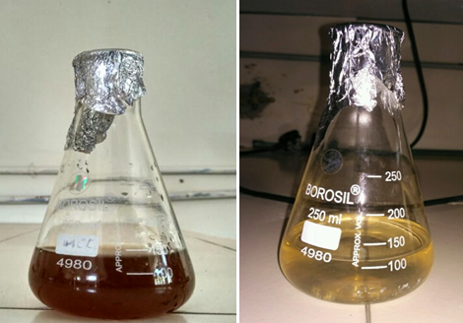
In the process of converting extracted metallic silver into silver nanoparticles, an aqueous solution of AgNO3 is mixed with Psidium guajava leaf extract within a 250 mL Erlenmeyer flask. This mixture is then incubated at a controlled temperature. Over time, a noticeable transformation occurs, with the solution changing its color from brown to light yellow, signaling the successful synthesis of nanoparticles. To separate the silver nanoparticles from the supernatant liquid, the resulting brown solution is subjected to centrifugation at speeds ranging from 6000 to 15000 rpm. The supernatant liquid that remains is further processed by undergoing an additional round of centrifugation to ensure the complete separation of the remaining silver nanoparticles (AgNPs). The obtained nanoparticles are carefully washed with ethanol to remove any residual impurities and then subjected to drying in a hot air oven. Throughout this process, a series of experiments are conducted by systematically varying the concentrations of both the AgNO3 solution and the Psidium guajava leaf extract. These experiments aim to determine the optimal conditions for the efficient production of silver nanoparticles.

Figures 3: Formation of Nanoparticles: The Nanoscale Particle Generation Process
  - The Impact of Process Parameters
    - The Influence of Leaf Extract Concentration and Silver Nitrate Solution Ratio on Silver Nanoparticle Synthesis:
The transformation of metallic silver into nanoparticles is contingent upon several critical process variables, including the ratio of leaf extract concentration to silver nitrate, pH levels, reaction time, temperature, and stirring. These variables exert a significant influence on the conversion of metallic silver into silver nanoparticles. To assess the impact of leaf extract and silver nitrate concentrations, UV-VIS spectroscopy was employed. Various concentration ratios of leaf extracts and silver nitrate solutions were examined for their effects on silver nanoparticle (AgNP) synthesis. Notably, a solution comprising 5 mL of plant extract and 1 mL of silver nitrate displayed a distinct and favorable absorption peak at 390 nm, as illustrated in Figure 4, demonstrating the correlation between the ratio of leaf extract concentration to silver nitrate solution and the synthesis of silver nanoparticles.

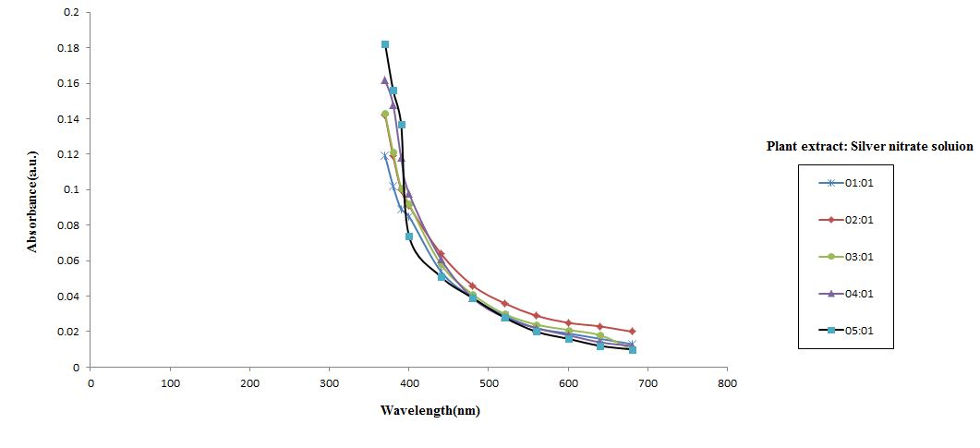

Figure 4. The impact of the Leaf Extract Concentration to Silver Nitrate Solution Ratio on the Synthesis of Silver Nanoparticles

The obtained results have been compared with standard graphs representing commercial silver nanoparticles. Upon analyzing Figure 5, which depicts the absorbance versus wavelength plot, it becomes evident that the synthesized silver nanoparticles fall within the range of commercial silver nanoparticles.

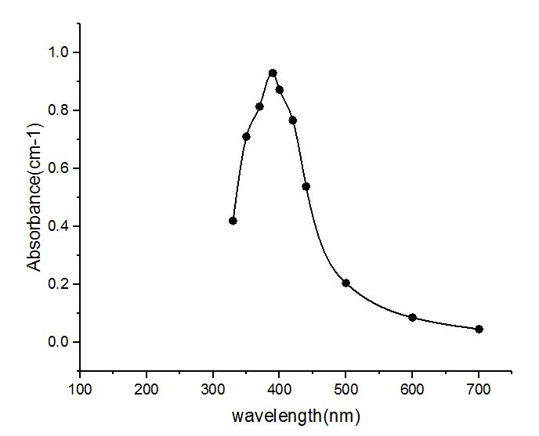

Figure 5. UV-Visible Absorption Spectra: Graphs of Absorbance vs. Wavelength
    - The Impact of pH on the Synthesis of Silver Nanoparticles:
The influence of pH on the biosynthesis of silver nanoparticles (AgNPs) was systematically examined by employing a range of pH levels, including 1, 3, 5, 7, 9, 11, and 14. To maintain these pH levels, solutions of 0.1N HNO3 and 0.1N NaOH were used. The resulting solutions were analyzed by measuring their absorbance using UV-VIS spectroscopy. pH emerged as a pivotal factor significantly affecting the formation of silver nanoparticles through biosynthesis. Figure 5 illustrates the pronounced impact of pH on AgNPs formation. The pivotal role of pH lies in its ability to alter the electrical charges of biomolecules, thereby influencing their capping and stabilizing capacities and, consequently, the growth of nanoparticles. Notably, it was anticipated that particle size would be larger in an acidic medium compared to a basic one. Figure 6 reveals an absence of peaks within the pH range of 1, 3, and 5, suggesting that an acidic medium is unfavorable for AgNPs biosynthesis. Conversely, Figure 6 demonstrates an increase in peak intensity at alkaline pH levels of 9, 11, and 14, signifying an enhanced formation of silver nanoparticles in basic environments.
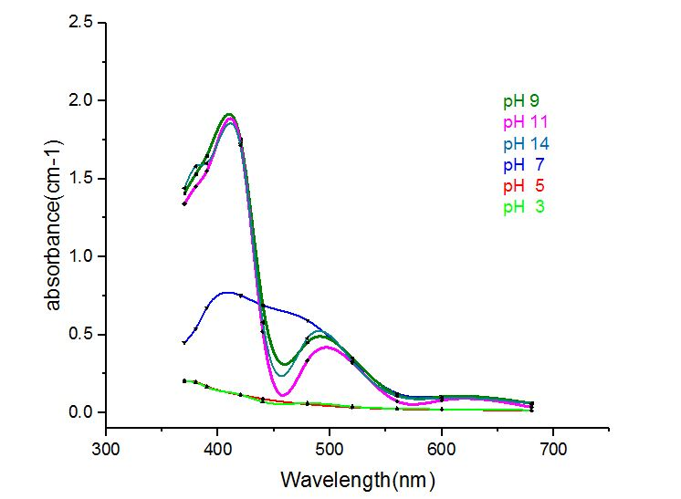

Figure 6 The impact of p^{H} on synthesis of silver Nanoparticles
    - The Influence of Time on the Synthesis Reaction
The impact of time on the synthesis reaction was investigated by conducting the experiment over various time intervals, ranging from 0 minutes to 120 minutes. The resulting solutions were subjected to UV-VIS spectroscopy for absorbance measurements. It was observed that the absorption increased progressively as a function of reaction time, with the highest absorption recorded at 24 hours of incubation (as depicted in Figure 7). Subsequently, UV-Vis spectra recorded after the 24-hour mark indicated no further increase in absorption, confirming the completion of the reaction within this time frame. Figure 7 visually illustrates the effect of reaction time on the formation of silver nanoparticles through plant-mediated synthesis
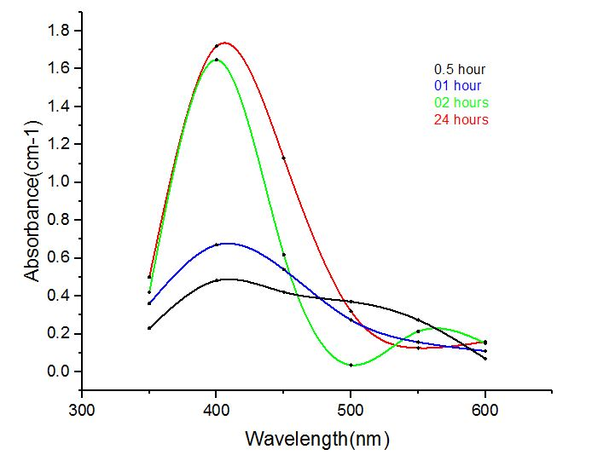
Figure7. The impact of time on synthesis of silver nanoparticles
3.4.4 The Influence of Temperature on synthesis of silver nano particles:
The reaction temperature exerts a substantial influence on the production of silver nanoparticles through plant-mediated biosynthesis. This impact on the reaction was investigated by conducting incubations at different temperatures, specifically at 30°C, 40°C, and 50°C. Notably, as the temperature decreased, the rate of silver nanoparticle formation increased. However, beyond a certain point (30°C), further temperature increases led to a decrease in absorption. Figure 8 visually illustrates the effect of temperature on the formation of silver nanoparticles.
3.4.5 The Influence of Mixing on the Synthesis of Silver Nanoparticles:
Experiments were carried out to investigate the impact of mixing on the production of silver nanoparticles through plant-mediated synthesis. Figure 9 provides visual evidence that mixing enhances the growth of nanoparticles, with an increase in absorption observed as the reaction mixture undergoes stirring or mixing. This figure vividly portrays the effect of mixing on the formation of silver nanoparticles through plant-mediated synthesis.

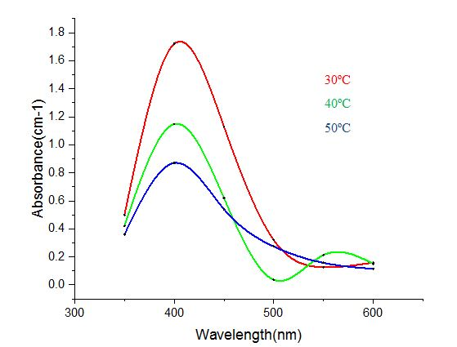
Figure 8. The impact of temperature on the synthesis of silver nanoparticles.

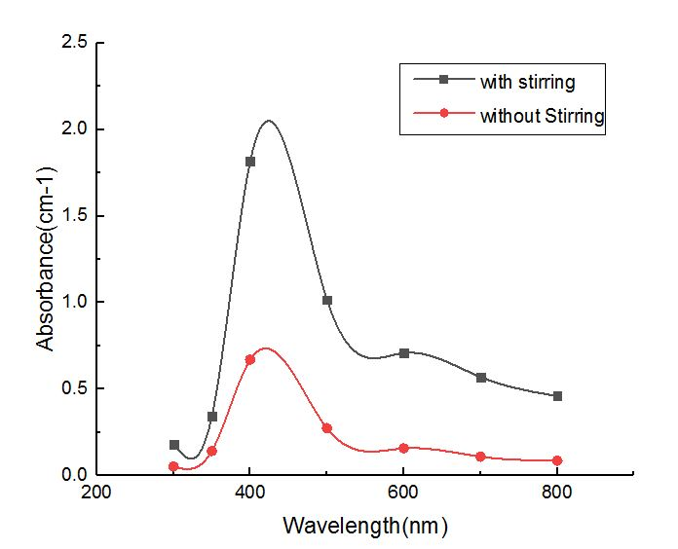
Figure 9. The impact of mixing on the the synthesis of silver nanoparticles.
- Characterization of Synthesized Silver nanoparticles
Under optimized conditions for enhanced silver nanoparticle production via plant-mediated synthesis, a series of experiments were conducted. The silver nanoparticles obtained through this process were subsequently subjected to characterization using Scanning Electron Microscopy (SEM) and Transmission Electron Microscopy (TEM). These characterization techniques were employed to ascertain the morphological characteristics and size of the particles.
The SEM analysis yielded images displaying the distinctive features of rapidly biologically synthesized silver nanoparticles, although the exact shape of these nanoparticles was not definitively determined. Figure 10 presents the SEM photographs of the silver nanoparticles synthesized through the mediation of Psidium guajava plants.
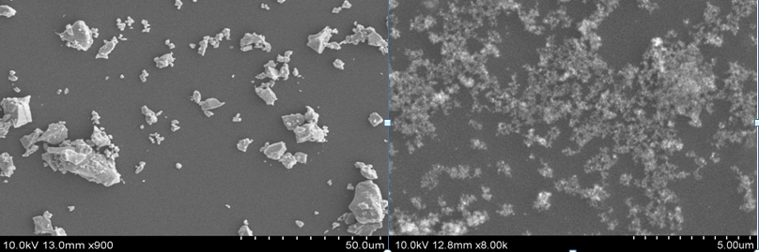

Figure10. Exploring the Morphological Features of Silver Nanoparticles through SEM Analysis
In contrast, Figure 11 presents TEM images of the synthesized silver nanoparticles, providing a more precise depiction of their shape. Additionally, Figure 11 confirms that the obtained nanoparticles fall within the nanometer size range.
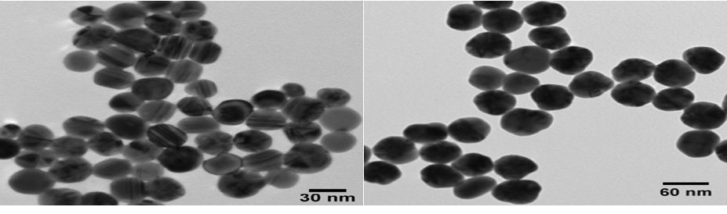

Figure 11. Nanoscale Structure of Silver Nanoparticles through TEM Imaging
4.1 Assessing the Antimicrobial Efficacy:
To evaluate the antimicrobial efficacy of the synthesized silver nanoparticles, the agar well diffusion method was employed against pathogenic bacteria sourced from the National Collection of Industrial Microorganisms (NCIM) in Pune, India. Specifically, the antimicrobial activity was tested against E. coli bacteria. This assessment involved allowing the synthesized silver nanoparticles to diffuse into the growth medium and interact with freshly seeded microbial cultures, with the diameter of the inhibition zone measured in millimeters.
The growth medium was prepared by dissolving 28 grams of commercially available nutrient Agar medium and 5 grams of Agar powder in 1000 milliliters of distilled water. Afterward, the medium was autoclaved at 15 lbs pressure and 121°C for 15 minutes, thoroughly mixed, and poured into 100 mm petri plates (25-30 ml per plate) while still in a molten state. These petri plates, each containing 20 ml of Nutrient Agar medium, were then seeded with 24-hour cultures of microbial strains. Wells were cut into the agar, and 20 μl of the biosynthesized silver nanoparticles were added to each well. The plates were subsequently incubated at 37°C for 24 hours. The assessment of antimicrobial activity was conducted by measuring the diameter of the inhibition zone formed around each well.
The synthesized silver nanoparticles exhibited significant antimicrobial activity against the gram-positive bacterium E. coli. The resulting zones of inhibition displayed uniform circular patterns due to the confluent growth on the agar surface. Figure 12 illustrates the antimicrobial activity of the biosynthesized silver nanoparticles. Notably, the silver nanoparticles exhibited the highest antimicrobial activity against E. coli, with an average inhibition zone ranging from 20 to 30 millimeters. This antimicrobial effect is attributed to the silver nanoparticles' ability to increase cell membrane permeability, ultimately leading to cell death (Baker et al., 2005; Shahverdi et al., 2007).
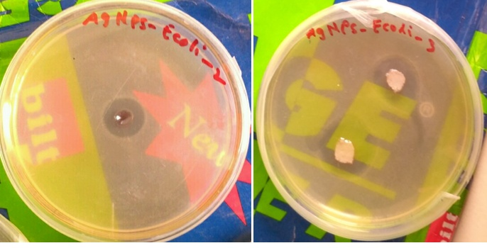

Figure 12. Assessment of the Antimicrobial Efficacy of Biosynthesized Silver Nanoparticles
- Conclusion
In this study, aimed to establish a straightforward and swift method for synthesizing silver nanoparticles using Psidium guajava leaf extract as a precursor, alongside AgNO3 solution. The AgNO3 solution was derived through the chemical treatment of exposed X-ray sheets with HNO3 and subsequently separated and stored for future applications. The precursor solution was prepared from Psidium guajava leaves, and it was mixed with the extracted AgNO3 solution in the required proportions, allowing the reaction to proceed. The resulting mixture was then subjected to ultra-centrifugation to isolate the silver nanoparticles, which were subsequently washed with ethanol and dried. These dried silver nanoparticles were stored at room temperature in Eppendorf tubes. Characterization of the biosynthesized silver nanoparticles was conducted through SEM, TEM, and UV-visible spectroscopy. The silver nanoparticles synthesized through this biological process exhibited a prominent absorbance peak within the range of 390-430nm. TEM analysis revealed that the size of these silver nanoparticles fell within the range of 30-60nm, consistent with commercial silver nanoparticles. Furthermore, the synthesized silver nanoparticles exhibited significant antimicrobial activity against the bacterial pathogen E. coli, as evaluated through the agar well diffusion method. Notably, the biosynthesized silver nanoparticles demonstrated the highest antimicrobial activity against E. coli, with an average inhibition zone ranging from 20 to 30mm.
References

[1] Anjali Dasari, Maheswari C, (2019). Production of agno₃ from x-ray sheets and plant mediated synthesis of silver Nanoparticles. J. of Eme. Tech. Innov. Res., 6, 487- 494.
[2] Baker C, Pradham A, Pakstis L, Pochan D.J, Shah S.I, (2005). Synthesis and antibacterial properties of silver nanoparticles. J. Nanosci. Nanotechnol, 5: 244-249.
[3] Bar H, Bhui D.K, Sahoo G.P, Sarkar P, De S.P and Misra A, (2009). Green synthesis of silver nanoparticles using latex of jatrophacuras. Colloids and surfaces. Physicochemical and Engineering Aspects,339(1): 134-139.
[4] Begum N.A, Mondal S, Basu S, Laskar R.A, and Mandal D, (2009). Biogenic synthesis of Au and Ag nanoparticles using aqueous solutions of Lack Tea leaf extracts. Colloids and Surfaces B:Biointerfaces, 71(1): 113-118.
[5] Begum N.A, Mondal S, Basu S, Laskar R.A, and Mandal D, (2009). Biogenic synthesis of Au and Ag nanoparticles using aqueous solutions of Lack Tea leaf extracts. Colloids and Surfaces B:Biointerfaces, 71(1): 113-118.
[6] Bhainsa K.C and D’Souza S.F (2006). Extracellular biosynthesis of silver nanoparticles using the fungus Aspergillusfumigatus. Colloids and Surfaces B: Biointerfaces, 47: 160-164.
[7] Bhattacharya D and Rajinder G, (2005). Nanotechnology ang potential of microorganisms. Crit Rev Biotechnol, 25: 199-204.
[8] Birloaga, I., Vegliò, F., 2018. Overview on hydrometallurgical procedures for silver recovery from various wastes. J. Environ. Chem. Eng. 6, 2932–2938.
[9] Dae-Young Lee , Claude Fortin, Peter G.C. Campbell., 2005. Contrasting effects of chloride on the toxicity of silver to two green algae, Pseudokirchneriellasubcapitata and Chlamydomonas reinhardtii. Aquatic Toxicology 75, 1127-135.
[10] Dattu Singh, VandanaRathod, ShivarajNinganagouda, jyothiHiremath, Ashishkumar Singh, and Jasmine Mathew, (2014). Optimization and Characterization of Silver Nanoparticle by Endophytic Fungi penicillium sp. Isolated from Curcuma longa(Turmeric) and Application Studies against MDR E. coliand S. aureus. Bioinorganic Chemistry and Applications, 408021:1-9.
[11] Elumalani E.K, Prasad T.N.V.K.V, Hemachandran j, ViviyanTherasa S, Thirumalai T, and David E, (2010). Extracellular synthesis of silver nanparicles using leaves of Euphorbia hirta and their antibacterial activities. J. Pharm. Sci. & Res, 2(9): 549-554.
[12] Elumalani E.K, Prasad T.N.V.K.V, Hemachandran j, ViviyanTherasa S, Thirumalai T, and David E, (2010). Extracellular synthesis of silver nanparicles using leaves of Euphorbia hirta and their antibacterial activities. J. Pharm. Sci. & Res, 2(9): 549-554.
[13] Goosey, M., Kellner, R., 2003. Recycling technologies for the treatment of end of life printed circuit boards (PCBs). Circuit World 29, 33–37.
[14] Khunprasert, P., Grisdanurak, N., Thaveesri, J., Danutra, V., Puttitavorn, W., 2008. Radiographic film waste management in Thailand and cleaner technology for silver leaching. J. Clean. Prod. 16, 28–36.
[15] Lalitha A, Subbaiya R, and Ponmurugan P, (2013). Green synthesis of silver nanoparticles from leaf extract Azhadirachtaindica and to study its anti-bacterial and antioxidant property. Int.J. Curr. Microbiol. App.Sci, 2(6): 228-235.
[16] Leela, A. and Vivekanandan, M. (2008) Tapping the Unexploited Plant Resources for the Synthesis of Silver Nanoparticles. African Journal of Biotechnology, 7, 31662-3165.
[17] M.C.Vatts and S.K.Singh., 2015. Assessment of gold and silver in assorted mobile phone printed circuit boards (PCBs). Waste Manag. 45, 280-288
[18] R. Cayumil, R. Khanna , R. Rajarao , P.S. Mukherjee , V. Sahajwalla, 2016. Concentration of precious metals during their recovery from electronic waste. Waste Manag. 57, 121-130.
[19] Sasikala, D., Govindaraju, K., Tamilselvan, K. and Singaravelu, G. (2012) Soyabean Protein: A Natural Source for the Production of Green Silver Nanoparticles. Biotechnology and Bioprocess Engineering, 17, 1176-1181.
[20] Seema Garg (2012) Rapid biogenic synthesis of silver nanoparticles using black pepper (Piper nigrum) corn extract. International Journal of Innovations in Biological and Chemical Sciences, 3: 5-10.
[21] Sohail Yasin a , Lin Liu a , Juming Yao b (2013) Biosynthesis of Silver Nanoparticles by Bamboo Leaves Extract and Their Antimicrobial Activity. Journal of Fiber Bioengineering and Informatics 6, 77–84.
[22] Syed, S., 2016. Silver recovery aqueous techniques from diverse sources: hydrometallurgy in recycling. Waste Manag. 50, 234–256.
[23] Xing, W.D., Lee, M.S., 2019. Development of a hydrometallurgical process for the recovery of gold and silver powders from anode slime containing copper, nickel, tin, and zinc. Gold Bull 52, 69–77.
[24] Young Jun Park, Derek J. Fray, 2009. Recovery of high purity precious metals from printed circuit boards. Journal of Hazardous Materials, 164, 1152-1158.

