Recent advancements in pharmaceutical applications for Nanophthalmos

Anshu*, Ashu Goel, Dr Neha Sharma, Dibazz Ahmad
IIMT College of Medical Sciences, IIMT University, O Pocket, Ganga Nagar, Meerut, Uttar Pradesh 250001.
Ashu Goel
School of Pharmacy, Bharat Institute of Technology Meerut, NH58 Bypass, Partapur Meerut.
Dr Neha Sharma
Department of Pharmaceutical Education & Research, South Campus, BPSMV, Sonipat.
Dibazz Ahmad
Mission College of Pharmacy, Siristi, Amouli, Bhagatua, Varanasi.
Correspondence Author: Anshu*
Email. Id: anshu.gujjar360@gmail.com
Mobile No: 7505973407

Abstract:
Anterior and posterior segment shortening that is proportionate to axial hyperopia is a feature of nanophthalmos. Angle-closure glaucoma, both acute and chronic, is more likely to develop as a result of this condition. Operative procedures for glaucoma and cataracts may involve complications. Identifying the nanophthalmic eye, pre-operative planning, and intraoperative management approaches can help in these difficult instances to reduce vision loss and facilitate successful surgery.

Introduction:
An uncommon congenital eye disorder called nanophthalmos is characterized by abnormally small eyeballs with normal interior eye components. From the Greek terms "Nanos" (dwarf) and "ophthalmos" (eye), the term "Nanophthalmos" is formed. People with Nanophthalmos have smaller-than-average eyes, which can present several optical and anatomical difficulties. It can affect both eyes and is present from birth. The eyes are typically half the size of a typical adult eye, measuring less than 20 mm in diameter (Sauer & Krishnan, 2022). There are several vision issues that nanophthalmos can bring on, including:
The most frequent vision issue connected to nanophthalmos is near-sightedness. Near-sighted people have trouble perceiving distant objects.
Cataracts: Another problem that individuals with nanophthalmos frequently encounter is cloudy lenses. Glare, impaired vision, and difficulty seeing at night are all effects of cataracts. (Elder, 1994).
Glaucoma is a severe eye disease that can harm the optic nerve and cause blindness. People who have nanophthalmos are more likely to develop glaucoma.
The retina, the light-sensitive tissue at the back of the eye, can tear away from the rear of the eye in a disease known as retinal detachment. A retinal tear may result in an abrupt, serious loss of vision (Slavotinek, 2011).
Nanophthalmos can be caused by several factors, including:
Genetics: Parents with nanophthalmos are frequently passed the condition on to their children.
Nanophthalmos can result from some illnesses, such as rubella, which can harm the eyes.
Trauma: An eye injury from a head injury or another type of trauma can also harm the eye and cause nanophthalmos.
Although there is no known treatment for nanophthalmos, there are steps that can be taken to enhance eyesight and avert problems. These remedies could consist of:

Near-sightedness and other visual issues related to nanophthalmos can be treated with eyeglasses or contact lenses. Surgery may be required to correct glaucoma, remove cataracts, or reconnect a detached retina.
A promising treatment for nanophthalmos is gene therapy. To fix the underlying genetic issue, gene therapy entails inserting a healthy copy of a gene into the eye. This method may be used to treat nanophthalmos and stop the emergence of problems.
The prognosis for those who have nanophthalmos varies depending on how severe the disorder is and whether any complications are present. The majority of persons with nanophthalmos can keep good vision with early diagnosis and treatment (Nowilaty et al., 2013).
Improved imaging techniques: Patients with nanophthalmos can now see their eyes more clearly thanks to improvements in imaging techniques including optical coherence tomography (OCT) and ultrasonic biomicroscopy (UBM). This has improved the detection and treatment of side effects like glaucoma and retinal detachment.
Modern surgical procedures Patients with nanophthalmos now have better visual outcomes thanks to new surgical methods such as phacoemulsification and intraocular lens (IOL) implantation. With the use of these procedures, the hazy lens can be removed and replaced with an improved optical lens (IOL).
A promising treatment for nanophthalmos is gene therapy. To fix the underlying genetic issue, gene therapy entails inserting a healthy copy of a gene into the eye. This method may be used to treat nanophthalmos and stop the emergence of problems.
These developments have raised the quality of life for those who suffer from nanophthalmos and given them hope for a cure. Better treatments for this illness must yet be developed, therefore further study is still required.
Here are some additional details about each of these advancements:
New imaging technologies: Non-invasive imaging methods OCT and UBM can produce precise images of the eye. The thickness of the cornea and retina can be measured, and the optic nerve head can be seen, using OCT. The anterior section of the eye, which includes the lens, iris, and ciliary body, can be imaged with UBM. These imaging methods have aided in the more accurate diagnosis of nanophthalmos and associated side effects.
Modern surgical procedures a minimally invasive procedure for removing the clouded lens from the eye is phacoemulsification. An artificial lens is inserted into the eye during an IOL implantation surgery to replace the clouded lens. Through greater vision, these methods have improved the visual results for patients with nanophthalmos.
A promising treatment for nanophthalmos is gene therapy. To fix the underlying genetic issue, gene therapy entails inserting a healthy copy of a gene into the eye. This method may be used to treat nanophthalmos and stop the emergence of problems. To create secure and efficient gene therapy treatments for nanophthalmos, more study is still required (Yang et al., 2020).
In general, tremendous progress has been made recently in the identification and management of nanophthalmos. These developments have raised the quality of life for those who suffer from nanophthalmos and given them hope for a cure.

Application for nanophthalmos:
Here are some of the potential pharmaceutical applications for nanophthalmos:
- Drugs that help avoid the onset of complications: Cataracts and glaucoma may both be treated with drugs in the future. Targeting the underlying genetic flaws that cause these illnesses may be how these medications function.
- Vision-improving medications: Nanophthalmic patients may benefit from the development of vision-improving medications. These medications may be performed by enhancing the function of retinal cells already present or by promoting the creation of new retinal cells.
- Painkillers: People with nanophthalmos may feel discomfort from the illness itself or consequences like cataracts and glaucoma. The creation of painkillers is a possibility (Biscevic et al., 2019).
Complications of Nanophthalmos and Their Pathophysiological Bases:
The smaller size of the eye can result in a higher risk of certain eye complications, including:
Angle-Closure Glaucoma: An elevated risk of angle-closure glaucoma exists in those with nanophthalmos. This kind of glaucoma develops when the drainage angle of the eye is blocked, which causes an increase in intraocular pressure that may harm the optic nerve and impair vision.
Angle-closure glaucoma, also known as closed-angle glaucoma or narrow-angle glaucoma, is a kind of glaucoma that manifests as an abrupt and significant rise in intraocular pressure (pressure inside the eye) as a result of the narrowing or closing of the drainage angle within the eye. If not treated right once, this can cause an abrupt increase in intraocular pressure, harming the optic nerve and possibly resulting in vision loss.
The drainage angle of the eye is the point where the iris and cornea, the coloured and transparent parts of the eye, converge. In angle-closure glaucoma, the angle narrows or closes, which can obstruct the correct drainage of aqueous humour, the fluid that nourishes the eye. Consequently, the fluid accumulates and raises intraocular pressure.
Symptoms of angle-closure glaucoma can include:
• Sudden vision loss;
• Blurred vision;
• Halos surrounding lights;
• Severe eye discomfort;
• Headache;
• Nausea and vomiting;

Angle-closure glaucoma can be divided into two basic categories: acute angle-closure glaucoma and chronic angle-closure glaucoma.
Acute Angle-Closure Glaucoma: This is a medical emergency that needs to be handled right away. It can produce severe symptoms such as abrupt eye pain, impaired vision, headaches, and nausea as well as quick development. It can result in permanent eyesight loss if not treated quickly.
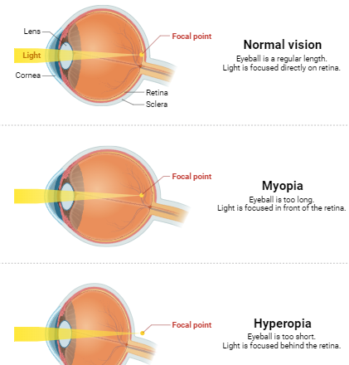
Fig: 1 Acute Angle-Closure Glaucoma:
When the drainage angle in the eye is suddenly and severely blocked, it can result in acute angle-closure glaucoma, a medical emergency that causes the intraocular pressure to rise quickly. If not treated right once, this might harm the optic nerve and could lead to permanent eyesight loss. Another name for acute angle-closure glaucoma is "acute angle-closure crisis" or "acute angle-closure attack."
The symptoms of acute angle-closure glaucoma can be quite severe and can include:
- Sudden and severe eye pain: The pain is frequently described as a severe aching or throbbing sensation in and around the eye. Aside from pain, irritation, and redness, there may also be tears.
- Blurred or hazy vision: Blurred or foggy vision, as well as the presence of halos surrounding lights, are common in people with acute angle-closure glaucoma.
- Headache: One of the most common symptoms of acute angle-closure glaucoma is a severe headache that is frequently centred on the forehead or temples.
- Nausea and vomiting: Similar to how a severe headache causes nausea and vomiting, an increase in intraocular pressure can do the same.
- Decreased or loss of vision: People may have a decline in vision or even total blindness as the illness worsens, particularly if the optic nerve suffers severe damage.
- Eye redness: Due to increased pressure and disturbed fluid circulation, the eye may seem red and irritated.
- Pupil dilation: The pupil of the afflicted eye may enlarge and become less responsive to changes in light.
For the optic nerve to be protected from further harm and to reduce the pressure associated with acute angle-closure glaucoma, prompt medical care is necessary. The main focus of treatment is to swiftly reduce intraocular pressure. Treatment choices could be:
Medications: To reduce intraocular pressure, medicines are frequently given orally or intravenously. These drugs either increase the outflow of aqueous humour (the fluid that fills the eye) or decrease its production.
Laser therapy: To let the aqueous humour flow more freely and relieve the pressure, laser techniques like laser peripheral iridotomy or laser iridoplasty can make a tiny hole in the peripheral iris.
Surgery: In some circumstances, surgery might be required to make an opening in the iris permanent and enhance drainage.
It's critical to remember that acute angle-closure glaucoma is a dangerous disorder with a fast-acting risk of irreversible vision loss. Visit an emergency department right away or seek immediate medical attention if you or someone you know is exhibiting signs and symptoms of acute angle-closure glaucoma so that you can be properly diagnosed and treated.
Chronic Angle-Closure Glaucoma: Chronic narrow-angle glaucoma, often referred to as chronic angle-closure glaucoma, is a form of glaucoma that gradually worsens over time as a result of a persistent partial obstruction of the drainage angle in the eye. The symptoms of chronic angle-closure glaucoma may not be as severe or sudden as those of acute angle-closure glaucoma, which is a medical emergency. If neglected, it can still cause harm to the optic nerve and visual loss. This form progresses more gradually and frequently exhibits no symptoms at first. It could have less severe symptoms at first, but over time, if untreated, it can still harm the optic nerve and result in vision loss.
To stop further optic nerve damage, angle-closure glaucoma treatments mainly include lowering intraocular pressure. This can be accomplished with a mix of prescription drugs, laser treatments, and occasionally surgery. The intention is to reduce intraocular pressure by widening the drainage angle and allowing the aqueous humour to drain more freely.
It's critical to get quick medical assistance if you believe you or another person may have angle-closure glaucoma. As early diagnosis and management can help maintain vision and prevent problems, routine eye exams and screenings are crucial for detecting and controlling glaucoma (Zhang et al., 2017).
Here are some key points about chronic angle-closure glaucoma:
- Slow Progression: Unlike the sudden onset of symptoms seen in acute angle-closure glaucoma, chronic angle-closure glaucoma develops gradually over months or years. This slow progression can make it harder to detect in its early stages.
- Asymptomatic Early Stages: Individuals with chronic angle-closure glaucoma may not experience noticeable symptoms in the early stages. Regular eye examinations, including measurement of intraocular pressure and examination of the drainage angles, are essential for early detection.
- Mild Symptoms: As the condition progresses, mild symptoms may develop, such as intermittent blurring of vision, difficulty seeing in low light, mild eye discomfort, or occasional halos around lights.
- Optic Nerve Damage: The optic nerve, which carries visual data to the brain, can get damaged over time as a result of increased intraocular pressure. The person may not immediately detect a progressive decrease in peripheral vision as a result of this injury.
- Diagnosis: Chronic angle-closure glaucoma is usually identified after a thorough eye examination that includes intraocular pressure measurement, evaluation of the drainage angles using specialized methods (such as gonioscopy), inspection of the optic nerve, and testing of the visual field.
- Treatment: To stop additional damage to the optic nerve, the goal of treatment for chronic angle-closure glaucoma is to lower intraocular pressure. In some cases, surgery (such as trabeculectomy or eye drops), laser therapy (laser trabeculoplasty), or a combination of these may be necessary.
- Regular Follow-Up: People with chronic angle-closure glaucoma need to be continuously monitored by an ophthalmologist to gauge the condition's development and alter therapy as necessary.
It's crucial to remember that persistent angle-closure glaucoma if improperly treated, can cause irreversible visual loss. Regular eye exams are essential for early identification and intervention, especially for those who are more vulnerable (such as those with a family history of glaucoma or those of Asian heritage). Consult an eye care specialist for a comprehensive assessment if you have any worries about your eye health or notice any changes in your vision.
Retinal Detachment: Due to the anatomical variations in the eyes, patients with Nanophthalmos are more likely to experience retinal detachment. The retina may be more likely to separate from the back of the eye because of the smaller size of the eye. A dangerous disorder of the eyes called retinal detachment occurs when the retina, a layer of tissue at the back of the eye, separates from its usual place. The retina is essential to visual perception because it collects and sends light signals to the brain, which enables humans to see. If a detached retina is not treated right away, it may cause vision loss or perhaps blindness (Wilkinson, 2021).
There are three main types of retinal detachment:
Rhegmatogenous Retinal Detachment: This kind of retinal detachment, which is the most frequent, happens when a tear or hole forms in the retina. This rip enables vitreous gel fluid—a gel-like liquid that fills the back of the eye—to flow through and collect behind the retina, leading to the retina's separation. A separation of this kind may cause an unexpected loss of eyesight.
Tractional Retinal Detachment: Scar tissue on the retina's surface contracts and pushes the retina away from the underlying tissue, causing Tractional detachment. This may be brought on by illnesses like diabetic retinopathy, in which abnormal blood vessels develop on the surface of the retina (Mishra & Tripathy, 2021).
Exudative (Serous) Retinal Detachment: This kind of detachment is brought on by the build-up of fluid behind the retina, which is frequently brought on by underlying medical diseases such as inflammation or tumours. Usually, retinal tears or holes are not the reason for it.
Retinal detachment symptoms can include:
The sudden appearance of floaters (small spots or specks that float across the field of vision)
- Blurry or distorted vision
- Flashes of light in the afflicted eye
- A shadow or curtain-like appearance falling over the visual field
Treatment: A medical emergency requiring rapid attention is retinal detachment. It can result in loss of eyesight which is irreversible if untreated. The nature and extent of the separation will determine the available treatments:
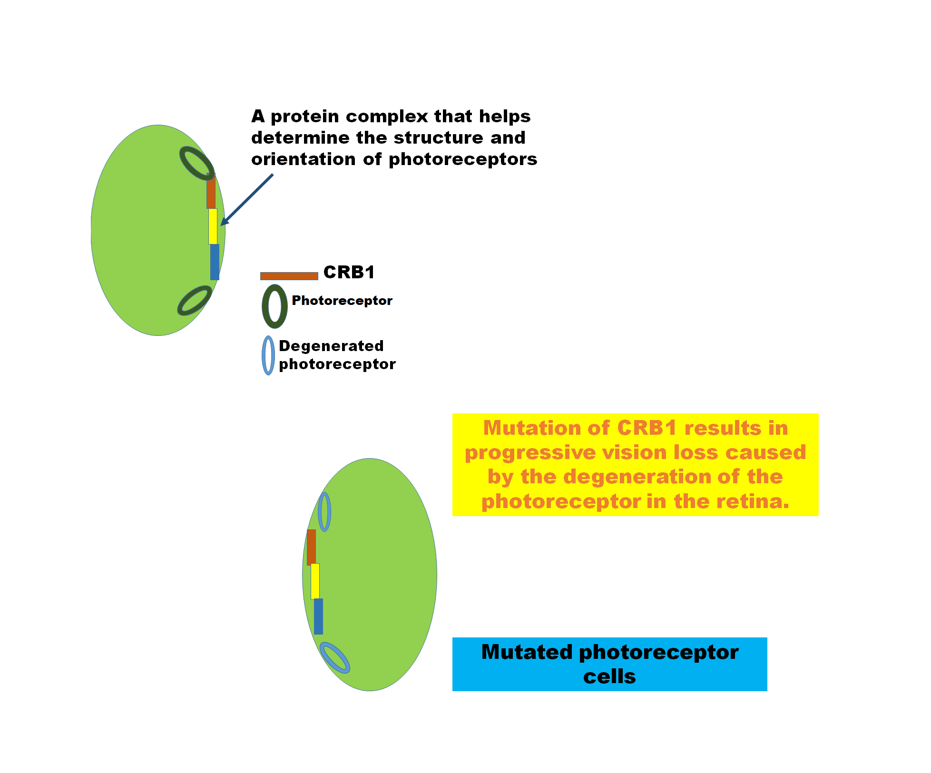
- Scleral Buckling: To indent the eye's wall and realign the retina, a silicone band called a "scleral buckle" is wrapped around the eye.
- Vitrectomy: The vitreous gel is taken out of the eye during this treatment and replaced with silicone oil or a gas bubble, which aids in pushing the retina back into position.
- Laser or cryotherapy: These procedures can be used to seal retinal tears or holes by forming scar tissue around them. This prevents further fluid from going through.
The kind of retinal detachment, its location, and how quickly therapy is given all affect how well the condition responds to treatment. The best chance for maintaining vision is through early identification and care. It's crucial to get quick medical assistance from an eye care specialist if you detect any unexpected changes in your vision, particularly if you see light flashes or the start of floaters (ISRCTN15940019, 2021).
Hyperopia (Farsightedness): Hyperopia, a condition where distant objects are perceived more clearly than close-by ones, can result from smaller eyes.
A refractive problem of the eye called hyperopia sometimes referred to as farsightedness, causes one to perceive distant things more clearly than close-up ones. When light enters the eye, it concentrates behind the retina rather than directly on it, resulting in this condition. Close-up things may become hazy as a result, although distant ones may look crisper.
In a healthy eye, the cornea and lens work in concert to precisely focus (refract) light onto the retina, which is in charge of sending visual signals to the brain. In hyperopia, the cornea and lens either have less focusing capacity than necessary or the eyeball is typically shorter than normal. Light beams thus focus behind the retina rather than directly on it.
Depending on the degree of hyperopia, some people may not experience serious visual issues. However, if hyperopia progresses, it can cause more obvious symptoms and make it difficult to do activities like reading, sewing, or using a computer, which calls for sharp close-up vision (Velez et al., 2017).
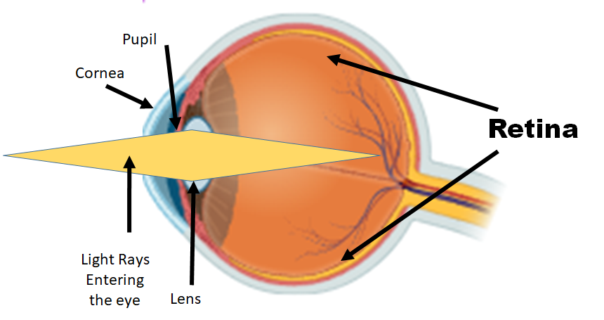
Symptoms of hyperopia may include:
- Distorted vision while viewing close-ups of items.
- Eye fatigue or pain during extended close-up work.
- Headaches, particularly after reading or performing up-close work.
- The inability to focus on close objects without squinting.
A thorough eye exam that frequently includes a visual acuity test, a refraction test (to establish the prescription required to correct the vision), and an assessment of the internal structures of the eye can be used to diagnose hyperopia.
Treatment for hyperopia typically involves corrective lenses For example, contact lenses or eyeglasses can change how light enters the eye so that it is properly focused on the retina. Glasses or contacts may need to be worn all the time or just when doing close-up work, depending on the degree of hyperopia and personal preferences.
Some people with hyperopia may potentially benefit from refractive procedures like LASIK (Laser-Assisted in Situ Keratomileusis) or PRK (Photorefractive Keratectomy). These techniques alter the cornea's structure to enhance the eye's focusing capacity. But whether a person is a good candidate for surgery depends on things including their age, eye health, and level of hyperopia (Grzeszkowiak & Wierzbowska, 2022).
To keep track of vision changes and make sure that any vision correction is precise and current, routine eye exams are crucial. It is advised to arrange an eye exam with an optometrist or ophthalmologist if you have hyperopia symptoms or observe changes in your vision to receive the correct diagnosis and treatment (Areiter et al., 2016).
Challenges with Surgical Procedures: Individuals with Nanophthalmos may find surgical operations more difficult due to the small size of the eye (Grzeszkowiak & Wierzbowska, 2022).
While surgical operations are frequently very helpful and important for addressing a variety of medical issues, they can also present certain difficulties and hazards. Here are some typical difficulties linked to surgical procedures:
- Risks associated with anaesthesia: During surgery, anaesthesia is used to create a controlled condition of unconsciousness or numbness. The hazards of anaesthesia, however, might include allergic responses, negative effects on the cardiovascular system, and difficulties managing the airway.
- Infection: Despite stringent sterilizing measures, infections can develop after surgery. Infections at the surgical site can extend healing periods, raise healthcare expenses, and in extreme circumstances, cause serious problems.
- Bleeding: During surgical operations, tissue is cut, which may cause bleeding. Blood transfusions or more procedures may be required as a result of severe bleeding, which the surgeons attempt to manage throughout the procedure.
- Scarring and Wound Healing: Scarring is one of the body's reactions to surgery. Even while some scarring is normal, unsatisfactory wound healing can result in severe scarring, wound dehiscence (when the incision opens), or even tissue necrosis.
- Pain Management: Effective pain management is essential for the comfort and recovery of patients since postoperative discomfort is prevalent. Ineffective pain management can result in protracted hospital stays, a slower rate of recovery, and general unhappiness.
- Complications: During or following surgery, complications might occur. These concerns can range from mild to more serious, necessitating further medical attention. Infections, blood clots, organ damage, and other problems can be complications.
- Allergic Reactions and Drug Side Effects: Patients who are allergic to drugs, anaesthesia, or surgical supplies may develop adverse reactions. The recovery of the patient may also be impacted by the negative effects of drugs used before, during, or after surgery.
- Nerve and tissue damage: Surgical operations need the manipulation of delicate bodily parts. Deficits in sensory or motor function may result from unintentional injury to the nerves, blood vessels, or surrounding tissues.
- Recovery and Rehabilitation: Depending on the treatment, the patient's health, and other variables, the post-operative recovery period might vary greatly. Some procedures call for extensive physical therapy, lifestyle changes, or rehabilitation.
- Failed or incomplete procedure: Technical issues, unanticipated problems, or patient-specific circumstances can often prevent surgical treatments from producing the desired results.
- Long-Term effects: Some surgical procedures may have long-term effects that don't always show up right away. For instance, modifications or problems may be needed after joint replacement surgery.
- Psychological repercussions: Surgery can have psychological repercussions, such as stress, worry, and changes in body image, particularly if the operation produces obvious alterations.
Before having any surgical operation, people should be in open discussion with their healthcare professionals about any potential risks, advantages, and alternatives. In-depth pre-operative assessments, informed consent procedures, adherence to sterile techniques, and monitoring throughout and after surgery are just a few of the steps that surgeons and medical teams take to reduce these risks.
Risk of Macular Degeneration: Age-related macular degeneration (AMD), another name for macular degeneration, is a disorder that worsens over time and damages the macula, a tiny but vital area of the retina that is in charge of central vision and fine-tuning visual processes. The ability to read, drive, identify faces, and carry out other everyday tasks can all be adversely impacted by AMD, which is the most common cause of visual loss in those 50 and older. Nanophthalmos may be linked to an increased risk of certain kinds of macular degeneration (Dave et al., 2022).
Numerous genes have been linked to the genesis of Nanophthalmos, which is frequently attributed to hereditary causes. To learn more about the causes and possible treatment targets, genetic investigations are still being conducted.
To treat Nanophthalmos, one must also take care of its comorbid conditions, such as glaucoma and retinal detachment. This could entail using prescription drugs, laser treatment, and surgery. Although there haven't been many specialized pharmacological therapies created just for Nanophthalmos, current ophthalmology research may result in fresh perspectives and future interventions.
To keep an eye on their eye health and deal with any possible consequences, people with Nanophthalmos must collaborate closely with ophthalmologists and other eye care specialists. The issues created by this illness may be better managed as medical science develops and new therapies and methods are developed.
There are two main types of AMD:
Dry AMD (Non-neovascular AMD): In roughly 80–90% of instances, this is the kind of AMD that is more prevalent. In the macula, which causes a progressive loss of central vision, light-sensitive cells gradually degenerate. Under the retina, druse, or little yellow deposits, build up in dry AMD. Geographic atrophy, a more severe type of dry AMD that involves a considerable thinning of the macular tissue, can occasionally develop from the less severe variant known as dry AMD.
Wet AMD (Neovascular AMD): Wet AMD is less frequent but more severe, and it can cause sudden, severe vision loss. It takes place when unnatural blood vessels develop under the retina and start to leak blood and fluid, harming the macula in the process. Wet AMD can cause abrupt visual alterations, such as distorted or wavering lines and black areas in the centre of the field of vision.
Factors that increase the risk of developing macular degeneration include:
- Age: Over 50s are more likely to get AMD than younger people. As people age, the danger increases.
- Family History: The probability of acquiring AMD is increased by a family history of the disease.
- Smoking: A substantial risk factor for AMD is smoking. It can increase the disease's risk by double.
- Race and Ethnicity: Caucasians are more likely to have AMD.
- Obesity: Obesity or being overweight may raise your risk of AMD.
- Cardiovascular Health: AMD risk has been linked to health issues such as high blood pressure, high cholesterol, and cardiovascular disease.
- Sunlight Exposure: Long-term UV radiation exposure, especially without shielding eyewear, may increase the risk of AMD.
- Diet: AMD risk may be increased by a diet lacking in antioxidants, vitamins, and minerals. A diet high in fish (high in omega-3 fatty acids), fruits, and green leafy vegetables, on the other hand, has been linked to a decreased risk.
While age and family history are unchangeable risk factors for AMD, others, including smoking and leading a healthy lifestyle, may be altered to help lower the risk. Regular eye exams are crucial because early identification and treatment can halt the spread of the illness and protect eyesight. While there is no known treatment for dry AMD, wet AMD can be treated with drug injections into the eye to stop the formation of aberrant blood vessels. Through dietary adjustments and low vision aids, management aims to halt development and preserve as much remaining eyesight as possible.
Conclusion:
Ophthalmologists will benefit from this thorough review of the available research on the management of NO problems. This chapter demonstrates how crucial it is for every ophthalmologist to comprehend the risks associated with nanophthalmos and the best ways to address them. To ensure a decrease in problems and an improvement in the safety and efficacy of therapy, this will help the creation of tailored treatment plans based on the conditions of each patient. Despite expanding the search to 20 years, we were unable to locate a large sample of case-control research on NO due to its rarity. Our analysis of each procedure's outcomes offered some broad pointers for reducing treatment-related problems. A genetic diagnosis of NO has been made public in recent years, and, there has been a gradual increase in the development of early imaging screening techniques and the measuring of IOL powers in patients with short axial length. To determine the most effective treatment plans for NO, these developments should be thoroughly investigated.

Reference:
Areiter, E., Neale, M., & Johnson, S. M. (2016). The spectrum of angle closure, uveal effusion syndrome, and nanophthalmos. Journal of Current Glaucoma Practice. https://doi.org/10.5005/jp-journals-10008-1211
Biscevic, A., Pidro, A., Pjano, M. A., Grisevic, S., Ziga, N., & Bohac, M. (2019). Lasik as a Solution for High Hypermetropia. Medical Archives (Sarajevo, Bosnia and Herzegovina). https://doi.org/10.5455/medarh.2019.73.191-194
Dave, S., Binns, A., Vinuela-Navarro, V., & Callaghan, T. (2022). What Advice Is Currently Given to Patients with Age-Related Macular Degeneration (AMD) by Eyecare Practitioners, and How Effective Is It at Bringing about a Change in Lifestyle? A Systematic Review. In Nutrients. https://doi.org/10.3390/nu14214652
Elder, M. J. (1994). Aetiology of severe visual impairment and blindness in microphthalmos. British Journal of Ophthalmology. https://doi.org/10.1136/bjo.78.5.332
Grzeszkowiak, J., & Wierzbowska, J. (2022). Choosing the right surgical treatment for hyperopia. In OphthaTherapy. Therapies in Ophthalmology. https://doi.org/10.24292/01.OT.120622
ISRCTN15940019. (2021). Surgical treatment of retinal detachment with and without combined cataract extraction. Https://Trialsearch.Who.Int/Trial2.Aspx?TrialID=ISRCTN15940019.
Mishra, C., & Tripathy, K. (2021). Retinal Traction Detachment. In StatPearls.
Nowilaty, S. R., Khan, A. O., Aldahmesh, M. A., Tabbara, K. F., Al-Amri, A., & Alkuraya, F. S. (2013). Biometric and molecular characterization of clinically diagnosed posterior microphthalmos. American Journal of Ophthalmology. https://doi.org/10.1016/j.ajo.2012.08.016
Sauer, T. C., & Krishnan, C. (2022). Nanophthalmos: Guidelines for Diagnosis and Therapy. In Albert and Jakobiec’s Principles and Practice of Ophthalmology: Fourth Edition. https://doi.org/10.1007/978-3-030-42634-7_181
Slavotinek, A. M. (2011). Eye development genes and known syndromes. In Molecular Genetics and Metabolism. https://doi.org/10.1016/j.ymgme.2011.09.029
Velez, G., Tsang, S. H., Tsai, Y. T., Hsu, C. W., Gore, A., Abdelhakim, A. H., Mahajan, M., Silverman, R. H., Sparrow, J. R., Bassuk, A. G., & Mahajan, V. B. (2017). Gene Therapy Restores Mfrp and Corrects Axial Eye Length. Scientific Reports. https://doi.org/10.1038/s41598-017-16275-8
Wilkinson, C. P. (2021). Retinal Detachment. In Pathologic Myopia, Second Edition. https://doi.org/10.1007/978-3-030-74334-5_23
Yang, N., Jin, S., Ma, L., Liu, J., Shan, C., & Zhao, J. (2020). The Pathogenesis and Treatment of Complications in Nanophthalmos. In Journal of Ophthalmology. https://doi.org/10.1155/2020/6578750
Zhang, Z., Zhang, S., Jiang, X., & Wei, Y. (2017). Combined 23-G Pars Plana Vitrectomy and Lensectomy in the Management of Glaucoma Associated with Nanophthalmos. Ophthalmic Research. https://doi.org/10.1159/000477620

