Extraction of phenolic content from the extract of
Hibiscus rosa-sinensis flower

Submitted in fulfilment of the requirements for the Award of the degree of

M.Sc. (Hons.) Chemistry SUBMITTED BY
Sandeep Kaur & Jasdeep Kaur

(Established Under Punjab Act No. 31 0f 2015)

DEPARTMENT OF CHEMISTRY

RIMT UNIVERSITY MANDI GOBINDGARH PUNJAB 14730 May 2023

ABSTRACT

An edible flowers are abundant sourcess of bioactive molecules as they contain, a plentiful source of antioxidant, anti-inflammatory, antibacterial, anticancer, and neuroprotective agents that have significant health advantages. The potential for phenolic molecule manufacturing using environmentally friendly extraction techniques is examined in the current study. So, choosing the right extraction technique is crucial if you want to recover the desired phenolic chemicals. The isolation of these compounds can be carried out by different methods such as traditional and non- traditional approaches.This will enable significant yields to be recovered from the sample matrix. As a result, the main focus of this review is on the various extraction techniques utilised to get phenolic chemicals from plant sources.The most efficient approach for achieving high total phenolic contents, antioxidant activity, and phenolic content was extraction with aqueous ethanol. For the isolation of phenolic compounds having antioxidant characteristics, optimised extraction techniques based on straightforward distillation extraction can be useful. In this investigation, hibiscus flower (rosa-sinensis) was utilised to produce extracts in a distillation extractor over the course of three to four hours. The flower sample was put in contact with particular solvents which is ethanol. After extraction, oily residues from the extracts were treated to flash chromatography, and the fractions resulting from this process were then characterised by gas chromatography coupled with mass spectrometry (GC-MS). The Folin-Ciocalteu technique was used to calculate the total phenolic content (TPC) from the Hibiscus ros- sinensis flower.
Keywords: Hibiscus rosa-sinensis flower, Ultra-Visible Spectrophotometer, Thin layer chromatography, Folin ciocaltea reagent, (GC-MS).

INTRODUCTION

Compounds with more or single aromatic rings coupled to a single or more hydroxyl groups are commonly called phenolic. They are the most common secondary plant metabolites with over 8000 known structures. They range from the simple phenolic such as phenolic acids; to the complex compounds like tannins. The compounds participate in plant defence against ultra violet (UV), pathogens, and other predators. Their presence in all plant organs makes them a vital ingredient of the human diet (Balasundram et al., 2006; Shah et al., 2018).
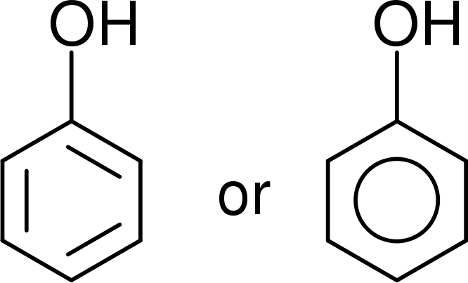

Figure 1: Structure of Phenolic Compound

Since ancient times, people have made use of the natural resources at their disposal and attempted to extract useful products from biomass. They have looked for natural remedies to treat various diseases and health issues, as well as to use plants and trees to produce various commodities, energy, and various tools and manufactured goods. There are many diverse and natural medicinal plants in the world. The flowers of Hibiscus have been reported in the ancient Indian medicinal literature with beneficial effects in various ailments ( Nadkarmi, A.K., 2006)Because they have the potential to provide a wide range of advantages to humanity, medicinal plants are receiving more attention than ever mainly in the medical and pharmaceutical fields.Traditional knowledge of medicinal plants is

a key component of complementary and alternative medicine (CAM) and has provided hints to the identification of important medications. Traditional Raw or as straightforward medical formulations, medicinal plants are frequently more affordable, locally accessible, and simple to consume.80% of the globe, according to the World Health Organisation.For their primary healthcare requirements, locals rely on traditional medicine, and the majority of this therapy uses plant extracts or their active ingredients(Buenz, E.J., and Dubey, N.K., 2004). Recently, interest in and usage of medicinal plant products have increased. The potential of therapeutic plants in the field of pharmacology(Triggiani, V., 2006) has been highlighted as a consequence of the identification and study of several medicinal plants utilising contemporary scientific methods. Phenolics are found mainly in fruits, legumes, vegetables, tea, wine, coffee, and accounts for the organoleptic characteristics of plant food. Likewise, phenolic compounds are responsible for the bitterness of fruits due to their interaction with salivary glycoprotein. Phenolics can also added to the colour of many fruits and vegetables. Technology for converting biomass into useful goods has been developed over 38,000 years (Antal, M.J., 2003). Beginning in the fourth century BC, the willow tree's leaves and bark were used to cure pain. This practise eventually led to the isolation of salicylates from various tree species and plants in the 19th century, which were then employed as active ingredients in the creation of commercial painkillers (Raskin, I., 1992).The industrial exploitation of fast-growing, short-rotation crops of herbaceous species like miscanthus (Marín, F., 2009), wheat (Cornejo, A., 2019) and camelina straw (B. Gómez- Monedero. 2015), as well as trees like eucalyptus (Gómez-Monedero, B., 2015) and poplar (X. et al.,Yu. 2020) has generated significant economic activity in the development of biobased products across various sectors, including the pulp and paper industry. In both in vitro and in vivo investigations, numerous research have demonstrated the preventive impact of polyphenols in cardiovascular and

neurological illnesses, as well as in various diseases and cancer (Cory et al., 2018; Forni et al., 2019; Pot et al., 2019; Vauzour et al., 2010).
  - History of Hibiscus rosa-sinensis

India is where Hibiscus rosa-sinensis most likely originated. Old Moors (Arabs) think Spain is where it first appeared. Others contend that Hibiscus rosa sinensis is not a natural herb but rather a collection of artificial hybrids. The term "Hibiscus" comes from the Greek word "hibiskos" which means white or marshmallow.
  - Overview of Hibiscus rosa-sinensis

Hibiscus rosa-sinensis, is a perennial shrub in the Malvaceae family. There are roughly 275 species in the genus Hibiscus. They have their origins in tropical and south Asia and are extensively scattered around the world. Most cultivated Hibiscus species are used as decorative plants (Lowry, J., 1976). All year long, they produce spectacular flowers with brilliant colours. There are numerous cultivars that produce flowers (single or double) in hues of red, peach, white, pink, and orange (Gilman, E.F., 1999). blooms' morphology suggests that hummingbirds and sunbirds, who are drawn to blooms that produce nectar, pollinate them. Different regions of the world have different names for Hibiscus rosa sinensis. It is referred to as Hibiscus de Chine (China), Joba (Bengali), Java (Telugu), Chinesischer Roseneibisch (German), Clavel japonés (Spanish), Hibiscus (Swedish), and Gudhal (Urdu). It is also known as Bent EL-Kunsil (Arabic), Rosa della Cina (Italian), Aka-bana (Japanese), Shoe flower (English),
  - Morphology of Hibiscus rosa-sinensis

The perennial shrub Hibiscus rosa-sinensis has tap roots. 3 to 12 cm long and 2 to 5 cm wide describe its leaves. Simple ovate or lanceolate leaves with whole bases and coarsely serrated tips/margins make up the plant's leaves. Flowers are full, pentamerous, pedicillate, and actinomorphic. Corolla measures 3 inches in

diameter and has five petals (Rao, K., Geetha, K., Banji, D., 2014). There are several types with corollas that vary in size and colour. Fruit is a 3 cm long capsule that occurs very infrequently (Ross, I.A., 2003). The optimal growth conditions for Hibiscus rosa sinensis are well-drained, slightly acidic soils. It uses fully decomposed organic matter in sandy soils to preserve the soil's aeration, drainage, and water-holding capacity. Plants need direct sunshine because insufficient light prevents flowers from blooming.

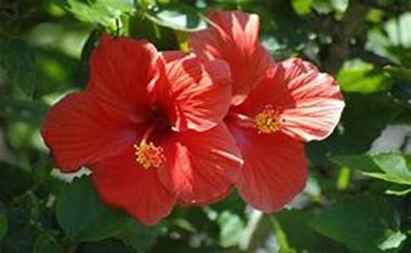

Figure 2: Structure of Hibiscus rosa-sinensis flower

  - Chemistry of Hibiscus ros- sinensis flower

Due to diverse plant kinds, environments, and harvesting circumstances, Hibiscus rosa sinensis chemical makeup differs throughout research. According to reports, hibiscus rosa sinensis contains proteins, carbs, lipids, and fibre. They also have sizeable levels of calcium, iron, beta-carotene, and vitamins. In addition to phosphorus (0.52/100g), calcium (1.67g/100g), carbohydrate (69.7g/100g), fibre (15.5g/100g), and ash (11.4g/100g), leaves also contain lipids (3.5/100g).

Flowers include iron (1.7 mg/100 g), calcium (39 mg/100 g), phosphorus (265 mg/100 g), fat (3.9 mg/100 g), carbs (86.3 mg/100 g), fibre (15.7 mg/100 g), vitamin B1 (0.29 mg/100 g), vitamin B2 (0.49 mg/100 g), vitamin B3 (5.9 mg/100 g), and vitamin C (3.9 mg/100 g) (V. Khristi, and V. Patel. 2016). Different plant portions include bioactive components, such as glycosides, terpenoids, saponins, and flavonoids, which give the plant its therapeutic effects. Stigma sterol, taraxeryl acetate, beta-sitosterol, and three cyclo propane compounds are found in the stem and leaves.
Quercetin-3-diglucoside, cyanidin-3- sophoroside-5-glucoside, kaempferol-3- xylosylglucoside, cyanidin-3, 5-diglucoside, and 3, 7-diglucoside are all abundant in flowers. Several possible antioxidants and anticancer substances, such as quercetin, glycosides, riboflavin, niacin, carotene, malvalic acid, gentisic acid, margaric acid, and lauric acid, are found in plant extract. The best source of tannins, mucilage, flavonoids, and saponins is found in roots (Khristi, V., and Patel, V., 2016). Because they bind to cholesterol, create insoluble complexes, and are excreted through the bile, saponins are beneficial for those with hypercholesterolemia because they lower blood pressure. Hibiscus rosa-sinensis total phenolic content, flavonoid profile, and anti-haemolytic action, however, are all unknowns. The present study was represent the total phenolic content traditional applications and efficacy. There is presence of Kaempferol, myricetin, quercetin, and rutin are flavonoids in a methanol extract of Hibiscus rosa- sinensis.
  - Uses of Hibiscus rosa-sinensis flower

There are numerous uses for Hibiscus rosa-sinensis in cuisine, cosmetics, and medicine. Jams, sauces, spices, and soups, among other food products, employ hibiscus extracts as flavourings (Baranova, V., Rusina, I., 2012). They are also used to improve the flavour and aroma of tea blends. This plant's essential oil is

employed in the cosmetic business since it contains a variety of chemically active ingredients.
Because of its pleasant, peaceful, and tranquil scent, it is a common ingredient in cosmetics such lotions, soaps, shampoos, conditioners, and fragrances. When used regularly, the oil is helpful in maintaining the elasticity and flexibility of skin and lessens the symptoms of ageing. Hibiscus rosa-sinensis flowers are believed to have cooling, emmenagogue, and demulcent properties. To create a deep purple dye that is used to blacken the shoes, flowers are crushed. In many parts of the world, dye is also used to colour food, spirits, and hair. Flowers are used as remedies for hypertension, sore eyes, and ulcers. This plant's leaves have laxative, aperient, and emollient properties. Abortion benefits from stem bark. various plant parts are employed to treat urinary infection. Roots are used as a treatment for gonorrhoea, stomach issues, and blood vomiting. Additionally, several diseases of cattle can be treated using roots. Leaf extracts in both alcohol and water have anti-infective, anti-dandruff, and preventative effects against a variety of skin conditions and allergies. Due to their anti-graying qualities, they are also used to promote hair growth and darken the colour of hair.

Problem statement

Extraction yield of total phenolic compounds is typically dependimg on different method. Besides the difference in polarities of extracting solvents might influence the solubality of the chemical constituents in a sample and its extraction yield.therefore the selection of an appropriate solvent is a major step to determine of total phenolic content from sample.

Review of Literature

PLANT | PLAN T  PART | SOLVRENT | METHOD | COMPUND EXTRACT | CHARACTE RIZED
Hibiscus sabdariffia | calyces | Ethanol, Methanol, Water. | Micro-wave assisted extraction at 20⁰C, 50⁰C,  75⁰C, 90⁰C. | Delphindin3-o sambubioside chloride,cyandin 3- o-sambubioside chloride hydroxycitrate. | UPLC-DAD
Populus salicacae | Bark | n-hexan, dichlorometha ne,  ethyl acetate. | Soxhlet extraction and chromatograp hy at 40⁰ C temperature. | 2,3dihydrofuran, aromatic, cinnamic acid. | GC-MS
Andryala glandulosa | Flower | Dichlorometh ane,ethanol, ethanol Dichlorometh ane,ethanol. | Liquid-liquid extraction was done. | Dichloromethane an extract contain hydrocarbon. In alcoholic extract luteolin, quinnic acid. | RP-HPLC  coupled withdiode array detection and ESI/MS

References:

- Liliana, C., Rodrigues, E., Noreña, C.P. Z; Institute of Food Science and Technology, Federal University of Rio Grande do Sul, Av. Bento Gonçalves, 9500, CEP 91501-970, Porto Alegre, RS, Brazil
- Autor, E., Cornejo, A., Bimbela, F., Maisterra, M., Gandía, L.M., Martínez- Merino, V. Extraction of Phenolic Compounds from Populus Salicaceae Bark.Biomolecules 2022, 12, 539.
- Madeir, C.Q., CCCEE, Universidade da Madeira, Campus Universitário da Penteada, piso 0, 9000-390 Funchal, Portugal.

Objectives

- The purpose of current study is the extraction of phenolic compound from
Hibiscus rosa-sinensis flower.
- Selection of an appropriate extraction method to get the good yield of TPC (total phenolic content).
- Determination and quatification of phenolic compounds by TLC and UV spectra.
- GC-MS of ethanolic extract of Hibiscus rosa- sinensis flower.

Methods for the extractiong of flower

The phenolic content and composition of a plant's leaves, roots, bark, flowers, or fruits differ significantly from those of its other plant parts. Fruits typically have varied distribution patterns for the flesh, skin, and seeds. The samples that are taken ought to be representative of the plant material that will be analysed, such as the whole plant or a chosen section of it. However, samples must be properly preserved until the analysis in order to prevent changes in their chemical composition. Depending on the storage duration and conditions, a considerable drop in the amounts of phenolic compounds in the source material may take place between sample collection and analysis. It is possible to keep samples in dry, frozen, or fresh form. Although they are perishable, fresh samples can be kept in the refrigerator.

Conventional methods

The traditional methods for extracting phenolic chemicals include soxhlet extraction, serial exhaustive extraction, decoction, percolation, infusion, digesting, and maceration (Alara et al., 2018a,b; Kaufmann and Christen, 2002; Sticher, 2008). At this time, the maceration approach is not frequently utilised because there are alternative, more practical methods available. Extraction by maceration is a straightforward procedure that involves agitating a pulverised

material continuously or occasionally at room temperature after soaking it in the suitable solvent in a closed system (Olejar et al., 2015; Sticher, 2008). Following the extraction phase, the solid components are separated from the solvent using a separation technique. According to (Cuji čić et al., 2016), this is typically accomplished through filtration, decantation, or clarifying. Despite being a simple procedure, it has some drawback like time-consuming and needing solvents in significant quantities. (Alara et al., 2018a,b; Kaufmann and Christen, 2002; Sticher, 2008.

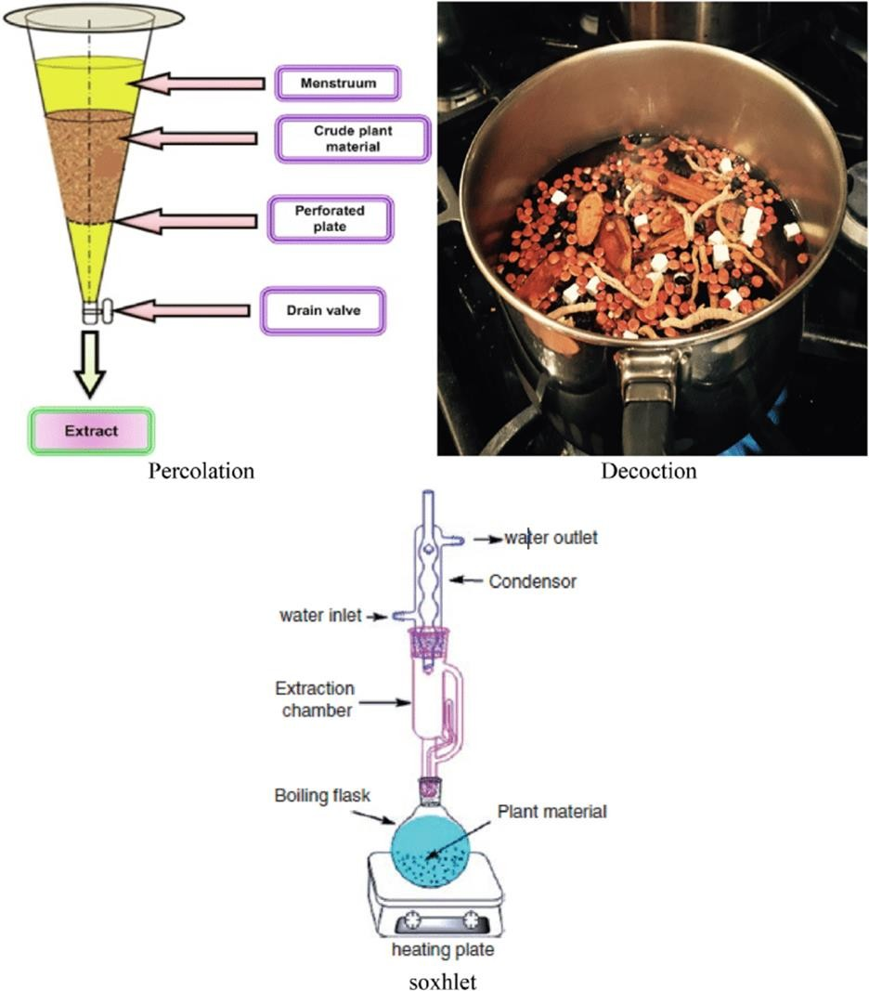

Figure 3: A various extraction method (A) Percolation (b) decoction (c) Soxhlet extraction.
Decoction procedure

The plant samples are either boiled for a shorter time or covered in boiling water and left to stand for a set amount of time when using the decoction procedure.

This approach is mostly suited for water-soluble and heat-stable phytochemicals derived from unprocessed pharmaceuticals. The pulverised material is placed in a closed system with the solvent being dropped gradually from the top to the bottom. This is comparable to the maceration process (Kaufmann and Christen, 2002; Sticher, 2008). Filtration is not necessary in this case because the percolator devices have filters that only permit solvent containing the extract to pass through. The issues with the percolation approach (lengthy, huge solvent volumes) are comparable to those with the maceration method. Due to the prolonged heating, this method cannot be used to extract thermolabile chemicals (Alara and Abdurahman, 2019).

Soxhlet apparatus procedure

The pulverised materials are placed in timbles (made of cellulose) and placed in the extraction chamber according to the soxhlet extraction method (Alara et al., 2018a,b; Luque de Castro and Garca-Ayuso, 1998) beneath a reflux condenser, over the collecting flask. After that, the solvent that has already been poured to the heating bottle is heated to create a vapour that will condense under cool running water and fall back into the timbles that contain the sample (Azwanida, 2015). After several attempts to sustain the reflux, the aqueous extract is finally recovered from the heating flask. Soxhlet extraction benefits from being a continuous process since it compared to percolation and maceration procedures, uses less time and solvent (Azwanida, 2015).However, because reports have emphasised the impact of excessive heat on the soxhlet extraction process, it is important to treat it carefully the polyphenols that are thermolabile (Seidel, 2012). Convenience is another benefit of the soxhlet extraction technique (Azwanida, 2015). These processes are different, but they all require an organic solvent at a specific feed-to-liquid ratio.
Methanol, water, chloroform, n-hexane, ethanol, propanol, ethyl acetate, and acetone are a few of the often used solvents for extracting polyphenols (Zhang,

2018). The polarity of these solvents varies, and as a result, their effects on the removing plant chemicals. As a result of their ease of mixing, organic solvents are taken into account while attempting to increase extraction yield, as suggested by numerous research (Zhang, 2018).There are still questions about the best solvent for the extraction of polyphenols, despite the fact that phytochemicals are often extracted using organic solvent and its aqueous formulation.Any solvent used for extraction must be chosen based on the following criteria: solvent power, solvent polarity, boiling temperature, solvent reactivity, viscosity, stability, safety considerations, legislative compatibility for food usages, and potential for reusability.

Methodology

  - Collection and processing of material

The Hibiscus rosa sinensis flower is collected from the local area. At first, running tap water was used to completely clean the blooms. The recovered samples were then twice cleansed in sterile distilled water to get rid of any remaining impurities. The flowers were afterwards converted into powder using a mechanical grinder after being let to dry in the shade at 40°C. The powder was kept in an airtight container at room temperature.

Materials

Sample preparation may require various devices, solvents, and/or chemicals to perform drying, grinding, sieving, extraction. In solvent extraction methanol (MeOH), ethanol (EtOH), acetone, and ethyl acetate (EtOAc) can be used as a solvent for the extraction of phenolics. Accelerated simple distillation extractor, device was used. Most of the extrcation was done by using ethanol as a solvent distilled water, Gallic acid used as standard, follin cioacalteau reagent, sodium carbonate, toluene reagent, Fecl₃, acetone, formaic acid and some others.

  - Extraction of flower Hibiscus rosa- sinensis

Using a simple distillation , the 50g of dried Hibiscus rosa-sinensis flower powder was progressively extracted with 30ml of ethanol. The entire extract was produced in 4-6 hours at boiling points of 80 °C. The product-solvent was filtered afterward employing a Rotavapor and lowered pressure to evaporate for dryness. The product's old version was used to screen for phytochemicals. Additionally, GC-MS analysis of the same product (Ethanolic eaxtract).
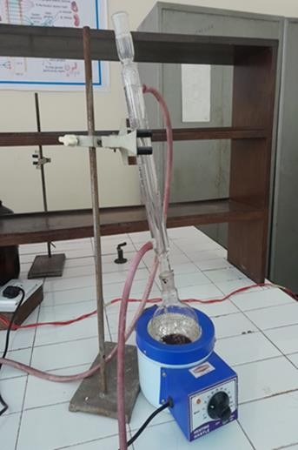
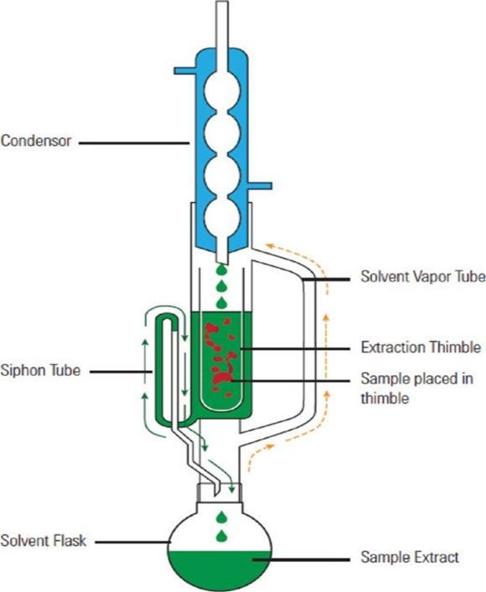

Figure 4: Simple distillation extractor Figure 5: Soxhlet exctractor

  - Measuring the amount of total phenolic content

Utilising the Folin-Ciocalteu colorimetric method, which Gao et al. [40] previously developed, the total polyphenol content was determined. The Folin- Ciocalteu reagent (0.2 mL), H₂O (2 mL), and spice extracts (100 L) were combined, and the mixture was incubated at room temperature for 3 minutes.

Total polyphenols were calculated after 1 h of incubation at room temperature following the addition of 1 mL of 20% sodium carbonate to the mixture. Using a UV-spectrophotometer, the absorbance of the resulting blue colour was determined at 765 nm. In order to quantify the toatal phenolic content , the gallic acid standard curve was used. Gallic acid equivalents (GAE), milligrammes per
100 g of dry weight (dw), were used to express the results. All determinations were performed in triplicate (n = 3).

Calculations:

Standard volume of sample(ml)dilution ×100
weight

Weight % = Ac-(As - A0)/Ac 100

Ac = (Absorption of control)( absorption of sample)

TLC (Thin layer chromatography) analysis of sample

- Preparation of Plant Extract

Kagan and Flythe (2014) for extraction of phenolic compounds from Trifolium pratense cv. Kenland.
To extract other compounds in other plants, check the phytochemical analysis literature for plant- or metabolite-specific extraction methods (many are described), or look for protocols such as those of Khurram et al.7,8 which isolate many compounds with a wide range of polarities.

Preparation of Thin-layer Plates

Clean TLC plates by developing in one or more polar, neutral solvents, in order to move adsorbed contaminants away from the zone of development.In a fume hood, prepare enough cleaning solvent (e.g. 15-100 ml of ethyl acetate-methanol

2:1, v/v) to cover the bottom of the TLC developing chamber, as well as the lower edge of a TLC plate when set inside the chamber.
Use commercially available glass TLC developing chambers (different sizes available, with lids) or foil-covered Pyrex beakers or preserving jars.
Use scissors to cut aluminum- or plastic-backed (flexible) silica gel plates, which come in various sizes (20 cm x 20 cm and smaller), to fit the available developing chamber. (Caution: silica can cause lung damage if inhaled. Work in a fume hood, and handle TLC plates with gloves to avoid getting skin oils onto the silica.)
Insert the plates into the chamber, with the tops leaning against the chamber walls. Plates should not touch each other. Cover the chamber and let the solvent move up the plate by capillary action.
When solvent has reached the top of the plates, remove plates from chamber and arrange in a standing position within the fume hood until solvent has evaporated.
Check to see if impurities have migrated near the top of the TLC plate by looking for a yellow band under visible light, or a fluorescent band under ultraviolet (UV) light (see the “impurity front” or IF in Figure 2B). If the majority of the plate still has a yellowish tinge, repeat the cleaning process.
After removing TLC plates from the chamber, discard the solvent. Allow residual solvent to evaporate completely before using the chamber for Protocol
To remove residual moisture that can affect migration of compounds on silica16, prop the plates upright in a drying oven at 100 °C (10-15 min for a 20 cm x 20 cm plate, and 5 min for 7 cm x 10 cm plates).
If a 100 °C drying oven is not available, heat plates for a longer period of time at lower temperatures (i.e. 40 min at 60 °C).
After the plates are dry, let them cool to ambient temperature before loading.

Preparation of Developing Chambers for Extract Separation

Use scissors to cut a piece of filter paper slightly below chamber height, and about half the chamber perimeter in width. This paper acts as a wick to draw solvent up the chamber wall and saturate the chamber with solvent vapors, thus improving reproducibility of separations1. In a fume hood, mix solvents (ethyl acetate- methanol 4:1, v/v, for this study). Pour solvent mixture into the chamber and cover. Wait until the entire wick is wet with solvent, indicating chamber saturation, to put plates into chamber.

Loading and Development of TLC Plates

Lightly mark the origin with pencil. If the TLC plate adsorbent is soft and easily damaged, make marks at edges. Compounds should be above the surface of the developing solvent when plates are inserted into the TLC chamber.
Dissolve extracts in enough organic solvent (in this case, methanol) to have a concentrated solution instead of a turbid suspension.
Load samples and standards as narrow bands with a microliter syringe or capillary micropipettes, leaving a 1 cm border on the sides of the plate. Allow the bands to dry (fanning the plate or loading it in a fume hood helps).
If a greater concentration of sample is needed on a plate, "overspot" by loading samples again on the dried bands.
With forceps or tongs, set plate(s) inside the saturated TLC chamber. Plates should not touch the wick because it may provide solvent to the plates at points of contact, thus altering the path of compound migration. Cover chamber and let plates develop.

Mass balance

Material balance is a application of the Conservation of Mass which is used in the industry to find out the quanitiy or composition of the residue here or in the

residue it can be find out the what is the amount of ash after complete combustion. As the following table shows the different qunantity of residue after the combustion at various temperature.

Table1: Mass balance and pH observed at different temperature in ethanol as solvent.

Reactant  (organic material) | Sample | Solvent (Ethanol) | Temperature | Heating time | Product obtained | pH | Mass balance
Rosa- sinensis  flower | 10.5g | 30ml | 80⁰C | 3hour | 15ml | 6.25 | 73%
Rosa- sinensis  flower | 14g | 40ml | 65⁰C | 2hour | 35ml | 7.1 | 71%
Orange  peel | 11g | 50ml | 50⁰C | 1 hour | 45ml | 6.3 | 68%

- GC-MS of Hibiscus rosa-sinensis

By using GC-MS Solid, gaseous, or liquid materials can all be studied using.The first step in analysis is the gas chromatograph, where a capillary column coated with a stationary (liquid or solid) phase separates the sample into its constituent components after efficiently vaporising it into the gas phase. An inert carrier gas, such as helium, hydrogen, or nitrogen, propels the chemicals. Depending on its boiling point and polarity, each compound elutes from the column at a different time as components of the mixture are separated. The retention time of a chemical

is the period of elution. Complex mixtures or sample extracts containing hundreds of different chemicals can be resolved using GC.

Results

  - Total Phenolic content

The antioxidant has received a lot of attention lately characteristics of food ingredients that are sourced from plants.Secondary metabolites widely found in plants include flavonoids and phenols. They possess a variety of biological and pharmacological traits that may offer protection from chronic illnesses 26,27. According to the current research, HFE has a phenolic content of 0.095mg gallic acid equivalent (GAE) per gram of extract (Graph 1).
Absorbance 765

18
16
14
12
15.9
Total Phenolic
15.2
12.8
13.5
11.2
12.1
10
8
9.4
8.22
7.1
Extract
Gallic Acid
6
4.21
4
2
0
2.28
2.65
0.1µg/ml 1.01µg/ml 1.05µg/ml 2.01µg/ml 3.5µg/ml 6.01µg/ml

Concentrations (µg/ml)

Weight percentage of phenolic content

We analyse the weight of phenolic content in the ethanolic extract of Hibiscus rosa sinensis by using Folin-Ciocalteu colorimetric method and the total weight is 1.8097447 µg/ml^{-1.}.

TLC (Thin layer chromatography) Analysis TLC of Standard phenolic compound
Retention factor (RF) is defined as the ratio of distance travelled by salute to distance travelled by solvent.
Distance travelled by salute(flower) = 4.5cm Distance travelled by solvent(ethanol) =8cm
RF value of standard phenolic compound =0.56

TLC of flower sample

Distance travelled by salute(sample) =5.2cm Distance travelled by salute(solvent) =12cm RF value of taken sample =0.48

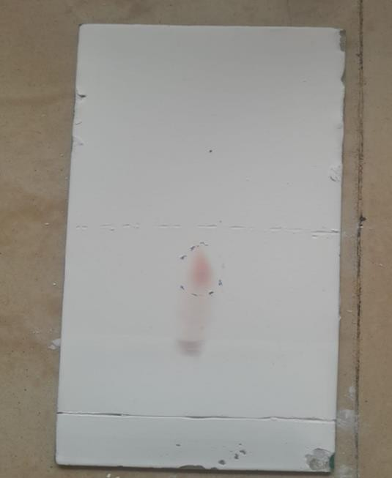

Figure 4: TLC of standard phenols Figure 5: TLC flower extract

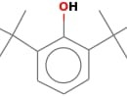
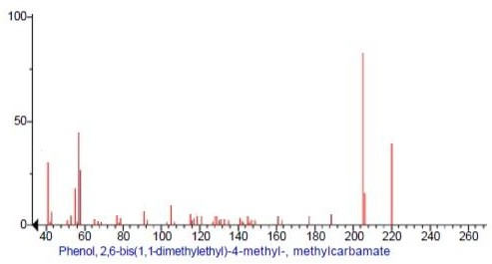
6.2 GC-MS of Hibiscus rosa-sinensis flower extract
Structure of given phenol

S.NO. | RT | Name of compounds | Molecular | MW | Uses
1 | 7.94 | Phenol, 2,6- bis(1,1- dimethylethyl)- 4-methyl-, methylcarbamate | C17H27NO2 | 277 | Phenol is used as an oral aesthetic/analgesic, commonly used to temporarily treat pharyngitis.  Phenol was widely used as an antiseptic.

Conclusion
In conclusion, phenolic chemicals derived from plants have a variety of uses, including analgesic, antipyretic, anticancer, antiviral, and antibacterial. Consequently, they have the capacity to enhance human health. The merits and disadvantages of various phenolic compound extraction techniques from plants were discussed in this chapter. The findings of this study showed that Hibiscus rosa-sinensis flowers have high levels of phenolic content (42.38 2.66 mg gallic acid equivalent (GAE) per gramme) and displayed outstanding antioxidant properties is reported. Phenol, 2,6-bis(1,1-dimethylethyl)-4-methyl-, methylcarbamate components was detected and used as an oral aesthetic/analgesic, commonly used to temporarily treat pharyngitis. Phenol was widely used as an antiseptic by GC-MS analysis. Rutin has been discovered as the extract's main flavonoid. Oxidative stress was artificially produced using H₂O to test the preventive impact of HFE on RBC hemolysis. As a possible source of natural remedies, the result of this study would assist determine the efficacy of the extract from Hibiscus rosa-sinensis antioxidants. It can be used to reduce or stop lipid oxidation, slow down the production of harmful oxidation products, and extend the shelf life of foods and medicines.

References

- Balasundram, N., Sundram, K., & Samman, S., (2006). Phenolic compounds in plants and agri-industrial by-products: Antioxidant activity, occurrence, and potential uses. Food chemistry, 99(1), 191- 203.
- Shah, S. R., Ukaegbu, C. I., Hamid, H. A., & Alara, O. R., (2018). Evaluation of antioxidant and antibacterial activities of the stems of Flammulina velutipes and Hypsizygus tessellatus (white and brown var.) extracted with different solvents. Journal of Food Measurement and Characterization, 12, 1947-1961.
- Buenz, EJ., Schnepple DJ., Bauer, BA., Elkin,PL., Riddle, JM., Motley TJ., T(2019) Trends in Pharmacological Sciences 2004; 25: 494-498.
- Dubey, NK., Kumar R., Tripathi, P.,(2004) Global promotion of herbal medicine: India’s opportunity. Curr Sci;81: 37-41.
- Triggiani, V., Resta, F., Guastamacchia, E., Sabba C., Licchelli, B., Ghiyasaldin S., (2006). Role of antioxidants, essential fatty acids, carnitine, vitamins, phytochemicals and trace elements in the treatment of diabetes mellitus and its chronic complications. Endocrine, Metabolic and Immune Disorders Drug Targets; 6: 77-93.
- Antal, M. J., GrÃ¸ nli M., (2003). The Art. Science, and Technology of Charcoal Production. Industrial and Engineering Chemistry Research, 42(8).
- Raskin, I., (1992). Role of salicylic acid in plants. Annual review of plant biology, 43(1), 439-463.
- Marín, F., Sánchez, J. L., Arauzo, J., Fuertes, R., & Gonzalo, A.
,(2009). Semichemical pulping of Miscanthus giganteus. Effect of

pulping conditions on some pulp and paper properties. Bioresource Technology, 100(17), 3933-3940.
- Gómez-Monedero, B., Bimbela, F., Arauzo, J., Faria, J., & Ruiz, M.,
P. (2015). Pyrolysis of red eucalyptus, camelina straw, and wheat straw in an ablative reactor. Energy & Fuels, 29(3), 1766-1775.
- Cornejo, A., Alegria-Dallo, I., García-Yoldi, Í., Sarobe, Í., Sánchez, D., Otazu, E., ... & Martínez-Merino, V., (2019). Pretreatment and enzymatic hydrolysis for the efficient production of glucose and furfural from wheat straw, pine and poplar chips. Bioresource technology, 288, 121583.
11.Yu, X., Xu, D., Sun, Y., Geng, Y., Fan, J., Dai, X., ... & Li, Y., (2020).
Preparation of wood-based panel composites with poplar veneer as the surface layer modified by in-situ polymerization of active monomers. Forests, 11(8), 893.
- Cory, H., Passarelli, S., Szeto, J., Tamez, M., & Mattei, J., (2018). The role of polyphenols in human health and food systems: A mini- review. Frontiers in nutrition, 5, 87.
- Forni, C., Facchiano, F., Bartoli, M., Pieretti, S., Facchiano, A., D’Arcangelo, D., ... & Jadeja, R. N., (2019). Beneficial role of phytochemicals on oxidative stress and age-related diseases. BioMed research international, 2019.
- Potì, F., Santi, D., Spaggiari, G., Zimetti, F., & Zanotti, I., (2019). Polyphenol health effects on cardiovascular and neurodegenerative disorders: a review and meta-analysis. International journal of molecular sciences, 20(2), 351.
- Vauzour, D., Rodriguez-Mateos, A., Corona, G., Oruna-Concha, M. J., & Spencer, J. P., (2010). Polyphenols and human health: prevention of disease and mechanisms of action. Nutrients, 2(11), 1106-1131

- Lowry, J. B., (1976). Floral anthocyanins of some Malesian Hibiscus species. Phytochemistry, 15(9), 1395-1396.
- Gilman, E.F., Hibiscus rosa-sinensis (1999). Institute of Food and Agricultural Science, University of Floryda. 254.
- Rao, K., Geetha, K., Banji D., (2014). Quality control study and standardization of Hibiscus rosa-sinensis L. flowers and leaves as per WHO guidelines Journal of Pharmacognosy and Phytochemistry. 3(4).
- Ross, I.A., Hibiscus rosa-sinensis (2003). In Medicinal Plants of the World, Springer; pp 253-266.
- Khristi, V., Patel. V., Therapeutic potential of Hibiscus rosa- sinensis-A review (2016). V. Baranova, I. Rusina, D. Guseva, N.
- Baranova, V., Rusina, I., Guseva, D., Prozorovskaia, N., Ipatova,O., Kasaikina, O., (2012). The antiradical activity of plant extracts and healthful preventive combinations of these exrtacts with the phospholipid complex. Biomeditsinskaia khimiia. 58(6): 712-726.
- Alara, O. R., Abdurahman, N. H., Ukaegbu, C. I., & Azhari, N. H., (2018). Vernonia cinerea leaves as the source of phenolic compounds, antioxidants, and anti-diabetic activity using microwave-assisted extraction technique. In
- Alara, O. R., & Abdurahman, N. H., (2019). Kinetics studies on effects of extraction techniques on bioactive compounds from Vernonia cinerea leaf. Journal of food science and technology, 56, 580-588.
- De Castro, M. L., & Garcıa-Ayuso, L. E., (1998). Soxhlet extraction of solid materials: an outdated technique with a promising innovative future. Analytica chimica acta, 369(1-2), 1-10.

- Azwanida, N. N., (2015). A review on the extraction methods use in medicinal plants, principle, strength and limitation. Med Aromat Plants, 4(196), 2167-0412.
- Seidel, V., (2012). Initial and bulk extraction of natural products isolation. Natural products isolation, 27-41.
- Zhang, Q. W., Lin, L. G., & Ye, W. C., (2018). Techniques for extraction and isolation of natural products: A comprehensive review. Chinese medicine, 13, 1-26.
- Gao, X., Ohlander, M., Jeppsson, N., Björk, L., Trajkovski, V., (2000). Changes in antioxidant effects and their relationship to phytonutrients in fruits of sea buckthorn (Hippophae rhamnoides L.) during maturation. J. Agric. Food Chem. 48, 1485-1490
- Baranova, V. S., Rusina, I. F., Guseva, D. A., Prozorovskaya, N. N., Ipatova, O. M., & Kasaikina, O. T., (2012). The antiradical activity of plant extracts and healthful preventive combinations of these exrtacts with the phospholipid complex. Biomeditsinskaya khimiya, 58(6), 712-726.
.

