REVIEW ON SOLAR ELECTRIC GRASS CUTTER

Shah Dhavalkumar Ashokbhai Shukla Virang Kishorchandra
Lecturer Lecturer
BMU, Surat BMU, Surat
dhavalshah111120@gmail.com virangshukla_1983@yahoo.co.in

Mr. Nimeshkumar Maheshbhai Lad Ketan Shashikant Shah
Lecturer Lecturer
Laxmi Institute of Technology, Sarigam BMU, Surat
nimeshlad20@gmail.com ketanshah_369369@yahoo.in

ABSTRACT:
A solar grass cutter is a machine that uses blades to cut a lawn at an even length
Power consumption becomes essential for future. Solar grass cutter is a very
Useful device which is very simple in construction. It is used to maintain and
Keep lawn in gardens, school, colleges etc.We have made some changes in the existing machine to make its application easier at reduced cost. Our main aim in pollution control and unskilled person can operate easily also. Maintain a lawn verifying and uniform surface look. In our project solar electric grass cutter is used to cut the different grasses for the different applications. This project of a solar powered electric grass cutter will receive the consumers from moving their own lawn and will reduce both environmental and noise pollution. The system uses the Arduino, micro-controller, battery, DC motor, ultrasonic sensor, relay board, Bluetooth module Arduino, DC to DC converter etc.

1. INTRODUCTION

A lawn mover is a machine or device utilizing one or more revolving blades to
Cut a grass surface to an even height. The first lawn mover was invented and
Patented in 1830 by EDWIN BUDDING outside.
Gloucestershire, England. This first mover was primarily designed to cut grass on sports grounds, cemeteries, and extensive gardens budding first machine was 19 inches wide. The different types of grass cutter are available in market like electrical grass Cutter and gasoline grass cutter. Electrical grass cutter – An electrical grass cutter is working on electricity through electrical motor. In electrical grass cutter used a single phase induction motor so it is required AC power supply. This cutter has supply through long wires so it is difficult to operate.
Gasoline grass cutter – In gasoline grass cutter required a fuel for running a
Cutter, the gasoline grass cutter makes the cutting work easier and save lots of
Time in garden care or landscape maintenance, light duty, weed cutting.

2. OBSERVATION ISSUES OF ELECTRIC GRASS CUTTER
• Expensive.
• Corded Models have limited reach and can cause a tripping hazard.
• Electrical problems can occur in wet areas.
• Cordless models have a shorter runtime.
• Cannot handle tall or thick areas of grass efficiently.
• Required long extension of wire.
• In electric grass cutter use a single phase induction motor, the weight of
device is more so it is more difficult to operate.

2.1 OBSERVATION ISSUES OF GASOLINE GRASS CUTTER
• In a gasoline grass cutter there is a required a fuel for running a cutter.
• Due to the engine it’s produced gases so it increases pollution and also it has noisy Operation.

3. OBJECTIVE
The project aims to use renewable energy sources like solar electricity and to
Operate a cutter equipped with various accessories and to cut and gather lawn
Grass. The DC motor, powered by a battery, where the charge is kept via a solar
Panel, has a spiral shaped grass cutting blade. The reason behind making this
Project is to save electricity by using solar energy and reducing man power.

4. LITERATURE SURVEY:

According to Amit Ankit Gupta, Kishan Narayan Birla, Renu Rani in title “Solar Grass cutter Using Ultrasonic Sensor” In this project we are using
Microcontroller for controlling various operation of grass cutter. Grass cutter operates automatically by the help of sensor which helps to detect the obstacle and avoiding collision. Ms.Y. Rutuja in “Automatic Solar grass Cutter”, the system has a smart functionality that allows it’s to cover the complete area of a lawn or garden by detecting corners using ultra sonic sensors and moving in a raster manner in order to cover the entire area. Jatinder K, AbhishekT, Ravinder S, RahulK. in “Manufacturing Of solar Grass cutter” The design objective is to
Come up with a mover that is portable, durable, easy to operate and maintain.

5. METHODOLOGY

BLOCK DIAGRAM
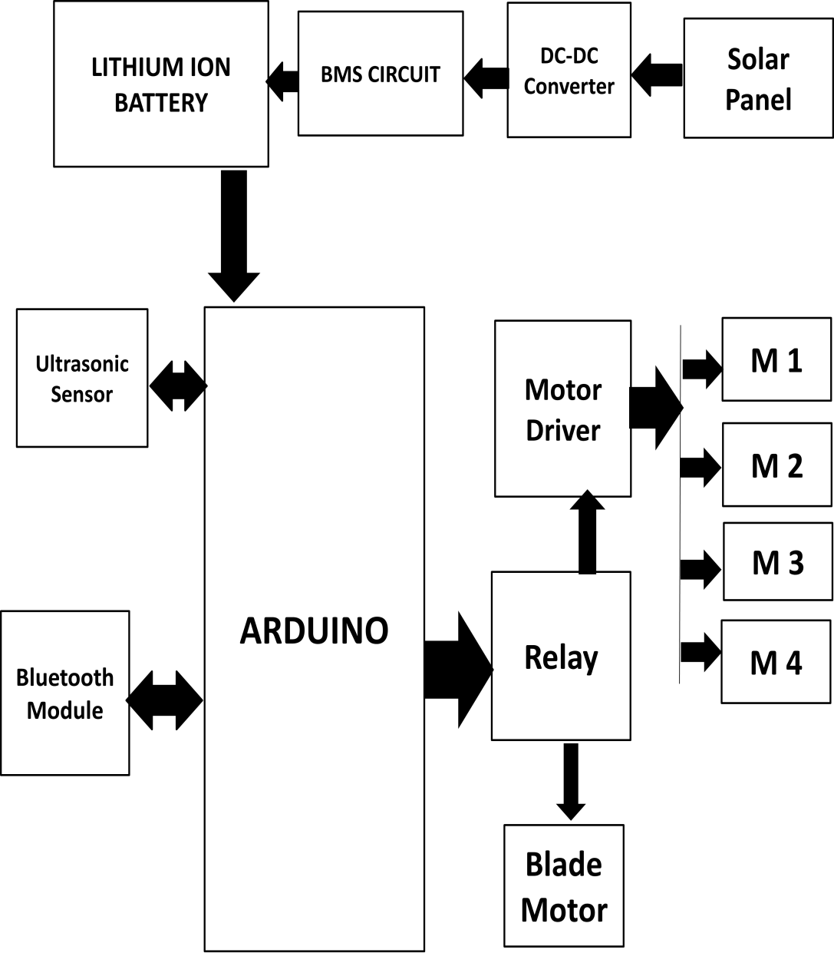

6. WORKING
The working of solar electric grass cutter, it has panels mounted in a particular
Arrangement in such a way that it can receive solar radiation with high
Intensity easily from the sun. These solar panels convert solar energy into
Electrical energy now this electrical energy is stored in batteries by using a solar
Charger. The main function of solar charger is to increase the current from the panels while batteries are charging, it also disconnects the solar panels from the
Batteries when they are fully charge and also connect to the panels when the
Charging in batteries is low. The motor is connected to the batteries through the connecting wires. it starts and stops the working of the motor, from this motors the powered transmits to the mechanism and this makes the blade to slide on the fixed blade and this makes the cut out the grass. The solar electric grass cutter operated by Bluetooth module / wireless remote, moves forward and backward direction by given command of user, contains four motors which are connected by separate wheels and one motor for grass cutter. Battery gives power to vehicle motor and also grass cutter motor in inner part of device have a set of blades which cut the grass to avoid any damage of blade to the object / human/ animal, ultrasonic sensor is used. Micro controller turns the vehicle until it gets clear of the object and moves the grass cutter again in forward direction.

7. ADVANTAGES

1. It is pollution free.
2. No required any external supply.
3. It is economical.
4. No any fuel cost.
5. Non skilled person can also operate.
6. Easy to move from one place to another place.
7. Freedom from long extension wires.

DISADVANTGES
1. More time required for charging the battery.

APPLICATIONS

1. Agriculture.
2. Playgrounds.
3. House gardens.
4. Small farms.
5. Colleges.

8. CONCLUSION

In the world today, all machines are designed with the aim of reducing or
Eliminating greenhouse gas emissions which is the major causes of climate
Change. The solar powered grass cutter will meet the challenge of environmental production and low cost of operation since there is no cost for fuelling. A solar electric grass cutter has been developed for the use of residence and establishment that have lawns where tractor driven movers could not be use. The machine capacity is adequate for its purpose the machine has proved to be a possible replacement for the gasoline powered grass cutter. The solar grass
Cutter which was designed such that the solar plate generates solar energy and
Utilizing this energy for the running the grass cutter motor & also for running
The wheels. Integrating futures of all the hardware components used have been
Developed in it. Presence of every module has been reasoned out and placed
Carefully.
9. FUTURE SCOPE
This can be further improved by incorporating the following modification to
Obtain better result. The mechanism given expected efficiency. This efficiency
Can be increased by using some other mechanism and speed of the motor is high because we have used light material and design of blades should be done based on types of grass used to cut. In future we can modify this model and improve its efficiency and make it easier to use. We can limit the energy consumption by using high rated or efficiency motor and parts. Finally, this project may give an inspiration to the people who can modify and can obtain better results

10. REFERENCE
[1] P.Amrutesh, B.Sagar and B.Venu, solar grass cutter with liner blades
By using scotch yoke mechanism, international journal of engineering,
Research and application.vol, 4, 2016, 2248-9622.
[2] E.Naresh, Boss babu and G.Rahul cutting machine by solar power,
International journal and magazine of engineering, technology, management
And research, vol.3, 2016, 2348-4845.
[3] Sujendran S.and Vedanta P.smart lawn mower for grass trimming
International journal of science and research, vol.3, 2014, 2319-7064
[4] Praful P.Ulhe, Manish D. Inwate, Fried D.Wankhede and
Krushnakumar S.Dhakle modification of solar grass cutting
Machine, international journal for Innovative research in science and
Technology, vol.2.2016, 2349-6010.
[5] Sultan Mohyuddin, Digesh K D, Vivek T K, Nazeya Khanam F and
Vidyashree H V, Automatic Grass Cutter, International Journal of Science,
Technology and Engineering, Vol.2, 2016, 2349-784X.

