Gender Equality in the Light of Tagorean Thoughts and Practices: An Analysis
Indrajit Mahato¹, Manmohan Ojha², Shabnam Parween³, Dr. Mazhar Shamsi Ansary⁴ & Dr. Pritilaxmi Swain⁵
- Ex-student, Department of Education, Vinaya-Bhavana, Visva-Bharati, Bolpur, Santiniketan, West Bengal, India. Email: mahatoindrajit22@gmail.com
- M.A. Student Department of Education, Sidho-Kanho-Birsha University, Purulia, West Bengal, India. Email- manmohanojha04@gmail.com
- Ex-student, Department of Political Science, Sidho-Kanho-Birsha University, Purulia, West Bengal, India. Email: ruhi7806@gmail.com
- Assistant Professor, Department of Education, Netaji Nagar College for Women, Netaji Nagar, Kolkata, West Bengal, India. Email: msansary2015@gmail.com
- Assistant Professor, Department of Sanskrit, Pali and Prakit, Bhasha Bhavana, Visva-Bharati, Bolpur, Santiniketan, West Bengal, India. Email: pritisans@gmail.com
Abstract:
Rabindranath Tagore, the Nobel laureate in literature, is one of the greatest poets, philosophers, humanitarians, social workers, freedom fighters, and prominent promoters of international understanding, not only in the context of West Bengal but also in India. He produced a large number of poetries, books, and novels that were written in different contexts and at various times. The long-standing prejudice between men and women is the cause of the society's backwardness. At that time too, one of the biggest predicaments was gender discrimination. 'Satidaho Protha', 'Balyo Bibaho', 'Bohu Bibaho', etc., as well as the class system were extremely cruel and vicious social systems, which stirred Tagore's imagination. He has therefore made an effort to combat gender discrimination through his writing and other endeavours. The fact that gender equality is now seen as one of the objectives of sustainable development is due to the persistence of gender discrimination. This qualitative study attempts to highlight the theoretical and practical work of Rabindranath Tagore in eradicating gender discrimination. This study is delimited to various short stories and poems by Rabindranath Tagore to analyse the theoretical aspect and the activities of Visva-Bharati to analyse the practical aspect.
Keywords: Rabindranath Tagore, SDGs, MDGs, Gender Equality, Visva-Bharati.
Introduction:
“Why should you not let woman empowered
be/with right to conquer her own destiny”
-Sobola by Rabindranath Tagore

Rabindranath is an ideal name in the history of Bengali and world literature. He was a poet, a writer, a philosopher and a social worker. Rabindranath Tagore was born on May 7, 1861 (25 Baisakh) in his ancestral home at Jorasanko, Kolkata (Mondal, 2019). He was opposed to traditional education from childhood. So, his thought also developed against the traditional belief. As the family was prosperous and educated, there was no shortage in his education and life. The impression of which, we can see in his various writings and activities. His pen has burned again and again to show a new direction to the society as well as the country. He was always trying to eradicate the ills of the society. He won the Nobel Prize in 1913 for his outstanding contribution to literature (Islam, 2022). We also remember him as a social reformer. Tagore wanted to open people's eyes through various social progressive writings such as women empowerment, elimination of gender discrimination etc. Rabi (the sun) in which society saw a new direction has set forever on 7th August 1941 (22nd Shravan). Yet his rays i.e., achievements are still illuminating us and showing a new direction to the society.
Rabindranath Tagore, being far-sighted and prudent, realized long ago that gender inequality was standing in the way of social progress. Without the equal rights and roles of men and women, the progress of the society and the country is not possible. As we keep pace with science and technology, we have become aware of the harmful effects of this disorder much later. The Millennium Development Goals (MDGs) program was adopted by the United Nations in 2000, with gender equality and women's empowerment as the third goal to be achieved by 2015 (Kabeer, 2005). Then another program called Sustainable Development Goals (SDGs) was adopted in 2015, which is said to be completed by 2030 where gender equality and women's empowerment are included in goal number five (Mohandas, 2018). To present a new society to the next generation, we have tried to eliminate the ills of the entire society. And behind our awareness there is a great contribution of Rabindranath, which we can know from his various works.
Rabindranath Tagore's language of protest was a little different. He chose the pen as a weapon of protest. While Nazrul Islam protested against gender discrimination through his poems like- Manush (Human), Nari (Woman), Rabindranath also wrote Chokher Bali (A Gain of Sand), Nastonirh (The Broken Nest), Manbhanjan (Fury Appeased) etc. In the short stories various fictional rebellious women (Charulata, Binodini, Giribala) spoke out against the so-called rules and order of the society (Sarkar, 2021). However, Rabindranath Tagore did not only resort to writing to restore gender equality, he also tried to restore gender power in practical ways. We can see this reflection in various programs, reading methods etc. of his creation Visva Bharati University (Sinha, 2020). That is, Rabindranath Tagore has hurt gender discrimination from both theoretical and practical aspects.
Objectives:
- To analysis the concept of Gender Equality in the theoretical perspective of Rabindranath Tagore.
- To elaborate the concept of Gender Equality in the practical perspective of Rabindranath Tagore by Visva-Bharati.
Methodology:
Qualitative method was used to analyze the objectives of this study. Primary and secondary sources have been used as sources of information. Rabindranath's various writings and information obtained from Visva-Bharati have been taken as primary data and various writings on Rabindranath and Visva-Bharati as secondary data.
Analysis:
Objective No. 1: To analysis the concept of Gender Equality in the theoretical perspective of Rabindranath Tagore.
Rabindranath Tagore, a campaigner of Feminist writing, always treats her female characters equal to their male counterpart. And this commitment towards the right of women makes him the true preacher of gender equality in India. In this section the authors have attempted to concentrate on several texts by Rabi Thakur that place an enormous value on eradicating gender inequality or strengthening gender equity. Below are some noteworthy writings that are highlighted:
Chokher Bali (1901)-
One of Rabindranath’s short story is Chokher Bali. Here Tagore takes the help female character named Binodini to make us aware of gender discrimination. If we analyse statements of Bionodini from this story, this will clarify the matter better.
If I had been uneducated, like other widows, I would have been able to easily endure society’s negligence.
Unlike other contemporary novelists of his age, he chooses a female character as the protagonist for this novel “Chokher Bali”. Not only this, but he makes her educated unlike other general women in that time. That’s why these above words uttered by Binodini reflect Tagore’s deep concern about empowerment of Women community and a heartfelt demand of equality for the women from the society.
Binodini here saying that, if, were an uneducated woman like the other women in the society then it would be easy for her to accept the negligence, insults, and torments from the society. But as Tagore gives her the opportunity of education, which has given her to fight for her right dignified place in the society. So here Tagore unlike other writer gives her character a new arch of education and makes her way smooth to the equal right for herself (Thakur, 1420).
Ghare Baire (1916)-
We know that, from the medieval time women are treated as inferior to a man. But it is wrong and full of prejudices. The real fact is that women and man are equal but our societies evolved through the time in such a way that people are used to think that man is superior. But this is not the case. At least Tagore proves it wrong and makes the women community more modern and braver in his creation of female Character.
Man can only think. Women have a way of understanding without thinking. Women were created out of God’s own fancy. Man, He had to hammer into Shape.
Here in these words Tagore gives more focus on the inner psyche of the female character which is much sharper and smarter than a male mindset. And that is the reason why Tagore is saying that God created Women out of his own fancy rather than by hammering them.
For we women are not only the deities of the household fire, but the flame of the soul itself
Gender equality is the essence of Tagore’s writings. He is always a modern thinker and a great philosopher of India who has a great vision for women empowerment. That is why he in his earlier phase of life understands the importance of women community for a nation to develop. And for women he does not refer to the urban elite women but women who have engaged themselves in the household works. Because they represent the major chunk of women of Indian society.
Here in these lines Tagore is expressing the importance of women in their domestic life. For this reason, through this line, he affirms that women are not only the deities or the Goddess tin a symbolic way they are the essence of the creation. So, through these marvellous lines, Tagore gives proper importance to the women community.
Samapti (1893)-
The most important aspect of Tagore is the rebellious nature of his female characters. Because of this nature which helps them to create a counter narrative against the male dominated society. And makes Tagore a real Prism from where the lights of Equality of Gender and Women Empowerment come out.
All the rules are wrong. Did anyone try to find what I like? You like me and I Should just follow all the rules.
Here in these lines, Tagore is talking about the nature of the rules and norms of the society which are very much misogynistic. Because in the male dominated society all the rules are created for and against women. Not any rule for man. What a woman wants is not the priority of the society. She has also a life and room of her own. But this society does not give any priority to it. Rather it makes more rules to restrain their freedom. But the uniqueness lies in the fact that the character does not accept traditional views but rather they fight against it.
The expression of her face is like a boy, not has any fear. Unlike other girls in the society the body is healthy and she does not have shame as the ornament of every girl.
To escape from the Patriarchal chain of rule one must have to be rebellious. And from the perspective of the first wave of feminism where the women try to reject their own identity and tries to take over the identity of their male counterpart.
Here in the short story Samapti the protagonist is Mrinmoyee who is a tomboy. She plays cricket in the mud and all other stuffs which a male child can do in the Indian society. But Tagore reverse this order of the society through this character. And she is rebellious not only playing and other things but in the moment of her marriage too she expresses her negative reaction towards it. Furthermore, she cuts her hair before the wedding. She is always placed as the representation of nature in the story who cannot be caged in the household activities.
Strir patra (1914)-
In this text Tagore portrays the most powerful women calling out the evils of patriarchy. Mrinal leaves husband and takes refuge in an island. And after fifteen years she writes a letter explaining that her husband attempted to kill her passions and talents, treated her as an accessory, and never stood up for the wrongs his family did to her, and thus lost her respect a long time ago.
I am Mejo- Bou, the second bride in your joint family. Today, fifteen years later, standing at the edge of the ocean, I understand that I also have other relationship, with the world and the World -Keeper.
Through Mrinal, Tagore describes a woman who is not afraid to choose herself before her husband and his family. And it is the indicator of gender equality and women empowerment. That is the reason despite a rigorous oppression from the society towards her bold nature and her decision to become a writer and create an independent space and time for herself.
Nashtanirh (1901)-
The main female character of this story that is Charulata lived a comfortable but emotionally void life with her ever-busy journalist husband, who had no time for her talents. She is a good singer and a writer who can write. The entry of his brother, Amal, who inspires her the most to take writing and singing as an alternative career option. And although she begins to discover her nascent talents, she chooses to remain with her husband.
Here Tagore explores the idea of a woman taking reins of her own desire and ambition and making a choice of her own violation. This gives a glimpse of how Tagore create the discourse in the human society about gender equality and woman empowerment.
Kshudhita Pashan (1895)-
When, like the river, we women keep to our banks, we give nourishment with all that we have: when we overflow them, we destroy with all that we are.
The women have two major identities in our society; on the one hand, she is the mother, and nourisher of her child. On the other she is the destroyer of the world. So, the world of Tagore is full of conflict. As a representative of modern world, he supports rights of the women and as a part of the traditional family he also does not try to fully abolish the norms of the society. Tagore always shows us the reality and leave it to the reader to take the ultimate decision on it. But so far as woman empowerment is concern, he is always proving himself as the best representative of the deprived women and the woman who has been in the marginal due to the patriarchal norms of the society (Thakur, 1368).
Sobola (1928)-
Through the poem ‘Sabla’, Rabindranath Tagore asked women to work hard to reach their goals. He questioned God about giving this right to women in a male-dominated society. If women are given rights, they will be able to write their own destiny. So the poet says –
Naarike apon vagya joy karibar
Keno nahi dibe aadhikar
Hey bidhata ?
-Sobola by Rabindranath Tagore

Abichar-
Through the poem of ‘Abichar,’ the poet shows that women are bound by the so-called rules and regulations of the society. The poet urged the male race to stand by the women. Only then will women be freed from the shackles of society and equality between men and women will return to society.
Akoda purush jadi paaper birudhhe
Daraye narir pase nahi naame juddhe
Ardhek kali makha samajer bukhta
Khabe tobe baare baare sanir chabukta.
-Abichar by Rabindranath Tagore
Manasi-
In the poem ‘Mansi,’ the poet shows that the main obstacle for women to come to the forefront is of the men. Because in this society men have arranged women as their own. Therefore, it is said at the beginning of the poem –
Sudhu bidhatar sristi naaha tumi naari
Purush gareche tore soundarjya sanchari.
-Manasi by Rabindranath Tagore

To satisfy their desires, the male race has been managing women in the society like themselves. For which the poet strongly protested against the male race. The main cause of gender discrimination is male caste. To highlight this heinous crime of men, the poet says-
Lajja diye, sajja diye, diye abaran,
Tomare durlav kari kareche gopan.
Pareche tomar pore pradipta basana-
Ardhek manabi tumi ardhek kalpona.
-Manasi by Rabindranath Tagore

Kalantar-
Rabindranath Tagore has tried to highlight women's power in various poems as well as essays. So, ‘Kalantar’ compares the power of women with the power of God in the article. The woman we have always neglected is the woman who holds the life of every human. So he said - Women are the oldest in human creation. Women's power in male society can be called Adya Shakti. It is this energy that carries life to life, sustains life.
-Kalantar by Rabindranath Tagore
So, we can say that, the seeds of women empowerment and gender equality are major characteristics of Tagore’s writings.
Objective No. 2: To elaborate the concept of Gender Equality in the practical perspective of Rabindranath Tagore by Visva-Bharati.
In Rabindranath Tagore we notice a different enthusiasm. While other writers tried to eliminate gender inequality through their writings, Rabindranath tried to bring back gender equality through some practical actions while writing. One of his famous achievements is Visva Bharati University which is now the only Central University of West Bengal. From teaching-learning system to festivals in this university, we can observe spontaneous participation of students without gender discrimination.
- Teaching-learning system in Visva-Bharati:
Children study together in a free discipline under the open sky in the university premises. This tradition has been going on for a long time. Girls participate spontaneously in the same way that boys participate in the teaching-learning process. Such practices go a long way in eradicating gender discrimination from the minds of children.

Figure 1: All are equally participated in teaching-learning process (Prahlad Sir was taking the PG class)
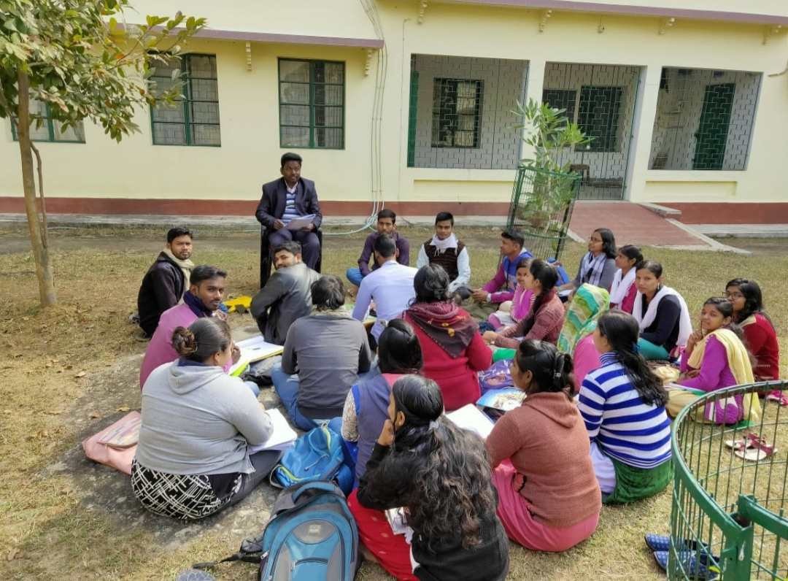
Source: Researchers’ depiction
- Festivals of Visva-Bharati:
Along with the teaching learning, various festivals and events are celebrated in this university, which helps to distinguish this institution from other institutions. In this context, India's first Prime Minister Jawaharlal Nehru said while accepting the Visva Bharati Bill, "We have looked upon this not only as a very great institution but as a very special and unique institution and we are particularly anxious that it should not fall into the rut of other universities.”. Among the festivals celebrated in Visva Bharati are Vasanta Utsav, Raksha Bandhan, Anand Bazar, Paush Utsav etc. (Yadav & Nath, 2022). Children spontaneously participate and rejoice in all festivals. Irrespective of caste-religion-caste-gender they feel one.
Figure2: Ananda bazar mela Figure 3: Vasanta Utsav
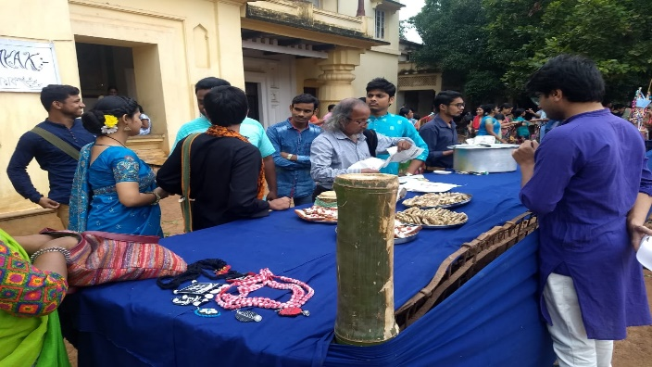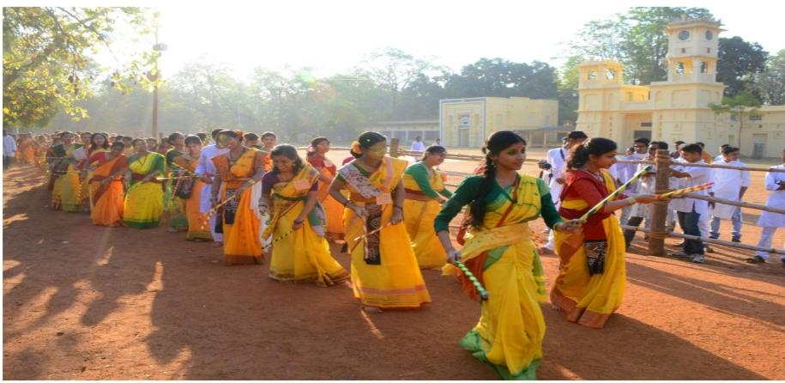
Source: Researchers’ depiction
- ICC for PSHWW:
Internal Complaints Committee for Prevention of Sexual Harassment against Women at Workplace (ICC for PSHWW) has been formed so that the dignity of girls and women studying and working in Visva Bharati is not degraded and they are not subjected to sexual harassment in any way. One of the causes of gender discrimination is sexual violence against girls and women. As a remedy for this and to bring back gender equality, this concern adopted by Visva Bharati is quite fruitful.
- NSS and NCC:
Apart from studies and sports, the children of this university are equally interested in country service and social service work. Hence, they spontaneously join National Service Scheme (NSS) and National Cadet Corps (NCC) equally.
Figure4: NSS and NCC parade practice
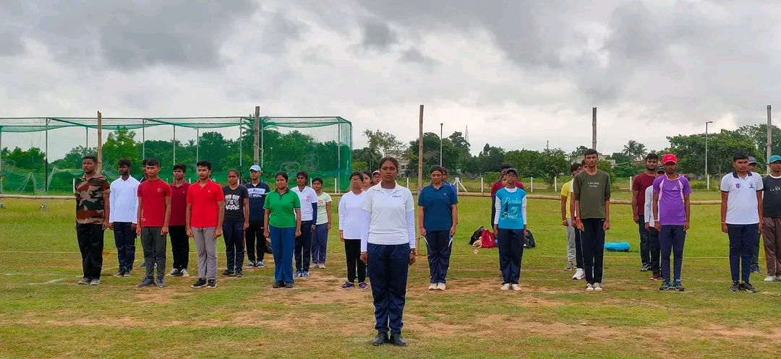
Source: Researchers’ depiction
- Upasana Griha:
Rabindranath established a house of worship every Wednesday morning for all those associated with Visva Bharati to connect with the spiritual world. Currently, students also join together here. Girls also play important roles in various events.
Figure 5: Upasana Griha
Source: Researchers’ depiction

Conclusion:
Rabindranath has played one of the important roles behind the child-centeredness that we can see in the current education system and reformation of the society. Rabindranath Tagore's contributions in both theoretical and practical fields are truly unforgettable in removing the main obstacle behind social progress, i.e., gender discrimination. As he has created a stir in people minds by his various short stories, he has shown how to eliminate gender discrimination through the activities of Visva Bharati. He also tried to eliminate this discrimination with the female members of the Tagore family. That is, we can observe the same mentality among the members of the Tagore family. Rabindranath Tagore's role as a pioneer, this time as his successor, we need to focus on this. For which Rabindranath Tagore said in a letter to Gandhiji about Visva Bharati, “Visva-Bharati is like vessel which is carrying the cargo of my life’s best treasure, and I hope it may claim special care from my countrymen for its preservation.”

References:
- Islam, M. (2022). A study of life history of Rabindranath Tagore and his contribution to Bengali literature. International Research Journal of Modernization in Engineering Technology and Science, 4(12), 925-929.
- Kabir, N. (2005). Gender equality and women’s empowerment: A critical analysis of the third Millennium Development Goal. Gender and Development, 13(1), 13-25.
- Mohandas, P. (2018). Sustainable Development Goals (SDGs)- Challenges for India.Indian journal of public health research and development, 9(3), 1-10. https://doi.org/10.5958/0976-5506.2018.00172.9
- Mondal, P. K. (2019). Educational thoughts of Rabindranath Tagore’s and it’s relevance in present education. Journal of Emerging Technologies and Innovative Research (JETIR), 6(3), 1-8.
- Sarkar, R. (2021). Breaking the stereotypes: A historical analysis of gender justice in Tagore’s short stories. International journal of creative research thoughts (IJCRT), 9(7), b110-b120.
- Sinha, K. A. (2020). Rabindranath: Santiniketan, Sriniketan and Visva-bharati(2nd ed.). Akshar Publication.
- Tagore, R. (1302). Manasi. Retrieved from- https://www.bangla-kobita.com/rabindranath/manoshee/
- Tagore, R. (1328). Sobola. Retrieved from- https://www.tagoreweb.in/Verses/mahuya-88/sobola-1047
- Tagore, R. (1368). Rabindra rachanabali. Shri Gouranga Press Private Limited.
- Tagore, R. (1420). Rabindra UponyasSamagra. Arjun Saha Subham.
- Tagore, R. (1425). Kalantar. Amrit sen.
- Tagore, R. Abichar. Retrieved from- https://kobita.mohool.in/index.php/%E0%A6%95%E0%A6%AC%E0%A6%BF%E0%A6%A4%E0%A6%BE%E0%A6%B0-%E0%A6%AC%E0%A6%BF%E0%A6%B7%E0%A7%9F/16-2019-10-09-08-04-21/585-%E0%A6%85%E0%A6%AC%E0%A6%BF%E0%A6%9A%E0%A6%BE%E0%A6%B0-%E0%A5%A4%E0%A5%A4-%E0%A6%B0%E0%A6%AC%E0%A7%80%E0%A6%A8%E0%A7%8D%E0%A6%A6%E0%A7%8D%E0%A6%B0%E0%A6%A8%E0%A6%BE%E0%A6%A5-%E0%A6%A0%E0%A6%BE%E0%A6%95%E0%A7%81%E0%A6%B0
- Yadav, S., & Nath, R. (2022). Cultural events in Visva-Bharati and the embedded values. MERI Journal of Education, 15(2), 74-79. Retrieved from- https://www.researchgate.net/publication/372891205_Cultural_Events_in_Visva-Bharati_and_the_Embedded_Values.

