Bianchi Type-I String Cosmological Models in the Self Creation Theory for Five Dimensional Space-Time

Jagat Daimary¹
¹Department of Mathematical Sciences,
BodolandUniverity, Kokrajhar, BTR, Assam, PIN-783370
kokrajhar, India
e-mail address:jagatdaimary@gmail.com¹

Jiten Baro^{*2}
²Department of Mathematical Sciences,
Kamrup College, Chamata, Nalbari, Assam,
PIN-781306
Nalbari, India
e-mail address: barojiten5@gmail.com^{*2}

ABSTRACT
We have defined a five-dimensional Bianchi Type-I String cosmological model in the framework of Barber's second self-creation theory for the case Reddy string $(ρ+λ=0)$ in this study. We assumed that the Eigen value $σ_{1}^{1}$ of the shear tensor $σ_{i}^{j}$ is proportional to the scalar expansion to derive a determinate solution of Barber's self creation field equations. We have discussed some of the physical and kinematic parameters of the model here. We defined in this research that the universe has remained anisotropic throughout its evolution. We also discovered that the model decelerates in a predictable manner. However, after the compactification transition and cosmic re-collapse, the universe will accelerate in finite time. Using the self creation theory for a five-dimensional space-time, we defined a new solution to the field equations for Bianchi type-I string cosmological models.

Keywords—Bianchi type-I; Five dimensions; String source; self creation theory; Reddy string.

INTRODUCTION

The study of String theory is required in the early stages of the universe's evolution, prior to the production of particles. Cosmic strings have attracted a lot of attention in cosmology because they are thought to cause density perturbations that guide the formation of galaxies [1]. The general relativistic approach of strings was pioneered by Letelier[2,3] and Stachel[4]. Many authors [5-15] have looked into various parts of string cosmologies in both the theory of relativity and alternative gravity theories. Massive strings are used to build the cloud instead of geometric strings. A geometric string with particles connected to its extension develops any enormous string. It's the simplest model because we're dealing with particles and strings at the same time. In theory, we can eliminate the strings and finish with a cloud of particles. Because strings are not detected at the current stage of the universe's evolution, it is an endearing character of a model of a string cloud to be used in cosmology.
Many authors have recently expressed an interest in researching theories with more than four space-time dimensions in which other dimensions are reduced to extremely small sizes, sizes that are beyond our current experimental detection capability[16]. Chodos and Detweller[17] proposed a cosmological dimensional contraction technique in which the five-dimensional cosmos devolves naturally into a four-dimensional universe as a result of dimensional contraction. Marciano [18] proposes that measuring time variations in fundamental constants experimentally could provide persuasive evidence for the existence of other dimensions. Many cosmologists [19-33] have looked into higher-dimensional cosmological models with a variety of matter fields.
Adjusting Brans-Dicke theory[34] and general relativity, Barber[35] has introduced two self-creation theories. Self-contained gravitational and matter fields are used to create the universe in these ideas. Barber's first theory is contradictory and unexpected with experiment, according to C. H. Brans [36] and Barber's second theory is an adjustment of general relativity to a G-variable theory. The scalar field, according to Barber's theory, merely separates the matter tensor that acts as a reciprocal gravitational constant.
The Barber’s second self creation theory field equations are given by
$$R^{ij}-\frac{1}{2}g_{ij}R=-\frac{8π}{ϕ}T_{ij} (1)$$
and
$$□ϕ=\frac{8}{3}νT (2)$$
Here $□ϕ=ϕ_{;k}^{k}$ represents the invariant D’Alembertian and $T_{ij}$ denotes the trace of energy momentum tensor which is representing all non-gravitational and non-scalar field matter and energy. Here ν denotes a coupling constant to be defined from experiments. The calculations of the deflection of light prevents the value of the coupling to $\left|ν\right|≤{10}^{-1}$. If ν⟶ 0, this theory approaches to Einstein's theory in every respect.
and
$$T_{;j}^{ij}=0 (3)$$
This follows from the field equation (1) and (2).

In this research, we used Reddy string $(ρ+λ=0)$ inside the framework of Self-Creation theory to derive a Bianchi type-I string cosmological model. We discussed the higher dimension, string cosmology, and Barber's second self-creation theory in the first section. In section II, the Bianchi type-I metric is presented, and the field equations for general relativity are found. We looked into the solution of the survival field equations in section III. In Section IV, we defined the models' physical and kinematical parameters. In section V, we went over the physical and geometrical nature of our model with a graph. Finally, in section VI, we introduced the conclusion.

METRIC AND FIELD EQUATIONS

Let us consider five dimensional LRS Bianchi type-I metric in the following form
$$ds^{2}=-dt^{2}+A^{2}\left(dx_{1}^{2}+dx_{2}^{2}\right)+B^{2}dx_{3}^{2}+C^{2}dx_{4}^{2} (4)$$
Here A, B and C are function of Cosmic time t. For cosmic string the energy momentum tensor is taken as follows
$$T_{j}^{i}=ρu^{i}u_{j}-λx^{i}x_{j} (5)$$
where 𝜌, λ denotes the energy density and the tension density of the system of string respectively. Both are function of cosmic time t and $u^{i}, x^{i}$ represents the system five velocities and direction of anisotropy respectively.
The direction of string satisfies the following relations
$$u^{i}u_{i}=-x^{i}x_{i}=-1 and u^{i}x_{i}=0 (6)$$
We assume
$$ρ=ρ_{p}+λ (7)$$
where, $ρ_{p}$ represents the rest energy density of the particles. Here 𝜌 and $ρ_{p}$ may be positive or negative.
For metric (4), we obtain the spatial volume V, scalar expansion Ѳ, the Hubble parameter H, deceleration parameter q, the shear scalar σ in the following way, respectively.
$$V=R^{4}=A^{2}BC (8)$$
$$Ѳ=u_{,i}^{i}=2\frac{A'}{A}+\frac{B'}{B}+\frac{C'}{C} (9)$$
$$H=\frac{R'}{R}=\frac{1}{4}\left(2\frac{A^{'}}{A}+\frac{B^{'}}{B}+\frac{C^{'}}{C}\right) (10)$$
$$q=-\left(\frac{H^{'}+H^{2}}{H^{2}}\right) (11)$$
$$σ^{2}=\frac{1}{2}σ_{ij}σ^{ij}=\frac{1}{2}\left[2\frac{{A'}^{2}}{A^{2}}+\frac{{B'}^{2}}{B^{2}}+\frac{{C'}^{2}}{C^{2}}\right]-\frac{Ѳ^{2}}{8} (12)$$
where prime symbol represents ordinary differentiation with respect to cosmic time t.
The Barber's second self creation theory the field equations (1) and (2) with (3), for the metric equation (4) can be define as follows
$$\frac{A″}{A}+\frac{B″}{B}+\frac{C″}{C}+\frac{A'B'}{AB}+\frac{A'C'}{AC}+\frac{B'C'}{BC}=\frac{8π}{ϕ}λ (13)$$
$$\frac{A″}{A}+\frac{B″}{B}+\frac{C″}{C}+\frac{A'B'}{AB}+\frac{A'C'}{AC}+\frac{B'C'}{BC}=0 (14)$$
$$2\frac{A″}{A}+{(\frac{A'}{A})}^{2}+\frac{C″}{C}+2\frac{A'C'}{AC}=0 (15)$$
$$2\frac{A″}{A}+{(\frac{A'}{A})}^{2}+\frac{B″}{B}+2\frac{A'B'}{AB}=0 (16)$$
${\left(\frac{A^{'}}{A}\right)}^{2}+2\frac{A^{'}B^{'}}{AB}+2\frac{A^{'}C^{'}}{AC}+\frac{B^{'}C^{'}}{BC}=\frac{8π}{ϕ}ρ \left(17\right)$
$ϕ^{″}+\left(2\frac{A'}{A}+\frac{B'}{B}+\frac{C'}{C}\right)ϕ^{'}=\frac{8π}{3}ν\left(λ+ρ\right) \left(18\right)$
$$ρ^{'}+\left(2\frac{A'}{A}+\frac{B'}{B}\right)ρ+\left(ρ-λ\right)\frac{C'}{C}=0 (19)$$

SOLUTION OF THE FIELD EQUATIONS

Here the fields equations (13) - (18) are six independent equations involving six unknowns (A, B, C, p, 𝜌 and 𝜙). In order to define a determinate solution, we consider the Eigen value $σ_{1}^{1}$ of shear tensor $σ_{i}^{j}$ is proportional to the expansion Ѳ and without loss of generality it leads to
$$C=A^{2}B (20)$$
The field equations (13)-(19) with the help of (20) become as follows
$$3\frac{A″}{A}+2\frac{B″}{B}+4{(\frac{A'}{A})}^{2}+{(\frac{B'}{B})}^{2}+8\frac{A'B'}{AB}=\frac{8π}{ϕ}λ (21)$$
$$3\frac{A″}{A}+2\frac{B″}{B}+4{(\frac{A'}{A})}^{2}+{(\frac{B'}{B})}^{2}+8\frac{A'B'}{AB}=0 (22)$$
$$4\frac{A″}{A}+\frac{B″}{B}+7{(\frac{A'}{A})}^{2}+6\frac{A'B'}{AB}=0 (23)$$
$$2\frac{A″}{A}+\frac{B″}{B}+{(\frac{A'}{A})}^{2}+2\frac{A'B'}{AB}=0 (24)$$
$$5{(\frac{A'}{A})}^{2}+{(\frac{B'}{B})}^{2}+6\frac{A'B'}{AB}=\frac{8π}{ϕ}ρ (25)$$
$$ϕ^{″}+2\left(2\frac{A'}{A}+\frac{B'}{B}\right)ϕ^{'}=\frac{8π}{3}ν\left(λ+ρ\right) (26)$$
$$ρ^{'}+\left(2\frac{A'}{A}+\frac{B'}{B}\right)ρ+\left(ρ-λ\right)\left(2\frac{A'}{A}+\frac{B'}{B}\right)=0 (27)$$
For this paper we define string cosmological models for Reddy string i.e,
$$ρ+λ=0 (28)$$
With the help of (28), equation (27) becomes
$$ρ=\frac{L}{C^{3}} (29)$$
where, L is a constant of integration. Also by applying (28) in equation (26) we get
$$ϕ^{'}=\frac{D}{C^{2}} (30)$$
D is the constant of integration.
From equation (21) and (25) with the help of equation (28) we get,
$$3\frac{A″}{A}+2\frac{B″}{B}+9{(\frac{A'}{A})}^{2}+2{(\frac{B'}{B})}^{2}+14\frac{A'B'}{AB}=0 (31)$$
Also, from equation (22) and (23) we get,
$$-\frac{A^{″}}{A}+\frac{B^{″}}{B}-3{\left(\frac{A^{'}}{A}\right)}^{2}+{\left(\frac{B^{'}}{B}\right)}^{2}+2\frac{A^{'}B^{'}}{AB}=0 (32)$$
Again From equation (31) and 3 times of (32) we get
$$\frac{B'}{B}\left(\frac{B″}{B}+\frac{B'}{B}+4\frac{A'}{A}\right)=0 (33)$$
From equation (33) we get the following cases

Case (i):$\frac{B″}{B}+\frac{B'}{B}+4\frac{A'}{A}=0$Case (ii):$B^{'}=0$
Case (iii):$\frac{B″}{B}+\frac{B'}{B}+4\frac{A'}{A}=0$ and $B^{'}=0$
Now,
Case (i): For this case we get
$$B^{2}=2\int{\frac{m_{1}}{A^{4}}dt}+m_{2} (34)$$
where$m_{1}$ and $m_{2}$ are constants of integration. Here by taking different values to A we get different values of B. So we get infinite number of solution for B which shows that the solution is not unique in this case. Hence we assume the same case in another way as follows
$$\frac{B″}{B}+\frac{B'}{B}=-4\frac{A^{'}}{A}=m (35)$$
From equation (35) we get
$$B^{2}=2\left(\frac{m_{1}}{m}e^{mt}+m_{2}\right) (36)$$
and
$$A=m_{3}e^{-\frac{mt}{4}} (37)$$
where${ m}_{1}$, $m_{2}$ and $m_{3}$ are constants of integration.
From equation (20) we have
$$C=m_{4}{2e^{-mt}\{\left(\frac{m_{1}}{m}e^{mt}+m_{2}\right)\}}^{\frac{1}{2}} (38)$$
where$m_{4}$ is constant of integration.
Now by taking the proper choice of coordinates, constants and with the help of equations (36), (37), (38) we can write metric (4) as follows
$$ds^{2}=-dt^{2}+e^{-\frac{mt}{2}}\left(dx_{1}^{2}+{dx}_{2}^{2}\right)+\left(e^{mt}+\frac{m}{I}\right)dx_{3}^{2}+\left(e^{-mt}+\frac{I}{m}\right)dx_{4}^{2} (39)$$
where$I=(\frac{m_{1}}{m_{2}})$
Case (ii): Here we get
$$B=L (40)$$
L is a constant of integration.
From equation (32) we get
$$A^{4}=4\left(L_{1}t+L_{2}\right) (41)$$
and from (20)
$$C=2L{(L_{1}t+L_{2})}^{\frac{1}{2}} (42)$$
where, $L_{1}$, $L_{2}$ are constant of integrations. Therefore after choosing some suitable coordinates the model (4) can be written as follows
$$ds^{2}=-dt^{2}+t^{\frac{1}{2}}\left(dx_{1}^{2}+dx_{2}^{2}\right)+dx_{3}^{2}+tdx_{4}^{2} (43)$$
Case (iii): Here A, B, C are all constants. So model (4) can be written as follows
$$ds^{2}=-dt^{2}+dx_{1}^{2}+dx_{2}^{2}+dx_{3}^{2}+dx_{4}^{2} (44)$$

PHYSICAL AND KINEMATICAL PARAMETERS

Case (i): In this case we obtain the model (39) which represents an exact five dimensional Bianchi type-I string cosmological model in Barber's self creation theory. For this model we obtain the physical and kinematical parameters rest energy density, tension density, particle density, scalar field, scalar expansion, volume, deceleration parameter and shear in the following way,
$$ρ=M{(e^{-mt}+\frac{I}{m})}^{-\frac{3}{2}}$$
$$λ=-M{(e^{-mt}+\frac{I}{M})}^{-\frac{3}{2}}$$
$$ρ_{p}=2M{(e^{-mt}+\frac{I}{M})}^{-\frac{3}{2}}$$
$$ϕ=\{m_{6}+\frac{m_{5}}{I}\log{(1+\frac{I}{m}e^{mt})}\}$$
$$Ѳ=-\frac{m^{2}}{I}{(e^{mt}+\frac{m}{I})}^{-1}$$
$${V=e}^{\frac{-mt}{2}}{(e^{mt}+\frac{m}{I})}^{\frac{1}{2}}{(e^{-mt}+\frac{I}{m})}^{\frac{1}{2}}$$
$$q=(4\frac{I}{m}e^{mt}-1)$$
$σ={\{\frac{m^{2}}{16I^{2}}{\left(e^{mt}+\frac{m}{I}\right)}^{-2}(3I^{2}e^{2mt}+2mIe^{mt}+m^{2})\}}^{\frac{1}{2}}$, where I = ($\frac{m_{1}}{m_{2}}$) is constant.
Case (ii): Here we define the model (43) which is represents five dimensional Bianchi type-I string cosmological model in Barber's self creation theory.
The physical and kinematical parameters rest energy density, tension density, particle density, scalar field, scalar expansion, volume, deceleration parameter and shear for the model (43) are as follows,
$$ρ=\frac{L}{t^{\frac{3}{2}}}$$
$$λ=-\frac{L}{t^{\frac{3}{2}}}$$
$$ρ_{p}=2\frac{L}{t^{\frac{3}{2}}}$$
$$ϕ=D\log{t+M}$$
$$Ѳ=\frac{1}{t}$$
$$V=t$$
$$q=3$$
$$σ=\sqrt{\frac{11}{8}}\frac{1}{t}$$
The graphical representation of all the parameters are ($M=I=m=1)$

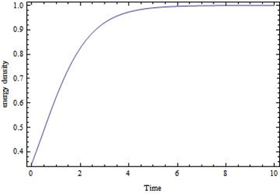
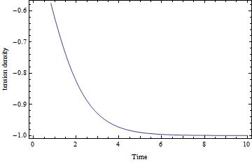
Figure-1. Energy density 𝜌vs. time for case (i) Figure -2. Tension density λ vs. time for case (i)

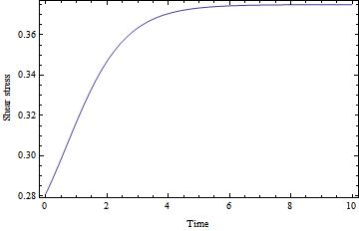
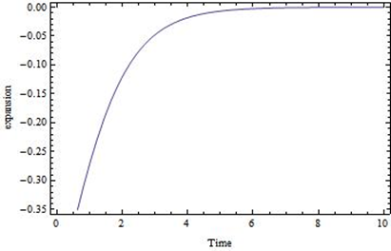
Figure -3. Scalar expansion Ѳ vs. time for case (i) Figure -4.shear stress σ vs. time for case (i)

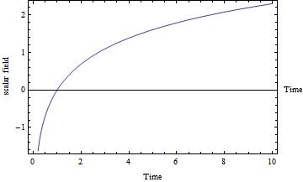
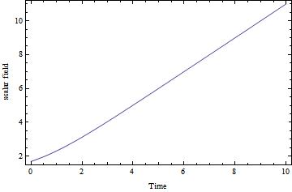
Figure -5. Scalar field ϕ vs. time for case (i) Figure -6. Scalar field ϕ vs. time for case (ii)
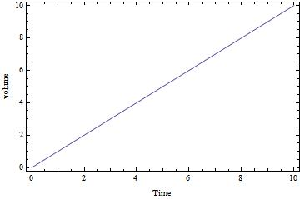
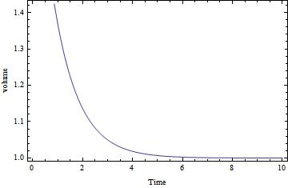

Figure -7. Volume V vs. time for case (i) Figure -8. Volume V vs. time for case (ii)
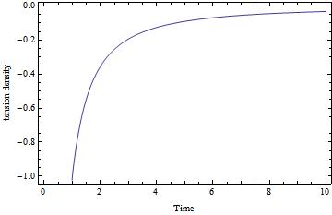
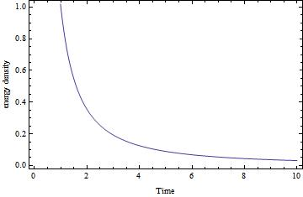

Figure -9. Energy density𝜌 vs. time for case (ii) Figure -10. Tension density λ vs. time for case (ii)
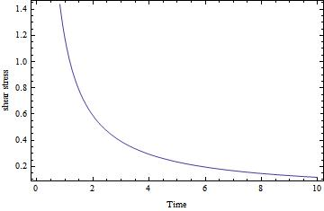
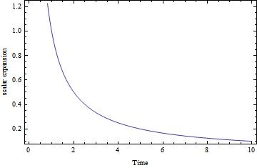

Figure -11. Scalar expansion Ѳ vs. time for case (ii) Figure -12.shear stress σ vs. time for case (ii)

PHYSICAL INTERPRETATIONS

We discuss all the physical and geometric behaviours of the models for Reddy string [i.e., ($ρ+λ=0$)] as follows
Case (i):In this instance, the energy density 𝜌, particle density $ρ_{p}$, scalar field 𝜙, volume V, and shear stress 𝝈 (as shown inFigure-1, Figure-5, Figure-7, Figure-4) rise with time and become infinitely huge as time approaches infinity. But tension density λ and scalar expansion Ѳ (shown inFigure -2, Figure -3) decreases when time is increases also they diverge when time is infinity. For this case the model's Deceleration parameter "q" is decelerating q > 0 at t = 0 and decreasing as time passes, eventually becoming accelerating $q<0$ after a finite period of time. Also, $q→-1$ at t→∞ shows that the current model universe is transitioning from a decelerating to an accelerating phase, indicating that the model is inflating following a deceleration period. Also, $\lim_{t→∞}{\frac{σ^{2}}{Ѳ^{2}}≠0,}$ which shows that the model is not isotropic for large values of time t.
Case (ii): Here, at $t=0$, the model (43) begin with a big-bang and vanishes at t = ∞. The energy density 𝜌, tension density λ, particle density$ρ_{p}$, scalar field 𝜙, scalar expansion Ѳ and shear stress σ (shown inFigure-9, Figure-10, Figure-6, Figure-11, Figure-12) are decreases when time is increases. All of them will vanish when time tends to infinity. At the initial epoch all of them will diverge. Volume V (shown in Figure-8) is increases with increasing time and becomes infinity when time is infinity and will vanish at the initial epoch. Here we get the deceleration parameter $q=3$ which shows that, $q>0$, so the model decelerates in the standard way . Here also the model does not approach isotropy for large values of time t. (Since, $\lim_{t→∞}{\frac{σ^{2}}{Ѳ^{2}}≠0}$)
Case (iii): In this case we get the model defined by (44) is a flat model.

CONCLUSION

In this research, we used Reddy string $(ρ+λ=0)$ to investigate Bianchi type-I String cosmological models within the framework of Self-Creation theory. The resulting model universe is anisotropic, accelerating, and expanding. The DP "q" produced here decelerates at first and then accelerates after a finite time, implying inflation in the model after a deceleration epoch, which is consistent with the current observational scenario of our universe's accelerated expansion as type la supernovae[37-38]. The early epoch model universe obtained here is anisotropic, but recent observations show that there is a disparity in the measurement of microwave intensities coming from the sky in different directions, prompting us to investigate the universe using the LRS Bianchi type-I metric to describe the universe in more reasonable circumstances. Shear reduces with time during inflation, eventually resulting in an isotropic universe with relatively little shear. Our model, as expected, meets the energy criteria $ρ≥0$and $ρ_{p}≥0$, implying that our derived models are physically realistic in comparison to current observational evidence.The tension density and particle density are comparable, and the model predicts a late-time matter-dominated universe that matches current observational data. In addition, the model depicts an exponentially expanding universe that begins with the great bang at cosmic time t = 0 and ends with inflation. Finally, we can say that all of the above solutions and results reported in the work are novel, agree well with current cosmological observations, and are valuable for a better understanding of the development of the universe in Bianchi type-I space-time with bulk viscous fluid. This research will likely be valuable in analysing various types of Bianchi Models in various space-times. The model will be studied in greater depth in higher-dimensional space-time, taking into account all of the observational discoveries, which will be our next work.

REFERENCES

[1] Ya.B.Zeldovich, “Cosmological fluctuations produced near a singularity”,Mon.Not.R.Astr.Soc. vol. 192,pp. 663-667, 1980.
[2] P.S.Letelier, “Clouds of strings in general relativity”, Phys.Rev.D, vol. 20, pp. 1294-1302, 1979.
[3] P.S.Letelier, “String cosmologies”, Phys.Rev.D, vol. 28, pp. 2414-2419,1983.
[4] J.Stachelt, “Thickening the string. I. The string perfect dust”, Phys.Rev.D, vol. 21, pp. 2171-2181, 1980.
[5] J.K.Singh andS.Ram, “String cosmological models of Bianchi type-III”, Astrophys.Space Sci., vol. 246, pp. 65-72,1997.
[6] D.R.K.Reddy, “A string cosmological model in a scalar-tensor theory of gravitation”, Astrophys.Space Sci., vol. 286, pp. 359-363,2003.
[7] K.S.Adhav, M.R.Ugale, C.B.Kale andM.P.Bhende, “Bianchi Type-VI String Cosmological Model in Saez-Ballester's Scalar-Tensor Theory of Gravitation”, Int.J.Theor Phys., vol.46, pp. 3122-3127,2007.
[8] D.R.K.Reddy and R.L.Naidu, “Five dimensional string cosmological models in a scalar-tensor theory of gravitation”, Astrophys.Space Sci., vol. 307, pp. 395-398,2007.
[9] K.S.Adhav, M.V.Dawande and V.B.Raut, “Bianchi Type-III String Cosmological Models”, Int J. Theor Phys., vol. 48, pp. 700-705,2009.
[10] A. K.Yadav, V. K.Yadav and L.Yadav, “Bianchi type-V string cosmological models in general relativity”, j.phys., vol. 76, pp. 681-690, 2011.
[11] K. M.Singh and K. P.Singh, “String cosmological models in the Brans-Dicke theory for five-dimensional space-time”, Astron. Astrophys.,vol. 12, pp. 39-45, 2012.
[12] P.K.Sahoo, B.Mishra, P.Sahoo and S.K.J.Pacif, “Bianchi type string cosmological models in f(R,T) gravity”, Eur. Phys. J. Plus., vol. 13, pp. 11-12,2016.
[13] D.D.Pawar, G.G.Bhuttampalle andP.K.Agrawal, “Kaluza-Klein string cosmological model in f(R,T) theory of gravity”, N.Astro., vol. 65, pp. 1-6,2018.
[14] A.K.Sethi, B.Nayak and R.Patra, “String Cosmological Models with Bulk Viscosity in Lyra Geometry, Journal of Physics”, vol. 1344, pp. 1-8.2019.
[15] R.K.Mishra andH.Dua, “Bulk viscous string cosmological models in Saez-Ballester theory of gravity”, Astrophys. Space Sci.,vol. 364, pp. 1-12,2019.
[16] K.D.Krori and M.Barua, “Higher-dimensional Bianchi type-I cosmologies”, Phys.Letters A, vol. 123, pp. 379-381, 1987.
[17] A.Chodos andS.Detweiler, “Where has the fifth dimension gone?”, Phys. Rev., vol. 21, pp. 2167-2170, 1980.
[18] W.J.Marciano, “Time Variation of the Fundamental "Constants" and Kaluza-Klein Theories”, Phys. Rev. Letters, vol. 52, pp. 489-491,1984.
[19] D.J. MC Manus, “Five-dimensional cosmological models in induced matter theory”, J. Math.Phys.,vol. 35, pp. 4889-4896,1994.
[20] G. P.Singh,S.Kotambkar andA.Pradhan, “Higher dimensional cosmological model in lyra geometry: revisited”, Int. J.Mod. Phys. D, vol. 12, pp. 853-860,2003.
[21] R.Venkateswarlu andK. P. Kumar, “Higher Dimensional FRW Cosmological Models in Self-Creation Theory”, Astrophys.Space Sci., vol. 301, pp. 73-77,2006.
[22] G.S.Khadekar and G.R.Avachar, “Five-dimensional cosmological model with a time-dependent equation of state in Wesson's theory”, Astrophys. Space Sci., vol. 312, pp. 311-314,2007.
[23] G.Mohanty, R.R.Sahoo andK.L.Mahanta, “Five dimensional LRS Bianchi type-I string cosmological modelinSaez and Ballester theory”, Astrophys. Space Sci., vol.312, pp. 321-324,2007.
[24] A. F.Bahrehbakhsh, M.Farhoudi and H.Shojaie, “FRW cosmology from five dimensional vacuum Brans-Dicke theory”, Gen. Relativ. Gravit., vol. 43,pp. 847-869,2011.
[25] T.Ramprasad, R.L.Naidu and K.V.Ramana, “Five dimensional FRW bulk viscous cosmological models in Brans-Dicke theory of gravitation”, Astrophys. Space Sci., vol. 357, pp. 1-4.2015.
[26] V.U.M.Rao, D.C. Rao Papa andD.R.K.Reddy, “Five dimensional FRW cosmological models in a scalar-tensor theory of gravitation”, Astrophys. Space Sci.,vol. 357, pp. 1-5,2015.
[27] P. S.Singh and K. P.Singh, “A Higher Dimensional Cosmological Model for the Search of Dark Energy Source”, Int. J. Geo. Meth.Mod. Phys., vol. 18, pp. 1-17,2020.
[28] A. M. Al-Haysahand A.H. Hasmani, “Higher dimensional Bianchi type-I string cosmological model in f(R) theory of gravity”, Heliyon, vol. 7, pp. 1-4,2021.
[29] D. R.Manekar, S. R.Bhoyar and H. Kumar, “Five Dimensional Inflationary Universes in the Saez-Ballester Theory”, IJMTT, vol. 67, pp. 71-78, 2021.
[30] J.Daimary and R.R.Baruah, “Five Dimensional Bianchi Type-I String Cosmological Model with Electromagnetic Field”, J. Math. Comput. Sci., vol. 11, pp. 6599-6613,2021.
[31] K.P.Singh andJ.Baro, “Higher Dimensional LRS Bianchi Type-I String Cosmological Model with Bulk Viscosity in General Relativity”, Indian J. Sci. Technol., vol. 14(16), pp. 1239-1249, 2021.
[32] D.Trivedi and A.K.Bhabor, “Higher dimensional Bianchi type-III string cosmological models with dark energy in Brans-Dicke scalar-tensor theory of gravitation”, New Astron., vol. 89, pp. 1-9,2021.
[33] P.K.Chundawat andM.Mehta, “Bianchi Type-III String Cosmological Model In f(R,T) Gravity theory with Bulk Viscous fluid”, Turk. J. Comput. Math. Educ., vol. 12, pp. 3267-3274,2021.
[34] C.Brans and R.H.Dicke, “Mach’s Principle and a Relativistic Theory of Gravitation”, Phys.Rev.,vol. 124, pp. 925-935,1961.
[35] G. A.Barber, “On Two "Self-Creation" Cosmologies”,Gen. Rel. Grav.,vol. 14,pp. 117-136, 1982.
[36] C. H.Bran, “Consistency of Field Equations in "Self-Creation" Cosmologies”,Gen. Rel. Grav.,vol. 19 (5), pp. 949-952,1987.
[37] A. Riess,“Observational evidence from Supernovae for an accelerating Universe and a Cosmological Constant”. Astron. J., vol. 116, pp. 1-63,1998.
[38] S.Perlmutter, “Mesurments of Ω and L from 42 high-redshift supernovae”,Astrophys J.,vol. 517, pp. 565-586,1999.

