Futuristic trends of Digital Marketing and Online Shopping In India
Vandana Nigam
Abstract:
This paper gives some views on current and future trends of online shopping and digital marketing. This paper is based on secondary data. The contents are based on recent research studies and on what is happening in the business world.
In the study it has been fond that online shopping and digital marketing are growing very fast in India. Digital marketing is cost effective and having a large impact on commercial impact on business. Increasing use of social media is creating a new way to attract the targeted customer. As customer’s needs and preferences are changing and always want something new , online shopping is helping them in fulfilling their demands. In this study it has been found that online shopping is the future of Indian Market. In future digital marketing will help in increasing the Indian economy.
Key words : Internet, Digital marketing, online shopping,e-commerce, social media.
Introduction:
Over the past few decades the evolution of marketing techniques can be seen through internet platforms. As a result, the traditional marketers as well as conventional businesses are busy in reviewing and polishing their strategies to squeeze the benefits of digital marketing. Digital marketing strategies help marketers to define their goals, target an audience, and develop a digital marketing plan that are best to reaches that audience. These strategies provide direction for a given campaign or program and a framework for evaluating outcomes.
Today, everything is digital, and digital marketing has been integrated into almost every aspect of business, fundamentally changing how companies communicate with and deliver value to customers.
In a country as densely populated as India and with millions of mobile phones and social media users, digital marketing is booming in the country. Everybody who wishes to scale their business and market their products and services far and wide needs to embrace digital marketing through the internet as this medium has no
geographical barriers.
Today, digital marketing is a boon for modern-day retailers, thus retailers must ensure the proper implementation of digital marketing tactics. It is needed a strong online presence using tools such as website design and development, search engine marketing, content marketing, email marketing, and social media marketing is crucial to make the most out of digital marketing and its various platforms and leverage the growth of business or organization.
Online shopping is already on a boom especially after the pandemic. During the pandemic it has undoubtedly taken the front seat and became the one of the most favored and chosen modes for purchasing things for the majority of people.
The exponential rise of digital literacy and awareness has made online shopping such an integral and inevitable part of our lifestyle. The biggest perk of this kind of shopping is that it can be done within minutes, at the ease and comfort of your house or wherever you are, by just clicking a tab.
According to India Brand Equity Foundation, the Indian e-commerce market is expected to reach USD 16-20 billion by 2025 and USD 350 billion by 2030.
Why online shopping is becoming a consumer’s need ?

What will you do if you suddenly realize that there is no milk or bread in the fridge? Or, for the mothers if their children are demanding to eat burger or pizza but due to household activities they are unable to go out to purchase it ? In that case the option is online. There are many options available like we can order these things with one click on the smart phone to the respective grocery or food online delivery app, and then receive the order in just the next couple of minutes. This process is so simple and relaxing. Not just food or grocery, one can make quick online purchases for apparels, gadgets, electronics, furniture, books, footwear, accessories, jewelry, etc.
In INDIA online shopping is becoming popular because people’s needs and wants are increasing gradually and especially youths those are going to colleges and coaching and offices , they want latest fashion clothes and other accessories at low price which is easily available in the online shopping apps like Amazon, Myntras, Flipkarts and many more.
There are various marketing techniques in which consumers get information about the products' changes. Print media and electronic media also play vital roles in online shopping. Now, local vendors are also selling their goods online as well
as offline.
So there are some factors responsible for the online shopping:
· Increase in the needs and demand of the consumer
· Influence of social media
· Digital marketing
· Omni-channel marketing
Advantages of online shopping:
After pandemics online shopping is becoming an important part of the Indian’s lifestyle. Anyone can order anything from grocery to medicines or from food to clothes ect. can purchase online with one click. So, it could be said that there are so many benefits of doing online shopping. Like:
· Online shopping is super convenient and time-saving as it can be done 24*7, while being at home, at work, in the car or from anywhere in the
world.
· Online shopping is very affordable and people can avail heavy discounts, coupon codes, referral discount, credit and debit discounts which helps in purchasing things at good and affordable rates.
· In online shopping customers may get a variety in products and a wide range of products in just one click.
· Apart from the easy deliveries online shopping also allows hassle-free returns as well. If a customer does not like the product, can replace or return the product within a given time frame after stating the reason . Sometimes customers get his money back.
· Online shopping also enables us to send gifts to friends or relatives without any matter of distances.
· Online shopping also provides facilities of tracking order delivering
status.
Disadvantages of the online shopping:
· There is a risk of frauds such as hacking, identity theft, credit card scams, phishing, and other scams during online shopping.
· Online shopping majorly decreases contact with the community. If we do online shopping continuously, we never have to leave home to shop
outside.
· Sometimes buyers have to face an unexpected delay in the delivery of the booked item.
· It is not possible to touch things in order to get the exact idea of the product's quality. It can only be possible when the product is booked and delivered to us.
· In online shopping, a product is collected from a packaging unit, and it further goes through various different locations during transit therefore there is a high possibility of broken or scratches on sensitive products
during transit.
· Some of the processes of return or refund are easier, but many sellers make it complicated for the buyer.

Why is Digital Marketing needed in India?
Today, many companies, big or small, retailers, distributors, even small and big vendors are also using digital marketing to sell their goods and services. The reason behind this is that most consumers are having smartphones and they do research for the products online before buying. Digital marketing strategies are crucial to businesses. But companies across the globe also employ digital marketing to more easily target their audiences online and via mobile devices — and many are seeing a significant return on investment (ROI) because of these
efforts.
There some reasons why digital marketing is becoming popular:
· Easy way to target the customer
· It requires low investment and high ROI.
· Advanced online certification
· Reaching mobile users
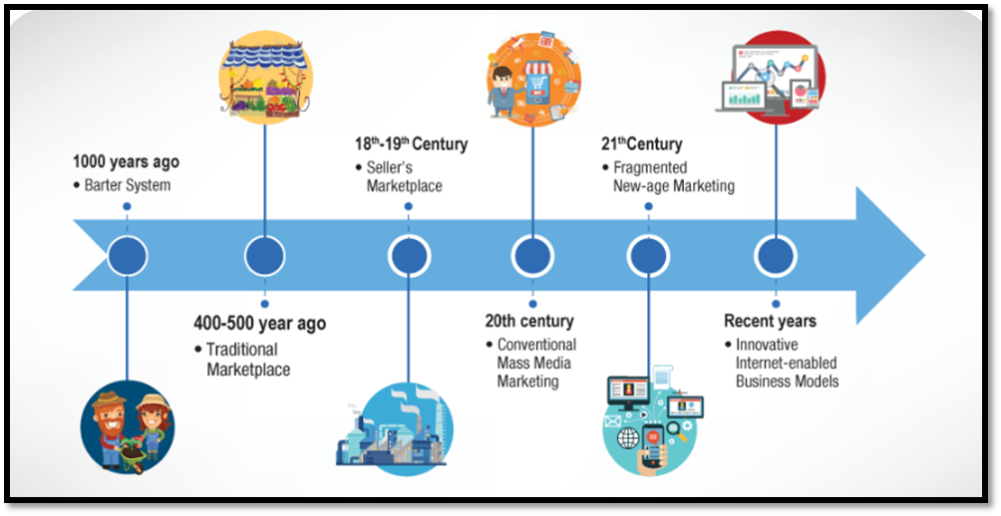
Advantages and disadvantages of digital marketing:
As it could be seen that digital marketing is becoming popular in every stream not only in cities but it is becoming popular among the rural areas also. As we know each and every thing has some pros and cons similarly digital marketing is also having some advantages and disadvantages.
Some advantages are:
· Digital marketing is used to build the brand through direct campaigns and personalized content to bring the customers much closer and make them experience the unique proposition and value of the brand.
· Digital marketing gives businesses the platform for one-to-one or individual marketing, which will help the brand leverage competition by designing the content or advertising that gives the customers that the brand is addressing their individual needs.
· A properly planned and well-targeted digital marketing campaign can reach the right customers at a much lower cost than traditional marketing methods.
· Digital marketing helps in expanding the brand’s presence and creates a platform to reach many customers. The brand becomes global as digital marketing provides the platform for global display, allowing even newcomers and start-up brands to have an equal footing with big and
established enterprises dominating the traditional market.
· Digital marketing lets you create engaging campaigns using content marketing tactics. This content (images, videos, articles) can gain social currency - being passed from user to user and becoming viral.
· The cost-efficient nature of digital marketing is immensely advantageous for businesses. Spending on digital marketing in comparison to
traditional marketing campaigns is very less.
· Unlike other media which require people to get up and make a phone call, or go to a shop, digital marketing can be seamless and immediate
· It allows companies to find new markets and trade globally for only a small investment.
Disadvantages of digital marketing:
Despite the many advantages in digital marketing there are some limitations that are also incurred in it. These are as follows:
· Skills Requirement. In order to effectively carry out marketing campaigns, it is important that the company has the proper expertise and knowledge about the digital platform. Therefore it requires skilled and technological upgraded manpower.
· This is the era of e-commerce. Many companies, either big or small, are using digital marketing due to which it becomes difficult to stand out from the crowd and grab the attention of the target audience.
· Digital marketing is very time consuming and challenging. Thus, it becomes important for the companies to make proper strategies and tools which can help in boosting the effectiveness of the campaign.
· Depending on the technology is a big challenge before the companies as sometimes weblinks do not work properly or web pages do not load, in this case customers switch to another sites or brand.
· Anyone can give positive or negative feedback about any product and services on the company’s web page. Sometimes these negative feedbacks and reviews may not be true. But it may badly affect the reputation of the companies, because customers see the reviews before buying any product.
· Sometimes security and privacy of the websites of an organization may be hacked by the hackers.
Impact of e-commerce on the Indian economy:
The emergence of many eCommerce start-ups in India has enabled businesses to meet the shopping needs of the consumers. Companies like Swiggy, Zomato, Big Basket, Spencer, Blinkit etc. ensure quick delivery of necessary goods within one hour without taking any delivery charges if one is regular customer but sometimes they provide some discount coupons or gifts while Amazon, Max, Myntra, and even Flipkart have provided customers with a wide range of collections at their
fingertips.
It could be seen that in India, since last two-three years e-commerce business are in boom. Indian economist analysed that the e-commerce industry reported $24 billion in 2017 , which was now reached upto $50 billion by the end of the 2022. Reliance Digital reported a 2.5 times increase in online orders, with digital channels including Ajio, Trends, and JioMarts accounting for 19% of its core retailing revenues. Likewise, Hindustan Unilever Ltd.'s contributed to nearly 15% of its total sales as a result of its digital efforts through D2C channels.
There are still only 289 million active eCommerce shoppers out of approximately 658 million active internet users in India. This indicates that more than half of active internet users are still not shopping online. It is a massive opportunity for brands and businesses, which will shape the future of eCommerce in India in the next 5-7 years.
Although the retail sector faces fierce competition from e-commerce and a significant portion of retail sales is still projected to occur offline, the evolution of e-commerce may strengthen the resilience of physical storefronts.What’s happening is that innovative brands are adopting a digital perspective to enhance in-person retail experiences, integrating offerings to provide an enhanced customer experience across all channels.
Strong economic performance, Foreign Direct Investments (FDI), increased use of smartphones, and a young population are the driving factors for the growth of e-Commerce. One key factor which is contributing to the transformation of the retail landscape is the popularity of mobile apps. Consumers are increasingly rely on their smartphones to browse products, compare prices, and make purchases. This shift towards mobile commerce has created new opportunities for retailers to engage with customers and offer a seamless shopping experience.
Future trends of digital marketing in India:
The Indian digital marketing market is expected to grow at a CAGR of 32% between 2023 and 2028. The digital marketing industry size in India is expected to reach 24.1 billion by 2028.
The growth of the Indian eCommerce market is HUGE, estimated to cross over 7 trillion (in Indian rupees) by 2023.
With the growth of eCommerce, the digital marketing market size will also
increase.
Due to the pandemic, many offline businesses are building an online presence in India. Thanks to mobile payment systems like Paytm, Phonepe, UPI, etc – people are now easily purchasing products online.
According to the Times of India, by 2023, the quantity of dynamic Indian web clients will reach around 666 million, which is HUGE.
According to the Goldman Sachs report, the digital marketing career scope in the Indian market will be valued at $160 billion by 2025. According to the experts , The Indian eCommerce market is expected to reach $170 billion by 2025 (Bain) and India's online shopper base is to reach nearly 500-600 million by 2030 and become the 2nd largest globally (IBEF).
Scope of Digital Marketing in the Future:
The growth of digital marketing has been very impressive and the numbers show that the growth is going to see an upward trend in the future. Simply put, the future of digital marketing looks secure and bright.
More and more opportunities will keep coming in and thus, being creative, innovative, and updated with the latest trends would be the basic principle of every digital marketer.
The growth that we have witnessed on the Internet over the years especially since covid, is here to stay. People are adapting to the new normal and in fact are now very comfortable with carrying out things online, be it for shopping, ordering food or medicines, or even carrying out banking transactions online!
Hence, to cater to these new-formed demands of consumers, digital marketing is extremely essential.
Conclusion:
The main aim of digital marketing in India is to promote digital media, because today people are using smartphones anywhere and anytime and following social media frequently. Therefore, they can order anything from food and medicines online. Therefore, nowadays shopping trends are changing from traditional to digital. But still there is a wide population in India believing in traditional ways of shopping i.e. offline shopping, especially on occasions like marriages etc. In the future, digital marketing and online shopping will increase more than yet and Indian economy will also boost in the future

References :
- Marketing Management by Philip Kotler - 15th Edition
- MARKETING MANAGEMENT: INDIAN CASES Paperback – Picture Book, 31 July
2017 by Gupta Prachi (Author), Aggarwal Ashita (Author), Majra Hufrish (Author), Jacob Isaac (Author), Jain Varsha (Author)
- Business Economics (Microeconomic Analysis), 13th Edition Paperback – Picture
Book, 1 January 2016 by H L Ahuja (Author)
- https://www.peppercontent.io/blog/future-of-digital-marketing-in-india/
- https://intellipaat.com/blog/what-is-scope-of-digital-marketing-in-india/
- https://timesofindia.indiatimes.com/readersblog/manish-kumar-singh/future-of-digital-ma rketing-in-india-30738/
- https://www.simplilearn.com/the-scope-of-digital-marketing-article
- https://iide.co/blog/scope-of-digital-marketing/
- https://digiaccel.in/blog/future-of-ecommerce-in-india/
- ·https://timesofindia.indiatimes.com/blogs/voices/the-rise-of-e-commerce-and-the-futureof-retail-spaces/

