Automatic Phase Changer

AVDHESH  Dept. of Electrical Engineering  Bansal Institute of Engineering &  Technology  Lucknow, India ak1477898@gmail.com | RISHIKESH NISHAD  Dept. of Electrical Engineering  Bansal Institute of Engineering &  Technology  Lucknow, India  nishadrishikesh80@gmail.com  KAMLESH NISHAD  Dept. of Electrical Engineering  Bansal Institute of Engineering &  Technology  Lucknow, India 7318141494mrj6@gmail.com | NAGENDRA CHAUDHARI  Dept. of Electrical Engineering  Bansal Institute of Engineering &  Technology  Lucknow, India  Chaudharinagendra33@gmail.com

Abstract—Power stability in developing countries creates need for automation of electrical power generation. This automation is required as the rate of power outage becomes predominantly high. Most industrial and commercial processes being dependent on power supply, if the processes of change-over are manual, serious time is not wasted but also creates devices or machine damage from human error during the change-over connections, which could bring massive losses.[1]So by using automatic phase changer we can change the phase from faulty phase to available source phase andAlso there is no time required as the phase is changed automatically within a few seconds. The main aim of this paper is to present the real idea of an automatic phase switch for 230V to 240V AC. Although, there are most of the designs that can perform almost similar functions like, single phase change-over switches, two phase automatic transfer switch and three phase automatic change-over switch ,but this model is about an automatic phase switchover which is designed for only three phase alternating current input power to single phase output applications.[8]
Keywords—power stability; public supply; power generation
Introduction—
Electrical energy is easily available energy and the main advantage of electrical energy is that we can convert any form of energy into electrical energy and then electrical energy can be change in to any form of energy like mechanical or kinetic energy. As everybody knows that demand of energy is increasing day by day and electrical energy is one of them.[15] Most companies, industrial, commercial and even domestic are dependent on public power supply which has erratic supply such as phase failure, phase imbalances or total power failure due to one or more technical problem in power generation, transmission or distribution. If all the three phases are available, there is need for automation of phase change during phase failure or total power failure in any of three phases in order to safe guard consumer appliances from epileptic power supply. In most cases, many manufacturing companies, whether they are domestic or industrial, which employ single phase equipment for its operation sometimes experience challenges during failures in power supply.[8]
This project is designed to check the availability of any live phase, and the load will be connected to the particular live phase only. Even a single phase is available the load will be ON condition.[12]And also it is designed to provide uninterrupted AC mains supply i.e., 230 volt to a single phase load. This is achieved by automatic changeover of the load from the missing phase to the next available phase in a 3 phase system. It is often noticed that power interruption in distribution system is about 70% for single phase faults while other two phases are in normal condition. Thus, in any commercial or domestic power supply system where 3 phase is available, it is advisable to have an automatic changeover system for uninterrupted power to critical loads in the event of missing phase.[11]

I.LITERATURE REVIEW
In most developing and underdeveloped parts of the world, the supply of electricity for industrial, commercial and domestic use is highly unstable. This gives rise to the frequent use of alternative sources of power supply to meet up with the energy demands. The Automatic three phase selector automatically switches over to the alternative phases when there is a power outage. The Automatic three phase selector is a device that links the load and the three phases and relay switches. This device maintains constant power supply to the load by automatically activating the phases when there is need. To ensure the continuity of power supply, many homes, offices and industrial facilities require a steady and stable power supply, and because of the growing complexity of electrical systems it becomes imperative to give attention to supply phases reliability and stability.Over the years many approaches have been implored in selection of phases. Some of them are discussed below .[5] In the past the regular practice had been to manually select the required phase in a three phase system with the help of a cut off (an electrical connector devices).This is used by appropriately interconnecting end and selecting between the phases by manually plugging in to premeasured or detected voltage. This is known as the conventional approach to phase selection. Its limitations are as follows
i. It is strenuous to operate. ii. It causes device to damage. iii. It can cause fire outbreak and/or electrocution.
A changeover switch is designed to transfer a house (or business) electricity from the commercial power grid to a local generator when outage occurs. Also known as “transfer switches,” they connect directly to the generator, commercial power supply or line, and the house. When the homeowner or business owner experiences a power outage, he or she can switch over to the generator via a changeover switch.[8] It is mostly used in domestic and industrial level, to auto switch power supply from Generator to Mains and vice-versa. The automatic change over switch has the following advantages:
- It reduces its change over timing to the minimum due to its fast response to power outage.
- It maintains high quality of service through its fast and prompt response. The automatic change-over switch can be used in any place where alternative power is needed to complement the main power supply. In this project, a generating set is used to represent the alternative power supply.
- The generator must have electrical ‘start and stop’facility.
- The generator’s battery has to be in good condition always.
- Minimizes damages to lives/equipment since it has its own monitoring system and its switching requires no human contact with the switch, thus eliminating human error.[8]

II.METHODOLOGY
All the domestic residential loads are mainly connected to single phase supply and ion case of power failure or any faults occurs the power is available in other two phases but we cannot utilize that power and for utilizing that power we require manual operation which results in fire accidents and also not as much reliable. Therefore we need automatic switching from one phase to other automatically which is made possible by this “AUTOMATIC 3-PHASE
CHANGER”.
As we earlier told that manual operation is not suitable in case of change of phase to other phase, it is not possible because we are dealing with 3- phase 415V supply which may cause fire accidents. And manual changing is not possible at every time as identifying the phase of power interruption is difficult.
So therefore instead of manual operation of phase changing we require automation which is done by “AUTOMATIC 3PHASE CHANGER”. Its automatically switches to the phase where the power is available. So in this our aim is to design a circuit called automatic phase changer or
selector.[15]

Components & Equipment Required

Component names | Rating | Quantity
Step down transformer | (220v-9v),300Ma | 3
Fuse | (F1-F3-5A) | 3
Transistor | (T1-T2-T3)Bc=557 | 3
Relay | (RL1-RL3)12V1c/o relay | 3
Zener diode | (ZD1-ZD3)-5-1 volts | 3
Variable resistance | (VR1-VR3)=10K | 3
Resistance | (R1-R2-R4-R5-R7-  R8)=3.3K,(R3-R6R9)=10K | 9
Diode |  | 9
Capacitor | (C1-C4=100µf)25v,(C5C7=470µf)35v | 7
Wire |  | As req.

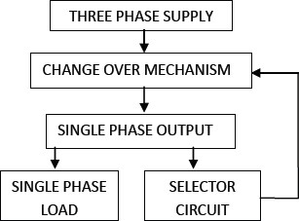

Fig. : Block Diagram of Automatic Phase Selector System

Circuit diagram:-

supply of the motor after a certain time. But our main objective is to select an active
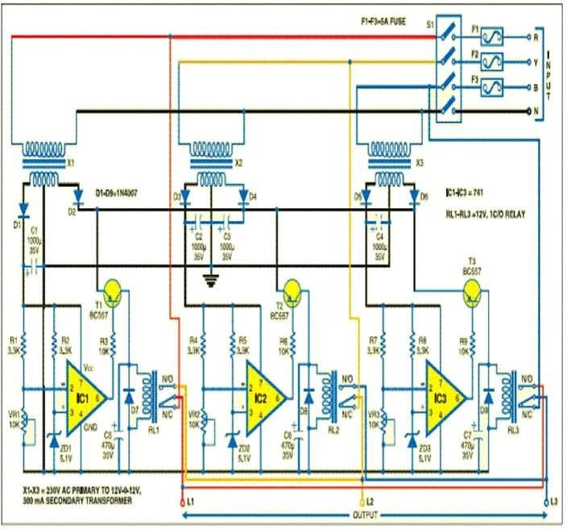

IV.APPLICATION
III.ADVANTAGE OF THE SYSTEM
Power failure or low voltage. Automatic Phase Changer
1. Improve overall efficiency of power system in residential automatically cuts supply during low voltage, thus it protects
area.
- Maintain continuity of power supply.
- High Stability
- Zero Man-Made Errors
- Continuous Running of Single Phase Load 6. More automatic operation with the elimination of selector switch.
7. Reduced circuit size and easier implementation. 8. The problem of sparking between the selector switch and the phase connection does not arise.
- Works according to the phase availability
- Low cost and reliable circuit

the equipment from the harmful effects of unhealthily low
voltage. It can be used in

  - Residential building.
  - Commercial offices.
  - Factories operating with 1 phase machineries.
  - Hospitals/Banks/Institutions
5.It automatically supplies voltage in case of fault or low voltage in up to 2 of the 3 incoming phases.

Automatic phase changer finds huge application in the modern world .This device is more cost effective, reliable and of maintenance free.

V.CONCLUSION
It is concluded that we get the desired output from the auto phase selector. Automatically it is selecting the active phase when the connected phase is absent. The only problem is when all the three phases are not active, the motor continues to rotate and will not stop until we switch off the 12V supply of the motor manually. This problem can be overcome by implementing a timer circuit which will automatically switch off the power phase automatically to save the time and without hampering the work. This objective is satisfied successfully here. This desired output results from automatic phase selector. Automatic phase selector selects active live phase and makes fast switching.This objective is satisfied successfully here.

VI.REFERENCE

- Vipula Tippa,AnkitaKedar,KarunaNikum Automatic Phase Changer: A Review, International Journal of
Engineering Research & Technology (IJERT) ISSN: 22780181 Published by, www.ijert.org ICIATE - 2017 Conference Proceedings Volume 5, Issue 01
- Ofoegbu E.O, OgbeJoy.O A Microcontroller based Automatic 3-Phase Selector for Load Control in Home Applications International Journal of Research and Innovation in Applied Science (IJRIAS) | Volume IV, Issue X, October 2019|ISSN 2454-6194
- Shubham S.Vaiddya,NiramjanV.Hendwe, Chetan B.Bhagat,P.V Automatic Cost Effective Phase Selector System Volume 3,Issue 2, February 2020. [4] Ganesh Balu Shinde,Prathanresh Amol Dange, Yashodhan Ranjit Bhosalo,Auinash Dattatray Bansode,Prof.
M.S Bijali.Auto Phase Selectur .Volume 2,Issue 9, june2022 [5] Lawal abdurRaheeunO, Jimoh Adeyemi A. Lawal Olatunji A, TiamiyAhmed.K Design and Implemention of a three-phase 6KVA automatic phase selector in a three-phase supply circuit, Valume 5,no.1 June 2017
- Ashish kumar Gupta, Chandan Singh,Gurpreet Singh, Arun kumar Automatic Cost Effective phase slectorValume 4,Issue 5,May 2015.
- Ehiabhili, J., Ezeh, C. and Orji, O., 2018. Single Phase Microcontroller-Based Automatic Changeover Switch. International Journal of Electronics, Communication & Instrumentation Engineering
Research and Development (IJECIERD), 8(1), pp.7-16 [8] Niranjan V.Hendee, Shubham s.Vaidya, Chetan B. Bhabat, P.V rant An automatic phase selector from any Available Three phase supply system ,Volume 7,Issue 2, February 2020.
- Ofualagba, G. and Udoha, E.E., 2017. Design and Simulation of Automatic Phase Selector and
Changeover Switch for 3-Phase Supply. International Journal of Novel Research in Electrical and
Mechanical Engineering, 4(2), pp.28-35
- AyassGhosh ;ShamikChattaraj , Snehashis Dos, Kuustav Mallick , design of automatic Phase Selector from any available Three phase supply . Vol-7, Issue-2,frb-2016.
- Takle Rameshwar G ,Vanjole Prasad L, Motale Dnyaneshwar G, Jadhav Sanket s, Prof. Dr Haripriya H. Kulkarni (2019).
Automatic Phase Selector Journal of
Electrical Power System Engineering and Technology, 4(2), 15- 19 http://doi.org/ 10.5281/zenodo.3252418
- M.AjayDara , 2B Trimurthula, b.Sai Krishna , Ram Praveen , m.kartik Automatic Active phase selector for single phase load from three phase supply volume 6,issue-4
april -2020
- Ayan, G., Shamik, C., Snehashis, D. and Kaustav, M., 2016. Design of Automatic Phase Selector From Any Available Three Phase Supply. International Journal of Scientific and Engineering Research, 7(2), pp.854-856
- Singh, H.D., Aakasha, A., Akash, S. and Murugan,
R., 2021. AUTOMATIC CHANGEOVER WITH THREE-PHASE SUPPLY IN EDUCATIONAL
INSTITUTION. Turkish Journal of Computer and Mathematics Education (TURCOMAT), 12(13),
pp.7119-7134
- Mrs. Pooja jaina , Pawan Singh Rajawat b ,
Radha krishan Sharma b , Rohit Nagarb , Rahul Rajb
AUTOMATIC THREE PHASE CHANGER
International Journal of Advanced in Management, Technology and Engineering Sciences Volume 8,
Issue V, MAY/2018 ISSN NO : 2249-74

