Implications of Blockchain Technology using smart contracts for paperless Trade in India

Dr. Ankur Mittal

Sr. Associate Professor, Core Cluster

University of Petroleum & Energy Studies

Abstract

Blockchain technology (BCT) is revolutionizing how the world transfers goods and services; using a combination of mathematics and cryptography to provide an open, decentralized database of any value transaction. It thus creates a record that can be authenticated by every participant. Soon in future, anyone with access to the internet will be able to use blockchain-based systems to securely conduct transactions **without the need of any third-party applications**. The present study explores the implementation of BCT to enhance paperless trade in India and would eradicate the need of digitally signed documents for custom clearance and later the paper discusses about appropriate scenarios for BCT for two different countries to facilitate trade. However in order to have full proof solid structured BCT platform the support of government is required as currently it is linking e-sanchit with block chain as the technology is still maturing and many challenges need to be addressed. This paper can help Indian Government for implementation of Block chain, distributed ledger technology for digital foreign trade.

**Introduction**

In 1997, Nick Szabo, a computer scientist, law scholar and cryptographer conceptualized smart contracts, which are essentially small computer programs that exist inside blockchains. They are instrumental in doing away with third-party services, thereby **cutting transactional costs**. Smart contracts are unique; in that they are **immutable and distributed**. This means that they cannot be tampered with and the output of the contract is validated by others in the network.

Nations and multinational companies involved in trading face innumerable roadblocks during their exchange of goods and services. Shipment tracking is an unwieldy, time-consuming task which is always at risk of human error, smuggling, fraud or trafficking. Not only do international deals require a lot of movement of records, from bills of lading to cargo documents and contracts; but also, a huge amount of manpower, ranging from customs officials to company employees to dock workers. Moreover, the banks are involved at each step; the sender’s, the receiver’s and the correspondent entity. This translates to **loss of money** for the vendor and customer, which goes in ensuring the smooth functioning of these middlemen processes. The reason these processes are present in the first place, is to ensure accountability and security.

Blockchain technology can do away with these tedious steps and provide a higher level of security in transferring sensitive information if used to document international trade deals, along with improving the overall customer satisfaction. Smart contracts are estimated to be able to cut the number of documents involved in a deal by 50% and remove banks from the equation completely. Further, cases of dispute can be arbitrated with just a few taps on a computer keyboard by any arbiter with a transaction key, as opposed to the months of settlement that would take place in a traditional contract. In a nutshell, a few benefits of blockchain are as follows:

1. Abolishing paper contracts
2. Digital protection for systems against hostile cyberspace forces
3. Timely settlement of transactions across borders
4. Reduction in expensive documentation delays

Corporations all over the world have already adopted blockchain in their various dealings. Danish shipping company Maersk, which uses a blockchain developed by IBM, records nearly 200 messages between farmers, brokers, governments, ports and banks – all in a single transaction. The addition of information starts as soon as the work is initiated and cannot be altered unless approved by all the involved parties. Walt Disney Company, of Mickey Mouse and Disneyland US fame, has devised its own internal blockchain solution, called Dragon chain. Swiss giant Nestle is working on a consortium with IBM to remove middlemen from their worldwide shipping of foodstuffs.

The implementation of these two closely related technologies, i.e., blockchain and smart contracts, in the documentation of India’s rapidly changing e-commerce sector is what we will discuss in this report.

ICEGATE is the country’s centralised electronic portal that offers e-filing services to our trading partners. Documents such as bill of entry for imported goods, shipping bills for exported goods and electronic communiqués such as E-mail, FTP and web uploads between customs and their clients regarding their cargo can be accessed on this terminal. Other services offered include online registration of IPR, e-payment, tracking status among others.   
  
Despite having this system in place, which has undergone centralization, customs offices still exist at over 134 physical locations, which are connected to a common Data Centre via internet (WLAN MLPS). The only security in document filing is provided by way of digital signatures on the entry and shipping bills, among other documents on the gateway.

While this is an improvement from the old practice of entering signatures by hand on a much-used ledger, given the arrival of blockchain technology, there is a large scope of improvement to this current scenario.

National Institute of Transforming India (NITI) Aayog is building a data analytics forum called India Chain, which is a blockchain technology specific to Indian trade. It will revolutionize the workings of Aadhaar, Jan Dhan Yojana, Mobile Trinity and many other services. India Chain will boost the revenue coming in from the agriculture industry, increase the transparency of transactions, reduce fraud and increase the speed on contract enforcement.

The various fields where blockchain can be implemented in India number more than 30, but in case of trade, the following areas can be improved:

1. Trade Finance
2. Cross-border payments
3. Supply Chain management
4. GST

At any point in time, we will be able to assess the condition of a product being traded, who owns it, and to whom it will be delivered. Thus, a measure if increased scalability and innovation will be seen on the face of Indian trade.

Indian consulting giants such as Price Waterhouse Co. and Deloitte and tech companies such as Infosys, have already built platforms to implement blockchain technology in their banking transactions.

It is now the turn of the Indian government and companies involved in trading and shipping, to make use of this technology to streamline their services.

The main obstacle is the frank absence of legal framework in India to support the use of blockchain. Once a set of laws governing this is put in place, it will make the documentation of trade much easier and allow smaller companies, who may be intimidated by the current system, to conduct international business deals securely.

Characterizing Blockchain Technology

Basic Concept

Blockchain refers to a type of data structure that digitally identifies and tracks transactions and shares this information across a distributed computer network, creating a sort of distributed trust network. Smart contract is another term which is linked to blockchain technology in a manner: a computer protocol which automatically performs the functions once the transaction is triggered without the involvement of third parties.

A blockchain has no transaction cost. This technology is a simple yet ingenious way of transmitting data from A to B in a fully automated and secured manner. One entity initiates the process by creating a first block called Genesis Block and this block is validated by other participants on peer to peer basis. And then this block is added to a chain with unique identification. Soon in future, anyone with access to the internet will be able to use blockchain-based systems to securely conduct transactions without the need of any third-party applications.



Figure 1 Blockchain Workflow

The reason why the blockchain has gained so much attention is that:

* It is not owned by just a single entity, therefore it’s called decentralized network
* Data is stored inside cryptographically means.
* It is immutable, so nobody can falsify the records.
* Network is transparent so that you can route the data if you want to.

Smart Contracts

It is another term commonly used to characterize the blockchain technology; this is a computer protocol which aims to allow the secured and facilitated performance of contracts without the involvement of any third party and thus reduces the transaction costs associated with contracting. It shows real-time progress through the supply chain. The participants will thus be readily informed of where an in-transit container is located and be able to check the status of Customs documents while reviewing Bills of Lading and other shipping documents’ data. The blockchain technology will ensure that no party can modify, delete or even append any record without the required consent from others on the network only selected partners who are specifically interested in developing smarter processes for trade , whether it is a proof of purchase, a clearance form, a bill of lading, insurance – can be made part of a block. **Hence, Customs authorities will be able to see the necessary, tamper proof and accurate data (seller, buyer, price, quantity, carrier, finance, insurance etc.) that have been tied with the goods to be declared and to keep track of the location and status of such goods in real time. Such a complete visibility, if built into the sphere of regulatory oversite,**

With the blockchain technology, Customs administrations and other cross border agencies would significantly improve their capacity for risk analysis and targeting, thus contributing to improved trade facilitation.

## **Need for Study**

Nations and multinational companies involved in trading face innumerable roadblocks during their exchange of goods and services. Shipment tracking is an unwieldy, time-consuming task which is always at risk of human error, smuggling, fraud or trafficking. Not only do international deals require a lot of movement of records, from bills of lading to cargo documents and contracts; but also, a huge amount of manpower, ranging from customs officials to company employees to dock workers. Moreover, the banks are involved at each step; the sender’s, the receiver’s and the correspondent entity. This translates to **loss of money** for the vendor and customer, which goes in ensuring the smooth functioning of these middlemen processes. The reason these processes are present in the first place, is to ensure accountability and security.

Blockchain technology can do away with these tedious steps and provide a higher level of security in transferring sensitive information if used to document international trade deals, along with improving the overall customer satisfaction. Smart contracts are estimated to be able to cut the number of documents involved in a deal by 50% and remove banks from the equation completely. Further, cases of dispute can be arbitrated with just a few taps on a computer keyboard by any arbiter with a transaction key, as opposed to the months of settlement that would take place in a traditional contract. In a nutshell, a few benefits of blockchain are as follows:

1. Abolishing paper contracts
2. Digital protection for systems against hostile cyberspace forces
3. Timely settlement of transactions across borders
4. Reduction in expensive documentation delays

Problem Statement

As different digital platform for paperless trade are present for International trade documentation but none is as efficient as it should be. Currently Indian Government (CBEC) use e-sanchit and since 1 April 2018, it is necessary to use e-sanchit before filing bill of entry for custom approval. E-sanchit is digital paperless platform. It is launched on pilot basis with the aim of facilitating paperless trade across borders and uploading supporting documents. Hence, we will try to focus on more systematic, structured and secured environment to facilitate trade across borders through blockchain.

It is now the turn of the Indian government and companies involved in trading and shipping, to make use of Blockchain technology to streamline their services.

The main obstacle is the frank absence of legal framework in India to support the use of blockchain. Once a set of laws governing this is put in place, it will make the documentation of trade much easier and allow smaller companies, who may be intimidated by the current system, to conduct international business deals securely.

## **Research Questions**

* How can implementation of Blockchain Technology enhance Paperless trade in India?
* How blockchain will eradicate the need of Digitally signed documents for custom clearance?
* Challenging scenarios for implementations of Blockchain Technology for International Trade?

## **Research Objectives**

1. To examine the use of Blockchain technology in international trade documentation for Indian Government.
2. To know whether Blockchain powered Digital signatures could solve e-signature Headaches.
3. To suggest appropriate scenario for Blockchain Technology for two different countries to facilitate trade.

Literature Review

The Literature review is done considering two main objectives of the paper i.e.

**Objective 1: To examine the use of Blockchain technology using smart contracts for International trade Documentation in India**

To review literature for objective 1 the process is sequenced in 4 themes

1 – International paperless trade

2 – Blockchain Use cases

3 – Blockchain and Trade

4 – Blockchain evaluation for International Trade documentation in India

**Objective 2: To know whether Blockchain powered Digital signature are better for trade documentation**

1 – Blockchain + Digital signature

**Based on these themes the literature has been reviewed sequentially**

|  |  |  |  |  |  |  |
| --- | --- | --- | --- | --- | --- | --- |
| **S.NO** | **Article /Report Name** | **Authors** | **Year** | **Inference** | **Variables** | **Findings** |
| 1 | Digital Trade Facilitation: Paperless Trade in Regional Trade Agreements | Duval, Yann | 2017 | Digital trade in RTA | Paperless Trade | Detailed analysis on paperless trade measures in Asia pacific RTAs |
| 2 | Electronic bills of lading and central registries: what is holding back progress? | Goldby, Miriam | 2008 | It states the legal requirements that could satisfy electronic replication of bill of ladding from paper bill of ladding | Electronic International Trade | A road map towards paperless Trade and why the present system does not seem to provide a flexible solution |
| 3 | Facilitating Paperless International Trade | Emanuel Lareya | 2006 | Explanation of electronic documentation and processing of international trade transactions. | Digital Trade | ASEAN countries are making consistent efforts to facilitate paperless trading in the world. |
| 4 | Trade Facilitation and Paperless Trade Implementation | Report, Unece Regional | 2017 | How cross border Paperless Trade is overcoming the need for paper documents in UNECE Region | International Trade, Paperless Trade | UN region has made progress in easing international trade through advance electronic measures |
| 5 | Paperless Trading : How Does It Impact the Trade System ? | Paper, White | 2017 | Introduction to paperless trade and challenges across global level | Paperless Trading, Electronic Trade Documentation | Digitization and smart technology could accelerate paperless Trade, if right framework is in place. |
| 6 | UNCTAD/EDM/Misc.17/Rev.1 | Nations, United  On, Conference | 2017 | Overview of UNCTAD – promotes the participation in international Trade | UN International Trade, Developing Nations Trade | A platform which facilitates the process of international trading for developing member countries |
| 7 | BLOCKCHAIN TECHNOLOGY AND FINAL CHALLENGE FOR PAPERLESS FOREIGN TRADE | July, Published Online | 2018 | Development of information systems leading to the need to innovate use of blockchain on trading platforms | Blockchain Technology in International Trading | Decentralized structure of blockchain allows functions of various agencies to be integrated. |
| 8 | Blockchain Governance and Regulation as an Enabler for Market Creation in Emerging Markets | Marina Niforos | 2018 | To develop proper governance and regulatory body for market participants to lead stability | Blockchain Regulatory body, Blockchain Governance | Building a Global coordination mechanism could be difficult but translational cooperation are underway to develop public standard codes. |
| 9 | Can Blockchain Revolutionize International Trade? | Ganne, Emmanuelle | 2018 | An overview of the how blockchain could help in International trade | Challenges related to cross border trade | Lack of legal and regulatory issues for implementing blockchain for G2G |
| 10 | Blockchain Bills of Lading | Ong, Elson | 2018 | How blockchain technology will eliminate electronic bill of lading | Bill of lading, Blockchain | Various Laws that could enhance the use of new technology in shipping Industry |
| 11 | A Digital Revolution in International Trade? The International Legal Framework for Blockchain Technologies, Virtual Currencies and Smart Contracts: Challenges and Opportunities | Caria, Riccardo e |  | To provide worldwide legal environment, suitable for blockchain based solution. | Blockchain, Digital Trade, Framework in Blockchain. | Challenges faced in relation to the applicable laws for blockchain Technology. |
| 12 | Unveiling the Potential of Blockchain for Customs | Okazaki, Yotaro | 2018 | To discuss ways in which customs could leverage the power of blockchain | Customs Blockchain, International trade Customs | Customs will be able to have a clearer picture of international trade documentation with blockchain-based applications, |
| 13 | Blockchain in Public Sector | Binaifer Karanjia | 2018 | To examine various use cases of blockchain in India | India blockchain use cases, Trade | It showcases how blockchain could leverage various areas for government of India |
| 14 | Examples from Blockchain Implementations in Logistics and Supply Chain Management: Exploring the Mindful Use of a New Technology | Peter Verhoeven | 2018 | To define use cases of blockchain that could cater in the field of LSCM | Blockchain supply chain management | Discussion suggests that a good knowledge of blockchain and problems within the LSCM field is necessary to implement blockchain technology in a meaningful way |
| 15 | Can the new technology improve international trade? | Intelligence, Trade  Pacific, Asia | 2018 | Blockchain could enhance the efficiency of the process take place across borders | International Trade with blockchain | Examples of various countries taking part in international organization to enhance their foreign Trade |
| 16 | Smart contracts – Is the law ready | Chamber of Digital Commerce, Smart Contracts Alliance | 2018 | How smart contract could assist blockchain in the formation of laws | Smart Contract Laws for foreign Trade | Need of compliance for blockchain using smart contracts where security is an issue |
| 17 | Smart Contracts: Legal Framework and Proposed Guidelines for Lawmakers | Clifford Chance  European Bank for Reconstruction and Development (EBRD) | 2018 | A small touch over the laws for smart contract implementation | Smart Contract, Agreement, Blockchain based Laws | If certain laws are established for smart contracts that it would be easy for users to solve conflict and various other things |
| 18 | Can Blockchain Solve your Document and Digital Signature Headaches?  (Forbes Magazine) | **Alan Zeichick** | 2018 | Identified how blockchain could leverage use of digital signature for trade documentation | Blockchain Digital signature | Blockchain is above Digital Signature |
| 19 | The preservation of digital signatures on the blockchain | Thompson, Stephen | 2017 | Blockchain Technology can be a suitable platform to preserve digital signature | authenticity; blockchain; digital signatures; encryption; keys; trust | Adoption of blockchain to eliminate digitally signed documents would be more advantageous |
| 20 | Verify Documents with smart contracts in Azure Blockchain development kit | [Stefano Tempesta](https://msdn.microsoft.com/en-us/magazine/mt149362?author=stefano+tempesta) | 2019 | Technical knowledge of process flow of digitally signed documents | Authentic documents, Tampering, blockchain digital signature | Process Flow for digitally signed document on blockchain |
| 21 | Transition from Paper to Paperless: Dod’s Cals System | Cathy Rusinko and Frances Wolek | 1993 | A program to transfer information between diverse groups of U.S. government agencies is described, without the use of paper, rather using EDI. | A dated look at how digitization of trade documents was proposed over 25 years ago. | An “electronic superhighway” can be envisioned due to the efficiency brought about by the proposed CALS system. |

The table above describes in detail the different literatures reviewed. The gap was found after reading through all these articles, reports and news articles, and the business issue was made in line with the gap.

Literature Gap

The aim of this paper is to identify key areas and methods as to how blockchain technology and smart contracts can be used to drive trade documentation in India. While the material that was analysed provided sufficient knowledge on blockchain and its applications all over the world, there was a dearth of studies related to the Indian context. Hence, there was no past precedent to refer to while drafting the recommendations of this study. Moreover, Indian trading systems described in the e-Sanchit website make no mention of other nations and trading partners already using this technology and how we can make ourselves compatible with them. The conclusions hence drawn are based on an international system that is already in place, and the limitations of the customs budget that India offers as of today.

Research Methodology

Phases of Research:

1. Phase I – Secondary data collection- Research Papers
2. Phase II – Primary data analysis – Blockchain Expert Interview

Research design

A definitive objective of this review is to build up a Blockchain platform that could help Indian Government to ease out their custom approval operations related to International Trade Documentation and Digital signature.

This research has been carried out in a two-fold approach; an analysis of previous literature and a questionnaire-based survey.

1. The first method employed for this research includes a thorough study of literature relating to Paperless International trading, blockchain platform, Digital signatures and current system of Digital trading in India through e-sanchit. There is also an in-depth preparation on the use of smart contracts for trade between countries using same Blockchain platform. The aim is to curate material from various sources, analyze the data already recorded and present recommendations for the feasibility of using blockchain in paperless trading.

Main barriers to paperless trading in India are as follows:

1. Operational barriers  
   a) limited use of already present systems  
   b) lack of a trade community connected by blockchain  
   c) non-standardized customs procedures for each country  
   d) non-compatibility of existing paperless trade systems

e) security concerns

1. Legal barriers  
   a) viability of contract enforcement in different countries  
   b) reliability of contracts under each country’s jurisdiction  
   c) lack of ability of paperless documents to meet a government’s requirements to retain certain business records  
   d) reproducibility of smart contracts in international trade documents such as bill of lading

**Paperless Trading Systems in Different Countries**

ASEAN countries have recently shown a strong inclination towards moving their trading transactions into a secure paperless format, heavily relying on blockchain to provide streamlined security. This can be due to a few reasons, namely; a common consensus of governments and business sector on the benefits of the blockchain, technological advancements in the country and most importantly, an already present set of guidelines on international paperless trade in the APEC (Asia-Pacific Economic Cooperation). China, Japan, and Singapore have already implemented paperless trading using blockchain at their ports and borders. The remaining ASEAN nations have many mechanisms already in place and aim to become paperless within this decade.

According to a Customs Law (July 2000), China’s Customs Clearing projects have brought into effect electronic customs declarations on large shipments.

Japan has been almost completely digitized since 2001. All exporters who meet customs criteria for electronic documentation are forbidden from submitting any paper forms. The government’s initiative Air-NACCS or Nippon Automated Cargo Clear is a system used to simplify and facilitate its clearance procedures for air cargo.

Singapore's paperless trading systems are one of the region's most advanced. Trade-Net is a centralized, nationwide EDI processing system that connects 15 agencies. All import and export permits are electronically declared and approved, and traders can communicate with customs and other government offices.

**Indian Context**

The government of India already supports a few global initiatives with regards to paperless trading through ICEGATE platform. UN/CEFACT, along with a number of UN agencies who share a common interest in advancing paperless trade globally, including India, has collaborated to come up with a set of recommendations on how to govern blockchain-based trade globally.

**One approach is to enforce some non-obligatory norms within the scope of each nation’s laws;**

* For example, the 12th recommendation states that marine trade should be regulated by an electronic sea way bill in place of the traditional bill of lading.
* Similarly, the 14th recommendation provides guidelines for electronic document authentication by blockchain.

Though the scope of application of these provisions is immense, their enforcement can still vary greatly, depending on each country’s regulations. As of now, there exist only specific articles and studies on the use of blockchain in paperless trading that outline several ‘soft’ benefits, rather than binding commitments and hard laws.

What this thorough review points to is that India has in place a number of mechanisms to shift from paper-based to paperless trading within this decade. The ICEGATE platform is comprehensive and well able to deal with EDI, Bill of Lading, Bill of Entry along with a host of customs services. The need of the hour now, is to upgrade this already existing service and overcome the legal barriers that delay implementation of new technologies. ICEGATE is currently using digital signatures as its only support towards paperless trading, whereas it has the capacity to incorporate much more in terms of blockchain and smart contracts into its workflow. In a sense, the implementation of blockchain should happen in tandem with the use of paperless trade. Once a secure system of linked information and a ‘common ledger’ is implemented, the entire process of paperless trading will work much more efficiently.

1. The second portion of this study is a survey done in a direct question-answer interview format with various users and developers of blockchain technology. The questionnaire has been designed with the purpose of achieving an in-depth understanding of blockchain technology and smart contracts, using the expertise of the interviewees to develop a sense of self-reasoning and ultimately innovate some solutions to help implement blockchain on India’s ICEGATE e-Sanchit platform.

The answers of the questions are completely unbiased, with no external pressure or agency acting upon the responders. The responses are recorded, and the recommendations made by each are taken into account in the final conclusion.

**Note: The format of the survey is provided below in Annexure**

## **Sources of Data**

Secondary data will be used and analysed in this research. This data will be collected through the following manner:

* Examining the Use cases of Blockchain technology for International trade Documentation
* Referring to research papers based on countries currently working on paperless trade
* Blockchain Technology in Trade
* Various prior evaluation on blockchain Technology for international trade
* Research papers on Blockchain

## **Scope of the study**

This research gives detailed insights about the impact of recent developments in Blockchain technology in areas referring to International Trade and use of Digital Signature for E-documentation.

This paper can help Indian Government during the Implementation of Blockchain, a Distributed ledger Technology for digital Foreign Trade.

## **Limitation of the study**

The study is limited in the following aspects:

* Small sample size
* Polling was done on a similar professional group, thus, perspective given has been largely same
* Convenience sampling done
* Bias of self-assessment questionnaire when eliciting responses

No prior study has taken place related to Blockchain Technology in International trade in Indian context. Our target would be to do basic evaluation of the Blockchain Technology based on prior research and the need of implementing BCT for digital

There is no clear idea on the appropriate model of Blockchain Technology, that can be implemented. No prior research conducted on Indian blockchain platform for International trade documentation in India.

Data Analysis

## **Ongoing pilots/initiatives related to cross-border trade and utilizing Blockchain**

1. The first pilot project was launched by MAERSK-IBM, a global trade digitalization platform:

* Blockchain based on the Hyperledger Fabric and built by IBM and Maersk, the global transport and logistics entity, will be made available to shipping and logistics users on a pilot basis.
* A solution that allows the real-time exchange of through data pipeline that connects international trade entities.
* Customs will become more data-driven, they would be able to collect the necessary data in an accurate and timely way
* Data conveyed by the blockchain could be integrated automatically into Customs systems and checked against the data submitted by traders and transporters. In a more enhanced version, Customs could automatically clear the goods within the block chain itself.

1. Saudi Arabia’s customs system have successfully completed a pilot project between [IBM and Maersk’s “**TradeLens blockchain”** platform](https://newsroom.ibm.com/2018-08-09-Maersk-and-IBM-Introduce-TradeLens-Blockchain-Shipping-Solution) to its own cross-border trading platform [**FASAH**](https://www.fasah.sa/sanam/pfk/PfkMainServlet?pContents=/sau/sauWalkinUrl.jsp&pAction=FIRST&pPortalId=SAU)
   * The TradeLens blockchain platform was developed by [IBM and Maersk](https://blockchainstocks.com/agility-logistics-use-blockchain-platform-developed-international-business-machines-corp-nyseibm-maersk/) with the aim of being able to function as the backbone for the digital supply chains in Saudi Arabia
2. The Korea Customs Service (KCS) has entered into an agreement with Samsung SDS to implement the latter's blockchain innovation for an export customs clearance system.

## **Current Indian Custom Approval Process**

The Central Board of Excise & Customs on October 20, 2017, launched e- SANCHIT on a pilot basis. It was launched with the aim of facilitating trading across borders and to move towards paperless processing and uploading of supporting documents. In order to reduce physical interference between customs authorities and to fasten the clearance process, it is proposed to introduce a pilot - based facility for uploading digitally signed supporting documents. The proposed "Single Window Interface for Trade" (SWIFT), will definitely decrease interference with Governmental agencies and time in India.

**e-SANCHIT Mechanism**

1. Login into ICEGATE website. (icegate.gov.in)

2. Access the e-SANCHIT application as provided in Menu.

3. Upload document by clicking on Upload Documents button

4. Validate all PDF documents by using valid Digital Signature.

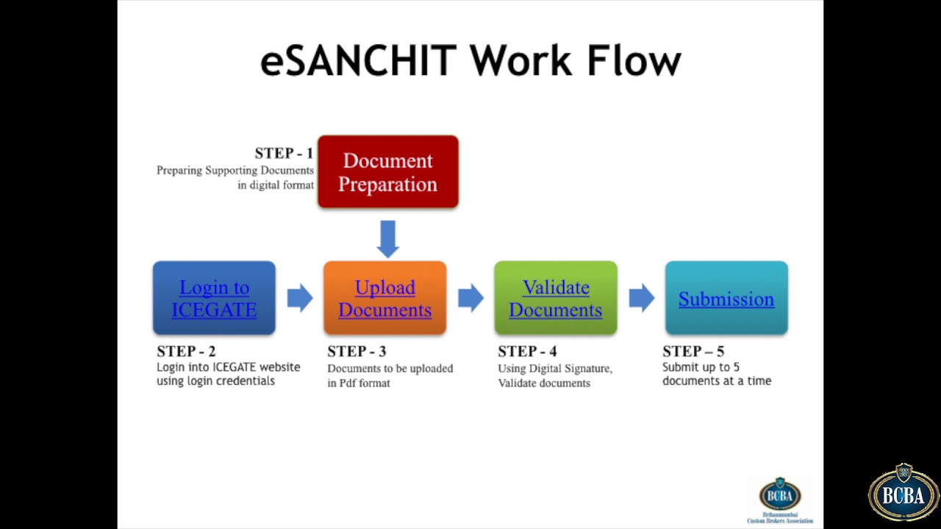

Figure 3 E-sanchit Workflow

**Mandatory Documents**

1. Bill of Lading / Airway Bill

2. Commercial Invoice

3. Packing List or Commercial Invoice

4. Bill of Entry

## **Types of Blockchain Platform for Trade documentation Custom Clearance**

The inherent characteristics of this technology make it a potentially tool to help implement government-to-government process across the national level. Blockchain using smart contracts can help in controlling our border trade procedures by proving single windows which would be more transparent and efficient.

**Private** **Blockchain**

* In private blockchains, consensus to validate, read and write data on blocks is controlled by only one entity that is truly trusted by the other participants in the network.
* The proof of transaction is done by a very limited number of participants called **miners**, which permits superior efficiency and much quicker processing of transactions comparative to public blockchains.
* Customs authorities could be equipped to upload and share information between unrelated parties. This could result in a fully integrated, end2end supply chain administration operating in a clear and trusted manner.
* Customs could automatically extract information from the primary sources for declaration purposes, thereby enhancing the accuracy and quality of their data and immutability thereof as well.
* Reducing the burden of manual verification and the resources required to validate declarations would lead to faster Customs declaration processing and reduced end-to-end lead time.

**Consortium Blockchains**

* It is a kind of private blockchain working under gathering authority as opposed to a private substance in which members are recognized.
* For example, a consortium blockchain possibly will form between 15 companies, each of which is operated through a device connected to the network. If second company only trades and shares its data with Company 3, 4 and 5, then only those companies will be given permission to read/write.
* These permitted blockchains are specifically used in the field of international trade, not without reason but numerous foundations are hesitant to put private day to day business data on an open, unapproved blockchain available.

The blockchain technology could be embedded into Customs’ practices through a common platform which could embrace paperless Trade. Such information, once linked into the chain of blocks, cannot be tampered by anyone; therefore, regular customs procedures would be limited to checking the submitted documents against their own database**. If they become a part of the network as a node, they could automatically clear goods that have been ‘pre-screened’ by Customs on its ledger at an earlier stage, even without withholding them at the time of declaration.**

## **Different scenarios of Blockchain platform proposed for paperless Trade**

Can Blockchain ease G2G procedures in a technical perspective?

The answer isn't straightforward. Moreover, it is highly dependent on technical interoperability across borders.

**Scenario 1**

The perfect situation would be one in which government bringing in and trading specialists would be a piece of a similar single blockchain. No interoperability would be required in such a case. Information could be traded legitimately through the stage starting with one gathering then onto the next in, based on the platform rules. Smart contracts could be encoded to impart just particular kind of information to other government specialists and other stage members. This situation, which is the most ambitious, is being tried by different characters in the field of import/export.

“**One such project initiative by Singapore Customs authorities, IBM developed a blockchain-based customs portal in collaboration with Singapore Customs, enabling them to send customs declarations documents from New York to Singapore.**

**Scenario 2**

Second scenario would be where government authorities on both importer and exporters sides are on network with two unique platform based on the same blockchain (for example Hyperledger Fabric). In such a case, “interoperability" will be required.

**Scenario 3**

In the coming years, it seems more likely to become reality. In Scenario 3, the government authorities on both sides of the transaction would belong to a different network, based on its own technology. Inter-ledger interoperability would be needed in such a case.

**Scenario 4**

In Scenario 4, the government authorities at the importer and exporter side would remain off the chain and the interaction would be through API (Application programming interface) which will help to extract information. In this case, Blockchain would do nothing to facilitate trade.

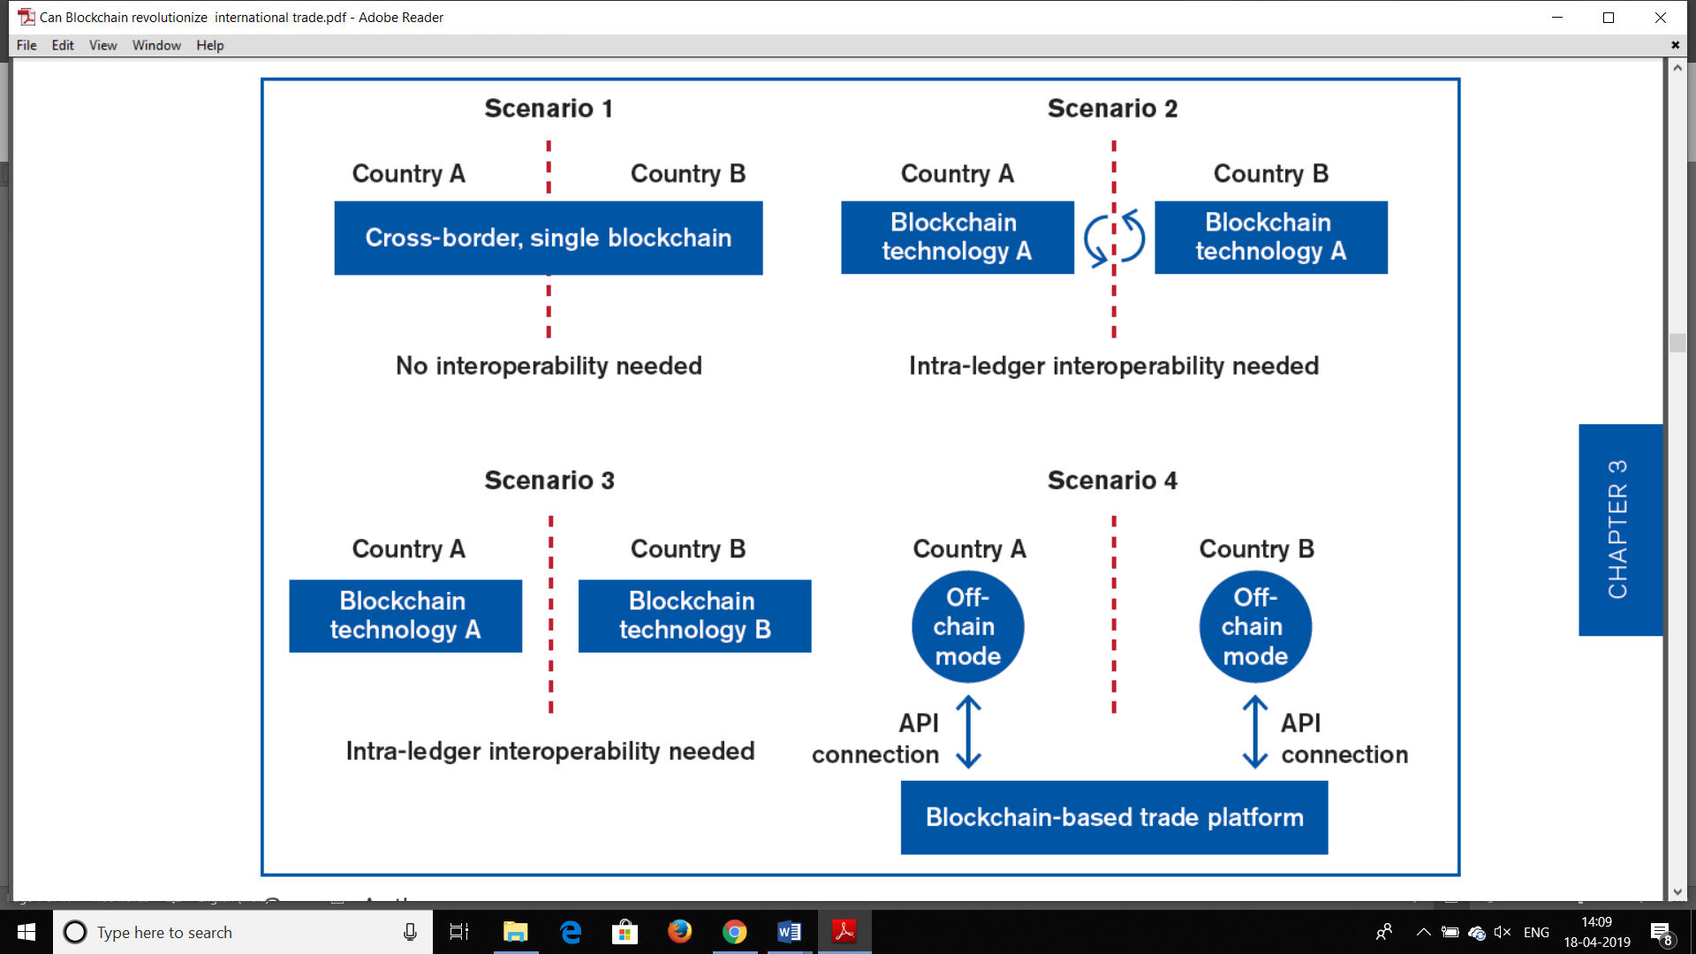

Figure 4 Different Scenarios for Blockchain Technology for paperless Trade

**Note: After studying all four scenarios, I came to an analysis that scenario 1 could be implemented for e-sanchit in India. Whereas scenario 2 and 3 is still under research and could take time to evolve.**

## **Blockchain Powered Digital Signature**

A blockchain Ledger is managed on a peer-to-peer basis by processors or servers–called "nodes" –without any mediators traditionally validating transactions. The information which is added to the block is shared between the participants and is also validated. The data which is feeded on the blockchain is "hashed", i.e. it is converted to a fixed-length binary string. It ensure that the message was generated and sent by authentic sender and was not tampered in between the journey. If the authentic sender does not want other participants in the network to see the message content itself, i.e. the information contained in the documents, he / she may choose to encrypt the message itself.

Thereby we won’t be needing any digitally signed (e-signature) supporting documents to be uploaded for custom approval of goods through e-sanchit in India.

## **Unveiling the potential Implication of blockchain for Indian Customs Authority**

Blockchain Technology could enhance the efficiency of customs authorities and could reduce the need for manual verification of e-documents. It could be used in particular to:

1. **Submitting requests for advance prosessing**

Once issued, rulings could always be stored securely on the blockchain in an authorized network and remain accessible to authorized participants, including all customs offices located across borders.

1. **Process of Release and clearance**

Customs’ databases do not necessarily have to take the form of a distributed ledger; by interfacing with blockchain-based platforms, Customs would significantly enhance their visibility in the supply chain from the early stages. They would then only have to check if there is any discrepancy between the data submitted by traders and those iteratively updated on the public ledger.

1. **Real time access to Information**

As Documents are uploaded via the system, they would be analyzed and evaluated on real time basis.

**Customs duty payment**

The customs duty installation process includes various partners, in particular the importer, customs department, custom house agents, exporter, and banks. The merchandise shipped by an exporter come to the customs department and, upon completion of all clearances and payments made to the customs by the importer, the last discharge of the goods to the importer. The procedure is time-consuming, mainly manual in nature prompting operational postponements.

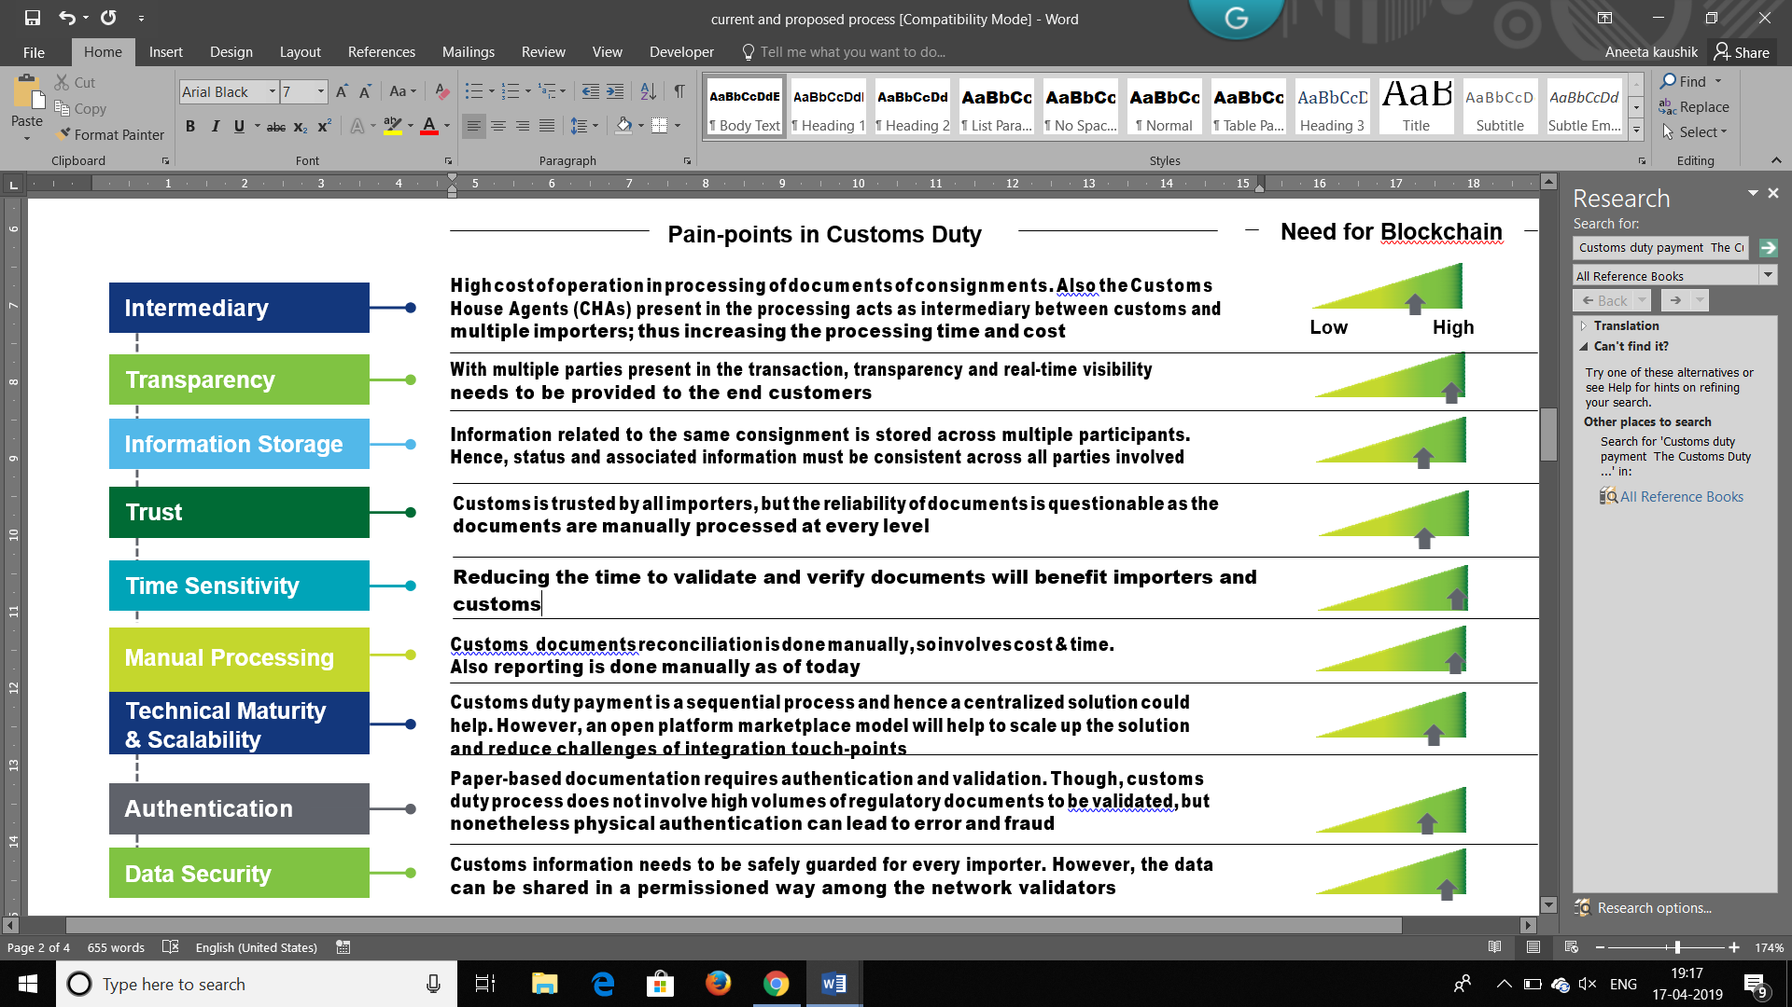

Figure 5 Blockchain Framework for customs duty payment

**Current Process**

We find a lot of manual processing and paper - based transactions that occur across participants in the present procedure. This prompts lack of transparency, mistrust and results in the presence of intermediate players such as custom house agents.

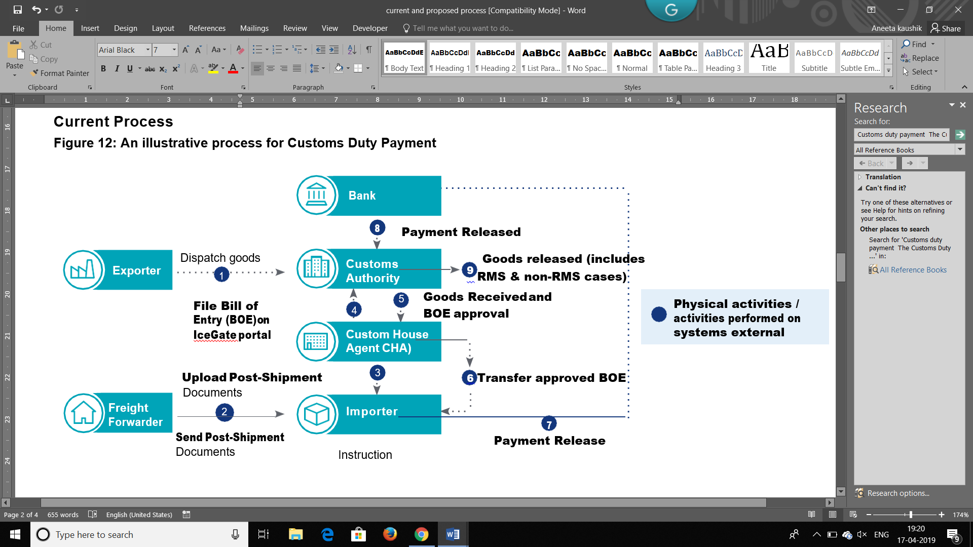

Figure 6 Process of Customs Duty Payment

**Blockchain based Future Process**

A Blockchain-based customs duties payment processing will enable real-time tracking and transparency of customs clearance processing to all relevant partners viz. Customs department importer, house clearing specialist and bank. The solution will help the Customs office better oversee space and cash cycle

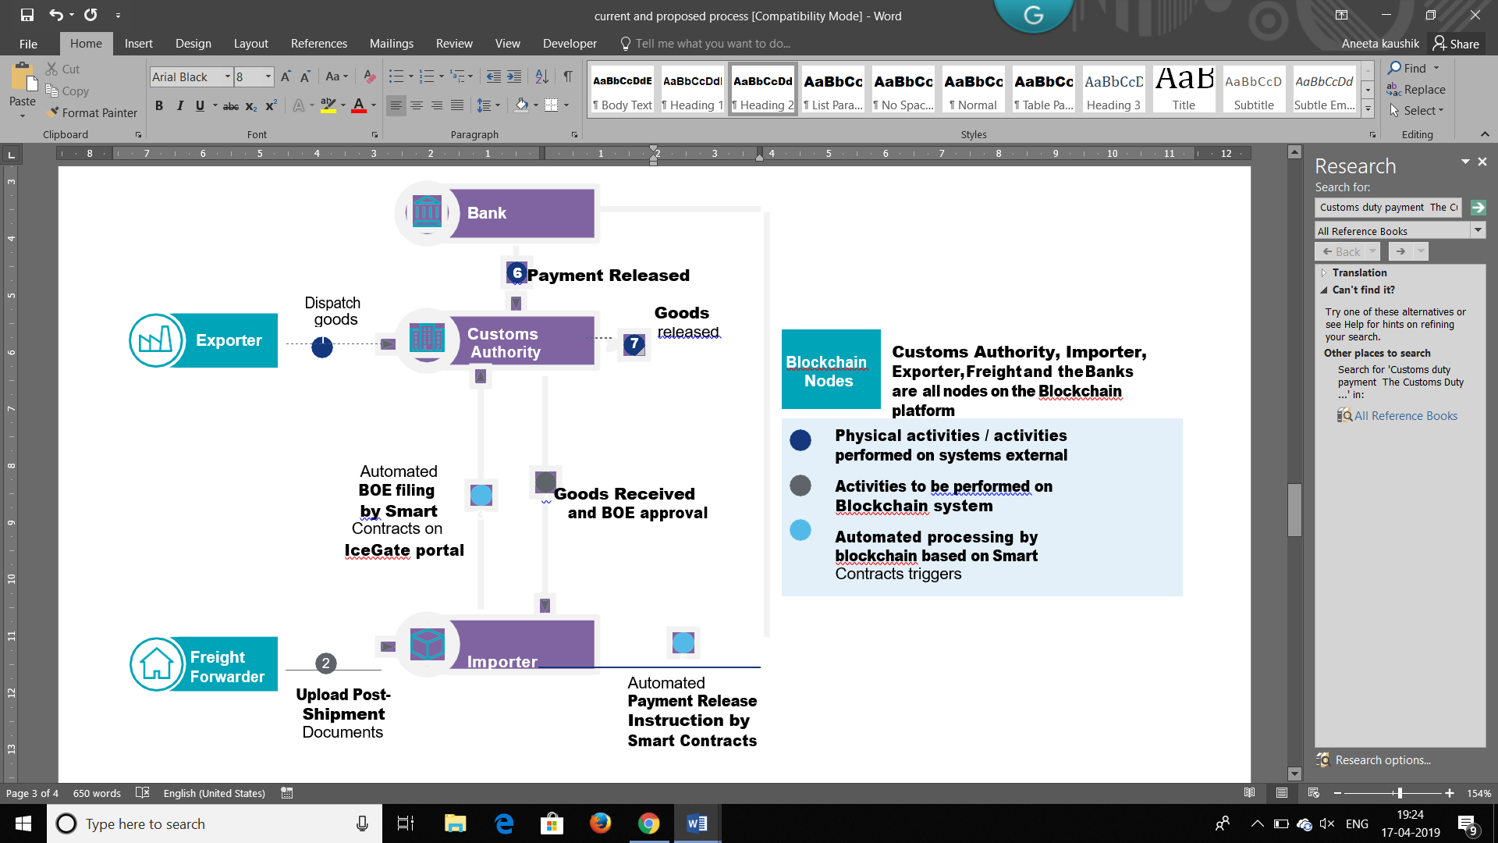

**Figure 7 Blockchain, future process**

## **Concern raised**

**Technical interoperability**

The development to advanced digital archives, for example, e-phyto declarations, has raised new interoperability issues. In the paper world, such archives are just exhibited to the competent authority in paper duplicates. The move to advanced digital reports requires establishment of ad hoc "e-bridges" between the skilful specialists of the importing and exporting nations, which can be a mind-boggling process.

**Regulatory issues**

Going paperless would require more than just technology and technical interoperability. It requires a standard regulatory framework for e-authentication methods and recognition of e-signatures, e-documents and e-transactions; that recognizes the authority of other government entities.

**Legal issues**

Blockchain frameworks that not only guarantee network technical challenges, but also have to deal with the legal status of blockchain transactions, and regulatory famework. Legitimate issues raised for utilization of Blockchain are of two kinds: general issues such as, the lawful status of blockchain exchanges and jurisdictional issues; and general issues identified with the utilization of Blockchain for specific cases.

Findings

**Questionnaire Based key Findings completed by blockchain developers:**

The survey shows that 90% of the respondents are more inclined towards having Blockchain for public sector in India. All our responses were from blockchain developers in which majority of them belongs to IBM.

The below chart shows 16 survey questions on x-axis and 15 responses on y axis. The blue and orange colour have an upper hand, from which we could conclude that people find it relevant to implement blockchain for paperless trade.

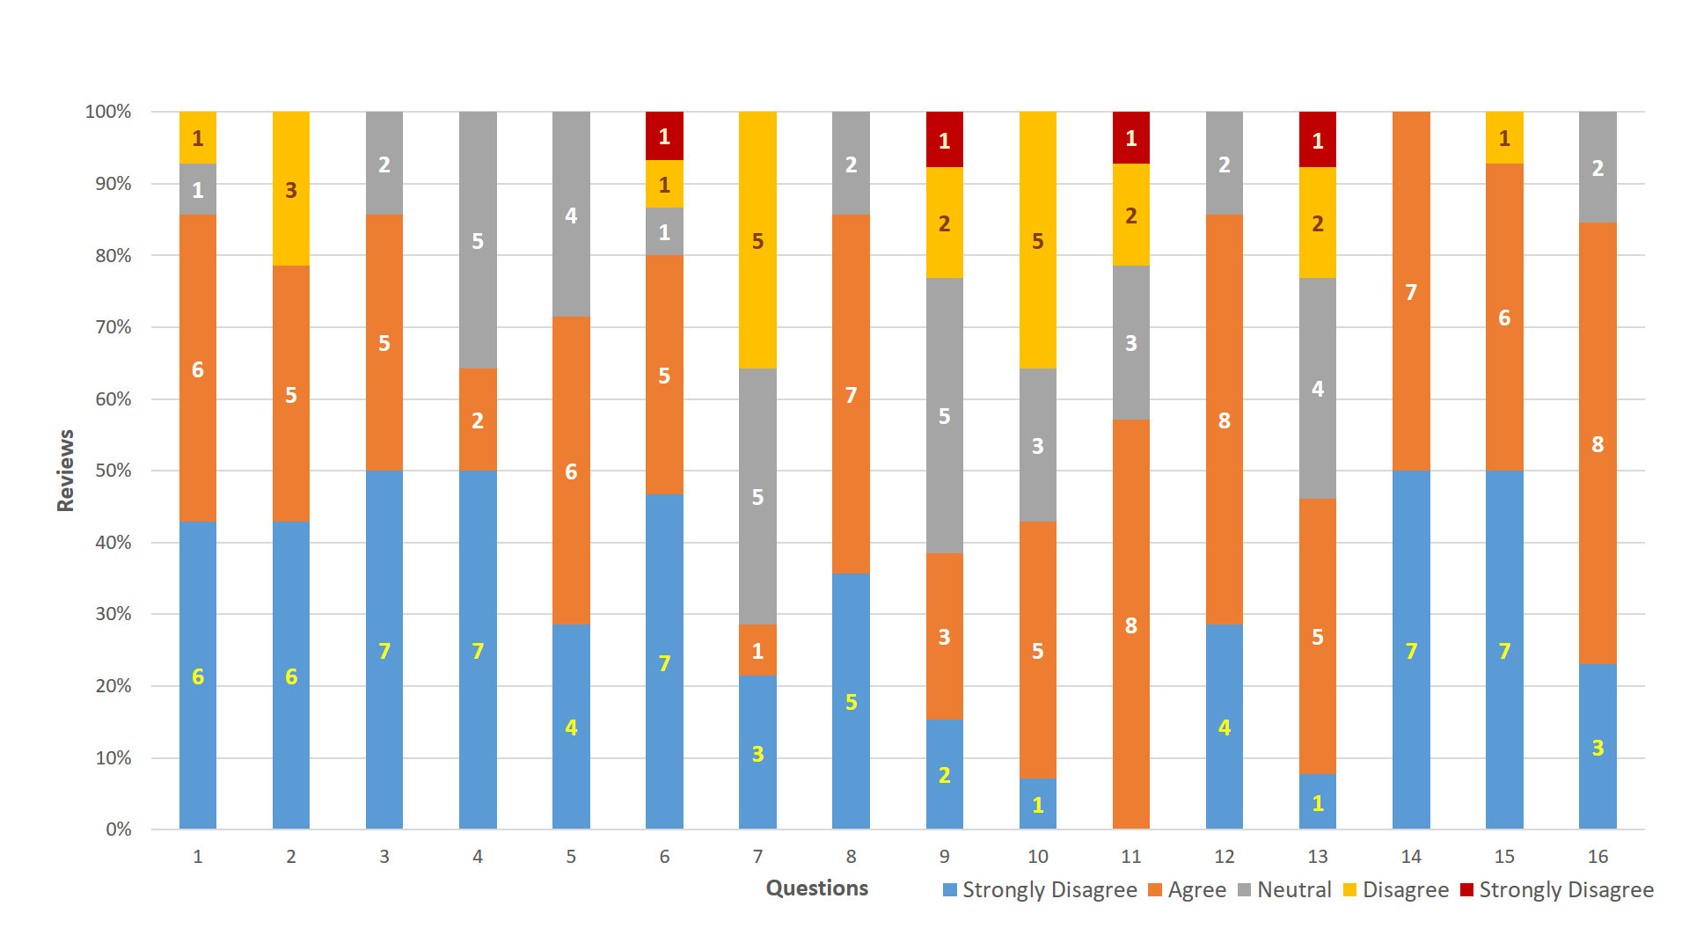

**Findings based on interviews with blockchain industry experts**

Even taking into account the fact that much of the information obtained people currently working on blockchain could be considered biased in one way or another, it is interesting to note that some of their comments confirmed the results obtained from five Blockchain industry experts, without the developers being aware of those results.

Our analysis of the interview data identifies key points about experts’ attitudes toward the Blockchain implementation that will inform how blockchain, can strengthen International Trade in India

**Through Interviews we reached at the following outcomes:**

* Blockchain could surely enhance International Trade in India
* Implementing Blockchain at a global scale could be challenging but not impossible.
* Trade network will be secured and efficient
* No need for digitally signed documents, if working on blockchain platform
* Technically feasible for e.g like Amazon infrastructure at a global scale with many servers in each country.
* Corda network could be a solution to implement such blockchain platform at a global scale (Advice from one of the industry expert)

**Note: The above survey is based on open end Analysis of interviews with Blockchain experts.**

Based on these findings we could analyse that our objective to examine the implications of Blockchain technology for paperless Trade in India could be taken into account and put forward for implementation purpose.

Conclusion

Technological innovations have shaped the world as we know it. Many have welcomed a new technology, Blockchain–a distributed ledger technology is the next big game-changer. It could change the businesses transactions that happen in day today life.

However, the technology is still at its nascent stage, and many challenges need to be addressed, including technical, interoperability and legal issues, before using it to its full potential. The Indian government could take advantage of this by linking e-sanchit with blockchain or by creating a separate infrastructure to facilitate paperless trade.

It could make international trade more standardized, but smart trade requires smart regulatory framework and that can only be achieved through coordintion. If we succeed in developing such a environment, the economy could leap with a drastic change and trade across borders might look revolutionary different after 5 to 10 years.

Recommendation

By the study and research, it is clear that there is need for full proof solid structured Blockchain platform to implement such a product. The product should be implemented with the help of government. As implementing import and export process for trade needs a lot of value proposition in the mind of the customer. Being government that provides this service will have a leap of faith to utilize the Blockchain technology initially.

Obviously, further studies need to be much broader based on technical interoperability and

 regulatory issues related to Blockchain Technology, but some suggestions have been made in this study that can be explored more fully, such as **Corda Platform.**

**References**

Bhatararat, P.(n.d.). Indicators for Trade Facilitation:

Binaifer Karanjia. (2018). Blockchain in Public Sector. Deloitte, (January).

Bralić, V., Kules, M., & Srancic H.(2018). Model for long-term preservation of digital signature validity: TrustChain, 89-103. <https://doi.org/10.17234/infuture.2017.10>

Brown, R. G. (2018). The Corda Platfor,: An Introduction. Corda Platform White Paper, I- 21. Retrieved from <https://www.corda.net/wp-content/uploads/2018/05/corda-platform-whitepaper.pdf>

Cals, W.P. (1993). TRANSITION FROM PAPER TO PAPERLESS: DOD ’ S CALS SYSTEM, 32-38.

Can Blockchain Revolutionize International Trade? (2018). Can Blockchain Revolutionize International Trade? <https://doi.org/10.30875/7c7e7202-en>

Caria, R. e. (n.d.). A Digital Revolution in International Trade? The International Legal Framework for Blockchain Technologies, Virtual Currencies and Smart Contracts: Challenges and Opportunities, 1- 18.

Chatterjee, S., Singla, V., & Lam, M. (2017). How Blockchain Can Reshape Trade Finance. Deloitte.

Duval, Y. (2017). Digital Trade Facilitation: paperless trade in Regional Trade Agreements.

Duval, Y., Unit, T. F.,Division, I., & Economic, U. N. (2017). Developing Regional Crossborder E- commerce through Paperless Trade Cross- border e- commerce & paperless trade, (June).

Economic, T. (2016). Economic and Social Council, 00595(May), 1-11.

Facilitation, T., & Trade, P. (2015).Trade Facilitation and Paperless Trade Implementation Survey 2015 Global Report.

Goldby, M. (2018). Electronic bills of lading and central registries : what is holding back progress?, 0834, <https://doi.org/10.1080/13600830802239381>

Intelligence, T., & Pacific, A. (2018).borders, (September).

July, P. O. (2018). 2018 Volume:15 S: 1-8, 2018(July).

Laryea, E. (2016). Facilitating Paperless international trade : a survey of Law and Policy in Asia Facilitating Paperless InternationalTrade : A Survey of Law and Policy in Asia, 0869. <https://doi.org/10.1080/13600860500131200>

Nations, U., & On, C. (n.d.). UNCTAD/EDM/Misc.17/Rev.1.

Netherlands Yearbook of International Law. (n.d.).

Notes, P. E., & Offerings, I. C. (2018). 20180921_EMCompass-Note-57-Blockchain-Governance_v1-1, 1-8.

Okazaki, Y. (2018). Unveiling the Potential of BlockChain for Customs, (45), 1- 24 .

Paper, W. (2017). Paperless Trading : How Does It Impact the Trade System?, (October).

Report, U. R. (2017) Trade Facilitation and Paperless Trade Implementation,

Saggu, A. (2015). STUDIES IN TRADE AND INVESTMENT 85 Trade Facilitation and Paperless Trade: State of Play and the Way Forward for Asia and the Pacific. (December).

Takac, P.F. (n.d.). relationships?

Verhoeven, P., Sinn, F., & Herden, T. (2018). Examples from Blockchain Implementations in Logistics and Supply Chain Management : Exploring the Mindful Use of a New Technology. Logistics, 2(3), 20. https://doi.org/10.3390/logistics2030020