Mechanical Act of Usual Fibre Reinforced Composites Considering Fly-Ash Customized Moulds

Satya Ranjan Patnaik
Department Of Mechanical Engineering, ABIT, Cuttack, Odisha.
satyaranjan.patnaik@gmail.com
Krutibash Khuntia
Dept. of Mechanical Engineering, Synergy Institute of Technology, Bhubaneswa, Odisha,
krutibash4u@gmail.com

ABSTRACT
In recent time the availability as well as suitability in diversified usages of usual fibre reinforced polymer composites in compare with synthetic fibre based polymer composites has been greatly experienced. The greatness of ordinary fibre reinforced polymer composites lies in its eco-friendly aspects. Among various fibres, jute is considered extensively functioning natural fibre in the market on behalf of the traits like ease of accessibility, reasonable mechanical attributes, under budget, trivial solidity, cheap fabricating value, etc. The effort is based on the observation concern to mechanical aspects of jute fibre reinforced epoxy composites taking fly-ash makes the filler. The jute fibre epoxy composites have been fabricated on diversifying the fibre contents of value 0, 5, 10, 15 and 20 weight % along with packing contents of 2 weight % respectively, on implementing simple hand lay-up method. The jute fibres were used without any alkali treatment in the epoxy composites and length of the fibres were 6mm. The fly-ash used was of the size of 0.5 to 300 micron. Consequently the fabricated unit taken up for passing through certain investigation like the physical aspects of the composite which includes tensile potency, impact power, hardness and other inherent issue like water absorption test. There is a nil fibre reinforced composite considered for standardising observational values.

Keywords- Polymer composites, jute fibre, hand lay-up, fly-ash fillers, Mechanical attribute.

- INTRODUCTION

Green composite with resin matrix and natural fibres as reinforcements are used for many experiments. Natural fibres like coconut shell [1], Jute [2,4] Satin fibre [9], Wooden flour [15] are used because they are light and strong. Recent developments in composites [6] shows they have different uses like Ecological design of automobile [4], oxygen resistant materials [17], electrical insulation and thermal conductivity materials [16] and many others. Previous developments on composite shows the use of artificial fibres like cellulose blast fibre [8], carbon fibres [9,10,11,12] glass tubes[16].The use of biodegradable resin shows no negative effect on environment because the end product will be co₂ and water. In order to enhance the potency of composite supplementary and to fill the voids nano-fillers such as flyash [1], Zno and Tio₂ [2], graphite nano-platelets [10] are used.

The composite does not have any negative impact on environment because its main component is jute fibre extracted from natural jute after processing [2]. The wastes of jute can also be used effectively to produce composite increasing its economic value. For complicated shapes compression moulding can be used. Further-more a proper binder necessary towards augmenting features like solidity, water resistance, brittleness, and other aspects of the composite. So to solve this issue we used biodegradable resin [1-3]. There are a number of functional domains where jute fibre is unreasonably adopted because of its ease of accessibility, under budget, significant physical stability value. Therefore this project is environment friendly and saves resources by utilising waste materials.
In this study, by using flyash with uniform particle size, jute fibers with uniform length and the biodegradable adhesive, several specimens were created by changing the ratio of those materials.Specimens were produced by using compression moulding at the room temperature. With regard to our natural composite, small quantities of biodegradable resin are used and the matrix consists of the resin with a mixture of fly-ash. The biodegradable resin is coated on jute to improve the water resistance and is also used to strengthen the adhesion of jute to improve the strength. The effects of biodegradable adhesive and jute fibres on the change in hardness and impact strength have been estimated via the physical characteristics of the composite. Therefore Tensile strength test, Charpy impact test, Rockwell hardness test made under some conditions was examined. In addition the specimen water absorption capacity was examined. From the experimental results, adhesive along with jute fibre consequences upon the total power of the proposed composite were clarified.

II. EXPERIMENTAL INVESTIGATIONS

A. Composite Fabrication

Keeping the current standards as pivot, the effort passed on with producing a mould box of magnitude 165×60×10 mm. Again the mould box comprising of plywood as ground surface along with 10mm wood pieces holding side boundary. Finally the wall of the unit wrapped with Berger putty in order to resist the seepage of epoxy resin. The tentative pictorial view of the box has been mentioned underneath.

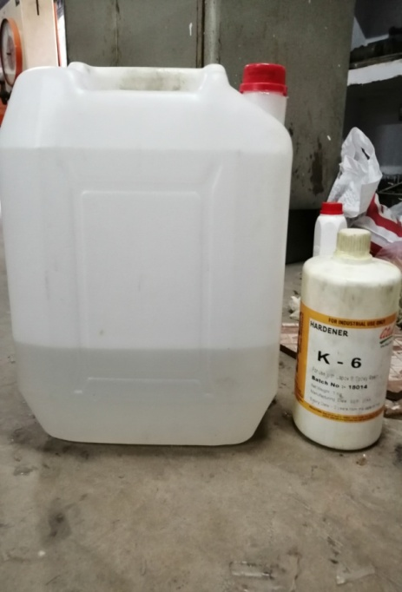
Fig.1 Pictorial view of Mould Box Epoxy Resin with Hardener

On behalf of the functional execution, there is sprinkling of mould occur for promoting comfortable withdrawal of composite out of the mould after the successful curing process. There may be either a mould spray or discharging unit can be installed on behalf of smooth withdrawal of the composite out of the mould next to the curing process. Then the epoxy B11 as well as the corresponding hardener k6 is combined considering weight as standard in the ratio of 10:1 which has confirmed by Atul Chemcials Pvt. Ltd. After that it has observed both materials i.e. stuffing and fibres specifically combined within the resin of epoxy content on behalf of reducing the ambient oxygen inclusion. Composites of various compositions with different fibre content of (5, 10, 15 and 20) wt% were prepared along with filler content of 2 wt% respectively. The mould is then covered and 5kg of load is applied over it. Consequent to this, keeping the temperature at room temperature magnitude, the prepared arrangement exposed for 24 hours to cure followed with 24 hours exposure to ambient air. Lastly the preparation has been made considering preferable specimen outer profile as per ASTM standard for different mechanical experimental observation. A complete description as well as composites built up of has clarified underneath;
Rule of mixture: The rule of mixture was used for the calculation of different fibre percentage for the composite.
$W_{f}=\frac{w_{f}}{w_{c}}$
And $ρ_{c}=\frac{1}{\frac{W_{f}}{ρ_{f}}+\frac{W_{m}}{ρ_{m}}+\frac{W_{n}}{ρ_{n}}}$

The volume fraction of fibre has been calculated by rule of mixture.

Table 1
Composition of composites
Composites | Epoxy resin(wt%) | Fibre (wt%) | Fly ash (wt%)
C1 | Epoxy (93 wt%) | jute fiber length 6mm (5wt%) | 2%
C2 | Epoxy (88 wt%) | jute fiber length 6mm (10wt%) | 2%
C3 | Epoxy (83 wt%) | jute fiber length 6mm (15wt%) | 2%
C4 | Epoxy(78 wt%) | jute fiber length 6mm (20wt%) | 2%
C5 | Epoxy(100 wt%) | Jute Fibre(0 wt%) | 0%

B. Mechanical tests

Tensile Test (ASTM D 638):

In present investigation tenacity description of 165 x 13 x 7 mm matching to ASTM-D-638 with 50 mm per minute cross head dynamicity, and gauge length 50 mm via UTM(INSTRON, UK 3382) respectively.
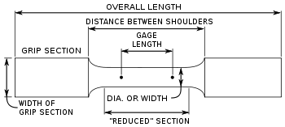
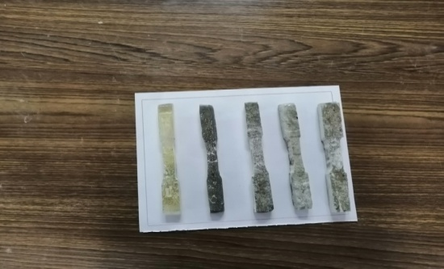

Fig.No.3 Tensile Test Specimens Fig. No.4 Tensile Test Specimen Nomenclature

Tensile strength is calculated by using following formulas:
Tensile Strength (MPa)=Force(Load)(N) / Cross Section Area (mm²)
Tensile Strength at Yield(MPa) = Max. Load recorded (N) / Cross Section Area (mm²)
The specific stress-strain curve plot has referred for the assessment of tensile modulus and elongation values. The evaluation of percent elongation at yield is carried out provided its value is superior than the value estimated at break point.
Tensile strength has estimated considering the underneath mathematical expressions:
Strain can be defined as, Change in Length (elongation) / Original Length (gauge length)
Elongation magnitude at yield: Δ L = ε (the value at the yield point) * L on the X-axis

The percentage elongation found at yield = Δ L * 100
The starting longitudinal segment mentioned in the load extension curve with separating stress difference Tensile modulus (the modulus of elasticity) is determined by extending the initial linear portion of the load-extension curve and dividing the difference in stress obtained from any segment of section on this straight line by the corresponding difference in strain, expressing the result in the unit of Mega Pascal (MPa).

Charpy Impact test

This very test will be executed for the awareness about the material stiffness. Throughout the experimentation, samples will be exposed to a greater quantity of force for a very limited time period. The indication of greater impact strength pointing out for any material, the higher amount of impact strength indicates that it can absorb a large amount of energy before failure. As the impact energy increases the toughness of material increases and its plasticity will be also large. In present investigation notched charpy impact strength of the specimens of dimensions 55x12.7x3mm was evaluated as per ASTM-E-23 with a notch depth of 2.54mm and notch angle of 45°. Minimum of three tests were performed for each composite sample average and corresponding standard deviation of these measurements is reported. The impact strength is calculated by dividing the impact values obtained from the scale by the thickness of the specimen. One point indicating the advantages of the Charpy test over an Izod test is that the specimen does not have to be clamped; therefore, it is free of variations in clamping pressures.

Rockwell hardness test

Hardness is defined as the resistance of a material to indentation, penetration, scratches, deformation and particularly, permanent deformation. Hardness is purely a relative term. Hardness of materials is impressed in number scale; so it has no unit. ASTM D 785: Standard Test Method for Rockwell Hardness of Plastic and Electrical insulating materials.

Rockwell hardness test is most commonly used for relatively hard plastics. It is defined as the resistance to indentation of the standard indenter. In Rockwell hardness A standard specimen is placed on the surface of the Rockwell Hardness tester. A minor load is applied and the gauge is set to zero. The major load is applied by tripping a lever. After 15 seconds the major load is removed. The specimen is allowed to recover for 15 seconds and then the hardness is read off the dial with the minor load still applied. Rockwell hardness is measured in R, L, M, E and K scales. The scale represents indenter size, major load and dial scale.

III. RESULT AND DISCUSSION

Mechanical characteristics of composites

In the present study, the observation concern to tensile strength, flexural impact and hardness have been accomplished for assigning the mechanical attributes of the epoxy based treated jute fibre and fly ash powder composites. Thereafter the mechanical features of composites considered for the comparison issue with those of neat epoxy resin.
Tensile Strength
The universal testing machine model - INSTRON 3382
Tensile testing parameters – specimen dimensions – width 12.7mm
Total length – 165mm, Gauge width – 20 mm, Thickness – 4mm
Tensile strength = force (N)/original cross section of the sample (mm2)
Tensile speed - 50 mm/min

It has observed that with the corresponding rise in the fibre and amount up to the inclusion of 10% in weight magnitude, the tensile strength of composites rises. But additional rise of fibre amount decreases the strength magnitude. Primarily the reduction in strength is because of ineffective adhesion among epoxy and fibre. Since there is a rise in fibre amount, collection of the same rather spreading of the fibre has been observed. It has also been monitored that resin is unable to enter between the two adjacent fibre layers. Apart from the above causes, diminishing in the tenacity magnitude may credit to micro bubbles which rise during processing.

Table 2
Tensile strength test outcomes of specimens.
Sl. No. | Specimen Composition | Tensile Strength(MPa)
C1 | Epoxy (93%)+Fibre(5%)+Fly ash(2%) | 47
C2 | Epoxy(88%)+Fibre(10%)+Fly ash(2%) | 52
C3 | Epoxy(83%)+Fibre(15%)+Fly ash(2%) | 45
C4 | Epoxy(78%)+Fibre(20%)+Fly ash(2%) | 36
C5 | Epoxy(100%)+Fibre(0%)+Fly ash(2%) | 84

Histogram No.1 Tensile Strength Test of Specimens
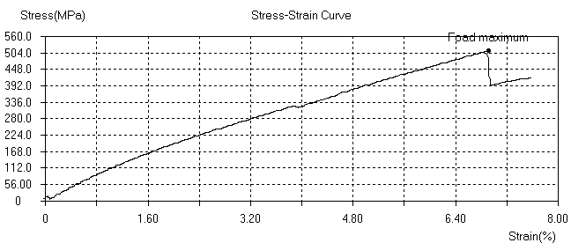
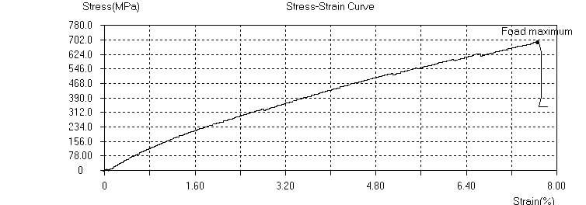

Fig.-3 Stress ~ Strain Curve with 5wt% Fibre

Impact Strength

Based on ASTM-D-256 implementing impact observations continued upon composite samples based on ASTM D 256 considering impact tester. Considering the pendulum impact carrying out devise, the notch impact potency concern to material shows crushing the U notched sample via one pendulum mallet, estimate the exhausted power, in addition to describing it to the cross section of the sample. The benchmarking of sample for ASTM E 23 experiences 64.5 × 12.7 × 3.0 mm with depth of the notch measures 2.5 mm.

TABLE NO. 3
Result of impact strength test of specimen
Sl. No. | Specimen Label | Energy Absorbed(J)
C1 | Epoxy (93%) + Fibre (5%) + Fly ash (2%) | 40
C2 | Epoxy (88%) + Fibre (10%) + Fly ash (2%) | 352
C3 | Epoxy (83%) + Fibre (15%) + Fly ash (2%) | 264
C4 | Epoxy (78%) + Fibre (20%) + Fly ash (2%) | 68
C5 | Epoxy (100%) + Fibre (0%) + Fly ash (0%) | 42

There is an absolute enhancement relating to impact strength on behalf of amalgamation of jute fibres and fly ash has been minutely observed. The impact strength gradually increases by increasing the jute fibre and fly ash contains. The composite of C2 shows the highest impact strength as compare to others. The energy absorption increases up to the 10wt% of fibre and then decreases considerably.

Rockwell Hardness

In designating the fact against hardness, it confirms obstruction towards penetration or poking. It also exhibits plastic distortion of the matter. As per the investigation evidence filling mass percentage certainly influences the hardness magnitude relating with composite matter. The fraction of fly ash along with jute fibres estimated on Rockwell scale relating to the composites have been summarised in the table underneath;
All the hardness tests were conducted at 60kgf load.

TABLE 4
Result of Rockwell hardness test of specimen.

Sl. No. | Specimen Label | Rockwell Hardness(R-Scale)
C1 | Epoxy (93%) + Fibre (5%) +Fly ash (2%) | 66
C2 | Epoxy (88%) + Fibre (10%) + Fly ash (2%) | 83
C3 | Epoxy (83%) + Fibre (15%) +Fly ash (2%) | 68
C4 | Epoxy (78%) + Fibre (20%) + Fly ash (2%) | 58
C5 | Epoxy (100%) + Fibre (0%) + Fly ash (2%) | 86

CONCLUSION

The jute fibre reinforced epoxy composites experimental investigation draws out significant physical features. The setting of jute fibre reinforced epoxy composites along with diverse filler contents considered feasible because of productive accomplishment of simple hand lay-up technique. The observations concern with mechanical attributes significantly improve, due to reinforcement of jute fibre and fly ash in the epoxy resin. Attributes like hardness and tensile strength relating to composites enhances with the rise in jute fibre along with fly ash contents up to 10 wt% of jute fibre. On the other hand additional rise in reinforcement decreases composite rigidity. And as a matter of fact the very reduction value is on behalf of inappropriate adhesion between fibre and epoxy. Further, composites impact rigidity enhances with the rise in jute fibre and fly ash contents up to 10wt%. The water absorption capacity is directly dependent upon the jute content in the composite. Following which the 5wt% jute composite showed least amount of water absorption where as the 15wt% jute composite showed highest amount of water absorption. In a nutshell the investigation not only enhanced interfacial attachment drawn out of superior adhesion among fibre and matrix but also successfully yields advanced mechanical attributes as well as fibre potency make out fewer fibres withdrawn.

REFERENCES

[1] Antaryami Mishra “Mechanical Properties of Coconut Shell Dust, Epoxy - Fly AshHybrid Composites” American Journal of Engineering Research (AJER)e-ISSN: 2320-0847 p-ISSN : 2320-0936Volume-6, Issue-9, pp-166-174
[2] Prasob P.A., Sasikumar M. “Static and dynamic behavior of jute/epoxy composites with ZnO and TiO2fillers at different temperature conditions” Polymer Testing 69 (2018) 52–62
[3] Raj B. Ladania, Shuying Wu, Anthony J. Kinloch, Kamran Ghorbania, Adrian P. Mouritz and Chun H. Wang “Enhancing fatigue resistance and damage characterisation in adhesively-bonded composite joints by 1 carbon nanofibres”
[4] Alves, C.,Ferrao,P.M.C.,Silva,A.J., et al., 2010.Ecodesignofautomotivecomponentsmakinguseofnaturaljute fiber composites.J.Clean.Prod.18,313–327. Doi:10.1016/J.JCLEPRO.2009.10.022.
[5] Nassar, .A.,Arunachalam, ,Alzebdeh, K.I., 2017. Machinability of natural fiber reinforcedcomposites:Areview.Int.J.Adv.Manuf.Technol.88,2985–3004. doi:10.1007/s00170-016-9010-9.
[6] Pickering, K.L,AruanEfendy, M.G., Le,T.M.,2016. Are view of recent developments in natural fibre compositesandtheirmechanicalperformance.Compos.PartAAppl.Sci. Manuf. 83,98–112. doi:10.1016/J.COMPOSITESA.2015.08.038.
[7] Ramesh, M.,Palanikumar,K.,Reddy,K.H.,2017.Plant fibre basedbio-composites:Sustainableandrenewablegreenmaterials.Renew.Sustain.EnergyRev.79,558–584. doi:10.1016/J.RSER.2017.05.094.
[8] Zimniewska,M.,Wladyka-Przybylak,M.,Mankowski,J.,2011.Cellulosicbastfibers, theirstructureandpropertiessuitableforcompositeapplications.InCelluloseFibers: Bio- andNano-PolymerComposites.Berlin,Heidelberg:SpringerBerlinHeidelberg,pp.97–119. doi:10.1007/978-3-642-17370-7_4.
[9] Zainab Al-Hajaj, Radovan Zdero, HabibaBougherara “Mechanical, Morphological, and Water Absorption Properties of a New HybridComposite Material made from 4 Harness Satin Woven Carbon Fibres and Flax Fibres in an Epoxy Matrix” Composites: Part A (2018)
[10] Yan Li, Han Zhang, Zhaohui Huang, Emiliano Bilotti,and Ton Peijs “Graphite Nanoplatelet Modified Epoxy Resin for Carbon FibreReinforced Plastics with Enhanced Properties” Journal of NanomaterialsVolume 2017, Article ID 5194872, 10 pages
[11] D. Carolan1,2,*, A. Ivankovic2, A. J. Kinloch1, S. Sprenger3, and A. C. Taylor1 “Toughened carbon fibre-reinforced polymeromposites with nanoparticle-modified epoxy matrices” J Mater Sci (2017) 52:1767–1788
[12] A. Garc´ıa-Carpintero · M. Herr´aez · J. Xu1 · C. S. Lopes · C. Gonz´alez1 “A Multi Material Shell Model for the Mechanical Analysis of Triaxial Braided Composites” Springer Science+Business Media Dordrecht 2017 DOI 10.1007/s10443-017-9593-9
[13] D. Carolan, A. Ivankovi, A. J. Kinloch, S. Sprenger, and A. C. Taylor “Toughened carbon fibre-reinforced polymer composites with nanoparticle-modified epoxy matrices”J Mat(2:1767–
[14] ZHANG, H “Interlaminar toughening of woven fabric carbon/epoxy compositelaminates using hybrid aramid/phenoxy interleaves” JCOMA 4688 Composites: Part A
[15] MatheusPoletto“mechanical, dynamic mechanical and morphological properties of composites based on recycled polystyrene filled with wood flour wastes” Maderas. Ciencia y tecnología 19(4): 433 - 442, 2017
[16] Li Zhang, Xingyu Li, Hua Deng, Yao Jing, Qiang Fu “Enhanced Thermal Conductivity and Electrical Insulation Properties of Polymer Composites via Constructing Pglass/CNTs Confined Hybrid Fillers” Composites: Part A , JCOMA 5178
[17] Vipin Vijay, Subramania Siva, Sreejith K. J, Prabhakaran P. V, RenjithDevasia“effect of boron inclusion in sioc polymer derived matrix onthe mechanical and oxidation resistance properties of fiber reinforced composites” Materials Chemistry and Physics, MAC 20130.

