BOOK CHAPTER TITLE:
ENERGY FROM WASTE: A NEW RENEWABLE ENERGY SOURCE
AUTHORS CREDENTIALS:
Lead Author:
Dr. Manoj Thakur, Assistant Professor (Environment Science), Vallabh Degree College (VGC), Mandi, Himachal Pradesh, India-175001
Email: manojthakur0083@gmail.com Mobile: 9418421270

Co-authors:
- Dr. Monika Panchani, Associate Professor (Zoology), Vallabh Degree College (VGC), Mandi, Himachal Pradesh, India-175001
Email: monikapanchani11@gmail.com Mobile: 9418263032
- Dr. Sanjay Narang, Associate Professor (Zoology), Vallabh Degree College (VGC), Mandi, Himachal Pradesh, India-175001
Email: sanjaynarang2020@gmail.com Mobile: 9418480595
- Dr. Radhika Jamwal, Assistant Professor (Zoology), Vallabh Degree College (VGC), Mandi, Himachal Pradesh, India-175001
Email : radhika_mnd@yahoo.co.in Mobile: 9418080991

BACKGROUND:
Globally around 50% of the population resides in urban regions and projections are there that it will increase to 70% by 2030¹. Industrialisation, urbanisation and economic growth have resulted in the generation of millions of tons of waste daily, which due to lack of its scientific management leads negative impacts on human health, air, water and land resources². Although efforts are being made towards its reduction, reuse and recycling but energy generation from could be one option to explore to meet the duel objective of waste management as well as energy generation. Energy from waste, also known as waste-to-energy (WtE), refers to the process of generating energy, typically in the form of electricity and/or heat, by treating and processing various types of waste materials. It involves harnessing the energy content present in waste and converting it into a usable form. The concept of waste-to-energy (WtE) has been around for many years, with its roots dating back to the late 19th century. The early developments in waste-to-energy technologies were primarily focused on reducing the volume of waste and minimizing the associated health and environmental hazards. Incineration, one of the oldest and most widely used waste-to-energy processes, gained popularity in the early 20th century. Initially, the primary goal was to dispose of waste efficiently and safely while generating some heat. However, as the need for energy resources grew, the focus shifted towards harnessing the energy content of waste and converting it into electricity and heat.
In the 1970s and 1980s, with increasing concerns over energy security and waste management, waste-to-energy gained renewed attention. Governments and organizations started recognizing the potential of waste as a valuable resource for energy production. This led to advancements in waste-to-energy technologies and the development of more efficient and environmentally friendly systems. Over the years, various countries, particularly in Europe and Asia, have invested in waste-to-energy infrastructure. For example, countries like Denmark, Sweden, and the Netherlands have made significant progress in utilizing waste for energy production. They have implemented stringent waste management policies, aiming to divert waste from landfills and promote sustainable waste treatment methods. The European Union has played a vital role in promoting waste-to-energy initiatives. The EU Waste Framework Directive sets targets for waste reduction, recycling, and energy recovery, encouraging member states to adopt sustainable waste management practices. This directive has contributed to the growth of waste-to-energy projects across Europe.
In recent years, there has been a growing global focus on the circular economy, resource efficiency, and renewable energy. Waste-to-energy fits into this framework by recovering energy from waste materials that cannot be easily recycled or reused. These are viable technologies to alleviate the growing energy insecurity in an era of growing industrialization accompanied by high power demand from the growing population³. It offers an opportunity to reduce greenhouse gas emissions, decrease reliance on fossil fuels, and mitigate the environmental impacts of waste disposal. However, waste-to-energy projects have faced criticisms and challenges. Concerns include emissions of pollutants during the incineration process, potential impacts on air quality and public health, and the possibility of discouraging recycling efforts. Addressing these concerns and implementing strict emission control measures are crucial for the successful and sustainable implementation of waste-to-energy projects. Overall, waste-to-energy has evolved as a significant component of integrated waste management strategies, providing an alternative to landfilling and contributing to a more sustainable approach to waste treatment while simultaneously generating renewable energy.
WASTE TO ENERGY METHODS:
There are different methods of generating energy from waste, including Incineration, anaerobic digestion, gasification, pyrolysis, landfill gas recovery etc. Lets discuss these one by one:
INCINERATION:
Incineration is the most common method, where waste materials are burned at high temperatures to generate energy in the form of heat and/or electricity. The heat generated during the combustion process is used to produce steam, which drives a turbine to generate electricity. Furthermore, the advantages of the ash created by waste incineration have made it even more appealing, as nothing is lost⁴. The resultant ash can be applied as a construction material in asphalt and concrete applications⁵. Incineration can also be combined with other waste treatment processes to enhance energy recovery.
The steps involved in the waste incineration process for energy generation are:
- Waste Pre-processing: Before incineration, the waste is sorted and pre-processed to remove recyclable materials and hazardous substances. This can include the removal of metals, glass, and plastics, as well as the treatment of certain waste fractions to reduce their environmental impact.
- Combustion: The waste is then fed into a combustion chamber within the incinerator, where it is burned at high temperatures, typically ranging from 800 to 1,200 degrees Celsius. The combustion process releases heat, which can be harnessed to produce steam.
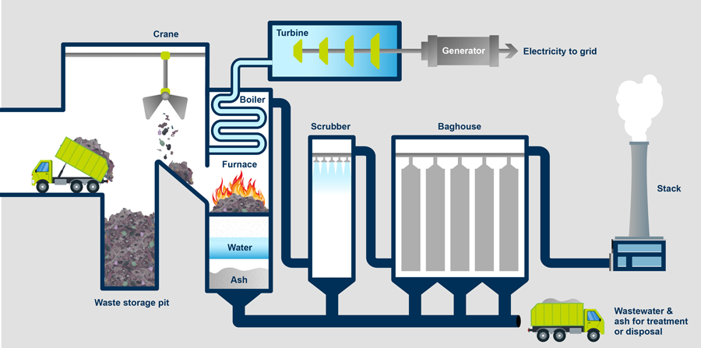
Source: https://ugc.futurelearn.com
- Heat Recovery: The heat produced from waste combustion is used to generate steam in a boiler. The steam drives a turbine connected to a generator, producing electricity. Alternatively, the heat can be utilized directly for industrial processes or district heating systems.
- Emission Control: To minimize the environmental impact, waste incineration plants employ various technologies to control emissions. These include flue gas treatment systems, such as scrubbers, fabric filters, and electrostatic precipitators, to remove particulate matter, heavy metals, and other pollutants. Additionally, systems like selective catalytic reduction (SCR) or selective non-catalytic reduction (SNCR) can be used to reduce nitrogen oxide (NOx) emissions.
- Residue Treatment: After the combustion process, the remaining ash and other solid residues, known as incinerator bottom ash (IBA) or fly ash, undergo further treatment. This may involve separating metals for recycling, recovering valuable materials, or stabilizing the ash for safe disposal in landfills.
Advantages of waste incineration for energy:
- Energy Recovery: It allows the conversion of waste into usable energy, reducing reliance on fossil fuels and contributing to renewable energy generation.
- Waste Volume Reduction: Incineration significantly reduces the volume of waste that would otherwise end up in landfills, helping to alleviate the burden on limited landfill space.
- Waste Disposal: Incineration can be an environmentally sound alternative to landfilling for non-recyclable and non-compostable waste, minimizing the potential risks associated with landfilling, such as leachate and greenhouse gas emissions.
Challenges of waste incineration process:
Waste incineration for energy generation is not without challenges and concerns. Key considerations include:
- Emissions and Air Quality: Incineration can release pollutants, such as particulate matter, heavy metals, and dioxins, into the air. Strict emission control technologies and monitoring systems are necessary to ensure compliance with environmental regulations and protect air quality.
- Public Perception and Acceptance: Waste incineration can face opposition from communities due to concerns about emissions, potential health risks, and the preference for recycling and waste reduction over energy recovery.
- Waste Hierarchy: It is essential to prioritize waste reduction, reuse, and recycling before resorting to incineration. Waste-to-energy should be considered as a complementary component of a comprehensive waste management strategy rather than a sole solution.
Case Studies:
Denmark - Copenhagen: The waste management system in Copenhagen, Denmark, is often cited as a leading example of sustainable waste incineration. The city's waste-to-energy plants, such as the Amager Bakke facility, efficiently incinerate waste, recover energy, and minimize environmental impacts through advanced emission control technologies. The success of Copenhagen's waste incineration approach is attributed to comprehensive waste management policies, public participation, and long-term planning.
Sweden - Västerås: The Västerås Waste-to-Energy Plant in Sweden is recognized for its high energy efficiency and effective waste management practices. The facility utilizes advanced technologies, such as grate combustion and flue gas treatment systems, to optimize energy recovery and reduce emissions. Västerås serves as an example of integrated waste management and energy generation, contributing to Sweden's renewable energy targets.
Maishima Incineration Plant, Japan and Afval Energie Bedrijf (AEB), Amsterdam, Netherlands are other renowned examples for their waste incineration and energy recovery capabilities.

Waste incineration in India has gained attention as a potential solution for managing the increasing volume of municipal solid waste (MSW) in the country. However, it is worth noting that waste management practices vary across different regions and cities in India, and waste incineration is not yet widely adopted compared to other waste management methods such as landfilling or composting. The Okhla Waste-to-Energy Plant, located in Delhi, is one of the oldest and largest waste incineration facilities in India. It incinerates a significant portion of the municipal solid waste generated in the city, generating electricity. The plant uses a combination of mass burn and refuse-derived fuel (RDF) incineration technologies. Ghazipur Waste-to-Energy Plant, Delhi, Timarpur-Okhla Integrated Waste Management Facility, Delhi, Jabalpur Waste-to-Energy Plant, Madhya Pradesh and Noida Waste-to-Energy Plant, Uttar Pradesh are some other examples of waste incineration facilities in India. The Noida Waste-to-Energy Plant in Uttar Pradesh is a modern waste incineration facility that converts municipal solid waste into electricity. These are a few examples of waste incineration facilities in India. However, it's important to note that waste management practices and facilities can vary across different states and cities in the country. The development and implementation of waste incineration projects in India are influenced by regional policies, infrastructure availability, public acceptance, and environmental considerations.
Regulations and best practices play a crucial role in ensuring that waste incineration for energy is carried out in an environmentally responsible and sustainable manner, with a focus on minimizing emissions, maximizing energy recovery, and promoting resource efficiency.
ANAEROBIC DIGESTION:
Anaerobic digestion is a waste to energy process that involves the decomposition of organic waste, such as food waste and agricultural residues, in the absence of oxygen. Bacteria break down the waste, producing biogas (a mixture of methane and carbon dioxide) as a byproduct. Biogas can be used directly for heat or electricity production or upgraded to natural gas quality for injection into the gas grid⁶. An important advantage of the anaerobic process is the possibility of producing hydrogen (H₂) in a stage known as acidogenic, and of producing methane (CH₄) in a stage known as methanogenic, being both products considered as energy vectors of the future⁷.Here's how anaerobic digestion is utilized for waste-to-energy:
- Waste Feedstock: Organic waste materials, such as food waste, agricultural residues, animal manure, and wastewater sludge, serve as the feedstock for anaerobic digestion. These waste materials contain high levels of organic matter, which can be effectively converted into biogas.
- Anaerobic Digesters: The organic waste is introduced into anaerobic digesters, which are sealed, oxygen-free tanks or vessels. The digesters create an environment favorable for the growth and activity of anaerobic microorganisms.
- Biogas Production: Within the anaerobic digesters, microorganisms break down the organic matter through a series of biological reactions known as anaerobic fermentation. This process releases biogas, primarily composed of methane (CH₄) and carbon dioxide (CO₂). Biogas is a valuable renewable energy resource.
- Biogas Utilization: The biogas produced during anaerobic digestion can be utilized for various energy purposes. It can be used directly for heating and cooking, or it can be converted into electricity and heat through combustion in engines or turbines. The captured biogas can also be upgraded to biomethane, a process that removes impurities (e.g., CO₂) to meet natural gas quality standards. Biomethane can then be injected into the gas grid or used as a transportation fuel.
- Digestate Management: The remaining material after anaerobic digestion, called digestate or effluent, is a nutrient-rich residue. It can be further processed and used as a high-quality organic fertilizer for agricultural applications.
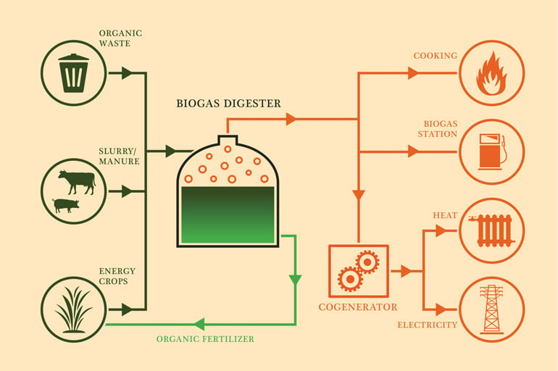
Source: https://blog.veolianorthamerica.com
Advantages of Anaerobic digestion for waste-to-energy:
- Renewable Energy Generation: Anaerobic digestion allows for the conversion of organic waste into biogas, a renewable energy source that can replace fossil fuels and reduce greenhouse gas emissions.
- Waste Diversion and Management: It provides a sustainable waste management solution by diverting organic waste from landfills and reducing associated environmental impacts.
- Nutrient Recovery: The digestate produced as a byproduct of anaerobic digestion can be used as an organic fertilizer, reducing the need for synthetic fertilizers and closing nutrient loops.
- Methane Emission Reduction: By capturing methane, a potent greenhouse gas, anaerobic digestion helps mitigate its release into the atmosphere, contributing to climate change mitigation.
Case Studies:
The Humber Energy Estuary, United Kingdom: The Humber Energy Estuary in the UK is home to several anaerobic digestion facilities that process a range of organic waste materials. These facilities generate biogas, which is upgraded to biomethane and injected into the gas grid. The biomethane is then used for heating and transportation purposes, reducing reliance on fossil fuels and lowering greenhouse gas emissions.
The Copenhagen Bioenergy Plant, Denmark: The Copenhagen Bioenergy Plant, also known as BIO4, is a large-scale anaerobic digestion facility in Denmark. It processes organic waste, including food waste and agricultural residues, to produce biogas. The biogas is upgraded to biomethane and utilized as a clean energy source for heat and power generation. The plant contributes significantly to Copenhagen's renewable energy targets and waste management goals.
The Pune Municipal Corporation Biogas Plant, India: The Pune Municipal Corporation in India operates a biogas plant that utilizes anaerobic digestion for waste-to-energy conversion. The plant processes food waste generated in the city to produce biogas, which is used for cooking and heating purposes. The project has not only addressed waste management challenges but has also provided a clean energy source for the community.

GASIFICATION AND PYROLYSIS:
Gasification and pyrolysis are thermal processes that convert waste materials into a mixture of gases, liquid fuels, and solid residues. Gasification involves heating the waste in a low-oxygen environment, while pyrolysis involves heating in the absence of oxygen. The resulting gases and liquids can be used for energy generation or refined into transportation fuels. Here's an overview of gasification and pyrolysis for waste-to-energy conversion:
Gasification:
Gasification is a thermo-chemical process that converts carbonaceous materials, including waste, into a synthesis gas (syngas) consisting primarily of carbon monoxide (CO) and hydrogen (H2). The process takes place in a controlled environment with limited oxygen supply and the key steps are:
- Feedstock Preparation: The waste feedstock, such as biomass, municipal solid waste, or agricultural residues, is sorted and processed to remove non-combustible materials.
- Gasification Reactor: The prepared waste is introduced into a gasification reactor, where it is subjected to high temperatures (typically above 700°C) and a limited oxygen supply. This causes the waste to undergo thermal decomposition, releasing syngas.
- Syngas Production: The thermal decomposition of waste in the gasification reactor results in the formation of syngas, which contains combustible gases like CO, H2, and traces of methane (CH4). The syngas can be further cleaned and conditioned to remove impurities.
- Energy Conversion: The syngas can be utilized for various energy applications. It can be combusted in a gas engine or turbine to produce electricity and heat. Alternatively, it can undergo further processing to produce transportation fuels or chemicals.
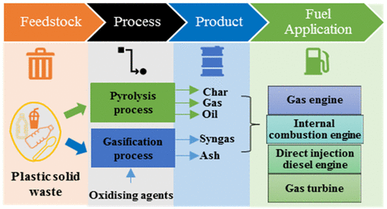
Source: https://pubs.acs.org
Pyrolysis:
Pyrolysis is a thermal decomposition process that converts waste materials into a mixture of solid, liquid, and gaseous products in the absence of oxygen. The process involves the following steps:
- Feedstock Preparation: Similar to gasification, the waste feedstock is prepared by sorting and removing non-combustible materials.
- Pyrolysis Reactor: The prepared waste is introduced into a pyrolysis reactor, which operates at elevated temperatures (typically between 300°C and 800°C) and low oxygen levels or no oxygen at all. This causes the waste to decompose into solid char, liquid bio-oil, and syngas.
- Product Collection and Processing: The solid char, liquid bio-oil, and syngas produced during pyrolysis are collected separately. The solid char can be used as a fuel or further processed into activated carbon. The liquid bio-oil can be upgraded and used as a renewable fuel or feedstock for chemicals. The syngas can be utilized for energy generation through combustion or further converted into other valuable products.
Advantages of gasification and pyrolysis:
Both gasification and pyrolysis offer potential benefits for waste-to-energy conversion:
- Energy Recovery: Gasification and pyrolysis enable the conversion of waste into useful energy forms, such as electricity, heat, and fuels, reducing dependence on fossil fuels.
- Waste Diversion: These technologies provide a means to divert waste materials from landfilling, helping to reduce environmental impacts and utilize the energy content in waste.
- Syngas Utilization: The syngas produced from gasification and pyrolysis can be used as a versatile energy source for various applications, including power generation, heat production, and the production of renewable fuels and chemicals.
However, it's important to note that the successful implementation of gasification and pyrolysis for waste-to-energy depends on several factors, including feedstock composition, process efficiency, emission control, and economic viability. Proper waste characterization and selection of appropriate technologies are crucial for maximizing the potential benefits and minimizing environmental impacts.
While waste gasification and pyrolysis technologies are still emerging in India, there are a few notable case studies showcasing their application for waste-to-energy conversion. Ramky Enviro Engineers, a leading environmental solutions provider in India, established a waste-to-energy plant in Hyderabad that utilizes gasification technology. The plant processes municipal solid waste using a gasification reactor, converting the waste into syngas. The syngas is then used for electricity generation, contributing to the local power grid. The facility incorporates advanced emission control systems to ensure compliance with environmental regulations.
Further, Indian Oil Corporation Limited (IOCL), in collaboration with the Gujarat Energy Research and Management Institute (GERMI), has set up a pilot pyrolysis unit for plastic waste management. Located in Gujarat, the plant utilizes pyrolysis technology to convert plastic waste into pyrolysis oil, gas, and char. The pyrolysis oil produced can be used as a fuel or feedstock for various applications, while the gas and char can be further utilized for energy purposes or other value-added products. These case studies demonstrate the ongoing efforts in India to explore and implement waste gasification and pyrolysis technologies for waste-to-energy conversion. As the country continues to address its waste management challenges and promote sustainable practices, the adoption of gasification and pyrolysis technologies is expected to increase in the future.
Case Studies:
Waste gasification plant in Derby, United Kingdom: The waste gasification plant in Derby, UK, known as the Sinfin Waste Treatment Plant, utilizes gasification technology to convert non-recyclable waste into energy. The plant processes approximately 190,000 tons of waste annually, generating electricity that is supplied to the grid. The gasification process converts the waste into a clean syngas, which is then combusted in a gas engine to produce electricity and heat. The facility incorporates advanced emission control technologies to minimize environmental impacts.
Plastic-to-Oil Conversion Plant in Japan: In Japan, a pyrolysis-based plant was established to convert plastic waste into oil. The plant processes various types of plastic waste, including packaging materials and single-use plastics, using pyrolysis technology. The pyrolysis process breaks down the plastics at high temperatures, resulting in the production of oil, gas, and a small amount of solid residue. The oil produced can be used as a fuel or further refined into other petrochemical products.
Waste-to-Energy Facility in Skive, Denmark: The waste-to-energy facility in Skive, Denmark, employs a combination of gasification and pyrolysis technologies to convert various types of waste into energy. The facility processes municipal solid waste, sewage sludge, and agricultural residues.
Biomass Gasification Plant in Güssing, Austria: The biomass gasification plant in Güssing, Austria, is an example of gasification technology applied to biomass waste to generate clean syngas since the 1990s, contributing to the reduction of fossil fuel dependency in the region.

LANDFILL GAS RECOVERY:
Indian municipal solid waste (MSW) contains 55-60% of biodegradable organic waste along with other mixed wastes, which gets degraded anaerobically in landfills, thereby producing a cluster of gases known as landfill gas (LFG)⁸. Landfill gas recovery, also known as landfill gas-to-energy (LFGTE), involves capturing and utilizing the methane-rich gas emitted from decomposing organic waste in landfills. Landfills produce methane gas as organic waste decomposes. Methane is a potent greenhouse gas, so capturing and utilizing it as an energy source can mitigate its environmental impact. Landfill gas can be collected, treated, and used for electricity and heat production. Here's an overview of landfill gas recovery:
- Gas Generation: When organic waste, such as food scraps, yard waste, and paper, decomposes in landfills, it produces landfill gas. Landfill gas is a mixture of gases, primarily consisting of methane (CH₄) and carbon dioxide (CO₂), with traces of other volatile organic compounds.
- Gas Collection: To recover landfill gas, a system of gas collection wells or pipes is installed throughout the landfill. These wells or pipes are strategically placed to capture the gas emitted during the waste decomposition process.
- Gas Treatment: The collected landfill gas often contains impurities, such as moisture, hydrogen sulfide (H₂S), siloxanes, and volatile organic compounds. Prior to utilization, the gas is treated to remove these impurities, which can corrode equipment and affect its energy value.
- Energy Utilization: Once the landfill gas is treated, it can be utilized for various energy applications. The most common use is generating electricity and heat. The gas is combusted in engines or turbines, which drive generators to produce electricity. The heat generated during the combustion process can also be recovered and used for district heating or industrial processes.
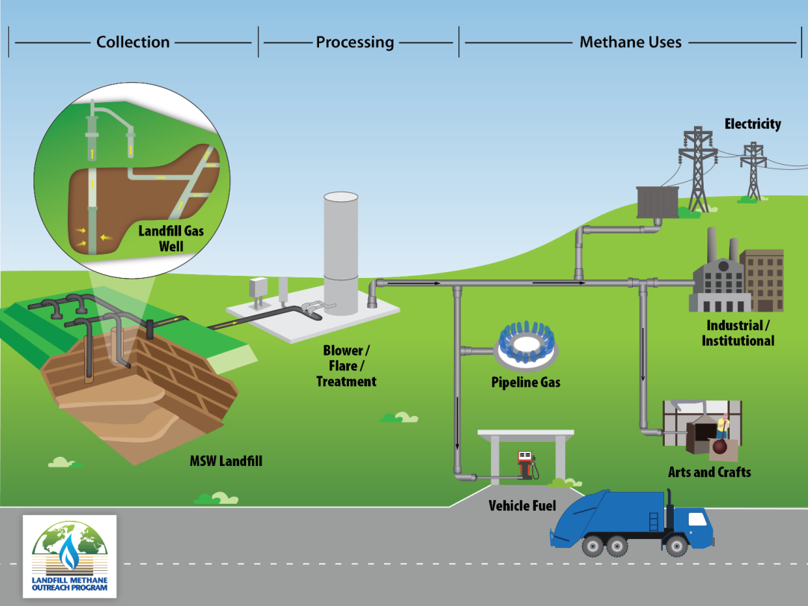
Source: https://www.epa.gov
Advantages of Landfill gas recovery:
Landfill gas recovery offers several environmental benefits:
- Reduces GHG Emision: Iit reduces greenhouse gas emissions by capturing and utilizing methane, which has a significantly higher global warming potential than carbon dioxide.
- Air Pollution Control: It helps to mitigate odors and air pollution that can result from uncontrolled gas release in landfills.
- Waste Reduction: Lastly, landfill gas recovery contributes to the diversion of waste from landfilling, promoting more sustainable waste management practices.
Case Studies:
Puente Hills Landfill, California, USA: The Puente Hills Landfill in Los Angeles, California, was one of the largest landfills in the United States. It implemented a successful landfill gas recovery project that captured and utilized the methane gas emitted from the landfill. The recovered gas was converted into electricity, supplying power to thousands of homes in the surrounding area.
Lachish Landfill, Israel: The Lachish Landfill in Israel implemented a landfill gas recovery project to reduce emissions and generate renewable energy. The captured landfill gas is utilized to produce electricity, helping to meet the energy needs of nearby communities.
Gazi Baba Landfill, North Macedonia: The Gazi Baba Landfill in North Macedonia implemented a landfill gas recovery system, significantly reducing methane emissions and generating electricity. The recovered gas is used for power generation, supplying electricity to the local grid.

Landfill gas recovery projects in India have gained momentum in recent years as the country strives to address waste management challenges and promote sustainable practices. The Ghazipur Landfill in Delhi, one of the largest landfills in India, has implemented a landfill gas recovery project. The project involves the installation of gas collection wells and a gas treatment system to capture and utilize the methane-rich gas emitted from the landfill. The recovered landfill gas is used for electricity generation, contributing to the local power grid. The Deonar Landfill in Mumbai, another significant landfill in India, has initiated a landfill gas recovery project. The Mulund Landfill in Mumbai has also undertaken a landfill gas recovery project which involves the installation of gas collection infrastructure to capture the methane gas emitted from the landfill. The Timarpur-Okhla Integrated Waste Management Facility in Delhi, which incorporates multiple waste management technologies, including landfill gas recovery, aims to address waste management challenges sustainably. These initiatives reflect the growing recognition of the importance of landfill gas recovery in India's waste management practices. By capturing and utilizing methane gas emitted from landfills, these projects help reduce greenhouse gas emissions, mitigate odor and air pollution, and promote renewable energy generation.
STATUS OF WASTE TO ENERGY WORLDWIDE AND INDIA:
According to the International Energy Agency (IEA), the global installed capacity of waste-to-energy plants was around 110 GWth (thermal) and 2.5 GWe (electric) in 2019. Europe has been at the forefront of waste-to-energy adoption, with countries like Denmark, Sweden, and Germany leading in terms of installed capacity and utilization rates. According to the World Energy Council, waste-to-energy contributes approximately 5% of the world's renewable energy generation.
India is the third-largest producer of municipal solid waste globally, generating around 62 million tonnes per year. As of 2019, the installed waste-to-energy capacity in India was approximately 223 MW, with over 70 waste-to-energy plants operational or under construction across the country. Some states in India, including Delhi, Maharashtra, and Telangana, have witnessed significant progress in waste-to-energy implementation. As per the Ministry of New and Renewable Energy, Govt. Of India, the total estimated energy generation potential from urban and industrial organic waste in India is approximately 5690 MW.
OPPORTUNITIES AND CHALLENGES OF WASTE TO ENERGY PLANTS:
Opportunities and challenges exist within the waste-to-energy (WtE) sector. Here's an overview of both:
Opportunities:
- Renewable Energy Generation: Waste-to-energy facilities can contribute to renewable energy generation by converting waste into electricity, heat, or biofuels. It reduces reliance on fossil fuels and helps meet renewable energy targets.
- Waste Management Solution: Waste-to-energy provides an alternative to traditional waste disposal methods like landfilling, reducing the need for landfills and mitigating associated environmental impacts. It promotes more sustainable waste management practices.
- Greenhouse Gas Emission Reduction: By capturing and utilizing methane, a potent greenhouse gas released from decomposing waste, waste-to-energy projects help reduce emissions and mitigate climate change.
- Resource Recovery: Waste-to-energy facilities often integrate material recovery processes to extract valuable resources from the waste stream, such as metals and organic materials. This contributes to the circular economy by maximizing resource efficiency.
- Local Economic Benefits: WtE projects can create employment opportunities, attract investment, and stimulate local economies. They contribute to the development of a green industry and support the growth of a sustainable energy sector.
Challenges:
- Feedstock Variability: Waste composition can vary significantly, posing challenges for efficient and reliable energy recovery. Waste-to-energy technologies must be adaptable to handle diverse feedstocks effectively.
- Emission Control and Public Perception: Emissions from waste-to-energy facilities, including air pollutants and odors, need to be effectively controlled to minimize environmental and public health impacts. Public acceptance and perception of waste-to-energy projects can also present challenges.
- Technology Selection and Scale: Choosing the appropriate waste-to-energy technology for specific waste streams and local conditions is crucial. The scale of the facility needs to align with the waste generation capacity and available resources.
- Waste Management Hierarchy: Waste-to-energy should be integrated within a comprehensive waste management system that prioritizes waste reduction, reuse, and recycling. It is essential to avoid potential conflicts with waste hierarchy principles.
- Financial Viability: Establishing and operating waste-to-energy projects can be capital-intensive. Securing appropriate funding, establishing viable revenue streams, and ensuring long-term economic viability are essential challenges.
Addressing these challenges requires a combination of technological advancements, effective policy frameworks, public engagement, and collaboration among stakeholders. By capitalizing on the on the opportunities and addressing the challenges, waste-to-energy can play a significant role in sustainable waste management and renewable energy generation. Also, it's important to note that energy from waste should be considered as a part of an integrated waste management strategy. Prioritizing waste reduction, recycling, and reuse should be the primary goals, with energy recovery from waste serving as a secondary option for materials that cannot be recycled or recovered in other ways.
SUMMARY:
Energy from waste, also known as waste-to-energy (WtE), refers to the process of generating energy, typically in the form of electricity and/or heat, by treating and processing various types of waste materials. The concept of waste-to-energy (WtE) has been around for many years, with its roots dating back to the late 19th century. There are different methods of generating energy from waste, including Incineration, anaerobic digestion, gasification, pyrolysis, landfill gas recovery. Incineration is the most common method, where waste materials are burned at high temperatures to generate energy in the form of heat and/or electricity. Anaerobic digestion is a waste to energy process that involves the decomposition of organic waste, such as food waste and agricultural residues, in the absence of oxygen. Gasification and pyrolysis are thermal processes that convert waste materials into a mixture of gases, liquid fuels, and solid residues. Gasification involves heating the waste in a low-oxygen environment, while pyrolysis involves heating in the absence of oxygen. The resulting gases and liquids can be used for energy generation or refined into transportation fuels. Landfill gas recovery, also known as landfill gas-to-energy (LFGTE), involves capturing and utilizing the methane-rich gas emitted from decomposing organic waste in landfills. Waste to energy projects offers several benefits including renewable energy generation, waste management solution, greenhouse gas emission reduction, resource recovery and local economic benefits. At the same time it also poses several challenges like issues with feedstock variability, emission control and public perception, technology selection and scale, waste management hierarchy and financial viability of such projects. The challenges need to be addressed in a holistic way keeping in view the primary goal of integrated waste management.
REFERENCES:
1. T. Gumbo, Scaling up sustainable renewable energy generation from municipal solid waste in the African continent: lessons from eThekwini, South Africa. Consilience, J Sustain. Dev. 12 (2014) 46–63.
2. L. Makarichi, R. Kan, W. Jutidamrongphan, K.-A. Techato, Suitability of municipal solid waste in African cities for thermochemical waste-to-energy conversion: the case of Harare metropolitan city, Zimbabwe. Water Manag. Res. 37 (1) (2019) 83–94, https://doi.org/10.1177/0734242X18804029.
3. T. Phuong, T. Pham, R. Kaushik, G. Parshetti, R. Mahmood, R. Balasubramanian, Food waste-to-energy conversion technologies: current status and future directions, Waste Manag. 38 (2015) 399–408, https://doi.org/10.1016/j. wasman.2014.12.004.
4. Byoung Hooi Cho, B. H. Nam, J. An, and H. Youn, “Municipal Solid Waste Incineration (MSWI) Ashes as Construction Materials—A Review,” no. 13, 3143, Jul. 2020, 10.3390/ma13143143
5. B. H. Cho, B. H. Nam, J. An, and H. Youn, “Municipal Solid Waste Incineration (MSWI) Ashes as Construction Materials—A Review,” Materials, vol. 13, no. 3143, Jul. 2020, 10.3390/ma13143143.
6. Awe OW, Zhao Y, Nzihou A, Minh DP, Lyczko N (2017) A review of biogas utilisation, puriﬁcation and upgrading technologies. Waste Biomass Valoriz 8:267–283. https ://doi.org/10.1007/s1264 9-016-9826-4
7. Cesaro A, Naddeo V, Amodio V, Belgiorno V (2012) Enhanced biogas production from anaerobic codigestion of solid waste by sonolysis. Ultrason Sonochem 19:596–600. https ://doi.org/10.1016/j.ultsonch.2011.09.002
8. Ramachandra, T. V., H. A. Bharath, G. Kulkarni, and S. S. Han. 2018. Municipal solid waste: Generation, composition and GHG emissions in Bangalore, India. Renewable and Sustainable Energy Reviews 82:1122–36. doi:10.1016/j. rser.2017.09.085.

***

