CONTENT

Joints
Structural and functional classification, types of joints movements and its articulation

Introduction
A point at which parts of an artificial structure are joined.
It is a structure in the human or animal body at which two parts of the skeleton are fitted together.
A joint is the site at which any two or more bones articulate or come together.
- Structural Classification based on 2 criteria
- Presence or absence of space between bones called synovial cavity
- Type of connective tissue that binds bones
- Functional Classification based on degree of movement
1. The structural classification of joints
A) Fibrous joints:- No synovial cavity bones held together by fibrous tissue rich in collagen fibers.
B) Cartilaginous joints:- No synovial cavity bones held together by cartilage.
C) Synovial joints:- synovial cavity bones held together by dense irregular connective tissue.
2.The functional classification of joints
A)Synarthrosis an immovable joint
B)Amphiarthrosis a slightly movable joint
C) Diarthrosis a freely movable joint

1.A.Fibrous Joints:
-The bones forming these joints are linked with tough,fibrous material.Such an arrangement often permits no movement.
-Lack a synovial cavity
-The articulating bones are held very closely together by dense fibrous connective tissue.Eg-coronal suture,Fibrous joints are immovable.
Three types
a)Sutures
b)Syndesmoses
c)Gomphoses
JOINTS (FIBROUS JOINTS)
a)Sutures:-
-A joint where two bony structures are united by thin layer of dense fibrous tissue
-Occur only between bones of the skull
b) Syndesmoses
-A joint where two bones are joined by a fibrous connective tissue arranged as bundle (ligament) or sheet (interosseous membrane) .Permits slight movement Greater distance between articulating bones,Distal tibiofibular joint- anterior tibiofibular ligament.
c) Gomphoses:
A joint where a bony structure is implanted deep into another bony structure. An example would be the joint between a tooth and the mandible (jaw bone)
Immovable joint,Joint in which a cone-shaped peg fits into a socket
Articulations of the teeth with the sockets of the maxillae and mandible
TYPES OF FIBROUS JOINTS:-
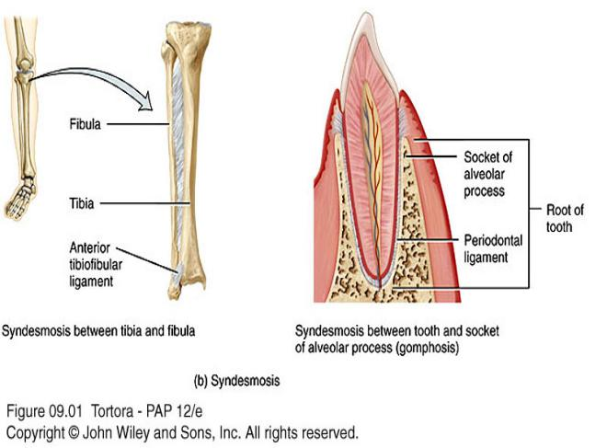

1.B.JOINTS (CARTILAGINOUS JOINTS):-
-These joints are formed by a pad of fibrocartilage,a tough material that acts as a shock absorber.
-Lacks a synovial cavity,allows little or no movement,Connected by either cartilage- -Hyaline or fibrocartilage
-Two types of cartilaginous joints
a)Synchondroses
b)Symphyses
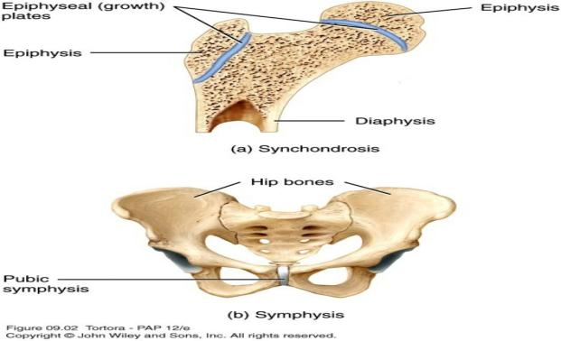
a)Synchondroses:
-Connecting tissue is hyaline cartilage,
-Epiphyseal (growth) plate,
b)Symphyses:-
-Slightly movable joint,Joints where bones are connected by a fibrocartilage
-Example:Pubic symphysis: Between the anterior surfaces of the hip bones
Intervertebral joints between the vertebrae

1.C.JOINTS (SYNOVIAL JOINTS):-
Synovial joints are characterized by the presence of a space or capsule between the articulating bones.
Synovial cavity allows a joint to be freely movable,bones are covered with layer of hyaline cartilage-Articular cartilage,articular Capsule,a sleeve-like capsule encloses the synovial cavity.
The articular capsule is composed of two layers,an outer fibrous capsule- dense irregular connective tissue,an inner synovial membrane-Areolar connective tissue and Synovial Fluid
The synovial membrane secretes synovial fluid.

Functions to reduce friction by:
- Lubricating the joint
- Absorbing shocks
- Supplying oxygen and nutrients to the cartilage.
- Removing carbon dioxide and metabolic wastes from the cartilage.
- Contains phagocytic cells to removes microbes.
1.C.JOINTS (SYNOVIAL JOINTS)
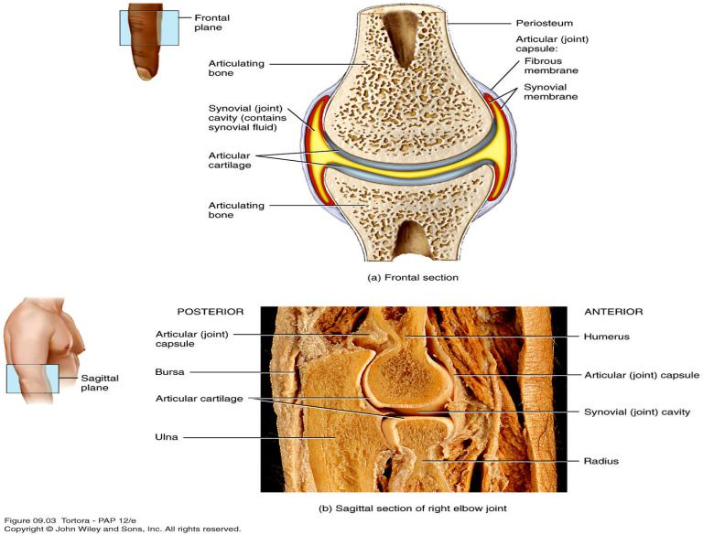
NERVES AND SUPPLY IN JOINTS (SYNOVIAL JOINTS)
-Nerve ending convey information about pain from the joint to the spinal cord and brain.
-Nerve endings respond to the degree of movement and stretch at a joint.
-Arterial branches from several different arteries merge around a joint before penetrating the articular capsule.
Bursae and Tendon Sheaths:-
- Bursae:-
Sac-like structures containing fluid similar to synovial fluid,located between tendons, ligaments and bones,Cushion the movement of these body parts,
- Tendon sheaths:-
Wrap around tendons,Reduce friction at joints

1.C.a.TYPES OF MOVEMENTS AT SYNOVIAL JOINTS:-
-Synovial joints are classified according to the range of movement possible or to the shape of the articulating parts of the bones involved.
-Specific terminology is used to designate the movements that occur at joints
Movements are grouped into four main categories:
1) Gliding
2) Angular movements
3) Rotation
4) Special movements
TYPES OF MOVEMENTS AT SYNOVIAL JOINTS:-
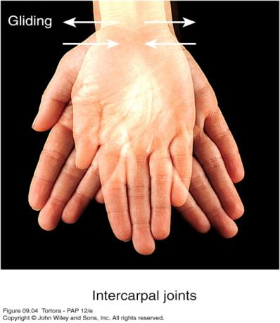
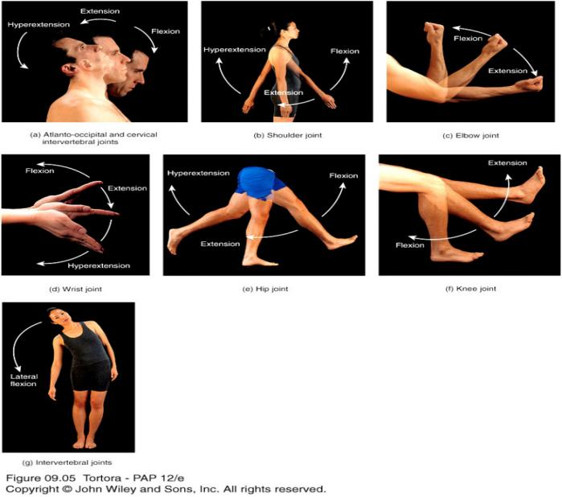
1)Gliding:-
-Simple movement back-and-forth and from side-to-side.
-There is no significant alteration of the angle between the bones.
-Limited in range.
-Intercarpal joints.
2)Angular Movements:-
-Increase or a decrease in the angle between articulating bones,angular movements include:
- Flexion
- Extension
- Lateral flexion
- Hyperextension
- Abduction
- Adduction
- Circumduction
a)Flexion:-
Decrease in the angle between articulating bones.
Bending the trunk forward but occasionally backward.
Eg-Knee Joint.
b)Extension:-
Straightening or bending backward.
Increase in the angle between articulating bones.
Flexion and extension are opposite movements.
c)Lateral flexion:-
Movement of the trunk sideways to the right or left at the waist.
d)Hyperextension:-
Continuation of extension beyond the normal extension.
Bending the trunk backward.
e)Abduction:-
Movement of a bone away from the midline.
Moving the humerus laterally at the shoulder joint
f)Adduction:-
Movement of a bone toward the midlineof the body.
Movement that returns body parts to normal position from abduction.

JOINTS (TYPES OF MOVEMENTS AT SYNOVIAL JOINTS)

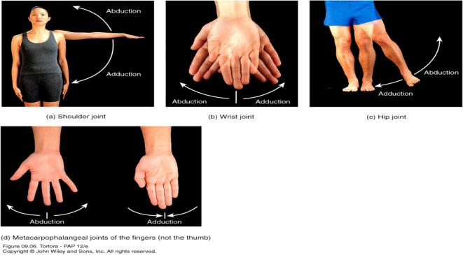
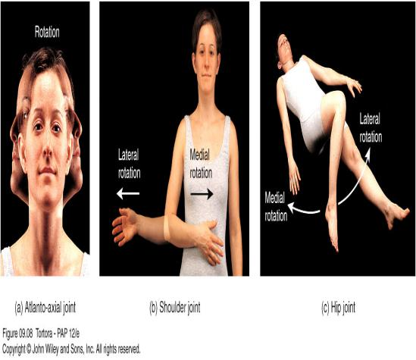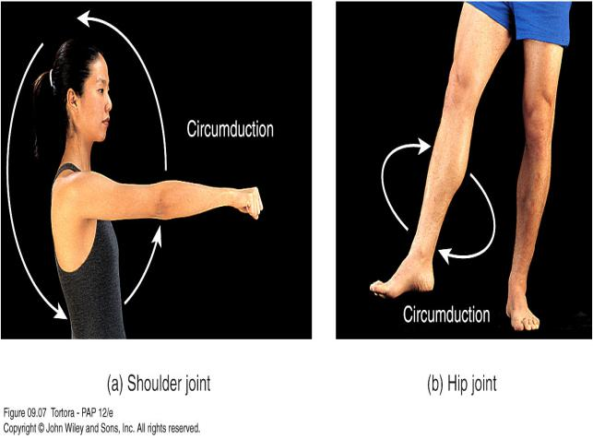
g)Circumduction:-
Movement of a limb or digit so that it describes the shape of a cone.
Movement of a body part in a circle.
Moving the humerus in a circle at the shoulder joints.

CIRCUMDUCTION:-
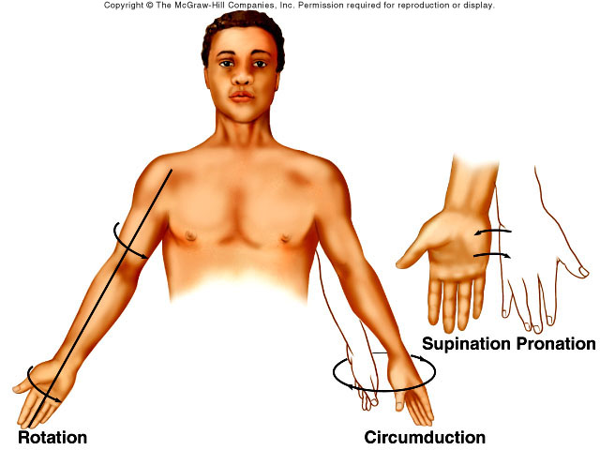
3)Rotation:-
Movement round the long axis of a bone.
A bone revolves around its own longitudinal axis.
Turning the head from side to side as when yow shake your head ‘no’.
4)Special Movements:-
a)Elevation
b)Depression
c)Protraction
d)Retraction
c)Inversion
d)Eversion
e)Dorsiflexion
f)Plantar flexion
g)Supination
h)Pronation
i)Opposition

SPECIAL MOVEMENTS:-
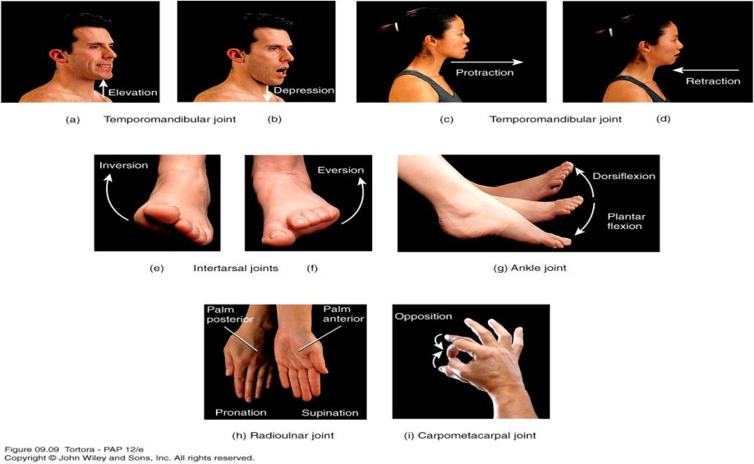
a)Elevation:-
Upward movement of a part of the body.
Closing the mouth
Its opposing movement is depression
b)Depression:-
Downward movement of a part of the body
Opening the mouth.
c)Protraction:-
Movement of a part of the body anteriorly
Thrusting the mandible outward
Its opposing movement is retraction
d)Retraction:-
Movement of a protracted part of the body back to normal
e)Inversion:-
Movement of the foot medially
Its opposing movement is eversion
f)Eversion:-
Movement of the sole laterally
g)Dorsiflexion:-
Bending of the foot at the ankle in an upward direction
Its opposing movement is plantar flexion
h)Plantar flexion:-
Bending of the foot at the ankle in a downward direction
i)Supination:-
Movement of the forearm so that the palm is turned upward
Its opposing movement is pronation
j)Pronation:-
Movement of the forearm so that the palm is turned downward
k)Opposition:-
Movement of the thumb in which the thumb moves across the palm to touch the tips of the fingers on the same hand.
1.C.b.TYPES OF SYNOVIAL JOINTS BASED ON TYPE OF MOVEMENT:-
Synovial joints are classified based on type of movement
1)Planar
2)Hinge
3)Pivot
4)Condyloid
5)Saddle
6)Ball-and-socket
1)Planar Joints:-
- Primarily permit back-and-forth and side-to-side movements.
- Articulating surfaces of bone are flat or slightly curved.
- Non axial movements.
- Intercarpal, Intertarsal, sternoclavicular, acromioclavicular, sternocostal, vertebrocostal joints.
2)Hinge joints:-
- Produce an opening and closing motion like that of a hinged door.
- The convex surface of one bone fits into concave surface of another bone.
- Monoaxial:Permit only flexion and extension,Knee, elbow, ankle
PLANAR JOINT AND HINGE JOINT:-
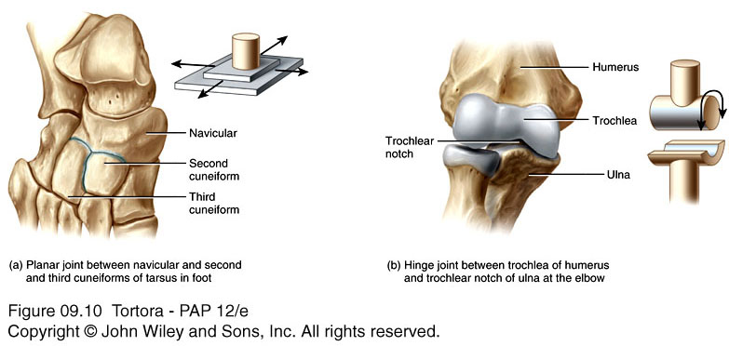

3)Pivot Joints
- Surface of one bone articulates with a ring formed partly by another bone and partly by ligament.
- Monoaxial.
- Radioulnar joints that enable the palms to turn anteriorly and posteriorly and atlantoaxial joints
4)Condyloid Joints
- The convex oval shaped projection of one bone fits into the oval-shaped depression of another bone.
- Biaxial.
- Wrist and metacarpophalangeal joints.

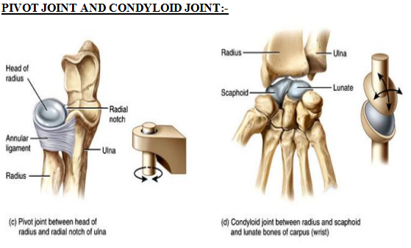

5)Saddle Joints:
- Articular surface of one bone is saddle-shaped, and the articular surface of the other bone fits into the “saddle”
- Biaxial:Carpometacarpal joint between trapezium of carpus and matacarpal of thumb
6)Ball-and-Socket Joints
- Ball-like surface of one bone fitting into a cuplike depression of another bone
- Multiaxial:Shoulder (Head of humerus fits into glenoid cavity of scapula), hip(head of femur fits into acetabulum of hip bone)

SADDLE JOINT AND BALL-and-SOCKET JOINT

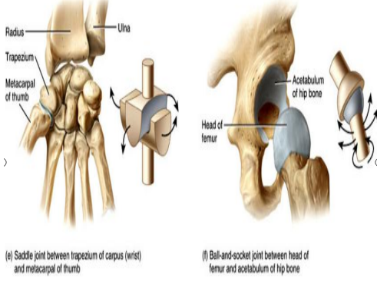

Disorders of Joints
a)Osteoporosis:
In this condition bone density(the amont of bone tissue) is reduced because its deposition does not keep pace with resorption.
b)Rickets &osteomalacia:
It is inadequate mineralisation of bone usually because of vitamin D deficiency
c)Arthritis:
Inflammatory joint diseases(RA,Rheumatoid disease):This is chronic progressive inflammatory autoimmune disease mainly affcting peripheral symovial joints.
d)Osteoarthritis(Osteoarthosis,OA):
This is a degenerative non-inflammatory disease result in pain and restricted movement of affected joints.
e)Gout:
This condition is more prevalent in males,it is caused by deposition of sodium urate crystals in joints,tendons provoking an acute inflammatory response.

QUESTION:-
5 MARKS:-
1.Write the functions of bones.
2.What are joints? Classify joints with examples.
2 MARKS:-
1.Difference between cartilage and bone.
2.Functions of bones.
3.Define rickets and gout.

