Phytochemical and antimicrobial profiling of Allium hookeri, a nutraceutical herb collected from Ema market of Khwairamband Keithel, Manipur
Suchitra Sanasam¹, Bhaigyabati Th², Pukhrambam Grihanjali Devi³*
¹ Department of Chemistry, Pravabati College Mayang Imphal,
²Department of Botany, Pravabati College, Mayang Imphal,
³ Department of Chemistry, G.P. Women’s College, Dhanamanjuri University, Imphal-795001, Manipur.
* Author for Correspondence, email: grihanjali@gmail.com

Abstract
Allium hookeri Thwaites, locally known as “maroi napakpi” in Manipur, is a perennial nutraceutical herb with immense beneficial and medicinal properties. People of the state use it in the preparation of almost all the daily dishes. Besides its culinary properties such as flavor and colour, maroi napakpi is used for its potential health benefits. Aqueous and methanolic extracts of A. hookeri contained almost all the phytochemicals except amino acids, carbohydrates and steroids and terpenoids. The total phenolic and flavonoid content was found to be higher in methanolic extract than the aqueous extract of the plant. Methanolic extracts showed a slight higher percentage DPPH scavenging activity and reducing power. Similar trend was noted in total anti-oxidant activity where methanolic extract showed higher activity than aqueous extract. Both methanolic and aqueous extracts of Allium hookeri showed antibacterial activity against P.aeruginosa (MTCC 424) only. Antibacterial action was found against S.aureus (MTCC 737) which is gram positive and against E.coli (MTCC 738) and P.aeruginosa (MTCC 424) which are gram negative. Both the extracts showed no antifungal activity against any of the test fungi. The present study provides a baseline data for future studies geared towards the therapeutic benefits of A.hookeri.
Key words: Allium hookeri, nutraceutical, antioxidant, antibacterial

- INTRODUCTION
Manipur lies in one of the 3 Biodiversity Hotspots – the Indo-Burma Hotspot – in India, among 34 such sites in the world (the other being the Western Ghats and Himalayas) (Conservational International, 2005) and abuts the South East Asian tropical Rainforests. With around 67% of the total geographical area comprising of hills and forests.It also represents a wonderful medley of scenic beauty, rich varieties of flora and fauna, miles of manicured agricultural fields, and a copious deposition of minerals. A treasure trove of numerous species of flora and fauna makes it rich in biodiversity and these also include some rare and endangered varieties. The wealth of around 1200 species of medicinal plants found among the varieties of Manipur flora needs to be studied, exploited for its therapeutic potential and most importantly conserved for the future. The consumption of medicinal plants as food by man has been a practice since antiquity. The phytochemicals and other bioactive principles present in these medicinal plants not only act as nutraceuticals but have been the source of different drugs and medicine which are used to alleviate, control, cure ailments and diseases.
Allium hookeri Thwaites is a wild perennial herb belonging to Liliaceae familyand locally known as “maroi napakpi” within the genus Allium and having immense beneficial medicinal properties (anti-diabetic, anti-fungal, anti-ulcer, anti-obesity, hepatoprotective, neuro-protective, hypolipidemic, anti-inflammatory activity reported in various in vitro and in vivo experimental animals including clinical trial) ⁽¹⁾. It is mainly grown and consumed in Southeast Asian countries like Sri Lanka, India, Bhutan, Myanmar, Korea and southwestern China. In India, it is mostly distributed in the two northeastern states, Manipur and Meghalaya. Because of its various medicinal values, allium hookeri is cultivated in the fields and kitchen garden of every household. People of our state use it in the preparation of almost all the local dishes ^{(1,2,3)} such as ‘kangshoi’, ‘bora’, ‘paaknam’, etc. It contributes to the flavour of the dish, color and taste. Besides its culinary properties, it is also being used for its potential health benefits. Traditional local practitioners/ healers have used the root of the plant for the treatment of cough, cold, healing burn, injuries and wounds ⁽¹⁾. The leaf juice mixed with salt is used for the treatment of stomach ulcer and ailments. They also use the leaf decoction to treat fever by applying the decoction on forehead ^{(4,5)}. Even fresh leaves are eaten raw for reducing blood pressure. Since A. hookeri has been associated with the traditional recipes of Meiteis and also with the ethnotherapy of certain diseases by local healers since the time immemorial, the plant has been regarded to have ethnobotanic relevance to the Manipuris. Because of its immense beneficial effects, it is consumed on a large scale by the people of Southeast Asian countries, including the people of Northeast Indian states of Manipur and Meghalaya, as a nutraceutical and functional food. Thus the objective of this study is to analyse the phytochemical and antimicrobial activities of Allium hookeri. collected from Ema market of Khwairamband Keithel, Manipur.
Further studies for identification of the bioactive components responsible for higher anti-oxidant activity and exploitation for large scale production for used in pharmaceutical industries will be our next target. Hence, we aimed to study the phytochemical screening and its antimicrobial activities of Allium hookeri .

- MATERIALS & METHODS

Plant sample

Allium hookeri was collected from Khwairamband Bazar, Ema Market, Imphal-West district of Manipur, Northeast India. Identification of the sample was done by L. Somarjit Singh, (Retd.) Associate Professor, Department of Botany, Imphal College, Imphal. Stem and leaves of the plant were washed with tap water and then rinsed with distilled water, shade dried and ground into fine powder (Figure 1).
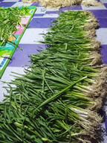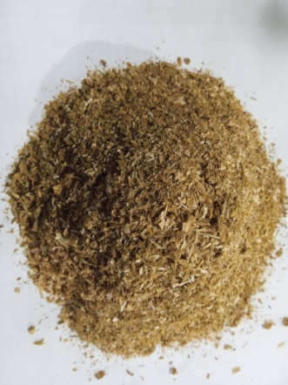
a b
Figure 1: Allium hookeri a) fresh and b) powdered form

Soxhlet extraction

40g of powdered Allium hookeri was extracted separately using 400 ml of methanol and double distilled water by soxhlation until the solvent become colourless in main chamber of the soxhlet extractor. The extract was evaporated to dryness and crude extract was obtained. The crude extracts were screened for the phytochemical constituents.
Phytochemical screening was carried out for aqueous and methanolic extracts of Allium hookeri using standard protocol ⁽⁶⁻¹⁰⁾.

Determination of total phenolic content

The amount of total phenolic content in aqueous and methanolic extracts of Allium hookeriwas determined with Folin-Ciocalteu reagent14, 15. 2.5 ml of 10% Folin-Ciocalteu reagent and 2 ml of Na₂CO₃ (2% w/v) were added to 0.5 ml of (3 replicates) extract solution (1mg/ml). The resulting mixture was incubated at 45⁰C for 15 mins. The absorbance was measured at 760 nm using UV Visible Spectrophotometer (UV-2700). Gallic acid (10-50 μg/ml) was used as a standard compound⁽¹¹⁻¹⁶⁾.

Total phenolic contents of the plant extracts in Gallic Acid Equivalent (GAE) were calculated by using the following formula16:
T = (C × V)/M
Where, T = total content of phenolic compounds, mg/g plant extract in GAE;
C = concentration of gallic acid established from the calibration curve, μg/ml;
V = volume of extract, ml; M = weight of the plant extracts, g.

Estimation of total flavonoid content

Total flavonoid content in the sample extracts were estimated by Aluminium chloride colorimetric method. The principle involved in Aluminium chloride (AlCl₃) colorimetric method is that AlCl₃ forms acid stable complexes with the C-4 keto groups and either the C-3 or C-5 hydroxyl group of flavones and flavonols. In addition it also forms acid labile complexes with the ortho-dihydroxyl groups in the A- or B-ring of flavonoids. Studies have reported Quercetin to be suitable reference for determination of total flavonoid content in plant sample extract. Therefore standard Quercetin solutions of various concentrations were used to make the calibration curve.

10 mg of quercetin was dissolved in 100ml methanol and then diluted to 6.25, 12.5, 25, 50, 80, and 100 μg/ml using methanol. Stock solution of extracts was prepared by dissolving 100 mg of each extract in 5ml methanol and transferred to 10 ml volumetric flask and made up the volume with methanol. 10% aluminium chloride and 1M potassium acetate were prepared using distilled water.
The assay was determined using 0.5ml of each extract stock solution and each dilution of standard quercetin taken separately in test tubes. To each test tube 1.5ml methanol, 0.1ml aluminium chloride solution, 0.1ml potassium acetate solution and 2.8 ml distilled water were added and mixed well. Sample blank for all the dilution of standard quercetin and both aqueous and methanolic extracts were prepared in similar manner by replacing aluminium chloride solution with distilled water. All the prepared solutions were filtered through Whatmann filter paper if necessary before measuring their absorbance. Absorbance was taken at 415 nm against the suitable blank. ^{(15,16,19)}.
Determination of free radical scavenging assay

The free radical scavenging capacities of aqueous and methanolic extracts ofAllium hookeriwere determined using DPPH assay19. DPPH solution (0.004% w/v) was prepared in methanol. Stock solution (1mg/ml) of each of the extract and standard ascorbic acid (1mg/ml) were prepared using methanol. Various concentrations (30-150μg/ml) of the extracts and ascorbic acid were taken in test tubes and 2ml of freshly prepared DPPH solution were added. The test tubes were protected from light by covering with aluminum foil. The final volume in each test tube was made to 4ml with methanol and incubated in dark for 30mins at room temperature. After incubation, the absorbance was read at 517nm using a spectrophotometer (UV-2700). Control sample was prepared containing the same volume of methanol and DPPH without any extract and reference ascorbic acid. Methanol was served as blank^{(15,16,20)}.

The percent DPPH scavenging activity was calculated by using the following equation:

$$\% Scavenging Activity =\frac{Absorbance of the control –Absorbance of the test sample}{ Absorbance of the control }×100$$

Estimation of reducing power

Various concentrations (30-150μg/ml) of the aqueous and methanolic A.hookeriextracts from the stock solution of (1mg/ml) in methanol were prepared in different test tubes. Ascorbic acid (1mg/ml) at various concentrations was used as standard. To each tube, 2.5ml of phosphate buffer and 2.5ml of 1% potassium ferricyanide were added. This mixture was kept at 50oC in water bath for 20 minutes. After cooling, 2.5ml of 10% trichloroacetic acid was added and centrifuged at 3000 rpm for 10mins (whenever necessary). The upper layers of solution (2.5ml) were transferred into fresh tubes and to each tube, 2.5ml of distilled water and 0.5ml of freshly prepared 0.1% ferric chloride solution were added. The absorbance was measured at 700 nm. Blank was prepared in similar manner excluding samples. Increased absorbance of the reaction mixture indicates increase in reducing power^{(15, 16 18)}.

Determination of total antioxidant activity

The phosphomolybdenum method was used to evaluate the total antioxidant activity of the extract ^{14,15,18}. Antioxidants can reduce Mo (VI) to Mo (V) and the green phosphate / Mo (V) compounds at acidic pH, which have an absorption peak at 695 nm, were generated subsequently. 0.3 ml of the sample aqueous and methanolic extracts (1mg/ml) as well as ascorbic acid (1mg/ml) was mixed with 3.0 ml of the reagent solution (0.6 M sulfuric acid, 28 mM sodium phosphate and 4 mM ammonium molybdate) separately. Reaction mixture was incubated at 95ºC for 90 min under water bath. Absorbance of all the mixtures was measured at 695 nm after cooling. Total antioxidant activity is expressed as the number of equivalents of ascorbic acid in micrograms (AAE). Total antioxidant activity was calculated by using the formula:

Total antioxidant = O.D. of test sample x concentration of standard in μg × made up volume of sample^{(17,18,21)}.
Antimicrobial Screening

Antimicrobial assay
Test organisms
The test bacteria used were the gram-positive organisms Staphylococcus aureus (MTCC 737), and Bacillus subtilis (MTCC 441), and the Gram negative bacteria Escherichia coli (MTCC 738) and Pseudomonas species (MTCC 424).The test fungi used were Fusarium oxysporum( MTCC 227), Trichoderma viride( MTCC 793) and Aspergillus Niger (MTCC 281). All the reference strains were procured from microbial type culture collection (MTCC), Institute of Microbial Technology (IMTECH), Chandigarh, India.
Media
Nutrient Agar (NA) and Nutrient Broth (NB) were used for bacterial culture and Potato Dextrose Agar (PDA) and Potato Dextrose Broth (PDB) were used for fungal culture in each experiment.
Antimicrobial Agents
Streptomycin (10 µg) and Kanamycin (30 µg) discs were used as positive control for bacteria and fungi respectively and sterile distilled water was used as negative control.

Preparation of Extract of Different Concentration
Stock solution of each of the crude extracts was prepared with N, N-Dimethyl sulfoxide (DMSO) making a concentration of 40 mg/mL . From the stock, three different dilutions were made to obtained 2 mg/50 µL 1 mg/50µL and 0.5 mg/50µL for both the aqueous and methanolic extracts.

Antimicrobial Activity
Antimicrobial activity was done by using Kirby-Bauer method.²¹ A loopful of freshly grown test organisms (both bacteria and fungi) were inoculated on NB (for bacteria) and PDB (for fungal) in an orbital shaker (150 rpm, 30°C). The test bacteria were incubated for 24 hrs while the test fungi were incubated for 48–72 hrs.0.1 mL each of the bacterial and fungal broths were spread uniformly with a sterile L shaped spreader on NA and PDA plates, respectively. Wells were punched with the help of a cork borer (6 mm diameter) on the media plates. Then 50 µL each of 500 µg, 750 µg and 1000 µg concentrations were put in each well in triplicates for both the extracts and kept at 40C for 1-hour for proper diffusion of the test organisms. It was then incubated for 24-48 hrs at 300 C. The zone of inhibition (in mm diameter) were measured (as mean of the triplicate readings) using a scale (18) and taken as the activity against the test organisms. The zone of inhibition was graded according to Kang SN et al.²² (Table 1). Streptomycin (10 µg) and Kanamycin (30 µg) discs were used as a positive control for bacteria and fungi, respectively and sterile distilled water as a negative control.
Table 1: Grading of zone of inhibition
Diameter of ZOI | Antimicrobial activity
6 - 8 mm No antimicrobial activity
8.1 - 9 mm Slight antimicrobial activity
9.1-12 mm Moderate antimicrobial activity
12.1 – 15 mm Clear antimicrobial activity
> 15 mm Strong antimicrobial activity

- RESULT AND DISCUSSION
Phytochemical constituents in aqueous and methanolic extracts of A. hookeri are listed in Table 2. Preliminary phytochemical screening shows the presence of most of the phytochemicals in both aqueous and methanolic extracts of A. hookeri except amino acids (in methanolic extract), carbohydrates and steroids and terpenoids. Cardiac glycosides were present in aqueous extract but absent in methanolic extract.
Table 2: Phytochemical constituents present in the whole plant extract ofAllium hookeri
Phytochemical constituents | Test | Allium hookeri
 |  | Aqueous extract | Methanolic extract
Aminoacids | Ninhydrintest | + | -
Alkaloids | Hager’stest | + | +
Carbohydrates(reducing sugar) | Benedict’stest | - | -
 | Fehling’stest | - | -
Flavonoids | Alkalinereagenttest | + | +
 | Lead acetate test | + | +
Phenolic compounds | Lead acetate test | + | +
Steroids andTerpenoids | FerricChloridetest | + | -
Saponins | Salkowski’stest | + | -
Tannins | Frothtest | + | +
 | Lead acetate test | + | +
Cardiac glycosides | Ferricchloridetest | +- | -
Oil | Keller-killianitest | + | +

The total phenolic content in aqueous and methanolic extracts of A. hookeri. was found to be 4.65 ± 0.02 mg/g (GAE) and 8.42 ± 0.02 mg/g (GAE) respectively indicating a higher total phenolic content in methanol extract than aqueous extract (Table 3). This phenolic compound have wide bioactivity including antioxidant properties/ activity which is due to the presence of the hydroxyl group and is responsible for the radical scavenging effect mainly due to redox potential.²¹
The total flavonoid content in aqueous and methanolic extract was found to be 9.095 ± 0.02 and 33.44 ± 0.02, respectively (Table 3). It was found to be higher in methanolic extract than the aqueous extract of the plant.

Table 3: Total phenolic and total flavonoid content in crude extracts ofAllium hookeri
Sample | Total phenolic content in mg /g of extract (in GAE) |  | Total flavonoid content in μg/100g of dried extract (in QE)
 | Aqueous | Methanol | Aqueous | Methanol
Allium hookeri | 4.65 ±0.02 | 8.42±0.02 | 9.095 ±0.02 | 33.44 ±0.02
* Assays were performed in triplicate. Values are expressed as means ±SD

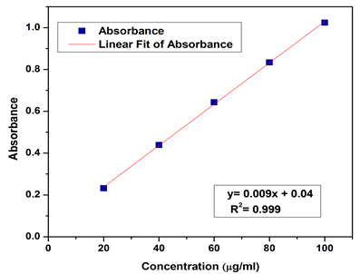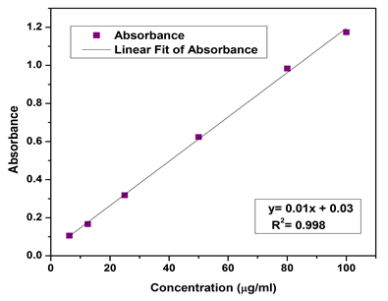
Figure 2: Standard curve of Gallic acid Figure 3: Standard curve for Quercetin

DPPH assay showed that an increase in concentration increases the free radical scavenging activity for the reference standard, ascorbic acid and crude aqueous and methanolic extracts of A.hookeri The assay indicates a dose dependent manner for standard and both the extracts of the plant sample as illustrated in Figure 4. Percentage DPPH scavenging activity of aqueous and methanolic extracts was comparable with standard ascorbic acid and methanolic extract showed higher scavenging activity than aqueous extract. It was observed that 100 μg/ml was required to scavenge 20% of DPPH radical in aqueous extract while the same amount was required to scavenged 28% of DPPH radical in methanolic extract. At the highest concentration (300μg/ml) used for the study, the DPPH scavenging activity of the standard, aqueous and methanolic extracts of A.hookeri were 99.28 %, 61.26 % and 63.41 % respectively. The presence of many phytochemicals in A. hookeri such as phenol, flavonoids, alkaloids etc may also help in preventing against free radicals.
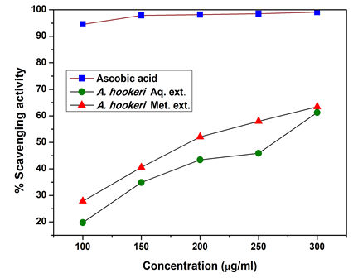
Figure 4. DPPH scavenging activity shown by standard and crude extracts of A.hookeri and crude extracts of A.hookeri

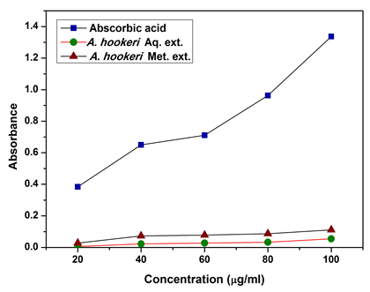
Figure 5. Reducing power shown by standard and crude extracts of A.hookeri
Reducing power assay indicates an increasing order for standard as well as for both the extracts of plant sample as shown in Fig ure 5. By measuring the formation of Pearls Prussian Blue at 700 nm, it is possible to determine the concentration of ferrous ions. Reducing power noted in aqueous and methanolic extract was almost equal with methanolic extract showing a slight higher in reducing power in methanolic extract than aqueous extract of the plant. Increased absorbance of the reaction mixture indicated increased reducing power of the extracts(24).
Similar trend was noted in total antioxidant activity where methanolic extract showed higher activity than aqueous extract. At highest concentration (100 μg/ml) used for the study, total antioxidant activity shown by methanolic extract was 20.4 ±0.02μg/ml AAE of extract while that of aqueous extract was 6.6 ±0.02 μg/ml AAE of extract. Total antioxidant activity shown by various concentrations (20-100 μg/ml) of crude aqueous and methanolic extracts of A.hookeriis shown in Table 4.

Table 4: Total antioxidant activity of Allium hookeri.
Concentration  (μg/ml) | Total antioxidant activity in μg/ml of extract (in AAE)
 | Allium hookeri
 | Aqueous | Methanol
20 | 0.9±0.01 | 5.4±0.02
40 | 2.1±0.02 | 9.0±0.02
60 | 4.2±0.02 | 12.9±0.02
80 | 5.7±0.01 | 15.5±0.01
100 | 6.6±0.02 | 20.4±0.02

Assays were performed in triplicate. Values are expressed as means ±SD
Antimicrobial Screening of both the methanolic and aqueous extracts of Allium hookeri showed that antibacterial activity was found against P.aeruginosa(MTCC 424)only (Figure 6)but not against any of the other test organisms for aqueous extract while antibacterial was found against S.aureus(MTCC 737) which is gram positive and against E.coli (MTCC 738) and P.aeruginosa(MTCC 424) which are gram negative (Figure 7). Both the extracts showed no antifungal activity against any of the test fungi. The methanolic extract exhibited more antibacterial activity when compared with the aqueous extract. Slight antibacterial activity was found againstS.aureus,E coliand P.aeruginosaat 500 μg/50μl but the activity becomes moderate when the concentration increases to 750μg/50μl and 1000 μg/50μl. At the maximum concentration it was found that the activity against Pseudomonas was strong for aqueous extract but moderate for methanolic extract. Thus the activity against the three strains increased with the increase in concentrations of the extracts.It clearly indicates that the methanolic extracts of A.hookeriwere more potent against gram negative bacteria then the grampositive bacteria.Aqueous extract of A. hookeri showed lesser antibacterial activity when compared to methanolic extract which showed moderate to strong activity. It was also observed that both the methanolic and aqueous extract showed antibacterial activity against gram negative bacteria only.
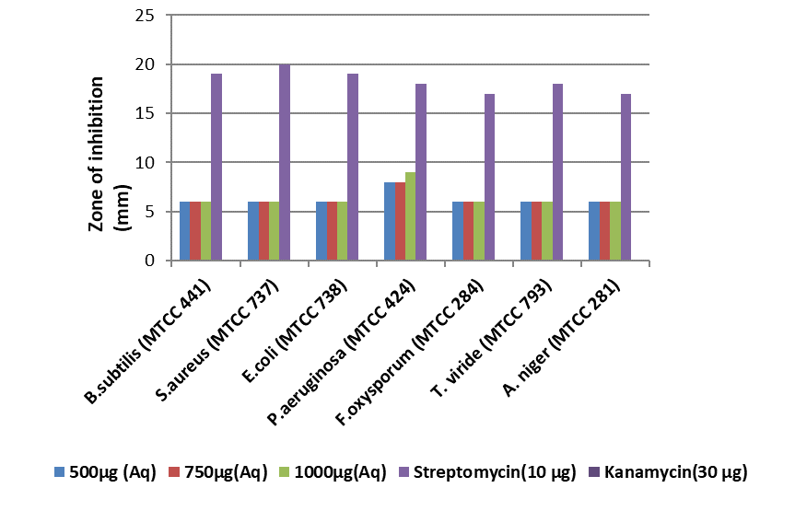
Figure 6: Antibacterial activity of aqueous extract of Allium hookeri. against the test organisms
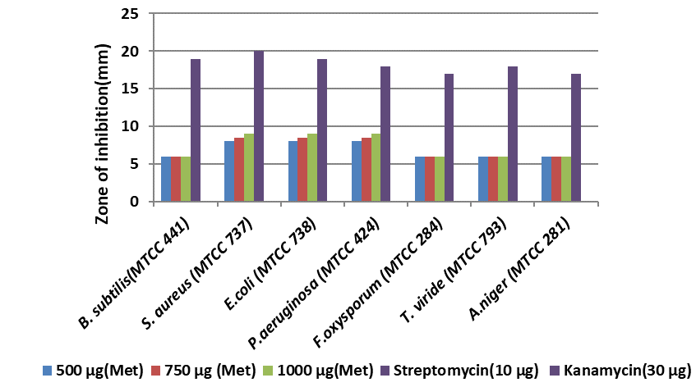
Figure 7: Antibacterial activity of methanolic extract of Allium hookeri. against the test organisms
- CONCLUSION
The aqueous and methanolic extracts of A. hookeri showed the presence of some of the phytochemicals such as alkaloids, flavonoids, phenolic compounds. Amino acids, saponins, steroids and terpenoids were present in aqueous extract but absent in methanolic extract. Methanolic extracts showed a higher total phenolic content than aqueous extract. Similar findings were also reported with our study on Allium odorum (28). The antioxidant property of flavonoids is that they are potent free radical scavengers due to presence of double bond in hydroxyl positions in their molecule.Percentage DPPH scavenging activity of aqueous and methanolic extracts showed that methanolic extract had higher scavenging activity than aqueous extract. DPPH method measures electron donating activity of other compounds in the mixture and hence provides an evaluation of antioxidant activity due to free radical scavenging. Determination of the free radical scavenging capacity or antioxidant potential of the test sample shows its effectiveness, prevention and repair mechanism against many health related disorders and diseases such as infections, diabetes, arthritis, cancer, AIDS etc. (1, 22). The medicinal and beneficial properties of A. hookeri have been attributed to the presence of varied organo-sulphur compounds in the plant (1). It can be added that the presence of different other phytochemicals in A. hookeri may also help in preventing against free radicals.
Reducing power of aqueous and methanolic extract was almost equal with methanolic extract showing a slight higher in methanolic extract than aqueous extract of the plant. Reducing power is associated with antioxidant activity and serves as a significant reflection of the antioxidant activity. Compounds with reducing power indicate that they are electron donors and can reduce the oxidized intermediates of lipid peroxidation processes so that they can act as primary and secondary antioxidants. (23). It results in the reduction of Fe³⁺ to Fe²⁺ by donating an electron. Similar trend was noted in total antioxidant activity where methanolic extract showed higher activity than aqueous extract. Antimicrobial screening of aqueous extracts of A. hookeri showed antibacterial activity against P.aeruginosa only which increases with the increase in the concentration of the extract.Methanolic extracts showed antibacterial activity against E.coli and P. aeruginosa which are both gram negative and also against S. aureus which is gram positive bacteria. Both the extracts showed no antifungal activity against any of the test fungi. The methanolic extract exhibited more antibacterial activity when compared with the aqueous extract. It was also observed that both the methanolic and aqueous extract showed antibacterial activity against gram negative bacteria only. As reported in our earlier study different solvents have been reported to have the capacity to extract different phytoconstituents depending on their solubility or polarity of the solubility or polarity in the solvent. Methanolic extracts have been reported to have higher solubility for more phytoconstituents, consequently showed higher antibacterial activity (25). Hence isolation of individual phytochemical constituent and subjecting it to biological activity will definitely give fruitful results. Further studies can be carried out to identify the bioactive components responsible for higher antioxidant activity and exploitation for largescale production for used in pharmaceutical industries. The present study provides a baseline data for future studies geared towards the therapeutic benefits of A.hookeri .
ACKNOWLEDGEMENT
The authors acknowledge the Advanced Institutional Level Biotech Hub, Imphal College (funded by DBT, Govt. of India) where the experiments of the present study were done. They also thank L. Somarjit Singh, Rtd. Associate Professor, Department of Botany, Imphal College, Imphal for identification of the plant specimen.
REFERENCES
- Barsha D, Prasenjit M, Jagat CB, Narayan CT .A review on phytochemical, pharmacological attributes and therapeutic uses of Allium hookeri.PhytomedicinePlus.2022. https://doi.org/10.1016/j.phyplu.2022.100262.
- Singh, K.B., Singh, N.M., 2014. Antioxidant and free radical scavenging potential of Allium hookeri Thwaites roots extract studied using in vitro models. Journal: JOURNAL OF ADVANCES IN BIOLOGY 4 (1).
- Singh V, Naseeruddin Shah KH, Rana. DK. Medicinal importance of unexploited vegetable under North Eastern regions of India. Journal of Medicinal Plant Studies. 2015; 3(3): 33-36.
- Ayam VS Allium hookeri, Thw. Enum. A lesser known terrestrial perennial herb used as food and its ethnobotanical relevance in ManipurAfrican J. of Food , Agriculture, Nutrition and Development 2022 V. 11(6) . 5389-5412.
- Singh, K.D., Chetia, D., Mazumdar, S., 2013. Anti-diabetic activity of methanolic extract of Allium hookeri leaves. Indo Am J Pharm Sci 3, 4098–4104. Stearn,
- Audu SA, Mohammed I, Kaita HA. Phytochemical screening of the leaves of Lophira lanceolate (Ochanaceae). Life Science Journal 2007; 4(4): 75-79.
- Edeoga HO, Okwu DE, Mbaebie BO. Phytochemical constituents of some Nigerian medicinal plants. African Journal of Biotechnology 2005; 4(7): 685-688.
- Tiwari P, Kumar B, Kaur M, Kaur G, Kaur H. Phytochemical screening and extraction: a review. InternationalePharmaceuticaSciencia 2011; 1(1): 98-106.
- Rathod VS, Valvi SR. Antinutritional factors of some wild edible fruits from Kolhapur District. Recent Research in Science and Technology 2011; 3(5): 68-72.
- Kokate CK. A text book of Practical Pharmalognosy. 5thed. Vallabh Prakashan, Delhi; 2005.p.107-111.
- Spanos GA, Wrolstad RE. Influence of processing and storage on the phenolic composition of Thompson seedless grape juice. Journal of Agricultural and Food Chemistry 1990; 38: 1565-1571.
- Lincoln. Measurement of total phenolics and ABTS assay for antioxidant activity. Crop Research Institute Report. New Zealand. 2001.
- Chakraborthy GS, Ghorpade PM. Free radical scavenging activity of Abutilon indicum(Linn) sweet stem extracts. International Journal of ChemTech Research 2010; 2(1):526-531.
- Bag, GC, P. Devi PG ,Bhaigyabati T, Phytochemical Screening and Antioxidant Activity of Meynalaxiflora Species Found in Imphal West District of Manipur. Int. J. Pharm. Sci. Rev. Res. 2016; 36(1): 137-143.
- Bhaigyabati T, Devi PG , Devi NR , Bag GC .Antioxidant activity, Total phenolic and total flavonoid content of oenanthe Javanica Blume (DC) collected from Imphal West District. International research Journal Of Pharmacy. 2017, 8(6) 63-67.
- Akbay P, Basaran AA, Undeger U, Basaran N. In vitro immunomodulatory activity of flavonoid glycosides from Urticadioica L.Phytotherapy Research 2003; 17: 34-37.
- Kaufman PB, Cseke LJ, Warber S, Duke JA, Brielmann. Natural products from plants. CRC press. New York. 1999. P. 20-22.
- Braca A, Tommasi ND, Bari LD, Pizza C, Politi M, Morelli I. Antioxidant principles from Bauhinia tarapotensis. Journal of Natural Products 2001; 64: 892–895.
- Oyaizu M. Japanese Journal of Nutrition and Dietetics 1986; 44(6): 307-315.
- Prieto P, Pineda M, Aguilar M. Analytical Biochemistry 1999;269: 337-341.
- Bauer AW, Kirby, WMM, Sherris JC and Truck M. Antibiotic susceptibility testing by a standardized single disk method. Am.J. Clin. Pathol. 1966; 45: 493-496. PMID:5325707.
- Kang SN, Goo YM, Yang MR, Ibrahim RI, Cho JH, Kim IS. et al.; Antioxidant and antimicrobial activities of ethanol extracts from the stem and leaf of Impatiens balsamina L. (Balsaminaceae) at different harvest times. Molecules 2013: 18(6) 6356-65.
- Rice-Evans CA Miller NI, Paganga G. Antioxidant properties of phenolic compounds.Trends Plant Sci. 1997; 4: 152-159.
- Kumar K and Abbas SG. Ethnomedicinal composition depends on floristic composition: A case studied in Sal forests of Jharkhand. International J. Pharmacy & Life Sci 2012;3(5) : 1710-1719.
- Chanda S., Dave, R., Kaneria M. and Nagani, K. Seaweeds: a novel, untapped source of drugs from sea to combat infectious diseases. Curr Res Technol Edn Top Appl Microm. Biotechnol. (2009); p. 473-480.
- Soni, A and Sosa, S. Phytochemical analysis and free radical scavenging potential of herbal and medicinal plant extracts. J. Pharma. Phytochem. 2013; 2(4):22-29.
- Cowan MM. Plant products as antimicrobial agents. Clin Microbiol Rev 1999. 12(4):564-82.
- Suchitra S, Bhaigyabati Th, Jessia G, Bag GC, Ranjit L3, Devi GP Phytochemical Profiling, Antimicrobial Activity and Gas Chromatography Mass Spectrometry Analysis of Allium odorum L. Collected from Ema market, Manipur. Intl. J. of Pharmacognosy and Phytochemical Research 2020; 12(3) 153-161.

