Revolutionizing Traditional Crafts: Women-led Innovations in the Cottage Industry
Ms. A. Anusuya.Full-Time PhD Research Scholar. PG & Research Department of Commerce. Rani Anna Government College for Women. Gandhi Nagar. Tirunelveli-627008.

Ms.M. Ramalakshmi.Full-Time PhD Research Scholar. PG & Research Department of Commerce. Rani Anna Government College for Women. Gandhi Nagar. Tirunelveli-627008.

Mrs.R. Shunmugaselvi.Full-Time PhD Research Scholar. PG & Research Department of Commerce. Rani Anna Government College for Women. Gandhi Nagar. Tirunelveli-627008.

Dr. V. Darling Selvi. Head andAssistant Professor of Commerce. PG & Research Department of Commerce. Rani Anna Government College for Women. Tirunelveli-627008. prof.darlingselvi@gmail.com. Contact Number: 94423 64293.

Abstract
The primary goal of the research inspects an empowerment of women in cottageindustries. The respondents' primary data will be gathered from them using a structured interview schedule. Secondary data will be gathered from a variety of sources, including periodicals, journals, etc. In this study used a sample of 200 respondents from Tirunelveli district with the use of SPSS 20 and AMOS 20 software, the researcher used a reliability test, exploratoryfactor analysis (EFA) and confirmatory factor analysis (CFA). It was concluded that todevelop entrepreneurship skills in the society in educational empowerment followed by fightagainst superstitions in social empowerment then to understand the activities of women’scommission in political empowerment and finally, to market the goods and services in economic empowerment is the highest factors. Initially, the confirmatory factor analysismodel did not fit. As per the modification indices one double arrow mark was connected witherror to error. After that, the model fit perfectly.
(Keywords: Cottage Industry, Educational Empowerment, Economic Empowerment, Political Empowerment and Social Empowerment)
Introduction
Increased economic, social, political, and educational strength of a person, group, or entity is referred to as women's empowerment. Women's control over financial and intellectual resources is just one example of the numerous facets of empowerment. Many of the demands of female entrepreneurs in rural regions are met by cottage enterprises, which have also created job possibilities for them and prevented the degeneration of their society. The majority of cottage industries are located in rural areas and focus on handicrafts like handicraft, pottery, knitting, and handlooming. It has been observed that women have gained economic independence in rural areas thanks to cottage industry. Women are able to make decisions through cottage industries and contribute to ongoing growth and change; as a result, cottage industries have developed into a channel for the empowerment of female entrepreneurs
Review of Literature
Samitowska (2011) examined the contributions, development, and importance of cottage industries to the Polish economy. The survey concluded that considerable financial barriers, such as restricted access to capital and insufficient starting finance, were impeding the growth of entrepreneurship. Because of this, the biggest obstacles facing cottage industries in Poland are a lack of adequate state funding, a lack of assistance from corporate institutions, poor financial resource management, fierce competition between Polish and foreign businesses, Polish law, and administrative bodies.
SubrahmanyaBala (2011) examined the influence of globalisation on the export potential of small-scale businesses and came to the conclusion that, even though the growth looked to be modest, the impact increased during the liberalisation phase even though it was considerable during the security period. The government may thus continue to spend in marketing, funding, and infrastructure to boost the output of these SSIs.
Shihabudheen (2012) in their study states that Micro businesses are crucial to the global empowerment of women and the development of rural areas, particularly in industrialised nations like India. Micro businesses attempt to create inclusive and equitable urban development with relatively low capital outlays, and They significantly contribute to the socioeconomic development of the disadvantaged and the reduction of poverty. By concentrating on micro firms that are a part of Kerala's government's flagship project to combat poverty, "Kudumbashree," this essay investigates the role of micro enterprises in women's empowerment.
Merlin Thanga Joy et al. (2013) in their paper, the authors discuss the economic benefits of cottage industries, which provide jobs for a sizable number of rural residents. The report makes the case that creating cottage industries is the most effective strategy to fight unemployment since our nation is overpopulated. The paper asserts that little is beautiful and that the government must devise even more initiatives to promote the expansion of cottage industries.
Srinivas, K., T. (2013) in their study concluded that Cottage Industries are the country's growth engine, and their role in inclusive development is that of micro, small, and medium-sized businesses. To consolidate this market, there have been numerous reforms at the federal and state levels in recent years. The lack of infrastructure and marketing linkages is the main cause of the cottage industry's slow growth in India. The state and federal governments' support is insufficient for the development of India's cottage industries. As a result, both the government and Indian businesspeople should take action to promote the development of these cottage industries in India.
Vijay Jariwala (2016) in their study learn about the challenges and opportunities faced by women entrepreneurs in Dang district who are running successful small businesses. It also looked at motivational causes, as well as woman entrepreneurs' key strengths and weaknesses. The study's results indicate that the challenge is finance marketing products and inadequate resources, as well as the fact that women's education plays a significant role in becoming a woman entrepreneur.
Research Methodology
The primary goal of the research inspect an empowerment of women in cottage industries. The respondents' primary data will be gathered from them using a structured interview schedule. Secondary data will be gathered from a variety of sources, including periodicals, journals, etc. In this study used a sample of 200 respondents from Tirunelveli district with the use of SPSS 20 and AMOS 20 software, the researcher used a reliability test, exploratory factor analysis (EFA) and confirmatory factor analysis (CFA).
Data Analysis and Interpretation
Table 1 Reliability Test
Factors | No. of variables | Cronbach's Alpha
Educational Empowerment | 4 | 0.890
Social Empowerment | 4 | 0.905
Political Empowerment | 4 | 0.863
Economic Empowerment | 4 | 0.824
Source: Primary data
The metric Cronbach alpha has been used to assess the data's reliability. The Cronbach’s Alpha for Educational Empowerment is 0.890, Social Empowerment is 0.905, Political Empowerment is 0.863 and Economic Empowerment is 0.824. As per the standards, the value needs to be greater than 0.5. Therefore, it can be said that the data is sufficient.
Table 2 KMO and Bartlett's Test

Kaiser-Meyer-Olkin Measure of Sampling Adequacy. |  | .897
Bartlett's Test of Sphericity | Approx. Chi-Square | 1899.062
 | df | 120
 | Sig. | .000
Source: Primary Data

The Kaiser-Meyer-Olkin Measure is a metric that determines the sufficiency of the sampling. The KMO test result, 0.897 which is greater than 0.5, can be regarded as excellent and valid for use in data reduction techniques. The Bartlett's test of Sphericity aids in determining whether the factor analysis results are worth while taking into account and whether the research project should continue to be analysed. With a Bartlett's Test of Sphericity significance level of 0.001, it can be concluded that there is a high degree of correlation between the variables, making factor analysis appropriate.
Table 3
Empowerment of Women in Cottage Industry
Statements | Components
 | Educational Empowerment | Social Empowerment | Political Empowerment | Economic Empowerment
To develop entrepreneurship skills in the society | .861
To develop leadership skills in the society | .835
To adopt technological developments | .822
To communicate with one another and exchange life experiences | .806
To fight against superstitions |  | .884
To work for social equality |  | .817
To proactively engage in community service |  | .798
To achieve the goal of Social freedom |  | .794
To understand the activities of women’s commission |  |  | .790
To participate actively in political activities |  |  | .777
Understand the importance of adult ownership. |  |  | .753
To participate actively in elections |  |  | .745
To market the goods and services |  |  |  | .811
To gain self-employment opportunities |  |  |  | .782
To achieve the goal of agricultural and cottage industrial development |  |  |  | .730
To improve saving ability |  |  |  | .708
Eigen value | 6.548 | 2.710 | 1.491 | 1.015
Percentage of Variation | 40.926 | 16.938 | 9.319 | 6.346
Source: Primary Data
Factor 1 is the combination of four factors and it can be termed as Educational Empowerment. The Eigen value of Educational Empowerment is 6.548 with 40.926 %of variance. Factor 1 has very high significant loading on the variable Todevelop entrepreneurship skills in the society (0.861) and moderately high loading on the variables of To develop leadership skills in the society (0.835), To adopt technological developments (0.822) and To connect with each other and share experiences in life (0.806).
Factor 2 is the combination of four factors and it can be termed as Social Empowerment. The Eigen value of Social Empowerment is 2.710with 16.938 %of variance. Factor 2 has very high significant loading on the variable To fight against superstitions (0.884) and moderately high loading on the variables of To work for social equality (0.817), To actively get involved in social service (0.798) and To achieve the goal of Social freedom (0.794).
Factor 3 is the combination of seven factors and it can be termed as Political Empowerment. The Eigen value ofPolitical Empowerment is 1.491 with 9.319% of variance. Factor 3 has very high significant loading on the variable To understand the activities of women’s commission (0.790) and moderately high loading on the variables of To participate actively in political activities (0.777), Understand the importance of adult ownership (0. 753) and To participate actively in elections (0.745).
Factor 4 is the combination of four factors and it can be termed as Economic Empowerment. The Eigen value of Economic Empowerment is 1.015 with 6.346%of variance. The Economic Empowermenthas very high significant loading on the variable To market the goods and services (0.811) and moderately high loading on the variables of To gain self-employment opportunities (0.782), To achieve the goal of agricultural and cottage industrial development (0.730) and To improve saving ability (0.708).
Table 4 Goodness of fit test for CFA Model
Measure | Estimate | Suggested Value | Interpretation
CMIN/DF | 1.279 | < 5.00 ( Hair et al., 1998) | Excellent
GFI | 0.930 | > 0.90 (Hu and Bentler, 1999) | Excellent
AGFI | 0.901 | > 0.90 ( Hair et al. 2006) | Excellent
NFI | 0.937 | > 0.90 (Hu and Bentler, 1999) | Excellent
CFI | 0.985 | > 0.90 (Daire et al., 2008) | Excellent
RMSEA | 0.037 | <0.08 (Hu and Bentler, 1999) | Excellent
Source: Primary data

From the above table it is found that the value of CMIN/DF is 1.279 which is less than 5.00 which indicates perfectly fit. Here Goodness of Fit Index (GFI) value (0.930) and Adjusted Goodness of Fit Index (AGFI) value (0.901) is greater than 0.9 which represent it is a good fit. The calculated Normed Fit Index (NFI) value (0.937) and Comparative Fit Index (CFI) value (0.985) indicates that it is a perfectly fit and also it is found that Root Mean Square Error of Approximation (RMSEA) value is 0.037 which is less than 0.08 which indicated it is perfectly fit.

CFA Model with Standardized Factor Loading
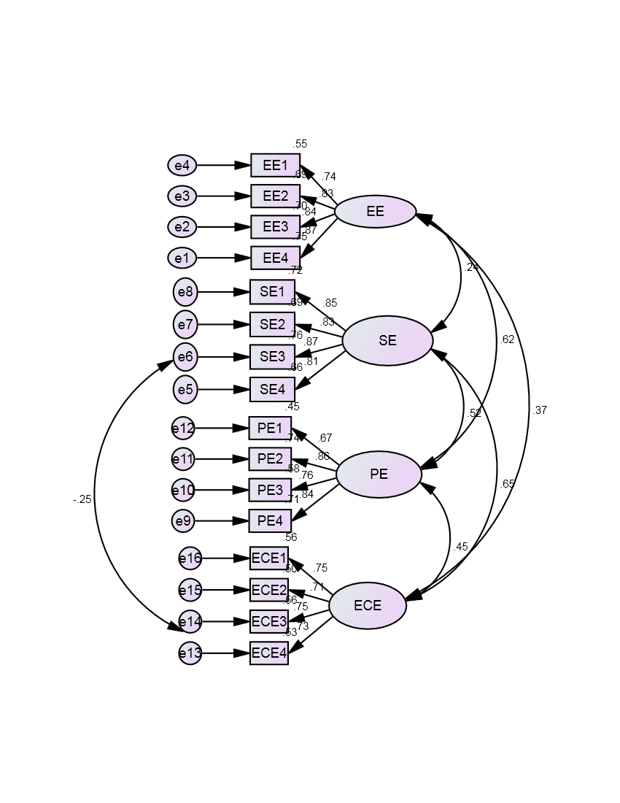

Based on the structural model, it is possible to conclude that Educational Empowerment, Social Empowerment, Political Empowerment and Economic Empowermentare statistically significant. Each factor has significant influence with other factors.

Table 5 Calculation of Average Variance Extracted (AVE) and Construct Reliability (CR)
 |  |  | Factor Loading | Item Reliability | Delta | AVE | Sum of FL | Sum of Delta | CR
EE4 | <--- | EE | 0.868 | 0.753 | 0.247 | 0.673 | 3.277 | 1.307 | 0.892
EE3 | <--- | EE | 0.838 | 0.702 | 0.298
EE2 | <--- | EE | 0.829 | 0.687 | 0.313
EE1 | <--- | EE | 0.742 | 0.551 | 0.449
SE4 | <--- | SE | 0.811 | 0.658 | 0.342 | 0.708 | 3.365 | 1.167 | 0.907
SE3 | <--- | SE | 0.872 | 0.760 | 0.240
SE2 | <--- | SE | 0.834 | 0.696 | 0.304
SE1 | <--- | SE | 0.848 | 0.719 | 0.281
PE4 | <--- | PE | 0.842 | 0.709 | 0.291 | 0.620 | 3.136 | 1.519 | 0.866
PE3 | <--- | PE | 0.761 | 0.579 | 0.421
PE2 | <--- | PE | 0.862 | 0.743 | 0.257
PE1 | <--- | PE | 0.671 | 0.450 | 0.550
ECE4 | <--- | ECE | 0.727 | 0.529 | 0.471 | 0.539 | 2.937 | 1.842 | 0.824
ECE3 | <--- | ECE | 0.751 | 0.564 | 0.436
ECE2 | <--- | ECE | 0.71 | 0.504 | 0.496
ECE1 | <--- | ECE | 0.749 | 0.561 | 0.439
Source: Calculated
TheConstruct Reliability is the method for assessing the contribution or significance of an item by examining the factors loading.The Construct Reliability (CR) of the four latent factors is greater than 0.70 which indicate good reliability and the value for Average Variance Extracted (AVE) is also greater than 0.50 which indicates adequate Convergent Validity. A high construct reliability indicates that internal consistency exists. The data has good Construct Reliability and Convergent Validity.
Table 6 Discriminant Validity of Women Empowerment
Factors | AVE | Squared Inter Correlation (SIC)
 |  | EE | SE | PE | ECE
EE | 0.673 |  | 0.056 | 0.387 | 0.135
SE | 0.708 | 0.056 |  | 0.275 | 0.428
PE | 0.62 | 0.387 | 0.275 |  | 0.198
ECE | 0.539 | 0.135 | 0.428 | 0.198
Source: Calculated
All Average Variance Extracted (AVE) estimates in the above table are larger than the corresponding Squared Interconstruct Correlation (SIC) estimates. This means the indicators have more in common with the factor they are associated with than they do with other factors. Therefore CFA model demonstrates Discriminant Validity.
Conclusion
It was concluded that to develop entrepreneurship skills in the society is the highestloading factor 0.861 in educational empowerment followed by fight against superstitions isthe highest loading factor with the value of 0.884 in social empowerment then to understandthe activities of women’s commission in political empowerment and to market the goods andservices in economic empowerment is the highest factor with the value 0.790 and 0.811respectively. Initially, the confirmatory factor analysis model did not fit. As per themodification indices one double arrow mark was connected with error to error. After that, themodel fit perfectly.
References
- 5)Hair JF, Anderson RE, Tantham RL (2006). Multivariate Data Analysis.10th edn., Prentice Hall: New Jersey. In: Malek AL- Majali, NikKamariahNik Mat (2011). “Modeling the antecedents of internet banking service adoption (IBSA) in Jordan: A Structural Equation Modelling (SEM) approach”. Journal of Internet Banking and Commerce. 16(1):8-13.
- 6)Hiremath, D. B., Hiremath, D. B., &Shiyani, R. L. (2015). Information and communication technology in agriculture and rural development.
- 7)Hu LT, Bentler PM (1999). Cutoff Criteria for Fit Indexes in Covariance Structure Analysis: Conventional Criteria versus New Alternatives, Struct. Equ. Model. 6(1):1-55.
- BalaSubrahmanya, M H and S V Kasturi (2011): “Role of SSI Internationalization in the Promotion of SSI Production and Total Exports in India”, International Economics and Finance Journal, 6(2), 167-185.
- Daire H, Joseph C, Michael RM (2008). Structural Equation Modeling: Guidelines for Determining Model Fit. Electron. J. Bus. Res. Methods 6(1):53-60.
- Hair JF, Anderson RE, Tatham RL, Black WC (1998), Multivariate Data Analysis, Prentice- Hall, Upper Saddle River, New Jersey. In: Marcin Pont and Lisa McQuilken (2002). Testing the Fit of the BANKSERV Model to BANKPERF Data. ANZMAG conference proceedings.865.
- Merlin Thanga Joy, R. Melba kan,(2013), “Emerging Opportunities and Challenges for Cottage Industries in India”, International Journal of Scientific and Research Publications, 3(3), 2013.
- Samitowska, W. (2011).”Barriers to the development of entrepreneurship demonstrated by micro, small and medium enterprises in Poland. Economics & Sociology”, 4(2), pp.42-49.
- Shihabudheen (2012), “Role of Micro Enterprises in Women Empowerment: Evidence from a Field Study of „Kudumbashree‟ Units in Ernakulam District in Kerala”, IOSR Journal Of Humanities And Social Science (JHSS) ISSN: 2279-0837, ISBN: 2279-0845. Volume 3, Issue 6 (Nov. - Dec. 2012), PP 06-12 Www.Iosrjournals.Org
- Srinivas, K. T. (2013) “Role of micro, small and medium enterprises in inclusive growth”, International Journal of Engineering and Management Research (IJEMR), 3(4), 57-61.
- Vijay Jariwala, V. (2016). Rural Women Entrepreneurs: A Case Study for Cottage Industries of Dang District. Jariwala, VS (2016), Rural Women Entrepreneurs: A Case study for Cottage Industries of Dang District, Indian Journal of Technical Education, 1(1), 1-8.

