ARTIFICIAL INTELLIGENCE IN HEALTHCARE

INTRODUCTION
AI's rapid expansion is revolutionizing medicine and various aspects of our lives. Through sophisticated algorithms and machine learning techniques, AI plays a crucial role in aiding doctors. It empowers them to make more precise diagnoses, spot potential health risks, and offer personalized treatment plans for patients. Utilizing extensive data, artificial intelligence (AI) revolutionizes the healthcare sector, offering the potential for enhanced patient results and a more streamlined healthcare system. However, responsible implementation, privacy protection, and ongoing collaboration between AI experts and medical professionals remain crucial for maximizing AI's benefits and ensuring ethical practices in the field of medicine. AI has the potential to revolutionize healthcare by offering efficient and effective solutions to critical issues in the medical industry. By harnessing extensive medical data, including imaging scans and laboratory findings, AI can identify subtle patterns that might evade human observation. Consequently, this enables healthcare professionals to provide more accurate diagnoses and customized treatments for patients. The fast-evolving realm of artificial intelligence utilizes sophisticated algorithms and machine learning methods, revolutionizing the medical landscape with improved diagnostic precision, the early detection of potential health hazards, and personalized therapeutic strategies for individual patients. AI has the capacity to revolutionize healthcare, offering streamlined and potent solutions to the sector's critical challenges. By analyzing vast volumes of medical data like imaging scans and lab results, AI can uncover patterns that human observation might overlook. This capability empowers doctors to make more precise diagnoses and administer more tailored treatments to patients, enhancing overall effectiveness and efficiency in healthcare.
The history of artificial intelligence in medicine dates back to the 1950s, when scientists began exploring the application of computers for analyzing medical data and assisting in diagnostic decision-making. Over time, AI technology progressed with the introduction of advanced algorithms and machine learning methods, enabling computers to handle more intricate medical data. By the 1990s, AI had found broader utilization in medicine, including tasks like analyzing medical images and facilitating drug discovery processes.
The early 2000s witnessed a significant advancement in AI with the introduction of deep learning algorithms, which revolutionized the field. These algorithms enabled computers to learn and adapt to new data in a more sophisticated manner, leading to the emergence of AI-powered medical systems capable of analyzing vast volumes of medical data and making precise predictions. Nowadays, AI is extensively applied in various medical areas, encompassing diagnosis, treatment planning, and health monitoring. As technology continues to progress, we can anticipate even more remarkable developments in the utilization of AI in healthcare.
Artificial intelligence (AI) seeks to replicate human cognitive abilities and is causing a significant revolution in the healthcare industry. This shift is fueled by the increasing availability of healthcare data and the rapid advancements in analytical techniques. AI is utilized for analyzing both structured and unstructured healthcare data, with classical support vector machines, neural networks, and contemporary deep learning methods being prominent AI techniques for structured data. Additionally, AI leverages natural language processing for handling unstructured data. Within the healthcare domain, AI has made significant advancements in three major disease areas: cancer, neurology, and cardiology. These developments have triggered a lively discussion on the potential of AI doctors eventually replacing human physicians. While it is unlikely that machines will completely replace human physicians in the foreseeable future, the integration of AI has shown significant potential to enhance healthcare. AI can assist physicians in making improved clinical decisions and may even take over certain aspects of healthcare, such as radiology, where AI has demonstrated successful applications. The progress in AI's implementation in healthcare has been facilitated by the growing accessibility of healthcare data and the rapid advancements in big data analytics.
Here we have discussed some selective areas that artificial intelligence are using in health care. There are;
- Medical imaging and diagnostics
- Electronic health records (EHR)
- Robot-assisted surgery
- Disease prediction and risk assessment
- Drug discovery and development
- Virtual assistants and chatbots
- Precision medicine
- Remote patient monitoring
MEDICAL IMAGING AND DIAGNOSTICS
The promising potential of artificial intelligence in radiology is expected to expand with technological advancements. AI's application in analyzing medical images, such as CT or MRI scans, through deep learning algorithms can identify patterns and anomalies that may be overlooked by human observation. This heightened accuracy can significantly aid radiologists in making more precise diagnoses and providing targeted treatments for patients. Moreover, AI's role in developing personalized treatment plans by analyzing a patient's medical history and pertinent data holds great promise for enhancing treatment effectiveness and minimizing complications. As AI continues to advance, it is poised to revolutionize healthcare by offering more efficient and effective solutions to the industry's most critical challenges, particularly in oncology, where it can further enhance diagnostic precision and enable personalized treatment approaches for patients.

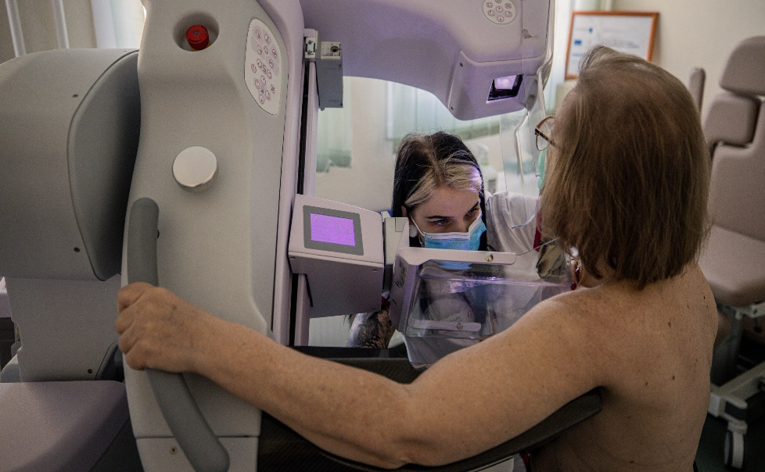
Fig: 1.1 AI imaging diagnostic for detecting spot cancer
Computer-Aided Diagnosis (CAD) systems use AI algorithms to aid in the interpretation of medical images. They analyze images and provide diagnostic suggestions to radiologists or other healthcare professionals. CAD can be particularly useful in the early detection of diseases and abnormalities, increasing the chances of successful treatment. It can streamline radiology workflows by automating routine tasks such as image sorting, annotation, and measurement. This allows radiologists to focus more on complex cases and make quicker and more accurate diagnoses and techniques like deep learning can be used to enhance image quality and improve the visibility of fine details in medical images. It helps in reducing image noise, improving resolution, and enhancing image contrast, leading to more accurate interpretations.
It can automate the analysis of histopathology slides, which are traditionally examined under a microscope. By analyzing digital pathology images, AI algorithms can assist pathologists in diagnosing cancers and other diseases, reducing the need for manual examination and improving efficiency.
Fig: 1.2 AI and Digital pathology
AI systems can provide real-time decision support to healthcare professionals during image acquisition and interpretation. For example, AI algorithms can help optimize image acquisition parameters, ensure image quality, and provide immediate feedback on potential issues.
ELECTRONIC HEALTH RECORDS
AI has the potential to be a valuable tool in primary care, with one possible application being the use of deep learning algorithms to analyses medical data, including imaging scans, lab results, and vital signs. AI systems can efficiently detect patterns and anomalies that human observation might miss, enabling doctors to make more precise diagnoses and offer targeted treatments to patients. Another potential application is the development of personalized care plans. By leveraging AI to assess a patient's medical history and relevant data, healthcare practitioners can create customized treatment plans tailored to the individual's specific needs and preferences. This approach shows promise for improving treatment effectiveness and minimizing the risk of complications.
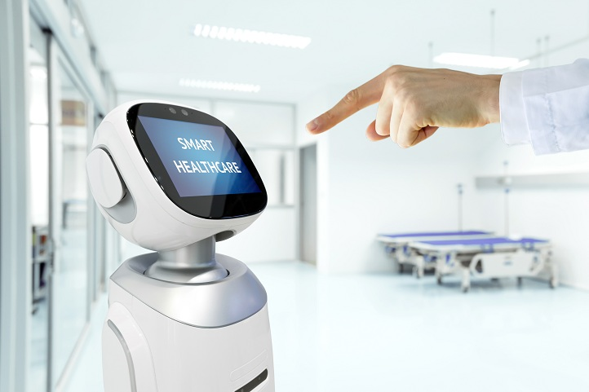
Fig: 2. AI in Electronic health record through fingerprint scanning
ROBOT-ASSISTED SURGERY
Robotic surgical assistants have transformed the field of healthcare by incorporating artificial intelligence (AI) into surgical procedures. These advanced systems combine robotic technology's precision and dexterity with the intelligence and decision-making capabilities of AI algorithms. As a result, a powerful tool is created that improves surgeon skills, improves patient outcomes, and allows complex procedures to be performed with greater efficiency and accuracy. Robotic surgical assistants are typically made up of robotic arms that are outfitted with specialized surgical instruments as well as a high-definition camera. These arms are operated by surgeons from a console, using intuitive hand movements and controls. The AI component comes into play during the procedure by providing real-time feedback and analysis, assisting the surgeon in making informed decisions. Robot assistants helps the surgeon in many surgeries such as; Rectal surgery, bladder related surgery, and cardiovascular surgery etc.

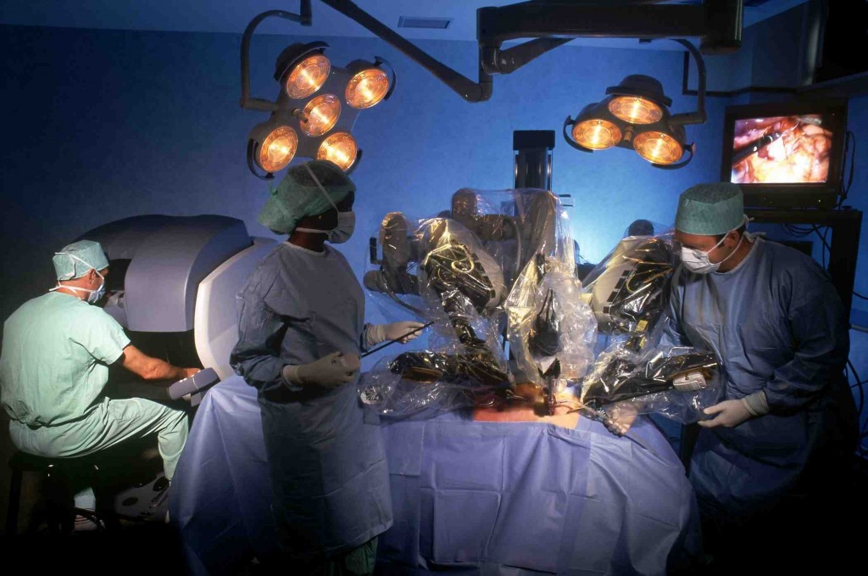
Fig: 3.1 AI in Rectal surgery through Robot-Assisted surgery
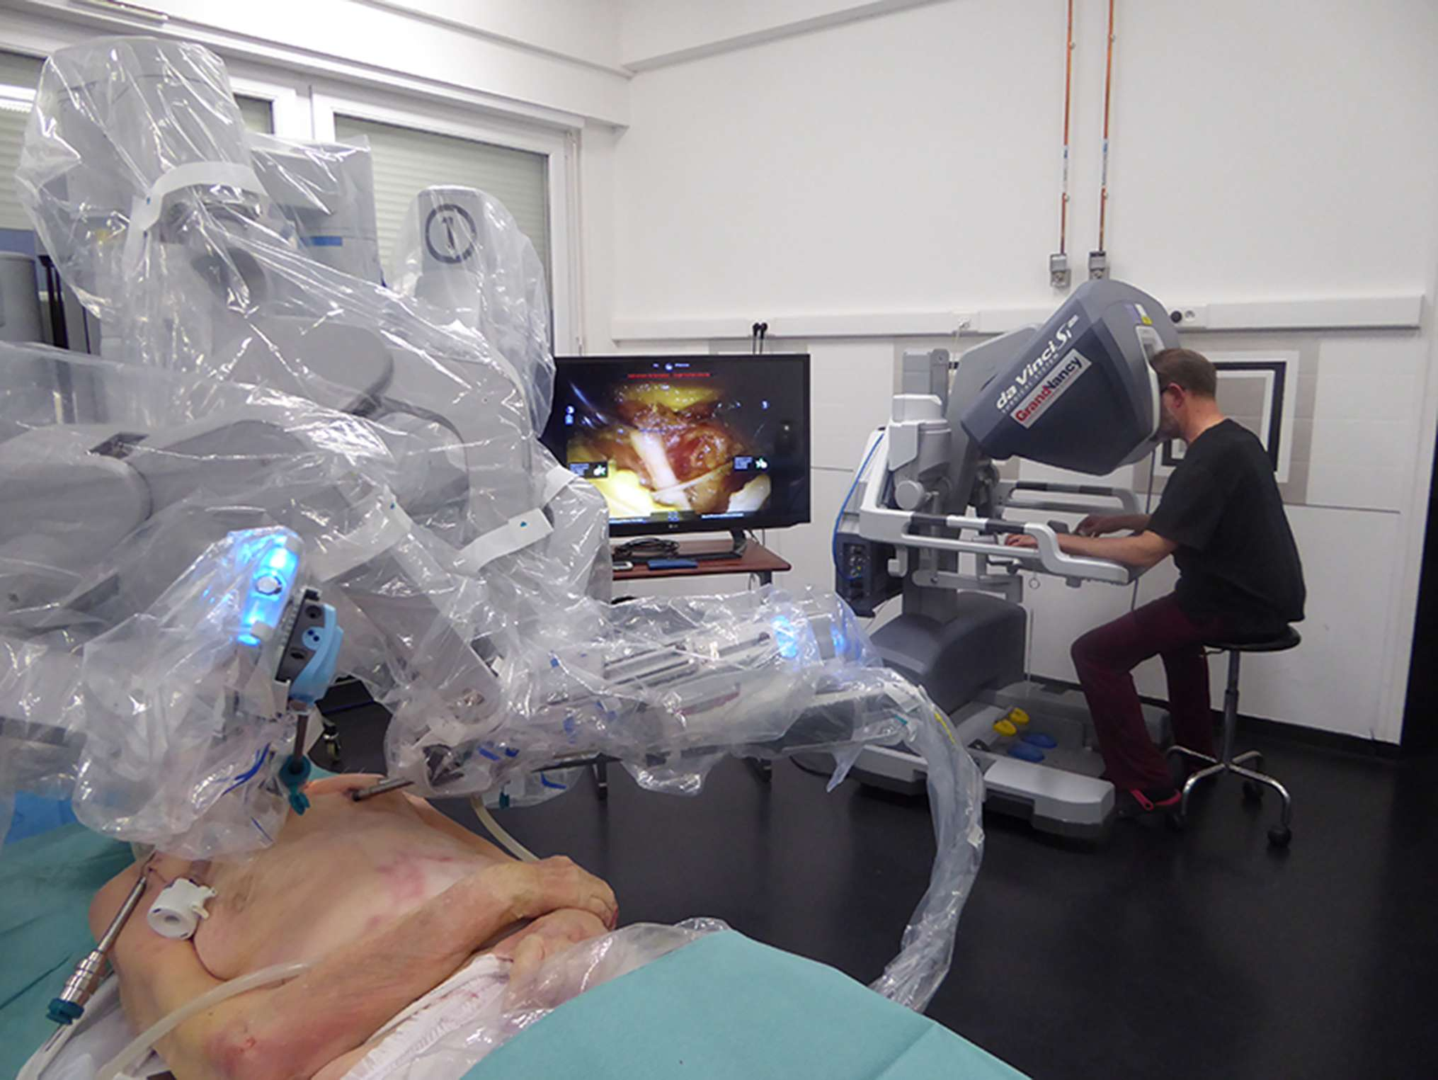
Fig: 3.2 AI Robot-assisted machine in cardiovascular surgery
One of the primary benefits of robotic surgical assistants is their ability to perform minimally invasive procedures. Surgeons can insert the robotic arms and instruments into the patient's body through small incisions, reaching areas that are difficult to reach with traditional open surgery. The AI algorithms in the robotic system aid in improving visualization, reducing hand tremors, and providing precise movements, resulting in better surgical outcomes and shorter recovery times for patients. Robots possess the unique capability to mimic precise movements, which proves particularly advantageous in hair transplant surgeries. In these procedures, the robot effectively extracts hair follicles and strategically implants them in designated areas of the scalp. Advanced force sensing technology is integrated into the robot, ensuring it maintains the desired force during both the harvesting and implantation processes. Moreover, abdominal surgical robots can be controlled using an eye-tracking camera, where surgeons can control the robot's movements by simply moving their eyes. The system also incorporates haptic feedback, enabling surgeons to sense the forces experienced by the robotic arms during the operation.
Robotics-assisted surgery, defined as "the use of a mechanical device to assist surgery in the place of a human-being or in a human-like manner," is rapidly influencing many common general surgical procedures, particularly minimally invasive surgery. In surgery, three types of robotic systems are used:
- Active systems execute predetermined tasks while being supervised and controlled by the operating surgeon.
- Semi-active systems enable surgeons to complement the pre-programmed components of the system with their own inputs and interventions.
- Master-slave systems operate without any autonomous elements and entirely rely on the surgeon's actions. During laparoscopic surgery or teleportation, the system transmits the surgeon's hand movements to surgical instruments, which faithfully replicate those actions.
Surgeons can benefit from navigation systems that assist in spatial localization and provide answers regarding anatomical orientation. Modern surgical navigation systems, equipped with an infrared-emitting stereoscopic camera and real-time marker tracking, can accurately determine the 3D position of prominent anatomical structures.
Furthermore, AI algorithms can analyze massive amounts of medical data, such as patient records, images, and research papers, to help surgeons with pre-operative and intra-operative decision-making. Using this knowledge, the AI can provide suggestions and recommendations based on patterns and evidence, allowing surgeons to make more informed decisions during surgery. Robotic surgical assistants have the potential to democratize access to specialized healthcare. They have the ability to remotely transmit surgical expertise, allowing surgeons in different locations to collaborate and perform procedures together. This capability allows for training, consultation, and improved access to quality healthcare, particularly in underserved areas.
AI has the potential to drive the evolution of robot-assisted surgery towards cognitive surgical robotics. Current surgical robots used in clinical settings primarily function as telemanipulators without any autonomous capabilities. However, in research, there have been advancements in the development of robots designed for situation-aware automatic needle insertion. A different system demonstrated superior performance compared to humans in bowel anastomosis using a porcine bowel model. Despite this, even the most advanced robotic systems lack the ability to comprehend the surgical scene or adapt to the surgical workflow. Therefore, it becomes crucial to develop and validate surgical workflow analysis and surgical scene understanding to a degree where they can become dependable sources of information for cognitive surgical robots. The successful establishment of these capabilities is a prerequisite for enabling cognitive robots to proficiently perform auxiliary tasks, including controlling the laparoscopic camera, manipulating tissue, and even executing more intricate surgical procedures like anastomosis. An AI-powered cognitive robot will possess the ability to understand its environment and potentially learn from previous experiences, leading to continuous improvements in its performance over time.
Finally, the incorporation of artificial intelligence into robotic surgical assistants has dramatically altered the healthcare landscape. These cutting-edge systems provide surgeons with increased precision, decision-making assistance, and access to vast amounts of medical knowledge. As technology advances, robotic surgical assistants are expected to play a growing role in improving patient outcomes and advancing the field of healthcare.
DISEASE PREDICTION AND RISK ASSESSMENT
Artificial intelligence (AI) has become a potent tool in the healthcare sector, specifically for disease prediction and risk assessment. By utilizing advanced algorithms and machine learning techniques, AI systems can analyze extensive patient data to identify patterns that might indicate disease development or heightened risk. These algorithms process data from various sources, including electronic health records, medical imaging scans, genetic profiles, and wearable devices, enabling them to detect subtle correlations that might be overlooked by human observers. The early detection of diseases like cancer, cardiovascular disorders, and diabetes through AI's predictive capabilities allows healthcare professionals to swiftly intervene and implement preventive measures or treatment plans, leading to improved patient outcomes.

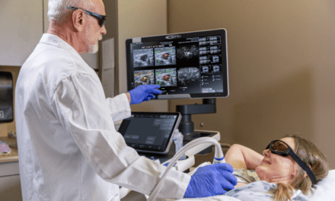
Fig: 4. Used of AI in diagnosing Breast Cancer
The potential of artificial intelligence in cancer therapy is far-reaching, spanning drug discovery, drug development, and clinical validation. A recent study focused on various adaptable machine learning algorithms capable of detecting lung cancer with connections to the internet of things. Additionally, it is worth noting that Diabetes Mellitus, commonly known as diabetes, is the primary cause of high blood sugar levels. AI is a low-cost method of reducing diabetes-related ophthalmic complications and avoidable blindness. Researchers have demonstrated that artificial intelligence can help to streamline chronic disease care. As a result, various machine learning algorithms are being developed to identify patients who are at high risk of developing chronic disease. Artificial intelligence, according to researchers, can predict when patients with heart disease will die. As a result, multiple algorithms have been used to predict the severity of the heart rate as well as its diagnosis.AI is proposed as a possible treatment for tuberculosis. They discovered that if the system suspects a stroke in the patient, AI can analyze and detect stroke signs in medical images, and they discovered that AI can diagnose hypertension by taking input data from blood pressure, demographics, and so on. A team of researchers has created an artificial intelligence system designed to accurately categorize cutaneous skin issues, offering valuable support to clinicians in enhancing their diagnostic precision. Moreover, researchers have found that AI has the potential to identify and treat liver disease at an early stage, thereby improving the prognosis and recovery rate for affected individuals.
One key advantage of AI in disease prediction and risk assessment is its ability to continually learn and improve its performance. As more data becomes available and new patterns are discovered, AI algorithms can adapt and refine their predictions, enhancing their accuracy and reliability over time. This iterative learning process allows AI systems to keep pace with emerging research and medical advancements, ultimately improving patient care and outcomes. Furthermore, AI can help address healthcare resource allocation challenges. By accurately predicting disease risks on an individual level, healthcare providers can allocate resources more efficiently, ensuring that those at higher risk receive appropriate interventions while reducing unnecessary procedures and treatments for individuals at lower risk. This targeted approach optimizes resource utilization and enhances overall healthcare system efficiency.
DRUG DISCOVERY AND DEVELOPMENT
Artificial intelligence (AI) has recently begun to ramp up its application in various sectors of society, with the pharmaceutical industry leading the way. AI algorithms can rapidly analyze massive databases of chemical compounds to predict their ability to bind to specific drug targets. This enables virtual screening, where potential drug candidates are identified based on their predicted interactions with target molecules, saving time and cost compared to traditional methods.
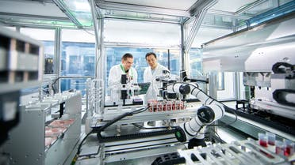
Fig: 5. AI Robotic Drug Discovery machine

Molecules. By learning from existing compounds and their interactions, AI models can generate novel structures with desired properties, optimizing factors such as efficacy, safety, and bioavailability. It can help identify novel drug targets by analyzing vast amounts of biological data, including genomics, proteomics, and medical literature. By uncovering disease-related patterns and relationships, and algorithms can pinpoint potential therapeutic targets that were previously unknown or underexplored.
AI algorithms can analyze patient data to identify suitable participants for clinical trials. By considering a range of factors such as medical history, genetics, and demographics, AI can optimize trial design, patient recruitment, and outcome prediction, resulting in more efficient and effective clinical trials. It can accelerate the process of identifying existing drugs that could be repurposed for new therapeutic uses. By analyzing large-scale data, including gene expression profiles, protein interactions, and disease databases, AI algorithms can identify potential drug candidates that have already been approved or tested for other indications. AI can analyze patient data and electronic health records to identify patterns that may indicate potential adverse events associated with specific drugs. By detecting signals of safety issues earlier, AI can help researchers and regulators make informed decisions regarding drug safety, and can assist in optimizing drug formulation and delivery methods. By analyzing data on drug solubility, stability, and pharmacokinetics, AI algorithms can help in designing formulations that enhance drug efficacy and patient compliance.
AI has the potential to revolutionize the process of discovering new drug molecules by replacing the traditional trial-and-error approach. Through various computational tools like QSPR, AI can effectively address formulation design challenges related to stability, dissolution, porosity, and more. Decision-support systems, driven by rule-based AI, aid in selecting appropriate excipients based on the drug's physicochemical properties and continuously adapt the process through feedback mechanisms. As manufacturing processes become more complex and demand for efficiency and product quality rises, modern manufacturing systems aim to transfer human knowledge to machines, reshaping manufacturing practices. The integration of AI into pharmaceutical manufacturing processes offers significant advantages. For instance, Computational Fluid Dynamics (CFD), which employs Reynolds-Averaged Navier-Stokes solvers, enables the automation of various pharmaceutical operations by studying agitation and stress levels in equipment like stirred tanks. Additionally, sophisticated methods like direct numerical simulations and large eddy simulations address intricate manufacturing flow challenges, showcasing AI's potential to optimize pharmaceutical production.
Nano robots are highly advanced miniature devices that incorporate integrated circuits, sensors, power supplies, and secure data backup. These robots are designed to operate with precision, avoiding collisions and identifying and attaching to specific targets within the body. They can be safely excreted after fulfilling their intended purpose. Recent advancements in Nano/micro robot technology have enabled these devices to navigate through the body based on physiological factors like pH, enhancing their effectiveness while minimizing potential side effects. The development of implantable Nano robots has opened up new possibilities for controlled drug and gene delivery, involving parameters such as dose adjustment and sustained and controlled release. AI tools, such as neural networks, fuzzy logic, and integrators, are utilized to automate and optimize drug release from microchip implants within the body. Nano medicines, which combine nanotechnology and medicine, offer promising approaches for diagnosing, treating, and monitoring complex diseases like HIV, cancer, malaria, asthma, and inflammatory conditions. The integration of nanotechnology and AI has the potential to solve formulation development challenges and significantly accelerate the drug discovery and development process, reducing costs and increasing success rates in bringing new drugs to market. However, it is crucial to recognize that while AI is a valuable tool, it should complement rigorous scientific research and human expertise rather than replace them entirely.
VIRTUAL ASSISTANTS AND CHATBOTS
AI has played a crucial role in the development of virtual assistants and chatbots in the healthcare sector. These intelligent systems are designed to engage with users, offer information, and assist with various healthcare tasks. While chatbots have been widely used in online retail, their integration into healthcare is gradually becoming more prominent. Well-designed chatbots have the potential to enhance customer retention, attract new users, and provide excellent customer service. With the growing trend of healthcare consumerism, which aims to make healthcare delivery more efficient and convenient, there is a need for better connections with members and patients. Fortunately, the healthcare industry possesses a wealth of plan information and extensive data from digital health records, enabling enriched consumer interactions. AI-enabled virtual assistants tailored for payers, providers, and members can contribute to simplifying and personalizing user experiences throughout the healthcare domain.
Virtual assistants and chatbots can offer personalized support and education to patients. They can answer common health-related questions, provide information on medications, explain medical procedures, and offer general health advice. AI enables these systems to understand user inquiries, retrieve relevant information from medical databases, and deliver accurate responses. Virtual assistants and chatbots can help users assess their symptoms and determine the appropriate course of action. By asking questions about symptoms and medical history, AI-powered systems can provide preliminary assessments and triage recommendations, such as suggesting self-care measures, advising a doctor's visit, or indicating the need for urgent medical attention. It driven virtual assistants can assist users in scheduling appointments with healthcare providers. By integrating with scheduling systems, these assistants can check availability, propose suitable appointment slots, and facilitate the booking process. This automation saves time for both patients and healthcare staff.
Virtual assistants and chatbots can help individuals manage their medications. They can send reminders for medication doses, provide information about drug interactions and side effects, and assist in medication adherence. AI algorithms can personalize reminders based on individual schedules and preferences also it enabled virtual assistants can support remote monitoring and telehealth initiatives. They can collect and analyze data from connected devices, such as wearable or home sensors, to track vital signs, activity levels, or sleep patterns. These assistants can offer insights and alerts to users and their healthcare providers, facilitating remote healthcare management. In addition it can provide mental health support and interventions. They can offer coping strategies for stress, provide resources for managing mental health conditions, and engage in conversations to alleviate loneliness or anxiety. AI algorithms can continuously learn from user interactions and personalize the support provided and powered virtual assistants and chatbots can help bridge language barriers in healthcare settings. They can translate medical information, instructions, and conversations between patients and healthcare providers, facilitating communication and ensuring better understanding .It important to note that while virtual assistants and chatbots in healthcare offer valuable support, they should not replace professional medical advice or clinical judgment. These system should be designed and continuously improved in collaboration with healthcare professionals to ensure accuracy, privacy, and ethical use of data.

PRECISION MEDICINE
The integration of artificial intelligence (AI) and precision medicine holds the promise of transforming healthcare. Precision medicine techniques aim to identify patient phenotypes with unique treatment responses or specific healthcare needs. AI contributes to this revolution by employing advanced computation and inference, enabling the system to learn and reason effectively. The result is augmented intelligence that empowers clinicians with valuable insights, enhancing their decision-making capabilities.
AI algorithms are used to analyze large-scale genomic data, including DNA sequencing, gene expression, and genetic variations. By identifying patterns and associations within this data, AI can assist in identifying genetic biomarkers, predicting disease risks, and determining the most effective treatments tailored to an individual's genetic profile. It cans integrate patient-specific data, including medical records, imaging results, and genomic information, to provide clinicians with evidence-based recommendations, and algorithms can assist in diagnosing complex diseases, predicting treatment outcomes, and suggesting personalized treatment plans based on patient characteristics.
AI plays a vital role in accelerating the drug discovery and development process for precision medicine. Machine learning models can analyze vast amounts of biological data to identify potential drug targets, optimize drug candidates, and predict drug response based on individual characteristics. AI can also facilitate the repurposing of existing drugs for specific genetic subsets of patients. Precision medicine relies on integrating diverse datasets from various sources, including electronic health records, wearable devices, and biomedical research. AI techniques, such as natural language processing and data mining, can analyze and extract meaningful insights from these heterogeneous data sources, enabling a comprehensive understanding of patient health and treatment options.
AI can analyze patient data to identify individuals at high risk of developing certain diseases. By considering various factors like genetic predisposition, environmental exposures, and lifestyle choices, AI algorithms can predict disease risks and enable early interventions. This allows for preventive measures and personalized interventions to mitigate or delay the onset of diseases, and it can enhance the design and execution of clinical trials in precision medicine. By leveraging AI algorithms, researchers can identify suitable patient cohorts for clinical trials based on specific genomic or phenotypic characteristics. AI can also aid in monitoring and analyzing trial data, enabling more efficient and precise evaluation of treatment efficacy. The integration of AI in precision medicine holds great promise for improving patient outcomes, optimizing treatment strategies, and advancing our understanding of complex diseases. However, it is essential to ensure that AI systems are developed ethically, with robust validation and rigorous evaluation, and in collaboration with healthcare professionals to ensure patient safety and privacy.

REMOTE PATIENT MONITORING
Artificial intelligence (AI) has significantly impacted remote patient monitoring (RPM) in healthcare, transforming the way patient data is collected, analyzed, and utilized. RPM refers to the use of technology to monitor patients' health remotely, allowing healthcare providers to monitor their conditions outside of traditional healthcare settings. AI plays a crucial role in enhancing RPM by improving data analysis, enabling early detection of health issues, and facilitating personalized care.
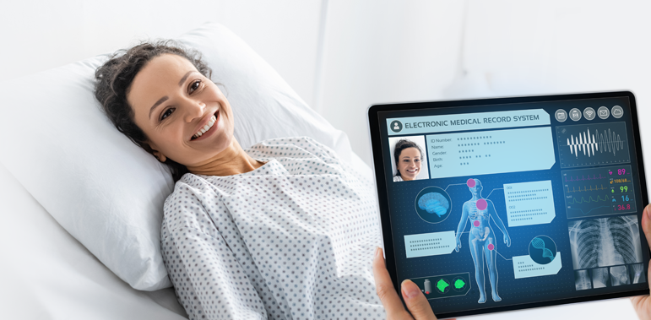
Fig: 6. RPM in Artificial Intelligence
AI algorithms can analyze large volumes of patient data, including vital signs, medical history, and patient-reported symptoms, to identify patterns, trends, and anomalies. By leveraging machine learning and predictive analytics, AI can provide healthcare professionals with valuable insights and support in making accurate diagnoses and treatment decisions. It powered wearable devices, such as smart watches or fitness trackers, can continuously monitor vital signs and other health parameters. These devices use AI algorithms to process the collected data, detecting abnormalities or significant changes in the patient's health status. Real-time monitoring enables early intervention, timely alerts, and improved patient outcomes, and predict potential health risks or complications by analyzing patient data over time. By applying predictive models to RPM data, AI algorithms can identify patients at high risk of developing specific conditions or experiencing adverse events. This enables healthcare providers to intervene proactively and provide targeted interventions to mitigate risks.
It can analyze individual patient data and generate personalized care plans based on their unique health profile. By considering factors such as medical history, genetics, lifestyle, and environmental factors, AI algorithms can recommend tailored interventions, medication adjustments, or lifestyle changes to optimize patient health outcomes.AI-powered tools can facilitate remote diagnostics by analyzing images, such as X-rays, CT scans, or pathology slides. Deep learning algorithms can be trained to detect and interpret patterns indicative of diseases, assisting healthcare professionals in making accurate diagnoses remotely. AI-powered chatbots or virtual assistants can interact with patients, answer questions, provide educational materials, and offer basic medical advice. These conversational AI platforms can help patients feel supported, informed, and connected to healthcare professionals, even when physically distant.
Overall, AI in remote patient monitoring holds great potential to improve healthcare outcomes, enhance patient experiences, and optimize healthcare resource utilization. It enables timely interventions, early detection of health issues, and personalized care, ultimately leading to more efficient and effective healthcare delivery. However, it's important to ensure ethical considerations, data privacy, and regulatory compliance when implementing AI in healthcare settings.
CHALLENGERS FOR ARTIFICIAL INTELLIGENVE IN HEALTH CARE
The increasing adoption of artificial intelligence in healthcare by various organizations brings along a set of challenges that demand immediate attention. These challenges revolve around ethical and regulatory concerns, particularly unique to the healthcare sector. Paramount among them is the issue of data privacy and security. AI systems gather vast amounts of personal health data, necessitating stringent measures to prevent any potential misuse or unauthorized access. Patient safety and accuracy are of utmost importance in healthcare AI applications. Ensuring that AI-generated decisions are reliable and safe requires thorough validation and transparency in the decision-making process. Moreover, training algorithms to effectively recognize patterns in medical data is a complex task that demands diverse and representative datasets while actively addressing biases.
Integrating AI with existing IT systems smoothly is another pressing challenge. Seamless integration is crucial to maximizing the benefits of AI while minimizing disruptions to established workflows. Gaining the trust and acceptance of physicians is vital for successful AI implementation. Proper education and communication can alleviate concerns and demonstrate the advantages of AI, ultimately leading to its effective use in healthcare settings. Adhering to federal regulations, such as HIPAA, is non-negotiable when dealing with healthcare data. Strict compliance is necessary to protect patient privacy and prevent legal consequences. Incorporating robust security measures is essential to safeguard sensitive patient data from potential exploitation for malicious purposes when utilizing AI in healthcare. Patient safety and accuracy are paramount concerns in AI implementation, requiring AI systems to be proficient in recognizing patterns in medical data, understanding relationships between diagnoses and treatments, and providing precise personalized recommendations for each patient. The integration of AI with existing IT systems can introduce complexities for medical providers, necessitating a comprehensive understanding of the current technology to ensure seamless operation. However, it's important to be aware that AI automation has the potential to replace certain job roles, which may lead to unemployment or changes in employment opportunities in specific sectors or professions. To address this, reskilling or up skilling the workforce may become necessary to adapt to emerging roles in the context of AI-driven healthcare.

Incorporating AI techniques into healthcare delivery poses distinctive challenges beyond the technical limitations that exist compared to human capabilities in vision, language processing, and context-specific reasoning. Healthcare professionals have historically been cautious about adopting new technologies, often preferring established methods for providing clinical care. Even with proper regulatory approval, the introduction of AI-enabled applications is likely to encounter resistance and opposition within the healthcare industry.
The field of precise clinical diagnostics faces ongoing challenges that demand continuous improvement to effectively combat emerging illnesses and diseases. Despite significant advancements, medical professionals acknowledge the obstacles that must be surmounted before AI-driven diagnostics can reliably predict illnesses and associated symptoms. Presently, scepticism among doctors towards AI-based approaches stems from uncertainties about their accuracy in disease detection. Therefore, substantial efforts are necessary to train AI systems and enhance the precision of disease diagnosis. In the future, AI-based research must be conducted with a clear understanding of these limitations, promoting harmonious collaboration between AI and clinicians to ultimately improve patient outcomes. Moreover, employing a decentralized federated learning model can facilitate the creation of a unified training model for disease datasets located in remote areas, aiding in the early detection of diseases.
Finally, gaining medical providers' acceptance and trust is critical for the successful implementation of AI in healthcare. Physicians must have trust in the reliability of AI systems and their ability to provide accurate guidance. Transparency becomes crucial as physicians need to understand how the AI system arrives at decisions, ensuring it relies on valid and current medical research. Additionally, adherence to federal regulations is essential to ensuring the ethical use of AI systems and safeguarding patient safety and well-being.
CONCLUSION
The integration of AI in basic healthcare facilities is poised to bring about cost reductions, making essential healthcare more affordable and accessible to everyone. With the rise of communicable and non-communicable diseases as well as new virus infections, AI will play a crucial role in swift disease detection and more effective patient care. The increasing population is straining healthcare staff, leading to sleep deprivation and mental exhaustion, adversely affecting patient treatment. However, rapid advancements in AI research, backed by government and industry support, make it highly probable that AI will be widely adopted in healthcare delivery, offering substantial cost savings and improved service quality. AI-smart robots will assist healthcare staff in providing more efficient patient care, alleviating their burden. Empowering individuals with AI-powered smart watches and bands will enable them to detect minor ailments themselves, saving time and money otherwise spent on hospital visits. The vast potential of artificial intelligence continues to grow, promising significant assistance to humanity through ongoing innovations
However, challenges such as data quality, bias, ethical considerations, human-AI collaboration, and technical limitations need to be addressed. Furthermore, potential negative effects of AI in healthcare, such as job displacement, bias and discrimination, security and privacy risks, and ethical concerns, must be mitigated through responsible AI practices and regulatory frameworks. By navigating these challenges and responsibly deploying AI in healthcare, we can harness its full potential to improve patient care, optimize treatment outcomes, and enhance the overall healthcare experience. AI, when implemented ethically and in collaboration with healthcare professionals, can be a valuable tool in advancing healthcare delivery and positively impacting global well-being.

REFERENCES:

1. Topol, E. J. (2019). High-performance medicine: the convergence of human and artificial intelligence. Nature medicine, 25(1), 44-56.

2. Chen, J., & Asch, S. M. (2017). Machine learning and prediction in medicine: beyond the peak of inflated expectations. New England Journal of Medicine, 376(26), 2507-2509.

3. Davenport, T., & Kalakota, R. (2019). The potential for artificial intelligence in healthcare. Future healthcare journal, 6(2), 94.

4. Fig 1.1 Source: Choi, J. W., & Kim, H. C. (2018). Artificial intelligence in medical imaging: Current advances and future directions. Precision and Future Medicine, 2(3), 115-121.

5. Fig 1.2 Source: Sharma, A., & Mishra, S. (2020). Artificial Intelligence and Its Application in Pathology. Journal of Oral and Maxillofacial Pathology, 24(3), 442.

6. Wang, D., & Khosla, A. (2021). Artificial Intelligence in Primary Care: A Scoping Review. Primary Care: Clinics in Office Practice, 48(2), 359-376.

7. Fig 2 Source: Sharma, A., & Mishra, S. (2020). Artificial Intelligence and Its Application in Pathology. Journal of Oral and Maxillofacial Pathology, 24(3), 442.

8. Fig 3.1 Source: Al-Jabir, A., Kerwan, A., Nicola, M., Alsafi, Z., Khan, M., Sohrabi, C., & Amawi, H. (2020). Impact of the Coronavirus (COVID-19) pandemic on surgical practice-Part 2 (surgical prioritisation). International Journal of Surgery, 79, 233-248.

9. Fig 3.2 Source: Zhou, S., Liao, H., Nie, Z., He, Y., Hu, Y., Wu, W., ... & Chen, Y. (2019). Novel design and fabrication of a soft robotic hand for minimally invasive surgery. Soft Robotics, 6(1), 123-135.

10. Oprea, A. D., Talpos-Niculescu, C., Rusu, M. C., Vaida, C., & Oprea, G. (2020). Advances in robotic technology and artificial intelligence in surgery. Journal of Mind and Medical Sciences, 7(2), 224-230.

11. Fig 3.3 Source: Noh, Y. (2021). Image-guided surgery using augmented reality and artificial intelligence. Journal of the Korean Medical Association, 64(9), 647-656.

12. Fig 3.4 Source: Davenport, T., & Kalakota, R. (2019). The potential for artificial intelligence in healthcare. Future healthcare journal, 6(2), 94.

13. Fig 4 Source: Gholami, M., & Salimi, M. (2020). Application of Artificial Intelligence for Breast Cancer Diagnosis: A Comprehensive Review. Breast Cancer: Targets and Therapy, 12, 157.

14. Guntaas, S., Paul, R. S., Kaur, H., & Gupta, A. (2021). Application of Artificial Intelligence and Machine Learning in Predicting and Diagnosing Various Diseases: A Review. Journal of Big Data, 8(1), 1-13.

15. Lundberg, S. M., & Lee, S. I. (2017). A unified approach to interpreting model predictions. In Advances in neural information processing systems (pp. 4765-4774).

16. Minaee, S., Kalchbrenner, N., Cambria, E., Nikzad, N., & Chenaghlu, M. (2021). Deep learning in drug discovery and medicine; Scratching the surface. Computational and Structural Biotechnology Journal, 19, 2951-2975.

17. Fig 5 Source: Colasanti, R., & Bovo, E. (2021). Artificial intelligence and the drug discovery process: challenges and perspectives. European Journal of Medicinal Chemistry, 219, 113419.

18. Xu, Y., & Wang, X. (2018). Drug discovery: AI to the rescue?. Science, 360(6385), 478-479.

19. Tian, F., Zhang, H. H., Zhang, J. G., Huang, Y. P., & Pan, L. L. (2021). A systematic review of artificial intelligence in drug discovery. Expert Opinion on Drug Discovery, 16(1), 17-31.

20. Prajapati, K. D., Patel, K., Modi, H., & Patel, M. (2014). Artificial intelligence techniques in formulation development: A review. Asian Journal of Pharmaceutical Sciences, 9(4), 163-170.

21. Chatbots in healthcare: Where are we now? (2018). Healthcare IT News.

22. Abd-Alrazaq, A. A., Rababeh, A., Alajlani, M., Bewick, B. M., Farran, B., Househ, M., & Shah, Z. (2020). Artificial Intelligence Chatbot Application as a Tool to Address the COVID-19 Pandemic: Development and Implementation Study. Journal of Medical Internet Research, 22(8), e20420.

23. Restifo, A., Narayan, A., Malkani, S., Uppal, J., Chu, S. K., & Vawdrey, D. K. (2020). Using virtual health assistants and chatbots in clinical practice: Systematic review. Journal of Medical Internet Research, 22(10), e20246.

24. Esteva, A., & Topol, E. J. (2019). Reinventing clinical trials with artificial intelligence. JAMA, 322(20), 1901-1902.

25. Kumar, P., Sharma, M., & Patel, S. K. S. (2021). AI and Precision Medicine in Oncology: A Need of Present and Future. Frontiers in Pharmacology, 12, 11.

26. Fig 6 Source: Gao, R., Ai, J., Cui, Y., & Li, J. (2021). The Role of Remote Patient Monitoring in Chronic Disease Management. Frontiers in Medicine, 8, 13.

27. Khoja, S. (2020). Artificial intelligence in remote patient monitoring. Journal of the American Medical Association, 323(23), 2380.

28. Dixon, B. E., & Cassel, C. K. (2020). AI and the future of medicine. Annals of Internal Medicine, 173(1), 59-60.

29. Ong, S. L., & Koh, J. W. K. (2018). AI in healthcare: The end of physicians?. Annals of the Academy of Medicine, Singapore, 47(11), 477-478.

