“Things” and Communication Trends in IoT
Manjuanath R¹  Professor, CSE Department  R R Institute of Technology, Bengaluru,  Karnataka, India, drmanjunath.raj@gmail.com | Sowmya Naik P²  Professor, CSE Department  City Engineering College, Bengaluru  Karnataka, India, sowmya.vturesearch@gmail.com
Shivashankar³  Professor, ECE Department  R R Institute of Technology, Bengaluru,  Karnataka, India, drmanjunath.raj@gmail.com | Sumanth V⁴  Associate Professor, CSE Department  Acharya Institute of Technology, Bengaluru,  Karnataka, India, ssumanth6@gmail.com
ABSTRACT
Currently, there is an excess of IoT communication protocols, the technologies used to connect IoT devices to the internet, used across the world. The extensive collection of communication protocols can lead to problems with interoperability between and within IoT ecosystems. There is presently no global IoT communication standards, making large-scale IoT distribution more complex than it desires to be. A combined “Things” and Communication Trends in IoT standards are essential to realize the occupied potential of IoT. The main focus of IoT technology is endpoint security, i.e. refers to the protection of associated computing devices. The central premise of IoT is the term “connectivity Sensors and Actuators”. The IoT devices are associated to Internet over a wide diversity of communication technology. This book chapter describes the several technologies elaborate in IoT communication. The diversity in communication increases the enquiry to select for the future and proposed application. The main objective of the application requirements to define very evidently. The features applications such as range, frequency bands, power consumption, topology, constrained devices, constrained-node and networks influence the choice of choosing one or more IoT communication technology.

- INTRODUCTION
The Internet of Thing (IoT) describes the network of physical objects “things” are embedded with sensors, actuators, software, and other technologies for the resolution of connecting and trading information with other communicating devices and systems through the internet. These IoT communicating devices range from ordinary domestic objects to sophisticated industrial tools.
IoT is the networking of physical things that comprise electronics implanted within their building in order to communicate and sense connections between each other or with admiration to the peripheral environment. In the forthcoming years, IoT-based technology will offer advanced levels of services and practically change the way people lead their daily lives. Advancements in medicine, power, gene therapies, agriculture, smart cities, and smart homes are just a very few of the categorical examples where IoT is strongly established.
Specific sensors will also be equipped within existing spaces to monitor the health and universal well-being of senior citizens, while also safeguarding that suitable treatment is being directed and assisting public people to recover lost flexibility via therapy as well. These sensors form a network of intelligent sensors which are able to collect, process, transfer and study valued data in different situations, such as connecting in-home monitoring devices to hospital-based systems. Other customer devices to inspire healthy living which are connected scales or wearable heart monitors, are also a possibility with the IoT. The applications of Communication Trends in IoT are end-to-end health monitoring using IoT platforms also available for prenatal and long-lasting patients, helping them to manage health vitals and recurring medication requirements.

- SENSORS IN INTERNET OF THINGS
A sensor does exactly as its name indicates: It senses. More specifically, A sensor measures some physical quantity and converts that measurement reading into a digital representation. That digital representation is typically passed to another device for transformation into useful data that can be consumed by intelligent devices or humans. Sensors can be readily embedded in any physical objects that are easily connected to the Internet by wired or wireless networks. Because these connected host physical objects with multidimensional sensing capabilities communicate with each other and external systems, they can interpret their environment and make intelligent decisions.

- Applications For Sensors
Sensors have been around since the early days of electricity and have been in use in a very wide range of applications. We use sensors in electronics projects, robotics, industry, and much more. Table 1 is a brief list of typical applications of sensors.

Table 1: List of Sensor Applications
Automation  Robotics  Embedded Systems  Computers  Smart Cars  Avionics  Satellites | Smart Homes  Smartphones  Smart Watches  Energy plants  Remote Sensing  Communications  Medical domain

- Sensors Categories
Active or passive: Sensors can be categorized based on whether they produce an energy output and typically require an external power supply (active) or whether they simply receive energy and typically require no external power supply (passive).
Invasive or non-invasive: Sensors can be categorized based on whether a sensor is part of the environment it is measuring (invasive) or external to it (non-invasive).
Contact or no-contact: Sensors can be categorized based on whether they require physical contact with what they are measuring (contact) or not (no contact).
Absolute or relative: Sensors can be categorized based on whether they measure on an absolute scale (absolute) or based on a difference with a fixed or variable reference value (relative).
Area of application: Sensors can be categorized based on the specific industry or vertical where they are being used.
How sensors measure: Sensors can be categorized based on the physical mechanism used to measure sensory input.
What sensors measure: Sensors can be categorized based on their applications or what physical variables they measure.

- Sensor Types
The most useful classification scheme for the pragmatic application of sensors in an IoT network, is to simply classify based on what physical phenomenon a sensor is measuring. This type of categorization is shown in Table 2.

Table 2: Different Types of Sensors
Temperature Sensor |  | One of the most common and most popular sensors is the Temperature Sensor. A Temperature Sensor, as the name suggests, senses the temperature i.e., it measures the changes in the temperature.
Proximity Sensors |  | A Proximity Sensor is a non-contact type sensor that detects the presence of an object. Proximity Sensors can be implemented using different techniques like Optical (like Infrared or Laser), Sound (Ultrasonic), Magnetic (Hall Effect), Capacitive, etc.
Infrared Sensor (IR Sensor) |  | IR Sensors or Infrared Sensor are light based sensor that are used in various applications like Proximity and Object Detection. IR Sensors are used as proximity sensors in almost all mobile phones.
Ultrasonic Sensor |  | An Ultrasonic Sensor is a non-contact type device that can be used to measure distance as well as velocity of an object. An Ultrasonic Sensor works based on the properties of the sound waves with frequency greater than that of the human audible range.
Light Sensor |  | Sometimes also known as Photo Sensors, Light Sensors are one of the important sensors. A simple Light Sensor available today is the Light Dependent Resistor or LDR. The property of LDR is that its resistance is inversely proportional to the intensity of the ambient light i.e., when the intensity of light increases, its resistance decreases and vise-versa.
Smoke and Gas Sensors |  | One of the very useful sensors in safety related applications are Smoke and Gas Sensors. Almost all offices and industries are equipped with several smoke detectors, which detect any smoke (due to fire) and sound an alarm.
Alcohol Sensor |  | As the name suggests, an Alcohol Sensor detects alcohol. Usually, alcohol sensors are used in breathalyzer devices, which determine whether a person is drunk or not. Law enforcement personnel uses breathalyzers to catch drunk-and-drive culprits.
Touch Sensor |  | We do not give much importance to touch sensors but they became an integral part of our life. Whether you know or not, all touch screen devices (Mobile Phones, Tablets, Laptops, etc.) have touch sensors in them. Another common application of touch sensor is trackpads in our laptops.
Color Sensor |  | A Color Sensor is an useful device in building color sensing applications in the field of image processing, color identification, industrial object tracking etc. The TCS3200 is a simple Color Sensor, which can detect any color and output a square wave proportional to the wavelength of the detected color.
Humidity Sensor |  | If you see Weather Monitoring Systems, they often provide temperature as well as humidity data. So, measuring humidity is an important task in many applications and Humidity Sensors help us in achieving this.
Tilt Sensor |  | Often used to detect inclination or orientation, Tilt Sensors are one of the simplest and inexpensive sensors out there. Previously, tilt sensors are made up of Mercury (and hence they are sometimes called as Mercury Switches) but most modern tilt sensors contain a roller ball.
Radiation Sensor |  | A radiation sensor is an electronics instrument that senses and measures the radiation particles like alpha, beta, gamma, neutrons, X-rays.
Level Sensor |  | The main role of the level sensor is to measure the level or height of different materials like solid, liquid, and gaseous.
Vibration Sensor |  | Sometimes, a vibration sensor is known as Piezoelectric Sensor.  The vibration sensor detects and records any movement or activities. And it provides data or signals to connected machines or systems.
Image Sensor | The image sensor is an electronic device that is used to detect the image pixels and provide information to the display devices.
Flame Sensor | The flame sensor easily detects fire or flame of nearby materials. These detected signals are passed to the connected control devices.
Leak Sensor | A leak sensor is used in a closed vessel or vacuum for detecting water leakage, fluid leakage, air leakage, etc.
Mark Sensor | Mark sensor works as a photoelectric type of sensor. It is used to sense colour marks in the presence of objects.
Flow Sensor or Float Sensor | Flow sensor measures and detects virtually any process fluid. This detected data will be provided to the controller system. It is used in industrial areas, power generating instruments, power plants, etc.

- How To Choose The Right Sensor?
There are many factors to consider while choosing a sensor for any project. But all starts by selecting the physical parameter we are willing to measure. Then it’s the time to consider some other factors to get the best sensors for best results and within the given constraints such as budget, accuracy, etc. Down below are some of the most important factors to consider.
Range of Operation: The most important factor to consider in a sensor is the operating range.
Accuracy (Resolution): Decide on the required resolution (accuracy) of the sensor your applications need prior to choosing a sensor.
Total Cost: Electronic sensors range widely in price. You can easily guess that high accuracy sensors are always way more expensive than low accuracy ones. The operating wide dynamic rage also plays a role in determining the price point of the sensor, etc.
Interfacing Method: As we’ve stated earlier, some sensors are analog and others are digital. Hence, there are different ways to interface and read these sensors using analog input pins of an MCU.
Data Rate (For Digital Sensors): Digital sensors can send you readings (data) at a rate we call the sampling rate. Typically sensors’ rate is defined by ksp/s (kilo samples per second) which is a thousand sample points (readings) in a second. Some sensors can supply up to a few Msp/s. Most of the time, it’s a programmable feature in sensor modules. Documentation: Good documentation is key whether to choose a sensor or not
Example: Smart Phones.
More than a billion smart phones are sold each year, and each one has well over a dozen sensors inside it (shown in Figure 1), and that number continues to grow each year. Imagine the exponential effect of extending sensors to practically every technology, industry, and vertical.

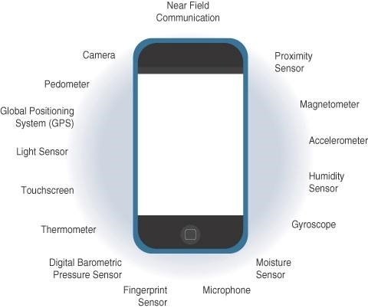

Figure 1: Sensors in a Smart Phone

- ACTUATORS IN INTERNET OF THINGS

Actuators are natural complements to sensors. Sensors are designed to sense and measure practically any measurable variable in the physical world. They convert their measurements (typically analog) into electric signals or digital representations that can be consumed by an intelligent agent (a device or a human). Actuators receive some type of control signal (commonly an electric signal or digital command) that triggers a physical effect, usually some type of motion, force, and so on. Figure 2 below demonstrates the symmetry and complementary nature of these two types of devices.

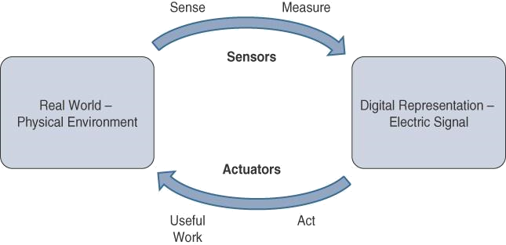

Figure 2 : How Sensors and Actuators Interact with the Physical World.

Figure 3 below gives comparison of Sensor and Actuator Functionality with Humans. Humans use their five senses to sense and measure their environment. The sensory organs convert this sensory information into electrical impulses that the nervous system sends to the brain for processing. Similarly, IoT sensors are devices that sense and measure the physical world and (typically) signal their measurements as electric signals sent to some type of microprocessor or microcontroller for additional processing. A processor can send an electric signal to an actuator that translates the signal into some type of movement (linear, rotational, and so on) or useful work that changes or has a measurable impact on the physical world.

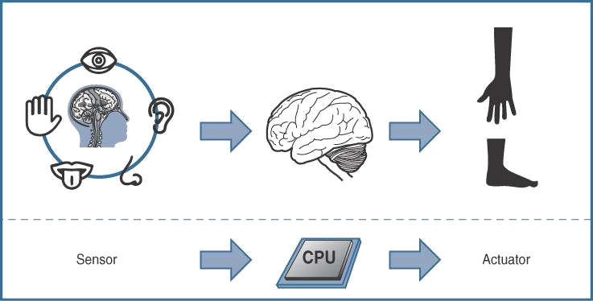

Figure 3: Comparison of Sensor and Actuator Functionality with Human

- Classification of Actuators
Much like sensors, actuators also vary greatly in function, size, design, and so on. Some common ways that they can be classified include the following:
Type of motion: Actuators can be classified based on the type of motion they produce (for example, linear, rotary, one/two/three-axes).
Power: Actuators can be classified based on their power output (for example, high power, low power, micro power).
Binary or continuous: Actuators can be classified based on the number of stable-state outputs.
Area of application: Actuators can be classified based on the specific industry or vertical where they are used.
Type of energy: Actuators can be classified based on their energy type.

- Types of Actuators
The different types of actuators are shown in below Table 3.

Table 3: Types of Actuators
Types of Motion and functions
Linear Actuators | Linear actuators, as their name suggests, are devices that move in a straight line. They are typically found in hydraulic and pneumatic equipment and can be mechanical or electrical.
Rotary Actuators | Rotary actuators, in contrast to linear types of actuators, produce a round motion. Most machines, as the term “rotary” implies, use rotating elements to accomplish a turning movement. If a machine needs to move forward, backward, up, or down, they are frequently utilized in connection with a linear actuator.
Types of Energy
Hydraulic Actuators | Hydraulic actuators use a fluid-filled cylinder with a piston positioned in the middle to function. Hydraulic actuators typically create linear movements, with a spring linked to one end for return motion. These actuators can be found in a variety of exercise equipment, including steppers and car transport carriers.
Pneumatic Actuators | Pneumatic actuators are one of the most dependable machine motion alternatives. To create mechanical movement, they use compressed gases. Many businesses prefer pneumatic actuators because they can perform extremely accurate actions, particularly when starting and stopping machines.
Electric Actuators | Electrical actuators, as you might expect, rely on electricity to function. Electric cars, manufacturing gear, and robotics equipment are all well-known examples. They produce accurate motion in the same way that pneumatic actuators do because the flow of electrical power is constant.

- Applications for Different Types of Actuators
In engineering, actuators are frequently used to introduce motion. They can, however, be clamped to an option in order to cease motion. Actuators are used in a variety of applications which are shown in Table 4.

Table 4: Types of Actuators
Hydraulic piston  Comb drive  Relay  Electric motor  Digital micromirror device | Thermal bimorph  Electroactive polymer  Piezoelectric actuator  Servomechanism

- SMART OBJECTS IN INTERNET OF THINGS
Smart objects are the building blocks of IoT. They transform everyday objects into a network of intelligent objects that are able to learn from and interact with their environment in a meaningful way. The ability to communicate over a network has a multiplicative effect and allows for very sophisticated correlation and interaction between disparate smart objects.
- Smart Objects: A Definition
Smart objects is often used interchangeably with terms such as smart sensor, smart device, IoT device, intelligent device, thing, smart thing, intelligent node, intelligent thing, ubiquitous thing, and intelligent product. A smart object, as described throughout this book, is a device that has, at a minimum, the following four defining characteristics (presented in figure 4).
The main components of “Things” and Communication Trends in IoT are Processing unit, communication devices, Sensor(s) and/or actuator(s) and power sources.
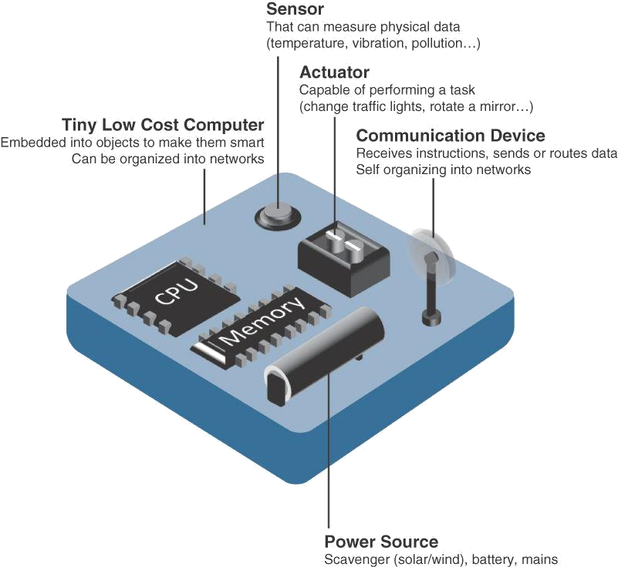

Figure 4 : Characteristics of a Smart Objects
- Trends in Smart Objects
Size is decreasing: Some smart objects are so small they are not even visible to the naked eye. This reduced size makes smart objects easier to embed in everyday objects.
Power consumption is decreasing: The different hardware components of a smart object continually consume less power.
Processing power is increasing: Processors are continually getting more powerful and smaller. This is a key advancement for smart objects, as they become increasingly complex and connected.
Communication capabilities are improving: IoT is driving the development of more and more specialized communication protocols covering a greater diversity of use cases and environments.
Communication is being increasingly standardized: There is a strong push in the industry to develop open standards for IoT communication protocols.

- COMMUNICATION CRITERIA
Connecting “things,” a large number of wired and wireless access technologies are available or under development. Before reviewing some of these access technologies, it is important to talk about the criteria to use in evaluating them for various use cases and system solutions. Criteria’s are used in evaluating access technologies of various use cases and system solutions.
Range: How far does the signal need to be propagated? What will be the area of coverage for a selected wireless technology? Should indoor versus outdoor deployments be differentiated? Very often, these are the first questions asked when discussing wired and wireless access technologies. The simplest approach to answering these types of questions is to categorize these technologies in to short, medium and long range. Short range: The classical wired example is a serial cable. Wireless short range technologies are often considered as an alternative to a serial cable, supporting tens of meters of maximum distance between two devices. Medium range: This range is the main category of IoT access technologies. In the range of tens to hundreds of meters, many specifications and implementations are available. The maximum distance is generally less than 1 mile between two devices, although RF technologies do not have real maximum distances defined, as long as the radio signal is transmitted and received in the scope of the applicable specification. Long range: Distances greater than 1 mile between two devices require long-range technologies. Wireless examples are cellular (2G, 3G, 4G) and some applications of outdoor IEEE 802.11 Wi-Fi and Low-Power Wide Area (LPWA) technologies. LPWA communications have the ability to communicate over a large area without consuming much power. These technologies are therefore ideal for battery-powered IoT sensors.

Frequency Bands: Radio spectrum is regulated by countries and/or organizations, such as the International Telecommunication Union (ITU) and the Federal Communications Commission (FCC). These groups define the regulations and transmission requirements for various frequency bands. For example, portions of the spectrum are allocated to types of telecommunications such as radio, television, military, and so on.

Frequency Bands: Radio spectrum is regulated by countries and/or organizations, such as the International Telecommunication Union (ITU) and the Federal Communications Commission (FCC). These groups define the regulations and transmission requirements for various frequency bands. Focusing on IoT access technologies, the frequency bands leveraged by wireless communications are split between licensed and unlicensed bands. Licensed spectrum is generally applicable to IoT long-range access technologies and allocated to communications infrastructures deployed by services providers, public services, broadcasters, and utilities. Unlicensed Spectrum : The ITU has also defined unlicensed spectrum for the industrial, scientific, and medical (ISM) portions of the radio bands. These frequencies are used in many communications technologies for short-range devices (SRDs). Unlicensed means that no guarantees or protections are offered in the ISM bands for device communications.

Power Consumption: While the definition of IoT device is very broad, there is a clear delineation between Powered nodes and Battery-powered nodes. A powered node has a direct connection to a power source, and communications are usually not limited by power consumption criteria. However, ease of deployment of powered nodes is limited by the availability of a power source, which makes mobility more complex. Battery-powered nodes bring much more flexibility to IoT devices. These nodes are often classified by the required lifetimes of their batteries. For devices under regular maintenance, a battery life of 2 to 3 years is an option.

Topology: For connecting IoT devices, three main topology schemes are dominant: star, mesh, and peer-to-peer. For long-range and short-range technologies, a star topology is prevalent, as seen with cellular, LPWA, and Bluetooth networks. Star topologies utilize a single central base station or controller to allow communications with endpoints. For medium-range technologies, a star, peer-to-peer, or mesh topology is common. Peer-to-peer topologies allow any device to communicate with any other device as long as they are in range of each other.

Constrained Devices: constrained device usually has very limited power, memory, and processing cycles. The IoT is largely made up of constrained devices, such as smart sensors and embedded devices. They are designed for use in a very rough environment. To reduce possible attacks to a minimum, they have just a few communication interfaces. They are located in a highly secured environment.

Constrained-Node Networks: Constrained-node networks are often referred to as low-power and lossy networks (LLNs). Low-power in the context of LLNs refers to the fact that nodes must cope with the requirements from powered and battery-powered constrained nodes. Lossy networks indicates that network performance may suffer from interference and variability due to harsh radio environments. Layer 1 and Layer 2 protocols that can be used for constrained-node networks must be evaluated in the context of the following characteristics for use-case applicability: Data rate and throughput, Latency and determinism, and Overhead and payload.

- CONCLUSION
This chapter gives introduction to communication of IoTs, sensors, sensor applications, sensor classifications and types. Then we have discussed about actuators, actuators applications, actuator classifications and types. It also presented the smart objects and trends in smart objects. In this chapter, we have debated about the current communication trends such as range, frequency bands, power consumptions, topology, constrained devices, and constrained node network technologies which are popularly used in evaluating access technologies of various use cases and system solutions. IoT communication and technologies refers to the system of interconnected computing devices which can communicate and transfer of data without any requirement of clear humanoid or computer interactions. “Things” and Communication Trends in IoT trends has projected the world dynamics and outlook in terms of both research innovation and business world. With numerous types of sensors, devices, and applications, IoT trend empowers not just easier existing, but also additional well-organized and real one. For example, a voice assistant will help the costumer to switch on or switch off lights and fans, but also “sense” when there is not in use and switch off the appliances to save electricity power. IoT- led applications to comprehend users’ customs and ingesting patterns using complex programs or algorithms and then apply them to customize the application outputs.

Reference:

- Rajesh Kumar Kaushal, Rajat Bhardwaj, Naveen Kumar, Abeer A. Aljohani, Shashi Kant Gupta, Prabhdeep Singh and Nitin Purohit,
“Using Mobile Computing to Provide a Smart and Secure Internet of Things (IoT) Framework for Medical Applications”, Wireless Communications and Mobile Computing-Hindawi, Volume 2022 | Article ID 8741357 | https://doi.org/10.1155/2022/8741357, 2023.
- Rajesh Kumar Kaushal, Rajat Bhardwaj, Naveen Kumar, Abeer A. Aljohani , Shashi Kant Gupta, Prabhdeep Singh and Nitin Purohit, “Using Mobile Computing to Provide a Smart and Secure Internet of Things (IoT) Framework for Medical Applications”, Hindawi- Wireless Communications and Mobile Computing Volume 2022, Article ID 8741357, pp.13-22, https://doi.org/10.1155/2022/8741357, 2022.
- Ebenezer Esenogho, Karim Djouani and Anish M. Kurien , “Integrating Artificial Intelligence Internet of Things and 5G for Next-Generation Smartgrid: A Survey of Trends Challenges and Prospect”, IEEE Access, DoI 10.1109/ACCESS.2022.3140595, Volume- 10, 2022.
- K. Shafique, B. A. Khawaja, F. Sabir, S. Qazi, and M. Mustaqim, ‘‘Internet of Things (IoT) for next-generation smart systems: A review of current challenges, future trends and prospects for emerging 5G-IoT scenarios,’’ IEEE Access, vol. 8, pp. 23022–23040, 2020.
- Accessed: Jul. 10, 2021. [Online]. Available: https://siliconsemi conductor.net/article/106227/AI_In_Sensors_For_IoT
- P. P. Raya and N. Kumar, ‘‘SDN/NFV architectures for edge-cloud oriented IoT: A systematic review,’’ Comput. Commun., vol. 169, pp. 129–153, Jan. 2021.
- K. Shafique, B. A. Khawaja, F. Sabir, S. Qazi, and M. Mustaqim, ‘‘Internet of Things (IoT) for next-generation smart systems: A review of current challenges, future trends and prospects for emerging 5G-IoT scenarios,’’ IEEE Access, vol. 8, pp. 23022–23040, 2020.
- P. P. Raya and N. Kumar, ‘‘SDN/NFV architectures for edge-cloud oriented IoT: A systematic review,’’ Comput. Commun., vol. 169, pp. 129–153, Jan. 2021.
- Z. Wang, Y. Liu, Z. Ma, X. Liu, and J. Ma, ‘‘LiPSG: Lightweight privacypreserving Q-learning-based energy management for the IoT-enabled smart grid,’’ IEEE Internet Things J., vol. 7, no. 5, pp. 3935–3947, Jan. 2020.
- Z. Wang, Y. Liu, Z. Ma, X. Liu, and J. Ma, ‘‘LiPSG: Lightweight privacypreserving Q-learning-based energy management for the IoT-enabled smart grid,’’ IEEE Internet Things J., vol. 7, no. 5, pp. 3935–3947, Jan. 2020.
- Akshi Kumar, Danda B. Rawat, Neeli Rashmi Prasad and Sumarga Kumar Sah Tyagi, “AI-Integrated Wireless Communications and Computing Trends for Next-Generation IoT”, Wireless Communications and Mobile Computing-Hindawi, 2023.

