AUTHOR-Dr. Sakshi Deorah
Junior Resident
Department of Oral Pathology and Microbiology
King George’s Medical College, Lucknow
Uttar Pradesh, India
CRISPR in Dentistry: A Revolution in Oral Health
ABSTRACT
Dental science has experienced significant advancements in the treatment of dental diseases and improvements in oral health. Despite these advancements, it can still be difficult to properly treat some oral conditions. The development of CRISPR (Clustered Regularly Interspaced Short Palindromic Repeats) technology, also holds promise for revolutionising dentistry. CRISPR gives scientists the ability to change DNA sequences, opening up previously unimaginable options to target genes linked to dental diseases, dangerous bacteria, and inherited dental abnormalities. This thorough chapter examines the fundamentals of CRISPR, as well as its uses in several dentistry specialisations, ethical issues, and prospective effects on oral health.
KEYWORDS: CRISPR; Cas9; dentistry; oral cancer.
1. Introduction
A paradigm change in genetic research has been brought about by the development of CRISPR (Clustered Regularly Interspaced Short Palindromic Repeats) technology, which also has the potential to transform dentistry. Cas9 (CRISPR associated protein 9) is a protein that is employed in CRISPR gene therapy. It has the ability to cut DNA like a pair of molecular scissors (an endonuclease), which can change the genome. ⁽¹⁾ With the use of the versatile and accurate genome editing technology CRISPR, researchers may change DNA sequences, providing previously unheard-of opportunities to target certain genes linked to dental illnesses, harmful microorganisms, and genetic dental problems. This chapter explores the principles of CRISPR, its uses in several dental specialties, ethical issues, and the potential applications of this ground-breaking technology for improving oral health.
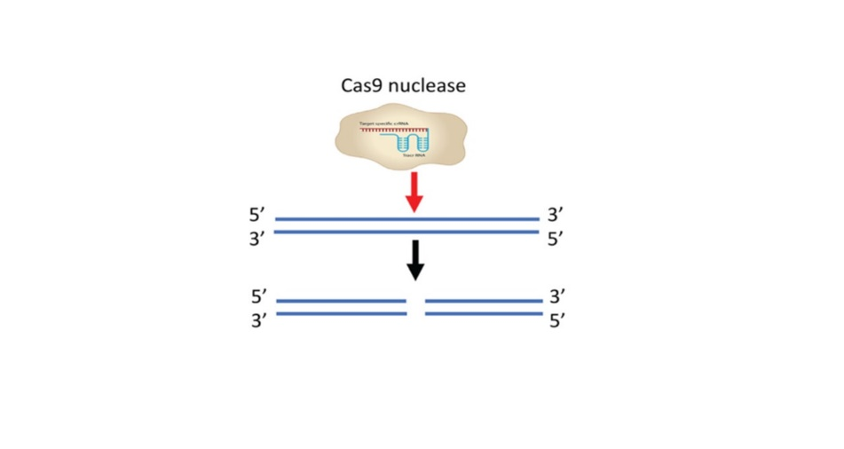
FIGURE 1. Genome Editing

2. CRISPR Fundamentals and Mechanisms
2.1 Overview of CRISPR-Cas System
Historical background and discovery of CRISPR-Cas system.

CRISPR repeats were first discovered by accident in 1987 by Osaka University researcher Yoshizumi Ishino and his colleagues, in the Escherichia coli genome during an analysis of genes involved in phosphate metabolism. ^{(2,3)}
In 2000, CRISPR was found widespread in both bacteria and archaea. ⁽⁴⁾ In 2013, the demonstration of Cas9 genome engineering for the first time in eukaryotic cells. ^{(5,6)} In, 2018 a study was carried out showing the potential ability of CRISPR- Cas9 System in the reduction of pro-tumorigenic behaviour in human OSCC. ⁽⁷⁾

2.2 CRISPR-Cas system Mechanisms
Prokaryotes have an adaptive immunity system called the CRISPR-Cas system that enables them to fight against genetic invaders like bacteriophages and plasmids. Since this defense system may specifically target DNA sequences that are guided by single guide RNAs (sgRNAs), it has been repurposed for genome editing applications. The CRISPR-Cas9 process is activated as part of a bacteria's natural immune response to a virus. When a virus infects bacteria, a little portion of the virus' DNA is inserted into the bacterial genome's CRISPR locus as spacers. As a result, the bacteria acquire a virus-specific adaptive immunity. Pre-rRNA and tracrRNA are created when the CRISPR locus is activated by subsequent infection with a virus that is identical. They aid in the gRNA (guide RNA) synthesis process. Using Cas9, the guide RNAs (gRNAs) cleave the complementary portions of the invading virus genome.
2.3 Types of CRISPR Systems
Different CRISPR systems and their unique applications in genome editing.
A summary of different CRISPR systems and their potential applications in genome editing and other scientific fields.
1. CRISPR-Cas9 System
The protein Cas9 is the basis of a more straightforward CRISPR system from Streptococcus pyogenes. The trans-activating CRISPR RNA (tracrRNA) and crRNA are two tiny molecules that make up the four-part Cas9 endonuclease system.The CRISPR-Cas9 technology was first introduced in a 2015 publication by Chinese researchers P. Liang and Y. Xu, who demonstrated its ability to effectively edit genes in human tri-pronuclear zygotes.
2. CRISPR-Cas12 (Cas12a) System
In comparison to Cas9, Cas12a caused a "staggered" cut in double-stranded DNA rather than Cas9's "blunt" cut, relied on a "T rich" PAM (offering an alternate targeting site to Cas9), and simply needed a CRISPR RNA (crRNA) for successful targeting. In contrast, Cas9 needs both a transactivating crRNA (tracrRNA) and a crRNA.After cleaving its target, Cas12a stays linked to the target and cleaves other ssDNA molecules without discrimination. This is a distinguishing characteristic of Cas12a.This characteristic is known as "trans-cleavage" or "collateral cleavage" activity.
3. CRISPR-Cas13 System
Leptotrichia shahii's nuclease Cas13a, originally known as C2c2, was characterised in 2016. Cas13 is an RNA-guided RNA endonuclease, which means it can only cut single-stranded RNA and not DNA. Cas13 attaches to and cleaves a ssRNA target after being directed there by its crRNA. Similar to Cas12a, the Cas13 stays linked to the target before indiscriminately cleaving other ssRNA molecules. ⁽⁸⁾

3. Applications in Bacterial Pathogens
3.1 Dental Plaque:
The Function of Streptococcus Mutans in Dental Plaque
Glucosyltransferases (Gtfs), a key component of streptococcus mutans' pathogenicity, use sucrose to create extracellular polysaccharides (EPS), which result in the development of dental plaque biofilm. The first phase in the process of dental plaque formation is biofilm formation. Self-targeting CRISPR arrays with spacer sequences identifying with gtfB were created and cloned onto plasmids in a work by Gong T et al. To obtain the necessary mutations, this plasmid was converted into UA159 (self-targeting). This led to a significant decrease in the production of EPS and subsequently, the breakdown of biofilm formation.⁽⁹⁾
3.2 Dental Caries: An oral health concern
The primary aetiological agent of human dental caries is streptococcus mutans. In the oral cavity, there is already a normal bacterial flora, but when this flora multiplies, disease might start to develop. Therefore, we should be aware of how to control bacterial composition to maintain a dynamic, healthy equilibrium in the oral ecology. Demineralization of the tooth surface and the eventual emergence of dental caries are caused by the dysbiosis of the biofilm, which is accompanied by changes in the bacterial composition and particularly accumulation of S. mutans. Although various antimicrobial tactics, including antibiotics, antimicrobial peptides (such as C16G2, which specifically targets S. mutans in the oral microbiome) , and lytic bacteriophages, could provide partial solutions, a precise and programmable method that can distinguish between closely related microorganisms and that allows for fine control over the makeup of a microbial population is still lacking. Researchers have created antimicrobials with a predetermined range of activity using RNA-guided nucleases (RGNs) CRISPR/Cas technology. RGNs also allow for the selective knockdown of specific strains using genetic signatures, which allows for the manipulation of complicated bacterial populations. ^{(9,10)}
3.3 Periodontal Diseases: The Role of CRISPR
The main pathogen causing microbial dysbiosis has been identified as Porphyromonas gingivalis, a Gram-negative anaerobic rod. Nearly 95% of P. gingivalis clinical strains have been discovered to contain CRISPR arrays. In the periodontal pocket, where bacteriophages are prevalent and may even outnumber bacteria, it's probable that this genetic immune system of bacteria helps to regulate the microbiome of "chronic" periodontitis. Therefore, CRISPR technology can be a tremendous asset and a potential tool for dental clinics to assist avoid the development of dental plaque and ultimately to prevent periodontitis. ⁽¹¹⁾
4. Chronic Pain
Many dentists are concerned about chronic discomfort in a variety of orofacial illnesses. Numerous drugs, ranging from NSAIDs to opioids, temporarily relieve symptoms, but once the effect of the prescription wears off, the pain returns. It was discovered that some variations in this gene render the affected person incapable of feeling pain. The cause of this is a defective gene that inhibits the movement of pain signals through the neural pathway by controlling certain molecules involved in this process that are present on the surface of neurons. CRISPR allows for the editing of epigenetic markers that activated this pathway. ⁽¹²⁾
5. Oral Cancer
The most prevalent form of oral cancer is OSCC. With the use of the cutting-edge technology CRISPR, cancer can be treated by genetically altering the patient's own cells. A small number of genes that change rapidly are the focus of most research, however there is another class of slower mutating genes that can also cause tumours. By CRISPR technology- Knockout of Cancer driving genes, Correcting cancer-associated mutations using CRISPR-mediated homology-directed repair (HDR). ⁽¹³⁾
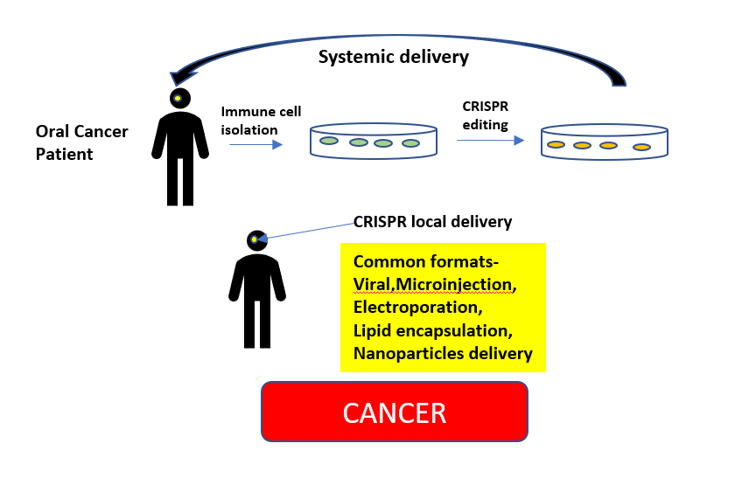
FIGURE 2. Application of Crispr System in Oral Cancer
Kiyosue et al. investigated the immunohistochemistry expression of the p75 neurotrophin receptor (p75NTR) in oral leukoplakia (OL) and OSCC. The findings of this study revealed that p75NTR is expressed in populations of undifferentiated cells in OL and OSCC. This study also came to the conclusion that p75NTR may have a role in OSCC invasion and poor prognosis. ⁽¹⁴⁾ Using CRISPR/Cas9 technology, Huang et al. examined the significance of the p75NTR in human tongue squamous carcinoma cells. This study shows that deletion of p75NTR suppresses various tumor-promoting features of SCC-9 cells, indicating that p75NTR is a viable target for the development of innovative treatment methods for tongue cancer. ⁽¹⁵⁾
6. Craniofacial Malformations
CRISPR-based basic research has revealed previously unknown pathways for craniofacial development. The quick identification of specific gene mutations is made possible by CRISPR.
In recent years, the use of mesenchymal stem cells (MSCs) in the treatment of oral and craniofacial diseases has gained significant attention. MSC subsets have been discovered in the pulp, periodontal ligament, and alveolar bone. CRISPR/Cas9 edited MSCs can treat disorders of the mouth, gums, and face. ⁽¹⁶⁾

7. Salivary Dysfunction
Xerostomia is a common side effect of radiation therapy for cancer patients. The CRISPR/Ca9 method can be used in this situation to increase the expression of the AQP1 gene. A water-specific protein called aquaporin 1 (AQP1) may encourage salivation. ⁽¹⁷⁾ CRISPR/Cas9 system has been successfully used to target important genes in many cell lines and may be possible to develop successful MSC-derived therapy for primary Sjogren’s syndrome. ⁽¹⁸⁾
8. Viral Infections
Herpes viruses (herpes simplex virus), human cytomegalovirus (HCMV) (infectious mononucleosis), and Epstein-Barr virus (EBV) (hairy leukoplakia, mucocutaneous ulcers) are responsible for a variety of oral lesions. The genomes of virus-infected cells can be targeted using the CRISPR/Cas9 system. As a result, the virus is rendered dormant and is unable to reproduce inside the host cell. ⁽¹⁹⁾
9. Palate and Tooth Development
The C-terminal domain of the Msx1 gene has been shown to be important for the development of the tooth and palate using the CRISPR/Cas9 technology. In non-syndromic tooth agenesis, the MSX1 homeodomain has been found to mostly affect premolars and third molars. ⁽¹⁹⁾
10. CRISPR for Dental Tissue Regeneration
Periodontal Tissue Regeneration: Cementum, periodontal ligament, and alveolar bone can all be stimulated to regenerate through the use of CRISPR-mediated genome editing. The restoration of periodontal health and the treatment of periodontal disorders may both benefit from this strategy. ⁽²⁰⁾

Ethical Considerations for use of CRISPR
The use of CRISPR poses a number of ethical issues, such as the possibility of undesired off-target consequences, the implications of germline editing, and the responsible application of gene editing technology in human patients. For the appropriate and secure implementation of CRISPR, it is essential to strike a balance between scientific advancement and ethical issues.

Conclusion
CRISPR technology has emerged as a transformative force in dentistry, offering innovative solutions for dental diseases and genetic dental disorders. By harnessing the power of genome editing, CRISPR opens up new possibilities for personalized dental care, tissue regeneration, and pathogen control ultimately enhancing oral health and quality of life for patients.
CRISPR technology represents a ground breaking advancement in research and offers unprecedented potential for targeted therapeutic interventions. However, careful research, ethical considerations, and regulatory oversight are imperative to ensure the safe and responsible integration of CRISPR technology.
References
- Goyal, Anjana & Doomra, Reena & Garg, Aayushi & Kruthiventi, Hemalata. (2019). CRISPR Gene Therapy in Dentistry. Asian Pacific Journal of Health Sciences. 6. 182-183. 10.21276/apjhs.2019.6.2.26.
- Ishino Y, Shinagawa H, Makino K, Amemura M, Nakata A. Nucleotide sequence of the iap gene, responsible for alkaline phosphatase isozyme conversion in Escherichia coli, and identification of the gene product. J Bacteriol, 1987; 169: 5429–5433.
- Han W., & She, Q. CRISPR History: Discovery, Characterization, and Prosperity. CRISPR in Animals and Animal Models, 2017; 1–21.
- Mojica FJ, Diez-Villasenor C, Soria E, Juez G. Biological significance of a family of regularly spaced repeats in the genomes of Archaea, Bacteria and mitochondria. Mol Microbiol, 2000; 36: 244–246.
- Cong L, Ran FA, Cox D, et al. Multiplex genome engineering using CRISPR/Cas systems. Science, 2013; 339: 819–823.
- Mali P, Yang L, Esvelt KM, Aach J, Guell M, DiCarlo JE, Norville JE, Church GM. RNA-guided human genome engineering via Cas9. Science, 2013; 339: 823–826.
- Huang, P, Tong, D, Sun, J, Li, Q, Zhang, F. Generation and characterization of a human oral squamous carcinoma cell line SCC-9 with CRISPR/Cas9-mediated deletion of the p75 neurotrophin receptor. Arch Oral Biol, 2017; 82: 223–232.
- Carte J, Christopher RT, Smith JT, et al. The three major types of CRISPR-Cas systems function independently in CRISPR RNA biogenesis in Streptococcus thermophilus. Mol Microbiol. 2014;93(1):98-112. doi:10.1111/mmi.12644.
- Gong, T et al, Genome editing in Streptococcus mutans through self-targeting CRISPR arrays. Molecular Oral Microbiology, 2018.
- Citorik RJ, Mimee M, Lu TK. Sequence-specific antimicrobials using efficiently delivered RNA-guided nucleases. Nat Biotechnol, 2014; 32(11): 1141-1145.
- Chen, T., & Olsen, I. Porphyromonas gingivalis and its CRISPR-Cas system. Journal of Oral Microbiolog, 2019; 11(1): 1638196.
- Thomas L. Using CRISPR to switch off pain gene becomes a possibility with new study. News Medical Life Sciences, Jan 7 2020.
- Yirka B. Identified: 15 genes that trigger rapid growth of head and neck squamous cell carcinoma. Oral cancer news compiled by the oral cancer foundation March, 2020.
- Kiyosue, T., Kawano, S., Matsubara, R., Goto, Y., Hirano, M., Jinno, T., et al. Immunohistochemical location of the p75 neurotrophin receptor (p75NTR) in oral leukoplakia and oral squamous cell carcinoma. International Journal of Clinical Oncology, 2013; 18(1): 154–163.
- P. Huang et al. Generation and characterization of a human oral squamous carcinoma cell line SCC-9 with CRISPR/Cas9-mediated deletion of the p75 neurotrophin receptor. Archives of Oral Biology, 2017; 82: 223–232.
- Yu N, Yang J, Mishina Y, Giannobile WV. Genome Editing: A New Horizon for Oral and Craniofacial Research. J Dent Res. 2019;98(1):36-45. doi:10.1177/0022034518805978.
- Wang Z et al., CRISPR-Cas9 HDR system enhances AQP1 gene expression. Oncotarget, 2017; 8, (67):111683-111696.
- Chen W, Yu Y, Ma J, et al. Mesenchymal stem cells in primary Sjogren‟s syndrome: prospective and challenges. Stem Cells Int, 2018; 2018: 4357865.
- Vastardis, H., Karimbux, N., Guthua, S. W., Seidman, J. G. & Seidman, C. E. A human MSX1 homeodomain missense mutation causes selective tooth agenesis. Nat. Genet, 1996; 13: 417–421.
- Andrés de Pablo J, Javier Serrano L, García-Arranz M, Romeu L, Liras A. Gene and Cell Therapy in Dental Tissue Regeneration [Internet]. Human Tooth and Developmental Dental Defects - Compositional and Genetic Implications. IntechOpen; 2022. Available from: http://dx.doi.org/10.5772/intechopen.97757.

