**Energy Audit of a Higher Education Institute – The First Step towards Greening a College Campus**

*Nandini Gupta*

*Department of Environmental Science*

*Bir Bikram Memorial College, Agartala, Tripura, 799004*

**Abstract**

An energy audit is a systematic study or survey to create an energy efficiency program in any establishment. It consists of activities that seek to identify conservation opportunities as a prelude to the development of an energy saving program. At colleges and universities, energy consumption has a large impact on both financial and environmental interests. This paper is just one step towards our destination of achieving energy efficient green campus.

The methodology adopted for this study includes a systematic survey of facilities and collection of data regarding lighting loads, fan loads, computers, printers, pumps and air conditioning etc. Next step of the energy audit is the analysis of collected data and identification of areas with high potential of energy conservation. This study is also aimed to identify energy conserving ways in the Bir Bikram Memorial College campus by which energy wastage can be minimized. A key goal of the project is to increase the knowledge of college community regarding the need to save energy and contribute towards reducing greenhouse gas emissions. In this project we attempt to carry out energy audit of Bir Bikram Memorial College campus to ascertain the energy consumption pattern and to identify potential energy savings measures to be adopted to create a climate responsible green campus.

**Keywords:** Institutional energy audit, Energy conservation, Energy management

1. **Introduction**

Energy conservation can be a good solution to all the energy demands. Energy conservation means reducing energy consumption, using less of an energy service. Energy audit is an efficient service which investigates the possible ways of energy conservation in a building or a system without negative output. As per the Energy Conservation Act, 2001, Energy Audit is defined as "the verification, monitoring and analysis of use of energy including submission of technical report containing recommendations for improving energy efficiency with cost benefit analysis and an action plan to reduce energy consumption". Implementation of recommended measures can help consumers to achieve significant reduction in their energy consumption levels. A successful energy management program begins with energy conservation; it will lead to adequate rating of equipments, using high efficiency equipments and change of habits which causes enormous wastages of energy. Energy auditing is an integral part of energy conservation and its management.

Bir Bikram Memorial College is selected for the energy auditing due to the fact that the number of people involved in an educational building is huge and the prospect of energy conservation is significantly high. The objective of this paper is to study the energy consumption of our college campus and reduce the consumption without affecting the output. The institutional buildings are considered here because of the uncontrolled and unpredictable usage of light, fans in a number of classrooms, practical rooms, auditoriums and also rooms with computer facilities and UPS.

1. **Objective of Energy Audit Exercise**

The objective of Energy Audit is to promote the idea of Energy Conservation in the Campus of Bir Bikram Memorial College to make it a climate responsible campus. The purpose of the energy audit is to identify, quantify, describe and prioritize cost saving measures relating to energy use in different blocks and building of the College.

Energy Audit Study was directed towards:

* Identification of areas of energy wastage and estimation of energy saving potential in the College campus
* Suggesting cost-effective measures to improve the efficiency of energy use.
* Estimation of implementation costs and payback periods for each recommended action.
* Documenting results & vital information generated through these activities.

1. **Energy Audit Methodology**

**Energy Audit**

Energy audit is an efficient service which investigates the possible ways of energy conservation in a building or a system without negative output. Audit activities in general order include:

* **Identification of all energy systems**
* **Evaluation of conditions of the systems**
* **Analysis of impact of improvement to those systems.**
* **Preparation of energy audit report**

The methodology adopted for this audit was a three step process comprising of:

**1. Data Collection** – In preliminary data collection phase, exhaustive data collection was performed using different tools such as observation, interviewing key persons, and measurements.

**2. Data Analysis -** Detailed analysis of collected data was done using Microsoft Excel 2007. The database generated through Excel was used for producing graphical representations.

**3. Recommendation –** On the basis of results of data analysis and observations, some steps for reducing power consumption without affecting the comfort and satisfaction were recommended along with their cost analysis

**1. Data Collection-** Toknow the power consumption pattern in detail, the exhaustive data collection exercise was performed at all the departments.

* Information about the general electrical appliances was collected by observation and interviewing.
* The details of usage of the appliances were collected by interviewing key persons
* Light intensity was measured using Lux meter at all the places
* Approximations and generalizations were done at places with lack of information

**2. Data Analysis-** In data analysis, the data collected is processed to draw significant conclusions to pinpoint loopholes and identify the areas to focus upon. Analysis of the power consumption observations obtained was used to obtain the power consumption pattern and also to get the information about the points where electric power is wasted.

**3. Recommendation-** Energy as well as cost analysis of different appliances was performed and recommendations were made based on the capital cost recovery time. Following were the steps involved in this process:

* The capital cost involved in replacing an appliance and/or process was estimated.
* The energy saving by the replacement was calculated in terms of price of energy per year.
* These two costs were compared to calculate the capital cost recovery time which is defined as the total time by which the saving in energy bill balances the capital cost involved.

**D. Results and Discussion**

**1. Bir Bikram Memorial College’s present energy scenario**

Bir Bikram Memorial College is a premier Government Institution of Higher Education in Tripura. Bir Bikram Memorial College campus has an approximate area of 6 acres with student community strength of around 4000 in Commerce, Arts and Science streams together. There are 51 faculty members and 33 non teaching staffs in the College. This College enjoys 24- hour electricity supply. This College is divided in three blocks namely Academic block, Science block and Administrative block. Academic block is the largest .It’s a six-storied building with two basement floors. Science block is a long two-storied building while Admistrative block consists of a large three- storied building.

* Specific Energy Consumption (SEC)

The Specific Energy Consumption (SEC) is defined as the energy consumption per unit of product output. The specific energy consumption by students, faculty and staff members was calculated from the electric bills which formed the College’s SEC. The SEC was calculated as 24.57 kWh/person/annum (for 2014-2015 financial year) and Rs. 173.22/- per person per annum.

**1.2. Academic building**

Academic building structural foundation was planned for Basement I+ Basement II+ Ground floor + 3 floors. The total covered area of all the floors is **4545.99** square mt. Dimension of each individual room is indicated in the layout drawing (Plate.3). The building is painted with cream colour to give a decent and traditional institutional look. Total connected load of the academic building is **99682 Watt.**

**Room analysis on the basis of energy consumption**

**Basement I** consists of 1) Canteen kitchen 2) Canteen room 3) Toilet (Gents) and corridor. Total covered area for Basement I is: **224.34 square mt.** So basement –I is having total 3 rooms. Total energy consumption per month in the basement I is **620.1 kWh.** (Table 1 in Annexure)

**Basement II** consists of 1) Professors’ room 2) Examination committee’s room 3) Staff toilet (Ladies and Gents) 4) Xerox room and locker room 5) Locker room and Corridor. Total covered area for Basement II is: **411.85square mt .** So in basement –II is having a total of 5 rooms. Total energy consumption per month in the basement II is**1336.01 kWh (**Table 2 in Annexure)

**Ground floor** covered an area of **1414.54 square mt** with **10** nos of theory classrooms, one seminar room and 2 toilets (Ladies and gents). Energy consumption per month in the ground floor is **2246.26 kWh** (Table 3 in Annexure)

**First floor** covered an area of **659.22 square mt** with 6 nos of theory classrooms, 2 toilets and corridor. Energy consumption per month in the first floor is **1110.52 kWh** (Table 4 in Annexure)

**Second floor** covered an area of **964.42 square mt** with 5 nos of theory classrooms, one smart class, Library, music room, 2 toilets and corridor. Total energy consumption per month in the second floor is **1945.44 kWh**(Table 5 in Annexure)

**Third floor** covered an area of **871.59 square mt** with 5 nos of theory classrooms, 2 toilets, Computer room, conference hall and corridor. Total energy consumption per month in the second floor **1634.25 kWh** (Table 6 in Annexure)

**1.3. Administrative block**

Administrative block is a large three- storied building having a total of 13 rooms. Principal’s office, DDO room and UGC room are situated in this building. Ground floor, 1st floor and 2nd floors of the building covered an area of **601.08 sq mt, 631.47** sq mt and **569.29** sq.mt respectively. Energy consumption units per month of ground floor, 1st and 2nd floors are **899.34** kWh, **2359.5** kWh and **1161.784** kWh respectively. Total connected load of the administrative building is **35827 Watt** (Table7, 8,9 in Annexure).

**1.4. Science Block**

Science block consists of a long two- storied building having a total of 9 rooms. Physics and Chemistry labs, boys and girls’ common rooms are situated here. Ground floor of the building covers an area **of 564,54 Square mt and the total energy consumption 1305.24 kWh**. (Table 10 in Annexure). 1st floor covered an area **of 470.63 Square mt. Total** energy consumption of 1st floor is **158.73kWh and** Total connected load of Science block is **19191Watt.** (Table 10& 11 in Annexure)

|  |  |  |  |  |
| --- | --- | --- | --- | --- |
| **Table 12. TOTAL CONNECTED LOAD FOR DIFFERENT USAGE( IN WATT)** | | | | |
|  | **Lighting** | **Fan load** | **Other electronic appliances** | **Total** |
| Academic Block | 42035 | 26445 | 31202 | **99682** |
| Science Block | 5900 | 3025 | 10266 | **19191** |
| Administrative Block | 14228 | 5920 | 15679 | **35827** |
| **Total** | **62163** | **35390** | **57147** |  |
| **TOTAL CONNECTED LOAD OF THE COLLEGE**  **1,54,700 Watt** | | | | |

(Number of lights, fans and other electrical appliances and their respective wattage details are given in Annexure Table No.1-11)

**Fig.3.Load Distribution in the College**

**2. Analysis of lighting system efficiency in the College**

The first step in determining the efficiency of the fluorescent lighting system, is to calculate the energy used per square metre. This is achieved by dividing the classroom floor area by the total wattage of the lighting system.

**Table 13. Energy used per sq meter**

|  |  |  |  |
| --- | --- | --- | --- |
| **Name of Blocks** | **Area (Sq.mt)** | **Total wattage of light(Watt)** | **Energy used per sq meter**  **(Watt/ sq.mt)** |
| **Academic block** | 4545.99 | 42035 | **9.25** |
| **Science block** | 1035.17 | 5900 | **5.70** |
| **Administrative block** | 1801.85 | 14228 | **7.90** |
|  | 7383.01 | 62163 | **8.42** |

The second step is to measure the lighting lux levels. A lux is the lumens per square metre and a lumen is the measurement for light. As per the Energy Conservation Building Code (ECBC) – 2006, published by the Bureau of Energy Efficiency (BEE), Govt. of India, the recommended **illuminance** are as given below in Table 14

**Table 14 ECBC Standard**

|  |  |
| --- | --- |
| **Type of Interior Or Activity** | **Minimum Illuminance required(In Lux)** |
| General | 200 |
| Reading Room | 200 |
| Reading tables | 200 |
| Bathrooms | 50 |
| Computer Workspace | 300 |
| Parking Area | 20 |
| Music Rooms | 200 |
| Interior Sports halls | 200 |
| Corridors, passageways &Stairs | 50 |
| Cafeterias ,Dining Rooms and Mess Rooms | 150 |
| Canteens , Food Preparation and Cooking | 300 |

**Table 15. Lux meter Reading of Academic Block**

|  |  |  |
| --- | --- | --- |
| **Floors** | **Rooms and other Places of the College** | **Illuminance (Lux)** |
| Basement I | Corridor | 30 |
| Toilet | 60 |
| Canteen | 230 |
| Basement II | Corridor | 47 |
| Toilet | 44 |
| Professor’s room, exam committee room, locker room | 40 |
| Ground floor | Class rooms | 470 |
| Corridor | 180 |
| 1st floor | Class rooms | 580 |
| Corridor | 230 |
| 2nd floor | Class rooms | 790 |
|  | Library | 260 |
|  | Corridor | 260 |
| 3rd floor | Class rooms | 940 |
|  | Corridor | 260 |

**Table 16.Lux meter Reading of Science Block**

|  |  |  |
| --- | --- | --- |
| **Floors** | **Rooms and other Places of the College** | **Illuminance (Lux)** |
| Ground floor | Physics lab | 22 |
| Corridor | 220 |
| Girls common room | 26 |
| Boys common room | 50 |
| Student’s Council room | 230 |
| Chem. Lab | 110 |
| 1st floor | Class rooms | 50 |
| Corridor | 150 |

**Table 17** **Lux meter Reading of Administrative Block**

|  |  |  |
| --- | --- | --- |
| **Floors** | **Rooms and other Places of the College** | **Illuminance (Lux)** |
| Ground floor | Academic sec. | 390 |
| Corridor | 266.69 |
| 1st floor | Principal’s office | 450 |
| Meeting ROOM | 260 |
| Establishment section | 380 |
| Corridor | 260.75 |
| 2nd floor | Toilet | 30 |
| E.V.S lab | 170 |
| Conference hall | 4270 |
| Corridor | 450 |

According to the ECBC standards it is found that the current lighting intensities are high in most of the class rooms and office rooms in academic building and Administrative building. Very low light intensities were observed in all the laboratories. Toilets also show lower lux level than the standard. In the Academic block, lux readings of all the rooms in the basement II area are below the ECBC standard.

**2 .Benchmarking**

Benchmarking is the process of comparing the performance of a given process with that of a best possible process and to try to improve the standard of the process to improve quality of the system, product, and services etc.It allows organizations to develop plans on how to adopt best practices, usually with the aim of increasing some aspects of performance. Benchmarking may be a one-off event, but it is often treated as a continuous process in which organizations continually seek to challenge their practices. The basis for benchmarking the energy consumption at Bir Bikram Memorial College is energy consumed per person (including teaching staff and students). The benchmarking parameters here are: Block wise energy performance, kWh consumed per m2 of area and , kWh consumed per capita.

**3. Energy saving potential in the Bir Bikram Memorial College**

3.1. **Elimination of Energy Wastages**

It has been observed that in all the toilets exhaust fans are on for 6 hours a day though it is not required and much of the total load consumed can be saved without any effect on their performance. This wastage of energy can be saved if the usage hours are reduced to 3 hours per day.

* **Energy and Cost Saving Calculation for reducing Exhaust fan’s operating hours**

Total 37 Exhaust fans ( each 40 Watt) are there in our College.

Total energy consumption 40x 37=1480 Watt

Currently exhaust fans are on for 6 hrs /day

Power consumption /day= 1480x6=8880 Watt-hr

(1 kWh=1 unit) =8.88 kWh

Energy cost/day= 8.88x7.05=Rs.62.60/-

Energy cost per month for 26 days working days=62.60x26=Rs. 1627.60/-

Annual energy Cost=Rs.1627.60x12=19531.20/-

Now we calculate assuming the operating hours -3 hrs /day

Total energy consumption 40x 37=1480 Watt

Power consumption /day= 1480x3=4440 Watt-hr

(1 kWh=1 unit) = 4.44 kWh

Energy cost/day= 4.44 x7.05=Rs.31.30 /-

Energy cost per month for 26 days working days=31.30x26=Rs. 813.8/-

Annual energy Cost=Rs.813.8x12=9765.6 /-

**Annual energy cost saving =Rs (19,531.20-9,765.6)/-= Rs. 9765.6/-**

**b)** **Energy saving by operating the photocopier machine only when required or avoiding using machine in the sleepy mode which consume the energy as follows**

Power Consumption of Xerox Machine in Non Operating Mode = 1x 100Watt

Energy Saving for Approximate Sleepy Mode Hours For 1 hours In A Day =100W x 1hr/day = 100Wh/Day

Energy in kWh = 100/1000 = 0.1kWh/day

Energy for a Month = 0.1kWh x 26days =2.6 kWh =2.6 Units Monthly Energy Cost =2.6 x 7.05 =Rs18.33/-

**Annual Energy Cost Saving = Rs18.33x12 =Rs 219.96/-**

* **Saving energy cost by using energy efficient appliances**

**Energy Saving By Replacing All Fluorescent Lamps (FL) by CFL lights**

* **Energy Saving Cost Estimation of FL**

Total no. of F lamps or tubes = 1072

Actual wattage of FL inclusive of choke =50W

Energy consumed by FL for an operating of 5 hour per day

=1072 x50x5 =268000 watt-hours

Energy consumed by FL for an operating of 5 hour per month = 268000x26 working days=6968000 watt-hr/month =6968kWh

Monthly Energy consumed cost by FL= 6968x7.05= Rs.49124.40/-

Annual Energy Consumed cost by FL=49124.40x12= Rs. 589492.80/-

**b)Energy saving by replacing the CFL of equal similarities of fluroscent lamp**

23 watt CFL can give an illumination =1600 lumens

50 watt FL can give an illumination =2400 lumens

Therefore Number of 23 watts of C FL required to get the illumination level of 2400 lumens = 1.5

Hence the total wattage of FL = 1072 x 50watts =53600 watts

Number of CFL required replacing all FL @ the rate of 23 watts x1.5,

34.5 watts CFL=50watts FL. =53600 /34.5watts = 1554

Power saving by CFL replacement = 1554 x15.5 watts =24087 watts

Energy consumption from CFL for an operated average hour/day for 5 hours = 24087watts x5 hours = 120435 watt-hr =120.435 kWh

Daily cost of energy consumption by CFL =120.435x7.05 kWh=Rs.849.06/-

Saving Cost of energy /day = Rs.849.06/-

Monthly Energy cost saving due to CFL=849.06x26working day=Rs.22,075.73/-

**Annual Energy cost saving=22075.73x12=Rs. 2,64,908.82/-**

Payback Period Calculation:-

Investment on 1 CFL of 23 watts = Rs230/-

Total cost of replacement =1554 x 230 = Rs. 3,57,420 /-

**Payback Period = 3,57,420 /2,64,908.82= 1 year 4 months**

**c) Use of Motion Sensors in Corridors and Toilets:**

Corridors and toilets have large potential of saving energy by use of automation tools. Motion sensors can be used there to automatically switch on the light when there is any movement and switch off the light when there is no movement. This can greatly reduce the total load in corridors and toilets.

Average number of tube lights in a corridor = 4

Average power of the tube lights = 50W

Average number of motion sensors required = 3

Average reduction in usage per day by motion sensor = 4h

Total energy saved in corridor per year = (4x50x4x26x12)/1000 = 249.6 kWh

Saving in Rs. Per year = 249.6 x7.05 = Rs. 1760/-

Cost of installation per motion sensor = Rs. 250

Total cost of installing motion sensors in a corridor = 3x250 = Rs. 750/-

Capital Cost Recovery Time = (750/1760) = 0.42 yr=5 months

Hence, the capital cost recovery time for installing motion sensors in corridors is 0.42 years. Toilets are also having comparable capital cost recovery time. Hence, this is a highly recommended step to largely reduce the consumption in corridors and toilets.

**Table 18. Summary of energy saving potential in the Bir Bikram Memorial College**

|  |  |  |  |  |
| --- | --- | --- | --- | --- |
| **Mode of energy saving** | **Cost to be saved in Rupees (Rs)** | **Investment in Rupees** | **Payback period** | **feasibility** |
| Replacing Fluorescent Tubes by CFL | **2,64,908.82/-** | 3,57,420/- | 1year 4 months | Technically & Economically feasible |
| Operating the photocopier machine in active mode | **219.96/-** | Nil | Nil | Technically feasible |
| Reducing Exhaust fan’s operating hours | **9765.60/-** | Nil | Nil | Technically feasible |
| Use of Motion Sensors in a typical  Corridor | **1760/-** | 750/- | 5 months | Technically feasible |

**E. Recommendations for Better Energy Efficiency**

Based on the analysis of the power consumption data, certain steps have been recommended for improving energy efficiency of the campus. Complete cost analysis of implementation of recommended measures has been performed wherever necessary. Also, a number of general measures for energy efficiency have been listed.

* Replacing of all T-12 Fluorescent Tubes by CFL is recommended.
* All Interior walls should be painted using Enameled paint which would reflect light.
* Switch off the photocopier machine at the main outlet itself when not in use or in other words machine should not be kept in stand by and sleep mode which consumes power.
* Use of Motion Sensors in Corridors and Toilets.
* Check star ratings for all new installations
* New constructions and renovations should be energy efficient
* Create awareness by frequent awareness programs
* Use of posters and hoardings as reminders
* Install tubelights in proper position, orientation, with reflector and electronic ballast
* Replace fans instead of repairing

**F. Future Plan**

* Energy audit is a continuous process. Regular monitoring is strongly needed after implementation of the recommendations.
* Formation of a College level committee headed by the Principal to review the implementation of energy conservation measures is needed. All departments and section heads should submit a bi-annual report of compliance for review and action.
* An annual review of the implementation of the energy saving measures should be taken up and performance should be monitored. A report of the same should be sent to the Principal. Electrical energy consumption should be made an important subject in the Institute budget with separate heads for departments**.**
* The college must continue to identify new opportunities for cost savings, energy security, and environmental leadership.

**G. Conclusion**

A famous quote “Energy saved is Energy generated”. This shows that apart from increasing the generation capacity at higher cost, one must go for the energy audit to save the electricity at much lower cost. Because of the continuously growing demand for electricity, it is putting stress on the power utility for increasing the capacity to meet the load demand. Energy audit in all the sectors with few changes in the existing system can conserve energy, which in turn will reduce the power demands in our country.

At colleges and universities, energy consumption has a large impact on both financial and environmental interests. For example, less CO2 is emitted if less electricity is used. Reductions in CO2 emissions can be paired with financial benefits as well as it will help in mitigating global warming, climate change and natural resource conservation. Good environmental performance positively influences the reputation of a College. Furthermore, a lower CO2 emission and energy efficient practices can result in a better image of the College for students, employees vis-a-vis other educational institutions. Bir Bikram Memorial College can create a climate responsible energy efficient green campus through implementation of some simple recommendations as formulated in this energy audit project. Creating a green and climate responsible campus is challenging and requires determination and a long-term commitment on the part of the entire campus community. These efforts, however, can yield significant paybacks such as environmental and economic sustainability, reputation as a leader through example, economic benefits and improved quality of life on campus.

Bir Bikram Memorial College and other academic institutions can play a critical role in shaping the mindset of the young generation to conserve energy and to be environmentally-conscious. With the findings of this energy audit, the college is well positioned to take on a leadership role in addressing energy conservation and climate change. At the same time, the college must continue to identify new opportunities for cost savings, energy security, and environmental leadership.

**Acknowledgements**

We are deeply indebted to the Principal, Bir Bikram Memorial College for extending logistic support and rendering all possible facilities in compilation of the Energy Audit Report.

**References**

* Free guide to achieving financial success as an energy auditor by Energy audit Institute-USA.
* Working manual on energy auditing by the Asian productivity organization(apo) and National productivity council (npc) in New Delhi, India, conducted in 2007.
* Energy Conservation Building Code (ECBC) – 2006, published by the Bureau of Energy Efficiency (BEE), Govt. of India
* Official website of the Bureau of Energy Efficiency, Govt. of India, [www.beeindia.nic.in](http://www.beeindia.nic.in/)
* <http://www.energymanagertraining.com/new_course.php>
* US Government’s Energy Star page for fluorescent bulbs, <http://www.energystar.gov/index.cfm>
* George Mel & Jose Victor: Energy audit of IIT Bombay campus:2008
* [www.en.wikipedia.org/wiki/Energy_audit](http://www.en.wikipedia.org/wiki/Energy_audit)
* The Energy Conservation Act, 2001, <http://powermin.nic.in/acts_notification/energy_conservation_act/index.htm>

**ANNEXURE**

|  |  |  |  |  |  |  |
| --- | --- | --- | --- | --- | --- | --- |
| TABLE1. **Basement-I** | | | | | | |
| **Palces** | **Name of the equipments** | **Rating of equipment(watt)** | **Number of equipments** | **Connected load (Watt)** | **Total running hrs/day** | **Energy consumed /month(kwH)** |
|  | Tube light | 50 | 20 | 1000 | 5 | 130 |
| Canteen  Kitchen | Fan | 55 | 15 | 825 | 5 | 107.25 |
|  | Exhaust fan | 40 | 1 | 40 | 5 | 5.2 |
|  | Bulb light | 15 | 1 | 15 | 5 | 1.95 |
|  | Tube light | 50 | 28 | 1400 | 5 | 182 |
| Canteen | Fan | 55 | 15 | 825 | 5 | 107.25 |
| (Toilet) | Tube light | 50 | 1 | 50 | 5 | 6.5 |
|  | Exhaust fan | 40 | 4 | 160 | 5 | 20.8 |
|  | Bulb light | 15 | 3 | 45 | 5 | 5.85 |
| Corridor | Tube light | 50 | 5 | 250 | 5 | 32.5 |
|  | Alarm bulb | 100 | 1 | 100 | 5 | 13 |
|  | Wall light (CFL) | 15 | 4 | 60 | 5 | 7.8 |
| **Total energy consumption per month =620.1 kWh** | | | | | | |

|  |  |  |  |  |  |  |
| --- | --- | --- | --- | --- | --- | --- |
| TABLE. 2.**Basement-II** | | | | | | |
| **Places** | **Name of the equipments** | **Rating of equipment(watt)** | **Number of equipments** | **Connected load (watt)** | **Total running hrs/day** | **Energy consumed**  **/month(kwH)** |
| **Professor’s room)** | Tube light | 50 | 32 | 1600 | 5 | 208 |
|  | Fan | 55 | 21 | 1155 | 5 | 150.15 |
| **Xerox and Locker Room** | Tube light | 50 | 25 | 1250 | 5 | 162.5 |
|  | Fan | 55 | 15 | 825 | 5 | 107.25 |
| **Locker room** | Tube light | 50 | 21 | 1050 | 5 | 136.5 |
|  | Fan | 55 | 12 | 660 | 5 | 85.8 |
|  | Room ac |  | 1 | 0 | 5 | 0 |
|  | Xerox machine | 1300 | 1 | 1300 | 5 | 169 |
|  | Table fan | 80 | 1 | 80 | 5 | 10.4 |
|  | Inverter | 50 | 1 | 50 | 24 | 31.2 |
| **Exam committee room** | Tube light | 50 | 8 | 400 | 5 | 52 |
|  | Fan | 55 | 6 | 330 | 5 | 42.9 |
|  | Computer | 120 | 2 | 240 | 5 | 31.2 |
|  | Printer | 120 | 2 | 240 | 5 | 31.2 |
| **Ladies toilet** | Exhaust fan | 40 | 1 | 40 | 5 | 5.2 |
|  | Bulb | 100 | 1 | 100 | 5 | 13 |
| **Gents toilet** | Tube light | 50 | 2 | 100 | 5 | 13 |
|  | Exhaust fan | 40 | 3 | 120 | 5 | 15.6 |
|  | Bulb light | 100 | 3 | 300 | 5 | 39 |
| **Corridor** | Tube light | 50 | 4 | 200 | 5 | 26 |
|  | CFL light | 15 | 3 | 45 | 5 | 5.85 |
|  | Alarm bell | 2 | 1 | 2 | 5 | 0.26 |
| **Total energy consumption per month =1336.01 kWh** | | | | | | |

|  |  |  |  |  |  |  |
| --- | --- | --- | --- | --- | --- | --- |
| **TABLE3.Ground floor** | | | | | | |
| **Places** | **Name of the equipments** | **Rating of equipment** | **Number of equipments** | **Connected load (Watt)** | **Total running hrs/DAY** | **Energy consumed /month(KWH)** |
| **(watt)** |
| Room No - 101 | Tube light | 50 | 22 | 1100 | 4.5 | **128.7** |
|  | Fan | 55 | 12 | 660 | 4.5 | **77.22** |
| Room No - 102 | Tube light | 50 | 27 | 1350 | 4.5 | **157.95** |
|  | Fan | 55 | 15 | 825 | 4.5 | **96.525** |
| Room No - 103 | Tube light | 50 | 29 | 1450 | 4.5 | **169.65** |
|  | Fan | 55 | 15 | 825 | 4.5 | **96.525** |
| Room No - 104 | Tube light | 50 | 8 | 400 | 4.5 | **46.8** |
|  | Fan | 55 | 6 | 330 | 4.5 | **38.61** |
| Room No.105 | Tube lights | 50 | 14 | 700 | 1 | **18.2** |
|  | Ceiling fans | 55 | 16 | 880 | 1 | **22.88** |
|  | CFL Bulbs | 15 | 7 | 105 | 1 | **2.73** |
|  | Sound box | 150 | 2 | 300 | 1 | **7.8** |
|  | Projector | 297 | 1 | 297 | 1 | **7.722** |
|  | Tube light | 50 | 1 | 50 | 1 | **1.3** |
| Toilet | Exhaust fan | 40 | 1 | 40 | 1 | **1.04** |
| (F) |
|  | Tube light | 50 | 1 | 50 | 1 | **1.3** |
| Toilet | Exhaust fan | 40 | 1 | 40 | 1 | **1.04** |
| (M) |
| Room No - 107 | Tube light | 50 | 16 | 800 | 4.5 | **93.6** |
|  | Fan | 55 | 12 | 660 | 4.5 | **77.22** |
| Room No.108 | Tube light | 50 | 10 | 500 | 4.5 | **58.5** |
|  | Ceiling fans | 55 | 6 | 330 | 4.5 | **38.61** |
| Room No - 109 | Tube light | 50 | 26 | 1300 | 4.5 | **152.1** |
|  | Fan | 55 | 15 | 825 | 4.5 | **96.525** |
| Room No.110 | Tube lights | 50 | 25 | 1250 | 4.5 | **146.25** |
|  | Ceiling fans | 55 | 15 | 825 | 4.5 | **96.525** |
| Room No.113 | Tube lights | 50 | 21 | 1050 | 4.5 | **122.85** |
|  | Ceiling fans | 55 | 12 | 660 | 4.5 | **77.22** |
| Corridor | Tube lights | 50 | 8 | 400 | 4.5 | **46.8** |
| CFL bulbs | 15 | 12 | 180 | 4.5 | **21.06** |
| Motor pump | 6000 | 2 | 12000 | 1 | **312** |
| Toilet(F) | Tube lights | 50 | 1 | 50 | 4.5 | **5.85** |
|  | C.F.L | 15 | 1 | 15 | 4.5 | **1.755** |
|  | Exhaust fan | 40 | 5 | 200 | 4.5 | **23.4** |
| **Total energy consumption per month =2246.26 kWh** | | | | | | |

|  |  |  |  |  |  |  |
| --- | --- | --- | --- | --- | --- | --- |
| **TABLE4. 1st floor** | | | | | | |
| **Places** | **Name of the equipments** | **Rating of equipment(watt)** | **Number of equipments** | **Connected load(Watt)** | **Total running hrs/day** | **Energy consumed /month(kwH)** |
| Room No.201 | Tube Lights | 50 | 22 | 1100 | 4.5 | **128.7** |
| Ceiling Fans | 55 | 12 | 660 | 4.5 | **77.22** |
| Room No.202 | Tube lights | 50 | 26 | 1300 | 4.5 | **152.1** |
| Ceiling Fans | 55 | 15 | 825 | 4.5 | **96.525** |
| Room No.203 | Tube lights | 50 | 29 | 1450 | 4.5 | **169.65** |
| Ceiling Fans | 55 | 15 | 825 | 4.5 | **96.525** |
| Room No.204 | Tube lights | 50 | 12 | 600 | 4.5 | **70.2** |
| Ceiling Fans | 55 | 6 | 330 | 4.5 | **38.61** |
| Defence studies   room | Tube lights | 50 | 16 | 800 | 1.5 | **31.2** |
| Ceiling Fans | 55 | 16 | 880 | 1.5 | **34.32** |
| CFL bulbs | 15 | 7 | 105 | 1.5 | **4.095** |
| over head projector | 750 | 1 | 750 | 1 | **19.5** |
| Toilet | Tube lights | 50 | 1 | 50 | 1.5 | **1.95** |
| exhaust fan | 40 | 1 | 40 | 1.5 | **1.56** |
| Room No.207 | Tube lights | 50 | 12 | 600 | 4.5 | **70.2** |
| Ceiling Fans | 55 | 6 | 330 | 4.5 | **38.61** |
| corridor | Tube lights | 50 | 8 | 400 | 4.5 | **46.8** |
| CFL bulbs | 15 | 12 | 180 | 4.5 | **21.06** |
| diode bulb | 100 | 1 | 100 | 4.5 | **11.7** |
| **Total energy consumption per month =1110.525 kWh** | | | | | | |

|  |  |  |  |  |  |  |
| --- | --- | --- | --- | --- | --- | --- |
| **TABLE.5.2nd floor** | | | | | | |
| **Places** | **Name of the equipments** | **Rating of equipment**  **(watt)** | **Number of equipments** | **Connected load (Watt)** | **Total running hrs/day** | **Energy consumed/month(kwh)** |
| Room No - 301 | Tube lights | 50 | 22 | 1100 | 4.5 | **128.7** |
|  | ceiling fan | 55 | 12 | 660 | 4.5 | **77.22** |
| Room No 302 | Tube lights | 50 | 30 | 1500 | 4.5 | **175.5** |
|  | ceiling fan | 55 | 15 | 825 | 4.5 | **96.525** |
| Room No - 303 | Tube lights | 50 | 30 | 1500 | 4.5 | **175.5** |
|  | ceiling fans | 55 | 15 | 825 | 4.5 | **96.525** |
| Library | Tube lights | 50 | 80 | 4000 | 4.5 | **468** |
|  | ceiling fans | 55 | 38 | 2090 | 4.5 | **244.53** |
|  | CFL light | 15 | 15 | 225 | 4.5 | **26.325** |
|  | Vacuum cleaner | 400 | 1 | 400 | 1 | **10.4** |
|  | Table fans | 80 | 1 | 80 | 4.5 | **9.36** |
|  | Computer | 120 | 2 | 240 | 4.5 | **28.08** |
|  | Printer | 120 | 1 | 120 | 4.5 | **14.04** |
| Smart class | Tube lights | 50 | 14 | 700 | 2.25 | **40.95** |
|  | ceiling fan | 55 | 16 | 880 | 2.25 | **51.48** |
|  | CFL light | 15 | 8 | 120 | 2.25 | **7.02** |
|  | Sound box | 150 | 4 | 600 | 2.25 | **35.1** |
|  | LCD projector | 297 | 1 | 297 | 2.25 | **17.3745** |
|  | Computer | 120 | 1 | 120 | 2.25 | **7.02** |
|  | Amplifier | 160 | 1 | 160 | 2.25 | **9.36** |
| Toilet  (M) | Tube lights | 50 | 1 | 50 | 2.25 | **2.925** |
|  | Exhaust fans | 40 | 1 | 40 | 2.25 | **2.34** |
|  | CFL Bulb | 15 | 1 | 15 | 2.25 | **0.877** |
| Toilet (F) | Tube lights | 50 | 1 | 50 | 2.25 | **2.925** |
|  | Exhaust fans | 40 | 1 | 40 | 2.25 | **2.34** |
|  | Bulb | 15 | 1 | 15 | 2.25 | **0.877** |
| Music dept. | Tube lights | 50 | 30 | 1500 | 1.5 | **58.5** |
|  | ceiling fan | 55 | 15 | 825 | 1.5 | **32.175** |
|  | sound box | 150 | 1 | 150 | 1.5 | **5.85** |
|  | Amplifier | 160 | 1 | 160 | 1.5 | **6.24** |
|  | wall speaker | 150 | 6 | 900 | 1.5 | **35.1** |
| Corridor | Tube lights | 50 | 8 | 400 | 4.5 | **46.8** |
|  | CFL light | 15 | 10 | 150 | 4.5 | **17.55** |
|  | Alarm light | 100 | 1 | 100 | 4.5 | **11.7** |
|  | bell | 2 | 1 | 2 | 4.5 | **0.234** |
| **Total energy consumption per month =1945.443kWh** | | | | | | |

|  |  |  |  |  |  |  |
| --- | --- | --- | --- | --- | --- | --- |
| **TABLE.6.3rd floor** | | | | | | |
| **Places** | **Name of the equipments** | **Rating of equipment**  **(watt)** | **Number of equipments** | **Connected load (Watt)** | **Total running hrs/day** | **Energy consumed /month(kwh)** |
| Room No -401 | Tube | 50 | 22 | 1100 | 4.5 | 128.7 |
|  | Fan | 55 | 12 | 660 | 4.5 | 77.22 |
| Room No - 402 | Tube | 50 | 30 | 1500 | 4.5 | 175.5 |
|  | Fan | 55 | 15 | 825 | 4.5 | 96.525 |
| Conference hall | Tube | 50 | 52 | 2600 | 1 | 67.6 |
|  | Fan | 55 | 38 | 2090 | 1 | 54.34 |
|  | LCD projector | 297 | 1 | 297 | 1 | 7.722 |
|  | Sound box | 300 | 4 | 1200 | 1 | 31.2 |
|  | Amplifier | 160 | 1 | 160 | 1 | 4.16 |
|  | CFL light | 15 | 13 | 195 | 1 | 5.07 |
|  | Mixer | 1000 | 1 | 1000 | 1 | 26 |
| IT department | Tube | 50 | 10 | 500 | 1.5 | 19.5 |
|  | Fan | 55 | 16 | 880 | 1.5 | 34.32 |
|  | Computer | 120 | 20 | 2400 | 1.5 | 93.6 |
|  | CFL light | 15 | 8 | 120 | 1.5 | 4.68 |
|  | Printer | 120 | 1 | 120 | 1.5 | 4.68 |
|  | Internet server | 6000 | 1 | 6000 | 4.5 | 702 |
| Corridor | Tube | 50 | 12 | 600 | 4.5 | 70.2 |
|  | CFL light | 15 | 11 | 165 | 4.5 | 19.305 |
|  | Alarm light | 100 | 1 | 100 | 4.5 | 11.7 |
|  | Bell | 2 | 1 | 2 | 4.5 | 0.234 |
| **Total energy consumption per month =1634.256 kWh** | | | | | | |

**Administrative block**

|  |  |  |  |  |  |  |
| --- | --- | --- | --- | --- | --- | --- |
| **TABLE.7.Ground floor** | | | | | | |
| **Places** | **Name of the equipments** | **Rating of equipment(watt)** | **Number of equipments** | **Connected load (Watt)** | **Total running hrs/day** | **Energy consumed/month(kwH)** |
| Store room | Stand fan | 100 | 1 | 100 | 6 | 15.6 |
|  | Tube Lights | 50 | 2 | 100 | 6 | 15.6 |
|  | Ceiling Fans | 55 | 1 | 55 | 6 | 8.58 |
| Academic  sec. | Tube Lights | 50 | 15 | 750 | 6 | 117 |
|  | Ceiling Fans | 55 | 8 | 440 | 6 | 68.64 |
|  | computer | 120 | 1 | 120 | 6 | 18.72 |
|  | printer | 120 | 1 | 120 | 6 | 18.72 |
| Stipend section | Stand fan | 80 | 1 | 80 | 6 | 12.48 |
|  | Ceiling Fans | 55 | 6 | 330 | 6 | 51.48 |
|  | Tube Lights | 50 | 12 | 600 | 6 | 93.6 |
| Corridor | Tube light | 50 | 5 | 250 | 6 | 39 |
|  | Fan | 55 | 6 | 330 | 6 | 51.48 |
|  | CFL bulb | 15 | 12 | 180 | 6 | 28.08 |
|  | CFL bulb | 15 | 9 | 135 | 6 | 21.06 |
|  | Aqua guard | 20 | 1 | 20 | 6 | 3.12 |
| Gents toilet | Bulb | 15 | 1 | 15 | 6 | 2.34 |
|  | Exhaust fan | 40 | 4 | 160 | 6 | 24.96 |
|  | Tube light | 50 | 4 | 200 | 6 | 31.2 |
| Ladies toilet | Tube light | 50 | 2 | 100 | 6 | 15.6 |
|  | Exhaust fan | 40 | 3 | 120 | 6 | 18.72 |
|  | Bulb light | 15 | 1 | 15 | 6 | 2.34 |
| Store room | CFL light | 15 | 4 | 60 | 6 | 9.36 |
|  | Tube light | 50 | 10 | 500 | 6 | 78 |
|  | Fan | 55 | 5 | 275 | 6 | 42.9 |
|  | Exhaust fan | 40 | 1 | 40 | 6 | 6.24 |
|  | CFL bulb | 15 | 1 | 15 | 6 | 2.34 |
| Reception room | Tube light | 50 | 1 | 50 | 6 | 7.8 |
|  | Fan | 55 | 1 | 55 | 6 | 8.58 |
|  | CFL bulb | 15 | 1 | 15 | 6 | 2.34 |
| Store room | Tube light | 50 | 1 | 50 | 6 | 7.8 |
|  | Fan | 55 | 1 | 55 | 6 | 8.58 |
|  | CFL bulb | 15 | 2 | 30 | 6 | 4.68 |
|  | Motor pump | 2400 | 1 | 2400 | 1 | 62.4 |
| **Total energy consumption per month =899.34 kWh** | | | | | | |

|  |  |  |  |  |  |  |
| --- | --- | --- | --- | --- | --- | --- |
| **TABLE.8.1st floor** | | | | | | |
| **Palces** | **Name of the equipments** | **Rating of equipment**  **(watt)** | **Number of equipments** | **Connected load (Watt)** | **Total running hrs/day** | **Energy consumed/month**  **(kWh)** |
| Establishment | Tube Lights | 50 | 12 | 600 | 6 | 93.6 |
|  | Ceiling Fans | 55 | 6 | 330 | 6 | 51.48 |
|  | Bulbs | 15 | 6 | 90 | 6 | 14.04 |
|  | Printer | 150 | 1 | 150 | 6 | 23.4 |
|  | Computer | 120 | 1 | 120 | 6 | 18.72 |
|  | Heater | 2000 | 1 | 2000 | 6 | 312 |
| Cash Room | Tube Lights | 50 | 10 | 500 | 6 | 78 |
|  | Ceiling Fans | 55 | 4 | 220 | 6 | 34.32 |
|  | Bulbs | 15 | 2 | 30 | 6 | 4.68 |
|  | Computer | 120 | 1 | 120 | 6 | 18.72 |
|  | Printer | 150 | 1 | 150 | 6 | 23.4 |
| D.D.O Room | Tube Lights | 50 | 6 | 300 | 6 | 46.8 |
|  | Ceiling Fans | 55 | 3 | 165 | 6 | 25.74 |
|  | Computer | 120 | 1 | 120 | 6 | 18.72 |
|  | Printer | 150 | 1 | 150 | 6 | 23.4 |
|  | Heater | 2000 | 1 | 2000 | 6 | 312 |
|  | Calling bell | 2 | 1 | 2 | 6 | 0.312 |
|  | Stand Fan | 80 | 1 | 80 | 6 | 12.48 |
| Room  For meeting | Tube light | 50 | 14 | 700 | 6 | 109.2 |
|  | Fan | 55 | 4 | 220 | 6 | 34.32 |
|  | CFL light | 15 | 6 | 90 | 6 | 14.04 |
| Xerox room | Tube light | 50 | 1 | 50 | 6 | 7.8 |
|  | Fan | 55 | 1 | 55 | 6 | 8.58 |
|  | CFL light | 15 | 1 | 15 | 6 | 2.34 |
|  | Xerox machine | 1300 | 3 | 3900 | 6 | 608.4 |
| Room of PS to the principal | Tube light | 50 | 2 | 100 | 6 | 15.6 |
|  | Fan | 55 | 2 | 110 | 6 | 17.16 |
|  | CFLlight | 15 | 1 | 15 | 6 | 2.34 |
|  | Alarm | 2 | 1 | 2 | 6 | 0.312 |
|  | Computer | 120 | 1 | 120 | 6 | 18.72 |
|  | Table fan | 50 | 1 | 50 | 6 | 7.8 |
| Principal's room | Tube light(with reflector) | 50 | 12 | 480 | 6 | 74.88 |
|  | CFL light | 15 | 4 | 60 | 6 | 9.36 |
|  | Fan | 55 | 5 | 275 | 6 | 42.9 |
|  | Computer | 120 | 2 | 240 | 6 | 37.44 |
|  | Table fan | 50 | 1 | 50 | 6 | 7.8 |
|  | Printer | 120 | 1 | 120 | 6 | 18.72 |
|  | Inverter | 50 | 1 | 50 | 24 | 31.2 |
|  | Scanner | 36 | 1 | 36 | 6 | 5.616 |
|  | Fax | 30 | 1 | 30 | 6 | 4.68 |
| Toilet | Tube light | 50 | 1 | 50 | 6 | 7.8 |
|  | Exhaust fan | 40 | 2 | 80 | 6 | 12.48 |
|  | CFL light | 15 | 1 | 15 | 6 | 2.34 |
| Toilet(f) | CFL bulb | 15 | 2 | 30 | 6 | 4.68 |
|  | Exhaust fan | 40 | 3 | 120 | 6 | 18.72 |
|  | Tube light | 50 | 1 | 50 | 6 | 7.8 |
| Gents toilet | Tube light | 50 | 4 | 200 | 6 | 31.2 |
|  | Exhaust fan | 40 | 4 | 160 | 6 | 24.96 |
|  | CFL bulb | 15 | 1 | 15 | 6 | 2.34 |
| Corridor | Tube light | 50 | 1 | 50 | 6 | 7.8 |
|  | CFL Bulb | 15 | 4 | 60 | 6 | 9.36 |
|  | Tube | 50 | 5 | 250 | 6 | 39 |
| **Total energy consumption per month =2359.5 kWh** | | | | | | |

|  |  |  |  |  |  |  |
| --- | --- | --- | --- | --- | --- | --- |
| **TABLE.9.2nd floor** | | | | | | |
| **Places** | **Name of the equipments** | **Rating of equipment**  **(watt)** | **Number of equipments** | **Connected load (Watt)** | **Total running hrs/day** | **Energy consumed/month**  **(kwH)** |
| Corridor | Tube lights | 50 | 5 | 250 | 6 | 39 |
|  | Bulbs | 15 | 4 | 60 | 6 | 9.36 |
|  | Calling bell | 2 | 1 | 2 | 6 | 0.312 |
|  | C.F.L tube | 15 | 1 | 15 | 6 | 2.34 |
| Gents toilet | Tube lights | 50 | 1 | 50 | 6 | 7.8 |
|  | Exhaust fan | 55 | 4 | 220 | 6 | 34.32 |
|  | Bulbs CFL | 15 | 4 | 60 | 6 | 9.36 |
| Conference hall | Tube Lights | 50 | 36 | 1800 | 6 | 280.8 |
|  | Bulbs CFL | 15 | 9 | 135 | 6 | 21.06 |
|  | Ceiling Fans | 55 | 22 | 1210 | 6 | 188.76 |
| U.G.C room | Tube light | 50 | 12 | 600 | 2 | 31.2 |
|  | CFL bulb | 15 | 6 | 90 | 2 | 4.68 |
|  | Computer | 120 | 2 | 240 | 2 | 12.48 |
|  | Xerox machine | 1300 | 1 | 1300 | 2 | 67.6 |
|  | Fan | 50 | 6 | 300 | 6 | 46.8 |
|  | Scanner | 36 | 1 | 36 | 6 | 5.616 |
|  | Printer1 | 120 | 2 | 240 | 6 | 37.44 |
|  | Printer2 | 120 | 1 | 120 | 6 | 18.72 |
| E.V.S lab | Refrigerator | 299 | 1 | 299 | 24 | 186.576 |
|  | Hot plate | 1000 | 1 | 1000 | 1 | 26 |
|  | Autoclave | 1000 | 1 | 1000 | 1 | 26 |
|  | Hot air oven | 2000 | 1 | 2000 | 1 | 52 |
|  | Incubator | 1000 | 1 | 1000 | 1 | 26 |
|  | Weighing machine | 20 | 1 | 20 | 1 | 0.52 |
|  | pH. meter | 20 | 1 | 20 | 1 | 0.52 |
|  | Spectro-photometer | 200 | 1 | 200 | 1 | 5.2 |
|  | Tube light | 50 | 4 | 200 | 1 | 5.2 |
|  | CFL bulb | 15 | 4 | 60 | 1 | 1.56 |
|  | Fan | 55 | 4 | 220 | 1 | 5.72 |
| Record room | Tube light | 50 | 4 | 200 | 1 | 5.2 |
|  | CFL bulb | 15 | 2 | 30 | 1 | 0.78 |
|  | Fan | 55 | 2 | 110 | 1 | 2.86 |
| **Total energy consumption per month =1161.784 kWh** | | | | | | |

**Science Block**

|  |  |  |  |  |  |  |
| --- | --- | --- | --- | --- | --- | --- |
| **TABLE.10.Ground floor** | | | | | | |
| **Places** | **Name of the equipments** | **Rating of equipment**  **(watt)** | **Number of equipments** | **Connected load (Watt)** | **Total running hrs/day** | **Energy consumed**  **/month**  **(KwH)** |
|  | Diode bulb | 100 | 1 | 100 | 5 | 13 |
|  | Tube light | 50 | 3 | 150 | 5 | 19.5 |
|  | Aqua guard | 20 | 2 | 40 | 5 | 5.2 |
| Corridor | Motor pump | 1800 | 1 | 1800 | 1 | 1.8 |
|  | water cooler | 200 | 2 | 400 | 5 | 52 |
| Physics lab | Tube light | 50 | 25 | 1250 | 2.5 | 81.25 |
|  | Diode bulb(large) | 200 | 8 | 1600 | 2.5 | 104 |
|  | Ceiling fan | 55 | 15 | 825 | 2.5 | 53.625 |
|  | Refrigerator | 150 | 1 | 150 | 1 | 3.9 |
|  | D.C Power supply | 2 | 3 | 6 | 2.5 | 0.39 |
|  | Computer | 120 | 1 | 120 | 2.5 | 7.8 |
|  | Printer | 150 | 1 | 150 | 2.5 | 9.75 |
| common room(girls) | Diode bulb | 100 | 6 | 600 | 5 | 78 |
|  |
|  |
|  | fan | 55 | 10 | 550 | 5 | 71.5 |
| common room(boys) | Tube Light | 50 | 14 | 700 | 5 | 91 |
|  |
| Student's council | Tube light | 50 | 4 | 200 | 6 | 31.2 |
|  | Fans | 55 | 4 | 220 | 6 | 34.32 |
| Chemistry lab | Tube light | 50 | 20 | 1000 | 3 | 78 |
|  | Fans | 55 | 9 | 495 | 3 | 38.61 |
|  | Bulbs | 100 | 3 | 300 | 3 | 23.4 |
|  | Hot plate | 1200 | 2 | 2400 | 3 | 187.2 |
|  | Melting point apparatus | 200 | 2 | 400 | 3 | 31.2 |
|  | Regulator water bath | 1000 | 1 | 1000 | 3 | 78 |
|  | Refrigerator | 200 | 1 | 200 | 3 | 15.6 |
|  | Distillation pump | 2500 | 1 | 2500 | 3 | 195 |
| **Total energy consumption per month =1305.245kWh** | | | | | | |

|  |  |  |  |  |  |  |
| --- | --- | --- | --- | --- | --- | --- |
| **TABLE.11.1st floor** | | | | | | |
| **Places** | **Name of the equipments** | **Rating of equipment**  **(watt)** | **Number of equipments** | **Connected load (Watt)** | **Total running hrs/day** | **Energy consumed /month (kWh)** |
| Room No.11 | Tube Lights | 50 | 2 | 100 | 3 | 7.8 |
|  | Diode Bulbs | 100 | 1 | 100 | 3 | 7.8 |
|  | Ceiling Fans | 55 | 4 | 220 | 3 | 17.16 |
| Room No.10 | Tube Lights | 50 | 2 | 100 | 3 | 7.8 |
|  | Diode Bulbs | 100 | 3 | 300 | 3 | 23.4 |
|  | Ceiling Fans | 55 | 5 | 275 | 3 | 21.45 |
| Room No.9 | Tube Lights | 50 | 3 | 150 | 3 | 11.7 |
|  | Diode Bulbs | 100 | 2 | 200 | 3 | 15.6 |
|  | Ceiling Fans | 55 | 4 | 220 | 3 | 17.16 |
| Room No.8 | Tube Lights | 50 | 3 | 150 | 3 | 11.7 |
|  | Ceiling Fans | 55 | 4 | 220 | 3 | 17.16 |
| **Total energy consumption per month =158.73kWh** | | | | | | |

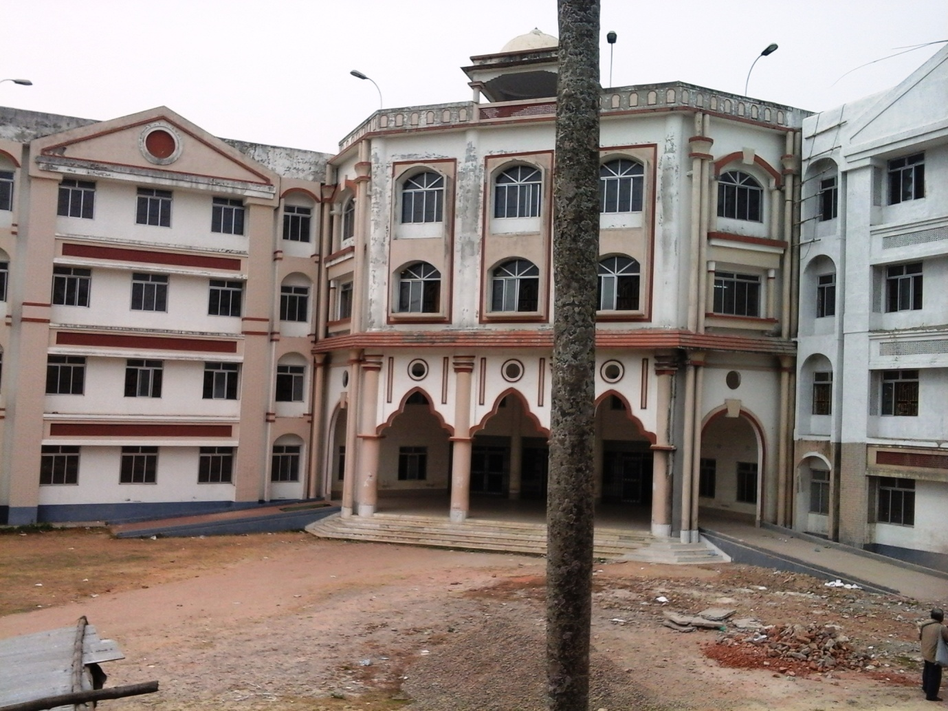

**Plate 1. Academic building of Bir Bikram Memorial College**

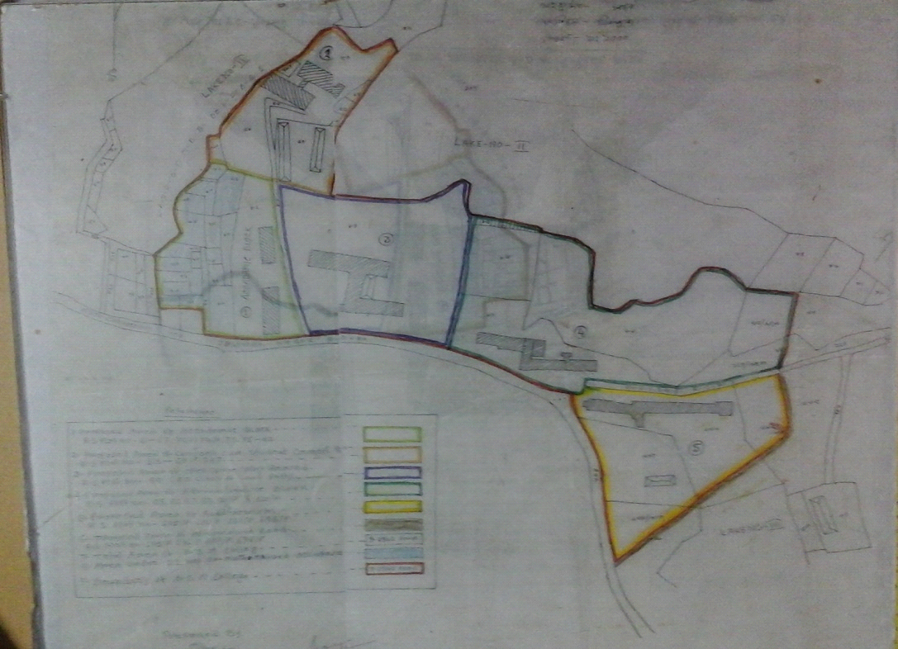

**Plate 2. Map of Bir Bikram Memorial College campus**

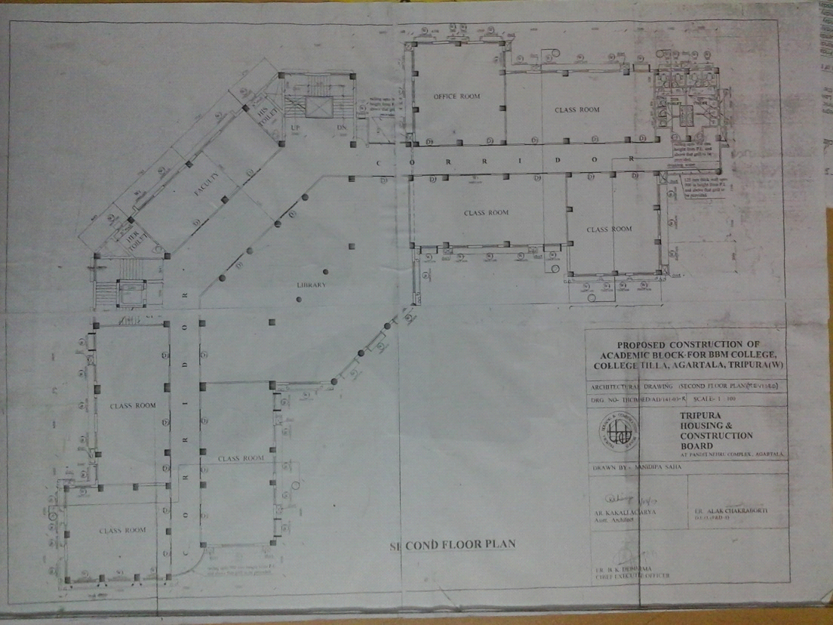

**Plate 3. Blue print of Academic building of Bir Bikram Memorial College with area**

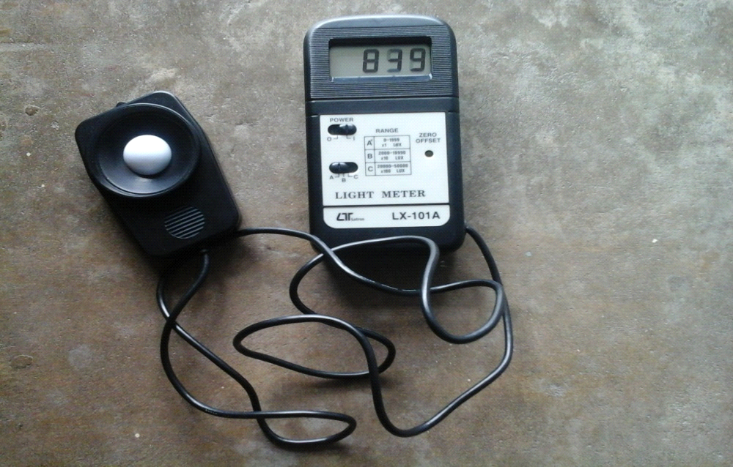

**Plate 4 . Lux meter used for light intensity study of Bir Bikram Memorial College buildings**