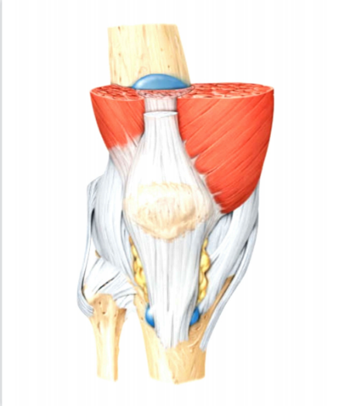
JOINTS
Dr.Deeparani Urolagin¹ ,Purushottam²,Survi³
Professor and HOD,R R college of Pharmacy,Bangalore
B.Pharm student,Aditya college of Pharmacy,Bangalore
B.Pharm student,Aditya college of Pharmacy,Bangalore

  - PREFACE-
- Introduction to joints
- Classification of joints
- Types of movement
- Structure of joints
- Disorders of joints

1.2 INTRODUCTION
A part of the body that allows movement by connecting two or more bones. Every bone in the body, except the clavicle in the larynx, meets at least one other bone in a joint. The shape of a bone depends on its function. It is either called articulation.
Greater movement of the joints leads to a higher risk of injury and reduced strength.
CLASSIFICATION OF JOINTS-
The number of joints depends on sesamoids ( bone embedded within the tendon or a muscle).
Joints are mainly classified structurally and functionally. Structural classification is determined by how the bones connect, while functional classification is determined by the range of motion between the bones in the joints.
Clinical and numerical classification:
- Monoarticular- concerning one joint
- Oligoarticular or pauciarticular- concerning 2-4 joints
- Polyarticular- concerning 5 or more joints
STRUCTURAL CLASSIFICATION (BINDING TISSUES)
Structural classification divides according to the type of binding tissues that binding tissue that connects the bones, there are four structural classifications of joints.
- Fibrous joints- here the connective tissues are rich with collagen fibers, they are dense and irregular.
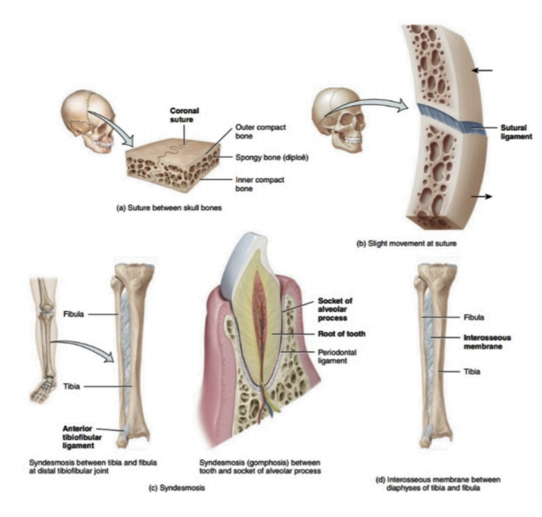
Fig 1. The presence of fibrous joints

- Cartilaginous joint- joined by cartilage. There are two types:
- Primary cartilaginous joints composed of hyaline cartilage.
- Secondary cartilaginous joints are composed of hyaline cartilage covering the articular surface of the involved bones with fibrocartilage connecting them.
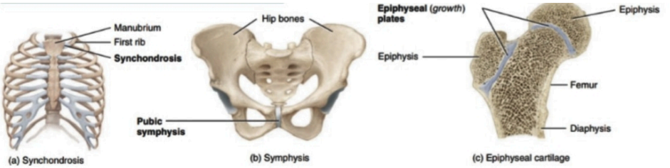
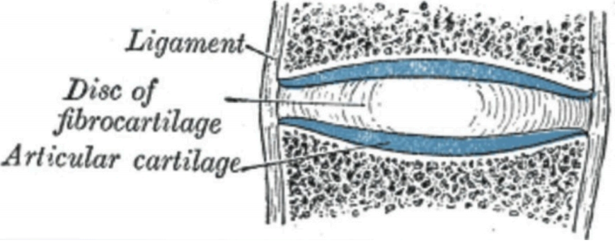
Fig 2. Structure and presence of cartilaginous joints and the structure of a vertebral disc.
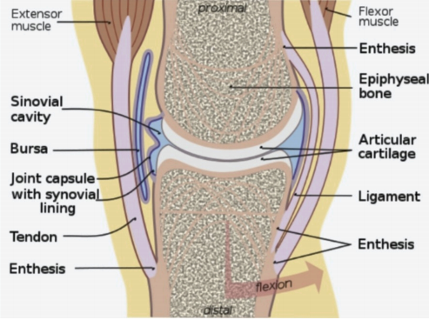
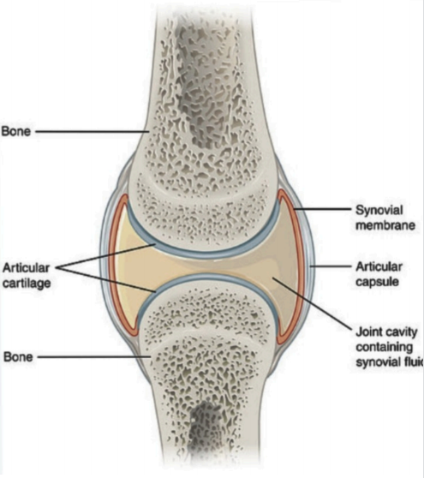
- Synovial joint- not directly connected - bones have a joint cavity and are connected by dense irregular connective tissue that forms a joint capsule, usually associated with accessory ligaments.
Fig 3. Structure of synovial joints
- Face joint- joint between two articular processes between two vertebrae.

FUNCTIONAL CLASSIFICATION (MOVEMENT)
Joints are classified functionally according to the type and degree of movement they allow; joint movements are described concerning the basic anatomical planes.
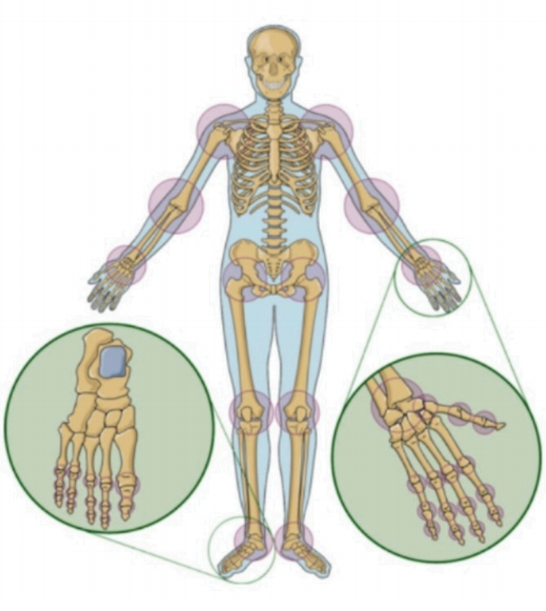
Fig 4. Presence of joints according to anatomical classification.

Based on the allowance of the movement joints are broadly classified into three classes this includes as follows:
- Immovable- no movement occurs in such joints because they are in close contact with each other. These are fibrous joints
- Slightly movable- this type of joint permits very little or restricted movement in which they are held together tightly. This allows the body to twist, or bend to the front, back, or side e.g. intervertebral disc.
- Freely movable or synovial joint- most of the joints in the human body are of this type. Hence the main purpose of a joint is motion.
TYPES OF FREELY MOVABLE JOINTS:
The six types of freely movable joints include:
- Ball and socket joint- Joint in which the head of the bone fits within the socket of the another bone, this includes hip joint or shoulder joint. Movement in all directions is allowed.
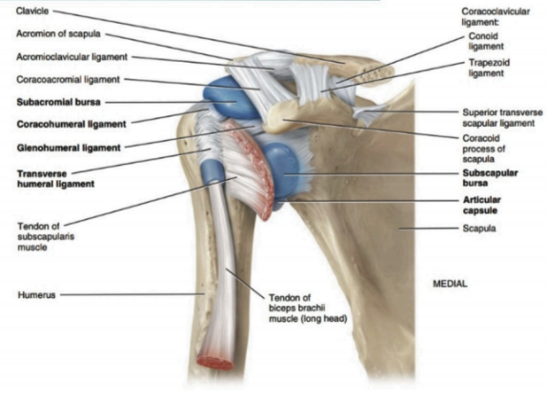
Fig 5. Ball and socket joint in the shoulder

- Saddle joint- this permits the movement back and forth and from side to side, but doesn’t allow rotation, such as the joint at the base of the thumb.
- Hinge joint- This involves unidirectional opening and closing of the two bones in one plane e.g. knee and elbow joints.
- Condyloid joint- this permits movement without rotation, such as the joint between the first and second vertebrae in the neck.
- Gliding joint- Smooth surfaces slide over each other to permit constrained development, such as wrist joints.
- Pivot joint- one bone swivels around the ring-shaped by another bone, such as the joint between the primary and moment vertebrae within the neck.
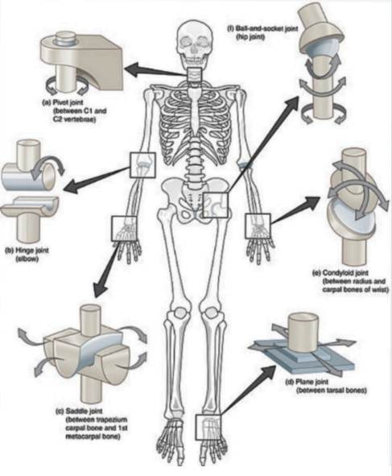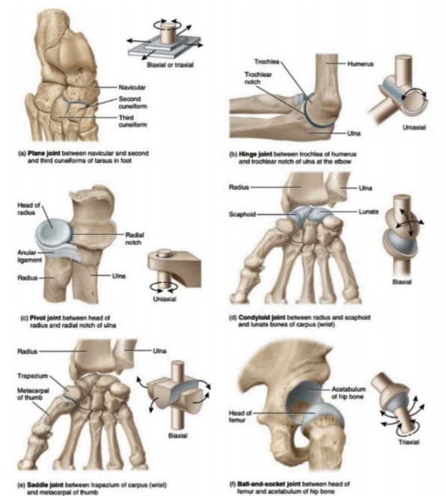
Fig 5a. The structure of different types of synovial joints.

CLASSIFICATION BASED ON NUMBER OF AXES
- Monoaxial (uniaxial)
- Biaxial
- Multiaxial
CLASSIFICATION BASED ON THE NUMBER AND SHAPES OF THE ARTICULAR SURFACES:
- Flat surface
- Concave surface
- Convex surface
BIOMECHANICAL CLASSIFICATION-
Depending on the number of bones the joints are anatomically classified as follows-
- Simple joint: joint including two enunciation surfaces (e.g. bear joint, hip joint)
- Compound joint: three or more verbalization surfaces (e.g. radiocarpal joint)
- Complex joint: two or more verbalization surfaces and an articular circle or meniscus (e.g. knee joint)
JOINTS may be anatomically classified into the following groups:
- Joints of the hand
- Elbow joint
- Wrist joint
- Axillary joint
- Sternoclavicular joints
- Vertebral articulations
- Temporomandibular joints
- Sacroiliac joints
- Hip joints
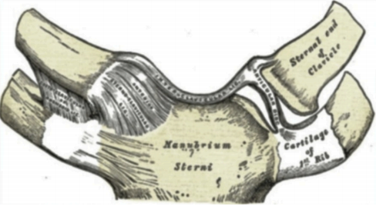
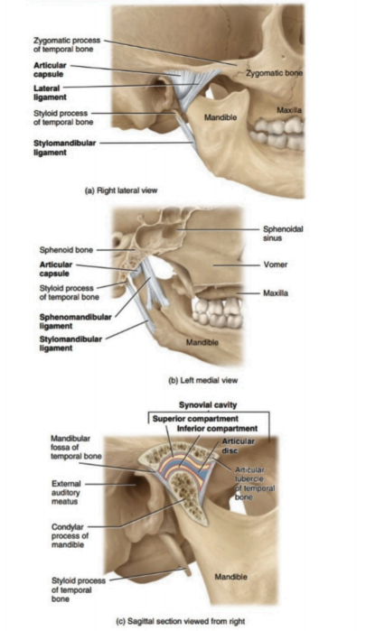
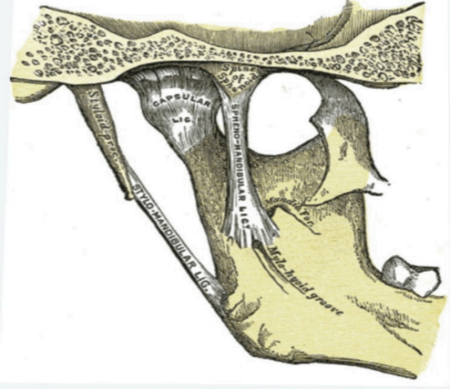
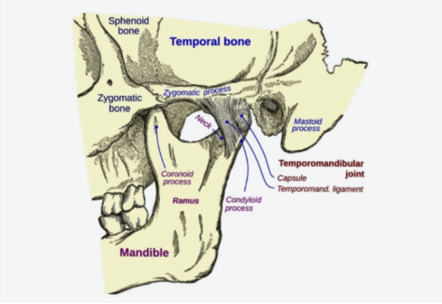
- Knee joints or tibiofemoral joint
d.
a.

b.

c.
Fig 6: a. Temporomandibular joints, b.Temporomandibular inner view, c. Strenoclavicular joints, d. Joints present in the jaw.

NOTE- Unmyelinated nerve fibers are abundant in joint capsules and ligaments, as well as in the outer part of the intra-articular menisci. These nerve fibers are responsible for pain perception when a joint is strained.
TYPES OF MOVEMENT
To achieve movement, the joint may:
- Change the angle between the bones
- Sliding of the two different surfaces on each other
- No displacement of the bone from a location only has rotatory motion.
TYPES OF MOVEMENT IN SYNOVIAL JOINT
- Gliding- straightforward development in which about level bone surfaces move back and forward and from side to side about one another.
- Angular movements- increase or decrease in the angle between articulating bones, these movements are limited in the range due to the structure of the articular capsules and associated with ligaments and bones.
- Flexion, Extension, Lateral Flexion, and Hyperextension- flexion and extension movements are opposite movements, in flexion, there is a decrease in the angle between articulating bones; extension (stretch out) increase in the angle between articulating bones is often used to restore the body postures.
- Abduction, Adduction, and Circumduction-
Abduction- radial deviation is the movement of the bone away from the midline.
Adduction- it is a type of movement where the bone moves near the midline, also called ulnar deviation.

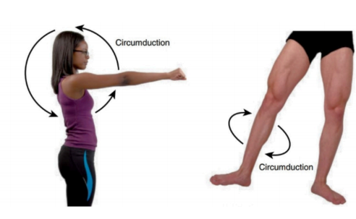
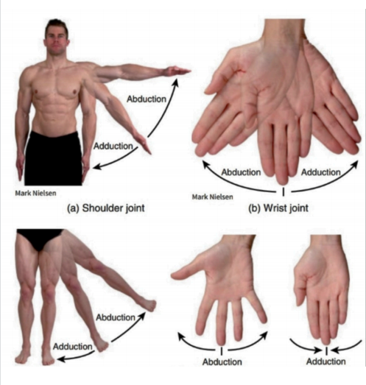
Circumduction- A movement of the distal end of a body part in a circle e.g. movement of the humerus at the shoulder point in circular motion.

Fig 7. The abduction and adduction and circumduction.
- Depression- the inferior movement of part of the body, such as opening the mouth to depress the mandible or returning shrugged shoulders back to its position.
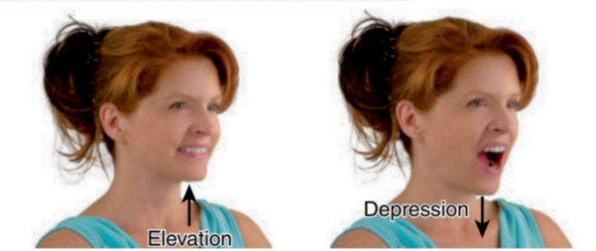
Fig 8. Elevation and Depression
- Protraction- the movement of the part of the body anteriorly in the transverse plane. Its opposite movement is retraction.
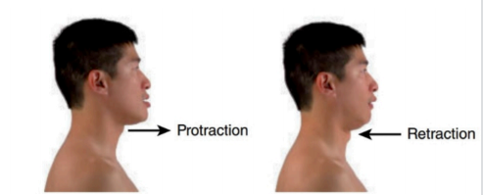
Fig 9. Protraction and Retraction
- Inversion- the movement of the sole medially at the intertarsal joints (between the tarsals). Its opposing movement is called eversion.
- Eversion- the movement of the sole laterally at the intertarsal joints.
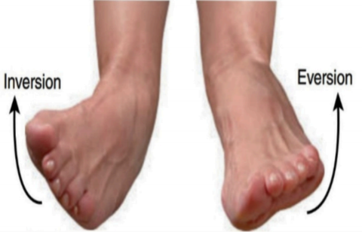
Fig 10. Inversion and Eversion.
- Dorsiflexion- bending of the foot at the ankle or talocrural joint (between the tibia, fibula, and talus) in the direction of the dorsum (superior surface), this occurs when you stand on your heels. Its opposing movement is plantar flexion.

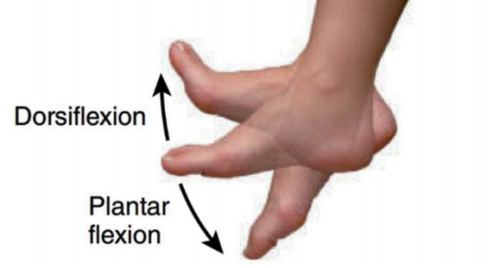
Fig 11. The movement of Dorsiflexion and plantar flexion.
- Plantar flexion- bending of the foot at the ankle joint in the direction of the plantar or inferior surface.
- Supination- the movement of the forearm at the proximal and distal radioulnar joints in which the palm is turned anteriorly.
- Pronation- the movement of the forearm at the proximal and distal radioulnar joints in which the distal end of the radius covers over the distal end of the ulna and palm is returned posteriorly.
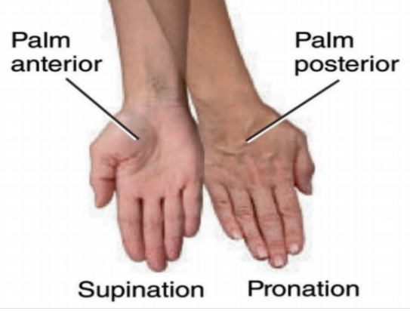
Fig 12. The movements of Supination and Pronation
- Opposition-the movement of the thumb at the carpometacarpal joint (between the trapezium and metacarpal of the thumb) in which the thumb moves across the palm to touch the tips of the fingers on the same hand.
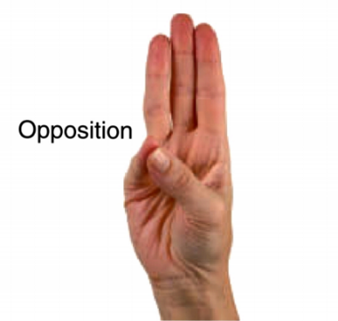
Fig 13. The movement in opposition.

STRUCTURE OF A JOINT

Ligaments are the tough connective bands that hold the joints. Smooth cartilage avoids contact as the bones move against one another.
Tendons are structures that are thick and tough that connect the muscle to bone.
DISORDERS OF JOINTS

- Arthritis- inflammation that causes stiffness and pain in the joints ( rheumatoid arthritis or gout) or degeneration (osteoarthritis)

- Osteoporosis- a condition in which bones become weak and brittle, this is usually caused due to low intake of calcium.

- Osteoarthritis- a degenerative disorder of joints, usually accompanied by pain and stiffness. It causes great pain and discomfort to large populations and affects both males and females.

- Bursitis- inflammation of the bursae (fluid-filled sacs that cushion and pad bones)

- Tendonitis- inflammation, irritation, and swelling of a tendon that is attached to the joint.

- Ankylosing Spondylitis- the disease of the spine in which there is gradual loss of mobility in the joints between the vertebrae. It mainly occurs in the male between the ages of 20 and 40.

- Gonococcal arthritis- it is an infection of joints, tendons, and muscles that occurs in those suffering from gonorrhea. Usually, women are more affected than men and this occurs at the age of 30.

- Gout- it is a chemical defect that causes the accumulation in the bloodstream of the waste product of metabolism also known as uric acid. Deposition of uric acid in the skin, joints, and kidneys.

- Juvenile Rheumatoid Arthritis (JRA)- refers to childhood arthritis for children under the age of sixteen affected by inflammatory arthritis.

QUESTIONS
5 marks-
- Define joints and classify them with examples?
- Write the different types of movements occurring in the synovial joint?

2 marks-
- Define osteoporosis and arthritis?
- What is gout?
- Write in general about the structure of the joint?
- Classify joints based on movement?
- Define the following:
- Ball and socket joint.
- Hinge joint.
- Pivot joint

