**CHAPTER–6**

**GREEN SYNTHESIS OF SILVER NANOPARTICLES USINGLEAF EXTRACT OF *SYZYGIUM AQUEUM* (WATER APPLE) ENCAPSULATED WITH POLYMER: ANTIBACTERIAL AND ANTIOXIDANTSTUDY**

**6.0 Abstract**

Polymer-encapsulated silver nanoparticles are created using the adaptable, affordable green synthesis technique. Silver nanoparticles, or AgNPs, are produced using the silver nitrate salt (AgNO3). Here, we synthesised silver nanoparticles that were enclosed in polymer. PVP is a type of polymer that is utilised as an encapsulant. PVP-b-AgNPs made from water apple (Syzygium aqueum) plant extract. FTIR, XRD, HR-TEM, and SAED are used to characterise the bio-synthesized PVP-silver nanoparticles. The UV spectroscopy is used to confirm the presence of silver nanoparticles and silver nanoparticles that have been enclosed in PVP. PVP-b-AgNPs' stretching vibrations are computed using XRD, and their crystallite size is calculated using FTIR.From the HR-TEM and SAED, PVP-b-AgNPs' morphology is derived. B. subtilis, S. aureus, S. typhi, and E. coli were investigated for the antibacterial activity of b-AgNPs and PVP-b-AgNPs. Astonishing antibacterial activity was displayed by the synthesised silver nanoparticles (AgNPs) and PVP-functionalized silver nanoparticles (PVP AgNPs). B-AgNPs and PVP-b-AgNPs both have strong antioxidant properties that make them effective DPPH scavengers.

**Keywords:**

*Syzygium aqueum*, Biosynthesis, silver nanoparticles, encapsulation, polyvinyl pyrrolidone(PVP)

**6.1 Introduction:**

**6.1.1 Green synthesis of nanoparticles:**

Through the use of nanoscale structures, or nanoparticles, in the fields of optics, electronics, biomedical science, mechanics, drug-gene delivery, chemical industry, optoelectronic devices, nonlinear optical devices, catalysis, space industries, energy science, and photoelectron chemical applications, nanotechnology is playing a crucial role in many important technologies[1].

Due to an increasing need to create eco-friendly procedures for the synthesis of nanomaterials, biosynthesis of metal nanoparticles has become an innovative and reliable technology in the last ten years. The production of metal nanoparticles by microbes has received a lot of attention. Silver-based single crystals were successfully biosynthesized by Klaus et al. at the cell poles of Pseudomonas stutzeri AG259. Using live Lactobacillus bacteria, Nair et al. successfully formed submicron crystallites of silver, gold, and an Ag-Au alloy. Li and colleagues investigated how dried Corynebacterium sp. SH09 and Aeromonas sp. SH10 isolated from gold mines could produce silver nanoparticles. By using fungus, Sastry et al. were able to synthesise metal nanoparticles[2-7].

The choice of an eco-friendly or green solvent, a good reducing agent, and a safe stabilising substance are the three key requirements for the synthesis of nanoparticles. Numerous synthetic methods, including physical, chemical, and biosynthetic methods, have been used to create nanoparticles. The majority of chemical approaches are excessively expensive and involve the use of poisonous and dangerous substances that pose a number of environmental risks[8]. The biosynthetic route is a secure, biocompatible, and environmentally responsible green method to synthesise nanoparticles for biomedical uses using plants and microorganisms[9]. Fungi, algae, bacteria, plants, and other living things can all participate in this synthesis. The availability of phytochemicals in plant extracts that function as stabilising and reducing agents has led to the usage of some plant components, including leaves, fruits, roots, stems, and seeds[10].

The production of nanomaterials can be done biologically using a variety of organisms, such as bacterial, fungal, and plant extracts. Plant-mediated biological synthesis is becoming more important due to its simplicity and ecofriendliness. This is because it can produce nanoparticles more effectively than other biological synthesis methods that require complicated procedures for maintaining microbial cultures. [11]

The manufacture of clean and ecologically friendly nanoparticles using "green chemistry" has been employed in the biosynthesis of nanoparticles, which is known as "green synthesis" and involves the use of bacteria, fungi, plants, actinomycetes, and other microorganisms[12].

There are numerous potential uses for green nanoparticle production in the medicinal and environmental sciences. Green synthesis specifically tries to reduce the use of harmful chemicals. For instance, it is typically safe to employ organic resources like plants. Reducers and caps are also present in plants. Here, we discuss the fundamentals of green chemistry as well as the most recent developments in plant-mediated nanoparticle synthesis. Gold, silver, copper, palladium, platinum, zinc oxide, and titanium dioxide are all examples of nanoparticles[13].

With the use of an extract from Syzygium aqueum (water apple) leaves, a green synthesis method has been created. To create Pd nanoparticles supported on activated Bentonite, crushed Syzygium aqueum (water apple) leaves are combined with a universal solvent, such as water[14].

The 131 genera and 5500 species that make up the Myrtaceae are distinguished by their high levels of antioxidants, including flavonoids, flavonols, anthocyanins, ellagitannins, and phenolic acids[15]. One of its larger genera, Syzygium, contains over 1100 species, many of which had previously been taxonomically mistaken for members of the genus Eugenia[16].The richest sources of phenolic and flavonoid compounds were five species of Syzygium (S. aqueum, S. cumini, S. jambos, S. malaccense, and S. samarangense) taken from the leaves and stems [17–21].Several Syzygium species, including S. cumini, S. samarangense, and S. jambos, have undergone significant research on both their phytoconstituents and biological functions. Antioxidant, antiviral, anti-diabetic, and hepatoprotective effects are among the documented pharmacological activities[22–23].

In folk medicine, Syzygium aqueum is frequently employed. Its leaves' extract, which is high in polyphenols, showed a wide range of powerful pharmacological qualities. Human keratinocytes (HaCaT cells) were shielded from UVA damage by the extract, which demonstrated strong antioxidant capabilities in vitro. Additionally, in rats with acute CCl4 poisoning, the extract decreased the increased levels of ALT, AST, total bilirubin (TB), total cholesterol (TC), and triglycerides (TG).

Syzygium aqueum, a plant in the Myrtaceae family and a native of Malaysia and Indonesia, is now found widely throughout the tropics. Epigallocatechin and epigallocatechin gallate, as well as vescalagin, castalagin, and samarangenins A and B, have all been extracted from the plant[25]. Many plant parts have been employed in traditional medicine. The leaf extract and its individual components myricitrin, myrilgalone G and B, phloretin, and europetin 3-O-rhamnoside from plants growing in Malaysia were found to have significant antihyperglycaemic activities[26].The water apple is a tropical country-specific species of brush cherry tree. It is readily used and can be collected from July to December. For the first time, stable AgNPs were produced using a water apple (Syzygium aqueum) aqueous fruit extract as a bioreductant[27].

Nanoparticles (NPs), which have an ultrafine size ranging from 1 to 100 nm, are well known. Metal nanoparticles (MNPs) are found among the NPs because of their optical, electrical, and photothermal properties[28].

The discipline of nanotechnology is expanding quickly and uses particles with a size of roughly a nanometer (10-9 m) or smaller to create instruments. The biological sciences, healthcare, and industrial technologies all stand to benefit significantly from nanotechnology[29]. An essential milestone in nanotechnology is the development of an environmentally benign method for creating metallic nanoparticles. The application of environmentally friendly nanotechnology to create selective and sensitive detection techniques in the analytical and biological sciences has gained importance recently[30–31].

There are several methods for creating silver nanoparticles, including photochemistry[32], thermal breakdown of silver compounds[33], electrochemistry[34], and more recently, green chemistry[35–36]. Evidently, many of the processes used to create nanoparticles are expensive and selectively use dangerous substances. Similar to the negative impacts of metals in applications, toxic substances can contaminate the surface of nanoparticles. The environmental friendliness of the biosynthesis of nanoparticles is what makes it so well favoured, and it is a technique that has received a lot of attention for the synthesis of materials[37]. Reducing sugars (aldoses), terpenoids, amino acids, and other organic chemicals are present in plant leaves or plant seed extracts[38] and are essential for affecting alterations in nanoparticle production. Certain extracts contain reducing, complexing, and stabilising chemicals that alter the size and shape of the developing nanoparticles. They have previously shown that biomass-reduced noble metal nanoparticles perform superbly for photochemical catalysis and selective hydrogenation[39–40].

The simplicity and environmental friendliness of plant-mediated biological synthesis are increasing its importance[41]. The ability of pure silver to repel microorganisms was well recognised. If silver is made into a nanoparticle, its antibacterial function is amplified, making it ideal for efficiently eradicating a variety of microbes. When examined for the treatment of various ailments, silver is recognised to be a safe substance for humans and to cause few to no allergic reactions[42]. The silver nanoparticles (AgNPs) have a wide spectrum of extracellular and intracellular target locations for their action. Actually, microorganisms typically find it more difficult to become resistant to silver than they do to antibiotics[43].

One of the most crucial nanomaterials is silver, which is employed in antibacterial agents, electronics, biosensors, food additives, industry, paints, and pharmaceuticals[44, 45]. For the creation of metal nanoparticles, biological materials like Hibiscus rosasinensis[44] and Foeniculum vulgare[46] have shown to be helpful.

By using a green strategy, many nanoparticles, including gold, silver, zinc oxide, and iron, have been easily synthesised. Metallic ions are bioreduced by the phytocompounds found in plant extracts, such as polyols, terpenoids, and polyphenols[47–50].

In the biological and pharmaceutical fields, silver nanoparticles can be extracted from a variety of therapeutic plants, including Saccharum officinarum[51], Helianthus annus[52], Cinamomum camphora[53], Oryza sativa[54], Aloevera[55], Capsicum annuum[56], Medicago sativa[57], Zeamays[58], and Magnolia Kobus[59].

A clever method was devised to create silver nanoparticles from AgNO3 utilising fruit extract from Melastoma malabathricum. Without the use of an additional capping agent, the reaction between the silver ions and the organic components in the fruit extract went smoothly at room temperature[60].

Compared to typically utilised physicochemical approaches, green production of silver nanoparticles (AgNPs) is non-toxic and environmentally benign. The purpose of this study is to synthesise, characterise, and evaluate the antibacterial and antioxidant activity of AgNPs made from the leaves of Moringa stenopetala (M. stenopetala) in aqueous solution[61].

Human diseases have developed antimicrobial and multidrug resistance (MDR), which has made it necessary to find new natural alternatives to combat this issue[62]. AgNPs appear to be an alternate antibacterial agent to antibiotics that can combat bacterial antibiotic resistance. AgNPs must therefore be developed as antibacterial agents. AgNPs appear to be viable antibacterial agents among the many promising nanomaterials because of their high surface-to-volume ratios and crystalline surface structure[63].

Silver nanoparticles (AgNPs) are synthesised using a novel, quick, and simple green chemical process.For the first time, stable AgNPs were created using an aqueous fruit extract of the water apple (Syzygium aqueum) as a bioreductant[64–65].

**Figure:6.1 Synthesis of nanoparticles by plant extract:**



High microbiological activity against both Gram-negative and Gram-positive bacteria was observed after polymers and surfactants were used to modify silver nanoparticles[66].

Chemical synthesis was used to create the nanoparticles, and polyvinylpyrrolidone (PVP) was used to stabilise them[67]. PVP, commonly referred to as povidone or polyvidone, is a polymer (C6H9NO) that is water soluble. N-vinylpyrrolidone is the monomer used to create PVP. It is a powder that is thin, flaky, and hygroscopic. By bulk, it absorbs about 40% of the water. It has excellent moisturising qualities. As a result, it creates films that form an attractive coating agent. PVP has unique physico-chemical features that make it a viable biomaterial for numerous important medical and non-medical applications, including solubility in both water and organic solvents, biocompatibility, chemical stability, and non-toxicity. PVP is widely utilised in a variety of healthcare, beauty, and haircare products. As a common ingredient in tablets, granules, pellets, softgel capsules, gels, hydrogels, films and coatings, membranes and mats of nanofibers, powders, syrups, oral or injectable solutions, coatings for medical devices, contact lenses, and many other products, PVP is widely used in the pharmaceutical industry [68–69].

PVP is one of the important capping agents that have been used in nanotechnology to get around problems with traditional ways of making nanoparticles, like their toxicity, size, and agglomeration.As a result, more applicable eco-friendly nanoformulations are made utilising PVP [70–71]. PVP has been used as a capping agent around metal nanoparticles such as iron (Fe), silver (Ag), gold (Au), zinc (Zn), etc. in a variety of studies [72].

**6.2 Material and methods:**

**6.2.1 Plant material and chemicals**

Sigma-Aldrich was used to buy silver nitrate. The leaves of Syzygium aqueum were gathered at the Ambika Nursery in the Gujarati city of Saraswati, Taluka, District Patan. Without using any additional purifying techniques, all compounds that were purchased have been utilised in analyses. Commercially available polyvinyl pyrrolidone (PVP MW 40,000) was utilised without further purification. received from the MTCC Chandigarh, Punjab, India, antimicrobial pathogens Mili-Q System (ultra pure water) was employed throughout the investigation to prepare the solutions.

**6.2.2 Leaf extract preparation**

We require 10g of fresh Syzygium aqueum leaves to start the process of manufacturing the plant extract. In order to completely clean the leaves and remove any unpleasant odours, deionized water was employed. The leaves were dried on filter paper, compellinged, and then powdered in a grinder. After that, add 100 ml of ultrapure water. The mixture was heated to a temperature between 600 and 700 °C and then brought to a boil. The mixture was then filtered using Whattman filter paper after cooling. Initial findings reveal a yellowish hue. The leaf extract solution creates the silver nanoparticles.

**6.2.3 Synthesis of Silver Nanoparticles**

As a green synthesised, we employed Syzygium aqueum leaf extract and silver nitrate solution, which we heated for one hour at 60°C while stirring continuously[73]. The combination changed from a light yellow to a dark brown tint after an hour. The reaction mixture was centrifuged at 10,000 rpm for an additional 20 minutes at room temperature after chilling for another 20 minutes. The precipitates were cleansed with deionized water to get rid of any remaining impurities, and they were then dried for four hours at 70 to 75 degrees Celsius.

**6.2.4 Synthesis of PVP formulated silver nanoparticles**

In 100 ml of ultra pure water, 0.2 gramme of PVP (Polyvinyl pyrrolidone) was dissolved, and the mixture was agitated for one hour at 80°C. The new solution was then progressively added to the AgNPs solution made from leaf extract. The coloration changed from dark brown to light brown after an hour. After 10 minutes at ambient temperature, the reaction mixture was centrifuged at 6000 rpm for 15 minutes. The precipitates were cleaned with deionized water before being dried in an oven for two hours at 70°C.

**6.2.5 Characterization of green AgNPs and PVP functionalized AgNPs**

Both b-AgNPs that had been synthesised and those that had been PVP functionalized were characterised using various instrumentation techniques. With the use of a UV-visible spectrophotometer (made by Perkin-Elmer USA), the synthesis of AgNPs was verified. To confirm the functional biomolecules linked to the generated b-AgNPs and PVP functionalized b-AgNPs, FTIR analysis was carried out in the 400–4000 cm-1 range with a resolution setting of 5 cm-1. An X-ray diffraction spectrometer with a Rigaku D/max 40 kV voltage was used to conduct an XRD examination to confirm purity. The structural morphology of the generated nanoparticles was examined using high resolution Transmission Electron Microscopy (HR-TEM).

**6.2.6 Anti microbial activity**

The biological effects of PVP-functionalized b-AgNPs and silver nanoparticles against gram-positive and gram-negative bacterial strains were investigated. The effectiveness of the antibiotic was evaluated using agar diffusion techniques[74]. A 10 mm-diameter disc was placed in the centre of the divided regions of the Petri dish plate after the nutritional agar medium had been distributed uniformly throughout it. To examine the effectiveness of the nanoparticles, we used PVP-functionalized b-AgNPs and 100 L of silver nanoparticles. For 24 hours, the culture medium was maintained at 37°C in an aerobic environment. The antibacterial properties of b-AgNPs and b-AgNPs with PVP-functionalization can be connected to the formation of zones on petri dish plates.

**6.2.7 Anti Oxidant properties**

**6.2.7.1.DPPH radical scavenging activity**

b-AgNPs and PVP-functionalized b-AgNPs were tested for anti-oxidant capabilities using the DPPH technique**[75]**. Because of its significant anti-oxidant capabilities, ascorbic acid was adopted as a standard. Ascorbic acid solutions of various concentrations (20,40,60,80,100,120 g/mL) were created for the experiment. To make DPPH, 20 mg of DPPH was weighed and dissolved in 100 ml of methanol. One millilitre of DPPH solution was mixed with one ml of b-AgNPs and PVP functionalized b-AgNPs and 1 ml of standard ascorbic acid solution, and the mixtures were incubated separately for 30 minutes. The absorbance was measured with a UV-visible spectrophotometer at 517 nm. Calculating free radical scavenging inhibition was done using the formula below.

% of Antioxidant activity = Absorbance of control – Absorbance of sample) ˣ 100

Absorbance of control

**6.2.7.2 Super oxide anion radical scavenging assay:**

Alsubki et al. discovered the radical scavenging ability of super oxide anion radicals**[76]**. By reacting with super oxide radicals formed from the phenzinemetho sulphate, NAD system, we were able to detect the NBT-induced purple formazan (NBT-induced purple formazan). It was done using this approach, in which a mixture of NBT (1 mM), NADH (1 mM), and PMS (0.1 mM) was incubated for 5 minutes at room temperature with various quantities of b-AgNPs and PVP encapsulated b-AgNPs, and the absorbance at 560 nm was determined. The percentage of inhibition was established by comparing it to a separate control number that had been previously determined. The ability to scavenge was measured using an equation.

.

Scavenging effect (%) = [(Ac-As)/Ac] X 100

Where , Ac is the absorbance of the control and As is the absorbance of the sample or standard.

**6.3 Result and discussion**

**6.3.1 b-AgNPs characterization**

The darkening of the precursor solution to a dark brown colour and the formation of brown precipitation on the inner surface of the reaction flask show that the synthesis of b-AgNPs was effective following the addition of a generous quantity of *Syzygium aqueum* leaf extract. Previous attempts to synthesize b-AgNPs using water apple (*Syzygium aqueum*) callus culture extract had similar success**[77]**. The colour of a nanoparticles is determined by the surface Plasmon resonance (SPR) of that particle**[78]**. It is shown in great detail in **Fig. 6.2** and **Fig. 6.3** how AgNPs were synthesized using *Syzygium aqueum* leaf extract.

M+M0M

Ag+Metal Ion Metal Nanoparticles Nanoparicles with

Organic Compound

**Fig. 6.2 Formation of biogenic AgNPs nanoparticles**

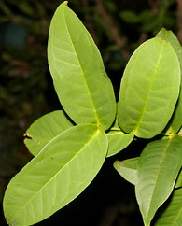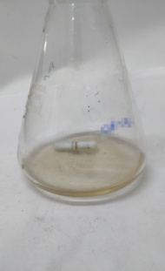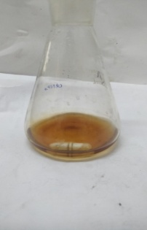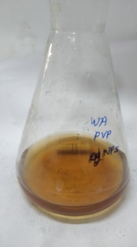

C

A

D

B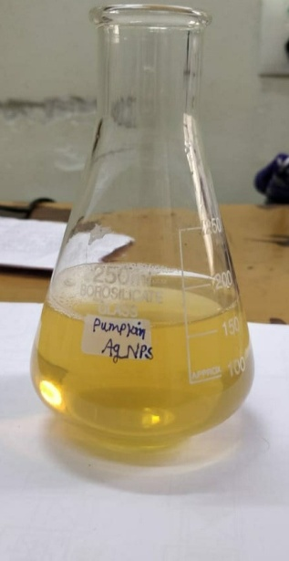

**Fig.6.3**[A] Plant Leaves of *Syzygium aqueum* , Colour change of Nanoparticles [B] At Initial time [C] After 1 hr formation of b-AgNPs [D] PVP-b-AgNPs

**6.3.2 UV-visible spectroscopy:**

The stabilizing agent method was followed by a reduction of Ag ions before the AgNPs were formed. For b-AgNPs, a 451nm band in the UV-visible spectrum was observed in the UV-visible spectrum **(Fig. 6.4 A, B, and C)**. This absorption band is due to the plasma resonance absorption of silver nanoparticles. Nanoparticles of Ag have a surface Plasmon peak of 400-500 nm**[79]**. In the synthesis of b-AgNPs, the leaf extract of *Syzygium aqueum* acts as a reducing-cum-surface capping agent.

Polymeric nanoparticles can be made in a variety of ways; depending on the application and the sort of medicine they are to contain**[80]**. These nanoparticles can be utilized in nanomedicine to encapsulate bioactive compounds. Polymer-based nanoparticles are preferred because of their ability to be used in medication delivery systems. These nanoparticles have properties such as controlled/sustained release, sub cellular size, and biocompatibility with tissues and cells**[81]**. The structural organization of nanoparticles separates them into two subgroups: nanocapsules and nanospheres**[82]**.

The surface was clearly visible in the UV-visible spectrum. The light brown colour is caused by the nanoparticles' plasmon resonance, which is encapsulated. b-AgNPs and PVP encapsulated b-AgNPs absorbance peaks range from 447 nm to 458 nm**[83]**. These findings are in line with earlier research in this area**[84]**. According to research, the SPR of most metallic compounds depends on their size and form**[85]**.



**Fig.6.4** UV –Visible Spectrum of [A] Plant Extract [B] b-AgNPs [C] PVP-b-AgNPs

**6.3.3 FTIR- Fourier transformed infrared spectroscopy:**

*Syzygium aqueum* leaf extract contains major metabolites such as vitamins, nucleic acids, proteins, and amino acids involved in the formation of b-AgNPs. In recent investigations, polysaccharides have been found to work as reducing and stabilizing agents**[86]**. When AgNPs were formed, proteins did not serve largely as reducing agents. According to certain research**[87]**, these macromolecules may play an important role in later stages of the creation of b-AgNPs, such as surface coating. Many secondary metabolites, including phenols, alkaloids, terpenoids, saponins, and so on, are effective reducing agents and can be used in all phases of b-AgNPs synthesis. FTIR spectroscopy shows the chemical behaviour of b-AgNPs and b-AgNPs encapsulated in other materials (FTIR). FTIR can also be used to determine the chemical structure of b-AgNPs and PVP-b-AgNPs. Functional groups in molecules can be identified using FTIR. Biomolecules that are involved in the creation of b-AgNPs and PVP-b-AgNPs can be studied using FTIR to discover which molecules are serving as coating or stabilizing agents**[88]**. The biomolecules responsible for the silver ions in *Syzygium aqueum* leaves aqueous extract and the capping agent that keeps biodegradable b-AgNPs stable were identified using FTIR measurements. b-AgNPs and PVP-b-AgNPs peaks were observed in the FTIR spectra **(Fig.6.5 A and B)** at 1089 cm-1, 1371 cm-1, 1632 cm-1, 2087 cm-1, 1450 cm-1, 646 cm-1, 565 cm-1, 3410 cm-1, 3138 cm-1, 1632 cm-1, 837 cm-1, while PVP-AgNPs peaks were recorded at 3402 cm-1, 3224 cm-1, 2079 cm-1, 2378 cm-1. In contrast to the biosynthesized AgNPs, the FTIR spectra of the pneumatic extract showed high peaks at 1089, 1361, 1632, 1637 cm-1 and lesser peaks at 2079, 2087, 1450, 1361, 646, 654, and 565 cm-1. Both AgNPs and PVP-AgNPs have the same C-H bonding vibrational peaks at 1371 and 1361 cm-1. The OH stretching of phenolic groups is associated with the conspicuous band attributed to 3410 and 3402 cm-1. The N-H stretching of amines was the primary cause of the 1371 and 1450 cm-1 peaks. Due to the presence of metal carbonyl stretching polymer, the bands at 1632 and 1632 cm-1 can be traced to C=O stretching **(Fig. 6.5)**. When the stretching vibrations associated with –OH and CH/CH2 groups are integrated with the aliphatic hydrocarbon group in polysachcharide, proteins, and poly phenols are molecules attached to the Ag surface, the presence of the peaks at 1632 and 1637 cm-1 was observed**[89-91]**. Analyzing the FTIR spectrum, researchers found that Ag+ ions could be reduced by the addition of oxygen and phenolic compounds could be oxidized by the addition of oxygen. b-AgNPs and polymer-capped b-AgNPs were both produced using an extract from *Syzygium aqueum* leaves as a reducing agent. The results are in line with previous studies on the topic**[92]**.

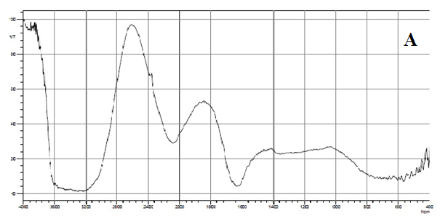

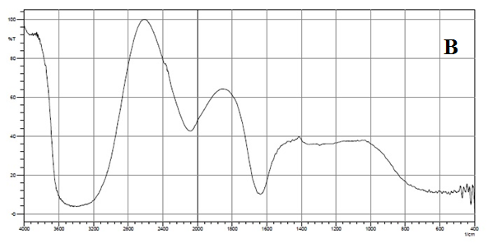

Fig. 6.5 FT- IR Spectrum of [A] AgNPs [B] PVP- AgNPs

**6.3.4 X- Ray diffraction**

Powder X-ray diffraction confirms the production of b-AgNPs and polymer-capped b-AgNPs (XRD). **Figure 6.6** shows the XRD patterns of b-AgNPs and polymeric b-AgNPs powder. Face-centered cubic (FCC) crystalline structure phase of silver is well-indexed by all diffraction peaks, which are in good accord with JCPDS file no.89-3722. At 27.740 (111), 32.170 (200), 38.090 (220), 36.2 (310), 46.23 (220), 77.410 (311), and 85.570 (322), indicative of significant diffraction peaks were detected, reflecting the FCC structure of silver. All of the peaks are in the same place, which is consistent with silver. The product's crystal structure may be seen in the XRD pattern, which has a strong peak**[93]**.

The bioconjugate between the polymer component and the formed polymer-capped b-AgNPs was modified by the PVP polymer in terms of phase change. The nearing of nanocrystal development is indicated by the significant reflection at (111)**[94]**. According to the Debye-Scherrer equation, the average crystal size of b-AgNPs generated in the bioreduction and PVP capped b-AgNPs is 17 nm.

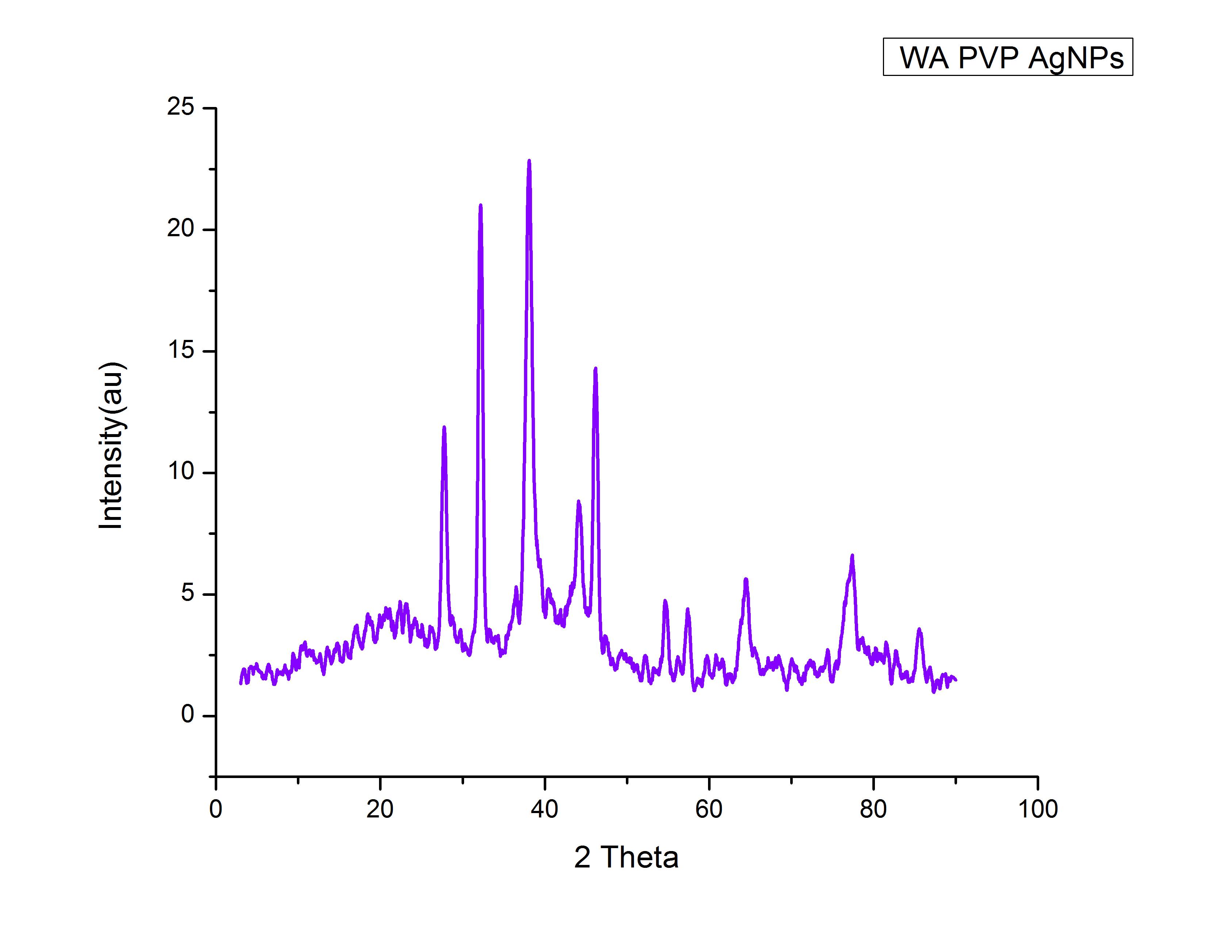

**Fig . 6.6** XRD pattern of PVP AgNPs

**6.3.5 HR-TEM Analysis**

High-resolution transmission electron microscopy (HR TEM) can all be determined using high-resolution transmission electron microscopy (HR TEM). TEM can be used to determine the precise size, shape, and morphology of produced silver nanoparticles **[95]**.

PVP-b-AgNPs that were produced in the range of 4 nm to 13 nm were captured in the high-resolution TEM picture (in line with XRD data). Spherical, well-spread, and homogeneous particles were discovered. Chemically reduced Ag ions were made zero-valent by coating them with biological molecules (extracted from *Syzygium aqueum* leaf extracts) that contain surface-bound hydroxyl groups. Particles appeared agglomerated as a result of this**[96]**.

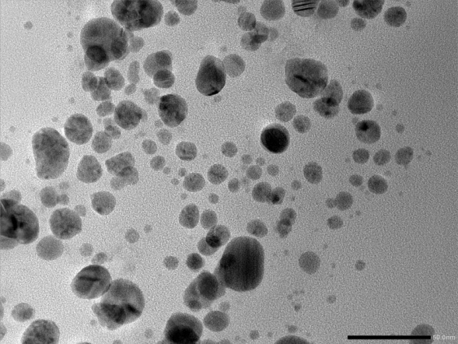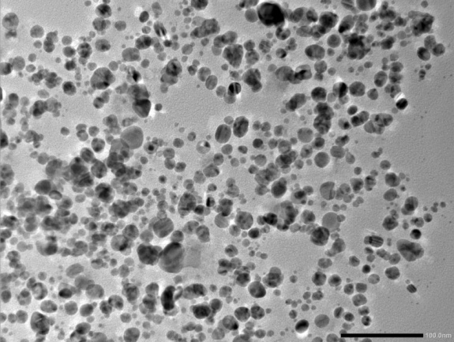

1. B.

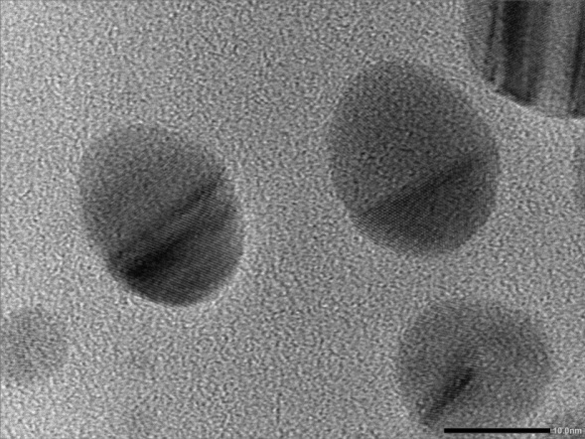

C.

**Fig. 6.7**  HR-TEM image of PVP- b-Ag NPs observed at 50 nm[A],100 nm[B],5 nm [C].

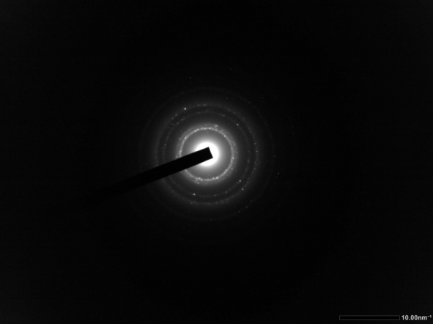

D.

**Fig. 6.7** [D] Selected area electron diffraction (SAED) pattern of PVP-b-AgNPs

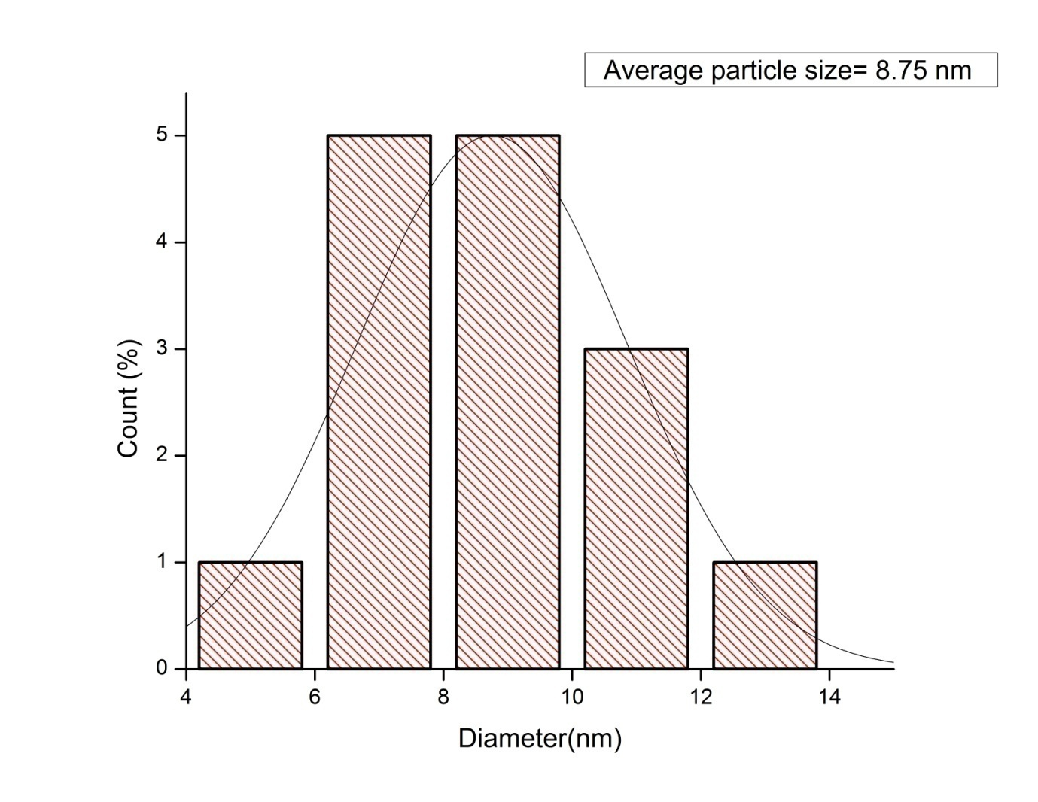

**Fig.6.8** The size distribution curves from the TEM analysis and SAED pattern of PVP functionalized b-AgNPs

The single plots in **Fig. 6.7** revealed ring patterns that were shown by the SAED pattern (D). The XRD findings are consistent with this conclusion. The TEM-derived curve for size distribution is shown in **Figure 6.8**. Particle sizes range from 8.75nm and above. Another factor that contributes to PVP–Ag nanoparticles size modification is *Syzygium aqueum* leaf extract polyphenolic compounds (components such as flavonoids and flavonols). As a result, a wide range of particle sizes are produced. Because of hydrogen interaction between hydroxide groups of diverse phenolic compounds, accumulations are produced**[97]**.

**6.3.6 Antimicrobial activity of b-AgNPs and polymeric capped b-AgNPs**

As illustrated, biogenic silver nanoparticles have proved their outstanding antibacterial activities in recent literature. Additionally, using water apple leaf extract and polymer capping, our study team created nanoparticles (19.37 nm) that were then tested on gram positive bacteria (*Salmonella typhi,E. coli*)) and gram negative bacteria (*Bacillus subtilis, Staphylococcus aureus*).

The antibacterial activity of AgNPs produced from water apple leaf extract, polymer-coated AgNPs, and extract was tested using a disc diffusion experiment in this study. The antibacterial activity of PVP-AgNPs (polymeric nanoparticles) was shown to be strong against all tested bacterial pathogens at a 100 µL concentration **(Fig. 6.9 A& B)**. Values in millimetres (mm) were obtained for the growth inhibition zones **(Table 6.1)**. As shown in table 1, the maximum zone of inhibition for *S. typhi* is around 20 mm. For*E.coli*,*B. subtilis* and *S. aureus*, the zone of inhibition was about 18 mm, 17 mm and 19 mm, respectively. It has been found that the suspension possesses antibacterial action against bacterial pathogens after it has been treated with AgNPs and PVP AgNPs nanoparticles. According to the findings, *S. typhi* was shown to be more sensitive than other pathogens. Antibacterial efficacy against gram-positive and gram-negative bacteria has long been shown with AgNPs**[98]**. As a result of the conformational changes induced by AgNPs on cell walls, which result in enhanced membrane permeability and thus bacterial cell death, PVP-AgNPs are more active**[99]**.

**Table : 6.1**

Antibacterial activity of plant extract, silver nanoparticles of *Syzygium aqueum* leaves and PVP capped silver nanoparticles.

|  |  |  |  |  |  |
| --- | --- | --- | --- | --- | --- |
| Test sample | Concentration  (In microliter) | Inhibition zone(in mm) | | | |
| *E.coli* | *Salmonella typhi* | *Bacillus subtilis* | *Staphylococcus aureus* |
| Plant extract | 100 | 15 | 18 | 15 | 15 |
| Peniciline | 100 | 13 | 16 | 14 | 16 |
| AgNPs | 100 | 17 | 18 | 16 | 18 |
| PVP-AgNPs | 100 | 18 | 20 | 17 | 19 |

Fig. 6.9A The assay of the minimum inhibition of PVP-b-AgNPs against the bacterial strains.

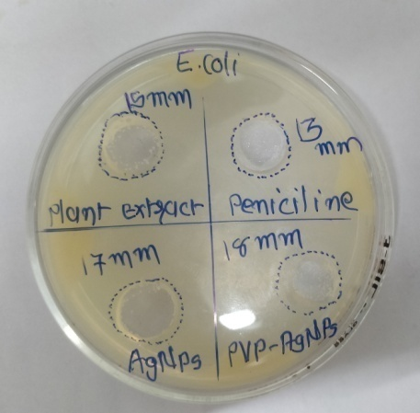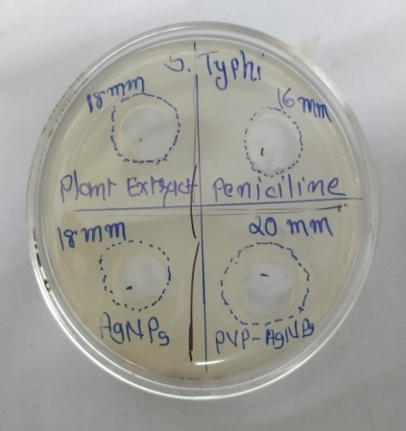

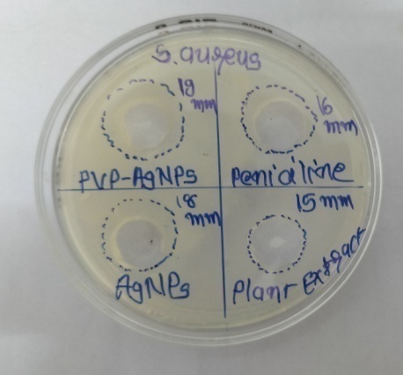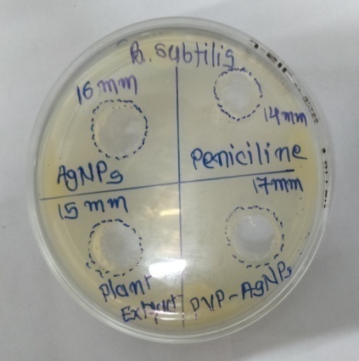

**Fig. 6.9B** Antimicrobial study of b-AgNPs And PVP-b-AgNPs against pathogenic bacteria

**6.3.7 Antioxidant properties of b-AgNPs and PVP Capping b-AgNPs**

**6.3.7.1 DPPH radical scavenging activity**

Antioxidants are known for their hydrogen-donating abilities, which allow them to scavenge DPPH. Different concentrations of b-AgNPs and PVP-capped b-AgNPs on DPPH radical scavenging activity are illustrated in **Fig. 10A**. "b-AgNPs and PVP-capped b-AgNPs have free radical scavenging properties that increase in concentration." PVP-capped b-AgNPs, on the other hand, exhibit a 52.94 percent increase in antioxidant activity at 120g/mL. In the same concentration, the standard ascorbic acid demonstrated 50.19 percent inhibition. activity of AgNPs, summarized before, allowed us to conduct our current research**[100]**.

Fig. 6.10 [A] DPPH radical scavenging activity

**6.3.7.2 Super oxide anion radical scavenging assay**

Because it is a precursor to more reactive oxygen species, the super oxide anion radical has a well-documented negative impact on living beings. It causes tissue necrosis and a wide range of illnesses, including cancer**[101]**. As can be seen in **Figure 10 B**, this study looked at the antioxidant activity of b-AgNPs, PVP-capped b-AgNPs, as well as Vitamin C. Antioxidant scavenging activity was 44.56 %, 46.32 %, and 45.41 % reduced by b-AgNPs and PVP-capped b-AgNPs at a concentration of 120 g/mL compared to Vitamin C's (45.41 percent). An increase in the concentration of nanoparticles resulted in an increase in the suppression of superoxide. b-AgNPs have been shown to have antioxidant-scavenging activities prior to this investigation **[102]**.

Fig.6.10 [B] Super oxide anion radical scavenging assay

**6.4 Conclusion:**

This study utilized organic components from *Syzygium aqueum* leaves as potential reducing and stabilizing agents for the production of AgNPs. In order to enhance the biocompatibility of b-AgNPs without the use of harmful or toxic compounds, they were functionalized with PVP. The generation of b-AgNPs and polymer b-AgNPs was confirmed using advanced characterization techniques (UV-vis, FTIR, HR-TEM, XRD). There were nano-sized b-AgNPs of 8 nm and 12 nm in the polymeric AgNPs that were synthesized and then tested.

The biomedical efficacy of the nanoparticles was evaluated using their antioxidant and antibacterial properties, respectively. It is possible that the biosynthesized b-AgNPs and PVP-capped b-AgNPs could be used as free radical scavengers in the treatment of various disorders, such as cancer. When compared to traditional antibacterial medications, PVP-b-AgNPs demonstrate greater action at lower concentrations against *E.Coli, B.subtilis, S.aureus,* and *S. typhi*, with greater sensitivity for *S. typhi* than for*E.Coli,S. aureus* and *B.subtilis*, according to our observations. Made PVP-b-AgNPs are a better choice for antibacterial drugs in the therapeutic biomedical field because they work well against infections.

**References:**

**[1].** Singh, T., Singh, A., Wang, W., Yadav, D., Kumar, A., & Singh, P. K. **(2019)**. Biosynthesized nanoparticles and its implications in agriculture. *Biological Synthesis of Nanoparticles and Their Applications*, 257-274.

**[2].**Klaus, T., Joerger, R., Olsson, E., & Granqvist, C. G. **(1999)**. Silver-based crystalline nanoparticles, microbially fabricated. *Proceedings of the National Academy of Sciences*, *96*(24), 13611-13614.

**[3].**Nair, B., & Pradeep, T. **(2002)**. Preparation of gold nanoparticles from Mirabilis jalapa flowers. *Cryst Growth Des*, *2*, 293-8.

**[4].**Zhang, H., Li, Q., Lu, Y., Sun, D., Lin, X., Deng, X., ... & Zheng, S. **(2005)**. Biosorption and bioreduction of diamine silver complex by Corynebacterium. *Journal of Chemical Technology & Biotechnology: International Research in Process, Environmental & Clean Technology*, *80*(3), 285-290.

**[5].**Mouxing, F. U., Qingbiao, L. I., Daohua, S. U. N., Yinghua, L. U., Ning, H. E., Xu, D. E. N. G., ... & Huang, J. **(2006)**. Rapid preparation process of silver nanoparticles by bioreduction and their characterizations. *Chinese Journal of Chemical Engineering*, *14*(1), 114-117.

**[6].** Mukherjee, P., Ahmad, A., Mandal, D., Senapati, S., Sainkar, S. R., Khan, M. I., ... & Sastry, M. **(2001)**. Fungus-mediated synthesis of silver nanoparticles and their immobilization in the mycelial matrix: a novel biological approach to nanoparticle synthesis. *Nano letters*, *1*(10), 515-519.

**[7].** P. Mukherjee, A. Ahmad, D. Mandal, S. Senapati, S.R. Sainkar, M.I. Khan, R. Ramani, R. Parischa, P.A.V. Kumar, M. Alam, M. Sastry, R. Kumar: Angew. Chem. Int. Ed. Vol. 40 **(2001)**, p.3585. <http://dx.doi.org/10.1002/1521-3773(20011001)40:19&lt;3585::AID> ANIE3585&gt;3.0.CO;2-K]

**[8].** Nath, D., & Banerjee, P. **(2013)**. Green nanotechnology–a new hope for medical biology. *Environmental toxicology and pharmacology*, *36*(3), 997-1014.

**[9].** Razavi, M., Salahinejad, E., Fahmy, M., Yazdimamaghani, M., Vashaee, D., & Tayebi, L. **(2015)**. Green chemical and biological synthesis of nanoparticles and their biomedical applications. *Green processes for nanotechnology*, 207-235.

**[10].** Singh, H., Du, J., Singh, P., & Yi, T. H. **(2018)**. Ecofriendly synthesis of silver and gold nanoparticles by Euphrasia officinalis leaf extract and its biomedical applications. *Artificial cells, nanomedicine, and biotechnology*, *46*(6), 1163-1170.

**[11]**. Sastry, M., Ahmad, A., Khan, M. I., & Kumar, R. **(2003)**. Biosynthesis of metal nanoparticles using fungi and actinomycete. *Current science*, 162-170.

**[12].** Pal, G., Rai, P., & Pandey, A. **(2019)**. Green synthesis of nanoparticles: A greener approach for a cleaner future. In *Green synthesis, characterization and applications of nanoparticles* (pp. 1-26). Elsevier.

**[13].** Green synthesis of nanoparticles using plant extracts: a review Sapana Jadoun1 · Rizwan Arif1 · Nirmala Kumari Jangid2 · Rajesh Kumar Meena3 Received: 19 July 2020 / Accepted: 6 August 2020 © Springer Nature Switzerland AG (2020)]

**[14].** Manjare, S. B., & Chaudhari, R. A. **(2020)**. Palladium nanoparticle-bentonite hybrid using leaves of Syzygium aqueum plant from India: Design and assessment in the catalysis of–C–C–coupling reaction. *Chemistry Africa*, *3*(2), 329-341.

**[15].** Nair, A. G. R., Krishnan, S., Ravikrishna, C., & Madhusudanan, K. P. **(1999)**. New and rare flavonol glycosides from leaves of Syzygium samarangense. *Fitoterapia*, *70*(2), 148-151.

**[16].** Wrigley, J. W., & Fagg, M. **(2013)**. *Australian native plants: cultivation, use in landscaping and propagation*. Reed New Holland.

**[17].** Saxena, M. S. J., Nema R., Sigh, D., and Gupta, A.**(2013)**. *Phytochemsitry of Medical Plants. Journal of Pharmacy and Phytochemistry*, *1*(6), 168-182.

**[18].** Chikezie, P. C., Ibegbulem, C. O., & Mbagwu, F. N. **(2015)**. Bioactive principles from medicinal plants. *Research Journal of Phytochemistry*, *9*(3), 88-115.

**[19].**Mandal, S., & Mandal, M. **(2015)**. Coriander (Coriandrum sativum L.) essential oil: Chemistry and biological activity. *Asian Pacific Journal of Tropical Biomedicine*, *5*(6), 421-428.

**[20].** Nadeem, M., Abbasi, B. H., Younas, M., Ahmad, W., & Khan, T. **(2017)**. A review of the green syntheses and anti-microbial applications of gold nanoparticles. *Green Chemistry Letters and Reviews*, *10*(4), 216-227.

**[21].** Sheela, D., & Cheenickal, M. **(2017)**. Total Phenolics and Flavonoids among The Selected Species of Syzygium, Gaertn. *Research Journal of Pharmacognosy and Phytochemistry*, *9*(2), 101-104.

**[22].** Sobeh, M., Esmat, A., Petruk, G., Abdelfattah, M. A., Dmirieh, M., Monti, D. M., ... & Wink, M. **(2018)**. Phenolic compounds from Syzygium jambos (Myrtaceae) exhibit distinct antioxidant and hepatoprotective activities in vivo. *Journal of Functional Foods*, *41*, 223-231.

**[23].** Sobeh, M., Youssef, F. S., Esmat, A., Petruk, G., El-Khatib, A. H., Monti, D. M., ... & Wink, M. **(2018)**. High resolution UPLC-MS/MS profiling of polyphenolics in the methanol extract of Syzygium samarangense leaves and its hepatoprotective activity in rats with CCl4-induced hepatic damage. *Food and Chemical Toxicology*, *113*, 145-153.

**[24].** Sobeh, M., Mahmoud, M. F., Petruk, G., Rezq, S., Ashour, M. L., Youssef, F. S., ... & Wink, M. **(2018)**. Syzygium aqueum: A polyphenol-rich leaf extract exhibits antioxidant, hepatoprotective, pain-killing and anti-inflammatory activities in animal models. *Frontiers in pharmacology*, *9*, 566.

**[25].** NONAKA, G. I., AiKo, Y., ARITAKE, K., & NISHIOKA, I. **(1992)**. Tannins and related compounds. CXIX. Samarangenins a and b, novel proanthocyanidins with doubly bonded structures, from Syzygium samarangens and S. aqueum. *Chemical and pharmaceutical bulletin*, *40*(10), 2671-2673.

**[26].** Manaharan, T., Appleton, D., Cheng, H. M., & Palanisamy, U. D. **(2012)**. Flavonoids isolated from Syzygium aqueum leaf extract as potential antihyperglycaemic agents. *Food chemistry*, *132*(4), 1802-1807.

**[27].** Firdaus, M. L., Fitriani, I., Wyantuti, S., Hartati, Y. W., Khaydarov, R., Mcalister, J. A., ... & Gamo, T. **(2017)**. Colorimetric detection of mercury (II) ion in aqueous solution using silver nanoparticles. *Analytical Sciences*, *33*(7), 831-837.

**[28].**Bhatt, K. D., Vyas, D. J., Makwana, B. A., Darjee, S. M., & Jain, V. K. **(2014)**. Highly stable water dispersible calix [4] pyrrole octa-hydrazide protected gold nanoparticles as colorimetric and fluorometric chemosensors for selective signaling of Co (II) ions. *Spectrochimica Acta Part A: Molecular and Biomolecular Spectroscopy*, *121*, 94-100.

**[29].** A. Nouailhat, “Introduction to Nanotechnology”, **(2008)**, Wiley, New York.

**[30].**Vahabi, K., & Dorcheh, S. K. **(2014)**. Biosynthesis of silver nano-particles by Trichoderma and its medical applications. In *Biotechnology and biology of Trichoderma* (pp. 393-404). Elsevier.

**[31].**Huang, J. T., Yang, X. X., Zeng, Q. L., & Wang, J. **(2013)**. A simple green route to prepare stable silver nanoparticles with pear juice and a new selective colorimetric method for detection of cysteine. *Analyst*, *138*(18), 5296-5302.

**[32].**Lin, X., Rong, F., Fu, D., & Yuan, C. **(2012)**. Enhanced photocatalytic activity of fluorine doped TiO2 by loaded with Ag for degradation of organic pollutants. *Powder technology*, *219*, 173-178.

**[33].**Navaladian, S., Viswanathan, B., Viswanath, R. P., & Varadarajan, T. K. **(2007).** Thermal decomposition as route for silver nanoparticles. *Nanoscale research letters*, *2*(1), 44-48.

**[34].**Rodriguez-Sanchez, L., Blanco, M. C., & López-Quintela, M. A. **(2000).** Electrochemical synthesis of silver nanoparticles. *The Journal of Physical Chemistry B*, *104*(41), 9683-9688.

**[35].**Lin, L., Wang, W., Huang, J., Li, Q., Sun, D., Yang, X., ... & Wang, Y. **(2010)**. Nature factory of silver nanowires: Plant-mediated synthesis using broth of Cassia fistula leaf. *Chemical Engineering Journal*, *162*(2), 852-858.

**[36].**Du, M., Zhan, G., Yang, X., Wang, H., Lin, W., Zhou, Y., ... & Li, Q. **(2011)**. Ionic liquid-enhanced immobilization of biosynthesized Au nanoparticles on TS-1 toward efficient catalysts for propylene epoxidation. *Journal of catalysis*, *283*(2), 192-201.

**[37].**Mukunthan, K. S., Elumalai, E. K., Patel, T. N., & Murty, V. R. **(2011)**. Catharanthus roseus: a natural source for the synthesis of silver nanoparticles. *Asian pacific journal of tropical biomedicine*, *1*(4), 270-274.

**[38].**Yilmaz, M., Turkdemir, H., Kilic, M. A., Bayram, E., Cicek, A., Mete, A., & Ulug, B. **(2011)**. Biosynthesis of silver nanoparticles using leaves of Stevia rebaudiana. *Materials Chemistry and Physics*, *130*(3), 1195-1202.

**[39].**Wu, X., Song, Q., Jia, L., Li, Q., Yang, C., & Lin, L. **(2012)**. Pd-Gardenia-TiO2 as a photocatalyst for H2 evolution from pure water. *International Journal of Hydrogen Energy*, *37*(1), 109-114.

**[40].**Jia, L., Zhang, Q., Li, Q., & Song, H. **(2009)**. The biosynthesis of palladium nanoparticles by antioxidants in Gardenia jasminoides Ellis: long lifetime nanocatalysts for p-nitrotoluene hydrogenation. *Nanotechnology*, *20*(38), 385601.

**[41]**. Sastry, M., Ahmad, A., Khan, M. I., & Kumar, R. **(2003)**. Biosynthesis of metal nanoparticles using fungi and actinomycete. *Current science*, 162-170.

**[42]**. Morones JR, Elechiguerra JL, Camacho A, Holt K, Kouri JB, Ramirez JT, Yacaman MJ. The bactericidal effect of silver nanoparticles. Nanotechnol., **(2005)**, 16: 2346-2353.

**[43]**. Lansdown, A. B. G., & Williams, A. **(2007)**. Bacterial resistance to silver in wound care and medical devices. *Journal of wound care*, *16*(1), 15-19.

**[44].**Philip, D. **(2010)**. Green synthesis of gold and silver nanoparticles using Hibiscus rosa sinensis. *Physica E: Low-Dimensional Systems and Nanostructures*, *42*(5), 1417-1424.

**[45].**Ahamed, M., AlSalhi, M. S., & Siddiqui, M. K. J. **(2010)**. Silver nanoparticle applications and human health. *Clinica chimica acta*, *411*(23-24), 1841-1848.

**[46].**Bonde, S. **(2011)**. A biogenic approach for green synthesis of silver nanoparticles using extract of Foeniculum vulgare and its activity against Staphylococcus aureus and Escherichia coli. *Nusantara Bioscience*, *3*(2).

**[47].** Carolin, C. F., Kumar, P. S., Saravanan, A., Joshiba, G. J., & Naushad, M. **(2017)**. Efficient techniques for the removal of toxic heavy metals from aquatic environment: A review. *Journal of environmental chemical engineering*, *5*(3), 2782-2799.

**[48].** Singh, J., Dutta, T., Kim, K. H., Rawat, M., Samddar, P., & Kumar, P. **(2018)**. ‘Green’synthesis of metals and their oxide nanoparticles: applications for environmental remediation. *Journal of nanobiotechnology*, *16*(1), 1-24.

**[49].** Ovais, M., Khalil, A. T., Islam, N. U., Ahmad, I., Ayaz, M., Saravanan, M., ... & Mukherjee, S. **(2018)**. Role of plant phytochemicals and microbial enzymes in biosynthesis of metallic nanoparticles. *Applied microbiology and biotechnology*, *102*(16), 6799-6814.

**[50].** Wang, Y., O'Connor, D., Shen, Z., Lo, I. M., Tsang, D. C., Pehkonen, S., ... & Hou, D. **(2019)**. Green synthesis of nanoparticles for the remediation of contaminated waters and soils: Constituents, synthesizing methods, and influencing factors. *Journal of Cleaner Production*, *226*, 540-549.

**[51].**Chaudhari, P. R., Masurkar, S. A., Shidore, V. B., & Kamble, S. P. **(2012)**. Biosynthesis of silver nanoparticles using Saccharum officinarum and its antimicrobial activity. *Micro & Nano Letters*, *7*(7), 646-650.

**[52].**Dubchak, S., Ogar, A., Mietelski, J. W., & Turnau, K. **(2010)**. Influence of silver and titanium nanoparticles on arbuscular mycorrhiza colonization and accumulation of radiocaesium in Helianthus annuus. *Spanish Journal of Agricultural Research*, (1), 103-108.

**[53].**Huang, J., Lin, L., Li, Q., Sun, D., Wang, Y., Lu, Y., ... & Lin, W. **(2008)**. Continuous-flow biosynthesis of silver nanoparticles by lixivium of sundried Cinnamomum camphora leaf in tubular microreactors. *Industrial & engineering chemistry research*, *47*(16), 6081-6090.

**[54].**Dar, P., Waqas, U., Hina, A., Anwar, J., Dar, A., Khan, Z., & Shafqat, T. **(2016)**. DBiogenic Synthesis, Characterization of Silver Nanoparticles Using Multani mitti (Fullers Earth), Tomato (Solanum lycopersicum) seeds, Rice Husk (Oryza sativa) and Evaluation of their Potential Antimicrobial Activity. *Journal of the Chemical Society of Pakistan*, *38*(4).

**[55].**Chandran, S. P., Chaudhary, M., Pasricha, R., Ahmad, A., & Sastry, M. **(2006)**. Synthesis of gold nanotriangles and silver nanoparticles using Aloevera plant extract. *Biotechnology progress*, *22*(2), 577-583.

**[56].**Li, S., Shen, Y., Xie, A., Yu, X., Qiu, L., Zhang, L., & Zhang, Q. **(2007)**. Green synthesis of silver nanoparticles using Capsicum annuum L. extract. *Green Chemistry*, *9*(8), 852-858.

**[57]**. Lukman, A. I., Gong, B., Marjo, C. E., Roessner, U., & Harris, A. T. **(2011)**. Facile synthesis, stabilization, and anti-bacterial performance of discrete Ag nanoparticles using Medicago sativa seed exudates. *Journal of colloid and interface science*, *353*(2), 433-444.

**[58].**Rajkumar, T., Sapi, A., Das, G., Debnath, T., Ansari, A., & Patra, J. K. **(2019)**. Biosynthesis of silver nanoparticle using extract of Zea mays (corn flour) and investigation of its cytotoxicity effect and radical scavenging potential. *Journal of Photochemistry and Photobiology B: Biology*, *193*, 1-7.

**[59].**Lee, S. H., Salunke, B. K., & Kim, B. S. **(2014)**. Sucrose density gradient centrifugation separation of gold and silver nanoparticles synthesized using Magnolia kobus plant leaf extracts. *Biotechnology and bioprocess engineering*, *19*(1), 169-174.

**[60].** SALPRIMA, Y. S., Falahudin, A., Meka, S. P., Gustian, I., & Ikram, S. **(2017)**. Melastoma malabathricum Fruit Extract-Mediated Synthesis of Silver Nanoparticles with Sensing Ability for High Concentrations of Mercury (II) Nitrate. *The Journal of Pure and Applied Chemistry Research*, *6*(3), 261.

**[61].** Mitiku, A. A., & Yilma, B. **(2017)**. Antibacterial and antioxidant activity of silver nanoparticles synthesized using aqueous extract of Moringa stenopetala leaves. *African Journal of Biotechnology*, *16*(32), 1705-1716.

**[62].** Haghighi Pak, Z., Abbaspour, H., Karimi, N., & Fattahi, A. **(2016)**. Eco-friendly synthesis and antimicrobial activity of silver nanoparticles using Dracocephalum moldavica seed extract. *Applied sciences*, *6*(3), 69.

**[63].** Zhang, X. F., Liu, Z. G., Shen, W., & Gurunathan, S. **(2016)**. Silver nanoparticles: synthesis, characterization, properties, applications, and therapeutic approaches. *International journal of molecular sciences*, *17*(9), 1534.

**[64].** Firdaus, M. L., Fitriani, I., Wyantuti, S., Hartati, Y. W., Khaydarov, R., Mcalister, J. A., ... & Gamo, T. **(2017)**. Colorimetric detection of mercury (II) ion in aqueous solution using silver nanoparticles. *Analytical Sciences*, *33*(7), 831-837.

**[65].** Functionalized Silver Nanoparticles as Colorimetric and Fluorimetric Sensor for Environmentally Toxic Mercury Ions: An Overview Nandan C. Pomal1 & Keyur D. Bhatt1 & Krunal M. Modi1 & Ajay L. Desai1 & Nihal P. Patel1 & Anita Kongor2 & Viliam Kolivoška3 Received: 4 January 2021 /Accepted: 10 February 2021]

**[66].** Sharma, V. K., Yngard, R. A., & Lin, Y. **(2009)**. Silver nanoparticles: green synthesis and their antimicrobial activities. *Advances in colloid and interface science*, *145*(1-2), 83-96.

**[67].** Balasurya, S., Syed, A., Thomas, A. M., Marraiki, N., Elgorban, A. M., Raju, L. L., ... & Khan, S. S. **(2020)**. Rapid colorimetric detection of mercury using silver nanoparticles in the presence of methionine. *Spectrochimica Acta Part A: Molecular and Biomolecular Spectroscopy*, *228*, 117712.

**[68]**. Teodorescu, M., & Bercea, M. **(2015)**. Poly (vinylpyrrolidone)–a versatile polymer for biomedical and beyond medical applications. *Polymer-Plastics Technology and Engineering*, *54*(9), 923-943.

**[69]**. Okoroh, D. O., Ozuomba, J. O., Aisida, S. O., & Asogwa, P. U. **(2019)**. Properties of zinc ferrite nanoparticles due to PVP mediation and annealing at 500 C. *Advances in nanoparticles*, *8*(02), 36.

**[70]**. Goodarz Naseri, M., Saion, E., & Khalil Zadeh, N. **(2013)**. The amazing effects and role of PVP on the crystallinity, phase composition and morphology of nickel ferrite nanoparticles prepared by thermal treatment method. *International nano letters*, *3*(1), 1-8.

**[71]**. Pandey, G., Singh, S., & Hitkari, G. **(2018)**. Synthesis and characterization of polyvinyl pyrrolidone (PVP)-coated Fe3O4 nanoparticles by chemical co-precipitation method and removal of Congo red dye by adsorption process. *International Nano Letters*, *8*(2), 111-121.

**[72]**. Ahlberg, S., Antonopulos, A., Diendorf, J., Dringen, R., Epple, M., Flöck, R., ... & Zellner, R. **(2014)**. PVP-coated, negatively charged silver nanoparticles: A multi-center study of their physicochemical characteristics, cell culture and in vivo experiments. *Beilstein journal of nanotechnology*, *5*(1), 1944-1965.

**[73].**HAMED, A. A. R., & MUSTAFA, S. E. **(2018)**. Extraction and assessment of pectin from pumpkin peels. *Asian Journal of Natural Product Biochemistry*, *16*(1), 1-7.

# [74]. N.M.Zain,AStpley. G.Sharma.CarbohydratePolymer . 112(2014) 195 – 202.Green synthesis of silver and copper nanoparticles using ascorbic acid and chitosan for antimicrobial applications

# [75].Bhakya, S., Muthukrishnan, S., Sukumaran, M., & Muthukumar, M. (2016). Biogenic synthesis of silver nanoparticles and their antioxidant and antibacterial activity. *Applied Nanoscience*, *6*(5), 755-766.

**[76].** Harsh Mistry .RashmiThakor .ChiragPatil .JitendraTrivedi .HimanshuBariya, **(2021)**Biogenically proficient synthesis and characterization of silver nanoparticles employing [marine procured fungi Aspergillusbrunneoviolaceus along with their antibacterial and antioxidative potency, BiotechnolLett ,https://doi.org/10.1007/s10529-020-03008-7.**43**, pages307–316

**[77].** Ismail, G. A., El-Sheekh, M. M., Samy, R. M., & Gheda, S. F. **(2021)**. Antimicrobial, antioxidant, and antiviral activities of biosynthesized silver nanoparticles by phycobiliprotein crude extract of the cyanobacteria Spirulina platensis and Nostoc linckia. *Bionanoscience*, *11*(2), 355-370.

**[78].**Iyer, R. I., & Panda, T. **(2018)**. Biosynthesis of gold and silver nanoparticles using extracts of callus cultures of pumpkin (Cucurbita maxima). *Journal of nanoscience and nanotechnology*, *18*(8), 5341-5353.

**[79].**Kumara Swamy, M., Sudipta, K. M., Jayanta, K., & Balasubramanya, S. **(2015)**. The green synthesis, characterization, and evaluation of the biological activities of silver nanoparticles synthesized from Leptadenia reticulata leaf extract. *Applied nanoscience*, *5*(1), 73-81.

**[80].**Wu, T., Lu, F., Wen, Q., Yu, K., Lu, B., Rong, B., ... & Lan, G. **(2018)**. Novel strategy for obtaining uniformly dispersed silver nanoparticles on soluble cotton wound dressing through carboxymethylation and in-situ reduction: antimicrobial activity and histological assessment in animal model. *Cellulose*, *25*(9), 5361-5376.

**[81].**Reis, C. P., Neufeld, R. J., Ribeiro, A. J., & Veiga, F. **(2006)**. Nanoencapsulation I. Methods for preparation of drug-loaded polymeric nanoparticles. *Nanomedicine: Nanotechnology, Biology and Medicine*, *2*(1), 8-21.

**[82].**Panyam, J., & Labhasetwar, V. **(2003)**. Biodegradable nanoparticles for drug and gene delivery to cells and tissue. *Advanced drug delivery reviews*, *55*(3), 329-347.

**[83].**Tiyaboonchai, W. **(2013)**. Chitosan nanoparticles: a promising system for drug delivery. *Naresuan University Journal: Science and Technology (NUJST)*, *11*(3), 51-66.

**[84].**Ashraf, J. M., Ansari, M. A., Khan, H. M., Alzohairy, M. A., & Choi, I. **(2016).** Green synthesis of silver nanoparticles and characterization of their inhibitory effects on AGEs formation using biophysical techniques. *Scientific reports*, *6*(1), 1-10.

**[85].** Behravan, M., Panahi, A. H., Naghizadeh, A., Ziaee, M., Mahdavi, R., & Mirzapour, A. **(2019)**. Facile green synthesis of silver nanoparticles using Berberis vulgaris leaf and root aqueous extract and its antibacterial activity. *International journal of biological macromolecules*, *124*, 148-154.

**[86].**Soylu, E., Soylu, S., & Kurt, S. **(2006)**. Antimicrobial activities of the essential oils of various plants against tomato late blight disease agent Phytophthora infestans. *Mycopathologia*, *161*(2), 119-128.

**[87].**Venkatpurwar, V., & Pokharkar, V. **(2011)**. Green synthesis of silver nanoparticles using marine polysaccharide: study of in-vitro antibacterial activity. *Materials Letters*, *65*(6), 999-1002.

**[88].**Mo, Y. Y., Tang, Y. K., Wang, S. Y., Lin, J. M., Zhang, H. B., & Luo, D. Y. **(2015)**. Green synthesis of silver nanoparticles using eucalyptus leaf extract. *Materials Letters*, *144*, 165-167.

**[89].**Rivera-Rangel, R. D., González-Muñoz, M. P., Avila-Rodriguez, M., Razo-Lazcano, T. A., & Solans, C. **(2018)**. Green synthesis of silver nanoparticles in oil-in-water microemulsion and nano-emulsion using geranium leaf aqueous extract as a reducing agent. *Colloids and Surfaces A: Physicochemical and Engineering Aspects*, *536*, 60-67.

**[90].** Philip, D. **(2011)**. Mangifera indica leaf-assisted biosynthesis of well-dispersed silver nanoparticles. *Spectrochimica Acta Part A: Molecular and Biomolecular Spectroscopy*, *78*(1), 327-331.

**[91].**Barua, S., Konwarh, R., Bhattacharya, S. S., Das, P., Devi, K. S. P., Maiti, T. K., ... & Karak, N. **(2013)**. Non-hazardous anticancerous and antibacterial colloidal ‘green’silver nanoparticles. *Colloids and Surfaces B: Biointerfaces*, *105*, 37-42.

**[92].**Mittal, A. K., Bhaumik, J., Kumar, S., & Banerjee, U. C. **(2014)**. Biosynthesis of silver nanoparticles: elucidation of prospective mechanism and therapeutic potential. *Journal of colloid and interface science*, *415*, 39-47.

**[93].**Rolim, W. R., Pelegrino, M. T., de Araújo Lima, B., Ferraz, L. S., Costa, F. N., Bernardes, J. S., ... & Seabra, A. B. **(2019)**. Green tea extract mediated biogenic synthesis of silver nanoparticles: Characterization, cytotoxicity evaluation and antibacterial activity. *Applied Surface Science*, *463*, 66-74.

**[94].**Wang, T., Jin, X., Chen, Z., Megharaj, M., & Naidu, R. **(2014)**. Green synthesis of Fe nanoparticles using eucalyptus leaf extracts for treatment of eutrophic wastewater. *Science of the total environment*, *466*, 210-213.

**[95].**Jain, N., Bhargava, A., Majumdar, S., Tarafdar, J. C., & Panwar, J. **(2011)**. Extracellular biosynthesis and characterization of silver nanoparticles using Aspergillus flavus NJP08: a mechanism perspective. *Nanoscale*, *3*(2), 635-641.

**[96].** B. Kumar , K. Smita , et al. , in: S. Ranjan, et al. (Eds.), **(2016)**Nanoscience in Food and Agriculture 2,Sustainable Agriculture Reviews, Volume 2, chapter 7 Springer International Publishin, Switzerland, , pp. 235–252. chapter 7 .

**[97].**Dibrov, P., Dzioba, J., Gosink, K. K., & Häse, C. C. **(2002)**. Chemiosmotic mechanism of antimicrobial activity of Ag+ in Vibrio cholerae. *Antimicrobial agents and chemotherapy*, *46*(8), 2668-2670.

**[98].**Kumar, B., Smita, K., & Cumbal, L. **(2016)**. Biosynthesis of silver nanoparticles using lavender leaf and their applications for catalytic, sensing, and antioxidant activities. *Nanotechnology Reviews*, *5*(6), 521-528.

**[99].**Nordberg, J., & Arnér, E. S. **(2001)**. Reactive oxygen species, antioxidants, and the mammalian thioredoxin system. *Free radical biology and medicine*, *31*(11), 1287-1312.

**[100].**Ramamurthy, C. H., & Padma, M. **(2013)**. mariya samadanam ID, Mareeswaran R, Suyavaran A, Kumar MS, et al. The extr a cellular synthesis of gold and silver nanoparticles an d their free radical scavenging and antibacterial properties. *Colloids and Surfaces B: Biointerfaces*, *102*, 808-15.

**[101].**Esmaeili, M. A., & Sonboli, A. **(2010)**. Antioxidant, free radical scavenging activities of Salvia brachyantha and its protective effect against oxidative cardiac cell injury. *Food and Chemical Toxicology*, *48*(3), 846-853.

**[102].**Liu, J., Jia, L., Kan, J., & Jin, C. H. **(2013)**. In vitro and in vivo antioxidant activity of ethanolic extract of white button mushroom (Agaricus bisporus). *Food and chemical toxicology*, *51*, 310-316.