INDUSTRY 5.0 & BUSINESS OPPORTUNITIES

Dr. Namita Rajput Dr. Jyotsna (Corresponding author)
Prof in Commerce Assistant Professor in Management
Sri Aurobindo College, Jagan Institute of Management Studies Sector-5 Rohini
University of Delhi GGS Indraprastha University
namitarajput27@gmail.com sanna.oswal2@gmail.com
Dr. Urvashi Sharma
Prof Department of Commerce
Delhi School of Economics
University of Delhi
urvashi13@gmail.com

Abstract:
Industry is knocking. Scholars and practitioners are debating it at conferences, symposiums, and seminars. The fourth industrial revolution holds many hopes for the future of effective and efficient manufacturing. It's interesting to note that Industry 5.0 is already being discussed in online forums and blogs. In discussions about Industry 5.0, industry is being chastised for not being able to meet all foreseeable future needs. While Industry 5.0 focuses on sustainability, Industry 5.0 focuses on mass production. We provide a critique of Industry and briefly present the arguments for Industry 5.0 in this research. Furthermore, regardless of its form, the next industrial revolution should be driven by both information technology and environmental concerns.
Introduction
The increased industrial production has a domino effect in other sectors. There is a new influx of a product that can be purchased in huge amounts. Many goods and services have fluctuating supply and demand relationships. There is a continual emergence of fresh commercial enterprises. Companies that already exist change to fit the market. The economy is always evolving, with some sectors becoming extinct while others emerge. Inter- and intra-industry dynamics are shifting. More money is being put towards scientific and technological study. There are various ways in which these shifts will impact our culture. For this reason, it has been dubbed an industrial revolution. There have been three distinct periods of rapid industrialization. It has been predicted that a new industrial revolution is just around the corner. The term "Industry 4.0" has been coined to describe this latest upheaval. The idea just appeared in 2011. 'Smart Manufacturing' and 'Smart Factories' are at the heart of Industry 4.0. Numerous conversations, conferences, seminars, and scientific studies have been held and conducted on the topic since its debut. It's true that Industry 4.0 has a lot of fans, but there are also some critics among academics and professionals. The argument that Industry 4.0 is just more of the same IT-supported manufacturing that has been around for a while is one of the most common knocks against it. As an added bonus, we have not yet seen the shifts that occurred during the first two industrial revolutions. There has been a lot of chatter but not much action thus far. Despite the fact that Industry 4.0 has only been around for a short period of time, several academics (including Rada, 2015; Sachsenmeier, 2016; stergaard, 2016; Gotfredsen, 2016; Rendall, 2017) have already begun discussing Industry 5.0. The German government funds a group of specialists and academics to develop the idea and definition of "Industry 4.0." In this sense, Industry 4.0 is a conceptual framework. The difficulty in redefining a specified notion is one of the problems with such concepts. Therefore, it is normal for some people to come up with a new definition and a new version of an industrial revolution when specialists have thoughts connected to one that fall beyond its already stated scope. The second half of this article provides an overview of the industrial revolutions. We'll talk quickly about Industry 4.0 after that. The fourth part of the paper is devoted to a critical analysis of Industry 4.0. Industry 5.0-related topics are given their own dedicated area. We end the report by arguing what the next industrial revolution — whatever its name and iteration — should include..
INDUSTRIAL REVOLUTIONS
Industry is defined as "economic activity associated with the processing of raw materials and fabrication of things in factories" by the Oxford English Dictionary. The term has been around since the 15th century, when it was first used. But by the late 18th century, the first industrial revolution had begun. As should be obvious, manufacturing technology breakthroughs are a driving force behind every industrial revolution. The development of the industrial age is shown graphically in Figure 1. Take note of how the time lapses between each industrial revolution are becoming shorter. Until the third revolution, a century passes between each one. Yet just 40 years separate the third and so-called fourth industrial revolutions..
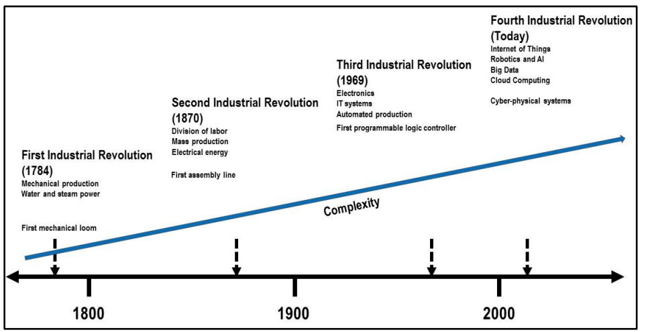
Figure 1: From Industry 1.0 to Industry 4.0
Industry 1.0: The first factories to use water or steam to power mechanical industrial equipment appeared around the end of the 17th century. With the aid of manufacturing equipment and cutting-edge energy sources, we saw a dramatic increase in output..
Industry 2.0: In 1870, the division of labour and mass manufacturing marked the beginning of the second industrial revolution. During this period of industrialization, electrical power replaced steam as the primary source of energy. At the tail end of the 18th century, we began to implement more scientific methods into production and corporate administration. We saw improvements in management with the technological developments in manufacturing and mass production. The field of classical management theory emerged around this period. Frederick Winslow Taylor's "The Principles of Scientific Management" was released in 1909. Based on his time spent working as a director of a mining firm, Henri Fayol penned the "14 Principles of Management" and published them in his book titled "Administration Industrielle et Générale.".
Industry 3.0: The employment of electronics and information technology (IT) systems in production marked the beginning of the third industrial revolution in 1969. Although electricity is still used to generate power, computers now provide the intellectual muscle behind the scenes in the "3.0" version of the business world. The electrical and information technological advancements that made possible the computational power needed for this industrial revolution.
Industry 4.0: Many professionals and academics believe that the fourth industrial revolution has already begun. The fourth industrial revolution is driven by new technologies, much as the previous three. A whole chapter is devoted to explaining Industry 4.0..
Industry 5.0: A number of online communities and weblogs are already discussing the next industrial revolution. Although we are currently in the midst of debating the dawn of the industrial revolution, it is fascinating to hear many futurists predicting the next revolution. However, it's possible that this is due to problems with Industry 4.0. Industry 5.0 receives its own dedicated section..
An estimated 1.6 million industrial robots are in use throughout the globe as of the beginning of 2016, citing the World Robotics 2016 Report. Additionally, it is anticipated that the global installation of industrial robots would increase by more than 13% year between 2016 and 2019. It is anticipated that growth would increase by double digits during the following several years. This explosive expansion is the consequence of a number of factors, as detailed in the study (International Federation of Robotics, 2016):
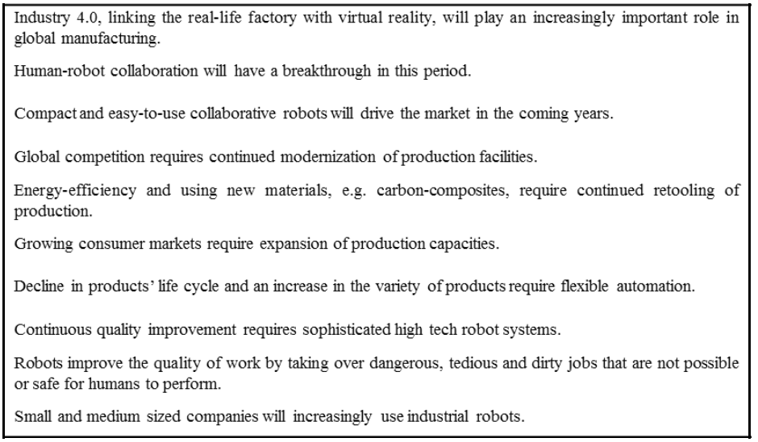
Table 1: Reasons for High Growth in Industrial Robot Installations
Increasing interest in and use of industrial robots for various purposes heralds the beginning of a new technological era..
Industry 4.0
Like past industrial revolutions, the purpose of Industry 4.0 is to improve production efficiency. It's the use of modern methods and equipment to produce goods in large quantities. In this view, it's clear that technology is the engine that drives industrial change. This is a cyclical process, after all. Industries benefit from technology and in turn generate demand for it. Also, the route to efficiency and effectiveness in industries establishes targets and generates a need for technology.
Industry 4.0 is predicated on smart manufacturing (Erkollar and Oberer, 2016). "Smart Manufacturing for the Future" is the tagline that Germany Trade and Invest (GTAI) has adopted for Indutrie 4.0. (Germany Trade and Invest, 2014). Smart industry, or "Industrie 4.0," is the transition from embedded systems to cyber-physical systems, as stated in the policy paper (Indutrie 4.0 - Smart Manufacturing for the Future). A paradigm shift from centralised to decentralised manufacturing is also facilitated by this.
Various cutting-edge technologies are, of course, helpful to the Industry 4.0 cause. These emerging technologies are information technologies (IT) that were not created with Industry 4.0 in mind. These cutting-edge gadgets include:
- Internet of Things (IoT)
- Cloud Computing
- Big Data
- Robotics and Artificial Intelligence (AI)
It is generally agreed that these technologies comprise the backbone of Industry 4.0. Many additional technologies, such as 3D printing, are also available. Industry 4.0 is being pushed forward by the European Union, and particularly Germany. Germany is a global powerhouse in the industrial sector and a global leader in many areas. Many articles have been published regarding the potential benefits of Industry 4.0. As a result, we give our attention to debates about Industry 5.0 as well as criticisms of Industry 4.0..
CRITIQUE OF INDUSTRY 4.0
Before Industry 4.0 was widely implemented, talks on what would become Industry 5.0 highlighted the shortcomings of the then-current industrial paradigm. Industry leaders and academics work together to define and conceptualise what we now call "Industry 4.0." The idea came about after several rounds of brainstorming and debate. This so-called revolution is, in this respect, top-down in nature. One may also argue that a bottom-up strategy is necessary. Research shows, for instance, that SMEs don't see the use in Industry 4.0 at the moment (Maier and Student, 2015). Some academics are likewise sceptical about Industry 4.0. (Hirsch-Kreinsen et al., 2016; Sachsenmeier, 2016). The revolution's viability is the first thing they question. The Internet of Things (IoT), robots, and big data all have large initial investment costs, making them impractical for widespread use by many enterprises across many sectors. When compared to large organisations, SMEs are at a disadvantage. It's important to remember the vital role that SMEs play in many markets. Negative social repercussions are another source of anxiety (Hirsch-Kreinsen et al., 2016). Due to technological advancements, many individuals may find themselves unemployed. However, technological advancements in industry result in brand new employment opportunities. Jobs created must outnumber those lost. People will have an unfavourable view of the new industrial revolution if this is not addressed. Industry 4.0 critics claim the movement is unimaginative. They claim that the product is the same but sold in different packaging. During the first industrial revolution, the idea of IT-supported manufacturing served as the groundwork. Thus, they argue that bolstering the sector with cutting-edge IT is a tired old tactic. Heavy reliance on the IT industry is inevitable as more businesses use IT. As time goes on, the IT industry as a whole will grow in wealth, size, and influence. Some people will naturally feel threatened by this. Yet, despite this trend in industry, IT firms were growing in prominence. Given the widespread integration of ICT into everyday life. Implications for one another will be unpredictable as IT and other sectors undergo rapid change. Uncertainty causes a natural dread of the future. The increasing independence of mechanical systems is also a source of worry. The first fully autonomous cars have hit the streets for testing. The sky is being overrun by unmanned aircraft systems. The public's mixed reactions to this kind of artificial autonomy are understandable. The most pressing concerns are security and the potential for privacy violation. Many different uses are found for the massive amounts of behavioural data collected by IT firms. The ultimate outcome may not be as harmless for the people even though the purpose is nice and economic. Such corporate practises are called "Surveillance Capitalism" by Zuboff (2016), who criticises them. According to Sachsenmeier (2016), there is a lack of completeness in current definitions of Industry 4.0 and associated ideas. There is obviously more work to be done on these ideas before they can be implemented in the industrial sector. According to Sachsenmeier (2016), there is a well-established pattern in the way ideas like this are implemented. To start, their potential is severely restricted at birth. Following this, interested parties from the political, academic, consultancy, and corporate spheres purchase and develop these ideas. The notion develops in response to the interests of these actors. The term "transformation" is used more often in conversations about this topic (Sachsenmeier, 2016). But the real world of commerce and culture has not yet been affected by these ideas. Findings from the German Allensbach Institute in April 2016 show that public opinion of Industry 4.0 has evolved from apathy to scepticism (Sachsenmeier, 2016).
According to a review of the 64 papers presented at the 10th Asia Pacific International Conference on Information Science and Technology (APIC-IST 2015), which took place in July 2015 in Da Nang, Vietnam, the vast majority of researchers have been concentrating on IoT and wireless sensor networks (Chung and Kim, 2016). There was a lack of study into areas such as 3D printing, the sharing economy, autonomous vehicles, nanotechnology, and biotechnology. According to Chung and Kim (2016), we need to prioritise a broad research agenda if we're going to successfully bring about the Fourth Industrial Revolution. An apparent focus and objective of Industry 4.0 is a rise in mass manufacturing. The fundamental shortcoming of Industry 4.0 as currently defined seems to be its disregard for environmental factors. Rada (2017) argues that the goal of Industry 5.0 should be to reduce waste and increase efficiency. The European Commission's goal for the bioeconomy is similarly focused on sustainability. Businesses and sectors should expect to feel significant effects from the bioeconomy..
INDUSTRY 5.0
Industry 5.0 might mean different things to different people. The fifth industrial revolution, or Industry 5.0, is about human and machine cooperation in the workplace, according to some futurists. Reference: (Johansson, 2017). The advantages of a mixed human and machine workforce are outlined by Gotfredsen (2016). Instead of a robotic manufacturing line, this will have a creative human touch. There will be an increase in available employment opportunities. Better roles will be created for humans to play on the industrial floor. Industry 5.0, as described by stergaard (2016), represents a return to more hands-on production management. Although Germany has been at the forefront of the fourth industrial revolution, Rendall (2017) contends that North America is in a prime position to take the reins in the fifth industrial revolution. Rendall (2017), like with many others, envisions human and machine working together in Industry 5.0. The concept of "Industry 5.0" has been the subject of several online threads and postings. Two industrial revolutions so close together, however, may be seen as a single event, according to Johansson (2017). To that end, Industry 4.0 may include interaction between machines and between humans (Johansson, 2017). We agree with Johansson, too (2017). The use of robots and AI is central to the concept of Industry 4.0. Inevitably, the development of AI and robotics will lead to the merging of human and machine forces. Supporting the case for a new industrial revolution with only the advent of human-machine cooperation on factory floors is lacking. When it comes to bionics and synthetic bionics, it's all part of Industry 5.0, according to Sachsenmeier (2016). In other words, bionics is a kind of technology that mimics or abstracts natural phenomena (Sachsenmeier, 2016). European Commission (2012) defines bioeconomy as:
Value-added goods, including food, feed, bio-based products, and bioenergy, are created via the production of renewable biological resources and the processing of these resources and waste streams. Agriculture, forestry, fishing, food processing, paper manufacturing, and a portion of the chemical, biotechnological, and energy sectors are all included. Its fields have a high potential for innovation because they draw on a variety of disciplines (biology, agronomy, ecology, food science, and social sciences), enabling and industrial technologies (biotechnology, nanotechnology, ICT, and engineering), and local and tacit knowledge.
Schütte (2017) argues that a bioeconomy is essential to building a sustainable economy. Ecological, economic, and industrial sustainability may all benefit from the careful utilisation of biological resources. In 2011, the German government announced the "National Research Strategy BioEconomy 2030," which placed bioeconomy at the top of the country's research policy agenda (German Federal Ministry of Education and Research, 2011). There are a total of five focus areas for this study programme. You may list them here:
- Securing global nutrition,
- Ensuring sustainable agricultural production,
- Producing healthy and safe foods,
- Using renewable resources for industry,
- Developing biomass-based energy carriers.
In Europe, the bioeconomy is crucial. It employs 22 million people at full capacity and generates a turnover of 2 trillion Euros each year. Schütte (2017) argues that the bioeconomy's guiding concept, biologization, may bring about a revolutionary shift in the industrial landscape. This means the bioeconomy has to play a crucial role in the next industrial revolution. Michael Rada proposes an alternative future for Industry 5.0. (Rada, 2015; Rada, 2017). According to Rada, one of the main goals of Industry 5.0 is to "use workforce of machines and people effectively, in cooperation with the environment." This transitions from the digital to the physical world is complete. Also, he defined what "industry 5.0" is (Rada, 2017). Industrial Upcycling is the driving force behind this future we see. The elimination of waste is central to this concept. Rada also emphasises the need of reintroducing human intervention during the production phase. He is very critical of the present tendency towards digitization, which he defines as the attempt to encode 1s and 0s into every living thing (Rada, 2015). Rada claims that the 6R framework and L.E.D. principles are integral parts of the Industry 5.0 paradigm. This is the 6R::
- Recognize: The first step is to appreciate the potential of industrial upcycling. The first necessary step is to become aware of it..
- Reconsider: Our business and production procedures need analysis and revision. Industrial Upcycling requires a process change to be fully realised..
- Realize: Business process improvement or innovation is the next step after identifying opportunities and reevaluating current procedures..
- Reduce: The essence of the technique is to make less wasteful use of resources in order to get better results..
- Reuse: The technique also emphasises recycling the resources that were already deemed viable for use before the procedure was optimised..
- Recycle: One of the primary goals of the industrial upcycling movement is to maximise recycling. The ideal, of course, is the zero waste scenario..
A real definition of a business improvement model is provided by the 6R approach. The term "business process innovation" or "business process improvement" may be used interchangeably depending on the circumstances. As a result, the rules, assumptions, and dynamics of process improvement attempts must be taken into account while using the 6R technique.
Logistics Effectiveness Model It was created with the goal of enhancing supply chain efficiency on a global scale. The purpose of this system is to reduce the inefficiencies that occur in today's typical vendor-buyer relationships. Lean, Effective, and Dynamic (L.E.D.) is the integration of supply chain practises that maximise visibility, profitability, and effectiveness all at once (Rada, 2017).
The term "Industrial Upcycling" refers to the process of reusing or repurposing four distinct types of garbage. There are many types of trash that need to be distinguished...
Physical Waste: The tangible remnants left behind from manufacturing and its aftermath. Essentially, it's garbage..
Social Waste: Simply said, it's the untapped potential of the workforce. Unemployment is the root cause of societal waste..
Urban Waste: Brownfields, vacant lots, and outdated infrastructure all fall under the category of "wasted space."
Process Waste: Overproduction, surplus inventory, and idle transport trucks are all examples of process waste.
If you ask Rada, best quantity and mass production are at the heart of the Industry 4.0 movement. Industry 5.0, on the other hand, is centred on improving people's quality of life via innovation and premium, tailor-made goods. Sustainability is Industry 5.0's overarching topic. It's important to remember that many businesses have launched green manufacturing and production initiatives in recent years. In addition, they prioritise CSR initiatives. People are becoming more conscious of the need to safeguard the environment. People start buying from businesses who are pioneering environmentally friendly manufacturing practises. Table 2 contrasts Industry 4.0 with its successor, Industry 5.0. It is important to remember that none of the two aforementioned industrial revolutions has really taken place. We may draw this parallel from the present debates. Possible major deviations from the now described revolutions exist. A superficial comparison reveals that industry 5.0 will have far-reaching and profound effects on society.
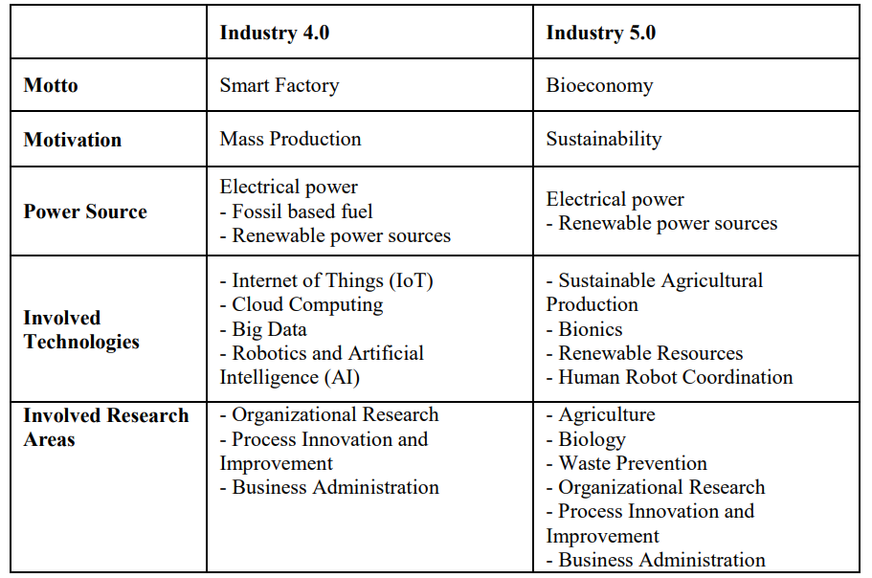
Table 2: Comparison of Industry 4.0 and Industry 5.0
Conclusion
The Fourth Industrial Revolution (Industry 4.0) is in its infancy. At the start of the 2010s, it was released to the public. In only a few short years, several futurists began debating what they called "Industry 5.0." Furthermore, these thinkers highlight the flaws in Industry 4.0 and offer Industry 5.0 as a solution. Industry 4.0 may have been implemented without proper foresight. Unlike previous industrial revolutions, which developed organically, Industry 4.0 is legally defined and imposed. It may be argued that the anticipated commencement of the artificial revolution is too soon.
For a notion to be considered a "industrial revolution," significant shifts must be seen throughout all sectors of the economy and in people's lifestyles. Based on the existing definition, "Industry 4.0" is more akin to a suggestion than anything else. Clearly, progress is still being made in the realm of Industry 4.0. Apparently, the point of Industry 4.0 is to facilitate smart mass manufacturing.
Industry 5.0 ideas centre on environmental sustainability. Both of them are insufficient on their own. One should keep in mind that mass production and sustainability are not incompatible. It may be more effective to merge these two directions or themes and reimagine the next industrial revolution. In light of this, "sustainable smart production" need to serve as the rallying cry for the subsequent industry. What's more, the next industrial revolution - whatever you want to call it, call it, or define it - should include the following technologies and fields of study:
- Internet of Things (IoT)
- Cloud Computing
- Big Data
- Robotics and Artificial Intelligence (AI)
- Sustainability and environmental protection
- Bioeconomy
- Waste Prevention
- Business Administration and Organizational Research
REFERENCES
- Chung, M., & Kim, J. (2016). The Internet Information and Technology Research Directions based on the Fourth Industrial Revolution. TIIS, 10(3), 1311-1320.
- Erkollar, E., Oberer, B. (2016). Endüstri 4.0 Akıllı Üretim İçin Politika ve Programlara Ait Bir Örnek: Alman Akıllı Çözümleri, In Smart Technology & Smart Management Edited by Vahap Tecim, Çiğdem Tarhan, Can Aydın. 2016, İzmir, Turkey
- European Commission (2012). Innovating for Sustainable Growth - A Bioeconomy for Europe. Retrieved from http://ec.europa.eu/research/bioeconomy/pdf/bioeconomycommunicationstrategy_b5_brochure_web. pdf .
- German Federal Ministry of Education and Research (2011). National Research Strategy BioEconomy 2030 - Our Route towards a biobased economy. Retrieved from https://www.bmbf.de/pub/National_Research_Strategy_BioEconomy_2030.pdf.
- Germany Trade and Invest (2014). Industrie 4.0. Smart Manufacturing for the Future. Supported by the German Federal Ministry of Economic Affairs and Energy, No 18473. https://www.gtai.de/GTAI/Content/EN/Invest/_SharedDocs/Downloads/GTAI/Brochures/Industries/i ndustrie4.0-smart-manufacturing-for-the-future-en.pdf, Accessed on 15 June 2017.
- Gotfredsen, S. (2016). Bringing back the human touch: Industry 5.0 concept creating factories of the future. Retrieved from http://www.manmonthly.com.au/features/bringing-back-the-human-touchindustry-5-0-concept-creating-factories-of-the-future/ .
- Hirsch-Kreinsen, H., Weyer, J., & Wilkesmann, J. D. M. (2016). “Industry 4.0" as Promising Technology: Emergence, Semantics and Ambivalent Character.
- International Federation of Robotics (IFR) (2016). Executive Summary. World Robotics 2016 Industrial Robots, Retrieved from https://ifr.org/img/uploads/Executive_Summary_WR_Industrial_Robots_20161.pdf.
- Johansson, H. (2017) Profinet Industrial Internet of Things Gateway for the Smart Factory. Master’s Thesis in Embedded Electronic System Design, Department of Computer Science and Engineering, Chalmers University Of Technology, University Of Gothenburg Gothenburg, Sweden 2017.
- Maier, A. and Student. D. (2015) Industrie 4.0 – der große Selbstbetrug, Manager Magazin, 13.02.2015, Retrieved from http://www.manager-magazin.de/magazin/artikel/digitalerevolutionindustrie-4-0-ueberfordert-deutschen-mittelstand-a-1015724.html .
- Østergaard, E. H. (2016). Industry 5.0 – Return of the human touch. Retrieved from https://blog.universal-robots.com/industry-50-return-of-the-human-touch .
- Pfeiffer, S. (2017). The Vision of “Industrie 4.0” in the Making—a Case of Future Told, Tamed, and Traded. NanoEthics, 11(1), 107-121.
- Rada, M. (2015) INDUSTRY 5.0 - from virtual to physical, 1 December 2015, https://www.linkedin.com/pulse/industry-50-from-virtual-physical-michael-rada, Accessed on 1 June 2017
- Rada, M. (2017) INDUSTRY 5.0 definition, 3 February 2017, Retrieved from https://www.linkedin.com/pulse/industrial-upcycling-definition-michael-rada.
- Rendall, M. (2017). The New Terminology: CRO and Industry 5.0. Retrieved from https://www.automation.com/automation-news/article/the-new-terminology-cro-and-industry-50.
- Sachsenmeier, P. (2016). Industry 5.0—The Relevance and Implications of Bionics and Synthetic Biology. Engineering, 2(2), 225-229.
- Schütte, G. (2017). What kind of innovation policy does the bioeconomy need? New Biotechnology.
- Zuboff, S. (2016). The Secrets of Surveillance Capitalism, FAZ.NET, 05.03.2016, Retrieved from http://www.faz.net/aktuell/feuilleton/debatten/the-digital-debate/shoshana-zuboff-secrets-ofsurveillance-capitalism-14103616.html?printPagedArticle=true#pageIndex_2 .

