EXPERIMENTAL INVESTIGATIONS ON ECO-FRIENDLY BLOCKS
Pawan Ghimire¹, Subhash Kumar Sah², Hakim Khan Hoshmand³, Tenzin Gyeltshen⁴, Dimple Bahri⁵
^{1,2,3,4}UG Students, Department of civil Engineering, Jain University, Bengaluru, India
⁵Assistant Professor, Department of Civil Engineering, Jain University, Bengaluru, India

---------------------------------------------------------------------***---------------------------------------------------------------------
Abstract - Concrete blocks are widely used as a building material due to their strength, durability, and cost. However, the production of concrete blocks also has a significant effect on the environment. It uses large amounts of cement, and the production of cement produces large amounts of greenhouse gases. One promising approach is to use alternative materials that have a lower carbon footprint as a partial replacement for cement. Rice husk ash is an agricultural waste that is produced by burning the outer shell of the paddy and comes out as a waste product from mills. It has pozzolanic properties, making it a suitable substitute for the partial replacement of cement in concrete production. Another strategy for making concrete blocks more eco-friendly is to incorporate plastic waste into the concrete mix. Plastic waste is an environmental issue, with large amounts ending up in landfills or polluting the oceans. We can use plastic waste in concrete blocks, preventing it from going to landfills. In this project, the use of RHA and plastic waste is combined to produce more sustainable concrete blocks. Cement is replaced for different percentages of RHA (5%, 10%, and 15%) and RHA Concrete blocks were cast, and the optimum strength was determined at 10% replacement. Again, along with the 10% RHA replacement, coarse aggregate is replaced by 2%, 4%, and 6% shredded plastic. The compressive strength of RHA-Plastic Concrete Block was determined, and it was found that compressive strength drastically decreases with the use of plastics. With the use of RHA, the water absorption of blocks decreases. The water absorption of RHA-Plastic blocks also decreased with the use of plastic.

Key Words: Eco-friendly, Environment, Concrete, Block, Rice husk ash, Shredded plastic.

1. INTRODUCTION

Due to excessive resource consumption and mining, the building industry's rapid expansion has resulted in environmental problems. Concerns include environmental damage, ecological imbalance, and greenhouse gas emissions. Inadequate waste recycling leads to pollution and contamination. To reduce the impact on the environment, it is necessary to increase recycling and reuse of waste materials. Extensive research has been conducted on incorporating waste materials into concrete blocks to address the significant waste generated annually. Different waste materials have been investigated as substitutes for cement and aggregates, leading to concrete blocks with improved sustainability and value. Agro-wastes, in particular, have shown potential for enhancing properties like compressive strength and fire resistance. However, careful consideration of the unique characteristics and limitations of each waste material is essential to maximizing its potential for producing environmentally friendly concrete blocks with added value.
According to studies, the majority of the rich materials might be used as a partial replacement for cement. This includes Rice husk ash, sugar bagasse ash, water hyacinth, etc. Rice husk ash, a valuable byproduct obtained from burning rice husk, the outer layer of rice grains, is rich in silica, cellulose, and lignin, typically comprising 15% to 20% silica content. In construction, this ash offers a sustainable alternative to cement. There are many benefits of using rice husk ash as a cement substitute.
Plastic, a versatile material created in 1907, has revolutionized numerous industries. However, the worldwide plastic trash epidemic has emerged as a major source of worry. Improper disposal and the non-biodegradable nature of plastics have resulted in environmental issues. In order to solve this problem, construction projects could use shredded plastic in place of coarse aggregate. Construction projects can help reduce waste and advance a circular economy by substituting shredded plastic for conventional coarse aggregate. The plastic granules may be combined with cement or other substances to produce composite materials with the desired qualities. The use of natural resources like gravel or sand is also reduced as a result of this strategy, which also lessens the amount of plastic trash that ends up in landfills. Shredded plastic can be used in buildings as a resource-saving, environmentally beneficial substitute.

Therefore, in this project, rice husk ash is used as a partial replacement for the cement, along with shredded plastics as the replacement for coarse aggregate in concrete blocks. The unique and value-added properties of each type of waste material are highlighted and discussed in detail, as are the basic properties of concrete blocks. This aims to provide a general idea of the future development of value-added eco-concrete blocks containing waste materials.

2. OBJECTIVES & METHODOLOGY
2.1 Objectives
- To evaluate the optimized percentage of cement replacement with Rice husk ash and determining the optimum percentage replacement of coarse aggregate by plastic waste.
- To investigate the mechanical property of eco-friendly blocks.
- To study the durability property of eco-friendly blocks.

2.2 Methodology
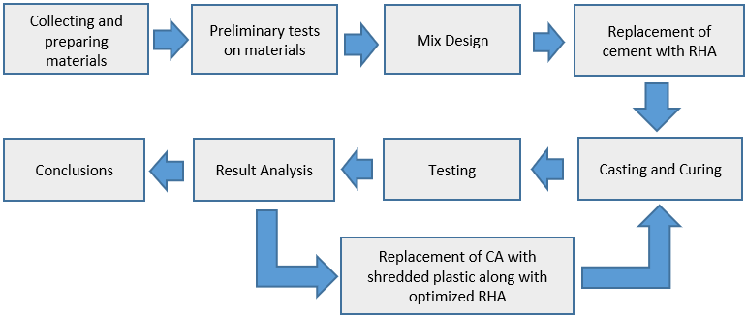
Fig. 1 Flowchart of Methodology

The acquisition of materials such as cement, fine aggregate, coarse aggregate, and rice husk ash was accomplished. Rice husk ash is brought from the ACT laboratory. Plastics were collected from the campus hostels and outside of the Jain University campus. The plastics were cleaned and dried in the sunlight. After that, the plastic was shredded into small pieces with the scissors and grinder. All the materials tests were conducted, and mix design was done as per IS 1062: 2009. After the mix design, cement was replaced with rice husk ash at 0%, 5%, 10%, and 15%. Blocks were cast in sizes of 190 mm x 100mm x 100mm. The compressive strength test is done on the 7th, 14th, and 28th days. The rice husk ash, with its marginal reduction in strength, is used with the shredded plastics. Coarse aggregate is replaced with shredded plastic by 2%, 4%, and 6%, and the blocks are cast along with the optimum rice husk ash. After curing, compressive strength tests are done for RHA-Plastic Concrete blocks on the 7th, 14th, and 28th days. The water absorption test is also carried out on blocks.

3. MATERIAL PROPERTIES

3.1 Cement
Ordinary Portland Cement (Birla) of Grade 53 was used in this project.

3.2 Rice Husk Ash
Rice husk ash was imported from the ACT Laboratory and used as a replacement for cement.
3.3 Shredded Plastic
Low density Polyethylene was collected from the campus hostel and outside of Jain university. Plastic was cleaned and dried in the sunlight and shredded into pieces with the help of scissor and grinder.

3.3 Water
Potable water from the laboratory tap is used for mixing.
3.4 Aggregate
Manufactured sand is used as fine aggregate, and 8mm coarse aggregate is used. For this project, the same type of coarse aggregate that is used in block factories is utilized.

4. MIX PROPORTION
Cement = 416 kg
Fine aggregate = 919.51 kg
Coarse aggregate = 819.72 kg
Ratio Proportion = 1: 2.21: 1.97
Materials Required for making 1 block
Table 1: Mix proportion of RHA Concrete Block
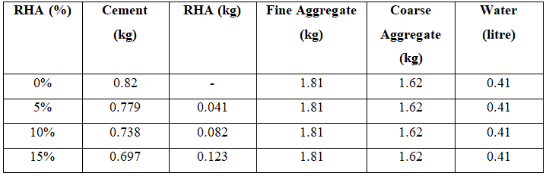

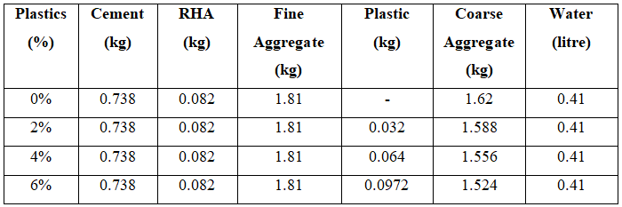
Table 2: Mix proportion of RHA-Plastic Concrete Block

Note: Coarse aggregate is replaced with shredded plastic (2%, 4% and 6%) in the optimum RHA (10%).
5. MIX PROCEDURE
All of the elements are hand blended in a dry state until a uniform color is attained. The water is then added and stirred for 4 minutes to ensure even distribution.
6. CURING
The blocks were demolded after 24 hours and taken into the curing tank for curing. Blocks were cured for 7, 14 and 28 days.

8. PROPERTIES OF CONCRETE
A. Fresh property of concrete
i) Workability of concrete
The slump test is used to measure the consistency or workability of freshly mixed concrete. It indicates the concrete mixture's water quantity, aggregate dispersion, and overall quality. In this test, the cone is filled with concrete layer by layer with 25 tampings each. Then the cone is vertically lifted. The slump test is shown in the figure.
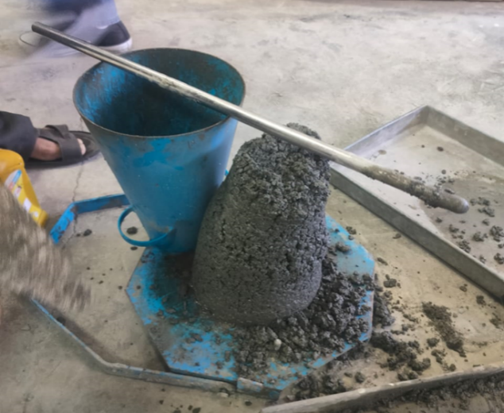
Fig. 2 Slump test
B. Mechanical properties of concrete blocks
i) Compressive strength test
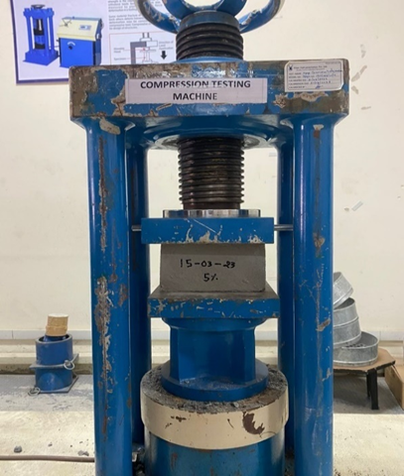
The compressive strength test was carried out on both RHA concrete block and RAH plastic concrete specimens of size 190 mm x 100 mm x 100 mm in a compression testing machine of capacity 2000 KN, as per IS 516:1959 Specification. It is shown in the figure below.

Fig. 3 Compressive strength test
C. Durability property of concrete blocks
i) Water Absorption of blocks
The water absorption of concrete cubes is a significant characteristic that reflects the concrete's resistance to water penetration. The concrete blocks were taken from the curing tank after 28 days of curing and allowed to air-dry until they attained a steady weight. The blocks were then placed in an oven and dried for 24 hours at 110°C. After drying, the blocks were removed, cooled, and weighed. These oven-dried blocks were then immersed in a curing tank for 24 hours. After the specified time, the blocks were removed from the tank, weighed again, and the water absorption was calculated based on the change in weight.

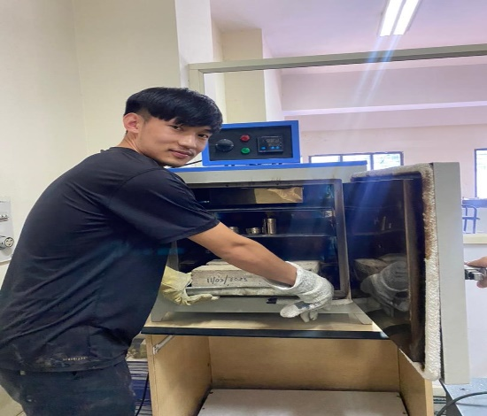

Fig. 4 Water Absorption test
9. RESULTS AND DISCUSSION

A. TEST ON CEMENT
Table 3: Physical properties of cement
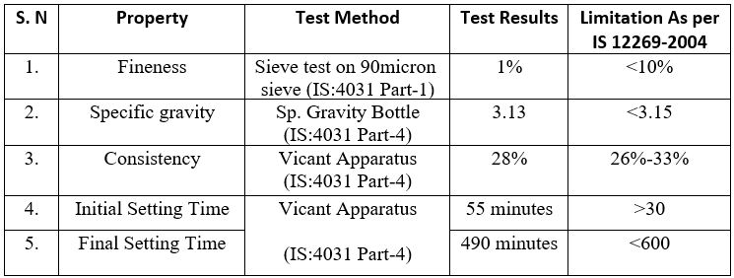

B. TEST ON RICE HUSK ASH
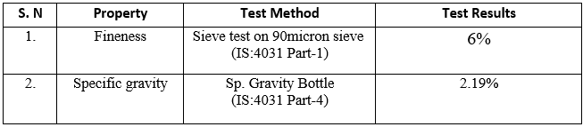
Table 4: Physical properties of RHA

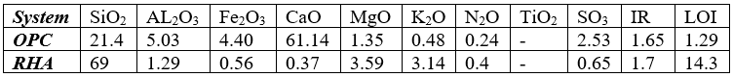
Table 5: Chemical properties of OPC and RHA

C. TEST ON SHREDDED PLASTIC
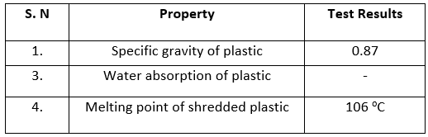
Table 6: Physical properties of shredded plastic

D. TEST ON AGGREGATES
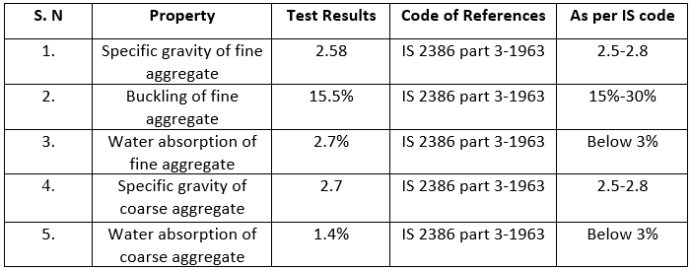
Table 7: Physical properties of aggregates

E. WORKABILITY OF CONCRETE
Table 8: slump test value

F. COMPRESSIVE STRENGTH

Fig. 5 Compressive Strength of RHA Concrete Blocks

Fig. 6 Compressive Strength of RHA-Plastic Concrete Blocks

G. WATER ABSORPTION

Fig. 7 Water Absorption of RHA Concrete Blocks

Fig. 8 Water Absorption of RHA-Plastic Concrete Blocks

10. CONCLUSIONS
- The average compressive strength of partially replaced cement by Rice husk ash for M-25 mix for proportions of 0%, 5%, 10% and 15% are 29Mpa, 26.18Mpa, 27.3Mpa and 21Mpa respectively at 28th day of curing.
- The average compressive strength reduced marginally with the 10% replacement of cement by RHA in comparison to conventional blocks, and it was 27.3MPa at 28th day.
- The average compressive strength of blocks with Optimum use of rice husk ash along with the replacement of coarse aggregate by shredded plastic with the 2%, 4% and 6% are 17Mpa, 13Mpa and 10Mpa at 28th day of curing respectively.
- The compressive strength of RHA-Plastic Concrete Blocks has been remarkably reduced with the replacement of coarse aggregate by shredded plastic.
- The water absorption of RHA Concrete blocks decreases as the percentage replacement of RHA increases. And the water absorption of RHA-plastic Concrete blocks also decreases with the increase in the percentage replacement of Shredded plastic.

ACKNOWLEDGEMENT

We would like to thank Dr. Hariprasad S.A., Director, Faculty of Engineering & Technology, JAIN (deemed to be the University), Dr. Dushyanth V. B. R., Head-UG, and Dr. Dasarathy A. K., Head of the Department, Department of Civil Engineering, guide Prof. Dimple Bahri, Assistant Professor, Department of Civil Engineering, Lab Assistant Mr. Channabasayya G.K., Project Coordinator Dr. Roshita David, and all the staff members of the Civil Engineering Department for their support, and Banashankari Concrete Blocks for providing the materials. We are also grateful to our family and friends, who provided us with everything we needed throughout the course.

REFERENCES

- Sahani, K., Joshi, B. R., Khatri, K., Magar, A. T., Chapagain, S., & Karmacharya, N. (2022). Mechanical properties of plastic sand brick containing plastic waste. Advances in Civil Engineering, 2022.
- Souza, A. B., Ferreira, H. S., Vilela, A. P., Viana, Q. S., Mendes, J. F., & Mendes, R. F. (2021). Study on the feasibility of using agricultural waste in the production of concrete blocks. Journal of Building Engineering, 42, 102491.
- Rocha, J. H. A., Rosas, M. H., Chileno, N. G. C., & Tapia, G. S. C. (2021). Physical-mechanical assessment for soil-cement blocks including rice husk ash. Case Studies in Construction Materials, 14, e00548.
- Khandelwal, V. (2019). Replacement of sand with shredded plastic in cement concrete. Int. J. Eng. Res. Technol, 8, 946-949.
- Waroonkun, T., Puangpinyo, T., & Tongtuam, Y. (2017). The development of a concrete block containing PET plastic bottle flakes. Journal of Sustainable Development, 10(6), 186.
- Verma, G., Khan, M. A., & Kumar, A. (2016). Effect of waste plastic as partial replacement of aggregate in concrete mixture: a review. Int Res J Eng Technol, 3(2), 1634-1636.
- Sutas, J., Mana, A., & Pitak, L. J. P. E. (2012). Effect of rice husk and rice husk ash to properties of bricks. Procedia Engineering, 32, 1061-1067.

