Book chapter

Biosurfactants: Needs and Future of new pharmaceutical additive to improve solubility in Global pharmaceutical and cosmetic industries

Sandeep Singh Bhadoriya^{1*}, Dr. Sachin Kumar Jain², Dr. Prashant Wadagbalkar ³

1. Malwanchal University, Indore Madhya Pradesh, India

2. Oriental University, Indore, Madhya Pradesh, India

3. Amaltas Medical College, Dewas, Madhya Pradesh, India

Introduction

Surface active agents are amphiphilic molecules that aggregate at interfaces, reducing cross-linking and forming cluster structures such as micelles [1]. Many synthetic and mainly petroleum-based surfactants are now available to meet the current surfactant needs of the market. Only 32% of the world production of surfactants is used in industry and about 54% of this is used in household/laundry detergents [2]. Surfactants come in many forms and are generally divided into four groups based on their charge: anionic, nonionic, cationic, and amphoteric. Most chemically derived antibiotics are cationic surfactants that are also effective against Gram-positive bacteria. Anionic and nonionic surfactants are non-toxic and effective against gram-negative bacteria. There are many important surfactants such as fatty alcohol ethoxylates (FAEO), linear alkylbenzene sulfonates (LAS) and lauryl ether sulfates (LES) [3]. Growing information of the application of renewable resources and "green products" has encouraged the development of alternatives to conventional surface active agents. Biosurfactant (BS) is an example of environmentally friendly alternatives [4]. Biosurfactants can be obtained from biologically continuous materials by microbial fermentation or enzymatic synthesis [5]. The main characteristic of biosurfactants is their low micelle concentration (CMC). This indicates that biosurfactants are more effective at lower concentrations than many chemically prepared surfactants. Biosurfactants are good choices for "green" detergents and surfactants because they can be biodegradable and only require a minimal amount to solve the problem. Important Components in Pharmaceutical Products: Surfactants, substances that reduce the surface energy of liquid, solid and/or gas phase interactions, have many roles in medicine [6,7]. Surfactants, in addition to their chemical structure, are amphiphilic, containing both hydrophilic and lipophilic domains. Their main role in medicine is to make drugs more soluble, especially those that are poorly soluble in water, including new and improved bioactive drugs (such as small molecular drugs, bio-peptides, bio- proteins, vitamins, vaccines and essential oligonucleotides) that can be delivered in-vivo. In addition, they increase the thermodynamic efficiency and diffusion rate as well as stability of the encapsulated drug. They are particularly crucial in the application of drugs to cell surface, cell membranes, skin surfaces and other biological surfaces. Bioactive Surfactants are also important plasticizers needed to improve the flowability and in vivo solubility of semi-solid delivery vehicles and viscous fillers such as those used in suppositories. For example, fatty acid esters of sucrose are important lubricants for tablets [8]. They can also be used as a wetting agent when mixing chemicals with powder, granule and nanoparticle-like carriers and dispersions. The most common application of surface-active agent is self-assembly in drug delivery devices. Self-mixing structures based on surfactant monolayers are emulsions, oil-in-water dispersions or vice versa. Emulsions are relatively large, typically microns to millimeters, and are thermodynamically unstable and often require mixing to achieve long-term stability. Both aerosol and microencapsulated media are prepared using emulsions. High-pressure homogenization can be used to prepared nanoemulsions or "microemulsions" with an average size of 0.05-1.0 ¬µm, which can be sterilized by application of microfiltration due to their small size and, again, easily prevent physiological clearance. enter interfaces in life. Nano-emulsions are commonly used for parenteral administration (as depicted in Figure 1). Water-oil-surface active agent mixtures often form thermodynamically stable microemulsions with a nanoscale structure [9,10]. Hydrophilic and lipophilic surfactant systems form O/W and W/O microemulsions, mainly consisting of spherical nanoparticles. Layered or bi-continuous microemulsions are dynamically mixed networks of oil and water separated by surface active agent monolayers and formed by a system of surfactants with balanced hydrophilicity and lipophilicity. Mixing water with ingredients that themselves microemulsify (emulsify itself) on contact with water is one way to create microemulsions (and emulsions) in vivo. Surfactants are also used as therapeutic agents. Examples of antimicrobial agents include glycolipid biosurfactants, amino acid surfactants and sugar fatty acid esters [11,12]. Glyco-lipid biosurfactant and polyunsaturated fatty acid monoacylglycerol (MAG) have anti-inflammatory properties [12,13]. Sophoro-lipid biosurfactants are anti-inflammatory agents [8]. Many cosmetics, emulsions and personal care products often contain surfactants (Figure 2 Represent commonly used conventional surfactants in Pharmaceutical and cosmetic Industry) [10, 11]. Conventional surfactants are nonionic and highly biocompatible. Separation of oligonucleotides requires the use of cationic surfactants. Recent studies have shown that bio-based cationic arginine derivatives can act as biocompatible carriers [12]. Phospholipids are a different class of bio-surfactants. Besides synthetic pulmonary surfactants used in the treatment of acute and neonatal depression [14,15], they are an important part of carriers called liposomes, that can consist of one or more phospholipid bilayers (monolayer or multilayer) [16-18].

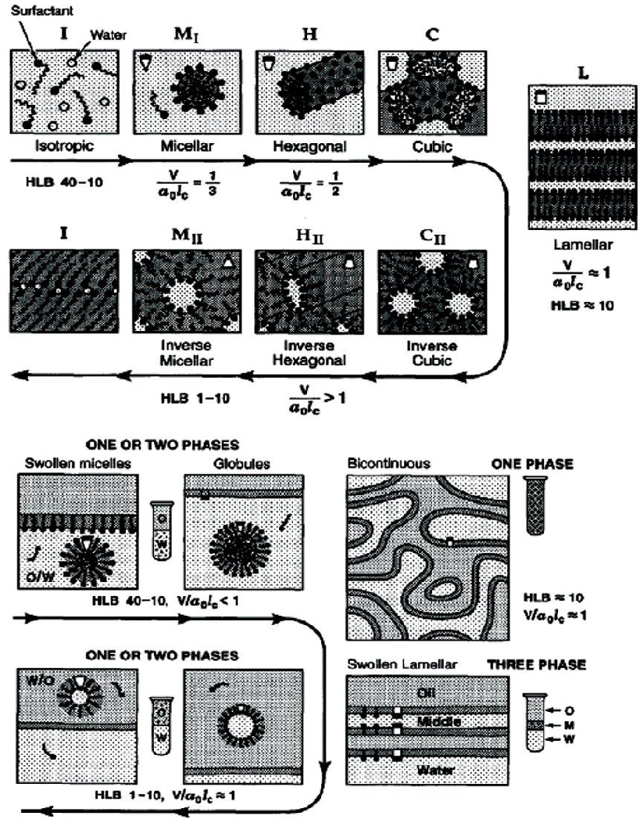

Figure 1: Surfactant self-assembly structures formed in: a) water surfactant and b) water-surfactant-oil systems as a function of the surfactant’s hydrophilic-lipophilic balance.

Merits of Biosurfactants

Biosurfactants have many merits over conventional chemically synthesized surfactants, some of which are: Biodegradability - Biosurfactants can be easily degraded by microorganisms [6]. Low toxicity - Biosurfactants are less toxic than conventional surfactants made from chemicals. In addition, it was shown that the EC50 values ​​of biosurfactants were higher than those of synthetic dispersants [7] (effective concentration reduces 50% of the test population). Availability of starting materials - Biosurfactants can be made from readily available and very cheap raw materials. The three main carbon sources are - hydrocarbons, carbohydrates and/or lipids - can be used individually or in combination [8]. Physical Factors - Many biosurfactants are unaffected by physical factors such as raised temperature, pH variation, and ionic strength tolerances. Lichen produced by Bacillus licheniformis strain was unaffected by temperatures up to 50 °C, pH range 4.5-9.0, and NaCl content of 50 g/l and Ca content of 25 g/l [9]. Surface Activity – A group of researcher stated that an ideal surfactant can reduce the surface tension of water from 75 to 35 mN/m and the surface tension of water/hexadecane from 40 to 1 m N/m [10]. Surfactin has the ability to lower the surface tension of water to 25 m N/m and the surface tension of water/hexadecane to <1m N/m [9].

Applications of Biosurfactants

1. Bio-compatibility and digestibility – This is an important application of biosurfactants as pharmaceutical additives, cosmetics adjuncts and functional food additives [8].

2. Surfactants used in Pharmaceutical industry are Primarily Natural resources based (Bio-based)
The development of "bio-based" surfactants is increasing, mainly due to the increase in raw material costs of crude petroleum compared to petrochemical raw materials (due to elevated global demand and reduced production and availability) and improvements in the sustainability of use from renewable raw materials [19]. In addition, dependence on dwindling crude oil supplies-exacerbated by growing global demand—has been related to environmental damage, including the 2010 Deepwater Horizon oil spill in the Gulf of Mexico, the year's worst environmental disaster. American history - as well as the production of greenhouse gases such as CO2 and their effects on climate change. These components have raised customer demand for more environmentally friendly products. Usually, the processing costs of bio-based surfactants are comparable to the production costs of petroleum-based surfactants. As a result, the market share of bio-based surfactants has recently raised and this trend is expected to continue. Most of the surface active agents are produced from renewable natural resources [19,20]. Sugar esters, polysorbates, MAG and fatty acid ethoxylates all derive fatty acid acyl components from oleo-chemicals, with fatty acid methyl or ethyl esters as the main feedstock, which make up the majority of biodiesel. Since fuels, chemical intermediates and bio-based products are produced in oil refineries, the development and expansion of petrochemical biorefineries effectively complement each other [19,20]. Raw materials enriched with saturated C10-C16 fatty acyl groups include palm, palm kernel (especially palm stearin, an acyl-rich by-product of palmitic acid fractionation of palm kernel oil), coconut oil and calyx oil. Cheap sources of 16:0, 18:0, 18:1, and 18:2 fatty acid groups are bacon, used cooking oils, waste oils, jatropha oil, sapineberry oil, sea-wood oil and soap. Castor oil, which is produced in Brazil, India and several other countries around the world, is a source of ricinoleic acid. Using heterogeneous catalytic reactions, medium chain fatty alcohols - the lipophilic group of APGs (Alkyl Polyglycosides) - can be prepared from either petroleum or fatty acid methyl esters. Rubber, soap, gums and other by-products of petrochemical production can be used directly for the production of phospholipids [21].
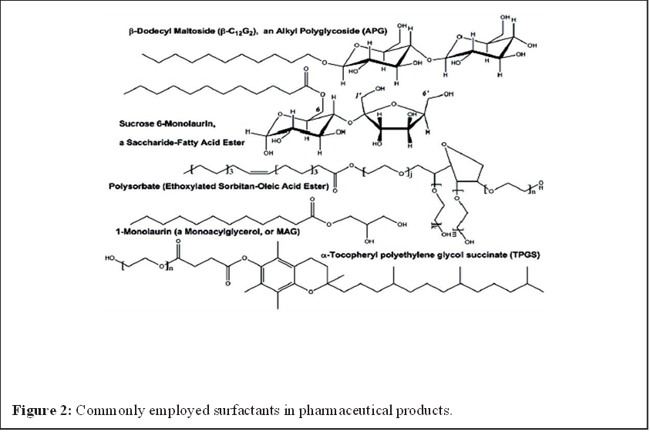

Applications of Biosurfactant in Pharmaceuticals and Cosmetic Industries
Biosurfactants have been suggested as a replacement for chemically produced surfactants in the cosmetics industry due to their effects on viscosity and product consistency through emulsification, foaming, water binding capacity, spreading, and wetting qualities (Table 1). These surfactants are used in insect repellents, antacids, bath products, acne pads, anti-dandruff products, contact lens solutions, baby products, mascara, lipsticks, toothpaste, dentine cleansers, and other items as emulsifiers, foaming agents, solubilizers, wetting agents, cleaners, antimicrobial agents, and mediators of enzyme action [22,23].

Table 1: Relevance of glycolipid biosurfactants to the pharmaceutical/cosmetic industry [23].

Glycolipid Type | Producing Organism | Activity | Pharmaceutical/Cosmetic Applications
Sophorolipids | Candida bombicola, Candida apicola | Antibacterial, Antioxidant, Moisturizing, Wetting, Foaming, Emulsifying, Stimulates dermal fibroblasts | Lotions, hair growth products, lip color, eye shadow, Anti-acne treatment, Body- -washes, deodorants, skin smoothing, anti-wrinkle products
Rhamnolipids | Pseudomonas aeruginosa | Antimicrobial, Emulsifying agent | Anti-wrinkle, and anti-aging products
Mannosylerythritol lipids | Candida antarctica | Antimicrobial, Emulsifying agent, Dispersant | Skin smoothing products and anti-wrinkle products

Bioprocessing Technology to Prepare biosurfactants for Pharmaceuticals

Enzymes can potentially produce many biobased surfactants [19]. Compared to chemical processing, bioprocessing has several merits, such as greater durability, lower energy consumption (due to low temperature), reduced production of waste and by-products, absence of harmful metal catalysts or acids/alkalis, and safer working conditions. The main demerits of using enzymes compared to chemical catalysts are their high cost (although this problem is mitigated if the enzymes are immobilized to allow re-use) and the slower reaction rates often associated with enzymatic reactions. In addition, due to the need to reduce inhibitory substances, the starting materials must be previously purified; for example, material containing fatty acyls must not contain phospholipids, aldehydes/ketones, peroxides or other impurities. However, enzymatic bioprocessing is expected to become cost competitive due to increased energy costs (as expected), increased safety benefits (due to government regulations and/or needed user products), and the capabilities of enzymes and their production systems increase (due to improved biotechnologies). Enzymatic bioprocessing is expected to become more competitive and attractive.

Discussion
Biosurfactants can improve the bioavailability of high molecular weight hydrophobic substances or drugs by increasing their surface area, desorbing them from surfaces and increasing their apparent solubility. This important property of biosurfactant can be used to develop drug formulations to improve bioavailability. Although the technology is still in its infancy, bioprocessing methods have been shown to have great application potential in the production of bio-based surfactants for pharmaceutical applications. Biocatalytic production is particularly attractive due to better durability, better selectivity of the desired products and less waste generation. To enable this approach, biotechnology must produce more robust enzymes at lower costs. Scientists and engineers continue to improve the design of enzymatic bioprocesses and eventually develop new biobased surface active agent for pharmaceutical applications as interest in and availability of renewable raw materials increases.

References

1. Van Hamme JD, Singh A, Ward OP (2006) Physiological aspects. Part 1 in a series of papers devoted to surfactants in microbiology and biotechnology. Biotechnol Adv 24: 604-620.
2. Banat IM, Makkar RS, Cameotra SS (2000) Potential commercial applications of microbial surfactants. Appl Microbiol Biotechnol 53: 495-508.
3. Develter DWG, Lauryssen LML (2010) Properties and industrial applications of sophorolipids. Eur J Lipid Sci Technol 112: 628-638.
4. Vaz DA, Gudiña EJ, Alameda EJ, Teixeira JA, Rodrigues LR (2012) Performance of a biosurfactant produced by a Bacillus subtilis strain isolated from crude oil samples as compared to commercial chemical surfactants. Colloids Surf B Biointerfaces 89: 167-174.
5. Syldatk C, Hausmann R (2010) Microbial Biosurfactants. Eur J Lipid Sci Technol 112: 615-616.
6. Chesko JR, Anderson C, Fox L, Kalvodova T, Dutil S, et al. (2009) Nonionic surfactants formulated into drug and vaccine delivery systems, in Non-Ionic Surfactants, edited by P.L. Wendt and D.S. Hoysted, Nova Science Publishers, Hauppauge NY USA 177-197.
7. Mishra M, Muthuprasanna P, Surya Prabha K, Sobhita Rani P, Satish Babu IA, et al. (2009) Basics and potential applications of surfactants-a review, Int J PharmTech Res 1:1354-1365.
8. Otomo N (2009) Biobased Surfactants and Detergents: Synthesis, Properties, and Applications, Hayes DG, Kitamoto D, Solaiman DKY, Ashby RD, (eds.). AOCS Press, Champaign, IL 275-298.
9. Garti N (2003) Microemulsions as microreactors for food applications. Curr Opin Colloid Interface Sci 8: 197-211.
10. Sagalowicz L, Leser ME, Watzke HJ, Michel M (2006) Monoglyceride SelfAssembly Structures as Delivery Vehicles. Trends in Food Science & Technology 17: 204-214.
11. Infante MR, Perez L, Moran C, Pons R, Pinazo A (2009) Synthesis, aggregation properties, and applications of biosurfactants derived from arginine. In: Biobased Surfactants and Detergents Synthesis, Properties, and Applications, Hayes DG, Kitamoto D, Solaiman DKY, Ashby RD, (eds.). AOCS Press, Champaign, IL USA 351-387.
12. Kitamoto D, Morita T, Fukuoka T, Imura T, Konishi M (2009) Self-assembling properties of glycolipid biosurfactants and their potential applications Curr Opin Colloid Interface Sci 14: 315-328.
13. Fortin S (2010) Polyunsaturated fatty acid monoglycerides, derivatives, and uses thereof. USA Patent 2009-535048, 20100160261.
14. Savić S, Tamburić S, Savić MM (2010) From conventional towards new-natural surfactants in drug delivery systems design: current status and perspectives. Expert Opin Drug Deliv 7: 353-369.
15. Müllertz A, Ogbonna A, Ren S, Rades T (2010) New perspectives on lipid and surfactant based drug delivery systems for oral delivery of poorly soluble drugs. J Pharm Pharmacol 62: 1622-1636.
16. Acosta EJ, Saad SMI, Kang N, Policova Z, Hair ML, et al. (2009) Lung surfactants: formulation, evaluation, and polymeric additives. In: Biobased Surfactants and Detergents: Synthesis, Properties, and Applications, Hayes DG, Kitamoto D, Solaiman DKY, Ashby RD, (eds.). American Oil Chemists’ Society Press, Champaign, IL USA 191-229.
17. Shailesh S, Neelam S, Sandeep K, Gupta GD (2009) Liposomes: a review. Journal of Pharmacy Research 2: 1163-1167.
18. Immordino ML, Dosio F, Cattel L (2006) Stealth liposomes: review of the basic science, rationale, and clinical applications, existing and potential. Int J Nanomedicine 1: 297-315.
19. Hayes DG (2009) Biobased Surfactants and Detergents: Synthesis, Properties, and Applications. D.G. Hayes DG, Kitamoto D, Solaiman DKY, Ashby RD. American Oil Chemists’ Society Press, Champaign, IL 3-25.
20. Giraldo L, Camargo G, Tirano J, Moreno-Pirajan JC (2010) Synthesis of fatty alcohols from oil palm using a catalyst of Ni-Cu supported onto zeolite. E-Journal of Chemistry 7: 1138-1147.
21. Gielen D, Newman J, Patel MK (2008) Reducing industrial energy use and CO2 emissions: the role of materials science. MRS Bulletin 33: 471-477.
22. Gharaei-Fathabad E (2011) Biosurfactants in pharmaceutical industry: A Mini Review. Am J Drug Discov Dev 1-11. 23. Williams K (2009) Biosurfactants for cosmetic application: Overcoming production challenges. MMG 445 Basic Biotechnology 5: 78.

