STRENGTHENING FPOs FOR WOMEN EMPOWERMENT THROUGH RENEWABLE AND SUSTAINABLE ENERGY: A STUDY IN BIHAR
*Dr MVK. Srinivas Rao & **Divya Bharti
ABSTRACT
In Bihar, about 97% of total landholdings and 76% of cultivated belong to Small and Marginal farmers. The establishment and promotion of FPOs are useful to states like Bihar in India because of their agricultural dependence and backwardness. Renewable energy generation will be a great tool for women empowerment though their active participation in FPOs via, canalizing their active participation towards generation of renewable energy along with their regular agricultural activities. This paper examines the status of women empowerment through FPOs and how renewable energy generation strategy would be helpful to create more incomes. The primary data was collected through pre tested interview schedule from 120 FPO members who were identified by stratified random sampling technique and analyzed by using appropriate statistical tools. The results of the research show that FPOs provide employment opportunities and income to the poor, house wives, students and unemployed who have no other means of income and opportunities to get some income sources and recognition in the society by reducing the household vulnerability in terms of nutrition, cloths, education and other expense. Renewable energy generation is costly affair which can be made possible with the collaboration of govt. agencies directly with the investment of cost required to generate renewable energy. However, many of them are not reaching their growth potential due to various factors mainly lack of market linkage, business premises, etc. Based on the findings policy options are given.

Key words: Renewable Energy, Sustainable energy, Small and marginal farmers (SMFs) , Women Empowerment, Farmer Producer Organization (FPO), Small Farmers' Agri-Business Consortium (SFABC), FPO Ecosystems, Minimum Support Price

*Dean, School of Commerce and Management Studies & Director, IQAC, Sandip University, Sijoul, Madhubani, Bihar
** Assistant Professor, School of Commerce and Management Studies Sandip University, Sijoul, Madhubani, Bihar

BACKGROUND AND RATIONALE:
Government of India has launched FPOs to organize small and marginal farmers into farmer collectives called FPOs. These FPOs, through economies of scale, aim to provide better collective strength to farmers for better access to production technology, value-addition services, high-quality inputs and marketing services for improving their incomes (Gurung, R. and Choubey, M. 2023). Women just like men have been involved in economic activities since early years. The contribution of women in economic activities is high in Bihar and playing multiple roles in the society: productive, reproductive and social that not fully recognized as economic contribution. However, their economic activities have focused primarily on meeting basic needs, yet lack of resources and control of resources has been common in Bihar like other developing countries. Government makes policy on women involvement of economy in every activity especially in FPOs business activities but not benefited as expected. The total FPOs registered in Bihar are 356 that include 38 Small Farmers' Agri-Business Consortium (SFAC), followed by 217 NABARD FPOs and 101FPOs registered by IAs under CSS for formation & Promotion of 10,000 FPOs (https://pib.gov.in) but the active FPOs with more women participation are 163 only. Hence there is a need to improve lot of measures from Govt. of Bihar to increase active FPOs with more women participation.
At the same time, the primary objective for deploying renewable energy in India is to advance economic development, improve energy security, improve access to energy, and mitigate climate change. Sustainable development is possible by use of sustainable energy and by ensuring access to affordable, reliable, sustainable, and modern energy for citizens. Strong government support and the increasingly opportune economic situation have pushed India to be one of the top leaders in the world’s most attractive renewable energy markets. The government has designed policies, programs, and a liberal environment to attract foreign investments to ramp up the country in the renewable energy market at a rapid rate. It is anticipated that the renewable energy sector can create a large number of domestic jobs over the following years (Kumar. J, C.R., Majid, M.A 2020). If we are able to combine these two forces and energies sources together that would create wonderful results and helpful the women empowerment and economic development in India.

2. The Conceptual Issues:
By the end of March 2019, there were approximately 7500 producer companies (PCs) registered in India (Neti, Govil and Rao 2019). The subsequent two years witnessed the registration of a large number of new PCs. Around the same time, the central government announced a scheme to promote 10,000 more producer organizations. This was followed by additional policy changes with the potential to favorably impact farmer producer organizations (FPOs). These rapid developments in both policy and practice warranted a re-examination of the current FPC landscape and the changes during the last two years (www.publications.azimpremjiuniversity.edu).
2.a. Farmers Producer Organizations:
A Producer Organization (PO) is a legal entity formed by primary producers, viz. farmers, milk producers, fishermen, weavers, rural artisans, craftsmen. A PO can be a producer company, a cooperative society or any other legal form which provides for sharing of profits/benefits among the members. In some forms like producer companies, institutions of primary producers can also become member of PO (www.nabard.org). The concept behind Farmer Producer Organizations is that farmers, who are the producers of agricultural products, can form groups. To facilitate this process, the Small Farmers’ Agribusiness Consortium (SFAC) was mandated by Department of Agriculture and Cooperation, Ministry of Agriculture, Govt. of India, to support the State Governments in the formation of Farmer Producer Organizations (FPOs). The role of FPO is to act as an aggregator for member farmers including from inputs to output which will enhance the economy of scale and bargaining power. Currently 2389 FPO's have been on boarded on e-NAM platform. FPOs bring together the cooperative values of mutual benefits to its members along with a corporate governance structure, and have become the preferred legal form for farmer collectives. The FPOs ecosystem in Bihar has grown rapidly during the period 2019-2022 with formation of 791 FPCs (www.enam.gov.in). The objectives of the FPO scheme are to build a sustainable agriculture sector by promoting and supporting Farmer Producer Organizations that enables farmers to improve production and productivity in the state, to provide support for the promotion of Farmer Producer Organizations through the qualified Resource Institutions (RIs), to promote economically viable and self-governing Farmer Producer Organizations, to provide the required assistance and resources such as technical knowledge, inputs, financial resources, and infrastructure to strengthen the FPOs, to enable farmers in accessing the markets through their FPOs, both as buyers and sellers, to create a policy environment for investments in FPOs to leverage their production and marketing strength (https://www.indiafilings.com).
2.b: FPOs in India: An overview:
2.b.1: The Frame of FPO Ecosystems in India:
The proposed framework can be broadly categorized into two parts: first, support system which provides support in various forms to the FPO; and second, operational structure which describes the activities of the FPO. Currently the producer organizations are getting support from multiple institutions via, SFAC, which is promoting and supporting producer organizations registered under the Companies Act; NABARD supports all forms of producer organizations; NCDC and NAFED are supporting cooperative forms of producer organizations. Under the proposed structure, a National Board for FPO (NBFPO) would act as the apex organization for promotion and development of all forms of producer organizations in the country.
There are several commodity specific boards existing in the country which are involved in development activities pertaining to the respective commodity. The National Board for FPO would also work in similar fashion. Various government institutions would work along with the national board so that there won’t be any sector-wise/geographical area wise overlapping or skewed development of FPOs. All the producer organizations may be part of a state level federation. The FPOs need four types of support which will drive growth and sustenance: Managerial competence, financial support, technology and capacity building. The financial support to the FPOs may be channelized through state level federation from various institutions. These government institutions along with CBBO, POPI and/or nearby KVKs would provide capacity building to the FPOs. The FPO federation may play active role in marketing promotion of the FPOs’ products at national and international level. In the current digital era, technology helps in improving operational efficiency and proper monitoring of the business activities. FPO would provide a platform for the agri-insurance companies to connect with the farmers for crop & livestock insurance. In forward linkage, the FPO would explore value addition possibilities, while Government may recognize the FPO as collection center as well as procurement center for the designated commodities under different schemes (www.naarm.org.in).
2.b.2: State wise details of FPOs in India:
As per the State wise details of FPOs in India under the scheme of formation and promotion of 10,000 FPOs by SFAC s on 21-7-23, Uttar Pradesh has occupied I st position by having 789 FPOs either registered or under the process of registration, out of 3599 FPOs across different states of our country, followed by FPOs of Madhya Pradesh 342, Bihar 290, Rajasthan 220, Maharashtra 210, Andhra Pradesh 206, Assam 166, Odessa 162, West Bengal 158 and so on. On the other hand, some state has very less FPO registrations via, Mizoram and Meghalaya 134each, Manipur 10 and Nagaland 8 (Table2.1).
Small Farmers Agribusiness Consortium (SFAC) is an Autonomous Society promoted by Ministry of Agriculture, Cooperation and Farmers’ Welfare, Government of India. It was registered under Societies Registration Act XXI of 1860 on 18th January, 1994. The Society is governed by Board of Management which is chaired, ex-officio, by Hon’ble Union Minister for Agriculture and Farmers Welfare as the President and the Secretary, Department of Agriculture, Cooperation and Farmers Welfare, Government of India, is the ex-officio Vice-President. SFAC is implementing the central schemes of Government of India namely VCA, EGCGS for economic inclusion of small and marginal farmers in agribusiness activities. Society is pioneer in organizing small and marginal farmers as Farmers Interest Groups, Farmers Producers Organization and Farmers Producers Company for endowing them with bargaining power and economies of scale. It provides a platform for increased accessibility and cheaper availability of agricultural inputs to small and marginal farmers and in establishing forward and backward linkages in supply chain management. This initiative has triggered mobilization of farmers for aggregation across the country with ultimate aim of sustainable business model and augmented incomes. Recently the Society has been entrusted with the task of implementation of the critically important Delhi Kisan Mandi and National Agriculture Market Scheme on e-platform to progressively free agricultural trade and offer price discovery to farmers (http://sfacindia.com).
Table 2.1: State wise details of FPOs in India
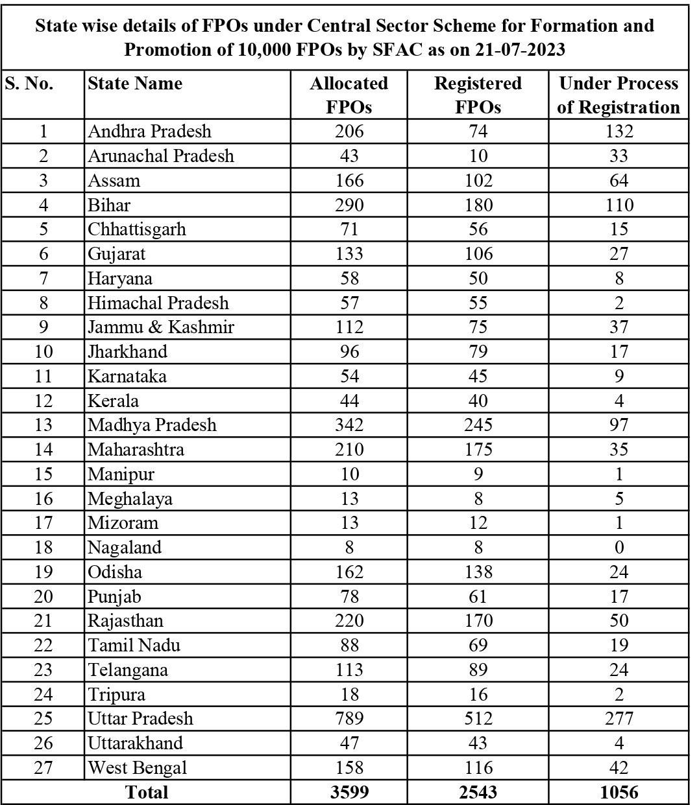
Source: http://sfacindia.com
2.b.3: FPOs in Bihar:
FPOs are promoted by Small Farmers Agri-Business Consortium (SFAC), followed by National Bank for Agriculture and Rural development (NABARD), Line department of state government, NGOs and private players. Nearly 7374 FPOs are mobilized across India (www.manage.gov.in).
Table 5.1: FPOs in Bihar
S.NO | District | NABARD FPOs |  | SFAC FPOs |  | NRLM FPOs |  | Total
 |  | No of FPOs | % | No of FPOs | % | No of FPOs | % | No of FPOs | %
1 | Araria | 02 | 1.69 |  |  |  |  | 02 | 1.23
2 | Arwal | 02 | 1.69 |  |  |  |  | 02 | 1.23
3 | Aurangabad | 03 | 2.54 |  |  |  |  | 03 | 1.84
4 | Banka | 01 | 0.85 |  |  | 01 | 14.28 | 02 | 1.23
5 | Begusarai | 01 | 0.85 |  |  |  |  | 01 | 0.61
6 | Bhagalpur | 01 | 0.85 |  |  |  |  | 01 | 0.61
7 | Bhojpur | 05 | 4.24 |  |  |  |  | 05 | 3.07
8 | Buxar | 01 | 0.85 |  |  |  |  | 01 | 0.61
9 | Darbhanga | 04 | 3.39 |  |  |  |  | 04 | 2.45
10 | East Champaran | 02 | 1.69 |  |  |  |  | 02 | 1.23
11 | Gaya | 03 | 2.54 | 02 | 5.26 |  |  | 05 | 3.07
12 | Gopalganj | 03 | 2.54 |  |  |  |  | 03 | 1.84
13 | Jamui | 08 | 6.78 |  |  |  |  | 08 | 4.90
14 | Jehanabad | 02 | 1.69 |  |  |  |  | 02 | 1.23
15 | Katihar | 02 | 1.69 |  |  |  |  | 02 | 1.23
16 | Khagaria | 02 | 1.69 |  |  | 01 | 14.28 | 03 | 1.84
17 | Kishanganj | 04 | 3.39 |  |  |  |  | 04 | 2.45
18 | Lakhisarai | 02 | 1.69 |  |  |  |  | 02 | 1.23
19 | Madhubani | 04 | 3.39 |  |  |  |  | 04 | 2.45
20 | Munger | 08 | 6.78 |  |  |  |  | 08 | 4.90
21 | Muzaffarpur | 06 | 5.08 | 06 | 15.79 | 02 | 28.57 | 14 | 8.59
22 | Nalanda | 10 | 8.47 | 03 | 7.89 | 01 | 14.28 | 14 | 8.59
23 | Nawada | 13 | 11.02 |  |  |  |  | 13 | 7.98
24 | Patna | 02 | 1.69 | 05 | 13.16 |  |  | 07 | 4.29
25 | Purnia | 02 | 1.69 | 02 | 5.26 | 01 | 14.28 | 05 | 3.07
26 | Saharsa | 03 | 2.54 |  |  | 01 | 14.28 | 04 | 2.45
27 | Samastipur | 04 | 3.39 |  |  |  |  | 04 | 2.45
29 | Saran | 02 | 1.69 |  |  |  |  | 02 | 1.23
30 | Sheohar | 02 | 1.69 |  |  |  |  | 02 | 1.23
31 | Sitamarhi | 03 | 2.54 |  |  |  |  | 03 | 1.84
32 | Supaul | 02 | 1.69 |  |  |  |  | 02 | 1.23
33 | Vaishali | 07 | 5.93 |  |  |  |  | 07 | 4.29
34 | West Champaran | 03 | 2.54 |  |  |  |  | 03 | 1.84
34 | East Champaran |  |  | 13 | 34.21 |  |  | 13 | 7.98
35 | Hajipur |  |  | 01 | 2.63 |  |  | 01 | 0.61
36 | Katihar |  |  | 02 | 5.26 |  |  | 02 | 1.23
37 | Rohtas |  |  | 01 | 2.63 |  |  | 01 | 0.61
 | Total | 118 | 100.00 | 38 | 100.00 | 07 | 100.00 | 163 | 100.00
 | Per cent- Horizontal |  | 72.39 |  | 23.32 |  | 4.29 |  | 100.00
Source: Author Compilation
The FPOs in Bihar with active women participation is steadily increasing. About 72.39 % of the FPOs are supported by NABARD, followed by SFAC (about 23.32 %) and NRLM (about 4.29 %)

2.c: Women Empowerment:
Women’s empowerment can be defined to promoting women’s sense of self-worth, their ability to determine their own choices, and their right to influence social change for themselves and others (www.worldvision.com.au). Empowerment is defined as “the process of enhancing an individual’s or group’s capacity to make purposive choices and to transform those choices into desired actions and outcomes’’ Empowerment is the process of obtaining basic opportunities for marginalized people, either directly by those people, or through the help of non-marginalized who share their own access to these opportunities. The development of MSMEs contribute for empowerment in terms of job creation, economic stability, and economic self-sufficient, improve family livelihood and improve their decision making on house hold expenditure. Ultimately their empowerment increase in terms of economy and social as well. The economic empowerment of women is one of the most fundamental components of achieving gender equality and women’s empowerment more broadly. If women participated in the economy identically to men, it would add up to USD 28 trillion, or 26%, to annual GDP in 2025 compared with a business-as-usual scenario; and this economic potential is highest in developing countries (www.oecd.org).
3. Renewable and Sustainable Energy:
The terms “renewable energy” and “sustainable energy” are often interchanged. However, their meanings are actually different. Renewable energy is defined as energy produced using natural resources that are constantly replaced and never run out. This includes, but is not limited to, solar energy, hydropower, bioenergy, geothermal, ocean energy, and wind energy. Sustainable energy refers to energy that meets the needs of the present generations without compromising the ability of future generations to meet their own needs (www.adecesg.com). Hence, Renewable energy is energy that is created and replenished naturally. Sustainable energy, on the other hand, is energy that reliably meets both the short- and long-term needs of a society. Sustainable energy maintains the natural environment. Its installations are made out of environment-friendly materials. The main source of Renewable energy are Sunlight and wind whereas, sustainable energies are hydroelectricity, biomass, geothermal, wind, wave, tidal and solar energies which maintains the natural environment. Its installations are made out of environment-friendly materials. On the other hand, Fossil fuels - coal, oil and gas are non-renewable resources that take hundreds of millions of years to form. Women formers can improve their living standards with the help of regenerating renewable energy from the abounded sources like wind and solar powers available at their fields with the help of govt. support agencies. Energy demand in the world is nowadays growing further out of limits of installable generation capacity. Therefore, future energy demands should be met by utilizing renewable energy sources. At present, the contribution of renewable energy to the world primary energy is not high to meet the primary energy and electricity supplies. Both developed and developing nations will necessarily continue to rely on fossil fuels in the coming decades. New enabling technologies related to renewable energies will help to reduce environmental costs, and thus the energy systems will be operated as both securely and economically without much environmental problems. New renewable energy markets are surely required in both the wholesale and retail markets (Şalvarlı, Mustafa & Salvarli, Huseyin. 2020). Under the PM-KUSUM scheme, FPOs can set up small solar power plants of up to 2 MW capacities and the power generated can be purchased by the distribution companies (www.thehindubusinessline.com).
4. Energizing Farmer Producer Organizations:

By March 2019, 7,374 FPCs had been formed with a total paid-up-capital (PUC) of ₹860.18 crore. In 2021, the ministry of agriculture and farmers’ welfare launched a central scheme to promote 10,000 farmer producer organizations with an allocation of ₹6,865 crore (www.livemint.com). Policy measures and the FPO ecosystems need strengthening to increase women’s participation. The recently announced 10,000 FPOs scheme isn’t gender transformative in nature and ignores women farmers. There are no gender specific targets for promoting women FPOs and participation of women farmers in mixed FPOs except for the mandate to have at least one female board member. Specific policy support that recognizes women led FPCs can pave the way to make them the beacon of women empowerment. Government schemes such as Dena Shakti Scheme, Pradhan Mantri Mudra Yojana may be tweaked to for easy access to capital for women FPCs. NITI Aayog’s Moving the Needle programme through The Women Entrepreneurship Platform can specifically target women led FPCs. RBI may create guidelines under PSL norms for easier access to capital for all women FPOs with practically no collateral. Increasing digital literacy through training and capacity building of women farmers through their FPOs will go a long way in keeping them up to date with technological tools. Leadership and governance training of such FPOs will ensure their long-term and financial viability. Apart from support from government through the above measures other players such as NGOs can also play an important role in creating the right eco system. Corporates may allot their CSR funds to building capacities of women FPOs and helping them with business linkages. Technologies should be developed to suit women farmers as well as ease the drudgery of household work. Not-for-profit organizations may work towards changing the mind-set among both women and men in villages towards supporting women in the entrepreneurial activities, operate their own bank accounts and become more self-reliant (https://www.dhyeyaias.com).
5. The Concept of Minimum Support Price:
Minimum Support Price (MSP) is a form of market intervention by the Government of India to insure agricultural producers against any sharp fall in farm prices. The minimum support prices are announced by the Government of India at the beginning of the sowing season for certain crops on the basis of the recommendations of the Commission for Agricultural Costs and Prices (CACP). MSP is price fixed by Government of India to protect the producer - farmers - against excessive fall in price during bumper production years. The minimum support prices are a guarantee price for their produce from the Government. The major objectives are to support the farmers from distress sales and to procure food grains for public distribution. In case the market price for the commodity falls below the announced minimum price due to bumper production and glut in the market, government agencies purchase the entire quantity offered by the farmers at the announced minimum price (www.vikaspedia.in).
Figure 5.1: Minimum Support Price for the farmers in India
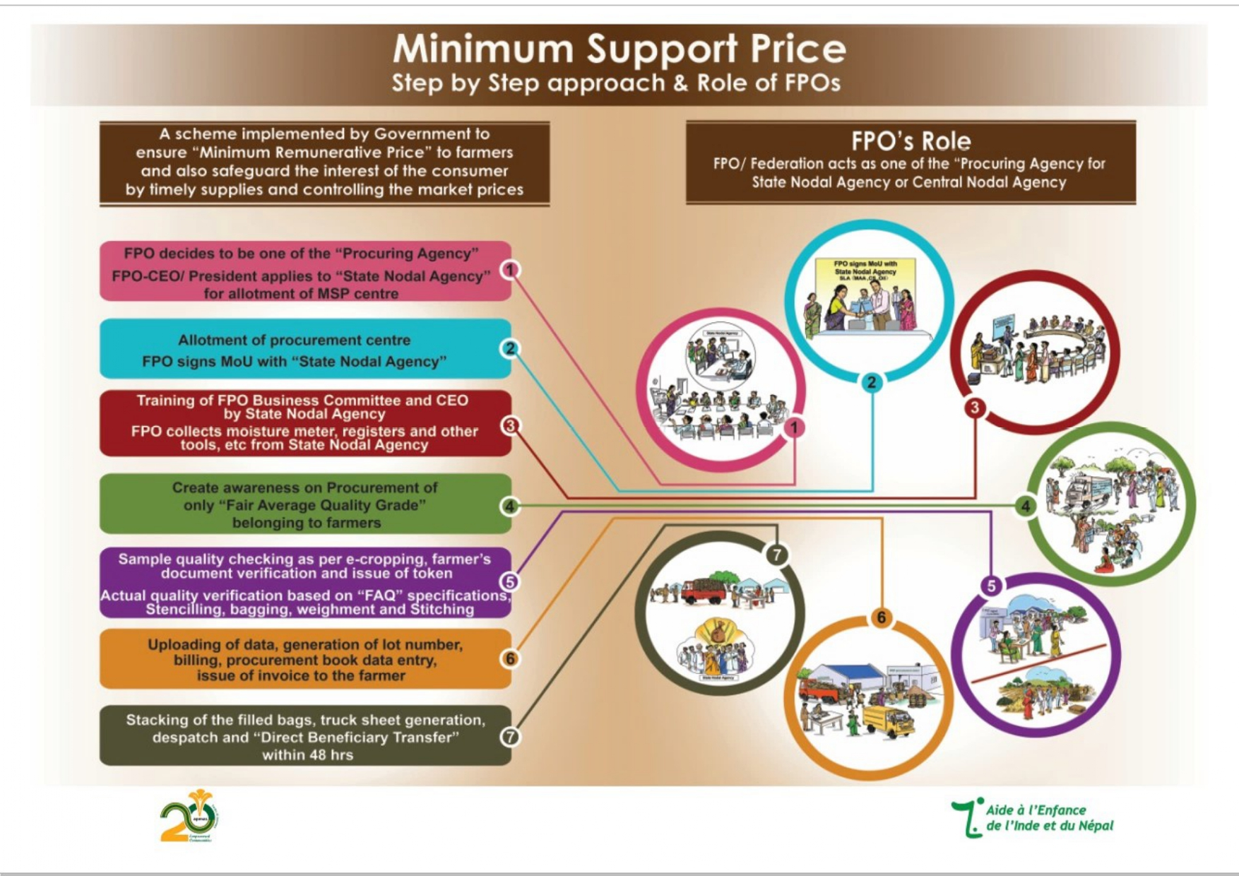
Source: www.vikaspedia.in

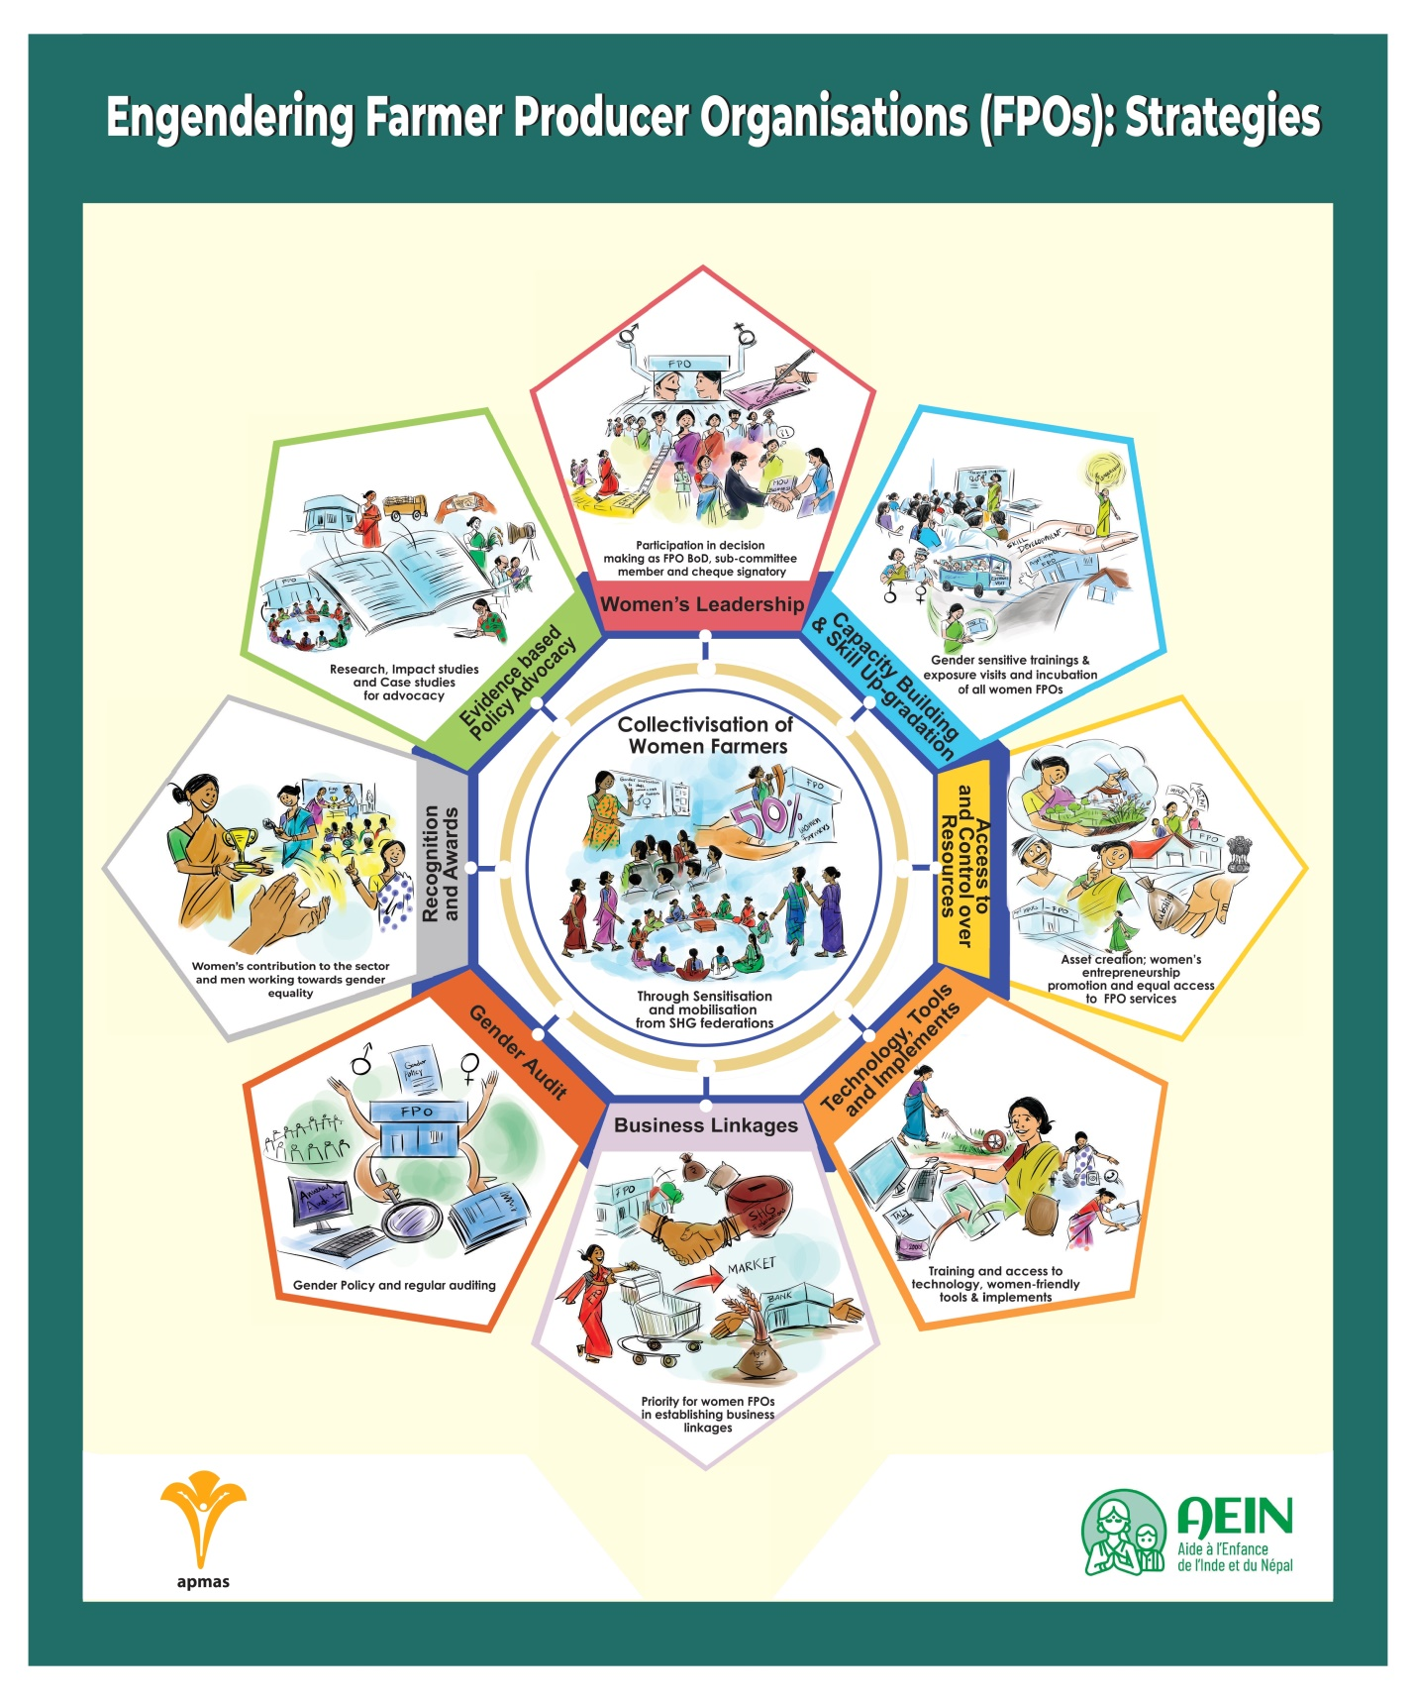

6. Factors affecting the Participation of Women in FPOs:

Education, farming experience, farming as the primary occupation, size of landholding, access to Internet, distance to the nearest market, medium level of social participation, extension contact, transportation facility and plan to expand the scale of operation in future are the major explanatory variables that have statistically significant impact on the farm households' participation in FPOs (Gurung, R. and Choubey, M 2023). Women are committed to their businesses: the proportion of women entrepreneurs using their savings for business purposes increased from 53% to 78% between 2017 and 2020.Women stay in business: Across 59 countries, the average rate for business discontinuance is about 10% lower for women than for men. Women are strong savers and prudent borrowers. Hence, Ensure the mixed up FPOs, with minimum 30% women as shareholders and in the governance structure of FPOs, Offer larger equity grants and subsidized processing infrastructure for FPOs with a minimum of 51% women shareholders, Have a separate cell and functional plan for the training and capacity building of women shareholders and women board members, Focus on training younger, educated women for agri-business management, as ‘agri-preneurs’, and appoint them as FPO managers and Have higher convergence with existing women’s collectives to form FPOs (www.ideasforindia.in).

7. CHALLENGES OF FPO WOMEN:
Across the country, it is estimated that 73.2 percent of the rural female workforce works in agriculture (compared to 55 percent of male workers). Approximately 80 percent of all economically active women are employed by the agricultural sector. Though women dominate various spheres of farming, their contribution has been largely neglected. This needs to change to ensure inclusive growth in the rural economy (www.dhyeyaias.com). According to a report by Azim Premji University in 2019 there were approximately 7,374 FPCs in the country. Of this, About 3 percent (or 220 were women’s FPCs. If we include women’s cooperatives in addition to this data, the number is likely to go up to around 1,000. This is a mere 5.9 percent of 17,000 FPOs expected in the country by 2024, and disproportionate when compared to women being 73 percent of the agricultural labor force (https://idronline.org). The MANDI baseline study also found that despite the gender focus of the mission, vision and bylaws of most (~90%) of these FPOs, women’s participation continued to be dismal. Furthermore, only 22% of these FPOs ever had training on gender-related topics for their leadership team or members. Women’s participation FPOs at the leadership level was limited. Only one out of three FPOs had at least one woman at the leadership level, one out of nine FPOs had two or more women at leadership level and two out of three had none (https://www.policycircle.org). The main problems are Gender and social norms restricting women’s mobility and financial empowerment; Poor knowledge of agricultural practices and crop production. However, The main challenges are The small farmer is an efficient producer but does not enter the value chain, Benefits of forming the producer organizations are clear, Influential and bigger farmers tend to join cooperatives and small farmers are not coming onto FPOs, It takes 4 to 5 years to form a FPO that can stand on its feet, There are so many marketing and financial issues which need to be addressed (http://sfacindia.com)
8. Need for the Study:
There is a need to promote women only FPOs to ensure better participation of women, enhance access to resources and services and sustain better income. This interalia will ensure the promoting entities and Implementing Agencies provided in the Ministry’s Operational Guidelines and other supporting mechanisms like Cluster Business Organizations locate value chains with higher women participation, adapt for women to join and focus on leadership development (www.nafpo.in). The intrinsic objective of these organizations is to link smallholders to larger corporate buyers as investments in the food retail and food processing sectors have increased tremendously. This means that farmers come together and leverage the resultant bargaining power to secure better prices in direct cooperation with retail and institutional buyers. The above also ensures that farmers are freed from the vagaries of dealing individually with traders and similar intermediaries across wholesale markets and the potential for losing out on income opportunities on account of poor price realization. It is in the FPO’s own interest to support its member farmers through information, training, and access to new technologies to meet the challenge of climate change (www.microsave.net)
9. REVIEW OF LITERATURE:
Women are playing very important role in hill
agriculture. Empowerment of women and enhancement of
their livelihood has immense importance for the development
of overall hill agriculture. The present study has focused on
various dimensions of women empowerment and livelihood
wellbeing as a consequence of association with Farmers
Producer Company. The MUPC is fundamentally women
governed and owned micro-enterprises which have the
cooperative principle as a base and very strong market
outlook. The study found that hill based farmer producer
company MUPC was highly effective in empowering
women. It was found that the FPO has a positive impact
on the livelihood well-being of hill farm women associated
with them. The resource poor women have enhanced their
economic capital followed by political, natural and human
capital. It is one of the most important achievements for the
poor women that after joining MUPC their human capital had
been enriched in addition to signicant economic gains. Thus
it can be concluded from the research results that the hill
based Farmers Producer Organization, MUPC, is working
for the upliftment of poor rural women of Uttarakhand and
has provided an option for livelihood enhancement to them.
The MUPC can act as a model for sustainable development
of rural livelihood. The other organizations can learn from
the model they followed, the good practices they perform to
enhance efciency of organization and betterment of poor
farmers of India, especially poor rural women working in
hilly area
Women are playing very important role in hill
agriculture. Empowerment of women and enhancement of
their livelihood has immense importance for the development
of overall hill agriculture. The present study has focused on
various dimensions of women empowerment and livelihood
wellbeing as a consequence of association with Farmers
Producer Company. The MUPC is fundamentally women
governed and owned micro-enterprises which have the
cooperative principle as a base and very strong market
outlook. The study found that hill based farmer producer
company MUPC was highly effective in empowering
women. It was found that the FPO has a positive impact
on the livelihood well-being of hill farm women associated
with them. The resource poor women have enhanced their
economic capital followed by political, natural and human
capital. It is one of the most important achievements for the
poor women that after joining MUPC their human capital had
been enriched in addition to signicant economic gains. Thus
it can be concluded from the research results that the hill
based Farmers Producer Organization, MUPC, is working
for the upliftment of poor rural women of Uttarakhand and
has provided an option for livelihood enhancement to them.
The MUPC can act as a model for sustainable development
of rural livelihood. The other organizations can learn from
the model they followed, the good practices they perform to
enhance efciency of organization and betterment of poor
farmers of India, especially poor rural women working in
hilly area
Women are playing very important role in hill agriculture. The dimensions of women empowerment and livelihood, wellbeing as a consequence of association with Farmers Producer Company is very important to develop the standards of the living. It was found that the FPO has a positive impact on the livelihood well-being of hill farm women associated with them. The MUPC can act as a model for sustainable development of rural livelihood. The other organizations can learn from the model they followed, the good practices they perform to enhance efficiency of organization and betterment of poor farmers of India, especially poor rural women working in hilly area (Mukherjee, et al 2020). Agriculture is an important component of rural livelihoods. Women play a pivotal role in all agricultural operations from planting through harvesting to post-harvest processing and marketing. With a view to focus on gender equality and empowerment of women and girls, several initiatives have been taken, such as earmarking of at least 30 per cent of the budget allocation for women beneficiaries in all ongoing programs and development activities; initiating women centric activities to ensure benefits of various beneficiary-oriented programs and schemes; and, focusing on women self-help groups (SHGs) to connect them to microcredit facilities through capacity-building activities, and to provide information and ensuring their representation in different decision-making bodies(www.teriin.org). Traditionally, providing agricultural services has been viewed as a male-dominated enterprise in India. Hence, the fruits of steadily growing farm mechanization practices were expected to be reaped predominantly by male farmers. A group of women farmers from Bihar challenged this traditional concept by becoming the very first agricultural service providers in India. Combining the hard-earned savings of members of a self-help group with a generous government subsidy, 24 women farmers from Bandra Village in Muzaffarpur district are now the proud owners of a mechanical rice transplanter. They shall soon provide mechanized transplanting services to rice farmers in their villages and build a better future for them with this machine (www.irri.org). Effective linkages among farmers play a crucial role in fostering growth within the agriculture sector. The farmers primarily rely on strong informal ties for accessing agricultural information and services. Furthermore, a disparity is observed between the FPOs in Bihar and Madhya Pradesh, with the former having a smaller number of linkage actors. The FPO in Bihar demonstrates stronger associations with government institutions and officials (www. epubs.icar.org.in). The Food and Agriculture Organization (FAO) estimates that women produce between 60- 80% of the food in most developing countries and responsible for half of the world’s food production, In India, around 65.1% of female workers are engaged in agriculture sector as compared to only 49.8% of male workers. Within agriculture, across crops and regions, majority of Indian women (60-75%) are involved in the agriculture either as ‘cultivators’ or ‘laborers’. Women’s contribution to agriculture, whether it is in subsistence or commercial, when measured in terms of number of tasks performed and time spent, is greater than men. Gender discrimination runs deeper at many levels.

10. OBJECTIVES OF THE STUDY:
The overall objective of this research paper is to assess the role of FPOs in women empowerment in Bihar. In line with this, following specific objectives are framed.
- To examine the role of FPOs in improving socio-economic condition of women.
- To identify the factors influencing the participation of women in FPOs in the study area.
- To trace out the facilitating factors and challenges for the women empowerment through FPOs.
- To know the synergy of Women FPOs and Renewable Energy generation for better women empowerment.
11. METHODOLOGY ADOPTED:
For this research paper, in Bihar has been selected purposively. To select the sample enterprises and respondents, stratified random sampling technique was used. At the beginning, the existing enterprises in the study are classified in to three categories such as manufacturing, service and trade sectors. Then 120 sample enterprises units were selected randomly from three sectors. Both primary and secondary data were collected to address the objectives and accomplish the research from different sources. Primary data was collected through pre tested structured interview schedule. The collected data was compiled and analyzed by using Descriptive statistics.

12. RESULTS AND DISCUSSION:
The profile of the sample FPOs women members reveals that majority (34.71%) of the sample women found within the age of 26-30 years, followed by 31-35 years (23.14%). 60.33% of FPOs are run by married women and 22.31% are by unmarried women, majority (39.67%) of the respondents have completed their secondary school education followed by junior grade (28.10%). Around half (48.76%) of the sample women members have the family size of 4 to 6 which implies business owners have higher number of family size which gives them burden in searching livelihood options. It is evident from the survey results, one third (33.88%) of the FPOs members have engaged in marketing activities of the agricultural product. service activities such as selling snacks, tea and coffee, secretarial service, beauty salon, managing pension, bar and restaurants etc. Other 33.06% are engaged in Agri processing manufacturing activities. Remaining 33.06% have engaged in other trade activities.
About 57% of the total sample had not engaged in any activities and they were having the position as members. Only 43% have engaged in various FPO activities. They are creating good no of employment opportunities in the days to come. About 90.90% of women have got full time work in FPO activities. The remaining (9.10%) works in their business as part time basis since they engaged in other home activities. This indicates that FPOs are playing a significant role in creating employment for women which will pave the road for women empowerment.
About 45.5% of sample women have other sources of income. The same results depicts that majority (67.27%) of them have the income source from their husbands, 20% from house rents and 12.73% from other sources. Hence it is inferred that other sources of income also contribute to their total income for 45.5% of the respondents.The most important factor in women empowerment is decision making on family expenditure. As results indicates, majority (57.85%) of the sample women entrepreneurs decide on family expenditure by themselves and with their husbands (39.67%) respectively after they involved in FPOs. It shows that women FPO members are largely independent in making decisions concerning their household expenditure, particularly with regard to the utilization of the money generated from their businesses including purchasing resources and house hold expenditure. Also involvement of husbands in making joint decisions also observed from the results of the survey. This indicates that involving in the enterprises create the opportunity for decision making in a partnership basis which is a sign of getting recognition for women in the family with their husbands. Therefore, whenever decision making increases ultimately women seems to be empowered. The decision making by their husband alone in taking decision on medication reduced tremendously (54.55%). Hence it is inferred that FPOs play a vital role in empowering the women in taking care of their health aspect by providing opportunity to improve their economic status so that they can be free from the control of women in home itself.

During the survey, most of the women reported that they have overcome from domination from the family. Previously most of them engaged in household activities such as caring their children, cooking food, cleaning the house and serving the elderly people etc. Also it was found that importance was given to the male compare to the female. Such situation has been changed after generating income from FPOs reported by sample women. Only insignificant percentage of them disagreed the argument. Hence it can be inferred that most of the sample women entrepreneurs have over come from such dominancy. Women FPO members are expected to benefit in terms of income generation, employment creation, access and control over resource, secure family livelihoods and other socio-economic benefit from FPOs. The overall benefits acquired by the women indicates that they have enjoyed so many benefits after starting their own business which are secured family livelihood in terms of meeting family expenditure for nutritional food, dress, education and other costs, increased decision making in family matters etc. The other significant advantage is social involvements on behalf of the family as well as in the community. To summarize, women who engaged in FPOs have got different types of benefits that support economic development and social wellbeing for them. The most significant benefits in the enterprises are secured family livelihood, social involvements, acquiring skill and knowledge of business, access to information, freedom from domination and access to income. Training is an important ingredient to improve the skill of the women to carry out the activities efficiently. Also training facilitate the women to utilize their resources appropriately for the purpose for which it was indented and leads to run a profitable venture. Moreover, training session will help them to interact with other members as well as outsiders so that they improve their confidence level since they have inferiority complex to mingle with others. Majority (63.33%) of them got the training on FPOs and their activities solving technical problems strengthen business skills (56.57%), leadership skills (50%), ways and means of saving (43.33%) and business management (36.67%) respectively. The respondents also take training on entrepreneurial knowledge, improving organizational capacity and employee management etc. Training components enable women in the FPOs to develop their new skill and knowledge that support their specific ventures. Working place is one of the main components that are needed for a successful and sustainable growth of FPOs existence, because it is essential in creating access to resources and the necessary markets. Most of them in the study do not have their own working premises. About 30% each of FPOs run their activities in the rental building and structure attached to home. The remaining are doing their activities in the home with space (16%), home without space (11%), open space (5.8%), no fixed location (2%) and others (5%) respectively. Therefore the premises are one of the problems for the expansion and development of FPO activities in this region.

Marketing their products or services effectively as well as accessing and acquiring information on business opportunities are the major bottlenecks that FPOs face all over the country (Bihar). Formal and informal linkages of business cooperation through networking are not common. It is essential that the marketing of products be linked to quality, price and timeliness of delivery and services. Most FPO women entrepreneurs sell their products to the customers who come to the market where they sell the products. About 79.3% of respondemts have not access to market linkage. These entrepreneurs produce and market their products and services around the homestead, thereby limiting their market to individual buyers or the immediate neighborhood. Only 20.7% of them have access to market linkage According to them, market linkage increase sale of products and services which makes them profitable enterprises and also support them in terms of reliable source of inputs and customers.

13. CONCLUSION AND RECOMMENDATIONS:
FPO provides employment to the poor, house wives, students and unemployed who have no other means of income and opportunity in the formal sectors. Women in the FPOs have ability to make decision on family expenditure and regarding money utilization after their involvement in FPOs. Also they benefited in terms of securing family livelihood, freedom from domestic domination, sanction for social involvement, acquiring skill and knowledge of business which support them for empowerment. Although FPO’s are significant in terms of reducing the household vulnerability in terms of nutrition, cloths, education and other expenses, they are also facing some problems. Many of them are not reaching their growth potential due to various factors mainly lack of market linkage, business premises, high material cost, lack of finance and others. Many of the constraints of women in FPOs face cannot be addressed with single intervention. Therefore, greater attention needs to be paid to the development of the sector in general and promoting women owned FPOs in particular by taking appropriate policy measures to reduce the problems to ensure women’s empowerment as a way to reducing poverty, achieve FPOs and promoting development of country. Based on the findings of this paper, following policy implications are forwarded.
- More Schemes along nodal agencies have be incorporated and to address the need for Meeting premises, Training programs, ICT training and MSP, free newsletters about govt. schemes periodical inspections, fund allocation etc, local government shall be encouraged to support FPOs in all respects.
- There is need to develop an Ecosystem for the healthy progress of FPOs
- Govt. should appoint nodal agencies and formulate policies to establish and promote FPOs with Renewable energy plants by women separately for energizing FPOs

REFERENCES:
- UNFPA, (2008), ‘Gender inequality and women’s empowerment’, Biharn society of population studies, Addis Ababa, Bihar.
- Devesh Roy et al (2020), TCI-TARINA Policy Brief No. 15
- https://pib.gov.in/PressReleaseIframePage.aspx?PRID=1806232
- https://enam.gov.in/web/stakeholders-Involved/fpos
- https://www.worldvision.com.au/womens-empowerment
- https://www.oecd.org/development/womens-economic-empowerment.htm
- https://naarm.org.in/wp-content/uploads/2022/04/FPO-Policy-Paper.pdf
- https://www.nabard.org/demo/auth/writereaddata/File/FARMER%20PRODUCER%20ORGANISATIONS.pdf
- https://www.manage.gov.in/publications/knowledgeseries/womenFPOs.pdf
- https://www.thehindubusinessline.com/opinion/boosting-women-led-fpos/article65204277.ece
- Mukherjee, et al (2020), Assessment of livelihood wellbeing and empowerment of hill women through Farmers Producer Organization: A case of women based Producer Company in Uttarakhand, Indian Journal of Agricultural Sciences. 90. 1474-81. 10.56093/ijas.v90i8.105945, www. researchgate.net/publication/348355977.
- https://www.teriin.org/sites/default/files/2020-05/women-in-agriculture-dp.pdf
- https://www.irri.org/news-and-events/news/women-introduce-mechanized-farming-bihar
- https://www.nafpo.in/wp-content/uploads/2021/12/NAFPO-Gender-Equitable-Transformation-of-Agriculture-_FPO-Guidelines.pdf
- https://www.microsave.net/2023/05/24/the-impact-of-climate-change-on-farmers-in-bihar-and-how-farmer-producer-organizations-can-help-them-adapt/
- https://publications.azimpremjiuniversity.edu.in/3401/1/Farmer-Producer-Companies-Report-2-Azim-Premji-University-2022.pdf
- https://vikaspedia.in/agriculture/market-information/minimum-support-price
- https://www.indiafilings.com/learn/scheme-for-promotion-of-fpo/
- http://sfacindia.com/UploadFile/Statistics/State%20wise%20summary%20of%20registered%20FPOs%20under%20Central%20Sector%20Scheme%20for%20Formation%20and%20Promotion%20of%2010,000%20FPOs%20by%20SFAC%20as%20on%2021-07-2023.pdf
- Gurung, R. and Choubey, M. (2023), "Determinants of agricultural households to join farmer producer organisations (FPOs) in Northeast India: evidence from Sikkim", International Journal of Social Economics, Vol. 50 No. 4, pp. 465-477. https://doi.org/10.1108/IJSE-04-2022-0216
- https://www.livemint.com/opinion/online-views/the-future-of-farmer-producer-companies-could-be-brightened-11664296144959.html
- https://idronline.org/the-10000-farmer-producer-organisations-scheme-ignores-women-farmers/
- https://www.policycircle.org/society/women-in-farmer-producer-organisation/
- https://www.dhyeyaias.com/current-affairs/daily-current-affairs/boosting-women-led-fpos
- https://www.dhyeyaias.com/current-affairs/daily-current-affairs/boosting-women-led-fpos
- https://www.ideasforindia.in/topics/agriculture/the-10000-fpos-scheme-ignores-women-farmers.html
- http://sfacindia.com/PDFs/Roundtable-Jaipur-Proceedings-Final.pdf
- http://sfacindia.com/Aboutus.aspx
- https://www.adecesg.com/resources/blog/renewable-energy-or-sustainable-energy/
- Kumar. J, C.R., Majid, M.A (2020). Renewable energy for sustainable development in India: current status, future prospects, challenges, employment, and investment opportunities. Energ Sustain Soc 10, 2, https://doi.org/10.1186/s13705-019-0232-1
- Şalvarlı, Mustafa & Salvarli, Huseyin. (2020). For Sustainable Development: Future Trends in Renewable Energy and Enabling Technologies. 10.5772/intechopen.91842, https://www.researchgate.net/publication/344732395_For_Sustainable_Development_Future_Trends_in_Renewable_Energy_and_Enabling_Technologies
- https://www.thehindubusinessline.com/economy/agri-business/why-renewable-energy-is-key-to-the-success-of-fpos/article37578273.ece

