Dr. Shraddha Purandare¹
Dr. Bhuma Sundar Raman²
¹Professor, Dr. D.Y Patil B-School, Pune
² Assistant Professor, St. Mira’s College for Girls
Corresponding Author: shraddha.purandare@dpu.edu.in

Agribusiness: Farm-to-Consumer Opportunities and Challenges
Abstract:
This chapter takes the reader on a tour of the origin of the agriculture market in India. The chapter discusses the development of farm-to-consumer during the past few years. The chapter discusses the necessity of customer direct selling. The structure of F2C activities and its current condition are also described in this section. The chapter also states the scenario during the Covid-19 pandemic The chapter goes into further detail about the various challenges with F2C. The chapter also lists upcoming trends to follow for better performance. A section that clarifies the effective tactics used by the businesses to improve performance and concludes with successful implementation examples.
Keywords: Agritech, Organic food, APMC markets,
Introduction:
The Indus Valley civilization provides the historical context for India's agricultural history. With a respectable 18% (Statista, 2021) contribution to GDP and roughly 60% of the population engaged India's agriculture sector is making modest strides as new reforms are implemented in the nation's expanding economy. After the United States, India has the second-largest area of arable land in the world. India has a huge potential for organic farming. On farms with less than an acre of land, the majority of the early work was carried out as test operations. About 5.71 million hectares of land are organically grown. This technique is mostly used to develop sugar crops (Statista, 2021) As reported by the Food and Agriculture Organization (FAO) of the United Nations, India is the second-largest producer of Fruits, as well as Vegetables, in the world in the year 2019. The quantum of production of Fruits and Vegetables in the Country during 2018-19, 2019-20 & 2020-21 (Third Advance Estimates), and the average quantum of production of these three years, is as under: - The following figures show a positive progression in fruits and vegetable market in India.
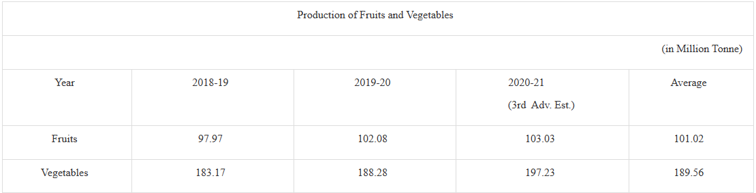
Source: Ministry of Agriculture and farmers welfare, 30 NOV 2021
In India, farmers' markets gradually became fashionable. It was described as a very urban phenomenon serving urban consumers' needs. Urban shoppers began to respond favorably to the farm-to-the-consumer market through the Weekly Bazaar since they could purchase fresh fruits and vegetables there from the producers or growers themselves. Farm to Consumer or popularly known as F2C, effectively creates a direct line of communication between farmers and end users, eradicating supply chain bottlenecks and ensuring better pricing for all parties. Farm-direct marketing entails selling a product directly to consumers from the farm. The farmer frequently receives a payment that is comparable to what the supermarket retailer charges. Compared to wholesale marketing, this strategy is more entrepreneurial or businesslike.
Background of Farm to Consumer:
Direct marketing is a common method of farming to customers in several nations, including the USA and the EU. Approximately 8% of American farmers engaged in direct or intermediary consumer sales to promote their products locally. In terms of the European Union, 15% of farmers there used to sell half of their output straight to customers. Customers valued the quality and variety of the products, the shopping experience, the general atmosphere, and the chance to support regional farms and businesses, according to a report by the Pacific Northwest Extension. In India, Rythu Bazar was established in Hyderabad in 1999, and since then, it has grown to be one of the most successful direct agriculture marketing strategies. The idea of Rythu Bazar was created to make direct marketing between consumers and farmers more convenient. The major goals of Rythu Bazar are to secure fair prices for farmers and to offer consumers fresh, high-quality veggies at affordable prices. Vegetable sales in Rythu Bazars are not subject to service fees or market fees. One of the nation's most effective examples of direct agriculture marketing is Rythu Bazar in Andhra Pradesh.

Need for Farm to Consumer:
Farmers and consumers in the country have long felt the need for farm direct marketing, which helps to ensure higher farmer compensation and higher consumer satisfaction levels through direct sales of agricultural products by farmers to consumers at reasonable prices. By selling agricultural products directly to consumers, middlemen, and commission agents—who typically charge farmers and agriculturalists a large commission fee for bringing their food to market yards and then unfairly inflating retail prices are eliminated.
Under the APMC (Regulation) Act of 1963, India established APMC (Agriculture Produce Marketing Committee) markets. At first, the farmers had to do business with consumers via the APMC. Farmers were forced to sell it to customers via APMC. The farm items were handled on several different levels, which resulted in 25% damages. Farmers were required to pay market fees, commission, and fees for loading, unloading, and weighing equal to 10–20% of the value of their produce. The traditional middlemen-based Indian structure developed over time which ultimately resulted in incurring less profits to farmers as against the costs. Apart from APMC, farmers looked for certain alternatives which would yield them some profit.
Roadside selling markets – Transporting farm products to a location where they can be sold to customers is a significant financial outlay for a farmer. Since they could do this wherever along the roadway in the village or city, it was a simple choice for them to enter roadside selling markets for the best prices with minimal infrastructure base and time savings.
Subscription Farming or Community Supported Agriculture (CSA) Programs - In this model, consumers get in touch with farmers and pay for their share of the produce before the growing season, which is often in the winter. Farmers secure the necessary funding and guarantee to deliver goods to buyers. Of course, to provide a high-quality product each week, it is necessary to establish communication with consumers and plan for on-farm pickup as well as off-farm delivery. This was one of the popular methods for decades.
Restaurants/Hotels/Dhabas – A good option for farmers is to create a contract with restaurants, dhabas, or hotels for specialty-produced goods. All gathered goods over a year may be provided to them under this arrangement. There are a few drawbacks to consider, including the possibility of a small and temperamental desired quantity as well as increased pressure to meet quality and quantity standards.
While exploring this option it was evident that agricultural products could boost farmers' incomes by 11–12% before they reach the customer. Since there has long been a need for changes, numerous states attempted to change the system of APMC and, in some cases, succeeded in clamping down on APMCs. Eventually, the APMC (Regulation) Act underwent some modifications. These changes made it so that farmers were not required to deliver their goods to APMC markets. Additionally, the government launched new programs, controlled markets, built infrastructure, and enacted laws to fix pricing. At farmer-consumer markets, farmers could sell their produce directly to customers, cutting out all steps of middlemen. The traditional buyers—wholesalers, market traders, independent mills, small-scale retailers, etc.—joined forces with various agribusinesses, major food-processing firms, supermarkets, and other entities. Direct contracts with food growers were entered into by several Indian and foreign businesses. Supply lines for food have become shorter. The consumers saw the combined effects of these actions. From the farm to the clients, the product was delivered as fresh as possible. Because there was little handling, freshness was preserved. Additionally, customers appreciated the variety of goods, minimal touch, and cleanliness.
Farm-to-Consumer Market in Fruits & Vegetables
India is the world's second-largest producer of fruits and vegetables after China. Fruits and vegetables can be found throughout the year due to the country's diverse geography and climate. India generated 204.61 million metric tonnes of vegetables and 107.10 million metric tonnes of fruits between 2021 and 2022. Farm-direct marketing entails selling a product directly to consumers from the farm. The farmer frequently receives a payment that is comparable to what the supermarket retailer charges. It ensures better pricing for both parties while assisting in the elimination of supply chain inefficiencies. Consumer purchasing patterns for fresh produce have transformed over a period. To be linked to farmers' markets, the farmer needs to have good transportation, and storage facilities, be technologically friendly-accepting different forms of payments (cash and e-cash), and have a plan to know and deploy which day to sell. The very objective of linking to a farmers' market is to bring the farm produce to several many consumers and get the best/highest price/kg. Also ensuring that the farmer remains in the competition line of the vendors. As the farmer's market provides a direct selling activity, customer interaction, and feedback from the base for promoting the farm produce to large numbers. Weekly fruit & vegetable markets are becoming the trend in the urban areas. Weekly farmer's markets are held in residential areas, ideally on an open piece of ground. The market is situated on a public, unoccupied plot that is either owned by a corporate, housing society, or a community-minded individual who is willing to rent the land out for a little sum of money. The agreement is practical for both parties given that the market only operates for a few hours in the morning or evening on one day of the week. The market does not need any specific infrastructure. Vegetables that are in season and fresh are available. The weekly market also gives customers the choice to purchase a variety of seasonal veggies right at their front door.

Figure 1: Traditional Vs Farm to Consumer Market
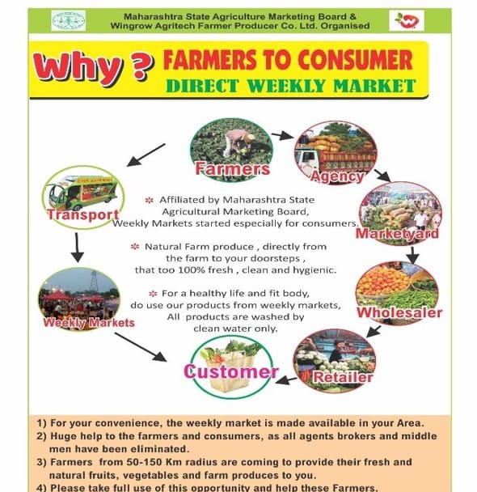
Farmers' markets also offered several advantages, such as
1. Quick access to many customers for a brief period each week
2. Possibilities to connect with customers to promote the products and get feedback
3. A means to build relationships with customers to draw people into agritourism
4. Less costly and risky than other direct marketing alternatives
It also has some downsides.
- Need to be accepted by the market.
- The necessity to follow market rules.
- Necessary to compete with those who sell comparable goods as competition is tough.
- Need to bear the charges, labor expenses, and other expenses related to market sales.

Certain leading companies in Farm to Consumer Weekly bazaar in India are Shree Swami Samarth Farmer Producer Company Ltd, INI farms, Sahyadri Farms, Kisan Connect, Shetsarathi Market, Krishihub, Agribazaar, etc. These companies work for the benefit of the farmers & ensure to provide farm fresh products to consumers.

Impact of COVID-19
The international food system benefited from the COVID-19 pandemic in disguise. More people bought food directly from farmers as a result. The new clients gave producers the chance to start direct marketing and increase their production. Many farmers saw a 30% to 50% boost in their direct food sales in 2020 compared to 2019. The growing unpredictable nature of the direct market remained the fundamental obstacle, nevertheless. Many consumers investigated the possibility of buying directly from farmers because of the outbreak. The number of people who would adhere to this practice of buying food directly from farmers, however, was unknown to the farmers. Additionally, the epidemic gave customers new access to online shopping alternatives. Farm producers had never investigated e-Commerce previously, but the Covid epidemic made them see how important e-commerce sales are. Many clients developed a routine of making purchases online and kept up the practice by ordering foods like meat, dairy, vegetables, and fruits, among other things. An easy way for customers to place orders is through word-of-mouth and online advertising. According to media sources, the agri-tech industry in India showed an increase in investor interest of 11.9% even during the epidemic year. Considering the ramifications of Covid-19, people have begun to rely heavily on online fruit and vegetable apps. Additionally, internet shoppers have more options and can have deliveries made in the comfort of their homes. Home delivery, self-service kiosks that are also based on applications, the many kinds of mobile shopping vans, and farmers' supermarkets are all helping to formalize last-mile delivery more quickly, at least in Tier I and II cities.

Challenges:
Farm to consumer market especially dealing in fruits and vegetables faces various challenges. As such agricultural products are seasonal in production and perishable by nature. The type of produce influences the demand as well. To avoid a total loss, farmers are occasionally compelled to sell their produce as soon as possible. They have a relatively low market price. The farmers as a result make very little or no profit.
The quality and freshness of the products, including prompt delivery, is the main issue in the production and sale of fruits and vegetables. The removal of undesired components employed in the growing and harvesting processes, such as chemicals, pesticides, bacteria, and other materials, contributes to the quality of fruits and vegetables. Numerous standards have been developed and are in use nationwide to ensure the quality of agri-food products. The safety and quality of the fruits and vegetables are guaranteed by all these laws, which are taken into consideration by businesses in this industry.
Second, the amount of time it takes for food to move from the point of production to the consumer's real plate is crucial for preserving the nutritious value of these fruits and vegetables. Getting perishable produce swiftly to the consumer in good time without compromising the quality of the goods has long been a major logistical challenge for businesses or producers of fruits and vegetables. Few businesses are making the necessary efforts to guarantee that fresh produce is delivered to consumers as soon as it is gathered.
Thirdly, the lack of appropriate cold chain infrastructure is another burning challenge. A lack of cold chain capacity, and a lack of a cold chain network, infrastructure such as cold storage and cooling sheds, etc.
Another challenge related to inking and integrating the many supply chain participants is crucial to the efficiency and profitability of the entire chain. In India's supply chain for fruits and vegetables, there is, nevertheless, a lack of forward and backward integration between farmers and other stakeholders. Insufficient number of warehouses and processing facilities for sorting, grading, packaging, etc. results in delivering quality products.
Transitional trends:
Post-Covid-19, however, there has been a marked increase in public awareness of the value of maintaining a strong immune system and choosing wholesome foods. Consumers who are urban and educated are particularly affected by the topic of food safety. Likewise, there is a growing demand for organic food products. The market for organic products was slow for a while, but it has recently picked up steam. Consumption of organic produce has increased by 50% overall thanks to additional clients. The shift in customer beliefs towards their health is the main driver of this market's expansion. The growth of the organic food industry is also being fuelled by increased incomes, improved living conditions, and government backing. For their safety and well-being, modern consumers prefer organic over conventional items. These goods are currently more widely known and in more demand. Consumers are increasingly concerned about the transparency of procedures and the traceability of their food as healthy living and wellness become an essential component of urban lifestyles. The rise of F2C agritech firms in India is being driven by this shift in customer preferences, particularly because of Covid-19. Since Covid-19 implications, people have begun to rely heavily on internet fruit and vegetable apps. Additionally, internet buyers have more options and can order deliveries that they can receive easily at home. Last-mile delivery is formalizing more quickly thanks to home delivery, self-service kiosks that are also based on applications, various mobile shopping van types, and farmers' supermarkets, at least in Tier I and II cities. However, there has been a movement from unorganized Modern Retail Format establishments to ones that are organized and use applications for online purchasing. Some of the factors causing the recent changes in how people shop for fresh vegetables include food safety and traceability. During the pandemic, several agriculture start-ups emerged. India is home to more than a thousand Agri-tech startups. Agri-tech companies have changed how they operate across the agricultural industry because of the epidemic. These start-ups have transitioned from traditional, informal, and analog marketplaces to more creative, formal, and digital ones, appealing to a wider audience.
Government initiatives:
The government has made numerous improvements to agriculture marketing. For example, the Indian government offers various programs to help promote organic farming throughout the nation. The APMC statute was updated to protect Farmers from being taken advantage of by huge retailers. It helps to keep the prices under control & the farm-to-retail pricing spread does not rise to unreasonably high levels. Also, the government of India launched various schemes to support farmers like soil health card, Pradhan Mantri Krishi Sinchayee Yojana, neem coated urea fertilizer, e- NAM Pan India electronic trading platform, Pradhan Mantri Fasal Bima Yojana.

Use of technology to improve performance:
As technology advanced, many businesses involved in the farm-to-consumer sector and weekly bazaars began to use blockchain technology. The Pandemic has considerably raised the expectations of consumers about food. Blockchain technology is mostly used in agribusinesses to track products, which involves the product's safety and quality. Technology would be used to ensure transparency. In all phases of the Agri-supply chain, blockchain aids in the collection, storing, and communication of product information. Every step of the supply chain records information about the products, which also guarantees proper hygienic conditions. This makes it possible for customers to decide intelligently about the high-quality food they should buy. Blockchain also aids in resolving issues in the supply chain relating to supply and demand. It brings complete transparency to consumers.
Conclusion:
Many obstacles still exist despite numerous government programs and attempts throughout the years. In India, buying fruits and vegetables has undergone a significant paradigm shift because of increased digital penetration, rising digital literacy, the pandemic, the proliferation of Agri-tech start-ups, the revolutionization of farming practices, and extensive government regulations and policies in this area. But ultimately, to bring the fragmented Agri sector up to speed with the rest of the globe, technology is the one of things that can address its inefficiencies. Awareness among the farmers about various options for selling their products, ensuring the availability of the appropriate infrastructure, and creating awareness about government schemes are some of the things that help curb the menace and farmers could directly reach out to customers and earn substantial profits.

REFERENCES:
B., Shibi & Aithal, Sreeramana. (2022). A Study on Challenges Faced by Farmers Using E-Commerce in Agriculture - A Survey of Thrissur District in the State of Kerala, India. International Journal of Case Studies in Business, IT, and Education. 600-610. 10.47992/IJCSBE.2581.6942.0220.
https://www.ibef.org/blogs/india-s-fruits-and-vegetables-industry
https://fmtmagazine.in/changing-trends-in-fruits-vegetables-shopping-in-india/
https://hospitality.economictimes.indiatimes.com/news/speaking-heads/changing-trends-in-fruits-vegetables-shopping-in-india/89804110
https://www.marketresearch.com/IMARC-v3797/Indian-Farming-Trends-Share-Size-34417761/
https://www.techsciresearch.com/report/india-organic-food-market/1761.html
https://www.financialexpress.com/india-news/f2c-agritech-startups-farm-to-fork-journey-made-easier/2549318/
Issues and Challenges in the Supply Chain of Fruits & Vegetables Sector in India: A Review. Available from: https://www.researchgate.net/publication/279866837_Issues_and_Challenges_in_the_Supply_Chain_of_Fruits_Vegetables_Sector_in_India_A_Review [accessed Jun 24, 2023].
https://www.geeksforgeeks.org/government-measures-to-improve-agricultural-marketing-in-india/
https://www.indianretailer.com/article/whats-hot/retail-trends/6-big-challenges-for-the-indian-organic-food-market.a7811
https://timesofindia.indiatimes.com/blogs/voices/agritech-widening-the-bottlenecks-of-farm-to-fork-supply-chains/
https://www.insightsonindia.com/agriculture/agricultural-marketing-and-issues/contract-farming/agricultural-produce-marketing-committee-apmc/

KEY TERMS & DEFINITIONS:
Organic Farming:
Biological fertilizers made primarily from animal and plant wastes and nitrogen-fixing cover crops are used in farming, which acts as a sustainable agricultural technique.
Agritech:
The use of technology and digital tools in agriculture is known as agri-tech, often referred to as ag-tech or digital agriculture. Automation, biotechnology, information monitoring, and data analysis are just a few of the many technologies that are included to increase yield, efficiency, and profitability.
APMC:
The Agricultural Produce Market Committee (APMC) is the marketing board established by the state governments to eliminate the exploitation incidences of farmers by intermediaries.

