Analyzing Deformation Characteristics Of Eco-Friendly Frictional Materials From Natural Fibers

Sunil Kumar Hemanth M
Research Scholar: Mechanical Engineering
NICHE, Kanniyakumari
Tamil Nadu, India
m.sunil.k.hemanth@gmail.com

J. Edwin Rajadhas
Head of Automobile Engineering
NICHE, Kanniyakumari
Tamil Nadu, India
edwinrajadhas@rediffmail.com

ABSTRACT
Frictional materials made from natural fibers has been recognised in over the years for their eco-friendly as well as sustainable in nature. This study focuses on the deformation analyses of frictional materials, specifically investigating their mechanical behaviour in response to external forces and changes in structure. Through ANSYS simulation, an aim to give a comprehensive method of the deformation characteristics in these materials and their potential applications. These findings are obtained in natural fiber materials like jute, palm fibers, abeca sheath fibers, coconut coir fibers, coconut oil residue, sesame oil residue and groundnut oil cake residue for the significant implications in development of more sustainable and efficient friction materials in various industrial applications like automobile, aerospace, military applications. The deformation characteristics are refer to the mechanical and frictional behaviour of a material in response to change in structure which include stress-strain curves, initial cracking stress with an elongation.
Keywords—Frictional behaviour; Natural fibers; Deformation; ANSYS; Stress-strain curves.
- INTRODUCTION
Natural fiber materials are sustainable and renewable resources that are accessible in nature and has benefits such as affordability, weightless, and ability to renewed. They are biopolymers that could be taken from plant tissues or animal tissues, with cellulose being the key factor of stem-root-flush bones based natural fibers [Thyavihalli, 2019]. Natural fiber composites have attracted great attention in recent years due to their good toughness and solidity, good in durability, and higher heat and vibration-sound behaviour. They are being used in a variety of applications including automotive, paperboard, and polymer composites [Naik, 2022]. Organic polymerises usually contain around 30-40% organic resin and are made up of binders, fillers, friction modifiers, and reinforcements. Choosing the suitable organic polymer based friction material for a particular application can be difficult due to the wide range of ingredients and formulations [Ammar, 2023]. Stress-strain behavior is an important measure of mechanical properties of solid materials, including natural fiber composites. Many low modulus natural fibers exhibit nonlinear axial stress-strain relationships, which are typically analyzed for orthotropic composites [Yi Chen, 2023]. The stress-strain relationship of a material is depicted by its stress-strain curve, illustrating the correlation between stress and strain, and is attained regularly by increasing levels of stress. Natural fiber materials have been shown to have better stress and strain properties than synthetic materials. The rising awareness of environmental concerns and sustainability has led to significant apprehension regarding the utilization of metallic and synthetic components in the materials industry in recent times. [G.S.Gehlen, 2022].
The usage of natural fibers in automotive materials is increasing due to its attractive properties of less weight, good strength, and biodegradability. The properties and characteristics of natural fiber materials used in automotive materials can vary relying on the type of fiber, methodology, and application. Few natural fibers used in automotive materials include flax, hemp, sisal, jute, and kenaf. These fibers are known for their high specific strength, low density, and good damping properties. They also have good thermal and acoustic insulation properties, which make them suitable for use in vehicle interiors, exteriors, durability and frictional behaviour components. In terms of processing, natural fiber materials are often processed into mats or sheets, which can be combined with thermoplastic or thermosetting resins to get composite materials. The mechanical properties of these composite materials can be improved by using techniques such as alkali treatment, silane coupling, and hybridization with other fibers such as glass fibers. Natural fiber composites also have a lower environmental impact compared to traditional automotive materials such as steel and aluminum. They are renewable and biodegradable, which makes them an attractive alternative for reducing the carbon footprint of automotive materials. However, natural fiber composites also have some limitations. They can be susceptible to moisture absorption, which can affect their mechanical properties. They also have lower impact resistance compared to traditional automotive materials, which can limit their application in certain areas such as impact protection. Overall, the properties and characteristics of natural fiber materials used in automotive materials make them an attractive alternative to traditional materials because of its weight less structure; it has better mechanical characteristics, and less environmental impact.
- Natural Fibers in Frictional Materials
. Composite materials have found extensive use across various industries in over the years, boasting a wide range of applications, which have emerged due to the development of new products. By comparing other materials, natural fibers offers relatively smaller reduction in weight, but modernized composite materials have led to significant development in all engineered materials. Composite materials are produced by combining multiple elements that has distinct chemical or physical properties. The cause of composite materials being consisting of fiber that gives hardness and durability to the material and the fiber mixtures that covers and assigning the load between the fibers is due to the mixture of several ingredients that have notably unrelated chemical and physical properties [Mohan kumar, 2022]. Natural fibers, also known as lingo-cellulosic fibers, are a type of fibrous material that is extracted from various parts of plants namely leaves, root, stems, and seeds. These fibers are collection of different amount of cellulose, hemicelluloses, wood polymeric substances, and lumen. Cellulose is the most abundant module of fiborous material and is a long-chain polymer made up of glucose units. It provides the fibers with strength and stiffness. Hemicelluloses are a group of complex carbohydrates that provide elasticity and resilience to the fibers. Lignin is a complex polymer that acts as a glue to fusing the fibers together, and it provides its yarns with resistance to moisture and microbial attacks. Lumen refers to the hollow space within the fiber. The proportions of these components can reliant on basis of the fiber, and this can affect the performance of the fiber. For example, cotton fibers are composed almost entirely of cellulose, while hemp fibers have a higher proportion of lignin and hemicelluloses. They can be classified into different categories based on their origin and properties. The main types of natural fibers contains seed fibers among cotton, bast fibers, hemp, flax, leaves of fibers as sisal, and husk fibers like coirs from coconut. These fibers can also be classified based on their physical properties, such as strength, elasticity, and moisture absorption. However, there are also some challenges associated by incorporating fibers into composite materials. For example, natural fibers are more susceptible to moisture absorption, which can affect their characteristics. Also, the properties of natural fibers can be dependent on the source and rectifying methods, can make it difficult to achieve consistent results. Despite these challenges, the trend towards incorporating naturally available materials in composite materials is expected to continue. Researchers are exploring new ways to enhance the performance of natural fibers and to develop new processing methods to overcome the challenges associated with their use in composites.
Natural fibers have gained popularity in industrialised uses because of its attractive properties notably cost effective, weight less, and biodegradability. Some of the commonly used natural fibers in industrial applications include:

Table 1: Natural fibers applications
Fibers | Properties and applications
 | Applications | Advantages
Flax seed | Compostes, textiles, paper products, Brake pad lining | Light weight, High stiffness, high strength, good thermal stability
Hemp | Composites, brake pad, textiles, construction materials | Tensile strength, excellent exposure to UV light, resistant to wear and tear
Jute | Packaging, textiles, construction | Tensile strength, biodegradable
Coconut Coir | Geotextiles, Erosion control applications, construction | Good tensile strength, resistant to abrasion
Sisal | Composites, ropes, carpenting | Good tensile strength, resistant to moisture
Kenaf | Brake pad and linings | Light weight, good frictional and thermal stability

Though its having important advantages, a few drawback of commonly used natural fibers in automotive friction purpose is that they tend to be absorb moisture easily. This could lead to a reduction in the frictional properties, which can affect the performance of the brake pads and linings. In addition, natural fibers may not have the same level of wear resistance and thermal stability as synthetic fibers, which can also impact the durability and performance of the automotive friction system. Another disadvantage of natural fibers is that they can be difficult to process and manufacture into brake pads and linings. The fibers may require additional treatments or modifications to improve their properties, which can add to the price and difficulty of the manufacturing process. In addition, the use of fibrous materials may require additional testing and certification to confirm that the brake pads and linings meet safety and regulatory standards. Despite these challenges, these fibers in automotive friction requirements is gaining popularity because of its renewable and environmentally friendly properties. To overcome these disadvantages, there are several ways to potentially overcome the disadvantages of using natural fibers for automotive frictional materials.
- Hybridization:
One approach is to combine natural fibers with other reinforcements, such as synthetic fibers or nanoparticles, to improve their properties and overcome their limitations. Hybridizing materials are typically made by mixing couple of several natural fibers with other materials such as synthetic fibers, nanoparticles, or resins. The combination of different materials can result in a mixtures of fiber compounds with improved mechanical, thermal, and frictional characteristics. Hybrid composites are fiber-reinforced polymers (FRPs) that combine several types of fibers in a individual matrix system to achieve specific characteristics. The concept of formation of hybridizing the composites is shown in fig.1. The hybridization of these fibers can also help to overcome the limitations of material mixtures in terms of in hydrophilic nature, wear resistance, and thermal stability. In addition to the use of synthetic fibers or glass, studies [Sikiru Oluwarotimi, 2022] are also exploring the use of other compounds like nano fillers and biodegradable polymers to enhance the performance of its consistent. This hybridizing process that achieving the alliance between natural fibers and nano-reinforced bio-based polymers have been shown to lead to boost properties along with reduced ecological impact. Also, hybridization of natural fibers is a technique for providing good frictional performance of natural fibers in automotive applications. By combining different materials, material prototype can be create for frictional behaviour with enhanced properties that can help to overcome the limitations of natural fibers and improve the performance and durability of materials.
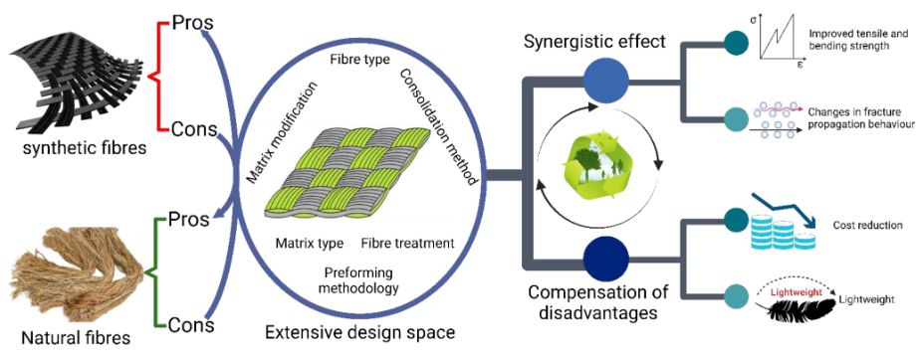
Fig.1 Fiber hybridization method [Sikiru Oluwarotimi, 2022]

Exploring the use of cashew nut shell liquid (CNSL) as an additive to enhance the properties of epoxy resin in hybrid polymer matrix development [Dinesh kumar, 2023]. CNSL is a value added product of the cashew nut and has been found to have potential as a bio-based material due to its chemical composition and unique properties. [Dinesh Kumar, 2023] developed hybrid polymer matrices by incorporating CNSL into epoxy resin as an additive. The resulting composite material is expected to have improved mechanical properties, such as increased strength, stiffness, and dimensional stability, as well as improved heat balance and resistance to wear. Various investigations has led to examine the mechanical and vibrational behavior of hybrid polymer matrices reinforced with eco-friendly fibers, like sisal, hemp, and incorporating CNSL as an additive. The use of CNSL as an additive in epoxy resin composite materials is a promising area of research that could lead to the improvement of more biodegradable and eco-friendly materials for a range of departments, including automotive frictional materials.
Some of the articles also focus on the use of mixture of compounds known as hybrid of materials, which syndicate couple of fibers to create materials with improved properties [Alagesan PK, 2020, Yentl Swolfs, 2018]. Natural plant fibers have drawbacks such as weak thermal and poor resistant to deformation [Hasan, 2021], high porosity, and bad adhesion to polymeric phase. However, these drawbacks could enhance by hybridization techniques. Hybrid composites of sisal mixed with glass, which has good porosity characteristics and elasticity compared to pure sisal mixtures. A 50 percentage of sisal mixtures can enhance in characteristics and performance due to rise in surface contact during mixing compounds with other natural fillers [Khalil, 2007]. The resultant mixtures affected by different fiber pattern, stricter formations like non-woven, woven, limited size, and thick and long fibers. [Sikiru Oluwarotimi, 2022]. The smooth hybrid composites with a combined form of organised epoxy-polymeric matrix subjected to impact at low speed, reinforced by the number of carbon and aramid fibers. [Mullaikodi, 2020]. The resulting epoxy compounds also observed to be lightweight and possess better mechanical properties. [Jawaid M, 2011]. The use of epoxy resin with pineapple and glass fibers. These studies explore the characteristics and performances of the mixtures and the effects of different treatments and variations in fiber content. One study found that the combination of pineapple and glass fibers in a 1:1 ratio with epoxy resin resulted in a lightweight composite with improved mechanical properties [Idicula, 2005]. Another study investigated the effects of chemical treatment of those fine fibers and found that it improved its inclusion of epoxy resins in it. [Indra reddy, 2018].
- Surface modification:
Natural fibers can be chemically treated or coated to improve their resistance to moisture, heat, and wear, which can enhance their performance in automotive frictional applications [Sudhanraj, 2020]. Modifying the surfaces of natural fibers is a significant technique used to improve their frictional behavior in various applications, including automotive frictional materials. Natural fibers are typically hydrophilic, which can lead to poor adhesion with the matrix material and reduced frictional performance [Guegan, 2019]. Surface modifications can help to overcome these issues by altering the surface layers and morphology of the fibers, which can improve their compatibility with the matrix material, increase their adhesion strength [Fry, 2020], and enhance their frictional properties. One common surface modification technique for natural fibers is mercerization, which involves the treatment of fibers with sodium hydroxide to remove impurities and increase their surface roughness [Eriksson, 1999]. Additionally, there are other techniques available for customizing surface by and coating treatments. [Fang, 2022], and physical treatments, such as plasma treatment and corona discharge. Studies have shown that modifying the surface can lead to significant improvements in the frictional behavior of composite materials. For example, enhancing of fibers with silane coupling agents can improve the boundary between the chain link of fibers and the matrix material, resulting a rise in the frictional characteristics of composite material [Liu, 2021]. The inclusion of boron carbide as reinforcing agent is to improve the performance of the composite material in terms of durability and friction properties. The composites exhibits impermeability, resistance to oxidation high temperature stability [Velavan, 2021].
- Optimization of processing parameters:
The progress made in incorporating natural fibers into composites in multiple sectors is driven by demands to reduce usage of energy and influence in environment. Similar to synthetic fibers, organic fiber gives many benefits in terms of renewable, gegradable, compact, less cost, development-cycle advantage, and excellent mechanical characteristics [M Li, 2020]. The manufacturing process can be optimized to improve the properties of natural fibers and ensure that they are properly integrated as frictional materials. For example brake pads and linings in terms of automotive applications. Natural fibers are becoming increasingly popular as a sustainable and environmentally friendly alternative to synthetic fibers [Mi Li, 2020]. They are widely used in various industries, including automotive, aerospace, and construction. One of the critical parameters that need to be optimized when working with natural fibers is their frictional behavior. The frictional behavior of natural fibers is influenced by various processing parameters, including fiber type, size, shape, surface morphology, and chemical composition [Jagadeesh, P, 2021]. Therefore, to optimize the frictional behavior of natural fibers, it is essential to understand the effects of different processing parameters on their frictional properties. Several techniques can be used to optimize the processing parameters of natural fibers for frictional behaviour [M. Muneer Ahmed, 2021]. One of the familiar approaches is the Taguchi method, which involves design of experiments to determine the optimal combination of processing parameters that will result in the desired frictional behavior. The Taguchi method [Keerthiveettil, 2022] uses a systematic approach to identify the most significant processing parameters and their level of effect on the frictional behavior of natural fibers. It involves selecting appropriate control factors, designing experiments, and analyzing the results to determine the optimal combination of processing parameters [Shinde D, 2021]. Other techniques that can be used to optimize the processing parameters of natural fibers for frictional behavior include response surface methodology [Xiaobing Cao, 2021], artificial neural networks [Arpitha, G.R, 2023], and genetic algorithms [Ahlawat, A, 2023]. These techniques enable researchers to explore the complex relationships between processing parameters and frictional behavior and identify the optimal processing conditions that will result in the desired frictional properties. In conclusion, the optimization of processing parameters of natural fibers for frictional behavior is critical to ensure their effective use in various applications. By using appropriate techniques such as the Taguchi method, the optimal combination of processing parameters [Aamir, M, 2019] that will result in the desired frictional behavior of natural fibers can be identified.
- Material selection:
Careful selection of the type of natural fiber used, as well as its processing and preparation, can help to ensure that it has the required properties for automotive frictional application. The selection of appropriate materials is critical for achieving the desired frictional behavior of natural fibers. The type of material used can significantly affect the frictional behavior of natural fibers, including their coefficient of friction and wear resistance. When selecting materials for natural fibers, several factors need to be considered, including the characteristics of the part, its processing parameters, surface morphology, and the chemical composition. For instance, the shape of the natural fiber can influence its tribological and mechanical behaviors in friction composites. The selection of fiber shape can affect the fiber's ability to bond with the matrix material and affect the resulting frictional behavior. The processing parameters used during the production can also affect the frictional behavior of natural fibers.
The natural fibers of Bamboo and Kenaf mixed with epoxy resin and hardner mixture in nano size to evaluate tensile test [Prabhudass, 2022]. These parameters can include temperature, pressure, and the presence of lubricants or other additives. The material selection should consider these parameters to ensure the desired frictional behavior is achieved. In summary, the selection of appropriate materials is crucial for achieving the desired frictional behavior of natural fibers. The material selection process should consider several factors such as mechanical properties, processing parameters, surface morphology, and rule of mixtures in volume fraction to ensure the optimal frictional behavior is achieved. The list of fibers used for selecting the best frictional property are displayed through table 2.
Abaca sheath has been used as a natural fiber reinforcement in frictional materials, such as brake composites, and has shown acceptable friction coefficient stability. Abaca, a leaf fiber, consists of elongated slender cells that contribute to the leaf's structural support. It possesses remarkable mechanical strength, resilience against saltwater damage, and exhibits a lengthy fiber length of up to 3 meters. The highest quality abaca grades are characterized by their fine, lustrous, light beige appearance, and exceptional strength. The material mixture of NaOH and epoxy resin to make a fine frictional property [Kurien, 2021].
Bamboo fiber has been investigated for use as a reinforcement in friction materials, such as brake composites. Studies have evaluated the tribological properties of bamboo fiber reinforced friction materials and have shown that they can have higher friction coefficient stability, contrast to non-bamboo fiber reinforced materials [Vijay Chaudhary, 2020]. The mechanical and tribological properties of bamboo fiber reinforced materials have been evaluated in various studies [Niu F, 2018], including their moisture regains, tensile properties, and friction properties.
Banana fiber is taken from the stem of the banana tree and has been used for centuries as a textile fiber and dried fiber for automotive frictional property as fillers [Gokul Kannan, 2022]. It is strong, biodegradable, and has high spinnability. Banana fiber can be blended with other fibers, such as sisal to produce brake pads. In addition to brake pads and linings, banana fibers have been used to create activated carbon for supercapacitors and cellulose nanofibril whiskers [Pramod V, 2023].
Coconut coir fiber has been investigated for use as a reinforcement in friction materials, such as brake composites. Studies have evaluated the influence of alkaline conditioning on the friction coefficient of single fibrills and the growth of new reinforced compounds in brake friction materials with coconut coir fiber [C Pinca-Bretotean, 2019]. Furthermore, coconut coir fiber has been investigated for its the characteristics of including its tensile strength, sound absorption, , and reduced health risks. These properties make it well-suited for a wide range of applications.
Flax fibers can obtain from both stem and seed but seed possess good frictional characteristics and have some features, which has limited fiber length, the presence of a lumen, fibres in stacks, and it is difficult to organise in one structure. [Anand Kumar, R, 2020]. The value of this reinforced compound using flax fibers is not always finest one due to factors like high water absorption, partial penetration, non-homogeneous grain size, and flexible fiber orientation. It is considered a potential functional food source due to its high-quality fiber content [Baley, C. 2019].
Jute fiber has been studied for its frictional properties in various applications, including as a reinforcement in polypropylene and epoxy hardener composites [C. Sivakandhan, 2020] and used as a reinforcement in non-asbestos brake friction composites to explore its physical, mechanical, and wear and friction properties. Studies [S. Senthilrajan, 2022] have also investigated the influence of moisture on the frictional characteristics of jute fiber for damping and wear properties of jute fiber compounds.
Kenaf fiber has been studied for its frictional properties in various applications, including as a reinforcement in polymeric composites and as a natural filler for non-metallic friction composites. Studies have investigated the influence of tissues stacking on its properties of kenaf and jute fiber compounds, as well as the mechanical behavior of kenaf [Prabhudhass, 2022], basalt, flax, and carbon bi-directional composites. Additionally, the mechanical functions of kenaf woven fabric mixtures have evaluated with and without silk fiber stitching and the friction and wear properties of kenaf fiber compounds has studied with the addition of magnetite reinforcement [Satish Pujari, 2023]
Oil palm fiber recognised for its frictional properties in various applications, including as a reinforcement in composites used in brake pads and organic friction materials. The studies [Arifin, 2022] have investigated the influence of oil palm fiber content on the friction and mechanical characteristics of the friction materials, and the part of capillary and sticky forces on tribological performance [A.B.M. Supian, 2021]. Also, oil palm fiber composites have been aged in water solutions to evaluate their wear properties, and the physical and mechanical properties of palm fiber loaded friction materials have been compared to other types of reinforced specimens.
Rice straw fiber has been studied for its frictional properties in various applications, including as a reinforcement in composites used in brake pads and organic friction materials. Studies [Faissal, 2021] have investigated the sliding frictional properties of untreated and extrusion treated rice straw, and the tribological parameter of rice straw dust in brake pads. Additionally, rice straw powder has been proposed as a possible friction material for use in brake pads [Ibrahim Matlu, 2009], and the wear and friction properties of linings with rice straw and rice husk [G.S. Gehlen, 2023] as natural ingredients have been investigated.
Sisal fiber has been studied for its frictional properties in various applications, including as a reinforcement in composites used in brake pads and organic friction materials. Studies [C. Sivakandhan, 2020] have investigated the tribological parameters of sisal fiber with resin brake linings, have been used as reinforcement in different types of composites, including resin-based and polymer-based materials, to enhance their frictional and wear properties [Idicula, 2005], and the friction properties of sisal fiber/nano-silica reinforced phenol formaldehyde resin composites [Pramod V, 2023]. In addition, studies have evaluated the frictional, wear properties of natural fibers, including sisal, reinforced PLA composite, and ramie fiber reinforced epoxy composites.

Table 2: Properties of fibers [Sunil Kumar, 2023]
No. | Fibres | Elongation(%) | Density g/cm³ | Young’s modulus (GPa) | Tensile strength (MPa)
1 | Abaca | 9-11 | 1.42-1.65 | 38-45 | 879-980
2 | Bamboo | 4.0–7.0 | 0.6–1.1 | 22.2–54.2 | 360.5–590.3
3 | Banana | 1.21-3.55 | 0.65-1.36 | 3.00-3.78 | 51.6-55.2
4 | Coconut (coir) | 27.21-32.32 | 0.67-1.15 | 4.0-6.0 | 173.5-175.0
5 | Flax | 2.70-3.6 | 1.27-1.55 | 50-70 | 500-900
6 | Jute | 1.69-1.83 | 1.3-1.45 | 20-50 | 300-700
7 | Kenaf | 1.56-1.78 | 0.15-0.55 | 23.1-27.1 | 295-955
8 | Oil palm | 2.13-5.00 | 0.7-1.55 | 2.7-3.2 | 227.5-278.4
9 | Rice straw | 2.11-2.25 | 0.86-0.87 | 24.67-26.33 | 435-450
10 | Sisal | 4.10-4.3 | 1.45-1.5 | 10-30 | 300-500

- Deformation Characteristics of Frictional Materials
Deformation properties of metals are a key aspect of their mechanical behaviour. Metals can undergo elastic deformation and plastic deformation, with elastic deformation referring to the short time deformation that disappears once the stress is removed and plastic deformation referring to the permanent deformation that occurs beyond the yield point. The mechanical properties of metals can contrast on factors such as the composition mixture, grain size and applied stress conditions [Lin, C, 2021]. The prediction of the behaviour of the materials under different loading conditions and designing structures and components that can withstand expected stresses [Jabłońska, 2022].
- Mechanisms of Deformation
The mechanisms of deformation are critical in determining the behavior of natural fiber materials in various applications. Understanding the mechanisms of deformation can help in the design and development of natural fiber materials with specific properties that are suitable for different applications. For example, a study on the compression strength mechanisms of low-density fibrous materials found that the deformation mechanism of natural fibers is mainly due to the sliding of fibers and non-slipping contacts [Ketoja JA, 2019]. This study suggests that the sliding of fibers and non-slipping contacts can be used to design natural fiber materials with high compression strength. Another study on the polymeric fiber-reinforced composites found that any characteristics of the fiber-matrix interface makes an acute role in defining the overall properties of the composite [Silu Huang, 2021]. The study suggests that improving the fiber-matrix interface can be a prime to the growth of natural fiber composites with enhanced mechanical properties. Also, understanding the mechanisms of deformation in natural fiber materials can help in identifying damage mechanisms [M. Muneer Ahmed, 2021] in defected natural fibers and developing strategies to overcome them. For example, a study on damage mechanisms in defected natural fibers found that the microfibrillar oriented [Kamarudin, S.H, 2022] structure of cellulose plays an essential role in cell wall reinforcement for strain hardening and under tension [Bo-Tao Huang, 2018]. The study suggests that understanding the damage mechanisms in natural fibers can help in designing strategies to improve their durability and mechanical properties. In summary, understanding the mechanisms of deformation in natural fiber materials is important for designing and developing natural fiber materials with specific properties suitable for different applications. It can also help in identifying damage mechanisms in natural fibers and developing strategies to overcome them. The micromechanical models for effective fibers [Serra-Parareda, , 2021] involve obtaining and employing their properties through an stability between total potential energy and chain link model by a common natural fiber material with polymer matrix composite structures [Nam Vu-Bac, 20018], the energy to change the size or orientation.

- Elastic deformation:
Elastic deformation is a type of reversible deformation that occurs in natural fibers under load. When a load is applied to a natural fiber material, it deforms elastically until it reaches a certain point where it becomes permanently deformed or damaged. The conventional fiber pullout test is not suitable for natural fiber-based composites to characterize the fiber-matrix interfacial bond. A modified pullout [Dayakar L. 2019] test method is suitable for the indirect characterization of interfacial properties of natural fiber matrix interface. The elastic deformation is reversible, which means that once the load is released, the fiber would return to its primary shape and size. An underlying mechanisms of elastic deformation in natural fibers are complex[A.C.N. Singleton, 2003] and depend on various factors such as the fiber's microstructure, chemical composition, and environmental conditions [Arredondo, S.P, 2022]. For example, a study on the elastic deformation of bamboo fibers found that the deformation mechanism is mainly due to the sliding of micro fibers within lignin. The study suggests that the orientation and arrangement of microfibrils in the cell wall [Pieczywek, P.M, 2023] plays a critical part in defining the elastic properties of bamboo fibers. Another study on the elastic deformation of spider silk fibers found that the deformation mechanism is mainly due to the reversible unfolding and refolding of protein chains within the fiber. The study suggests that the unique molecular structure of spider silk proteins allows for high elasticity and toughness, making them suitable for various applications [Gu, Yunqing, 2020]. In summary, elastic deformation is a reversible type of deformation that occurs in natural fibers under load. Understanding the mechanisms of elastic deformation can help in the design and development of natural fiber materials with specific properties suitable for different applications.
- Plastic deformation:
Plastic deformation is a type of permanent deformation that occurs in natural fibers when the applied load exceeds the material's yield strength [Gu, Yunqing, 2020]. In this region, the material undergoes plastic deformation, meaning it is no longer able to revert to its initial size once the load is released. Studies [Gholampour, A, 2020] suggest that plastic deformation in natural fibers is influenced by various factors such as the fiber's moisture content, temperature, and loading rate. For example, a study on the plastic deformation of some natural fibers in table 2 found that the deformation behavior is vastly reliant on the moisture content of the fibers. The study suggests that the presence of moisture weakens the hydrogen bonds [Kaixuan Zhao, 2022] between cellulose molecules, resulting in increased plastic deformation. Another study on the plastic deformation of natural fiber-reinforced composites found that the deformation behavior is influenced by the type and position of the fibers in its mixture. The study suggests that the presence of defects or damage in the fibers can lead to premature plastic deformation and failure of the composite [Mark Turk, 2017]. In summary, plastic deformation is a type of permanent deformation that occurs in natural fibers when the applied load exceeds the material's yield strength. Understanding the mechanisms of plastic deformation in natural fibers can help in the design and development of materials with specific properties suited for different applications [Mohamad Nurul Azman, 2020]. The mechanisms of permanent deformation in fibers is critical for designing and developing materials with specific properties suited for different applications [Pasakorn Sengsri, 2020], as well as for monitoring and predicting the performance of fiber-reinforced materials under various loading conditions. The permanent deformation in fibers is a topic of interest in a variety of fields such as materials science, engineering, and medicine [Leng, X., 2021, Zhang, Y, 2020]. For instance, a study on steel fibers showed that mineral fibers can be used to enhance the tensile strength of fiber-reinforced materials, while a study on human intervertebral disc annulus fibrous found that collagen fibers can undergo permanent deformation due to inelastic dissipation energy [Anna M.J., 2018]. Overall, understanding the mechanisms of permanent deformation in fibers is critical for designing and developing materials with specific properties suited for different applications, as well as for monitoring and predicting the performance of fiber-reinforced materials under various loading conditions [Ray, U, 2021].

- Factors influencing Frictional behaviour:
Factors such as fiber structure, moisture content, and temperature can influence the deformation behavior of materials. For example, the attributes of concrete, wood polymeric composites, and fiber-reinforced polymers are all affected by temperature and moisture content, and their deformation behavior can be influenced by the type and orientation of the fibers used [Nurazzi, N., 2022]. Moisture content [Akter, M, 2023] can weaken the hydrogen bonds between cellulose molecules in wood fibers, resulting in increased plastic. Accurately identifying the factors that influence the deformation behavior of materials is important for designing and developing materials with specific properties suited for different applications in friction and for predicting the performance of these materials under various loading conditions.
Friction is an important property to consider in natural fiber materials, as it can affect their performance and suitability for various applications. Natural fibers namely flax, hemp, jute, and kenaf, coconut coir, oil palm, sisal, abaca and other fibers [M.R. Sanjay, 2018] have been explored as potential alternatives to synthetic fibers in friction materials, due to its affordable price, thick, and environmental sustainability [J. Jefferson Andrew, 2022]. These fibers have shown promise in improving the frictional properties of composite materials used in applications notably brake pads [Ilie, F, 2022], clutch facings, and other automotive components [Sathyamoorthy G, 2022]. The tribological properties of natural fiber-reinforced polymer matrix compounds, which has found to exhibit good abrasion resistance. The tribological behavior of these materials is inclined by a variety of factors, including the type and orientation of the fibers, the matrix material, and the surface topography of the material [Karthikeyan S, 2017]. The use of natural fibers in friction materials is also being explored in other industries, such as paper manufacturing, where carbon fiber-reinforced paper composites have been developed for use in printer and copier components. The frictional behavior of these composites is important in determining their suitability for use in these applications.

- Analysis Techniques for Deformation Characteristics
Deformation-induced changes in frictional behavior refer to the modifications in frictional properties that occur due to deformation of materials, such as through mechanical or thermal processes. Studies has shown that deformation can significantly affect the frictional behavior of materials [Han Jiang, 2008], leading to changes in surface roughness, contact area, and adhesion [M. Klaassen, 2019]. These changes can affect the frictional properties of the materials, such as the coefficient of friction, and can have implications for a wide range of applications, including machining, wear resistance, and adhesion. The manipulation of deformation on fiber-to-fiber interactions where the contact area is an important aspect of understanding the mechanical behavior of fibrous materials, such as textiles, composites, and biomaterials [Hassani, F.-, 2023]. When two fibers come into contact and are subjected to an external force, the contact area between the fibers can change due to deformation, which can affect the strength, stiffness, and durability of the material [ Yutong Fu,, 2022]. The deformation can affect the fiber-to-fiber interactions in a variety of ways. For example, when fibers are stretched or compressed, they can undergo changes in their microstructure and surface topography, which can affect the adhesion and frictional properties of the fibers. Additionally, when fibers are bent or twisted, they can experience changes in their orientation and alignment, which can affect the overall strength and stiffness of the material [Sanghamitra Sethi, 2015]. The contact area between fibers can also be affected by deformation. When fibers are compressed, the contact area between them can increase, leading to a stronger bond between the fibers. Similarly, when fibers are stretched, the contact area can decrease, which can reduce the strength of the material [Silu Huang, 2021]. The influence of deformation on fiber-to-fiber interactions and contact area is crucial for predicting and controlling the mechanical behavior of fibrous materials. This knowledge can be applied in a variety of fields, such as textile engineering, automotive engineering, composite materials, and biomaterials, to improve the performance and durability of these mixture materials. The effects of deformation on surface roughness and contact mechanics are important considerations in the study of mechanical behavior and tribology, which is the science of friction, wear, and lubrication. When a material undergoes deformation, its surface roughness and contact mechanics can change, which can affect its mechanical properties and performance [A.I. Vakis,, 2018].
Surface roughness refers to the irregularities or deviations from a smooth surface, and it is an vital part in the contact mechanics of solids. When two surfaces come into contact, the surface roughness can affect the distribution of forces and the amount of friction between the surfaces [V.B. Svetovoy, 2015]. Deformation can alter surface roughness by causing changes in microstructure or by inducing plastic flow, which can lead to the formation of asperities or surface features. These changes can affect the contact mechanics of materials by altering the contact area, stress distribution, and adhesion between surfaces [Ning Nie, 2021]. Contact mechanics refers to the study of the deformation and stresses that occur when two surfaces come into contact. It can affect contact mechanics by changing the distribution of forces between surfaces and altering the contact area. For example, when a material is subjected to compression, the contact area between the surfaces can increase, leading to a stronger bond between the surfaces. Similarly, when a material is subjected to tension, the contact area can decrease, which can reduce the strength of the bond [Nathan T, 2017]. The effects of deformation on surface roughness and contact mechanics is important for a widespread usages, like machining, wear resistance, friction, cohesion and adhesion. For example, in manufacturing, controlling surface roughness and contact mechanics can be crucial for ensuring the quality and reliability of machined parts [Zhai, W, 2021]. In tribology, understanding the effects of deformation can help in the development of new lubricants and coatings that can improve the performance and durability of materials. Factors affecting frictional behavior are important considerations in many fields, including material science, engineering, and tribology. Several factors can affect frictional behavior, including fiber surface roughness, moisture absorption, and environmental conditions.

- Theoretical background of tensile test
The tensile test is a commonly used test in material science and engineering to determine the mechanical properties of a material. The test involves applying a uniaxial load to a test specimen and calculating the resulting deformation [R Vijay, 2021]. The theoretical background of the tensile test involves concepts such as stress, strain, and Young's modulus. When a tensile load is applied to a test specimen, it experiences stress, which is calculated as the force per unit area. Stress is formulated as the ratio of force to the cross-sectional area of the specimen. The strain is the ratio of the change in length of the specimen to its original length [Unni Santhosh, 2016]. Young's modulus is a measure of the stiffness of a material and is calculated as the ratio of stress to strain in the elastic region of the stress-strain curve. The tensile test can provide information about the ultimate tensile strength, yield strength, and ductility of a material [Lin, 2021]. The ultimate tensile strength refers to the maximum amount of stress that a material can endure before it fractures or fails. The yield strength is the amount of stress a material can withstand before it starts to undergo plastic deformation. Ductility is the ability to deform before it breaks and is typically measured as the elongation or reduction in percentage at a cross sectional area. The tensile test is an important test in material science and engineering because it allows measuring the physical properties materials under tension, notably the ultimate tensile strength, yield strength, and workability. It offers information on the reliability and safety of, components and products, helping companies in verifying the parts meet required levels of strength and ductility. Tensile testing is widely performed in almost every industry, and is a quick way to detect problems in the material. By measuring tensile strength,can predict how a material will perform under stress, and perform quality control checks to ensure the consistency and reliability of their products.
The Halpin-Tsai model is a micromechanics model that is commonly used in material science and engineering to predict the mechanical properties of composite materials mixed with short fibers. The model involves empirical equations that relate the aspect ratio of the fibers to the mechanical properties of the composite material [Idicula M, 2005]. The Halpin-Tsai model can be used to predict the tensile strength of composite materials by modifying the original equations to include the tensile strength of the fiber and the matrix material. Several studies have used modified versions of the Halpin-Tsai model to predict the tensile strength of composite materials and have shown good agreement with analytical data. The measurement of tensile strength of composite material is derived with the formula as
$$Halpin Tsai formula, S_{c}= S_{f} × . . . V_{f}+ S_{m} × V_{m} ..(1)$$

Here, S_{c} failure strength of composite,
V_{f} Volume fraction fiber
S_{f} Strength of fiber
S_{m} Strength of matrix
V_{m} volume fraction of matrix

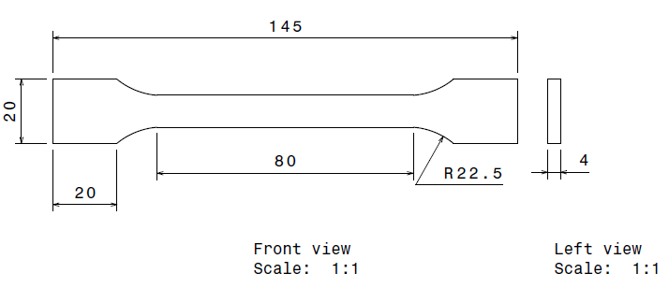
Fig2. Sample ASTM D638 specimen for tensile test

- Finite Element simulation
ANSYS Workbench R16.2 is used to carry out the working procedure for the fiber-reinforced composites in the cited materials in table 2. The ten different materials are taken into account for simulation as per ASTM D638 which denotes dog bone structure. The analysis are carried out for tensile test in uni-directional method. Stress can be attained by,
$$σ= P/A (1)$$

Here, $σ=$ tensile strength, N/m²
P = pulling load, N
A = area of the specimen, m²

Material selection is a critical aspect of the design process due to the vast array of options available in the market. Natural fibers are being utilized with reinforcements, offering the ability to decrease the weight of the vehicle. Most of the natural composites composed of resistant to .wear, friction, and accounts for over 90% of reinforcement. The selection of natural and synthetic fibers based on their material properties was involved in the investigation of fiber-reinforced composites. The design of the sample is followed as per ASTM standard in CATIA V5 [Fig.2] and imported into the ANSYS workbench. The type of analysis and fine element size were determined for each material. ANSYS was used for linear modelling with solid model, 8 nodes element, 1440 elements, and 8581 nodes [Fig.3] for drawing the samples. Load and boundary conditions [Fig.4] were applied at the surface, as one end fixed and other end applied a pull force of 15000N and the analysis results were interpreted in various graphs and recorded accordingly to deformation and stress-strain curves.
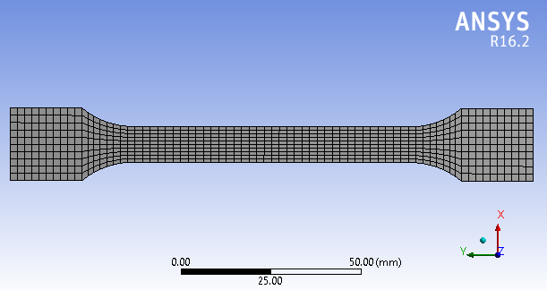
Fig3. Meshing

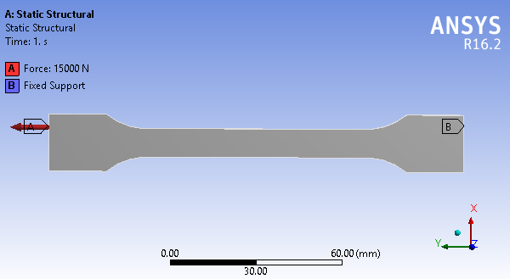
Fig.4 Boundary conditions applied

- Stress-Strain curve
The stress-strain relationship is an illustration of how a solid body responds to applied forces or stresses. It shows how the material deforms or changes in shape under different loads. In a stress-strain curve, stress (force per unit area) is marked on the horizontal plane and strain (deformation per unit length) is plotted on the vertical axis. The curve typically has several regions, including the elastic region where the material returns to its initial structure after the stress is released, while in plastic region where permanent deformation occurs, and the fracture point where the material breaks. The curve provides valuable information about the material's stiffness, strength, and ability to withstand external forces.
The Ramberg-Osgood equation is a mathematical relationship that approximates the stress-strain curve for a material, particularly in the elasticity-plasticity-fracture for deformed region. It is often used in engineering and materials science to describe the behavior of materials under deformation [Zhenyu Qiu, 2020]. The equation is represented as
$$ε= \frac{σ}{E}+K {\left( \frac{σ}{E}\right)}^{n} \left(2\right)$$
Where $ϵ$ is the sum of the elastic strain $ϵ_{e}$ and the plastic strain $ϵ_{p}$
$ε_{e}$ = $\frac{σ}{E}$ and $ε_{p}=K {\left(\frac{σ}{E} \right)}^{n}$
$σ$ stress, E Elasticity modulus. K and N are constants.
Considering $σ_{0}$ as reference stress and removing E from (4) the equation becomes
$$\frac{ε}{ε_{0}}= \frac{σ}{σ_{0}}+K ε_{0}^{n-1} {\left( \frac{σ}{σ_{0}}\right)}^{n} \left(3\right)$$
Where, $ε_{0}= {σ_{0}}/E$. Consider $α=Kε_{0}^{n-1}$, then the relation of Ramberg-Osgood equation becomes
$$\frac{ε}{ε_{0}}= \frac{σ}{σ_{0}}+ α {\left(\frac{σ}{σ_{0}}\right)}^{n} (4)$$
By obtaining the values of $α$ and n eq. (4) can be used to model the stress – strain curve.[ Fig. 5]
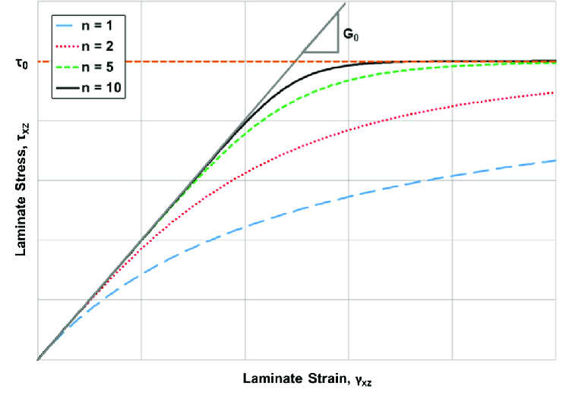
Fig. 5 Ramberg-Osgood equation representation [Bogetti, Travis, 2017]

- RESULTS AND DISCUSSION
Analytically the curves, which are generated by Ramberg-Osgood equation, the strain hardening of any natural fiber material, can model curves with slopes. To verify the applicability of this equation belongs to the material the tested stress-strain curves are explored by different studies.

Table 3: Elasticity and Strain Characteristics of Environmentally Friendly Materials
No. | Fibres | Deformation, mm | Max. Equivalent Stress,MPa | Max. Equivalent Strain
1 | Abaca | 1.441 | 446.43 | 0.011
2 | Bamboo | 1.84 | 447.55 | 0.017
3 | Banana | 14.78 | 476.5 | 0.136
4 | Coconut (coir) | 8.900 | 461 | 0.083
5 | Flax | 0.760 | 445.39 | 0.007
6 | Jute | 1.144 | 446.32 | 0.0111
7 | Kenaf | 1.9058 | 448.7 | 0.0185
8 | Oil palm | 18.35 | 483.3 | 0.1667
9 | Rice straw | 1.864 | 447.46 | 0.0181
10 | Sisal | 3.115 | 451.59 | 0.0301

The above table 3 shows the value of stress and strain and deformation for 3 seconds under ASTM tensile testing condition in ANSYS simulation for each fibers are representes as figure from Fig. 6 to fig.15

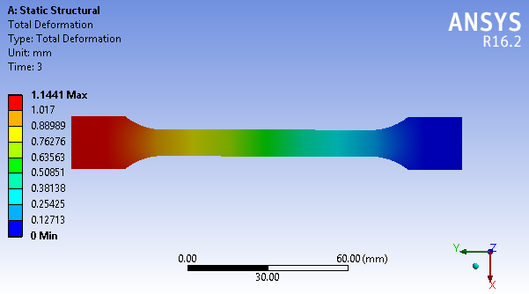
(6.a)
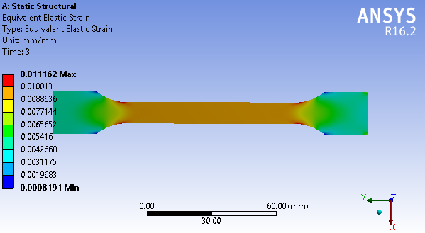
(6.b)
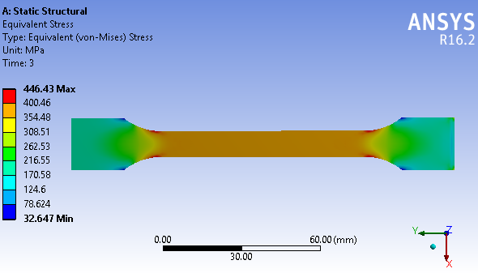
(6.c)
Fig.6 Simulation model of Abaca in tensile test (a) Deformation. (b) Strain, (c) Stress
.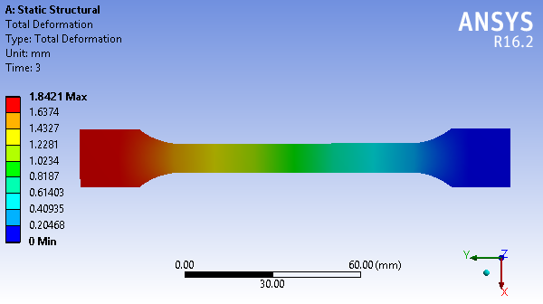
(7.a)
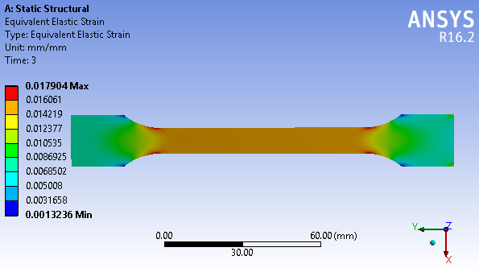
(7.b)
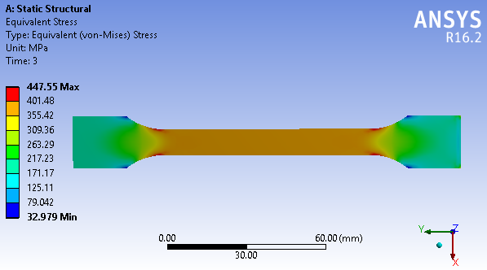
(7.c)
Fig.7 Simulation model of Bamboo in tensile test (a) Deformation. (b) Strain, (c) Stress
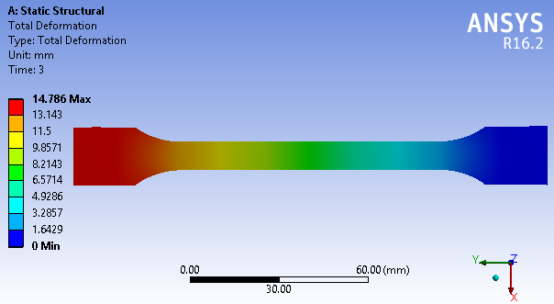
(8.a)
(7.c)
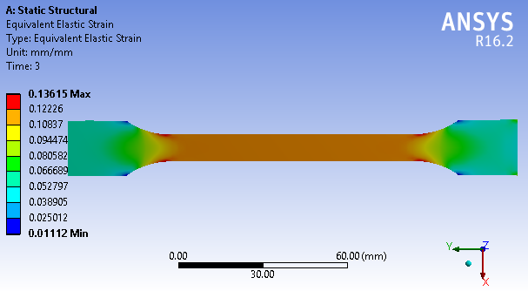
(8.b)
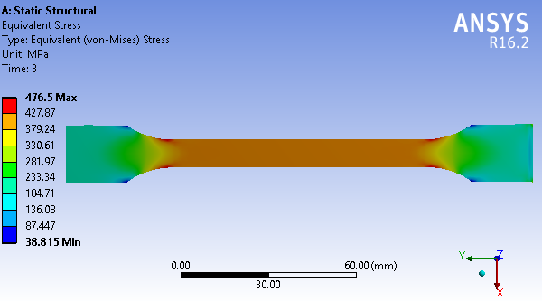
(8.c)
Fig.8 Simulation model of Banana in tensile test (a) Deformation. (b) Strain, (c) Stress
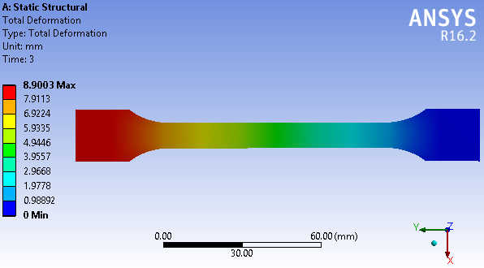
(9.a)
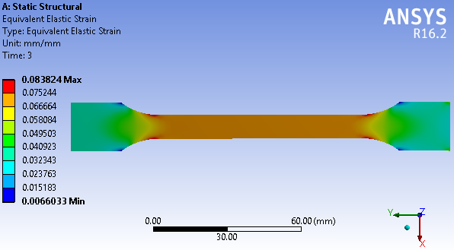
(9.b)
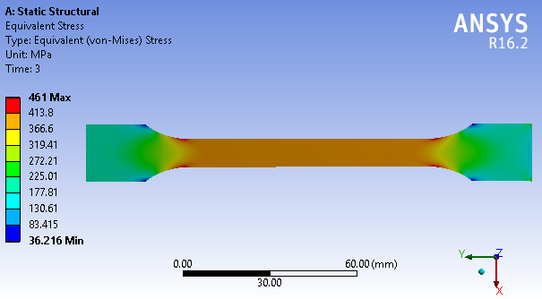
(9.c)
Fig.9 Simulation model of Coconut coir in tensile test (a) Deformation. (b) Strain, (c) Stress
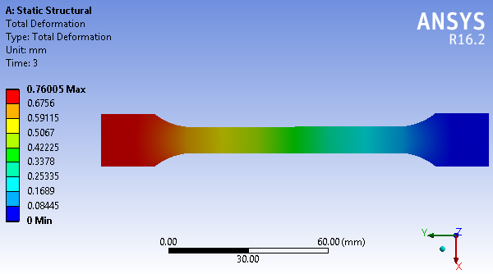
(10.a)
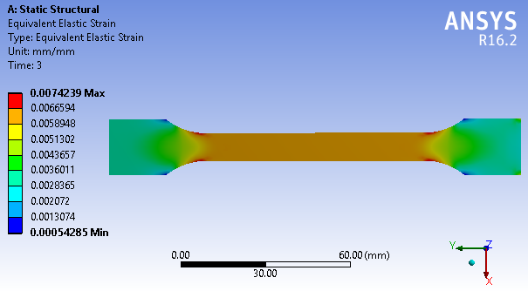
(10.b)
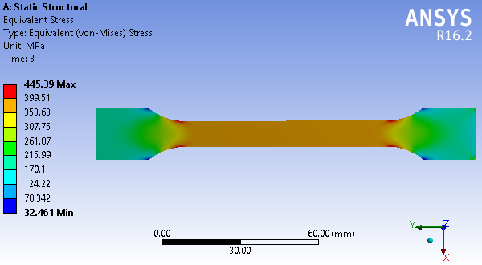
(10.c)
Fig.10 Simulation model of Flax seed in tensile test (a) Deformation. (b) Strain, (c) Stress
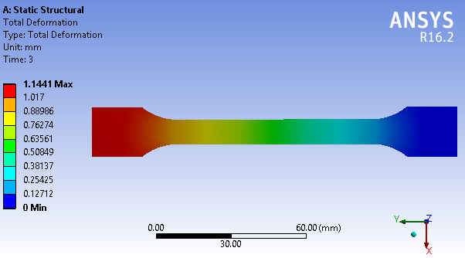
(11.a)
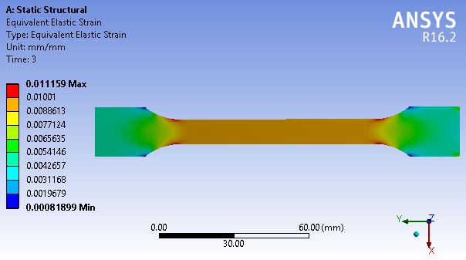
(11.b)
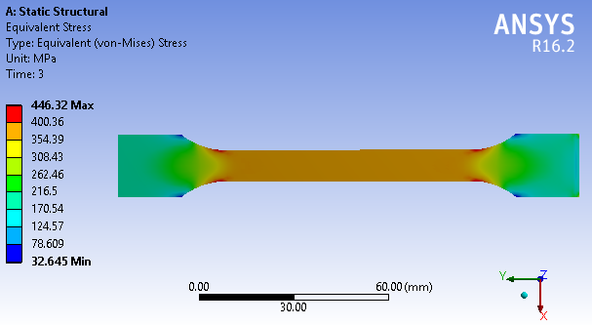
(11.c)
Fig.11 Simulation model of Jute in tensile test (a) Deformation. (b) Strain, (c) Stress
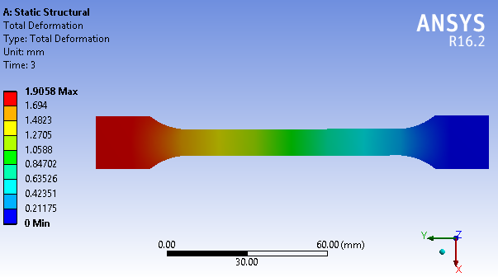
(12.a)
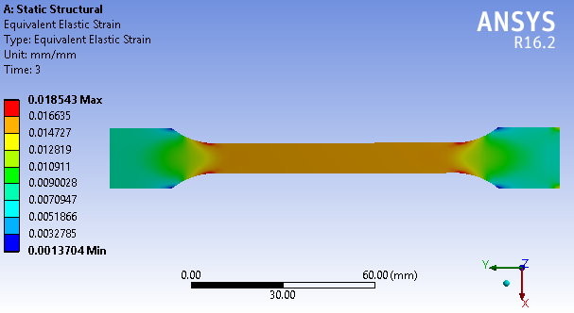
(12.c)
(12.b)
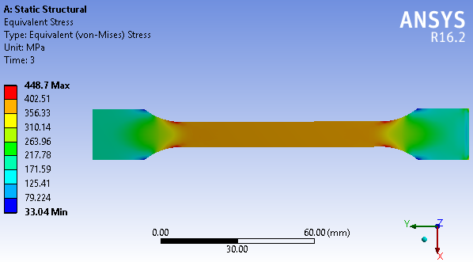
Fig.12 Simulation model of Kenaf in tensile test (a) Deformation. (b) Strain, (c) Stress
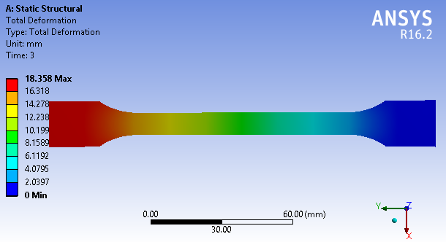
(13.a)
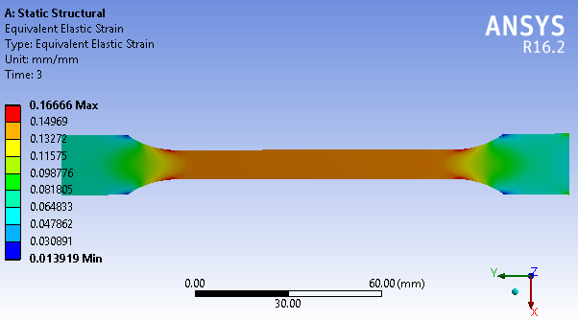
(13.b)
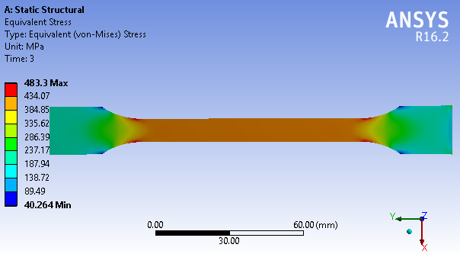
(13.c)
Fig.13 Simulation model of Oil palm in tensile test (a) Deformation. (b) Strain, (c) Stress
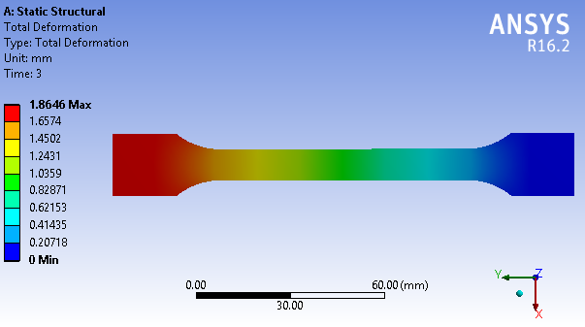
(14.a)
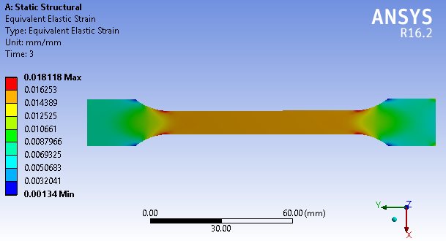
(14.b)
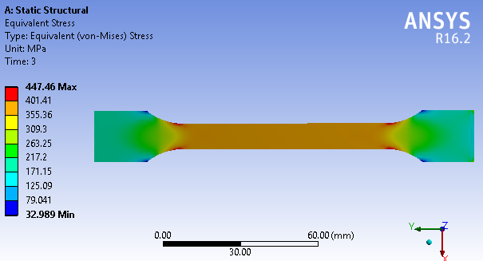
(14.c)
Fig.14 Simulation model of Rice straw in tensile test (a) Deformation. (b) Strain, (c) Stress
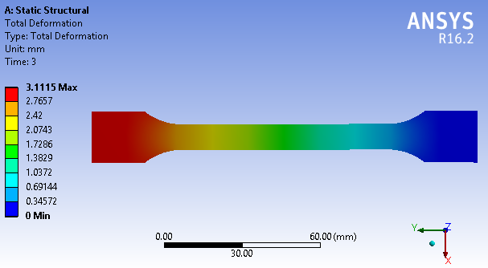
(15.a)
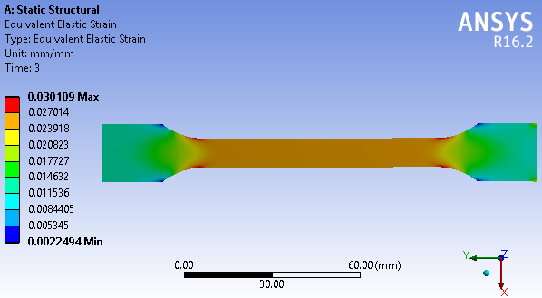
(15.b)
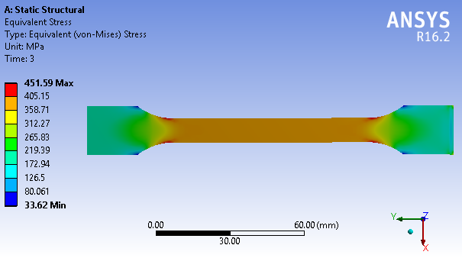
(15.c)
Fig.15 Simulation model of Sisal in tensile test (a) Deformation. (b) Strain, (c) Stress

The deformation of natural fiber materials significantly influences their frictional behavior, which in turn affects their performance in various applications. Understanding the mechanisms of deformation and the factors influencing friction in natural fiber materials is crucial for optimizing their performance and expanding their usage in diverse industries. Further research and development in this field will continue to enhance our understanding of the deformation and frictional behavior of natural fiber materials, leading to the creation of innovative and sustainable products.
During a tensile test, a material is subjected to increasing tensile (pulling) forces of 15KN upto the point of rupture. The deformation of the material is measured as strain, which is the ratio of deformed size to the initial size. A lower value of deformation indicates that the material can withstand higher loads or stresses before breaking or undergoing significant plastic deformation. This typically indicates a material with higher strength and better mechanical properties. So the value of Flax seed fiber is considered as lower deformed material of 0.76mm deviation whereas oil palm fiber occurs as higher deformed material of 18.35mm.
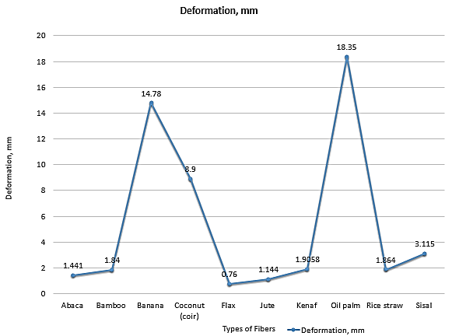
Fig. 37 Deformation obtained

In terms of stress during a tensile test is a measurement of the material's shape and size to deformation or breaking under tension. A higher stress value indicates that the material can withstand higher forces before reaching its breaking point. This typically indicates a material with higher strength and better mechanical properties. So the value of Oil palm as 483.3MPa among other fiber materials and flax seed of 445.39MPa as lower stress obtained material.
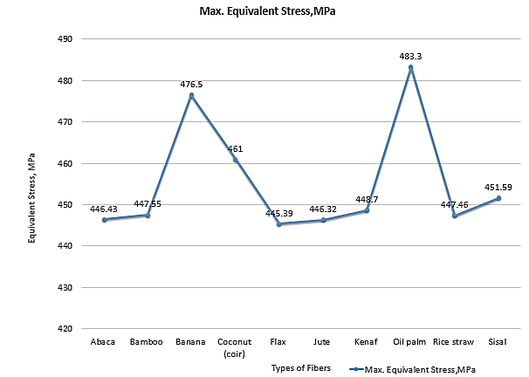
Fig. 38 Maximum Equivalent stress obtained

In terms of strain obtained during a tensile test, a lower value is generally considered better. Materials with lower strain values are desirable because they exhibit higher strength and are less likely to permanently deform or fail under load. However, it is important to consider the specific requirements and context of the application. In some cases, a higher strain value might be acceptable or even desirable, depending on factors such as desired flexibility or the material's intended purpose. So the value of strain 0.007(mm/mm) as lower for Flax seed fiber and the higher strain value of 0.1667 for oil palm fiber.
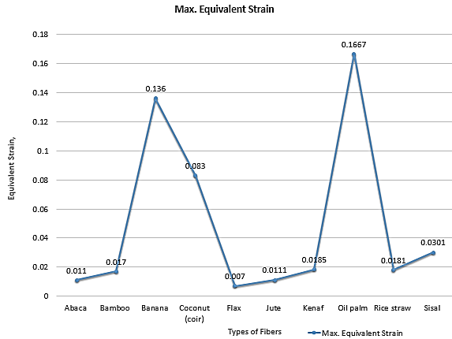
Fig. 39 Maximum Equivalent strain obtained
From the figure 37-Fig. 39 shows the representation of natural fibers of deformation and stress-strain analysis for ASTM tensile test. The combination of fibers under volume of mixtures can solve the good and better result to select the best material. Though it is individual trial, the results of deformation characteristics proceed through best results f rule of mixtures applied for frictional property.

- REFERENCES
[1] Ammar, Zeina, Hamdy Ibrahim, Mahmoud Adly, Ioannis Sarris, and Sherif Mehanny. 2023. "Influence of Natural Fiber Content on the Frictional Material of Brake Pads—A Review" Journal of Composites Science 7, no. 2: 72. https://doi.org/10.3390/jcs7020072
[2] Mohan Kumar A, Dimple Aiswarya N, Ashokavel S, Boopathi M, Numerical investigation of mechanical properties of hybrid fiber reinforced polymer composites, Materials Today: Proceedings, Volume 52, Part 4, 2022, Pages 2255-2263, ISSN 2214-7853, https://doi.org/10.1016/j.matpr.2021.08.096.
[4] Yi Chen, Minzhuo Du, Fisseha W Asmare, Xiaodong Liu, Tiejun Shi, Kan Zhang, Puxin Zhu, Ruixia Li, Shaw L Hsu and Dacheng Wu*. The Conception and Measurements of “Average Stress-Strain Curves” for Fibrous Materials. Fashion Technol. 8(4). TTEFT. 000695. 2023. DOI: 10.31031/TTEFT.2023.08.000695
[5] Thyavihalli Girijappa YG, Mavinkere Rangappa S, Parameswaranpillai J and Siengchin S (2019) Natural Fibers as Sustainable and Renewable Resource for Development of Eco-Friendly Composites: A Comprehensive Review. Front. Mater. 6:226. doi: 10.3389/fmats.2019.00226
[6] Naik, Venkatesh and Kumar , Mohan and Vijayan, Vijayan and Kaup, A Review on Natural Fiber Composite Material in Automotive Applications. Engineered Science. 2022, Volume 18, pages 1-10, ISSN: 2576-9898. DOI: http://dx.doi.org/10.30919/es8d589
[7] G.S. Gehlen, A.P.G. Nogueira, D. Carlevaris, L.Y. Barros, J.C. Poletto, G. Lasch, G. Straffelini, N.F. Ferreira, P.D. Neis, Tribological assessment of rice husk ash in eco-friendly brake friction materials, Wear, Volumes 516–517, 2023, 204613, ISSN 0043-1648, https://doi.org/10.1016/j.wear.2022.204613.
[8] Dineshkumar J & Jesudas T (2023) Hybrid polymer matrix development using cashew nut shell liquid as an additive into epoxy resin, Journal of the Chinese Institute of Engineers, 46:4, 380-388, DOI: 10.1080/02533839.2023.2194911
[9] M. Sunil Kumar Hemanth, J. Edwin Raja Dhas, Eco-friendly materials for brake pad- ANSYS overview, Materials Today: Proceedings, 2023, ISSN 2214-7853, https://doi.org/10.1016/j.matpr.2023.05.194.
[10] Alagesan, P.K. (2020). Recent Advances of Hybrid Fiber Composites for Various Applications. In Hybrid Fiber Composites (eds A. Khan, S.M. Rangappa, M. Jawaid, S. Siengchin and A.M. Asiri). https://doi.org/10.1002/9783527824571 ch18
[11] Yentl Swolfs, Ignaas Verpoest & Larissa Gorbatikh (2018): Recent advances in fibre-hybrid composites: materials selection, opportunities and applications, International Materials Reviews, DOI: 10.1080/09506608.2018.1467365
[12] Sikiru Oluwarotimi Ismail, Emmanuel Akpan, Hom N. Dhakal, Review on natural plant fibres and their hybrid composites for structural applications: Recent trends and future perspectives, Composites Part C: Open Access, Volume 9, 2022, 100322, ISSN 2666-6820, https://doi.org/10.1016/j.jcomc.2022.100322.
[13] S M, Mullaikodi & Sethuvelappan.P, & .M, Kamaraj & Naveen.E, & Ramanan.N,. (2020). Development of Hybrid Friction Material for Brake Pad Application. IOP Conference Series Materials Science and Engineering. 923. 1 - 11. 10.1088/1757-899X/923/1/012039.
[14] Jawaid M., & Khalil,H.A.(2011).Effect of layering pattern on the dynamic mechanical properties and thermal degradation of oil palm-jute Fibres reinforced epoxy hybrid composite," BioResources, 6, 2309-2322.
[15] M. Indra Reddy, M. Anil Kumar, Ch. Rama Bhadri Raju, Tensile and Flexural properties of Jute, Pineapple leaf and Glass Fiber Reinforced Polymer Matrix Hybrid Composites, Materials Today: Proceedings, Volume 5, Issue 1, Part 1, 2018, Pages 458-462, ISSN 2214-7853, https://doi.org/10.1016/j.matpr.2017.11.105.
[16] Hasan Öktem, Sıtkı Akıncıoğlu, İlyas Uygur & Gülşah Akıncıoğlu, “A novel study of hybrid brake pad composites: new formulation, tribological behaviour and characterisation of microstructure”, The Institute of Materials, Mineral and Mining, 2021
[17] Khalil, H.A.,Hanida, S.,Kang,C., & Fuaad, N.N.(2007).Agro-hybrid composite: the effects on mechanical and physical properties of oil palm Fibre (EFB)/glass hybrid reinforced polyester composites, Journal of Reinforced Plastics and Composites, 26,203-218.
[18] Eriksson,M., Bergman, F. and Jacobson, S. Surface characterization of brake pads after running under silent and squealing conditions. Wear, 1999, 232, 163–167
[19] Sudhanraj Jeganmohan . Banu Sugozu . Mukesh Kumar . David Raja Selvam, “Experimental Investigation on the Friction and Wear Characteristics of Palm Seed Powder Reinforced Brake Pad Friction Composites”, J. Inst. Eng. India Ser. D (January–June 2020) 101(1):61–69
[20] Idicula M, Malhotra SK, Joseph K, Thomas S (2005) Dynamic mechanical analysis of randomly oriented intimately mixed short banana/sisal hybrid fibre reinforced polyester composites. Compos Sci Technol 65(7–8):1077–1087. https://doi.org/10.1016/j.compscitech.2004.10.023
[21] Guegan, J., Southby, M. & Spikes, H. Friction Modifier Additives, Synergies and Antagonisms. Tribol Lett 67, 83 (2019). https://doi.org/10.1007/s11249-019-1198-z
[22] Fry, Benjamin M., Mang Yin Chui, Gareth Moody, and Janet SS Wong. "Interactions between organic friction modifier additives." Tribology International 151 (2020): 106438. https://doi.org/10.1021/acs.langmuir.9b03668
[23] Liu, T., Bai, R., Chen, Z., Li, Y., & Yang, Y. (2021). Tailoring of polyethylene fiber surface by coating silane coupling agent for strain hardening cementitious composite. Construction and Building Materials, 278, 122263. https://doi.org/10.1016/j.conbuildmat.2021.122263
[24] Fang C, Song X, Zou T, Li Y, Wang P, Zhang Y. Natural jute fiber treated with silane coupling agent KH570 reinforced polylactic acid composites: mechanical and thermal properties. Textile Research Journal. 2022;92(21-22):4041-4050. doi:10.1177/00405175221097101
[25] Prabhudass, J.M.; Palanikumar, K.; Natarajan, E.; Markandan, K. Enhanced Thermal Stability, Mechanical Properties and Structural Integrity of MWCNT Filled Bamboo/Kenaf Hybrid Polymer Nanocomposites. Materials 2022, 15, 506. https://doi.org/10.3390/ma15020506
[26] K. Velavan, K. Palanikumar, Elango Natarajan, Wei Hong Lim, Implications on the influence of mica on the mechanical properties of cast hybrid (Al+10%B4C+Mica) metal matrix composite, Journal of Materials Research and Technology, Volume 10, 2021, Pages 99-109, ISSN 2238-7854, https://doi.org/10.1016/j.jmrt.2020.12.004.
[27] Mi Li, Yunqiao Pu, Valerie M. Thomas, Chang Geun Yoo, Soydan Ozcan, Yulin Deng, Kim Nelson, Arthur J. Ragauskas, Recent advancements of plant-based natural fiber–reinforced composites and their applications, Composites Part B: Engineering, Volume 200, 2020, 108254, ISSN 1359-368, https://doi.org/10.1016/j.compositesb.2020.108254.
[28] Jagadeesh, P., Puttegowda, M., Mavinkere Rangappa, S., Siengchin, S., A review on extraction, chemical treatment, characterization of natural fibers and its composites for potential applications. Polym. Compos. 2021, 42(12), 6239. https://doi.org/10.1002/pc.26312
[29] M. Muneer Ahmed, H.N. Dhakal, Z.Y. Zhang, A. Barouni, R. Zahari, Enhancement of impact toughness and damage behaviour of natural fibre reinforced composites and their hybrids through novel improvement techniques: A critical review, Composite Structures, Volume 259, 2021, 113496, ISSN 0263-8223, https://doi.org/10.1016/j.compstruct.2020.113496.
[30] Keerthiveettil Ramakrishnan, S., Vijayananth, K., Pudhupalayam Muthukutti, G. et al. The effect of various composite and operating parameters in wear properties of epoxy-based natural fiber composites. J Mater Cycles Waste Manag 24, 667–679 (2022). https://doi.org/10.1007/s10163-022-01357-1
[31] Shinde D, Öktem H, Kalita K, Chakraborty S, Gao X-Z. Optimization of Process Parameters for Friction Materials Using Multi-Criteria Decision Making: A Comparative Analysis. Processes. 2021; 9(9):1570. https://doi.org/10.3390/pr9091570
[32] Arpitha, G.R., Mohit, H., Madhu, P. et al. Effect of sugarcane bagasse and alumina reinforcements on physical, mechanical, and thermal characteristics of epoxy composites using artificial neural networks and response surface methodology. Biomass Conv. Bioref. (2023). https://doi.org/10.1007/s13399-023-03886-7
[33] Xiaobing Cao, Zhou Li, Xiongfeng Zhou, Zhi Luo, Ji'an Duan, Modeling and optimization of resistance spot welded aluminum to Al-Si coated boron steel using response surface methodology and genetic algorithm, Measurement, Volume 171, 2021, 108766, ISSN 0263-2241, https://doi.org/10.1016/j.measurement.2020.108766
[34] Ahlawat, A., Phogat, A., Yadav, M. et al. Fabrication and analysis of ABS-HDPE-PC composite polymer filament used for FDM printing using hybrid algorithm. Int J Interact Des Manuf (2023). https://doi.org/10.1007/s12008-023-01389-3
[35] Aamir, M., Tolouei-Rad, M., Giasin, K. et al. Recent advances in drilling of carbon fiber–reinforced polymers for aerospace applications: a review. Int J Adv Manuf Technol 105, 2289–2308 (2019). https://doi.org/10.1007/s00170-019-04348-z
[36] Kurien, R.A., Selvaraj, D.P. & Koshy, C.P. Worn Surface Morphological Characterization of NaOH-Treated Chopped Abaca Fiber Reinforced Epoxy Composites. J Bio Tribo Corros 7, 31 (2021). https://doi.org/10.1007/s40735-020-00467-3
[37] Gokul Kannan, Rajasekaran Thangaraju & Francisco Mata Cabrera (2022) Sustainable Development of Agro-Industrial Waste-Based Banana Fiber/Fly Ash Polyester Composites for Wear and Friction Study, Journal of Natural Fibers, 19:16, 14771-14787, https://doi.org/10.1080/15440478.2022.2069183
[38] Pramod V Badyankal, P S Shivakumar Gouda, T S Manjunatha, B H Maruthi Prashanth, B H Shivayogi. (2023) Realization of mechanical and tribological properties of hybrid banana, sisal, and pineapple fiber epoxy composites using naturally available fillers. Engineering Research Express 5:1, pages 015070. DOI 10.1088/2631-8695/acc311
[39] Vijay Chaudhary, Furkan Ahmad, A review on plant fiber reinforced thermoset polymers for structural and frictional composites, Polymer Testing, Volume 91, 2020, 106792, ISSN 0142-9418, https://doi.org/10.1016/j.polymertesting.2020.106792.
[40] Niu F,, He, R, Li, J. The influence of polypyrrole coatings on the mechanical and friction and wear properties of bamboo fiber filled PA6 composites. Surf Interface Anal. 2018; 50: 111–116. https://doi.org/10.1002/sia.6345
[41] C Pinca-Bretotean and A L Craciun and A Josan and M Ardelean. Friction and wear characteristic of organic brake pads material. IOP Conference Series: Materials Science and Engineering. 2019 IOP Conf. Ser.: Mater. Sci. Eng. 477 012009. https://dx.doi.org/10.1088/1757-899X/477/1/012009
[42] Anand Kumar, R, Sindhu, S SS, Kumaresan, M, Sathish, S, Karthi, N, Vignesh, J, Sidharth, S P, Shreedhar, K V, Subash Rajasekar, P, Wear performance and Mechanical properties of Unidirectional Sisal/Carbon/Flax Hybrid Reinforced Epoxy Composites. IOP Conference Series: Materials Science and Engineering. 2020 IOP Conf. Ser.: Mater. Sci. Eng. 988 012010. https://dx.doi.org/10.1088/1757-899X/988/1/012010
[43] Baley, C., Gomina, M., Breard, J. et al. Specific features of flax fibres used to manufacture composite materials. Int J Mater Form 12, 1023–1052 (2019). https://doi.org/10.1007/s12289-018-1455-y
[44] C. Sivakandhan, G. Murali, N. Tamiloli, L. Ravikumar, Studies on mechanical properties of sisal and jute fiber hybrid sandwich composite, Materials Today: Proceedings, Volume 21, Part 1, 2020, Pages 404-407, ISSN 2214-7853, https://doi.org/10.1016/j.matpr.2019.06.374.
[45] S. Senthilrajan, N. Venkateshwaran & K. Naresh (2022) Parametric Study of different Fiber Parameters and their Influence on Acoustics and Vibration Behavior of Jute Fiber/Polyester resin Composites, Journal of Natural Fibers, 19:16, 13063-13075, DOI: 10.1080/15440478.2022.2085225
[46] Satish Pujari, Sattaru Santosh Kumar, Nambala S Naveen, Chinta Neelima Devi, Siva Rao Subramonian. Effect of magnetite on physical, tribological and magnetic characteristics of kenaf fibre. Emerging Materials Research. Volume 12 Issue 2, June 2023, pp. 196-203. ISSN 2046-0147 https://doi.org/10.1680/jemmr.22.00162
[47] Arifin, Y. F. ., Arsyad, M., Siswanto, R., Astawa, I. K. T. F., Muhammad Hafizhi Ridha, & Ramadhani, M. R. (2022). Tensile Strength and Durability of Oil Palm Empty Fruit Bunch Fiber in Soft Soil. GEOMATE Journal, 23(99), 72–81. Retrieved from https://geomatejournal.com/geomate/article/view/3610
[48] A.B.M. Supian, M. Jawaid, B. Rashid, H. Fouad, N. Saba, Hom N. Dhakal, Ramzi Khiari, Mechanical and physical performance of date palm/bamboo fibre reinforced epoxy hybrid composites, Journal of Materials Research and Technology, Volume 15, 2021, Pages 1330-1341, ISSN 2238-7854, https://doi.org/10.1016/j.jmrt.2021.08.115.
[49] Faissal Chegdani, Mohamed El Mansori, Mahmoud Taki, Ramsey Hamade, On the role of capillary and viscous forces on wear and frictional performances of natural fiber composites under lubricated polishing, Wear, Volume 477, 2021, 203858, ISSN 0043-1648, https://doi.org/10.1016/j.wear.2021.203858.
[50] Ibrahim Mutlu, 2009. Investigation of Tribological Properties of Brake Pads by Using Rice Straw and Rice Husk Dust. Journal of Applied Sciences, 9: 377-381. DOI: 10.3923/jas.2009.377.381
[51] Lin, C.-Y.; Kang, J.-H. Mechanical Properties of Compact Bone Defined by the Stress-Strain Curve Measured Using Uniaxial Tensile Test: A Concise Review and Practical Guide. Materials 2021, 14, 4224. https://doi.org/10.3390/ma14154224
[52] Jabłońska, Magdalena Barbara, Jasiak, Katarzyna, Kowalczyk, Karolina, Bednarczyk, Iwona, Skwarski, Mateusz, Tkocz, Marek and Gronostajski, Zbigniew. "Deformation behaviour of high-manganese steel with addition of niobium under quasi-static tensile loading" Materials Science-Poland, vol.40, no.3, 3922, pp.1-11 2022. https://doi.org/10.2478/msp-2022-0029
[53] Nam Vu-Bac, Timon Rabczuk, Xiaoying Zhuang, 15 - Continuum/Finite Element Modeling of Carbon Nanotube–Reinforced Polymers, Editor(s): Roham Rafiee, In Micro and Nano Technologies, Carbon Nanotube-Reinforced Polymers, Elsevier, 2018, Pages 385-409, ISBN 9780323482219, https://doi.org/10.1016/B978-0-323-48221-9.00015-7.
[54] Bo-Tao Huang, Qing-Hua Li, Shi-Lang Xu, Wen Liu, Hong-Tao Wang, Fatigue deformation behavior and fiber failure mechanism of ultra-high toughness cementitious composites in compression, Materials & Design, Volume 157, 2018, Pages 457-468, ISSN 0264-1275, https://doi.org/10.1016/j.matdes.2018.08.002.
[55] Ketoja JA, Paunonen S, Jetsu P, Pääkkönen E. Compression Strength Mechanisms of Low-Density Fibrous Materials. Materials. 2019; 12(3):384. https://doi.org/10.3390/ma12030384.
[56] Silu Huang, Qiuni Fu, Libo Yan, Bohumil Kasal, Characterization of interfacial properties between fibre and polymer matrix in composite materials – A critical review, Journal of Materials Research and Technology, Volume 13, 2021, Pages 1441-1484, ISSN 2238-7854, https://doi.org/10.1016/j.jmrt.2021.05.076.
[57] Kamarudin, S.H.; Mohd Basri, M.S.; Rayung, M.; Abu, F.; Ahmad, S.; Norizan, M.N.; Osman, S.; Sarifuddin, N.; Desa, M.S.Z.M.; Abdullah, U.H.; et al. A Review on Natural Fiber Reinforced Polymer Composites (NFRPC) for Sustainable Industrial Applications. Polymers 2022, 14, 3698. https://doi.org/10.3390/polym14173698
[58] Serra-Parareda, F.; Vilaseca, F.; Aguado, R.; Espinach, F.X.; Tarrés, Q.; Delgado-Aguilar, M. Effective Young’s Modulus Estimation of Natural Fibers through Micromechanical Models: The Case of Henequen Fibers Reinforced-PP Composites. Polymers 2021, 13, 3947. https://doi.org/10.3390/polym13223947
[59] Dayakar L. Naik, Achintyamugdha Sharma, Rajender Reddy Chada, Ravi Kiran, Todd Sirotiak, Modified pullout test for indirect characterization of natural fiber and cementitious matrix interface properties, Construction and Building Materials, Volume 208, 2019, Pages 381-393, ISSN 0950-0618, https://doi.org/10.1016/j.conbuildmat.2019.03.021.
[60] A.C.N. Singleton, C.A. Baillie, P.W.R. Beaumont, T. Peijs, On the mechanical properties, deformation and fracture of a natural fibre/recycled polymer composite, Composites Part B: Engineering, Volume 34, Issue 6, 2003, Pages 519-526, ISSN 1359-8368, https://doi.org/10.1016/S1359-8368(03)00042-8.
[61] Arredondo, S.P.; Corral, R.; Valenciano, A.; Rosas, C.A.; Gómez, J.M.; Medina, T.J.; Soto, M.; Bernal, J.M. Strength, Elastic Properties and Fiber–Matrix Interaction Mechanism in Geopolymer Composites. Polymers 2022, 14, 1248. https://doi.org/10.3390/polym14061248
[62] Pieczywek, P.M., Chibrikov, V. and Zdunek, A. (2023), In silico studies of plant primary cell walls – structure and mechanics. Biol Rev, 98: 887-899. https://doi.org/10.1111/brv.12935
[63] Gu, Yunqing, Yu, Lingzhi, Mou, Jiegang, Wu, Denghao, Zhou, Peijian and Xu, Maosen. "Mechanical properties and application analysis of spider silk bionic material" e-Polymers, vol. 20, no. 1, 2020, pp. 443-457. https://doi.org/10.1515/epoly-2020-0049
[64] Gholampour, A., Ozbakkaloglu, T. A review of natural fiber composites: properties, modification and processing techniques, characterization, applications. J Mater Sci 55, 829–892 (2020). https://doi.org/10.1007/s10853-019-03990-y
[65] Mohamad Nurul Azman Mohammad Taib, Nurhidayatullaili Muhd Julkapli, 4 - Dimensional stability of natural fiber-based and hybrid composites, Editor(s): Mohammad Jawaid, Mohamed Thariq, Naheed Saba, In Woodhead Publishing Series in Composites Science and Engineering, Mechanical and Physical Testing of Biocomposites, Fibre-Reinforced Composites and Hybrid Composites, Woodhead Publishing, 2019, Pages 61-79, ISBN 9780081022924, https://doi.org/10.1016/B978-0-08-102292-4.00004-7.
[66] Kaixuan Zhao, Xiaojing Tian, Jinfeng Xing, Na Huang, Hongjie Zhang, Huanying Zhao, Wenhang Wang, Tunable mechanical behavior of collagen-based films: A comparison of celluloses in different geometries, International Journal of Biological Macromolecules, Volume 214, 2022, Pages 120-127, ISSN 0141-8130, https://doi.org/10.1016/j.ijbiomac.2022.05.191.
[67] Mark Turk, Ian Hamerton, Dmitry S. Ivanov, Ductility potential of brittle epoxies: Thermomechanical behaviour of plastically-deformed fully-cured composite resins, Polymer, Volume 120, 2017, Pages 43-51, ISSN 0032-3861, https://doi.org/10.1016/j.polymer.2017.05.052.
[68] Pasakorn Sengsri, Sakdirat Kaewunruen, Additive manufacturing meta-functional composites for engineered bridge bearings: A review, Construction and Building Materials, Volume 262, 2020, 120535, ISSN 0950-0618, https://doi.org/10.1016/j.conbuildmat.2020.120535.
[69] Leng, X., Hu, X., Zhao, W., An, B., Zhou, X. and Liu, Z. (2021), Recent Advances in Twisted-Fiber Artificial Muscles. Adv. Intell. Syst., 3: 2000185. https://doi.org/10.1002/aisy.202000185
[70] Zhang, Y, Lu, M. A review of recent advancements in soft and flexible robots for medical applications. Int J Med Robotics Comput Assist Surg. 2020; 16:e2096. https://doi.org/10.1002/rcs.2096
[71] Anna M.J. Coenen, Katrien V. Bernaerts, Jules A.W. Harings, Stefan Jockenhoevel, Samaneh Ghazanfari, Elastic materials for tissue engineering applications: Natural, synthetic, and hybrid polymers, Acta Biomaterialia, Volume 79, 2018, Pages 60-82, ISSN 1742-7061, https://doi.org/10.1016/j.actbio.2018.08.027.
[72] Nurazzi, N. M., Norrrahim, M. N. F., Sabaruddin, F. A., Shazleen, S. S., Ilyas, R. A., Lee, S. H., ... & Nor, N. M. (2022). Mechanical performance evaluation of bamboo fibre reinforced polymer composites and its applications: a review. Functional Composites and Structures, 4(1), 015009. 2022 The Korean Society for Composite Materials and IOP Publishing Limited. https://dx.doi.org/10.1088/2631-6331/ac5b1a
[73] Akter, M., Uddin, M.H. & Anik, H.R. Plant fiber-reinforced polymer composites: a review on modification, fabrication, properties, and applications. Polym. Bull. (2023). https://doi.org/10.1007/s00289-023-04733-5
[74] Ray, U., Zhu, S., Pang, * Z., Li* 2002504, T., Mechanics Design in Cellulose-Enabled High-Performance Functional Materials. Adv. Mater. 2021, 33, 2002504. https://doi.org/10.1002/adma.202002504
[75] M.R. Sanjay, P. Madhu, Mohammad Jawaid, P. Senthamaraikannan, S. Senthil, S. Pradeep, Characterization and properties of natural fiber polymer composites: A comprehensive review, Journal of Cleaner Production, Volume 172, 2018, Pages 566-581, ISSN 0959-6526, https://doi.org/10.1016/j.jclepro.2017.10.101.
[76] J. Jefferson Andrew, H.N. Dhakal, Sustainable biobased composites for advanced applications: recent trends and future opportunities – A critical review, Composites Part C: Open Access, Volume 7, 2022, 100220, ISSN 2666-6820, https://doi.org/10.1016/j.jcomc.2021.100220.
[77] Sathyamoorthy G, Vijay R, Lenin Singaravelu D. Brake friction composite materials: A review on classifications and influences of friction materials in braking performance with characterizations. Proceedings of the Institution of Mechanical Engineers, Part J: Journal of Engineering Tribology. 2022;236(8):1674-1706. doi:10.1177/13506501211064082
[78] Karthikeyan S, Rajini N, Jawaid M, et al. A review on tribological properties of natural fiber based sustainable hybrid composite. Proceedings of the Institution of Mechanical Engineers, Part J: Journal of Engineering Tribology. 2017;231(12):1616-1634. doi:10.1177/1350650117705261
[79] Ilie, F.; Cristescu, A.-C. Tribological Behavior of Friction Materials of a Disk-Brake Pad Braking System Affected by Structural Changes—A Review. Materials 2022, 15, 4745. https://doi.org/10.3390/ma15144745
[80] Han Jiang, Robert Browning, Jason Fincher, Anthony Gasbarro, Scooter Jones, Hung-Jue Sue, Influence of surface roughness and contact load on friction coefficient and scratch behavior of thermoplastic olefins, Applied Surface Science, Volume 254, Issue 15, 2008, Pages 4494-4499, ISSN 0169-4332, https://doi.org/10.1016/j.apsusc.2008.01.067.
[81] M. Klaassen, E.G. de Vries, M.A. Masen, Friction in the contact between skin and a soft counter material: Effects of hardness and surface finish, Journal of the Mechanical Behavior of Biomedical Materials, Volume 92, 2019, Pages 137-143, ISSN 1751-6161, https://doi.org/10.1016/j.jmbbm.2019.01.006.
[82] Hassani, F.-Z.S.A., El Achaby, M., el Kacem Qaiss, A. and Bouhfid, R. (2023). Modeling of Natural Fiber-Based Biocomposites. In Handbook of Bioplastics and Biocomposites Engineering Applications (eds Inamuddin and T. Altalhi). https://doi.org/10.1002/9781119160182.ch4
[83] Yutong Fu, Xuefeng Yao, A review on manufacturing defects and their detection of fiber reinforced resin matrix composites, Composites Part C: Open Access, Volume 8, 2022, 100276, ISSN 2666-6820, https://doi.org/10.1016/j.jcomc.2022.100276.
[84] Sanghamitra Sethi, Bankim Chandra Ray, Environmental effects on fibre reinforced polymeric composites: Evolving reasons and remarks on interfacial strength and stability, Advances in Colloid and Interface Science, Volume 217, 2015, Pages 43-67, ISSN 0001-8686, https://doi.org/10.1016/j.cis.2014.12.005.
[85] A.I. Vakis, V.A. Yastrebov, J. Scheibert, L. Nicola, D. Dini, C. Minfray, A. Almqvist, M. Paggi, S. Lee, G. Limbert, J.F. Molinari, G. Anciaux, R. Aghababaei, S. Echeverri Restrepo, A. Papangelo, A. Cammarata, P. Nicolini, C. Putignano, G. Carbone, S. Stupkiewicz, J. Lengiewicz, G. Costagliola, F. Bosia, R. Guarino, N.M. Pugno, M.H. Müser, M. Ciavarella, Modeling and simulation in tribology across scales: An overview. Tribology International, Volume 125, 2018, Pages 169-199, ISSN 0301-679X, https://doi.org/10.1016/j.triboint.2018.02.005.
[86] V.B. Svetovoy, G. Palasantzas, Influence of surface roughness on dispersion forces, Advances in Colloid and Interface Science, Volume 216, 2015, Pages 1-19, ISSN 0001-8686, https://doi.org/10.1016/j.cis.2014.11.001.
[87] Ning Nie, Lihong Su, Guanyu Deng, Huijun Li, Hailiang Yu, Anh Kiet Tieu, A review on plastic deformation induced surface/interface roughening of sheet metallic materials, Journal of Materials Research and Technology, Volume 15, 2021, Pages 6574-6607, ISSN 2238-7854, https://doi.org/10.1016/j.jmrt.2021.11.087.
[88] Nathan T. Evans, F. Brennan Torstrick, David L. Safranski, Robert E. Guldberg, Ken Gall, Local deformation behavior of surface porous polyether-ether-ketone, Journal of the Mechanical Behavior of Biomedical Materials, Volume 65, 2017, Pages 522-532, ISSN 1751-6161, https://doi.org/10.1016/j.jmbbm.2016.09.006.
[89] Zhai, W., Bai, L., Zhou, R., Fan, X., Kang, G., Liu, Y., Zhou, K., Recent Progress on Wear-Resistant Materials: Designs, Properties, and Applications. Adv. Sci. 2021, 8, 2003739. https://doi.org/10.1002/advs.202003739
[90] R Vijay, S. Manoharan, S. Arjun, A. Vinod & D. Lenin Singaravelu (2021) Characterization of Silane-Treated and Untreated Natural Fibers from Stem of Leucas Aspera, Journal of Natural Fibers, 18:12, 1957-1973, DOI: 10.1080/15440478.2019.1710651
[91] Unni Santhosh, Jalees Ahmad, Greg Ojard, Robert Miller, Yasser Gowayed, Deformation and damage modeling of ceramic matrix composites under multiaxial stresses, Composites Part B: Engineering, Volume 90, 2016, Pages 97-106, ISSN 1359-8368, https://doi.org/10.1016/j.compositesb.2015.12.017.
[92] Zhenyu Qiu, Hualin Fan, Nonlinear modeling of bamboo fiber reinforced composite materials, Composite Structures, Volume 238, 2020, 111976, ISSN 0263-8223, https://doi.org/10.1016/j.compstruct.2020.111976.
[93] Bogetti, Travis, Walter, Matthew, Staniszewski, Jeffrey, Cline, Julia. Interlaminar Shear Characterization of Ultra-High Molecular Weight Polyethylene (UHMWPE) Composite Laminates. Composites Part A: Applied Science and Manufacturing. VL - 98, 2017/03/01. DO - 10.1016/j.compositesa.2017.03.018

