Nanocatalyst-Mediated Synthesis of Tetrahydrobenzo[b]pyrans: A Comprehensive Review
Ajit K. Dhasª, Dattatraya N. Pansareª*, Anant B. Kanagareª, Satish U. Deshmukhª, Rohini N. Shelke^{b}, Chandrakant K. Tagad^{c}
ªDepartment of Chemistry, Deogiri College, Station Road, Aurangabad 431 005, MS, India.
^{b}Department of Chemistry, R. K. M. M. Ahmednagar, 414001, Maharashtra, India
Tel No.: +91 9850108474, Fax No.: +91 0240-2359940
^{c}School of Bioengineering Sciences &amp; Research, MIT Art, Design and Technology
University, Pune-412201(MS), Maharashtra, India.
*Corresponding author E-mail: dattatraya.pansare7@gmail.com;

Abstract:
Tetrahydrobenzo[b]pyrans, a class of highly valuable heterocyclic compounds, have garnered substantial consideration due to their different medicinal properties and synthetic versatility. Their structural features make them promising candidates for drug development, agrochemicals, and materials science. Now a day, the application of nanocatalysts in organic synthesis has emerged as a powerful and eco-friendly strategy, significantly enhancing reaction efficiency and selectivity. This review provides inclusive analysis of the latest progressions and preparation procedures of Tetrahydrobenzo[b]pyrans utilizing nanocatalysts. Discussion incorporates numerous nanocatalyst types, including metal nanoparticles (MNPs), metal oxides, metal-organic frameworks (MOFs), and organic-inorganic hybrids, highlighting their unique characteristics and catalytic performance. The synthetic routes reviewed herein incorporate both conventional and green chemistry approaches, underscoring the growing emphasis on sustainable practices in chemical synthesis. The review delves into the synthesis of tetrahydrobenzo[b]pyrans through diverse catalytic transformations, such as multi-component reactions, cycloadditions, and cascade reactions. The role of nanocatalysts in facilitating these transformations is meticulously examined, with an emphasis on their ability to accelerate reaction kinetics, enhance yield, and promote regio-selectivity and stereo-selectivity. Moreover, mechanistic insights into the catalytic processes are discussed, shedding light on the underlying interactions between the nanocatalysts and reactants. Additionally, the review highlights the importance of nanocatalyst stability and recyclability, critical factors for supportable synthesis.
Keyword: Tetrahydrobenzo[b]pyrans; recyclability; sustainable synthesis; eco-friendly strategy

Introduction
An environmental and operative synthesis of 4H-pyrans with diverse applications in ecology, pharmacology, and optics has been successfully developed. This synthesis employs silica nanoparticles as a mild, neutral, and reusable promoter. The Multicomponent reaction (MCRs) have demonstrated great potential, environmentally approachable implements in synthetic as well as medicinal chemistry [1]. The flexibility and atom-economic nature of MCRs allow them to continue concluded a series of reaction stabilities, resulting in desired invention. The catalyst's characteristics significantly influence the yield, selectivity, and applicability of the reactions. Therefore, the quest for a cost-effective, mild, recyclable, and versatile catalyst for MCRs residues an important focus of research [2]. Polyfunctionalized 4H-pyrans are particularly intriguing because of their pharmacological and biological activity [3]. These derivatives have shown promise biological agent, and more [4,5]. The pharmacological applications of 4H-pyrans containing heterocyclic molecules are also on the rise, with potential uses in treating neurodegenerative diseases like Alzheimer's, schizophrenia, and myoclonus. Additionally, certain 4H-pyrans containing heterocyclic molecules have demonstrated utility as photoactive things [7]. Given the wide range of applications, researchers have explored various approaches, as like microwave and ultrasonic irradiation, for synthesizing the 4H-pyran unit [8].
Polyfunctionalized 4H-pyran scaffold have gained important kindness among synthetic chemists due to their remarkable biological and pharmacological activities [9]. These molecules exhibit diverse applications, functioning as anticoagulants, anticancer agents, anti anaphylactics and more [10]. Typically, the preparation of 4H-pyrans involves the use of malononitriles and stimulated methylene compounds with the attendance of the organic [11]. Furthermore, recent studies have revealed their potential medicinal applications in treating Parkinson’s disease, AIDS-connected dementa, schizophrenia, and myoclonus [12]. These versatile heterocycles also find uses in greasepaints, dyes, decomposable agrochemicals, and photoactive constituents [13]. Significant efforts have been dedicated to synthesizing pyran derivatives due to their wide-ranging applications. Various catalysts, such as β-cyclodextrin, TEBA, N-methylmorphine, Et₃N, I₂, organocatalyst, DBU, KF/basic Al₂O₃, ionic liquid, and NaBr, have been recently reported for these syntheses [14-23]. Although these methods offer certain benefits, they also suffer they also suffer from disadvantages as like extended reaction time, unacceptable yields, high costs, harsh response circumstances, and the use of ecologically poisonous reagents [24]. Synthetic strategies involving MCRs have proven to be valuable tools for rapidly introducing and developing molecular diversity [25]. MCRs enhance competence by combining several operations by combining several operational steps without the need to isolate intermediates or alter reaction conditions [26,27]. As a result of their merging and output, MCRs have garnered significant consideration from the combinatorial chemistry community [28]. Today, nanoparticles are used in a variety of processes beyond MCRs [29,30], including organic synthesis [31-34].
Subhash Banerjee approach:
Subhash Banerjee et. al. proposed an environmentally friendly and practical approach to synthesize 4H-pyrans containing heterocyclic molecules aniline derivatives with antimicrobial uses has been successfully established. This method utilizes slight and neutral silica nanoparticle as silica nanoparticles reusable promoter, as illustrated in scheme 1. The 4H-pyrans containing heterocyclic molecules are efficiently synthesized through a multicomponent reaction involving an aldehyde, malononitrile, and ethyl acetoacetate. This reaction can be carried out at reflux temperature or rt. In an alternative approach, polysubstituted anilines are obtained via a four component reaction involving ketone substituted aldehydes malononitrile in ethanol Additionally, the catalyst is highly operative in the synthesis of polysubstituted aniline with moderate with better yield (52-65%). This SiO₂ NP catalyst offers several advantages over traditional catalysts: it is mild, neutral, cost-effective, and environmentally friendly. Furthermore, ongoing research aims to explore SiO₂ NPs' potential as catalysts in other multicomponent reaction that lead to biologically active compounds [35].

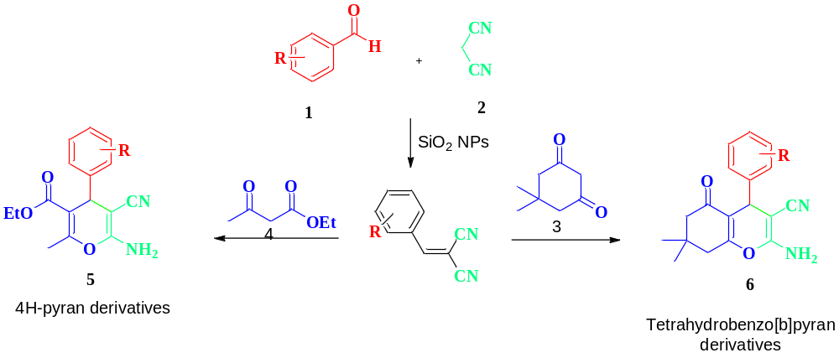
Scheme 1. Tetrahydrobenzo[b] pyrans derivatives.
H. Valizadeh approach:
H. Valizadeh et. al. stated herewith, a facile and effective method has been developed comprising ZnO nanoparticles as a reusable catalyst in [bmim]BF₄ (as shown in scheme 2) [36]. This procedure proposal numerous advantages over existing methods, counting higher yields, cost-effectiveness, ready availability of the catalyst, stability for storage, and ease of recycling for multiple cycles while maintaining consistent activity. Additionally, the procedure provides benefits such as great yields, small reaction times, and environmentally friendly.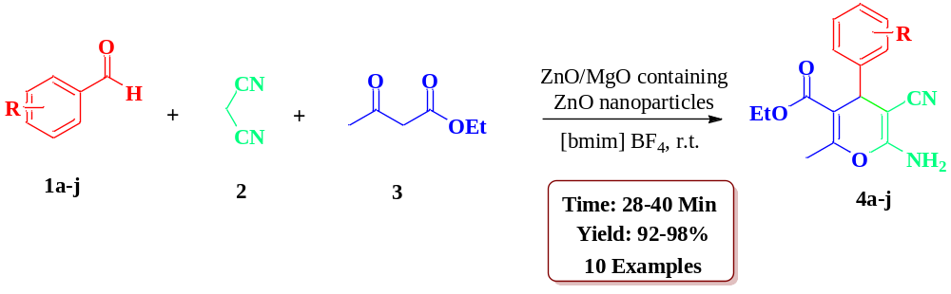
Scheme 2. Preparation of pyran with [bmim]BF₄
Pranabes Bhattacharyya approach:
Pranabes Bhattacharyya et. al. stated a green and greatly effective protocol was devised for pyran synthesis by employing multicomponent reaction. This reaction involved substituted aldehyde, malononitrile, and diketone, with the catalyst being nanostructured ZnO in an aqueous alcoholic medium (as shown in scheme 3). Furthermore, an eco-friendly approach for synthesizing 3,4-dihydropyridin-2-one was also established. This method involved pyran derivatives in water using p-Toluenesulfoni acid. Both of these novel synthetic protocols displayed excellent tolerance to outstanding yield of the desired molecules [37].
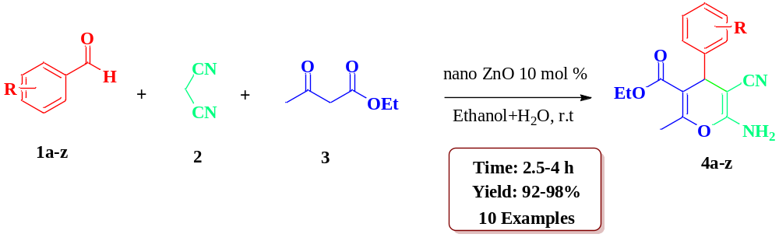
Scheme 3. Synthesis of pyran derivatives by using nono ZnO.
Mithu Saha approach:
Mithu Saha and colleagues introduced a new method for the synthesis of pyran scaffold. This method involves ligand-free Palladium nanoparticles as catalysts, enabling Konevenagel condensation monitored by Michael addition in a one-pot reaction (depicted in scheme 4). The key benefits of this technique include it is ease, little catalyst filling, price helpfulness and ease of handling. Furthermore, the Palladium nanoparticles can be reused up to more than three times deprived of any damage of activity. The researchers characterized the Palladium nanoparticles using residue X-ray diffraction (XRD) and transmission electron microscopy. This innovative technique allows the synthesis of extremely functionalized compounds using readily available starting materials [38].
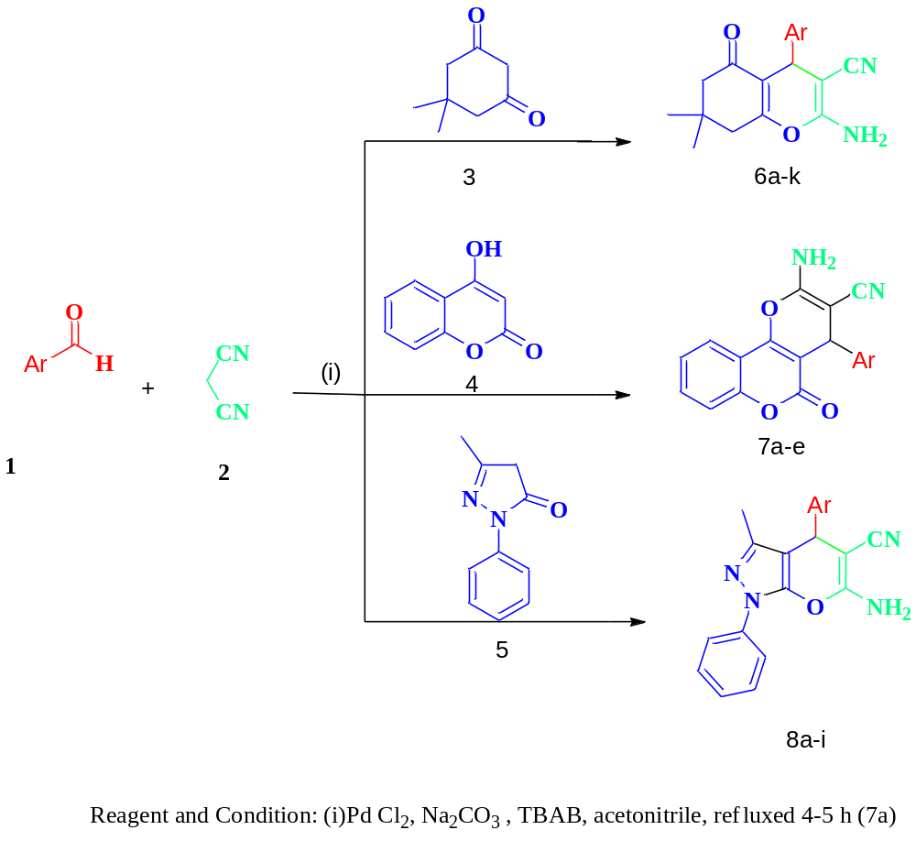
Scheme 4. Synthesis of pyran by using palladium NPs.
Javad Safaei-Ghomi approach:
Javad Safaei-Ghomi and colleagues have introduced an effectual and versatile approach for synthesizing polyfunctionalized 4H-pyrans. The use of SnCl₂/nano SiO₂ as a green and recyclable catalyst, as shown in scheme 5, is a key aspect of this method. The benefits of this approach comprise great yields, less reaction time, , simple workup and the catalyst’s cost-effectiveness and easy availability [39].

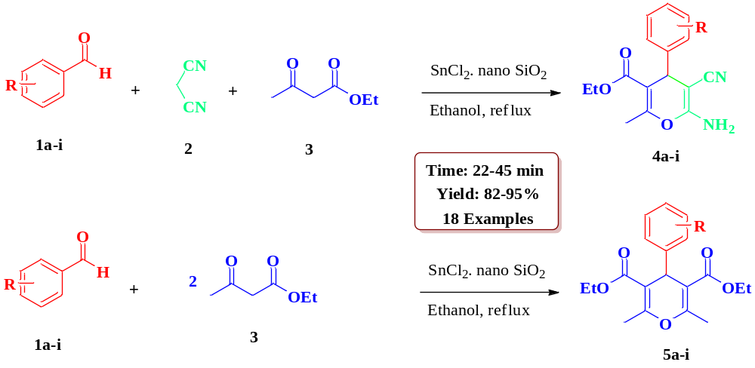
Scheme 5. SnCl₂/nano SiO₂ catalyzed synthesis of polyfunctionalized 4H-pyrans.
Omid Goli-Jolodar approach:
Omid Goli-Jolodar et. al. reported that C₄(DABCO-SO₃H)₂.4Cl, a nano bronsted acidic catalyst, was effectively utilized synthesis of 4-H pyrans. This synthesis encompassed various compounds, notably spirooxindole pyran and bis-pyrans in an aqueous medium, as shown in scheme 6. The method demonstrated numerous profits, as like mild reaction condition, clean reaction, less reaction time, and good yield. Additionally, the use of an affordable and nano-sized catalyst further contributes to the appeal and practicality of this methodology [40].

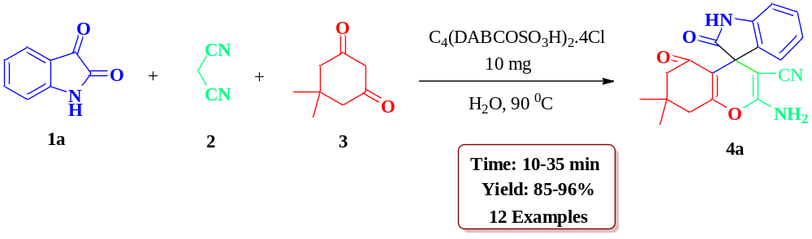

Scheme 6. Synthesis of pyran with C₄(DABCOSO₃H)₂.4Cl in water.

Hamid Reza Saadati-Moshtaghin approach:
Hamid Reza Saadati-Moshtaghin et. al. mentioned attractive catalyst comprising silica coated magnetite nanoparticles (H₂PO₄-SCMNPs) for the synthesis of biologically and pharmacologically active pyran derivatives under solvent free condition (as depicted in scheme 7). The benefits accessible by this procedure against beforehand described method can be concise as; the catalyst is very cheap, attractively distinguishable and recyclable. Moreover, the protocol is ecologically kind and the acceptable yield of product (60-95%) sideways with little reaction time is among other benefit (15 min) [41].
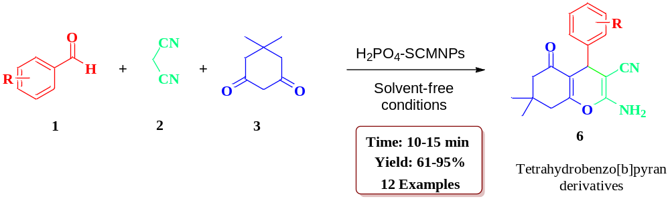
Scheme 7. Preparation of tetrahydrobezo[b]pyrans.
Dawood Elhamifar approach:
Dawood Elhamifar et. al. stated a new magnetic iron oxide based phenylsulfonic acid nanocatalyst (Fe₃O₄@Ph-SO₃H) with a core-shell structure was successfully made and utilized for the eco-friendly synthesis of tetrahydrobezo[b]pyrans. The synthesis of Fe₃O₄@Ph-SO₃H involved modifying attractive Fe₃O₄ core with 1,4-bis(triethoxysilyl)benzene (BTEB), tracked by sulfonation of aromatic ring (as depicted in scheme 8). Various techniques, including TGA, FTIR, PXRD, SEM, TEM, VSM, and EDX were working to illustrate the Fe₃O₄@Ph-SO₃H nanocatalyst. The green synthesis of tetrahydrobezo[b]pyrans was carried out efficiently in water as solvent, employing ultrasonic conditions at room temperature. The nanocatalyst demonstrated excellent performance, good product yield in short reaction times. Moreover, the nanocatalyst's recoverability, reusability, and toughness were investigated underneath the reaction conditions, confirming its practical applicability [42].
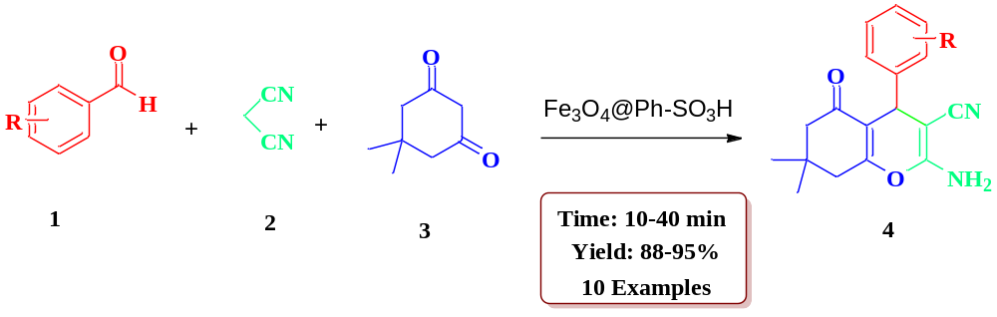
Scheme 8. Preparation of tetrahydrobezo[b]pyrans by using Fe₃O₄@Ph-SO₃H.

Mohammad Ali Zolfigol approach:
Mohammad Ali Zolfigol et al synthesized1-methylimidazolium tricyanomethanide {[HMIM]C(CN)₃}NPs and successfully utilized to synthesized tetrahydrobenzo-[b]-pyran derivatives under the solvent-free conditions at ambient temperature, [as depicted in scheme 9]. Expeditious synthesis and excellent yield are the striking features of this protocol [43].
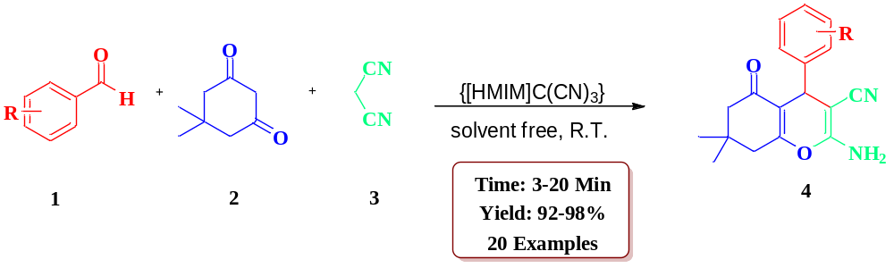
Scheme 9: Synthesis of (4) using substituted aldehyde, dimedone, malononitrile, and {[HMIM]C(CN)₃} as a nanocatalyst.
Mohammad Ali Zolfigo approach:
M. A. Zolfigo et al has successfully demonstrated an expeditious method to synthesize tetrahydrobenzo[b]pyran derivatives. This novel approach involves the condensation of dimedone, substituted aldehydes, and malononitrile, utilizing {[4,4′-Bipyridine]-1,1′-diium tricyanomethanide} ({[4,4’-BPyH][C(CN)3]2}) as a ecofriendly, and mild catalyst. The entire process is carried out at ambient temperature without solvent, as depicted in scheme 10 [44].
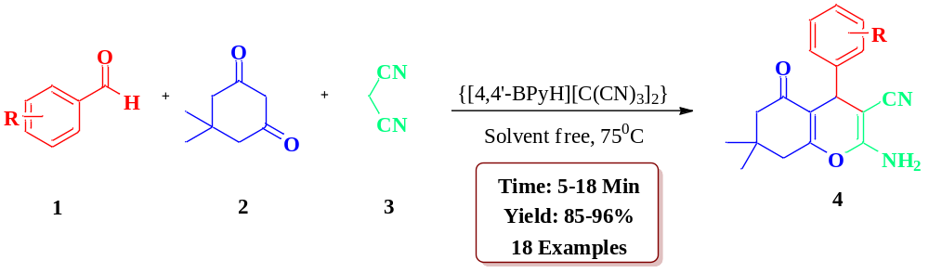
Scheme 10: Synthesis of (4) using substituted aldehyde, dimedone, malononitrile, and {[4,4’-BPyH][C(CN)₃]₂} as a nanocatalyst.
Fariba Heidarizadeh approach:
Fariba Heidarizadeh and colleagues prepared MnFe₂O₄@SiO₂@NHPhNH₂-phosphotungstic acid through the interaction between diamine-modified silica-coated manganese ferrite nanoparticles and H₃PW₁₂O₄₀. The produced nanoparticle were utilized to synthesize tetrahydrobenzo-[b]-pyran compounds using ultrasonic irradiation methods, as illustrated in scheme 11. This approach presents numerous benefits, such as significant yield, short reaction durations, convenient catalyst recovery, and the ability to reuse the catalyst [45].
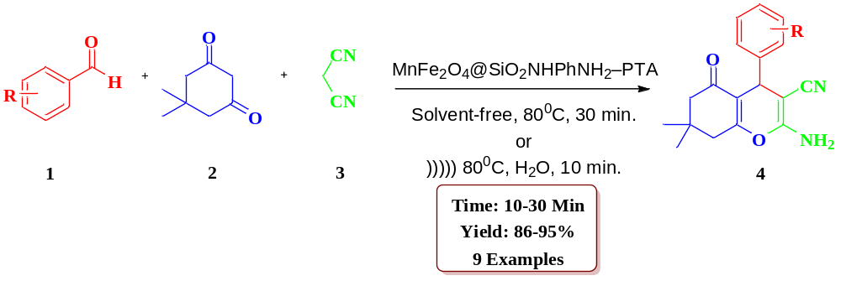
Scheme 11: Synthesis of (4) using substituted aldehyde, dimedone, malononitrile, and diamine-based silica coated manganese ferrite nanoparticles.
Behrooz Maleki approach:
Behrooz Maleki et al have made a significant contribution by developing a novel SO₃H dendrimer functionalized magnetic nanoparticles (Fe₃O₄@D-NH-(CH₂)₄-SO₃H) and successfully utilized to synthesize highly substituted pyrans and polyhydroquinolines utilizing one-pot multicomponent approach, [as depicted in scheme 12]. Rapid process, excellent yields, simple workup, and purification of process are the striking feature of this protocol [46].
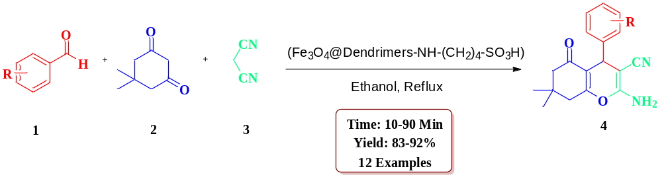
Scheme 12: Synthesis of (4) using substituted aldehyde, dimedone, malononitrile, and Fe₃O₄@D-NH-(CH₂)₄-SO₃H nanocatalyst.
Taiebeh Tamoradi approach:
T. Tamoradi et al presented a comprehensive study on the fabrication of Europium (Eu) which was supported on silica-modified core-shell CoFe₂O₄ magnetic nanoparticles functionalized with iminodiacetic acid. The team successfully showcased a well-defined procedure to synthesize one-pot multicomponent synthesis of tetrahydrobenzo[b]pyran compounds, employing ethanol as the reaction medium, and achieving good to excellent yields (as illustrated in scheme 13). Remarkably, the catalyst's magnetic nature allows for convenient separation and reusability up to six consecutive cycles in the reaction, with negligible activity loss [47].
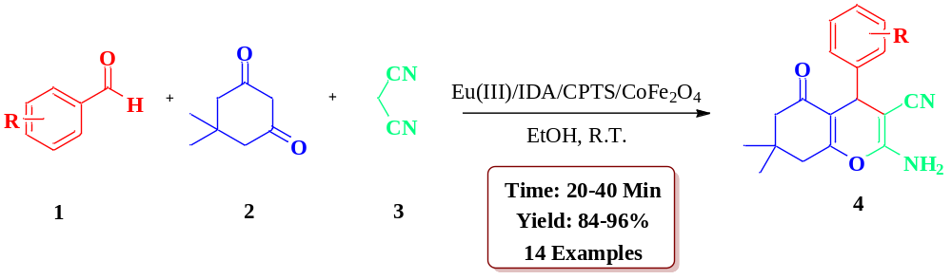
Scheme 13: Synthesis of (4) using substituted aldehyde, dimedone, malononitrile, and Eu(III)/IDA/CPTS/CoFe₂O₄ as a nanocatalyst.
Fatemeh Adibian approach:
F. Adibian et al have made a significant contribution by developing, magnetic multi-walled carbon nanotubes (MMWCNTs) that have been functionally enhanced with polyamidoamine (PAMAM) dendrimers and subjected to modification through butyl sulfonate. The synthesized nanocomposite (MMWCNTs-D-(CH2)₄-SO₃H) was successfully utilized to synthesize tetrahydrobenzo[b]pyran via the reaction of dimedone, different aldehydes, and malononitrile, as depicted in scheme 14 [48].
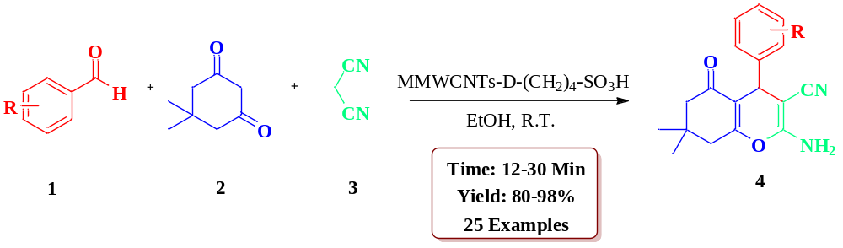
Scheme 14: Synthesis of (4) using substituted aldehyde, dimedone, malononitrile, and MMWCNTs-D-(CH₂)₄-SO₃H as a nanocatalyst.
Esmayeel Abbaspour-Gilandeh approach:
Esmayeel Abbaspour-Gilandeh et al in their scholarly work synthesized Zr@IL-Fe₃O₄ MNPs and effectively showcased the catalytic utility of Zr@IL-Fe3O4 MNPs in the synthesis of highly substituted pyran derivatives. This was accomplished through a one-pot three component condensation of 4 hydroxycoumarin/dimedone, malononitrile, and arylaldehydes under solvent-free conditions. This new methodology demonstrated some important features, including short reaction times, excellent yields, lower loading of the catalyst, easy work-up, and recyclability of the catalyst, as illustrated in Scheme 15 [49].
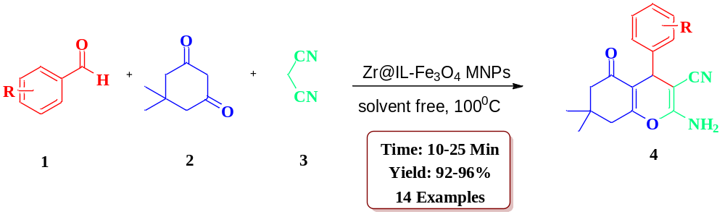
Scheme 15: Synthesis of (4) using substituted aldehyde, dimedone, malononitrile, and Zr@IL-Fe₃O₄ MNPs.
Geetika Patel approach:
Geetika Patel et al. conducted a study wherein they reported the manufacture of Co₃O₄ nanoparticles by disintegration of CoCl₂.6H₂O in an alkaline medium, utilizing the co-precipitation technique. This nanomaterial was successfully employed for synthesizing tetrahydrobenzo[b]pyran derivatives, resulting in remarkably high yields, as illustrated in scheme 16. The findings of this research hold significant importance in the realm of scientific and academic exploration [50].
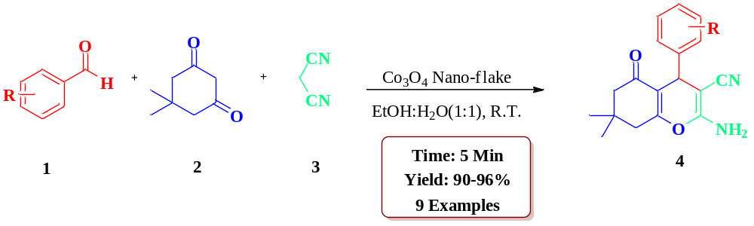
Scheme 16: Synthesis of (4) using substituted aldehyde, dimedone, malononitrile, and Co₃O₄ nano-flake as a nanocatalyst.

Conclusion:
In conclusion, the applications of tetrahydrobezo[b]pyrans and their derivatives in various fields, including medicinal chemistry and materials science, are explored. The potential of nanocatalysts to tailor the synthesis of tetrahydrobezo[b]pyrans for specific applications is emphasized, illustrating the versatility of this approach. This review underscores the significant contributions of nanocatalysts in the synthesis of tetrahydrobenzo[b]pyrans and their derivatives. The eco-friendly nature, enhanced catalytic activity, and potential for tailored synthesis make nanocatalysts indispensable tools in modern organic chemistry. As research in this area continues to evolve, the reviewed methodologies are anticipated to inspire further innovations in the synthesis of tetrahydrobezo[b]pyrans and expand their utility in diverse scientific and industrial applications.

[9] R.N. Shelke, A.B. Kanagare, S.U. Deshmukh, S.R. Bembalkar, D.N. Pansare, K. L.
Ameta, R.P. Pawar (2022) An Overview of the Synthesis of Pyrroline, Indolizine, and
Quinolizinium Derivatives Using Different Nanocatalysts. Nanocatalysis, 53-74.

References

- (a) P. Lu, Y. G. Wang, (2010) Strategies for Heterocyclic Synthesis via Cascade Reactions Based on Ketenimines. Synlett. 2, 65–173. (b) B. Ganem, (2009) Strategies for Innovation in Multicomponent Reaction Design. Acc. Chem. Res. 42, 463–472.
- S. Banerjee, S. Santra, (2009) Remarkable catalytic activity of silica nanoparticle in the bis-Michael addition of active methylene compounds to conjugated alkenes. Tetrahedron Lett. 50, 2037-2040.
- G. R. Green, J. M. Evans, A. K. Vong, in: A.R. Katritzky, C.W. Rees, E.F.V. Scriven (Eds.), (1995) Comprehensive Heterocyclic Chemistry II, Vol. 5, Pergamon Press, Oxford, 469.
- W.O. Foye, Prinicipi di Chemico Farmaceutica, Piccin, Padova, Italy, (1991) 416.
- L. Bonsignore, G. Loy, D. Secci, A. Calignano, (1993) Synthesis and Pharmacological Activity of 2-Oxo-(2H) 1-Benzopyran-3-Carboxamide Derivatives. European Journal of Medicinal Chemistry. 28, 517-520.
- N. Martin, C. Pascual, C. Seoane, J. L. Soto, (1987) Activated nitriles in heterocyclic syntheses. Heterocycles. 26, 2811-2816.
- D. Armetso, W. M. Horspool, N. Martin, A. Ramos, C. Seaone, (1989) Synthesis of Cyclobutenes by the Novel Photochemical Ring Contraction of 4-Substituted-2-amino-3,5- dicyano-6-phenyl-4H-pyrans. The Journal of Organic Chemistry, 54,11, 3069-3072.
- J.F. Zhou, S.J. Tu, Y. Gao, M. Ji, (2001) One pot synthesis of pyrans and pyrano[2,3-c]pyrazole derivatives under microwave irradiation. Chin. J. Org. Chem. 21, 742-745.
- Comprehensive Heterocyclic Chemistry II; Green, G. R., Evans, J. M., Vong, A. K., Katritzky, A. R., Rees, C. W., Scriven, E. F. V., Eds.; Pergamon Press: Oxford, (1995) 5, 469.
- Foye, W. O. Prinicipi di Chemico Farmaceutica; Piccin: Padova, Italy, (1991) 416.
- J. M. Quintela, C. Peinador, M. J. Moreira, (1995) A novel synthesis of pyrano[2,3-d]pyrimidine derivatives. Tetrahedron. 51, 5901–5912.
- L. L. Andreani, E. Lapi, (1960) On Some New Esters of Coumarin-3-carboxylic Acid with Balsamic and Bron- chodilator Action. Bollettino chimico farmaceutico, 99, 583-586. Italian. PMID: 13759798.
- E. A. A. Hafez, M. H. Elnagdi, A. G. A. Elagamey and F. M. A. A. Ei-Taweel, (1987) Nitriles in Heterocyclic Synthesis: Novel Synthesis of Benzo[c]coumarin and of Benzo[c] pyrano[3,2-c]quinoline Derivatives. Heterocycles, 26, 903-907.
- K. Kanagaraj, K. Pitchumani, (2010) Solvent-Free Multi-component Synthesis of Pyranopyrazoles: Per-6-amino-b- cyclodextrin as a Remarkable Catalyst and Host. Tetra- hedron Letters, 51(25), 3312-3316.
- D. Shi, J. Mou, Q. Zhuang, L. Niu, N, Wu and X. Wang, (2004) Three-Component One-Pot Synthesis of 1,4-Dihydropy- rano[2,3-c]pyrazole Derivatives in Aqueous Media. Syn- thetic Communications, 34(24), 4557-4563.
- F. Lehmann, M. Holm, S. Laufer, (2008) Three-Component Combinatorial Synthesis of Novel Dihydropyrano[2,3-c] pyrazoles. Journal of Combinatorial Chemistry, 10(3), 364-367.
- G. Vasuki, K. Kumaravel, (2008) Rapid Four-Component Reactions in Water: Synthesis of Pyranopyrazoles. Tetrahedron Letters. 49(39), 5636-5638.
- R. S. Bhosale, C. V. Magar, K. S. Solanke, S. B. Mane, S. S. Choudhary, R. P. Pawar, (2007) Molecular Iodine: An Efficient Catalyst for the Synthesis of Tetrahydrobenzo[b] pyrans. Synthetic Communications, 37(24), 4353-4357.
- S. Muramulla, C.G. Zhao, (2011) A New Catalytic Mode of the Modularly Designed Organocatalysts (MDOs): Enan- tioselective Synthesis of Dihydropyrano[2,3-c]pyrazole,” Tetrahedron Letters, 52(30), 3905-3908.
- J. M. Khurana, B. Nand, P. Saluja, (2010) DBU: A Highly Efficient Catalyst for One-Pot Synthesis of Substituted 3,4-Dihydropyrano[3,2-c]chromenes, Dihydropyrano[4,3- b]pyranes, 2-Amino-4hbenzo[h]chromenes and 2-Amino- 4H Benzo[g]chromenes in Aqueous Medium. Tetrahedron Lett., 66, 5637-5641.
- J.T. Li, W.Z. Xu, L.C. Yang and T.S. Li, (2004) One-Pot Synthesis of 2-Amino-4-aryl-3-carbalkoxy-7,7-dimethyl- 5,6,7,8-tetrahydrobenzo[b]pyran Derivatives Catalyzed by KF/Basic Al₂O₃ under Ultrasound Irradiation. Synthetic Communications, 34(24), 4565- 4571.
- X.S. Wang, M.M. Zhang, H. Jiang, C.S. Yao and S.J. Tu, (2007) Three-Component Green Synthesis of N-Arylquinoline Derivatives in Ionic Liquid [BmimD][BF₄L]: Reactions of Arylaldehyde,3-arylamino-5,5-dimethylcyclohex-2-enone, and Activemethylene Compounds. Tetrahedron, 63(21), 4439-4449.
- I. Devi and P. J. Bhuyan, (2004) Sodium Bromide Catalysed One-Pot Synthesis of Tetrahydrobenzo[B]Pyrans via a Three-Component Cyclocondensation under Microwave Irradiation and Solvent Free Conditions. Tetrahedron Lett., 45(47), 8625-8627.
- A. Domling, (2006) Recent developments in isocyanide based multicomponent reactions in applied chemistry, Chem. Rev. 106, 17–89.
- D. J. Ramon, M. Yus, (2005) Asymmetric multicomponent reactions (AMCRs): the new frontier, Angew. Chem. Int. Ed. 44, 1602–1634.
- C. Ma, Y. Yang, (2005) Thiazolium-mediated multicomponent reactions: a facile synthesis of 3-aminofuran derivatives, Org. Lett. 7, 1343–1345.
- E. Soleimani, M.M. Khodaei, N. Batooie, M. Baghbanzadeh, (2011) Water-prompted synthesis of alkyl nitrile derivatives via Knoevenagel condensation and Michael addition reaction, Green Chem. 13, 566–569.
- G. Evano, N. Blanchard, M. Toumi, (2008) New copper-mediated coupling reactions and their applications in natural products and designed biomolecules synthesis. Chem. Rev. 108, 3054–3131.
- A. P. Katariya, A. K. Dhas, A. B. Kanagare, D. N. Pansare, D. S. Bhagat, B. Kumar, (2023) Nano-catalyzed synthesis of pyranopyrazole and pyridine scaffolds. In: S. Bhunia, B. Kumar, P. Singh, R. Oraon, K.H. Kim, editors. Nanoparticles in Green Organic Synthesis Elsevier; 485–504.
- A. Kanagare, A. Yadav, A. Katariya, S. Deshmukh, (2023) Insights into 4,4′‐Arylmethylene‐Bis‐1H‐Pyrazol‐5‐Ols Scaffolds: Various Synthetic Routes and Their Applications. Chemistry Select,
- A. Dhas, A. Kanagare, M. Kanetkar, D. Pansare, S. Deshmukh, A. Katariya, (2023) Rapid and Efficient Synthesis of 4-substituted 2-amino Thiazole Using Copper Silicate as a Heterogeneous Reusable Catalyst. Lett Appl NanoBioScience. 12, 159.
- P. Jadhav, A. Kanagare, A. Dhirbassi, R. Pawar, (2022) Recent Advances in Nanocatalyzed Synthesis of Triazoles and Tetrazoles and Their Biological Studies. Nanocatalysis. CRC Press; 177–200.
- A. Kanagare, D. Pansare, A. Dhas, R. Pawar, (2022) Nanocatalysis: An Efficient Tool for the Synthesis of Triazines and Tetrazines. Nanocatalysis. CRC Press; 20.
- R. Shelke, A. Kanagare, S. Deshmukh, D. Pansare, R. Pawar, (2022) An Overview of the Synthesis of Pyrroline, Indolizine, and Quinolizinium Derivatives Using Different Nanocatalysts. Nanocatalysis. CRC Press; 22.
- S. Banerjee, A. Horn, H. Khatri, G. Sereda, (2011) A green one-pot multicomponent synthesis of 4H-pyrans and polysubstituted aniline derivatives of biological, pharmacological, and optical applications using silica nanoparticles as reusable catalyst. Tetrahedron Lett., 52, 1878–1881.
- H. Valizadeh, A. A. Azimi, (2011) ZnO/MgO Containing ZnO Nanoparticles as a Highly Effective Heterogeneous Base Catalyst for the Synthesis of 4H-Pyrans and Coumarins in [bmim]BF₄ . J. Iran. Chem. Soc., 8(1), 123-130.
- P. Bhattacharyya, K. Pradhan, S. Paul, A.R. Das, (2012) Nano crystalline ZnO catalyzed one pot multicomponent reaction for an easy access of fully decorated 4H-pyran scaffolds and its rearrangement to 2-pyridone nucleus in aqueous media. Tetrahedron Letters, 53, 4687–4691.
- M. Saha, A. K. Pal, (2012) Palladium (0) Nanoparticles: A Novel and Reusable Catalyst for the Synthesis of Various Pyran Derivatives. Advances in Nanoparticles, 1, 61-70.
- J. S. Ghomi, R. Teymuri, H. Shahbazi-Alavi, A. Ziarati, (2013) SnCl₂/nano SiO₂: A green and reusable heterogeneous catalyst for the synthesis of polyfunctionalized 4H-pyrans. Chinese Chemical Letters, 24(10), 921-925.
- O. Goli-Jolodar, F. Shirini, M. Seddighi, (2016) An efficient and practical synthesis of specially 2-amino-4H-pyrans catalyzed by C4(DABCO-SO₃H)₂.4Cl. Dyes and Pigments. 133, 292-303.
- H. Reza, S. Moshtaghin, F. M. Zonoz, (2017) Preparation and characterization of magnetite-dihydrogen phosphate as a novel catalyst in the synthesis of tetrahydrobenzo[b]pyrans. Materials Chemistry and Physics. 199, 159-165.
- D. Elhamifar, Z. Ramazani, M. Norouzi, R. Mirbagheri, (2018) Magnetic iron oxide/phenylsulfonic acid: A novel, efficient and recoverable nanocatalyst for green synthesis of tetrahydrobenzo[b] pyrans under ultrasonic conditions. Journal of Colloid and Interface Science, 511, 392–401.
- M. A. Zolfigol, N. B. Nejad, F. Afsharnadery, S. Baghery, (2016) 1-Methylimidazolium tricyanomethanide {[HMIM]C(CN)₃} as a nano structure and reusable molten salt catalyst for the synthesis of tetrahydrobenzo[b]pyrans via tandem Knoevenagel-Michael cyclocondensation and 3,4-dihydropyrano[c]chromene derivatives, Journal of Molecular Liquids, 221 851–859.
- M. A. Zolfigol, M. Yarie, S. Baghery, (2016) [4,4′-Bipyridine]-1,1′-diium tricyanomethanide as a nanostructured molten salt and its catalytic application in the synthesis of tetrahydrobenzo[b]pyrans, amido and aminoalkyl naphthol derivatives, Journal of Molecular Liquids, 222, 923–932.
- R. Mozafari, F. Heidarizadeh, P. (2019) Acid supported on SiO₂@NHPhNH₂ functionalized nanoparticles of MnFe₂O₄ as a recyclable catalyst for the preparation of tetrahydrobenzo[b]pyran and indazolo[2,1-b]phthalazine-triones, Polyhedron 162, 263–276.
- B. Maleki, O. Reiser, E. Esmaeilnezhad, H. J. Choi, (2019) SO₃H-dendrimer functionalized magnetic nanoparticles (Fe₃O₄@D-NH-(CH₂)₄-SO₃H): Synthesis, characterization and its application as a novel and heterogeneous catalyst for the one-pot synthesis of polyfunctionalized pyrans and polyhydroquinolines, Polyhedron, 162, 129–141.
- T. Tamoradi, B. Karmakar, M. Kamalzare, M. Bayat, A. T. Kal-Koshvandi, A. Maleki, (2020) Synthesis of Eu(III) fabricated spinel ferrite based surface modified hybrid nanocomposite: Study of catalytic activity towards the facile synthesis of tetrahydrobenzo[b]pyrans, Journal of Molecular Structure, 1219, 128598.
- Fatemeh Adibian, Ali Reza Pourali, Behrooz Maleki, Mehdi Baghayeri, Amirhassan Amiri, (2020) One-pot synthesis of dihydro-1H-indeno[1,2-b] pyridines and tetrahydrobenzo[b] pyran derivatives using a new and efficient nanocomposite catalyst based on N-butylsulfonate functionalized MMWCNTs-D-NH₂, Polyhedron. 175, 114179.
- M. Aghaei-Hashjin, A.Yahyazadeh, E. A. Gilandeh, (2021) Zr@IL-Fe₃O₄ MNPs as an efficient and green heterogeneous magnetic nanocatalyst for the one pot three-component synthesis of highly substituted pyran derivatives under solvent-free conditions, RSC Advances, 11, 23491–23505.
- G. Patel, A. R. Patel, G. Maity, S. Das, S. P. Patel, S. Banerjee, (2022) Fabrication of self-assembled Co₃O₄ nano-flake for one-pot synthesis of tetrahydrobenzo[b]pyran and 1,3-benzothazole derivatives, Current Research in Green and Sustainable Chemistry, 5, 100258.

