Use of bioinformatics tools to study phylogenetic analysis and sequence similarity of Malassezia sp. a pathogen involved in Dandruff.
¹DrNamrata Khurana,²DrUday Singh Ningwal
¹Assistant Professor, ² Assistant Professor,
¹Madhay Pradesh higher education,
¹MAHARAJA BHOJ GOVERNMENT P.G.COLLEGE, DHAR, INDIA
¹ namratakhurana15@gmail.com, ²usningwal@gmail.com

Abstract—:- One of the most prevalent species in the human skin microbiota, Malassezia species, has been linked to skin conditions like dandruff and seborrheic dermatitis. Although Malassezia plays a significant role in common skin diseases, little is understood about its molecular makeup. In this approach, bioinformatics can be quite helpful. Selected genes from Malassezia species can be subjected to BLAST P. It was discovered that M. restrictive shares similarities with the distant human pathogen Candida albicans and the plant pathogen Ustilago mayids by the use of blast, a bioinformatics tool. It is possible to identify the convergent and divergent features of Malassezia species using the bioinformatics tool Culstal W. Researchers must create more potent bioinformatics tools to help manage the growing issue of dandruff and itchiness on the scalp in the human population.

IndexTerms—Malassezia,Ustilago, Candidaalbicans,CLUSTALW,BLAST,Dandruff,scalp pruritus.
________________________________________________________________________________________________________

Introduction
One of the most important species of skin microbiota is the Malassezia species, which has been linked to a number of skin conditions, including dandruff and seborrheic dermatitis.The molecular makeup of malassezia is largely unknown. There are currently roughly 18 species of Malassezia known, including M.globosa,M.restricta are the most common species found in humans.malassezia is the eukaryotic biota of the human skin. Seborrheic dermatitis and dandruff are common skin conditions that cause itching and skin flaking. While seborrheic dermatitis is characterized by yellow flakes and irritation, dandruff is characterized by loose flakes and lack of inflammation. The proliferation of the commensel malassezia is the cause of dandruff and other diseases that affect about 50% of individuals. Three components seem to be involved in the etiology of D/SD: metabolism by microbiota, secretions from sebaceous glands, and individual vulnerability. (DeAngelis and others, 2005); Ro and Dawson, 2005). This chapter will describe the most common matches of M.globosa sequence and its phylogenetic analysis using bioinformatics tools BLAST and CLUTALW. BLAST is a tool of NCBI . It finds region of similarity between two or more sequences, the sequences can be either protein or nucleotide. BLAST stands for basic local alignment search tool. Blast is basically used to find out evolutionary and functional relationship between two individuals.it is not a single program but a family of programme like BLAST p , BLAST n , BLAST x, tBLASTn etc. it also helps to identify the member of gene families. CLUTALW is a multiple sequence alignment tool for DNA and protein sequence.it is not a tool for pairwise alignment but generally good for comparing three to four sequences. it is tool of European bioinformatics institute.

The front page of CLUSTALW looks like this

SOURCE: https://www.genome.jp/tools-bin/clustalw

Similarly the front page of blast looks like:

SOURCE: https://blast.ncbi.nlm.nih.gov/Blast.cgi?PROGRAM=blastn&PAGE_TYPE=BlastSearch&LINK_LOC=blasthome

Material and methods:
The NCBI GENBANK BLAST server version 2.2.30 (http://blast.ncbi.nlm.nih.gov) was utilized for alignment and homology searches (altschul et al. 1997).The NCBI data base has complete sequence of all the 9 chromosome of Malasseziarestricta as well as the Malasseziarestricta mitochondrion, complete genome. A specific protein synthesized by each chromosome was selected viz lipase protein sequence from chromosome 1 zinc finger domain from chromosome 2 , chitin synthetase from chromosome 3 pyruvate synthetase from chromosome 4, carboxyl methyltransferase from chromosome 5, cell division cycle protein 37 of chromosome 6, NADH dehydrogenase (ubiquinone) Fe-S protein 4 of chromosome 7,arginase protein of chromosome 8, DNA repair protein REV1 of chromosome 9 and BLASTp was carried out and homology was identified. The database used for for comparison was non redundant protein databases. Multiple sequence alignment by CLUSTAL W with a K tupule word size of 1 was also carried out between secretory lipase enzymes sequences of Malassezia restricta,Ustilago maydis and Canadida albicans . A questionnaire and random sampling technique were also used on a sample of around 243 respondents, of which 152 were female and the remaining 91 were male.

RESULT AND CONCLUSION:

Protein BLAST of lipase protein sequence of chromosome 1 revealed similarity with Ustilagosps and most of the smut fungi. The zinc finger domain on chromosome 2 was found to be similar to plant pathogen Ceratobasidiumsp and Mycenasps.
The chitin synthase [Malasseziarestricta] was found to be highly similar to Testiculariasps. andScleroderma sps. andUstilagosps,again all plant pathogen. The pyruvate synthetase gene from chromosome 4 was found to be similar to Violaceomycespalustrisand Ustilagosps.Carboxyl Methyl transferase protein sequence of chromosome 5 was again found to be similar to Ustilagosps.Cell division cycle protein 37 protein sequence of chromosome of chromosome 6 was found to be 98% to Ustilagosps.NADH dehydrogenase (ubiquinone) Fe-S protein 4 of chromosome 7 showed 84% similarity with Ustilagosps.Arginase protein of chromososme 8 was found to be 98% similar to Ustilagomaydis.DNA repair protein REV1of chromosome 9 was found to be 96% to Rhizopussps.and 63% to Ustilagosps.M.restricta was found to more be closely related with the plant fungal pathogen Ustilagomyadis. A MSA between the secretory lipase of C.albicans, M.ristrictaandU.mayadis showed M.restricta and U.mayadis to be more convergent then C.albicans.
A detailed summary of the result is given below in the –

Table 1:summary of BLAST P analysis of M.resticta
Name | RefSeq | Protein | Functional Protein Selected | SIMILARITY % WITH Ustilagomyadis
Chr | I | 835 | lipase protein | 85%
Chr | II | 782 | zinc finger domain | Showed similarity withCeratobasidiumsps
Chr | III | 746 | chitin synthase
Chr | IV | 464 | pyruvate synthetase | 84%
Chr | V | 532 | carboxyl methyltransferase | 64%
Chr | VI | 410 | cell division cycle protein 37 | 98%
Chr | VII | 280 | NADH dehydrogenase (ubiquinone) Fe-S protein 4 | 84%
Chr | VIII | 233 | arginase protein | 98%
Chr | IX | 108 | DNA repair protein REV1 | 63%
name | RefSeq | protein | Functional Protein Selected | SIMILARITY % WITH Ustilagomyadis
Chr | I | 835 | lipase protein | 85%
Chr | II | 782 | zinc finger domain | Showed similarity withCeratobasidiumsps
Chr | III | 746 | chitin synthase
Chr | IV | 464 | pyruvate synthetase | 84%
Chr | V | 532 | carboxyl methyltransferase | 64%
Chr | VI | 410 | cell division cycle protein 37 | 98%
Chr | VII | 280 | NADH dehydrogenase (ubiquinone) Fe-S protein 4 | 84%
Chr | VIII | 233 | arginase protein | 98%
Chr | IX | 108 | DNA repair protein REV1 | 63%

.

A questionnaire and random sampling technique were also used on a sample of around 243 respondents, of which 152 were female and the remaining 91 were male.15.9% said they flaked their scalp excessively. Dandruff was shown to be less common as people aged, with a higher incidence in the 25–34 age range. Patients with dandruff were shown to have more severe cases of scalp pruritus than those without dandruff. Among the subjects, antidandruff products of all kinds and home treatments proved to be the least effective.

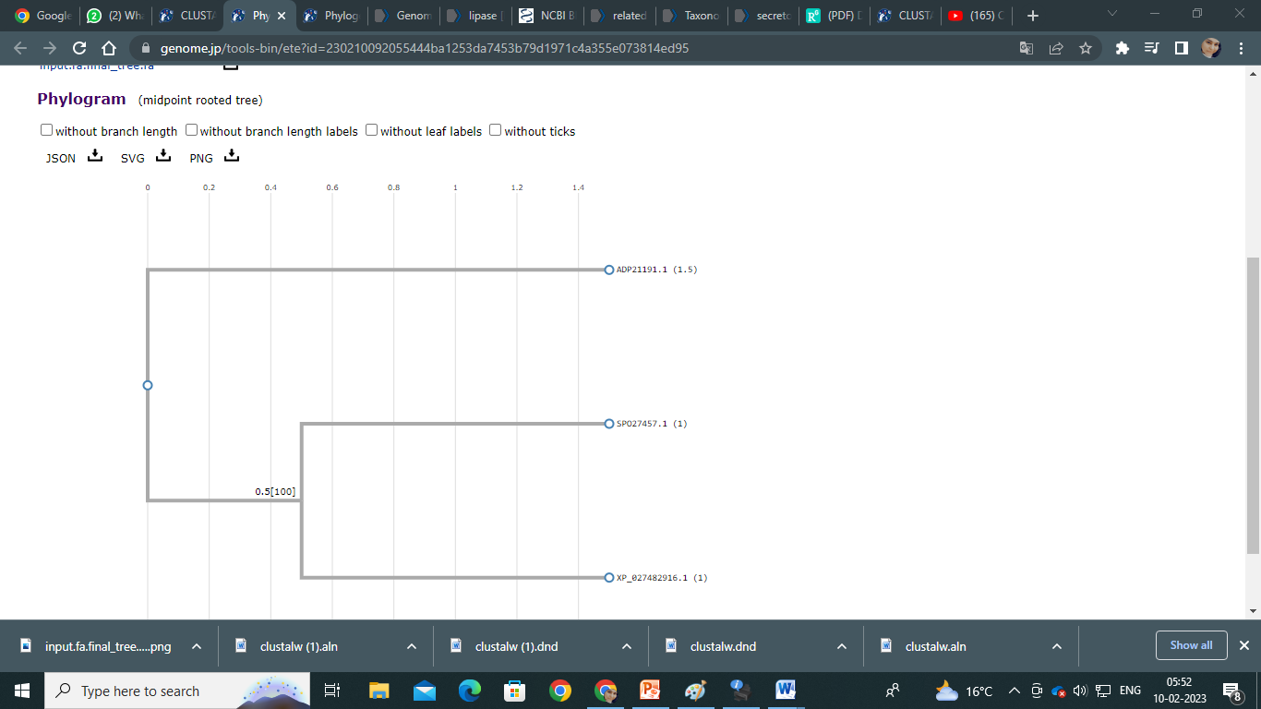
Figure 1: PhyML of secretory lipase

References

- American Academy of Dermatology. Acne-like breakouts could be folliculitis. (https://www.aad.org/public/diseases/a-z/folliculitis) Accessed 10/25/2022.mmy/myx134.
- Bart Theelen, Anastasia C Christinaki, Thomas L Dawson, Jr, TeunBoekhout, Vassili N Kouvelis, Comparative analysis of Malassezia furfur mitogenomes and the development of a mitochondria-based typing approach, FEMS Yeast Research, Volume 21, Issue 7, November 2021.
- Bart Theelen, Claudia Cafarchia, Georgios Gaitanis, IoannisDimitriosBassukas, TeunBoekhout, Thomas L Dawson, Jr, Malassezia ecology, pathophysiology, and treatment, Medical Mycology, Volume 56, Issue suppl_1, April 2018, Pages S10–S25, https://doi.org/10.1093/
- Mills KJ, Hu P, Henry J, Tamura M, Tiesman JP, Xu J. Dandruff/seborrhoeic dermatitis is characterized by an inflammatory genomic signature and possible immune dysfunction: transcriptional analysis of the condition and treatment effects of zinc pyrithione. Br J Dermatol. 2012 Jun;166Suppl 2:33-40. doi: 10.1111/j.1365-2133.2012.10863.x. PMID: 22670617.
- Xu, Jun & Saunders, Charles &hu, Ping & Grant, Raymond &Boekhout, Teun&Kuramae, Eiko&Kronstad, James &Deangelis, Yvonne & Reeder, Nancy &Johnstone, Kevin & Leland, Meredith &Fieno, Angela & Begley, William & Sun, Yiping& Lacey, Martin &Chaudhary, Tanuja&Keough, Thomas & Chu, Lien & Sears, Russell & Dawson, Thomas. (2007). Dandruff-associated Malassezia genomes reveal convergent and divergent virulence traits shared with plant and human fungal pathogens. Proceedings of the National Academy of Sciences of the United States of America. 104. 18730-5. 10.1073/pnas.0706756104.

