Socio-economic Implications of Human-Elephant Conflict: A Case Study in the Dharamjaigarh Forest Division

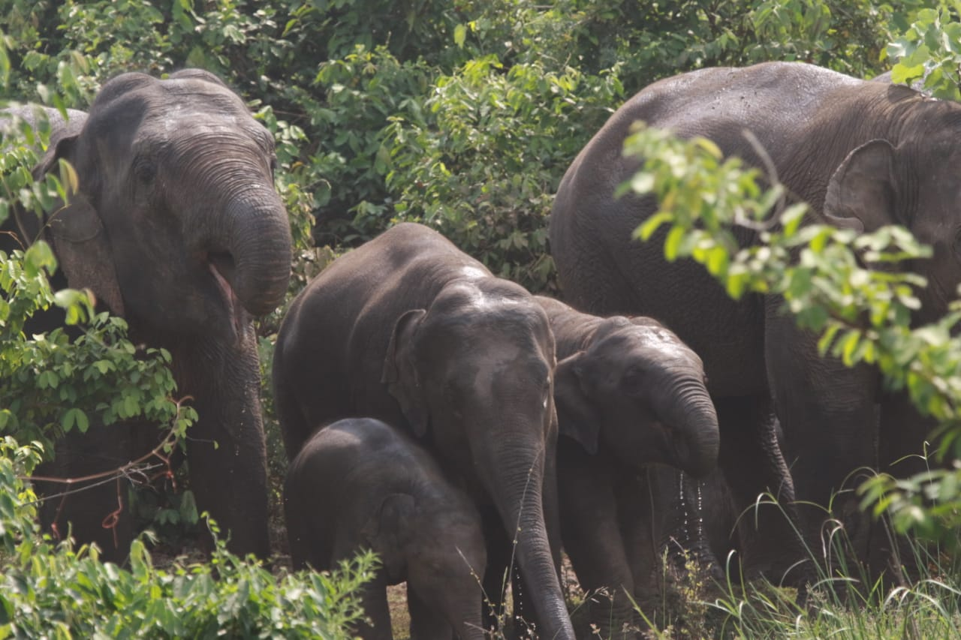

Introduction
The presence of elephants, in parts of India both historically and presently reflects a complex relationship between these majestic animals and the changing human landscape. The widespread distribution of elephants across the peninsula has been affected by habitat degradation, deforestation, and human encroachment. Although historical records indicate their existence in regions like Chhattisgarh, their extinction during the early 20th century followed by their return, in the late 20th century demonstrates the intricate dynamics of human-elephant interactions. This chapter delves into the distribution explores how human activities have impacted elephant habitats and examines the evolving patterns of elephant movement – all to shed light on the balance needed for humans and elephants to coexist in present day.
In the expanse of eastern India, around 2,500 elephants thrive (Anon, 2001). Among them, a select few groups have ventured into Chhattisgarh, setting the stage for a poignant human-elephant conflict. The narrative of this region's ecosystem reveals a somber transformation: once-vibrant habitats in Jharkhand and Odisha have succumbed to illegal logging, encroachment, industrial encroachment, and mining (Singh and Chowdhury, 1999; Singh, 2000). This degradation has coerced the local elephant populations to undertake extensive, disjointed migrations. The elephants, accustomed to traversing uninterrupted verdant stretches, now maneuver through fragmented forest patches, seeking larger havens. As a result of these environmental shifts, elephants have ventured into Chhattisgarh, as well as neighboring territories like Madhya Pradesh and Maharashtra, underscoring the complex interplay between habitat loss and their migratory movements.
Since 1988, the migration of elephants from various states to Chhattisgarh has been steadily rising. Presently, these majestic creatures inhabit the Surguja, Bilaspur, and Raipur forest circles. The period between 1993 and 2000 saw a temporary halt in migration due to elephant capture and training for forest patrolling in Achanakmar. However, in 2002, a herd of around 32 tuskers was sighted, now numbering 247-254 in northern Chhattisgarh, organized into 19 herds. Notably, Bilaspur Circle hosts 121 elephants, Surguja houses 110, and Raipur Circle is home to 23. The latest census reveals that the Korba region boasts the highest elephant population, with 69 individuals, closely trailed by Dharamjaigarh at 49, and Sarguja at 37. Notably, a significant portion of these elephants frequently engage in migratory patterns, traversing the vicinity of neighboring states such as Odisha and Jharkhand.
Since 2000, rising cases of Human-Elephant Conflict (HEC) have plagued Chhattisgarh due to increasing migratory elephants. Unfamiliar with such encounters, local residents attempt unguided elephant deterrence, leading to disoriented elephants causing substantial harm. The regions of Korba, Raigarh, Dharamjaigarh, Jashpur, and Sarguja in Chhattisgarh currently grapple with HEC. Notably, the Dharamjaigarh and Korba Forest Divisions have hosted a consistent elephant herd since 2000, potentially migrating from Jharkhand and Odisha. Tragically, Chhattisgarh recorded an annual average of 18.09 human deaths and 13.91 injuries due to HEC from 2006-07 to 2016-17, underscoring the urgency of addressing this crisis.

Study Area
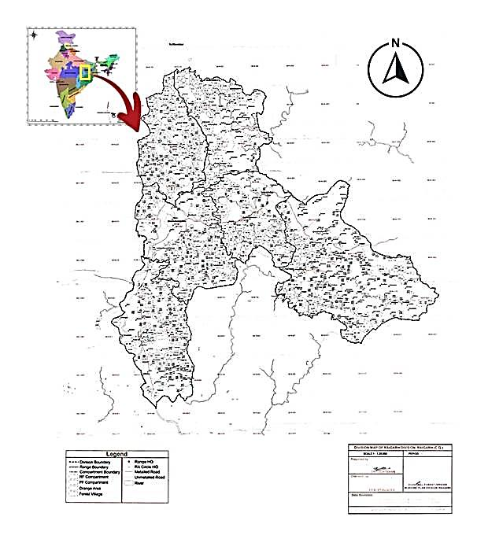

Dharamjaigarh forest division is primarily flat, with a small northern mountainous section (200m to 1100m elevation), transitioning to a central plateau. Southern-eastern hills form Kaapu and Lailunga plateau at 575m elevation. The Dharamjaigarh Forest Division connects with Sarguja, Jashpur, Odisha, Raigarh, and Korba. With abundant forest cover and connectivity, it serves as a significant elephant habitat. Chhal, despite being small, boasts dense forest preferred by elephants. Dharamjaigarh forest range is their second-choice habitat in the division.
The existing Dharamjaigarh forest division comprises primarily Sal Forest and Mixed Forest with Teak plantations. The area also features a range of climbers, herbs, shrubs, epiphytes, and parasites. Prominent tree species include Sal, Saja, Teak, Tendu, Mahua, Aamla, and Galgala. Bamboo species are also prevalent in the forest area.
Elephant Ranging
The complex interplay between habitat availability, anthropogenic activities, and the survival of Asian elephants (Elephas maximus) in certain regions. The pervasive impact of human activities, primarily large-scale mining operations and human disturbances. These factors have inflicted significant damage on the habitat, leading to forest destruction and disruptions in elephant movements throughout the year. Consequently, the once-established ranging patterns of these elephants have been compromised, hindering their ability to establish permanent range areas. This underscores the precarious existence of Asian elephants in this landscape.
The importance of vast, intact habitats becomes evident when considering the dietary needs of these elephants. Requiring more than 300 kg of fodder per day, Asian elephants necessitate extensive home ranges. These ranges, influenced by various factors such as nutrient availability, vegetation type, and human presence, change with the shifting seasons. As the landscape transitions between wet and dry seasons, elephant habitat preferences shift accordingly, emphasizing the significance of providing diverse and suitable habitats for their survival.
Tragically, the very habitats on which these elephants depend are increasingly under threat due to human-induced changes. Deforestation resulting from illegal logging, encroachments, and open-cast mining has forced elephants to seek refuge in neighboring regions, leading to a notable movement of elephants from Jharkhand into Chhattisgarh. This migration underscores the profound consequences of habitat loss, and the fact that these immense creatures are compelled to adapt to changing landscapes in order to secure their existence.
The intricate factors influencing elephant habitat utilization. Availability of water and nutritional quality of forage emerge as key drivers shaping their movement patterns. Elephants' attraction to lowlands, particularly cultivated ones, is evident. Even within protected reserves, elephants have been known to venture into cultivated lands, possibly as a foraging strategy. These lowlands offer accessibility, relatively flat terrains, and a consistent habitat in terms of vegetation, appealing to elephants' preferences.
The broader implications of habitat destruction and fragmentation are clear. Natural habitats, rich in biodiversity, are being replaced by profitable agricultural landscapes and plantations. Such conversions not only threaten the forest cover but also exacerbate human-elephant conflicts due to increased human settlements, agriculture, livestock grazing, and encroachments. As these landscapes evolve, so must the strategies for managing elephant populations. Understanding how these altered environments affect elephant distribution is imperative, especially as Asian elephants venture beyond protected areas into regions of higher human density.

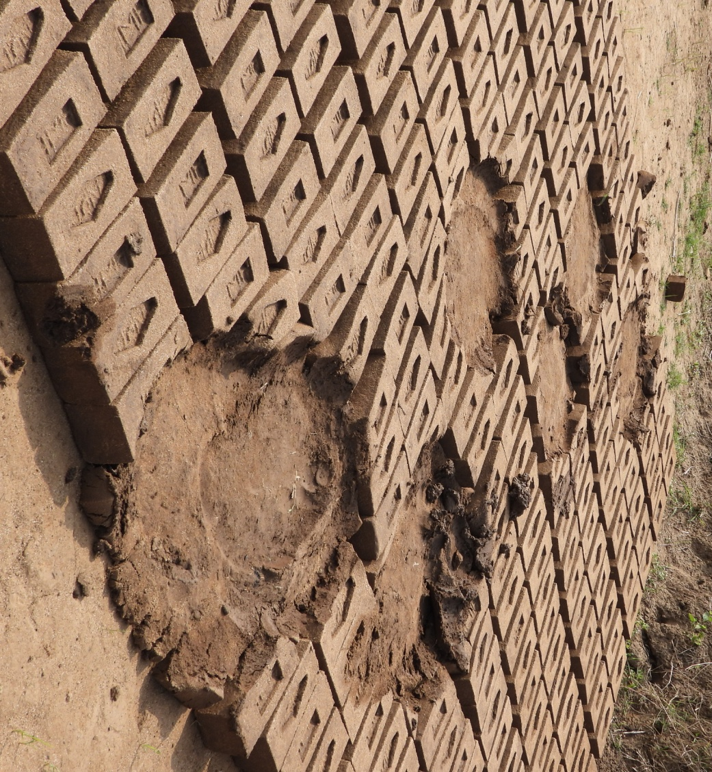

In conclusion, the intricate balance required for the survival of Asian elephants. Their extensive habitat needs, coupled with dependence on diverse and intact landscapes, make them vulnerable to habitat loss and human-induced disturbances. As human activities continue to transform natural habitats, conservation efforts must prioritize the preservation of expansive, interconnected habitats to ensure the continued existence of these magnificent creatures. Moreover, understanding the dynamic interplay between elephants, their habitat, and human activities is essential for implementing effective strategies to manage and protect these iconic animals in an ever-changing world. In Dharamjaigarh elephants are staying and ranging throughout the year also they found the place suitable.

Feeding Behavior
The feeding ecology of elephants, particularly Asian elephants, offers a fascinating insight into their adaptable dietary habits across various habitats and seasons. These majestic creatures are known as generalist feeders, consuming a diverse array of plant species including leaves, twigs, and grasses. Their diet composition fluctuates in response to environmental factors, with a preference for browsing during dry seasons and grazing when grasses are abundant in wet seasons. Several studies conducted across different regions have shed light on the plant families and genera that constitute a substantial portion of their diet. Species such as Acacia, Bambusa, Ficus, Musa, and more emerge as important dietary components. Remarkably, elephants exhibit selective preferences for certain plants, indicating a complex interplay between nutritional needs and available food sources. Additionally, the phenomenon of elephants raiding crops underscores the challenges they face in meeting their nutritional requirements. This behavior is driven by the nutrient-deficient nature of their wild diet, which compels them to venture into agricultural areas. Ultimately, the dietary strategies of elephants highlight their remarkable adaptability and the intricate balance between their ecological role and interactions with human landscapes.
The Dharamjaigarh carry dense forest and these are the tree species: Sal, Saja, Char, Tendu, Dhawara, Mahuwa, Senha, Kekar, Jamun, Teak/Sagon, Shisham, Harra, Khair, Haldu, Amaltas, Kusum, Palas, Aam, Semal, Bargad, Arjun, Bel, Peppal, Beer, Emli, Kullu, Chirol, Anjan, Dhaman, Gamari, Dimaru, Kathjamun on which elephants are feeding. They are using different part of plant like bark, leaves, steam & Fruits.
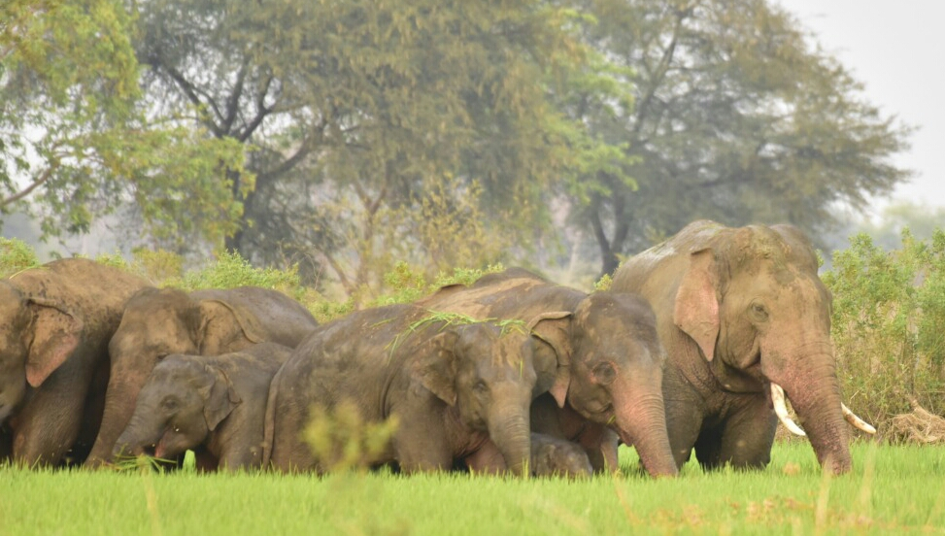

Conflicts
In the context of Dharamjaigarh, the issue of large-scale forest degradation has led to a complex and multifaceted conflict between wildlife and farming activities, resulting in significant challenges for both humans and animals. As highlighted in the cited text, this conflict stems from the need of a diverse range of wildlife to seek resources from human-affected areas due to the degradation of their natural habitats. This interaction has far-reaching consequences, particularly evident in the form of crop damage and potential threats to human lives.
The conflict is characterized by the intrusion of wildlife, notably elephants, into farming areas, leading to substantial crop damage and occasional human casualties. While the overall crop damage due to human-elephant conflict (HEC) in Dharamjaigarh may be comparatively less than in some other parts of India, the local impact remains significant. Previous studies have reported similar trends in different regions of India, with around 10% crop loss being a common figure irrespective of the location and time.
Notably, the variation in individual-level crop damage, ranging from 0.4% to a staggering 60.6%, underscores the disproportionate economic burden on marginalized farmers who rely heavily on subsistence agriculture. The limited cultivated area and the high dependence of these farmers on their crops exacerbate the negative impact of even a modest percentage of damage. This economic setback has broader implications, including annoyance among the affected population towards wildlife, particularly elephants. The loss of structural property, granaries, and livestock further compounds the economic strain on local communities.
Beyond the economic implications, human-elephant conflict has broader consequences for the overall well-being of rural inhabitants. The loss of earning members or their permanent disability due to such conflicts can have a profound impact, divesting families of their economic stability and livelihoods. These consequences, as documented in previous research, not only affect the psychology and behavior of local people but also reshape their attitudes toward wildlife and forest conservation. The increasingly prevalent instances of human-elephant conflict in Dharamjaigarh have contributed to a significant shift in the relationship between communities and their natural environment.
Ultimately, the conflict in Dharamjaigarh encapsulates the intricate interplay between human activities, wildlife behavior, economic vulnerabilities, and psychological well-being. The struggle for resources driven by large-scale forest degradation has led to a situation where both wildlife and humans are affected negatively, calling for comprehensive strategies that balance conservation efforts with the socio-economic needs of the local population.

Public Attitudes towards Human-Elephant Conflict
The intricate relationship between India's economy and its agricultural sector forms the cornerstone of its rural communities. With agriculture as the backbone of the nation, the rural economy becomes intricately tied to the fortunes of seasonal harvests. This delicate balance, however, is under constant threat from Human-Elephant Conflict (HEC), which poses substantial economic risks. Farmers, heavily reliant on the bounty of each harvest, face significant losses when their crops fall victim to marauding elephants. The repercussions of such losses are not confined solely to crops; property and livestock also fall prey to the devastating consequences of HEC, further exacerbating the economic toll on rural dwellers. Beyond its economic ramifications, HEC sends shockwaves through the very fabric of rural life, affecting overall well-being.

The repercussions extend even more dramatically when the primary breadwinner of a family succumbs to HEC or is permanently disabled. This catastrophic event leaves the family not only emotionally shattered but also economically vulnerable. Such a misfortune dismantles the economic stability painstakingly built over time, pushing the family into financial distress. These grim consequences reverberate deeply in the lives of the victims, a fact extensively documented in studies by Karanth et al. (2013) and Madhusudan (2003). The psychological and behavioral shifts in the affected communities are palpable, especially in areas with significant proximity to forests. The looming specter of food insecurity and danger to life ushers in a transformation in the locals' perception of elephants and their environment.

An additional factor exacerbating the economic fallout is the absence of viable alternative income sources. The majority of rural inhabitants depend heavily on seasonal agriculture for their livelihoods. Consequently, any disruption, such as damage from HEC, upends their economic stability, triggering a perceptual shift that casts the elephant from a revered entity to a symbol of adversity. This shift is consistent with earlier observations made in diverse regions of India, as highlighted by Sarkar et al. (2008a, 2013). As beliefs evolve, so too does the threshold of tolerance. The villagers' attitudes shift negatively with extended exposure to the forest, as evidenced by Sarker and Roskaft (2011). The escalating instances of HEC across the elephant's range countries inflict profound implications on conservation efforts, a point emphasized by Nsonsi et al. (2017), Patil and Patil (2017), Mumby and Plotnik (2018), Abdullah et al. (2019), and Sampson et al. (2019).
In the studied region, local sentiments took a downturn with the handling of ex-gratia payments. Delays and irregularities in compensating victim families for human casualties, injuries, and crop damage tarnished perceptions of elephant conservation. This phenomenon resonates beyond the study area, as demonstrated by Chakraborty (2018) in other parts of India and Ravenelle and Nyhus (2017) in various nations. To mend this fracture and build bridges toward effective conservation, forest departments must implement strategies to ensure timely compensation, fostering goodwill and cooperation among rural communities. In the face of these multifaceted challenges, a comprehensive conservation approach that takes into account the complexities of HEC and its impact on elephant preservation becomes an imperative task for government bodies.

Conclusion
In conclusion, the situation surrounding human-elephant conflict (HEC) in Chhattisgarh is characterized by a complex interplay of factors that makes predicting the nature and extent of conflicts challenging. With the ongoing mining and developmental activities in neighboring states, elephants have found a refuge in Chhattisgarh, while some continue to migrate between states within the region. The level of conflict has not yet escalated to extreme proportions within the study area, providing an opportunity for proactive intervention. The local communities' ability to coexist with elephants is a crucial aspect that requires time and support to develop. This presents a critical juncture for policy makers to step in, utilizing a combination of modern technologies and traditional methods to mitigate conflicts. Recognizing the significance of community engagement, ensuring alternative livelihoods, and prompt ex-gratia payments are essential for building a symbiotic relationship between fringe villagers and conservation efforts.

Furthermore, the establishment of a comprehensive policy framework is advocated to streamline ex-gratia payments for all types of damages and casualties resulting from human-elephant encounters. The implementation of community-level initiatives, such as the Grain for Grain Programme and the Watcher Scheme, forms a part of the holistic conservation strategy. However, it is imperative for communities to cultivate a sense of coexistence without impeding each other's progress. To foster effective coordination and knowledge-sharing among the states affected by elephant migration, the proposal for an interstate committee is a promising step forward. Inclusion of experienced individuals from Jharkhand and Odisha in the committee would infuse valuable insights, aiding in the formulation and execution of scientifically sound management plans. Ultimately, this collaborative approach stands to benefit both elephant conservation and the safety of human populations, underscoring the significance of harmonious cohabitation between people and wildlife.

References:
Abdullah A., Sayuti A., Hasanuddin H., Affan M. & Wilson G. (2019). People’s perceptions of elephant conservation and the human–elephant conflict in Aceh Jaya, Sumatra, Indonesia. European Journal of Wildlife Research, 65, 69.
Anon. (2001). Nature's Masterpiece: The Elephant, a report published by the Karnataka Government.
Archabald K., Naughton-Treves L. (2001). Tourism revenue sharing around national parks in Western Uganda: Early efforts to identify &reward local communities. Environmental Conservation, 28, 135–149.
Barnes R.F.W. (1982b). Mate searching behaviour of elephant (Loxodonta africana) bulls in a semi-arid environment. Animal Behaviour, 30(4), 1217-1223.
Berkes F. (2004). Rethinking community-based conservation. Conservation Biology, 18, 621–630.
Census of India. (2011). 2011 Census Data. Ministry of Home Affairs, Government of India.
Chakraborty S. (2018). Perception and attitude of local people towards human-elephant conflicts around Mahananda Wildlife Sanctuary, West Bengal, India. International Journal of Zoology Studies, 3(2), 93-95.
Conover M.R. (2002). Resolving human-wildlife conflicts: The science of wildlife damage management. Florida, USA: Lewis Publishers.
Emslie R. & Brooks M. (1999). Status survey and conservation action plan African rhino. IUCN/SSC African Rhino Specialist Group
Karanth K.K., Gopalaswamy A.M., Prasad P.K. & Dasgupta S. (2013). Patterns of human–wildlife conflicts and compensation: Insights from Western Ghats protected areas. Biological Conservation, 166, 175-185.
Karanth K.K., Kramer R.A., Qian S.S. & Christensen N.L. Jr. (2008). Examining conservation attitudes, perspectives and challenges in India. Biological Conservation, 141, 2357–2367.
Madhusudan M. (2003). Living amidst large wildlife: Livestock and crop depredation by large mammals in the interior villages of Bhadra Tiger Reserve, South India. Environmental Management, 31, 466–475.
Madhusudan M.D., Sharma N., Raghunath R., Baskaran N., Bipin C.M., Gubbi S. Johnsingh A.J.T., Kulkarni J., Kumara H.N., Mehta P., Pillay R. & Sukumar R. (2015). Distribution, relative abundance, and conservation status of Asian elephants in Karnataka, southern India. Biol. Conserv., 187, 34–40.
Mumby H.S. & Plotnik J.M. (2018). Taking the elephants’ perspective: Remembering elephant behavior, cognition and ecology in human–elephant conflict mitigation. Frontiers in Ecology and Evolution, 6, 122.
Nsonsi F., Heymans J.C., Diamouangana J., Mavinga F.B. & Breuer T. (2017). Perceived human–elephant conflict and its impact for elephant conservation in northern Congo. African Journal of Ecology, 56, 208–215.
Patil M.D. & Patil V.K. (2017). Farmers’ perceptions about elephant crop raiding in Sindhudurg District, Maharashtra, India. Gajah, 47, 4–9.
Ravenelle J. & Nyhus P.J. (2017). Global patterns and trends in human-wildlife conflict compensation. Conservation Biology, 31, 1247-1256.
Sampson C., Leimgruber P., Rodriguez S., McEvoy J., Sotherden E. & Tonkyn D. (2019). Perception of human–elephant conflict and conservation attitudes of affected communities in Myanmar. Tropical Conservation Science, 12, 1–17.
Sarkar P., Akhtar N. & Varma S. (2008b). Relationship between elephant corridors & elephant-human conflict. In: Varma, S., P. Sarkar & V. Menon (Eds), Pakke Pachyderms - Ecology and conservation of Asian elephant in Kameng Elephant Reserve, Arunachal Pradesh (pp. 82-85). Wildlife Trust of India, New Delhi, India.
Sarkar P., Subba S., Varma S. & Menon V. (2008a). Conservation action to mitigate conflict in and around Pakke Wildlife Sanctuary. In: Varma, S., P. Sarkar &V. Menon (Eds). Pakke Pachyderms-Ecology and Conservation of Asian Elephant in Kameng Elephant Reserve, Arunachal Pradesh (pp. 86-95). Wildlife Trust of India, New Delhi, India
Sarkar P., Varma S. & Gureja N. (2008d). Peoples’ perceptions of human-elephant conflict in and around Pakke Wildlife Sanctuary. In: Varma, S., P. Sarkar &V. Menon (Eds). Pakke Pachyderms - Ecology &Conservation of Asian Elephant in Kameng Elephant Reserve, Arunachal Pradesh (pp. 96-102). Wildlife Trust of India, New Delhi, India.
Sarkar P., Varma S. & Menon V. (2008c). Extent of human-elephant conflict in Kameng Elephant Reserve. In: Varma, S., Sarkar P. & Menon V. (Eds). Pakke Pachyderms - Ecology and Conservation of Asian Elephant in Kameng Elephant Reserve, Arunachal Pradesh (pp. 66-74). Wildlife Trust of India, New Delhi, India.
Sarkar P., Varma S. & Menon V. (2012). Food selection by Asian elephant (Elephus maximus) in Kameng Elephant Reserve in Northeast India. The Clarion, I(1), 70-79.
Sarkar P., Varma S. & Menon V. (2013). Peoples' perceptions on human-elephant conflict in Kameng Elephant Reserve of Northeast India. Indian Streams Research Journal, 3(10), 1-6.
Sarker A.H.M.R. & Røskaft E. (2011). Human attitudes towards the conservation of protected areas: a case study from four protected areas in Bangladesh Oryx, 45(3), 391-400.
Singh R.K. & Chowdhury S. (1999). Effect of mine discharge on the pattern of riverine habitat use of elephants Elephus maximus and other mammals in Singhbum forests, Bihar, India. Journal of Environmental Management, 57, 177-192.
Sukumar R. (1989b). The Asian elephant: Ecology and management. Cambridge University Press, Cambridge, 251.
Sukumar R. (1990). Ecology of the Asian elephant in Southern India. II. feeding habits and crop raiding patterns. Tropical Ecology, 6, 33–53.
Sukumar R. (1991). The management of large mammals in relation to male strategies and conflict with people. Biological Conservation, 55(1), 93-102.
Sukumar R. (1992). The Asian Elephant: Ecology and management. Cambridge, UK: Cambridge University Press.
Sukumar R. (2003). The living Elephants. Evolutionary Ecology, Behaviour and Conservation. New York: Oxford University Press.
Venevonghpet (1995). Status of elephant in Laos in a Week with elephants. Proceedings of the International Seminar on Asian Elephants, B.N.H.S.
Zhang L. (2007). Current conservation status and research progress on Asian elephants in China. Gajah, 27, 35-41.
Zinn H.C., Manfredo M.J. & Vaske J.J. (2000). Social psychological bases for stakeholder acceptance capacity. Human Dimensions of Wildlife, 5, 20–33.

