IoT based Pre-indication for accident avoidance system in vehicles
¹Dr.A.Sathish Kumar,
¹Professor, Department of ECE, Erode Sengunthar Engineering College, Erode
Abstract
Drunk driving is extremely dangerous because excessive alcohol consumption distorts the driver's thought patterns. According to his 2008 study by the World Health Organization, about 50-60% of traffic accidents are caused by drunk driving. Recently, the number of traffic accidents caused by drunk driving is increasing rapidly.Various techniques and techniques are used to reduce the incidence of traffic accidents caused by drunk drivers.
Keywords: IoT, MQ 6, Vehicle, Accident Avoidance, Node MCU
I. Introduction
The device displays alcohol sensor results when it detects airborne alcohol molecules present in the environment (see Figure 1.1) and displays warning text when a fixed threshold set in code is exceeded. Nor did the microcontroller,an alarm to warn of threshold crossings. The system required her two contents: alcoholic and non-alcoholic. One person administers the test and records when the threshold is crossed, he is the other person taking the test. The system has come a long way from proving drivers to brake when drunk, let alone real-time implementations.
The aim of this project is to minimize traffic accidents caused by drunk driving by leveraging Internet of Things (IoT) technology. With the help of this system, responsible law enforcement in smart cities can detect, monitor and track drunk drivers
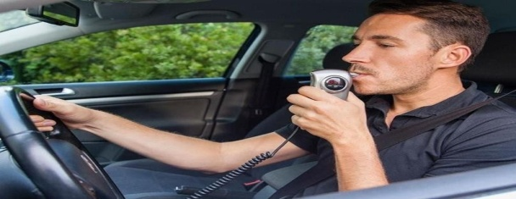
Fig.1.1Alcohol Detector(Non-Contactless)
Driving a car means taking certain risks. A smart driver is always aware of the risks, but never allows the level of risk to reach an unacceptable level. As shown in Figure 1.1, alcohol not only impairs driving ability, but also alters a driver's subjective risk assessment, leading to more reckless driving. Regardless of how much you drink, the alcohol concentration in your body reaches its peak. . The output of the sensor is directly proportional to the alcohol content. We strive to develop this project in a way that is accessible to everyone. The project doesn't cost much, but it pays off a lot because it focuses on people's safety. This project has a preventive effect to prevent accidents. In this project, we will first check if the person is drunk using the MQ-3 alcohol sensor.

II. Literature survey
Fatality AnalysisReportingSystem(FARS).2009 One of the primary goals of the National Highway Traffic Safety Administration (NHTSA) is to reduce the enormous number of people and property damage that traffic accidents cause to society. Accurate data are needed to support the development, implementation and evaluation of road safety programs aimed at reducing these tolls. NHTSA uses data from many sources, including the Mortality Analysis and Reporting System (FARS), which began operating in 1975.
National Survey of Driving Behavior and Attitudes. 1969, Rutgers University Press:
New Brunswick, NJ Questions about drinking problems in early alcohol surveys were often phrased "Have you ever had anything like this happen?" Such a formulation of the question is most likely to get a clearly positive answer. Bubber, Audit:
Tests to identify alcohol use disorders:
III. Existing method
Driving a car means taking certain risks. A smart driver is always aware of the risks, but never allows the level of risk to reach an unacceptable level. 30 minutes later if taken on an empty stomach. After 1 hour if taken with food. On the other hand, it takes a long time for alcohol to be excreted from the body. A healthy person eliminates alcohol, lowering her blood alcohol concentration by 0.1-0.15 grams/liter per hour. .. The IR sensor has a receiver that detects her IR light reflected. The receiver is designed to detect changes in the amount of reflected light and distinguish between reflected light and ambient light. This signal is sent to a microcontroller or other processing unit, which interprets the signal and makes a decision based on the presence or absence of an object. IR sensors can be used in many different types of object detection applications such as proximity sensors, reflective sensors, and obstruction sensors. In the proximity sensor, the sensor emits her beam of IR light and detects the reflected light to determine if there is an object within its sensing range.
IV. Vehicle control
The IoT drunk driving monitoring system is an epoch-making system that can be widely applied to smart cities and smart transportation systems. To enable this, the in-vehicle hardware portion of the system uses MQ3 (alcohol sensor) sensors that detect alcohol molecules in the air around the driver to determine if the driver has been drinking. A microcontroller is used to control the Corporation is used for this purpose. It is a 16-bit microcontroller with 40 pins spread across 5 ports (ports A through E). Port B (here used to connect the LCD module) and Port A are used to connect to the inputs of his MQ-3 sensor.
V. Implementationof VehicleControl

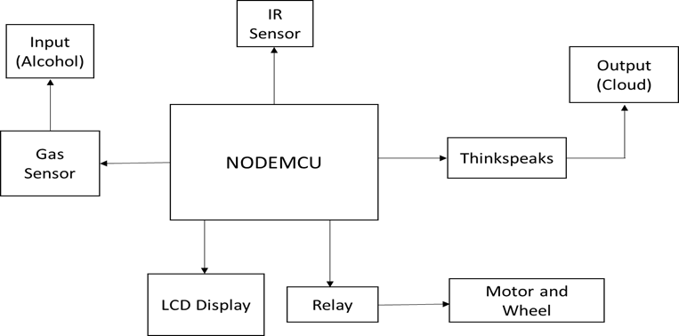

VI.FLOWCHART
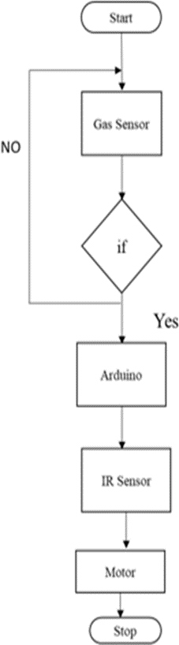
Fig.2 Flowchart
The MQ3 simple gas sensor is suitable for detecting alcohol and can be used as part of a breathalyzer. It has a high sensitivity to alcohol and a low sensitivity to benzene. Affected capacities can be compensated for via potentiometers. Tin oxide (SnO2) is a sensitive material in MQ-3 gas sensors and is less conductive in clean air. Gas leak identification is the method by which sensors detect potentially dangerous gas leaks. Node MCU is a low cost open source IoT platform. NodeMCU was created shortly after ESP8266 was released. On December 30, 2013, EspressifSystems began production of the ESP8266. NodeMCU was launched on his October 13th, 2014 when Hong submitted the first file of his Node mcu firmware to his GitHub.
VII. Thingspeak Cloud
ThingSpeak is an IoT analytics platform service that allows you to aggregate, visualize, and analyze live data streams in the cloud. He can send data from his device to his ThingSpeak™, instantly visualize live data, and send notifications using web services like Twitter® and Twili0N.
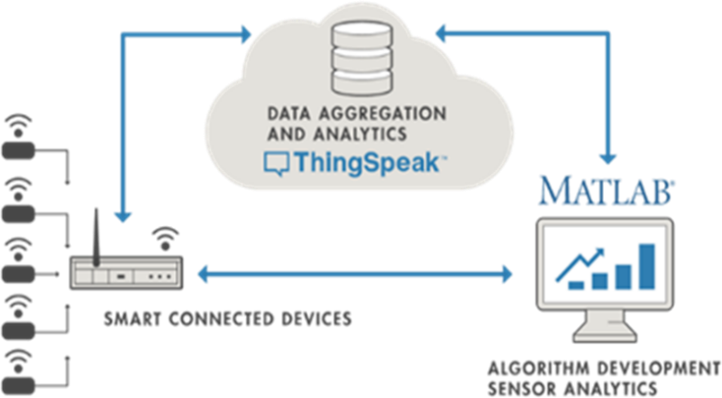
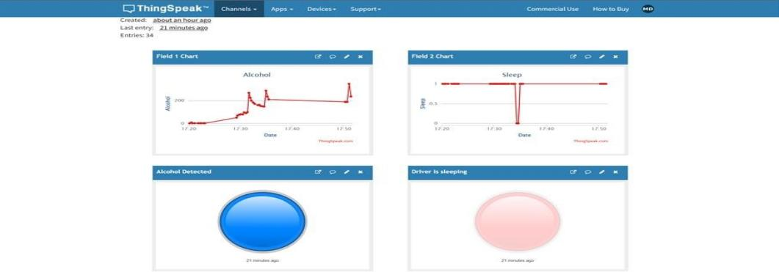
Fig.4Cloud Monitoring
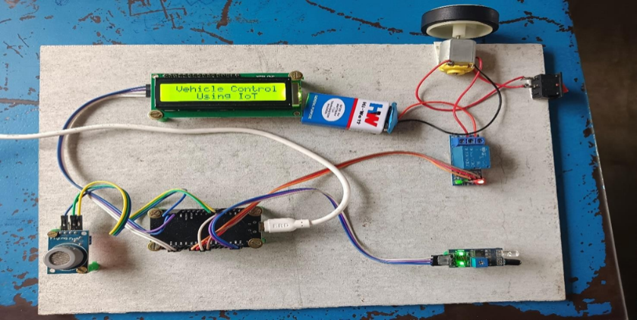
Fig 5. Hardware Implemented
FutureScope
Here we have made the relationship of alcohol sensor with Arduino and Uploaded the normal code to the Arduino using the Arduino IDE. we find whether he is in a common state or smashed state. Next,we us eThingSpeak to sendthe SMS cautioning to the different people who need to screen that individual.
Application
Smart alcohol detector locks the engine whether person had alcohol and tried to start the vehicle. To detect the alcoholic persons the policemen can use this mart IoT alcohol detector to store the information. Data can be captured based on timestamps and can be monitored after some days or months

VIII. Conclusion
The project mainly helps in alcohol detection system that was developed for road Transportation safety in smart city using InternetofThings(IoT)technology.This systematization checks tanked driving byautomatically closing down the vehicle that contains the drunk driver but-also permits for activity specialists to effectively find the shutdown vehicles utilizing the coordinates ofthevehicle sent to webserver. There are no ventures that cannot be made strides. One of the enhancements that could be made onthis system in the future is that it should be made smaller.The smaller the system,them or convenience the alcohol system is,the more likely drivers will accept it.

References

- Abid khan and Ravi Mishra (2021), ‘Drivers Fatigue Detection Using Efficient DetInAdvanced Driver Assistance Systems’ International Journal of Engineering Trends andTechnologyVol.02,pp.9-13.
- Arunvijay,D.andYuvraj,E.(2020)‘In-vehiclealcoholdetectionusinglow-costsensorsand genetic algorithms to aid in the drinking and driving detection’, International journalofstudent’sresearchintechnology&managementVol.2,pp.321-543.
- Azhagumurugan, R. and Karthik, A. (2017) ‘Detection of functional state after alcoholconsumptionbyclassificationandmachinelearningtechnics’InternationalConferenceonComputation of Power, Energy Information and Communication (ICCPEIC), pp. 108-111.
- Divyabharathi,P.andJeyaSingh,Y.(2016)‘DesignUsingTM4C123MicrocontrollerwithMotionDetectionApplication’,InternationalJournalofEngineeringResearch&Technology(IJERT),Vol.05,pp.9-21.
- Jim Isaac (2019) ‘Analysis of Road Accidents Using Machine Learning Techniques’,International Research Journal of Engineering and Technology (IRJET), Vol.01, pp. 84-91.
- Jacob Varghese (2022) ‘Vehicle alcohol detection system based on internet of thingstechnology’ International Conference on Inventive Computation Technologies (ICICT),pp.533-538.
- Karuppasamy,K. (2017) ‘A study of classification for driver conditions using drivingbehaviors’,InternationalResearchJournalofEngineeringandTechnology (IRJET),Vol.04,pp.1904-1907.
- Karthikeyan, R. and Dhandapani, A. (2021) ‘Future smart cities requirements, emergingtechnologies,applications,challenges’,JournalofComputerApplications,Vol.05,pp.56-87.

