**Social Welfare Maximization in a Restructured Power System using Bat Algorithm**

1Dr. Murali Matcha, 2Siddheswar Kar, 3Neha Verma

1 Associate Professor, Department of Electrical Engineering, Medi-Caps University, Indore, M.P, India

2,3 Assistant Professor, Department of Electrical Engineering, Medi-Caps University, Indore, M.P, India

E-mail: 1[murali_233@yahoo.com](mailto:murali_233@yahoo.com)

***Abstract:*** The basic key issue in restructured power market is to design an appropriate auction mechanism. This paper discusses the influence of elastic demand on congestion and Locational marginal prices (LMP’s) in double auction electricity market. This double auction problem of the pool based day-ahead electricity market is formulated as maximization of social welfare. This problem is subject to equality constraint given by real power balance equation and security constraint in the form of active power flow limits over the congested lines. DCOPF is adapted to solve this pool market problem by computing LMP’s at all buses under three different loss cases such as without loss case, concentrated loss case and distributed loss case. Linear bids are used for both generators and consumers. DCOPF is executed with Genetic algorithm and Bat algorithm. The algorithm is tested on three test systems e.g., IEEE 14 bus system, New England 39 bus system and Indian 75 bus system (practical data). In all the three test systems Bat algorithm has produced better social welfare than Genetic algorithm under all the three loss cases.

***Keywords:*** Elastic demand, Social Welfare, Bat algorithm, LMP, Concentrated loss, Distributed loss

**1. Introduction**

In restructured electric power industry, one of the essential components for electric power market design is to find an appropriate auction mechanism, capable of creating more fair competition and more efficient operation [5], [6]. In microeconomic principles, if an allocation of resources maximizes the total social welfare, it is said that the allocation exhibits efficiency [19]. In inelastic market ISO does not provide sufficient signals or incentives to a customer to adjust its demand in response to the price, i.e., the customer does not have any motivation to adjust its demand for electrical energy to adapt the market conditions and customer does not respond to market price. This means that the demand side is unable to protect itself by curtailing demand in response to high prices, and strategic behaviour of power suppliers will lead to price spikes. Lack of demand elasticity confers market power on suppliers. In a market that has fixed demand, MCP for energy is determined by the price structure of supply offers. Customers use the concept of *elastic demand* when they are exposed to and aware of the price of energy and arrange their activities in such a fashion as to reduce their demand as the price of the next available offer exceeds a certain level.

The assumption that each supplier or consumer cannot affect the price by its actions i.e., all market participants take the price as given, and then the market is said to be a *perfectly competitive market*. This assumption is usually not true for electricity markets. In a competitive market, it is the combination of all the consumers on one side and all the suppliers on the other side that determines the price. A graphical representation of demand and supply curves is shown in figure 1 with no transmission constraints. In figure 1 the market displays elastic demand, where the load responds directly to the price of supply offers, i.e., the demand varies with the price of offer. The intersection of demand and supply curves in figure 1 indicates that the operating point (the equilibrium point) of the market which defines the current MCP as well as the current level of electrical load. The former task is achieved by solving an optimal power flow (OPF), with the objective of maximizing social welfare or social surplus. Elastic markets can also be called as double auction model markets because both suppliers and consumers involve in the auction [12]. The explicit demonstration about social welfare maximization in double auction model with elastic demand during congestion in the transmission system and its nodal pricing due to congestion and losses in a pool market is presented in this paper.

Supply-demand equilibrium will set the market price and quantities. This equilibrium point is the point where the social welfare, subject to constraints is optimal [21]. Social welfare is the difference between total consumer benefit B(d) and total supplier cost C(s) i.e., (B(d) – C(s)). Graphically this equilibrium point can be described as the point where the incremental aggregate cost curve and the incremental aggregate utility curve cross. At this point any additional trade between the supply and demand sides will reduce the social welfare. Aggregating the individual incremental (marginal) cost bids of the generators forms the supply curve and the demand curve is formed by aggregating the incremental (marginal) utility of the loads. Some markets, in England and the PJM interconnection consists of only supply-side bidding. Few other markets, in New Zealand and California incorporate demand-side bidding also, allowing the consumers in the market to react to pricing [13].

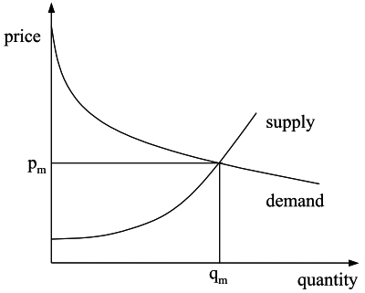

**Figure 1. Elastic market with unconstrained transmission**

In an unconstrained market, where the network is not considered, the solution of the optimization problem is characterized by a certain value of social surplus and the demand prices and generator prices at each bus are equal. In this situation a *market clearing price* is defined and it is unique for the whole system. On the contrary, if the network is constrained congestion can arise causing, along with losses, a different optimum, with a lower level of social surplus. In this situation a single market clearing price does no longer exist. The nodal price at each bus may vary according to the determined MW demand and supply, and their locations which reflect system loss and network congestion [1], [2]. The consumer located at bus ‘i’ will pay at nodal price ‘i’ for its marginal energy consumed and the supplier located at bus ‘j’ will be paid at nodal price j for its marginal energy supplied [3], [4] and [17].

**2. Supplier and customer functions representation**

Most of the electricity markets throughout the world include supplier bidding only, but some markets include consumer bidding also. So, it is very important to define the consumer utility function and supplier cost function. In literature most of the papers presented Social welfare maximization (SWM) problem with linear elastic supplier and customer curves [13], [15], [16] and [20]. In this paper a continuous bid curve model i.e., linear bid (corresponding to quadratic curves) is assumed for both suppliers and consumers. According to economic theory, a firm in a perfectly competitive market maximizes its profit when it sells/buys at its marginal cost/benefit. This implies that profit maximizing generators/loads will bid at marginal costs/marginal benefits, so ideally generators/loads should bid their true marginal cost/marginal benefit curves [20]. In this paper for bidding purpose, marginal cost curves are used for suppliers and consumers.

**2.1. Supplier cost function**

Supplier cost is the actual cost of producing power by a generator. Generally two types of generators are used by the suppliers: a hydro generator and a thermal generator. Hydro generators have a constant marginal cost and have different capacities depending on the water levels. The present study considered thermal generators only. The marginal cost for thermal generators vary with the amount of power generated and the data can be obtained from hourly generator bid data obtained from ISO. The capacity of a thermal generator is constant, independent of time [20]. The supplier bid curve is a positive linearly increasing price function w.r.to generated power. The generation cost function is the integration of the marginal cost function [20] and is represented as:

** ($/hr) (1)

where ai, bi, ci are the positive coefficients.

The supplier bid =  ($/MWh) (2)

The continuous bid curve of the supplier (linear bid) is shown in figure 2.

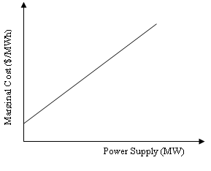

**Figure 2. Linear bid curve of a thermal generator**

**2.2. Customer utility function**

Customer’s utility is a measure of the customer’s benefit from the utilization of power, which can be obtained from the consumer’s bid curve. The bid curve represents the relationship between the price a customer is willing to pay and the amount of electric power demanded. The bid curve indicates how much is the additional MWh worth to the customer as the customer considers using one more MWh of electric energy. Every customer has his/her own bid curve. The aggregated bid curve represents different utility levels of the customers in the aggregation. Customer can be modelled in a manner analogous to the suppliers. A demand function is used, which is mathematically similar to the supply function, except that the demand function decreases as the price increases. The willingness to pay of the customer at bus k can be expressed through a positive linearly decreasing function [20]. The utility function is the integration of the marginal utility function and is represented as:

 ($/hr) (3)

where bi is positive coefficient and ci is negative coefficient.

The customer bid =  ($/MWh) (4)

The bid curve of the customer (linear bid) is shown in figure 3.

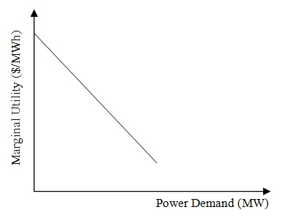

**Figure 3. Linear bid curve of the customer**

**3. Concept of Dead Weight Loss**

The sum of the net consumers’ surplus and of the producers’ profit is called the *social welfare*. It quantifies the overall benefit that arises from trading. The global welfare is maximum when a competitive market is allowed to operate freely and the price settles at the intersection of the supply and demand curves. The market clearing price is π* and the market clearing volume is q*. Under these conditions, figure 4 shows that the consumers surplus is equal to the sum of the areas labelled A, B and E and the producers’ profit is the sum of the areas labelled C, D and F. Producers surplus is defined as the amount of revenue received from selling the power to ISO, minus the cost of supplying the power. Consumer’s surplus is defined as the amount consumer is willing to pay, minus actual amount paid by the customer to ISO for consuming the power.

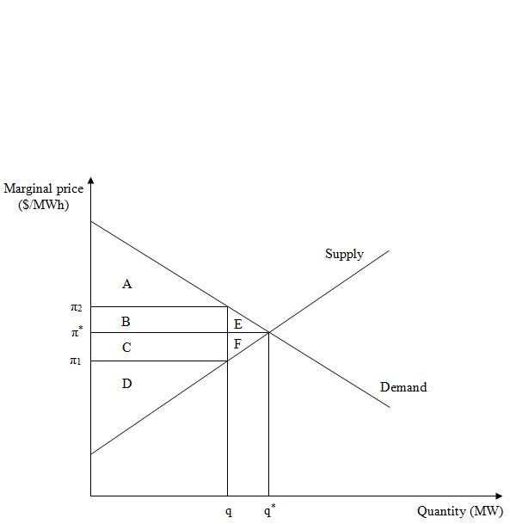

**Figure 4. Global welfare and deadweight loss**

When congestion occurs in the transmission system the amount of power traded reduces from q* to q. The corresponding prices are π1 and π2, called Locational Marginal prices which includes congestion price and loss price. The consumers’ surplus shrinks to area A and the producers’ surplus shrinks to area D. The ISO collects the difference π2 - π1 for each MW traded. The total amount collected by ISO in the form of congestion taxes is equal to the sum of areas B and C, which is also called as merchandising surplus. Merchandising surplus is defined as the amount paid by the customer to ISO for consuming the power, minus amount of revenue received by producer from selling the power to ISO. Due to congestion the global welfare reduces by an amount equal to the sum of areas E and F. This drop in global welfare is called the *deadweight loss* and is the result of the reduction in the amount traded caused by the price distortion [14]. The area due to Deadweight loss is neither useful to supplier nor useful to customer or ISO. This is one of the major drawbacks in electricity trading during system congestion.

Under the minimum cost centralized pool schedule, the generator or supplier profit can lead to an incongruity, i.e., units that are scheduled on, make negative profit. If allowed to self-schedule, the ISO presumes that such units would rather turn off in order to function at zero profit [18].

**4. Social welfare maximization (SWM) for LMP calculation with different loss cases**

Social welfare is originally defined by the Bergson – Samuelson [20] social welfare function. The new OPF is characterized by a composite objective function and is formulated with two terms, the total benefits and the total costs, whose difference represents the Social welfare (S.W) or Social surplus (SS).

 (5)

In the function SS, Ne is the number of buses with elastic load demand; Ng is the number of generators in the studied system. The ISO maximizes the social welfare subjected to an OPF solution based on all bids in the market [11]. In the transmission management, where the system operation and transmission functions are managed by a regulated transmission organization, the objective of transmission enhancement is to maximize social welfare. For the other transmission management practices, social welfare is also an important consideration and needs to be well defined [22].

In this paper LMP computation [7-10] with social welfare maximization as objective using DCOPF, with various loss cases has been studied. DCOPF (linear model) is used due to its fast convergence, with an assumption that the voltage profile is sufficiently flat, and the R/X ratio is less than 0.25. LMPs’ using DCOPF are computed with GA and Bat algorithms under three different loss cases such as without loss, concentrated loss and distributed loss cases. The obtained power generations and demands are used in calculation of LMP’s with and without loss for the congested transmission system. Generation Shift factors (GSF) have been used for the calculation of transmission line flows. Delivery factors (DF) at all buses have been used to consider the impact of marginal losses on LMPs’ [9]. In double auction model only major suppliers and customers are allowed for bidding. Hence all the suppliers and customers are not accounted for bidding. It is assumed that remaining suppliers and consumers will be engaged in bilateral transactions. This type of market is called as Coexisting Pool and Bilateral Model or Hybrid model as is shown in figure 5.

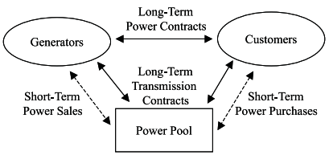

**Figure 5. Coexisting Pool and Bilateral Model**

The following section describes the mathematical model of different cases studied.

**4.1. Case 1: Without loss**

In this method the objective function is maximization of total social welfare subjected to power balance and line flow constraints. Active power generations of the generators and all the elastic customer demands are considered as set of variables for optimization problem. LMP’s are calculated after obtaining generator power outputs and the customer demands from the DCOPF problem. Supplier surplus, Customer surplus, Merchandising surplus or ISO surplus and finally Social surplus (which is a sum of all the previous three surpluses) are calculated.

The objective function is

 (6)  (7)

limitk , for k=1, 2 …M (8)  for i=1, 2 …N (9)  for i=1, 2 …N (10) where, N is number of buses, M is number of lines, B(d) is the total benefit function of all the elastic customers, C(s) is the total fuel cost function of all the suppliers, PGi is real power output of generator at bus i (MW), PDi is the real power demand at bus i (MW), Fk is line flow of line k, limitk is thermal limit of line k.



After getting power outputs of generators, slack bus power is calculated using equation (7) and the price at the reference (slack) bus needs to be calculated by substituting slack bus power in its linear bid curve. At the reference bus, both loss price and congestion price are always zero. Therefore, the price at the reference bus is equal to the energy component. Now the LMP formulation at a bus B can be written as

LMPB=LMPenergy+LMPBcong+LMPBloss (11)

The decomposition of LMP is shown here

LMPenergy = λ = price at the reference bus (12)

LMPBcong = – (13)

where  is the constraint cost or shadow price of line k, defined as:



$\frac{change in total cost}{change in {constraint}^{'}s flow}$

LMPBloss = λ  (DFB – 1) (14)

(LMPBloss = 0 for lossless power system)

If the losses and congestion are not considered (or they are not active at the optimal point), the solution of the optimization problem is characterized by a certain value of social surplus. The demand prices and the generator prices at each bus are equal. In this situation a market clearing price is unique for the whole system.

Social Welfare (S.W) = Supplier surplus (SG) + Customer surplus (SD) (15)

where SG = [MCP ($/MWh) × power generated (MW)] – C(s) (16)

SD = B(d) – [MCP ($/MWh) × power consumed (MW)] (17)

On the contrary, if network constraints are considered, even for a lossless system, congestion may arise due to any constraint violation. Then market clearing price no longer exists and the prices are different at all buses. Congestion may result in electricity price volatility and may lead to price spikes. System losses and congestion introduce *merchandising surplus* (SM) or ISO surplus. For a lossless system, with congestion SM may not be zero and can be either positive or negative. If the two effects, losses and congestion, are considered jointly, SM is usually greater than zero. SM can be adopted as a measure of congestion costs and is a reasonable metric to compare the congestion impact under different load elasticity conditions. The absolute value of SM decreases with an increase in elasticity. In a lossless system, for infinite elasticity, SM is zero as in an unconstrained market [15]. The demand responsiveness can play a major role in competitive electricity markets, particularly in the case of congestion [16].

S.W = SG + SD + SM (18)

where SG = [LMP ($/MWh) × power generated (MW)] – C(s) (19)

SD = B(d) – [LMP ($/MWh) × power consumed (MW)] (20)

SM = [LMP ($/MWh) × power consumed (MW)] – [LMP ($/MWh) × power generated

(MW)] (21)

**4.2. Case 2: With Concentrated loss**

The main objective is maximization of social welfare subjected to energy balance and line flow constraints. Generators’ active power outputs and elastic customer demands are taken as variables for optimization. However, in nodal price based electricity markets, system marginal losses have significant impact on the economics of power system operation. So, system marginal losses have to be taken into account for obtaining accurate prices. In this model it is assumed that total system loss is supplied by slack bus generator. The problem is to

 (22) s.t.  (23)  limitk,  for k=1, 2 …M (24)  for i=1, 2 …N (25)  for i=1, 2 …N (26)

where DFi is the delivery factor at bus ‘i’.

Pi is the real power injection at bus ‘i’

Ploss is the total system loss used to offset doubled average system loss caused by the marginal loss factor (LF) and the marginal delivery factor (DF). The derivation of (23) is given in [23].

**4.3. Case 3: With Distributed loss**

If the load demand is in GW, then loss will be of the order of hundreds of MW, and it is not feasible to add the total system loss to slack bus as this may cause the slack bus power output to violate its maximum limit. It was observed that concentrated loss case for social welfare maximization problem is a major drawback and therefore distributed loss case is proposed for social welfare maximization in this paper. Ei is the extra load at bus ‘i’ (for each bus, the total extra load is the sum of half of line losses which are connected to that bus) and it is defined as follows:

 (27)

where, Mi is number of lines connected to bus i.

The line flow Fk for this loss case is calculated as in (28).

 (28)

where GSFk-i is the generation shift factor of line ‘k’ to bus ‘i’.

The algorithm for this problem is the same as in case 2. After getting power outputs of generators, slack bus power is calculated using (23) for both the cases 2 and 3 and supplier surplus can be calculated using (19). LMP’s can be computed at all buses in the system using (11). With the obtained customer demands customer surplus can be calculated using (20). ISO surplus is calculated using (21). Then total social surplus is calculated using (18).

To check the correctness of the result, the obtained social welfare from (6) or (22) should be equal to the total social surplus obtained from (18). This is proved on all the test systems studied in this paper.

**5. Algorithm for LMP calculation in double auction model**

**5.1. GA and BAT algorithms**

**Step 1:** Read no. of buses, no. of lines, slack bus number, and Bus data. Read GA parameters like population size, chromosome length, no. of units, maximum no. of generations, elitism probability, crossover probability, mutation probability, and epsilon. Read a, b, c coefficients; min. and max. limits of generators. Read line data including line thermal limits.

**Step 2:** Generate randomly power generations of all generators except slack generator and decode them.

**Step 3:** Generate randomly power demands of all customers and decode them.

**Step 4:** Calculate Generation shift factors (GSF) using system ‘X’ matrix.

**Step 5:** Calculate initial line flows using GSF.

**Step 6:** Calculate the system loss i.e., Ploss in each line for cases2 and 3.

**Step 7:** Calculate the extra load at each bus ‘i’ using (27) from initial line flows for case 3, and then calculate new line flows using (28).

**Step 8:** Calculate loss factors and then delivery factors at each bus.

**Step 9:** Calculate Pgen of slack bus using (7) of case 1 or (23) of cases 2 and 3.

**Step 10:** Check for line flow limits (8). If the line limits are violated add penalties to objective function.

**Step 11:** Check for slack bus power limits (9). If it violates the limits add penalties to objective function.

**Step 12:** Calculate the social welfare with the randomly generated power generations and power demands using (6) for all cases and then calculate the fitness function = (objective function+ penalties).

**Step 13:** Sort the chromosomes in the descending order of fitness.

**Step 14:** Is iteration = max. no. of iterations. If yes go to step 20 else go to step 15.

**Step 15:** If fitness (1) == fitness (psize)🡪problem converged.

If no go to step 19.

Calculate the energy price of the reference bus either with fixed bids or with linear bids and then calculate LMPs’ at all buses and the decomposition of LMP.

**Step 16:** Calculate ISO payment to generators ( $\sum_{i}{(power}$ generation at bus i * LMP at bus i)) and then calculate suppliers surplus using (19).

**Step 17:** Calculate customers’ payment to ISO ( $\sum_{j}{(power}$ demand at bus j * LMP at bus j)) and then calculate customers surplus using (20).

**Step 18:** Calculate ISO profit using (21) for all the cases, calculate Social welfare using (18) & STOP.

**Step 19:** Use selection, crossover and mutation operators. Generate new population.

iteration = iteration +1; Go to step 4.

**Step 20:** STOP and print maximum number of iterations reached.

Using BA, the algorithm mathematically is similar to GA except the BA operators used. The detailed flowchart of LMP calculation with BA is given in next section.

**5.2. Bat algorithm (BA) flow chart in double auction model**

The flow chart of all the steps involved in LMP computation with Bat algorithm is presented in figure6.

**6. Results and Discussion**

Genetic algorithm (GA) and Bat algorithm (BA) are used to solve the DCOPF for all the three loss cases with Social Welfare Maximization as objective function. BA is first time proposed for SWM problem in this paper. Both the algorithms GA and BA with linear bids for cases 1-3 are applied on IEEE 14bus system [24], New England 39 bus system [25] and Indian 75 bus system [26]. The solution reported is the best solution over 20 different runs for both GA and BA. BA gives better solution of social welfare (S.W) (i.e., maximum S.W value) than GA for all the three cases of all test systems. Supplier surplus, Customer surplus, Merchandising surplus and Social surplus obtained are positive values for all loss cases and for all test systems studied. Some of these values are negative in single auction model [23] which should be avoided in competitive electricity markets. This is one major drawback in single auction model which can be overcome in double auction model. LMPs’ are also computed for all loss cases and all test systems while congestion is present in the system.

**6.1. Case study 1: IEEE 14 bus system**

The two algorithms GA and BA are tested initially on IEEE 14 bus system. This system consists of 2 generators and 11 loads. Both the generators and all the 11 loads are considered as suppliers and customers participating in market. It is observed that 9th line connecting 4-9 buses and 10th line connecting 5-6 buses are congested in all loss cases in both the methods. The shadow price or constraint cost is taken as 91.75 $/MWh for case 1 and 109.25 $/MWh for cases 2 and 3. These values are obtained from Power World Simulation. The generator power outputs and the corresponding social welfare are shown in table 1. The LMPs’ are shown in table 2. Figure 7 presents a comparison of social welfare or social surplus for all the three loss cases. Figures 8, 9 and 10 show the LMPs’ comparison for cases 1, 2 and 3. From the LMPs’ comparison graphs of all the cases, it is observed that LMP at 5th bus is minimum and maximum at 6th bus. 10th line connecting 5th and 6th buses is congested which is a very crucial line in IEEE 14 bus system because this line divides the system into two zones. Therefore the impact of this line is high on the system. The LMPs’ at both ends of 10th line have large difference and these LMPs’ emerged as minimum and maximum of the system LMPs’. It can be observed that even though BA takes more iterations than GA, per iteration time of BA is less than GA and hence the CPU time with BA is less than with GA.

The minimum and maximum LMP’s are indicated in red color in table 2. The highest LMP is reduced with Bat algorithm which leads to more customer surplus and less ISO surplus. From figure 7 it can be observed that for all the three cases, BA has given better social welfare than GA.

**TABLE 1. Generators’ active power outputs and social welfare for IEEE 14 bus system**

|  |  |  |  |  |  |  |
| --- | --- | --- | --- | --- | --- | --- |
| **Supplier bus No.** | **Power Generations in MW without loss**  **CASE 1** | | **Power Generations in MW with concentrated loss**  **CASE 2** | | **Power Generations in MW with distributed loss**  **CASE 3** | |
| GA | BA | GA | BA | GA | BA |
| 1(slack) | 223.853 | 146.952 | 228.638 | 150.597 | 226.552 | 134.45 |
| 2 | 41.1438 | 114.988 | 41.1438 | 114.988 | 42.94 | 130.837 |
| System loss MW) |  |  | 4.785 | 3.6454 | 4.745 | 3.4984 |
| Supplier surplus ($/hr) | 4933.56 | 2958.32 | 5150.64 | 3134.05 | 5115.71 | 2489.33 |
| Consumer surplus ($/hr) | 37561.4 | 40198.8 | 35932 | 38787.7 | 36007.8 | 39315.2 |
| Merchandising surplus or  ISO surplus ($/hr) | 5658.9 | 5586.63 | 6905.75 | 6737.79 | 6902.64 | 6685.34 |
| Social surplus ($/hr) | 48153.8 | 48743.7 | 47988.4 | 48659.5 | 48026.2 | 48489.9 |
| Iterations | 264 | 281 | 264 | 281 | 293 | 489 |
| CPU time (sec) | 48.1071 | 20.2850 | 48.1071 | 20.2850 | 36.4839 | 25.5068 |

|  |  |
| --- | --- |
|  |  |

**Figure 6. Flow chart of Bat algorithm for LMP calculation in double auction model**

**TABLE 2. Bus LMPs’ for IEEE 14 bus system**

|  |  |  |  |  |  |  |
| --- | --- | --- | --- | --- | --- | --- |
| Bus No. | **LMPs’ at all buses ($ / MWh)** | | | | | |
| **Without loss**  **CASE 1** | | **Concentrated loss**  **CASE 2** | | **Distributed loss**  **CASE 3** | |
| GA linear bids | BA linear bids | GA linear bids | BA linear bids | GA linear bids | BA linear bids |
| 1 | 34.213 | 22.831 | 34.921 | 23.371 | 34.612 | 20.981 |
| 2 | 34.478 | 23.096 | 35.86 | 23.927 | 35.539 | 21.479 |
| 3 | 35.23 | 23.849 | 37.737 | 25.492 | 37.408 | 22.981 |
| 4 | 35.88 | 24.498 | 38.225 | 26.092 | 37.898 | 23.6 |
| 5 | 33.214 | 21.832 | 34.87 | 22.808 | 34.545 | 20.33 |
| 6 | 106.044 | 94.662 | 121.629 | 109.555 | 121.304 | 107.073 |
| 7 | 67.773 | 56.392 | 76.186 | 64.06 | 75.859 | 61.57 |
| 8 | 67.773 | 56.392 | 76.186 | 64.06 | 75.859 | 61.57 |
| 9 | 84.551 | 73.17 | 96.156 | 84.034 | 95.829 | 81.545 |
| 10 | 88.371 | 76.989 | 100.742 | 88.608 | 100.415 | 86.117 |
| 11 | 97.053 | 85.671 | 111.03 | 98.916 | 110.704 | 96.428 |
| 12 | 104.345 | 92.963 | 119.755 | 107.629 | 119.429 | 105.137 |
| 13 | 103.018 | 91.636 | 118.193 | 106.061 | 117.866 | 103.567 |
| 14 | 92.625 | 81.244 | 105.951 | 93.77 | 105.623 | 91.268 |

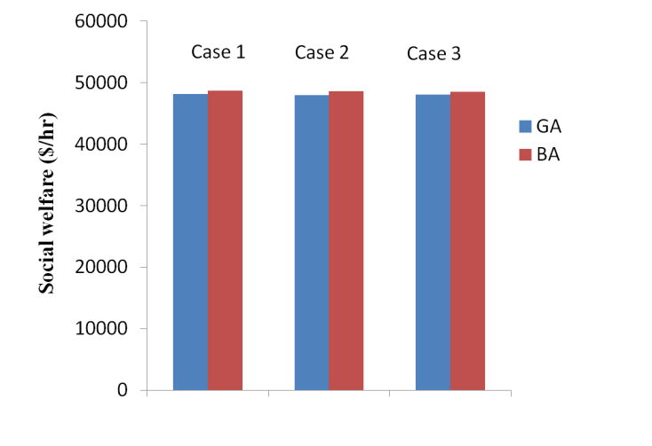

**Figure 7. Social welfare comparison for all the three loss cases of IEEE 14 bus system**

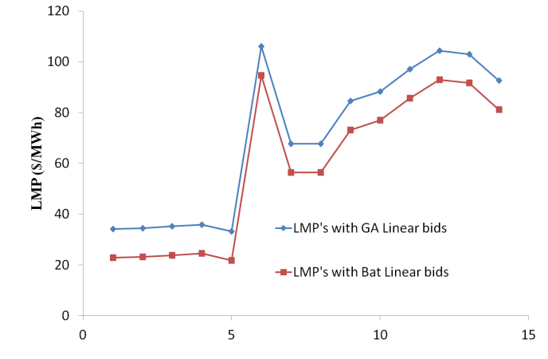

**Figure 8. LMPs' comparison for case 1 of IEEE 14 bus system**

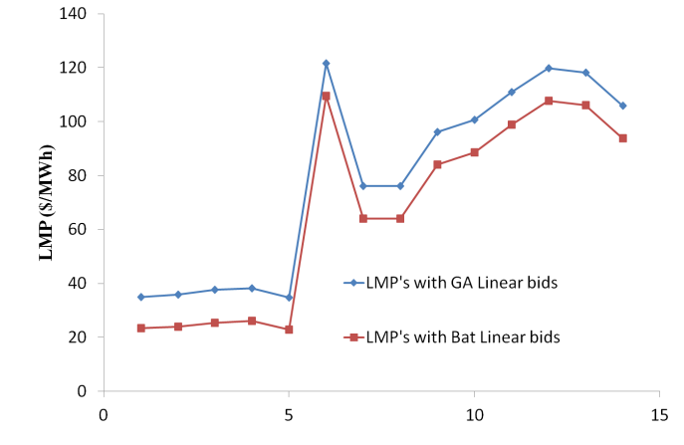

**Figure 9. LMPs' comparison for case 2 of IEEE 14 bus system**

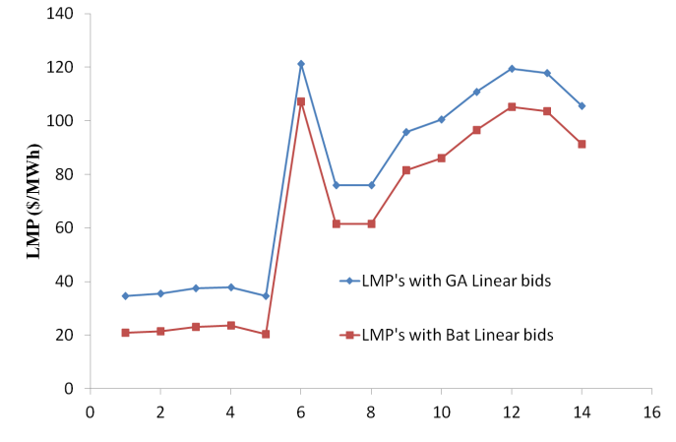

**Figure 10. LMPs' comparison for case 3 of IEEE 14 bus system**

**6.2. Case study 2: New England 39 bus system**

Both GA and BA are tested on New England 39 bus test system. This system has 10 generators and 19 loads. 4 generators are considered as suppliers and 4 major loads are considered as customers in the market. It was observed that only 46th line connecting 19–20 buses is congested for both methods in all loss cases. The shadow price or constraint cost is taken as 2.9 $/MWh for all cases which is obtained from Power World Simulation. The generator power outputs and the corresponding social welfare are shown in table 3. The LMPs’ are shown in table 4. Figure 11 presents a comparison of social welfare or social surplus for all the three loss cases. Figures 12, 13 and 14 show the LMPs’ comparison for cases 1, 2 and 3.

From figure 11 it can be observed that for all the three cases, BA has given better social welfare than GA. From the LMPs’ comparison graphs, it can be observed that for case 1 all the LMPs’ are same except at 20th and 34th buses. These are maximum of all and are indicated in red color in table 4. As the congested line connects 19th and 20th buses, LMP at 20th bus (i.e., sink node of the congested line) is raised to maximum value. 40th line connects 20th bus and 34th bus. As 34th bus is a dead end bus, LMP of 20th bus is reflected at 34th bus. For cases 2 and 3 also, LMPs’ are maximum at 20th and 34th buses, but for remaining buses LMPs’ vary slightly due to system losses. It can be observed that in table 3, even though BA takes more iterations than GA, per iteration time of BA is less than GA and hence the CPU time with BA is reduced than with GA.

**TABLE 3. Generators’ active power outputs and social welfare for New England 39 bus system**

|  |  |  |  |  |  |  |
| --- | --- | --- | --- | --- | --- | --- |
| **Supplier bus No.** | **Power Generations in MW without loss**  **CASE 1** | | **Power Generations in MW with concentrated loss**  **CASE 2** | | **Power Generations in MW with distributed loss**  **CASE 3** | |
| GA | BA | GA | BA | GA | BA |
| 31(slack) | 235.046 | 248.21 | 272.77 | 285.12 | 272.7 | 280.10 |
| 32 | 650.99 | 650.17 | 650.99 | 650.17 | 650.98 | 645.29 |
| 33 | 632.99 | 625.89 | 632.99 | 625.89 | 632.98 | 642.22 |
| 35 | 650.91 | 641.64 | 650.91 | 641.64 | 650.98 | 629.78 |
| System loss (MW) |  |  | 37.73 | 36.9 | 37.73 | 36.82 |
| Supplier surplus ($/hr) | 696.91 | 913.98 | 542.143 | 765.79 | 540.68 | 739.481 |
| Consumer surplus ($/hr) | 28630.7 | 28418.6 | 28013.5 | 27806.1 | 28014.5 | 27827.7 |
| Merchandising surplus or  ISO surplus ($/hr) | 1507.97 | 1507.17 | 1896.11 | 1889.56 | 1896.14 | 1885.62 |
| Social surplus ($/hr) | 30835.6 | 30839.8 | 30451.7 | 30461.5 | 30451.4 | 30452.8 |
| Iterations | 112 | 186 | 112 | 186 | 137 | 214 |
| CPU time (sec) | 83.689 | 30.3429 | 83.689 | 30.3429 | 148.868 | 145.316 |

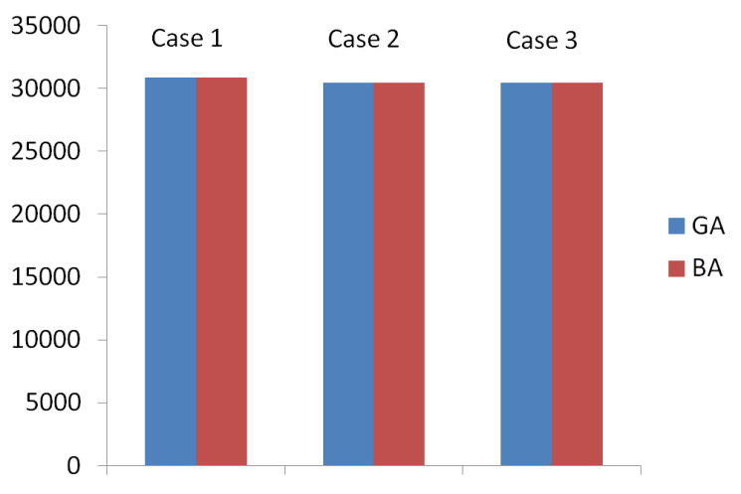

**Figure 11. Social welfare comparison for all the three loss cases of New England 39 bus system**

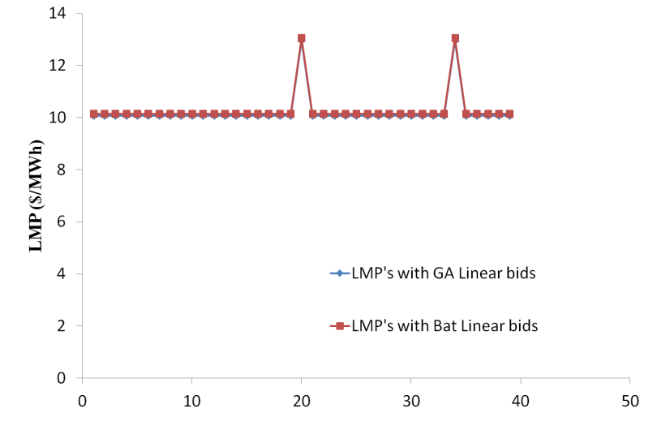

**Figure 12. LMPs' comparison for case 1 of New England 39 bus system**

**TABLE 4. Bus LMPs’ for New England 39 bus system**

|  |  |  |  |  |  |  |
| --- | --- | --- | --- | --- | --- | --- |
| Bus No. | **LMPs’ at all buses ($ / MWh)** | | | | | |
| **Without loss model**  **CASE 1** | | **Concentrated loss model**  **CASE 2** | | **Distributed loss model**  **CASE 3** | |
| GA linear bids | BA linear bids | GA linear bids | BA linear bids | GA linear bids | BA linear bids |
| 1 | 10.06 | 10.139 | 10.543 | 10.621 | 10.543 | 10.586 |
| 2 | 10.06 | 10.139 | 10.279 | 10.357 | 10.279 | 10.325 |
| 3 | 10.06 | 10.139 | 10.224 | 10.302 | 10.223 | 10.27 |
| 4 | 10.06 | 10.139 | 10.291 | 10.367 | 10.29 | 10.336 |
| 5 | 10.06 | 10.139 | 10.306 | 10.38 | 10.305 | 10.35 |
| 6 | 10.06 | 10.139 | 10.286 | 10.36 | 10.286 | 10.33 |
| 7 | 10.06 | 10.139 | 10.364 | 10.439 | 10.364 | 10.409 |
| 8 | 10.06 | 10.139 | 10.404 | 10.479 | 10.403 | 10.448 |
| 9 | 10.06 | 10.139 | 10.581 | 10.658 | 10.581 | 10.624 |
| 10 | 10.06 | 10.139 | 10.149 | 10.224 | 10.149 | 10.194 |
| 11 | 10.06 | 10.139 | 10.194 | 10.269 | 10.194 | 10.239 |
| 12 | 10.06 | 10.139 | 10.178 | 10.253 | 10.177 | 10.223 |
| 13 | 10.06 | 10.139 | 10.162 | 10.237 | 10.161 | 10.207 |
| 14 | 10.06 | 10.139 | 10.184 | 10.26 | 10.183 | 10.229 |
| 15 | 10.06 | 10.139 | 10.05 | 10.129 | 10.05 | 10.098 |
| 16 | 10.06 | 10.139 | 9.992 | 10.073 | 9.992 | 10.041 |
| 17 | 10.06 | 10.139 | 10.078 | 10.157 | 10.077 | 10.125 |
| 18 | 10.06 | 10.139 | 10.133 | 10.212 | 10.133 | 10.18 |
| 19 | 10.06 | 10.139 | 9.947 | 10.03 | 9.947 | 9.997 |
| 20 | 12.96 | 13.039 | 12.847 | 12.93 | 12.847 | 12.897 |
| 21 | 10.06 | 10.139 | 9.875 | 9.957 | 9.875 | 9.925 |
| 22 | 10.06 | 10.139 | 9.754 | 9.836 | 9.753 | 9.804 |
| 23 | 10.06 | 10.139 | 9.799 | 9.881 | 9.799 | 9.849 |
| 24 | 10.06 | 10.139 | 9.965 | 10.045 | 9.964 | 10.013 |
| 25 | 10.06 | 10.139 | 10.255 | 10.334 | 10.255 | 10.301 |
| 26 | 10.06 | 10.139 | 10.166 | 10.245 | 10.166 | 10.213 |
| 27 | 10.06 | 10.139 | 10.125 | 10.205 | 10.125 | 10.172 |
| 28 | 10.06 | 10.139 | 10.166 | 10.245 | 10.166 | 10.213 |
| 29 | 10.06 | 10.139 | 10.166 | 10.245 | 10.166 | 10.213 |
| 30 | 10.06 | 10.139 | 10.279 | 10.357 | 10.279 | 10.325 |
| 31 | 10.06 | 10.139 | 10.286 | 10.36 | 10.286 | 10.33 |
| 32 | 10.06 | 10.139 | 10.149 | 10.242 | 10.149 | 10.194 |
| 33 | 10.06 | 10.139 | 9.947 | 10.03 | 9.947 | 9.997 |
| 34 | 12.96 | 13.039 | 12.847 | 12.93 | 12.847 | 12.897 |
| 35 | 10.06 | 10.139 | 9.754 | 9.836 | 9.753 | 9.804 |
| 36 | 10.06 | 10.139 | 9.799 | 9.881 | 9.799 | 9.849 |
| 37 | 10.06 | 10.139 | 10.255 | 10.334 | 10.255 | 10.301 |
| 38 | 10.06 | 10.139 | 10.166 | 10.254 | 10.166 | 10.213 |
| 39 | 10.06 | 10.139 | 10.704 | 10.781 | 10.703 | 10.745 |

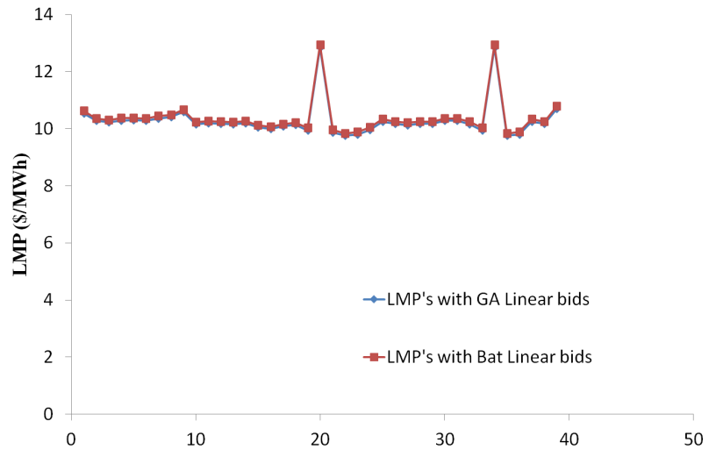

**Figure 13. LMPs' comparison for case 2 of New England 39 bus system**

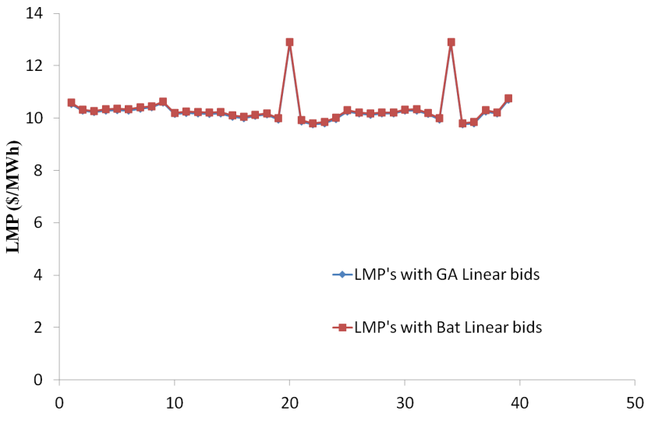

**Figure 14. LMPs' comparison for case 3 of New England 39 bus system**

**6.3. Case study 3: Indian 75 bus system**

GA and BA are tested on Indian 75 bus system also. This system has 15 generators and 40 loads. 10 generators are considered as suppliers and 9 major loads are considered as customers. All the remaining generators and loads are assumed to be engaged in bilateral transactions. It was observed that with GA for cases 1 and 2 line no. 9 (28-4), 11 (31-5) and 86 (25-72) are congested but for case 3 lines 9, 11, 39 (25-60), 43 (28-43) and 86 are congested. With BA for cases 1, 2 and 3 lines 9 and 86 are congested. The shadow price or constraint cost is taken as 3.35 $/MWh for case 1, 3.67 $/MWh for case 2 and 3.7 $/MWh for case 3 which are obtained from Power World Simulation. The generator power outputs and the corresponding social welfare are shown in table 5. Figure 15 presents a comparison of social welfare or social surplus for all the three loss cases. Figures 16, 17 and 18 show the LMPs’ comparison for cases 1, 2 and 3.

From table 5 it is observed that the social welfare is improved with BA than with GA and also the CPU time of BA is less than GA. Even though BA takes more iterations than GA, per iteration time of BA is less than GA and hence the CPU time with BA is reduced than with GA. From figures 16, 17, and 18, it is observed that, the LMP values at some buses (buses belong to congested lines and 70th bus) are raised to higher values, because of congestion in the system. For remaining buses LMP values vary slightly due to presence of losses in cases 2 and 3. Though 70th bus does not belongs to congested lines, the LMP at this bus is raised to a higher value because this bus is a dead end bus and is connected after bus 72 (which is belongs to congested line), so the LMP of 72nd bus is reflected at 70th bus.

**TABLE 5. Generators’ active power outputs and social welfare of Indian 75 bus system**

|  |  |  |  |  |  |  |
| --- | --- | --- | --- | --- | --- | --- |
| **Supplier bus No.** | **Power Generations in MW without loss**  **CASE 1** | | **Power Generations in MW with concentrated loss**  **CASE 2** | | **Power Generations in MW with distributed loss**  **CASE 3** | |
| GA | BA | GA | BA | GA | BA |
| 1(slack) | 365.95 | 258.75 | 429.29 | 314.95 | 383.72 | 276.57 |
| 2 | 359.99 | 350.15 | 359.99 | 350.15 | 358.99 | 359.33 |
| 3 | 270.00 | 273.22 | 270.00 | 273.22 | 279.68 | 270.76 |
| 4 | 199.99 | 199.91 | 199.99 | 199.91 | 199.99 | 198.67 |
| 5 | 279.99 | 272.57 | 279.99 | 272.57 | 279.99 | 273.71 |
| 6 | 210.00 | 216.19 | 210.00 | 216.19 | 210 | 218.64 |
| 7 | 150.00 | 153.6 | 150.00 | 153.6 | 150.00 | 156.76 |
| 8 | 170.00 | 174.98 | 170.00 | 174.98 | 179.99 | 171.14 |
| 9 | 649.99 | 648.86 | 649.99 | 648.86 | 649.97 | 641.32 |
| 10 | 170.00 | 172.02 | 170.00 | 172.02 | 179.76 | 173.39 |
| System loss (MW) |  |  | 63.335 | 56.198 | 62.17 | 54.143 |
| Supplier surplus ($/hr) | 2403.16 | 3187.45 | 4585.53 | 5047.88 | 6686.13 | 4289.62 |
| Consumer surplus ($/hr) | 6866.84 | 10320.5 | 2577.56 | 6701.9 | 1986.52 | 9088.36 |
| Merchandising surplus or  ISO surplus ($/hr) | 1971.85 | 248.05 | 3065.15 | 1143.64 | 1821.14 | 1106.01 |
| Social surplus ($/hr) | 11241.9 | 13756 | 10228.2 | 12893.4 | 10493.8 | 14484 |
| Iterations | 459 | 639 | 459 | 639 | 384 | 478 |
| CPU time (sec) | 2233.7 | 1153.79 | 2233.7 | 1153.79 | 1913.70 | 674.053 |

Customers who are involved in bidding will pay to ISO at the rate of its bus LMP for the consumed power. Suppliers who are involved in auction will be paid by ISO at the rate of its bus LMP for supplying power to the grid. Trading will be done for remaining generators and loads based on bilateral transactions. It can be observed from the case studies that slack bus power in distributed loss case is reduced than that in concentrated loss case and burden on the slack generator is removed. This is the main reason to propose the distributed loss case for SWM problem. Even though BA takes more iterations to converge than GA, the CPU time taken per iteration is very less in BA compared to GA as BA has less number of parameters to adjust and offers a better result with less population size. Bat algorithm works with small population of the order of 10-25 size. Therefore with BA, the total computational time for the convergence is very much reduced than with GA for all cases for all test systems studied. Hence, Bat algorithm with distributed loss case can be a best algorithm for SWM in double auction markets.

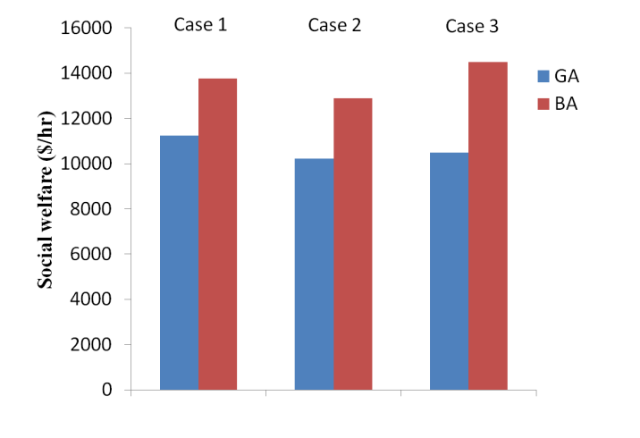

**Figure 15. Social welfare comparison for all the three loss cases of Indian 75 bus system**

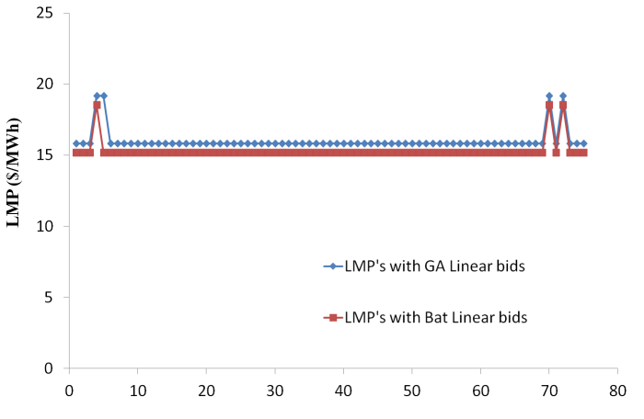

**Figure 16. LMPs' comparison for case 1 of Indian 75 bus system**

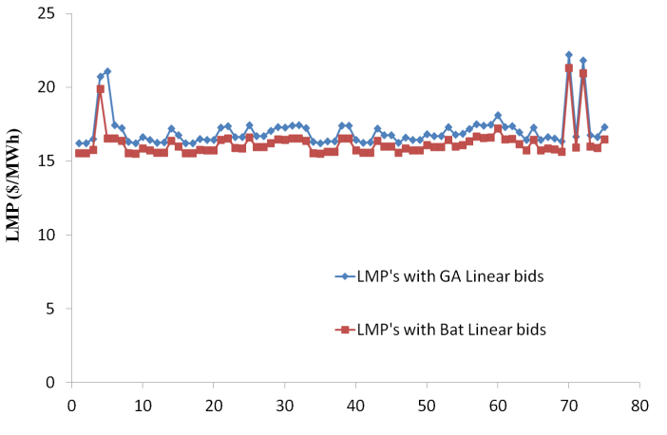

**Figure 17. LMPs' comparison for case 2 of Indian 75 bus system**

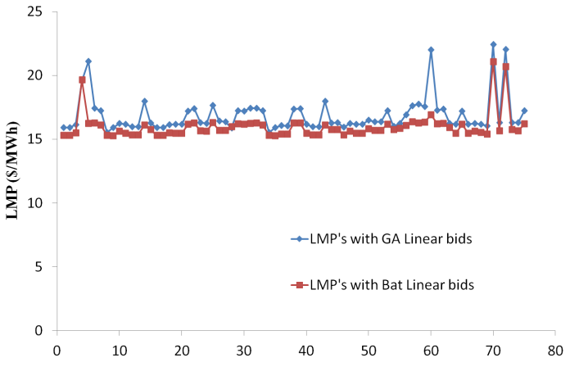

**Figure 18. LMPs' comparison for case 3 of Indian 75 bus system**

**7. Conclusion**

In this paper LMP calculation with Social Welfare Maximization as objective function with three different loss cases for congested system is attempted to allocate variable cost to the users of the grid. This problem is solved by DCOPF with GA and BA with generator linear bids. Consumers are modelled as elastic and hence consumer surplus exists. Only major consumers participate in bidding and they have choice to alter their demand according to the price of the suppliers. From the results, it is observed that BA produces better results compared to GA in terms of social welfare and computation time in all the loss cases for all the test systems studied. All the surpluses (e.g., supplier surplus, consumer surplus, ISO surplus and social surplus) are positive with both GA and BA in all the loss cases for all the test systems used.

**Appendix**

**Generation Shift Factor**

Generation shift factor is the ratio of change in power flow of line ‘k’ to change in power injection at bus ‘i’. GSF can be computed using (i), where B-1 is the inverse of B matrix, xk is reactance of line k, ‘a’ and ‘b’ are sending and receiving end buses of line k.

 (i)

**Delivery Factor**

The delivery factor (DFi) at the ith bus represents the effective MW delivered to the customers to serve the load at that bus. It is defined as (ii)

 (ii)



(iii)

 (iv)

 In (ii), LFi represents the loss factor at bus ‘i’ which is calculated using (v), Fk is the power flow in line k , Rk is the resistance of line k, Pi is the injected power at bus i,GSFk-i is the generation shift factor to line ‘k’ from bus ‘i’. LFi may be viewed as the change of total system loss with respect to 1 MW increase in injection at that bus. Interestingly, the loss factor at a bus may be positive or negative. When it is positive, it implies that an increase of injection at the bus may increase the total system loss. If it is negative, it implies that an increase of injection at that bus reduce the total loss.

**REFERENCES**

1. H. Singh, S. Hao, and A. Papalexopoulos, “Transmission congestion management in competitive electricity markets,” IEEE Trans. Power Syst., vol. 13, No.2, pp. 672 –680, May 1998.
2. Christie R.D., Wollenberg B.F., Wangensteen I., “Transmission management in the deregulated environment”, Proc. of IEEE, 88, (2), pp. 170 – 195, 2000.
3. Luonan chen, Hideki Suzuki, Tsunehisa Wachi, Yukihiro Shimura, “Components of Nodal prices for Electric Power Systems”, IEEE Trans. Power. Syst., vol.17, No.1, February 2002.
4. G. Hamoud, I. Bradley, “Assessment of transmission congestion cost and Locational Marginal Pricing in a competitive electricity market”, IEEE Trans. on Power Syst., Vol. 19, no.2, May 2004.
5. Thomas J. Overbye, Xu Cheng, Yan Sun, “A comparison of the AC and DC power flow models for LMP calculations”, IEEE 37th Annual Hawaii International Conference on System Sciences, 2004.
6. Yuan-Kang, Wu, “Comparison of pricing schemes of several deregulated electricity markets in the world”, IEEE/PES Transmission and Distribution Conference, 2005.
7. Yong Fu, Zuyi Li, “Different models and properties on LMP calculations”, IEEE Power Engineering Society General Meeting, 2006.
8. Haifeng Liu, Leigh Tesfatsion, A.A.Chowdhury, “Locational Marginal Pricing basics for Restructured wholesale power markets”, IEEE Power & Energy Society General Meeting, 2009.
9. Fangxing Li, Rui Bo, “DCOPF-based LMP Simulation: Algorithm, Comparison with ACOPF, and Sensitivity”, IEEE Trans. Power Syst., Vol.22, no.4, November 2007.
10. E. Litvinov, “Design and operation of the Locational marginal prices-based electricity markets” IET Gener. Transm. Distrib., Vol. 4, no. 2, pp. 315-323, 2010.
11. Hongyan Li, Leigh Tesfatsion, “ISO Net Surplus Collection and Allocation in Wholesale Power Markets Under LMP”, IEEE Trans. on Power Systems, Vol. 26, No. 2, MAY 2011.
12. Rajesh Rajaraman, Jayant V.Sarlashkar, Fernando L.Alvarado, “The effect of demand elasticity on security prices for the POOLCO and Multi-lateral contract models”, IEEE Trans. on Power Systems, Vol. 12, no. 3, August 1997.
13. J.D.Weber, T.J.Overbye, “A Two-Level Optimization Problem for Analysis of Market Bidding Strategies”, IEEE Power Engineering Society Summer Meeting, 1999.
14. James D. Weber, Thomas J. Overbye, “An Individual Welfare Maximization Algorithm for Electricity Markets”, IEEE Trans. on Power Systems, Vol. 17, no. 3, August 2002.
15. Ettore Bompard, Enrico Carpaneto, Gianfianco Chicco, George Gross, “The role of load demand elasticity in congestion management and pricing”, IEEE Power Engineering Society Summer Meeting, 2000.
16. Paolo Marannino, Riccardo Vailati, Fabio Zanellini, Ettore Bompard, George Gross, “OPF tools for optimal pricing and congestion management in a two sided auction market structure”, IEEE Power Tech Proceedings, 2001.
17. Surachai Chaitusaney, Bundhit Eua-Arporn, “Actual Social Welfare Maximization in Pool Market”, IEEE Power Engineering Society Summer Meeting, 2002.
18. Francisco D. Galiana, Alexis L. Motto, and Francois Bouffard, “Reconciling Social Welfare, Agent Profits, and Consumer Payments in Electricity Pools”, IEEE Trans. on Power Systems, Vol. 18, No. 2, May 2003.
19. Jiang Wu, Xiaohong Guan, Feng Gao, Guoji Sun, “Social Welfare Maximization Auction for Electricity Markets with Elastic Demand”, IEEE 7th World Congress on Intelligent Control and Automation, 2008.
20. Hongrui Liu, Yanfang Shen, Zelda B. Zabinsky, Chen-Ching Liu, Alan Courts, Sung-Kwan Joo, “Social Welfare Maximization in Transmission Enhancement Considering Network Congestion”, IEEE Trans. on Power Systems, Vol. 23, no. 3, August 2008.
21. Xiaoyan Zou, “Double-sided auction mechanism design in electricity based on maximizing social welfare”, Energy Policy, Elsevier, Vol.37 (2009) 4231–4239.
22. Kanwardeep Singh, Narayana Prasad Padhy, Jaydev Sharma, “Influence of Price Responsive Demand Shifting Bidding on Congestion and LMP in Pool-Based Day- Ahead Electricity Markets”, IEEE Trans. on Power Systems, Vol. 26, no. 2, May 2011.
23. M. Murali, M. Sailaja Kumari, M. Sydulu, “Optimal spot pricing in electricity market with inelastic load using constrained bat algorithm”, Journal of Electrical Power and Energy Systems, Elsevier, Vol.62, pp. 897-911, Nov 2014.
24. Iyambo P.K., Tzoneva R., Transient Stability Analysis of the IEEE 14-Bus Electric Power System, IEEE conference, Africon, 2007, (14 bus data).
25. New England 39 bus system data (online), Available at:

<http://sys.elec.kitami->it.ac.jp/ueda/demo/WebPF/39-New-England.pdf, (12/02/2001)

1. Indian75 bus Power system data, Uttar Pradesh State (A state of India) Electricity Board data”. (This data is obtained from Indian Institute of Technology, Kanpur)