An hybrid approach to Green Building Construction using timber
Ram Kumar V R, Amitava Sil,
Scientist, Institute of Wood Science and Technology
2/2, Biren Roy Road (West) Sarsuna, Kolkata-700061
Mobile No : :+919942317777
Email : ramce37@gmail.com

Abstract
India harbors the world's largest population and the most extensive construction sector globally, where the utilization of engineered wood products in building construction remains minimal. The advantages of incorporating timber into tall and commercial constructions are indisputable, contributing to the reduction of the carbon footprint, shortened construction times, and improved seismic and building physics performances. However, in India, engineered wood products have not been widely acknowledged as structural materials for tall and non-residential constructions. The implementation of hybrid timber buildings could offer a more rational approach to wood utilization, thereby fostering the development of more efficiently sustainable structures. In the years to come, this approach could lead to a higher proportion of engineered wood in buildings, bringing benefits to living conditions, the climate, and society at large.
Introduction
In India, substantial growth has been witnessed in sectors such as real estate and renewable energies. The escalation in oil prices has spurred research into enhancing energy efficiency and exploring alternative energy sources. Consequently, there is a pressing need to adopt more energy-efficient and sustainable building practices, leading to the surge of the hybrid green building movement in the last decade. In recent years, driven by mounting environmental and health concerns, green hybrid buildings have emerged as the fastest-growing construction trend. The commendable attributes of energy efficiency, modern trends, cost-effectiveness, and sustainability inherent in green hybrid buildings contribute to their increasing popularity. While India has a historical tradition of constructing environmentally friendly buildings, the contemporary concept of green buildings gained prominence only in the late 1990s. The country's own green building rating systems, such as the Green Rating for Integrated Habitat Assessment (GRIHA) initiated by The Energy and Resources Institute (TERI) and the Ministry of New and Renewable Energy (MNRE), along with the Indian Green Building Council (IGBC) established by the Confederation of Indian Industry (CII), began in the early 2000s. Since then, the green building movement and hybrid-based construction have gained significant momentum in India. However, challenges persist, with reports indicating a decline in sustainable architecture due to substandard construction materials and techniques. It is noteworthy that buildings in India contribute to 40% of the total energy consumption, with residential housing projects accounting for over 60% of this share. Green buildings, by promoting sustainability without disrupting the natural ecosystem, have the potential to reduce energy consumption, save costs, and make a substantial positive impact on the environment. India is anticipated to exhibit substantial market potential for green and eco-friendly buildings in the near future.

A report titled 'India Green Building Market Opportunity Outlook 2020' highlights that India holds the second position globally, surpassed only by the USA, with over 4500 green building projects encompassing approximately 4.17 billion square feet of built-up area. According to the report, India boasts a total of 146 LEED certified buildings and spaces, equating to nearly 2.8 million gross area square meters (GSM). This signifies a notable 10% surge in LEED-certified space in India since 2020, underscoring the substantial market potential for green buildings in the country. This growth is attributed to heightened awareness, environmental advantages, and government backing. Additionally, strategic initiatives like the smart city mission, coupled with an escalating focus on energy efficiency, contribute to the expanding market potential of green buildings and hybrid-based construction in India.
Furthermore, green buildings or hybrid-based constructions are frequently acknowledged for their operational cost savings. New green buildings are anticipated to generate a 14% reduction in operational costs, while green retrofit buildings are expected to yield a 13% decrease in operational costs over an average period of five years. The Green Building Council (USGBC) annual list of the top 10 countries and regions outside of the US for leadership in energy and environmental design (LEED) in 2021 underscores the substantial potential for the continued adoption of green building technology in the future.

Hybrid-Timber based construction systems
Hybrid-timber-based construction systems integrate wood with various materials (e.g., steel, concrete, and glass) and employ diverse techniques to provide a broad spectrum of structural solutions. Hybrid-timber construction extends beyond incorporating wood as it integrates materials like steel and concrete as integral components of a building's structural assemblies. This amalgamation of materials in building systems enables engineers to leverage the specific strengths of each, optimizing both structural and overall building performance. A hybrid, in this context, denotes a combination of mixed origins, illustrating the merging of different materials to harness the advantages of their individual components. Common construction products like softwood, hardwood, and short rotation timber can be synergistically combined with other wood materials or inorganic substances to achieve enhanced solutions. Industries focusing on producing suitable products fall into the following categories:Materials, e.g. engineered wood products (EWP).

- Components, e.g. composite floor structures in wood, steel and concrete.
- Systems, e.g. multi-storey structural frames in wood, with stabilising elements of steel or concrete.

Traditional constraints on timber construction height, stemming from concerns about raw material quality, structural stability, and fire resistance, have been addressed through innovative approaches such as Timber Hybrid buildings. These advancements involve not only improvements in the engineered wood utilized but also the strategic combination of timber with reinforced concrete, enabling the construction of taller buildings. Timber hybrid building denotes a structural form predominantly characterized by wood, steel, and concrete components. A prevalent type of timber hybrid structure involves integrating a cast-in-place concrete core to withstand lateral loads, while the timber structure bears the remaining gravity and diaphragm loads. According to pertinent research, timber hybrid structures optimize the performance of wood, steel/concrete, resulting in increased bearing capacity, fire resistance, and seismic performance compared to pure wood structures [Poirier et al., 2016].
Numerous investigations have affirmed the significant potential of timber and timber-hybrid constructions to achieve increased heights while maintaining desired structural and environmental performance [Zhang et al., 2021]. In the past two decades, North America, Europe, and various other regions have delved into the exploration of novel systems involving the construction of multi-storey and high-rise timber hybrid structures in conjunction with materials like concrete or steel. Numerous feasibility studies examining innovative tall timber-based hybrid structural systems have been conducted, accompanied by the testing of several prototype buildings. Concurrently, the successful construction and operation of tall timber and timber-hybrid buildings, such as the 18-story Brock Commons in Canada and the 18-story Mjostarnet in Norway (refer to figures 3, 4, and 4a), underscore their competitiveness in terms of structural performance, environmental sustainability, and construction efficiency [Zhang et al., 2022].

The initial investigations indicate that cross-laminated timber (CLT) manufactured from rubber wood and Melia outperforms pinewood-based panels, which is highly promising. Protocols have been established for producing laminated bamboo lumber and crushed bamboo lumber using Dendrocalamus brandisii, Bambusa vulgaris, B. bambos, and Guadua angustifolia. Various bamboo composites, including bamboo mat board (BMB), bamboo mat corrugated sheets and ridge caps (BMCS), and molded skin from bamboo mat for door shutters, have been developed and commercially applied (Bansal et al., 2013). These bamboo-based composites exhibit potential as alternatives to solid wood in both structural and semi-structural applications. The structural design for Brock Commons adopts a hybrid configuration, as illustrated in Figure 1. The foundations, ground floor, and cores (housing stairwells, elevators, and service risers) are constructed with cast-in-place concrete. From Levels 3 through Level 18, the structure comprises mass timber columns and floor panels, with connections and specific elements, such as the roof structure, incorporating steel. The outcomes of these projects confirm that superstructures are significantly lighter compared to reinforced concrete structures.
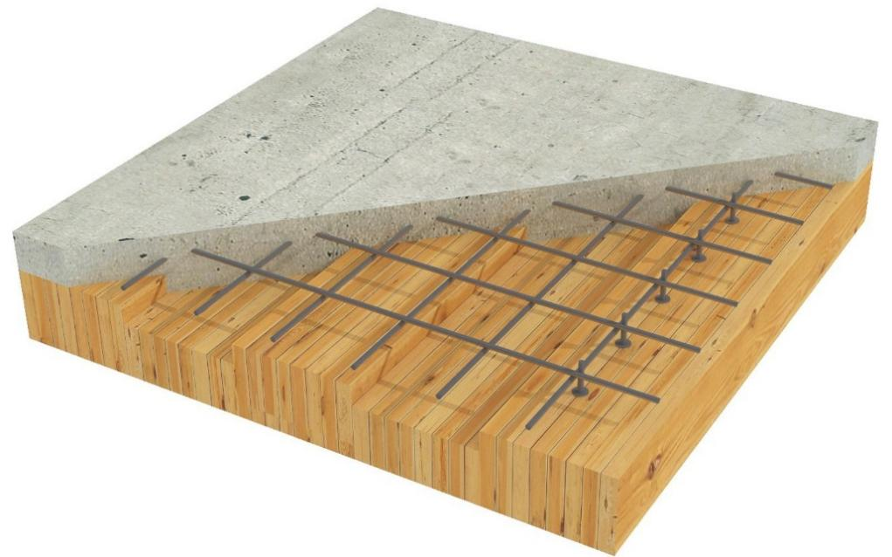
Fig 1. Flat floor structure comprising of CLT-concrete composite panels [5].
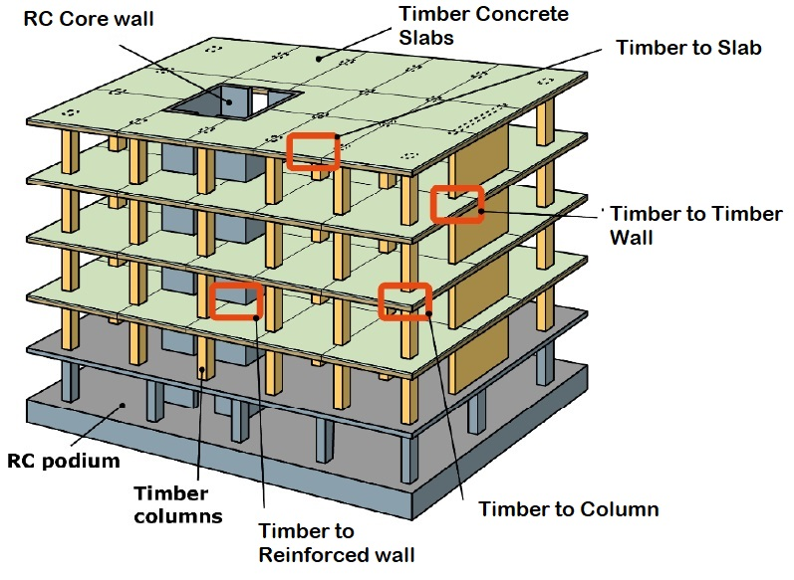
Fig 2. Earthquake resistant timber-concrete hybrid prefab structural system as a sustainable building alternative for Chile A project proposed by Pablo Guindos.
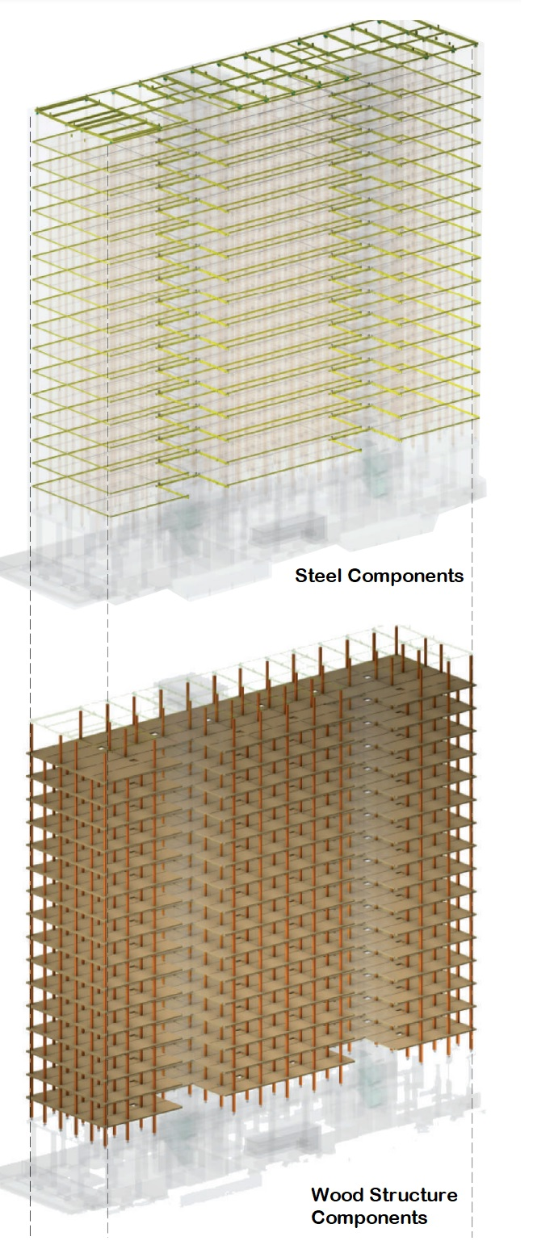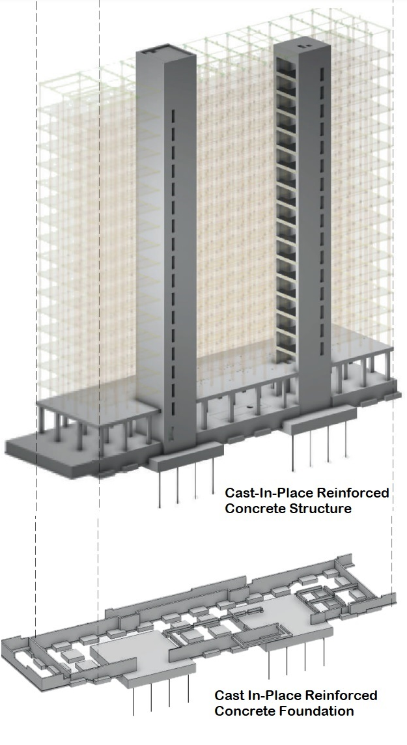

Fig 3. Brock Commons Tall Wood Building Structural System, Images courtesy: Acton Ostry Architects Inc. and Cad Makers Inc. [3].

Rating systems of Green Building
A green building is designed with ecological responsibility, utilizing natural resources efficiently throughout its entire lifecycle, encompassing planning, construction, operation, maintenance, renovation, and demolition. This comprehensive approach must align with eco-efficient practices. Rating systems, incorporating modules such as sustainable architecture, site selection and planning, water conservation, energy efficiency, building materials and resources, indoor environment quality, and innovation, play a crucial role. Specifically, the judicious use of wood and wood-based mass timber products, as well as adherence to building codes and standards, is pivotal for widespread recognition as green building materials. Certification standards for green buildings that identify and credit materials mitigating greenhouse gas emissions and other environmental impacts support efforts to address and adapt to climate change. Globally, the Leadership in Energy and Environmental Design (LEED) by the U.S. Green Building Council (USGBC) stands as a widely accepted standard for green building certification. LEED-certified buildings not only save costs, enhance efficiency, and reduce carbon emissions but also create healthier environments. They play a crucial role in addressing climate change, meeting Environmental, Social, and Governance (ESG) goals, enhancing resilience, and fostering equitable communities. To achieve LEED certification, projects earn points by meeting prerequisites and credits that address carbon, energy, water, waste, transportation, materials, health, and indoor environmental quality. The verification and review process by the Green Building Certification Institute (GBCI) awards points corresponding to different levels of LEED certification, as depicted in Figure 4. Among all LEED credits, 35% relate to climate change, 20% directly impact human health, 15% impact water resources, 10% affect biodiversity, 10% are related to the green economy, 5% impact the community, and 5% impact natural resources. LEED is a holistic system that considers the interconnectedness of critical elements—energy, water, health, and more—to create the most optimal building.

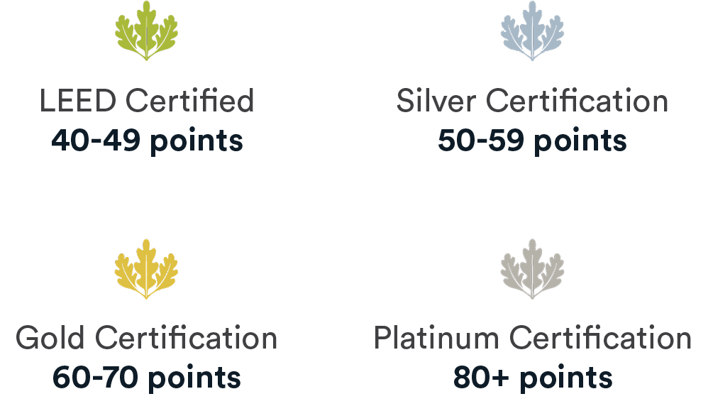
Fig 4. LEED certification system with colour code.

In India, certification for green buildings is granted by organizations such as the Indian Green Building Council (IGBC) and Green Rating for Habitat Assessment (GRIHA). Established by the Confederation of Indian Industry (CII) in 2001, IGBC has formulated a green building rating system aligned with the globally recognized LEED certification of the U.S. Green Building Council (USGBC). The IGBC rating system employs a scoring mechanism of 100 points for new buildings, distributed across various categories. Fulfillment of specific requirements in these categories is crucial for accruing points. The certification levels are outlined in Table 1. Additionally, Table 2 provides an overview of well-known green building rating systems in India and developed countries.

Table 1. IGBC-GRIHA rating systems (source: IGBC website).
Certification level | Buildings | Recognition
Certified | 40–49 | Best practices
Silver | 50–59 | Outstanding performance
Gold | 60–74 | National excellence
Platinum | 75–100 | Global leadership

Table 2. Rating systems around the globe (source: Wang et al. 2013)

Rating schemes for green buildings | Origin | Year
BREEAM - Building Research Establishment Environmental Assessment Method | UK | 1990
BEPAC - Building Environmental Performance Assessment Criteria | Canada | 1993
GBTool - Green Building Challenge | International | 1995
LEED - Leadership in Energy and Environmental Design | US | 2000
IGBC - Indian Green Building Council | India | 2001
NABERS - National Australian Building Environmental Rating System | Australia | 2001
GHEM - Green Home Evaluation Manual | China | 2001
CASBEE - Comprehensive Assessment System for Building Environmental Efficiency | Japan | 2001
BEE - Bureau of Energy Efficiency | India | 2002
GreenStar- Green Star Environmental Rating System | Australia | 2003
Protocollo ITACA -Istituto per l’Innovazione e Transparenzadegli Appalti e la CompatibilitaAmbientale | Italy | 2004
HQE - High Environmental Quality | France | 2005
GBP - Green Building Programme | EU | 2005
LEED India | India | 2006
GRIHA - Green Rating for Integrated Habitat Assessment | India | 2007
DGNB - Certification System German Sustainable Building Council Certification System | Germany | 2009
Miljobyggnad (Environmental Building) | Sweden | 2010
American National Standard Institute – Green Building Assessment Protocol for commercial (ANSI/GBI) | US | 2010
International Green Construction Code (IGCC) – International Code Council (ICC) | International | 2012

New Generation green building material
Taking care of the above criteria for resource efficiency and the green building concept, timber and timber based materials (engineered timber products, mass timber products, and others ligno-cellulosic materials) would be an effective solution for green building materials. The innovation of engineered wood products (EWP) from wood and bamboo can play a crucial role to integrate urban built environment with the natural system and to solve the problem of energy emissions towards green buildings. Products derived from wood are recognized for their substantial carbon sequestration and minimal carbon emissions. In sustainable harvesting practices, approximately 50% of the wood's weight converts into carbon, enhancing its inherent sequestration capacity. Consequently, structures incorporating wood-based systems contribute to increased carbon storage, effectively mitigating the carbon footprint in the atmosphere. The integration of mass timber products within hybrid construction demonstrates an innovative approach to achieving sustainable development goals through efficient resource management.

Various innovative Mass Timber Products (MTPs) are presently available in the Western market, as illustrated in Figure 5, while India is still in the early stages of adopting them. Key types of MTPs encompass Cross-Laminated Timber (CLT), Laminated Veneer Lumber (LVL), and Glue-Laminated Timber (Glulam). CLT, a prominent MTP, is crafted by arranging layers of dimension lumber perpendicular to each other, bonded to form structural panels exhibiting remarkable strength, dimensional stability, and rigidity. Typically comprising three, five, or seven layers, each ranging from 15 to 50 mm thick, CLT panels are joined with polyurethane, melamine, and phenolic-based adhesives. These panels can achieve sizes ranging from 10 to 60 feet and find application in major structural components like walls, roofs, and floor slabs. Another widely used MTP is Glulam, composed of individual wood layers aligned parallel to each other. Similar to CLT, Glulam incorporates dimension lumber selected for structural performance, bonded with durable, moisture-protected adhesives. Its excellent structural strength allows for versatile applications, including floor and roof decking, in addition to traditional beams and columns. In India, the Institute of Wood Science and Technology (IWST) has initiated a research program focusing on the development of mass timber elements such as CLT, Glulam, LVL, and bamboo lumber, utilizing diverse wood sources from trees outside forests (ToF) and various bamboo species. The suitability of rubber wood, Melia dubia, Eucalyptus, Silver oak, etc., is being assessed for CLT in this research.
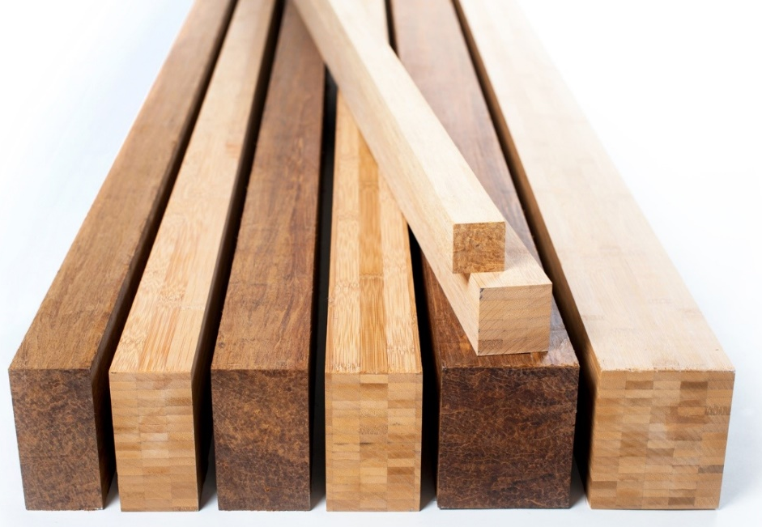
Fig 5. Bamboo composites (courtesy: Moso Studio).

Structural systems for mass timber construction
Throughout the last two decades, the mass timber building has experienced steady growth in multi-story construction in US, UK, Europe, Canada and Australia. A research was conducted globally on mass timber buildings of 350 projects during 2000–2021 by Raznjevic et al. (2021). In all these projects, the structural categorization of mass timber buildings is categorized as follows:
- 1-D Frame structure
- 2-D Bearing wall
- 3-D Volumetric modules
- Combination or hybrid

Frame structures encompass post-and-beam configurations, post-and-slab arrangements, and exoskeleton structures where vertical supports (apart from the core) are predominantly situated on the exterior. Typically, the frame is affixed to a core, with variations arising from the inclusion of supplementary stiffening components. While a structure may solely comprise a timber frame, achieving lateral stability often necessitates the integration of additional bracing systems. These systems may include shear walls, diagonally oriented Engineered Wood Products (EWPs), steel beams, and steel cross-bracing. For floor slabs, diverse EWP combinations, such as Cross-Laminated Timber (CLT) slabs, ribbed slabs, or CLT or Glulam-concrete composite floors, can be employed.

Panel walls typically configure as honeycomb or party wall structures, while certain case studies showcase configurations with solely a central core and external load-bearing walls linked to the floor slabs. Additionally, external structural elements, like circulation corridors or balconies detached from the main structure, were taken into account. Sub-categories encompass internal beams or columns, or a combination of both. Floor slabs predominantly consist of Cross-Laminated Timber (CLT) or utilize box floor and box beam elements. Volumetric modules, also known as spatial modules or 3-D modules, comprise pre-assembled volumes equipped with ready-made rooms and pre-installed services. The core may be constructed separately or modularly, mirroring the building's modular construction. While 3D modules commonly incorporate facades and balconies, this category often involves additional external frame structures for balconies or circulation corridors.

Hybrid structural systems encompass various combinations of categories, including projects falling into one of the following conditions:
- Lower and upper portions of the building volume are constructed in different ways
- Different areas of the footprint are constructed with different systems and
- Projects where two systems appear in combination with one another.

Another category involves the combination of mass timber with light frame construction, predominantly observed in projects in North America. This combination features light-frame walls and CLT floor slabs. In general, the prevalence of mass timber buildings is expected to continue growing in the near future, contingent upon available technologies, design expertise, building physics, construction methodologies, and regulatory standards. Recent technological strides in engineered timber products (EWP) and systems, coupled with regulatory adaptations in building codes, fire safety, and various government initiatives, have facilitated the ascent of multi-story timber construction to unprecedented heights, as illustrated in Figure 6.

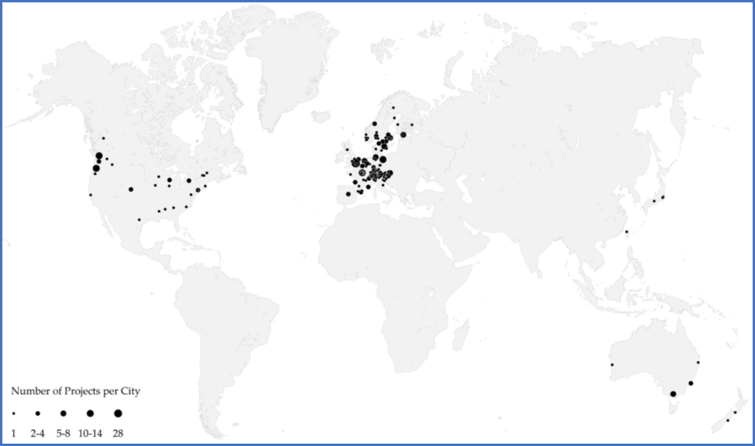

Fig 6. Timber building projects around the globe from 2000–2021 (source: Raznjevic et al. 2022).
Challenges and opportunities in hybrid timber buildings
With advancements in composites and inspiration from enhancements in timber, notable progress has been achieved, reminiscent of the success of reinforced concrete as a highly effective hybrid material. Combining concrete and steel offers the advantage of leveraging the strengths of both materials while mitigating their individual weaknesses. The amalgamation of concrete and steel rebar has significantly broadened the material's applications, transitioning from a limited number of unreinforced concrete structures, primarily subjected to compression forces and built before the 1900s, to reinforced concrete, now recognized as a predominant construction material worldwide. The substantial success of this material is, to a great extent, attributed to the successful hybridization of concrete and steel rebar. Concerning the weaknesses associated with wood, frequently cited issues include durability and fire safety, particularly for unprotected structural components exposed to outdoor conditions. However, addressing these concerns is feasible through structural wood protection, fire protective systems, adequate preservative treatment, or chemical modification, leading to substantial enhancements in durability and safety. Additionally, certain wood properties listed below can pose challenges in their utilization for building systems, presenting complexities for engineers.
(a) Widely varying strength properties, particularly tensile and bending
(b) Brittle fractures
(c) Relatively low mass
(d) Relatively low modulus of elasticity (elastic modulus)
(e) Difficult to execute stiff fixings/connections
(f) Fire safety, durability and serviceability
Vibration-related issues can be mitigated through the implementation of a composite floor structure within a hybrid structural system. From a static perspective, this structural type demonstrates high efficiency by optimizing the material properties, specifically leveraging the compressive strength of concrete and the tensile strength of wood. Given that the elastic modulus of concrete surpasses that of wood by threefold, the resulting bending stiffness of a composite floor structure significantly exceeds that of an equivalent wooden floor structure with the same height. The inclusion of more mass in the floor structure also provides the advantageous effect of enhancing resistance to global overturning, addressing a challenge that would otherwise necessitate costly countermeasures in tall and lightweight buildings.
The frequency and acceleration induced by wind load are significantly influenced by a building's stiffness and mass. Dynamic effects of wind-induced oscillations can lead to discomfort and health issues for the building occupants, potentially rendering the structure unsuitable for its intended function. In comparison to equivalent steel or concrete buildings, high-rise wooden buildings exhibit lower horizontal stiffness. This is primarily attributed to the wood's low elastic modulus and, to a considerable extent, the connections among various wooden components, which typically have notable flexibility. A practical approach to mitigate the risk of wind-induced vibrations is, once again, the adoption of a hybrid solution. In this scenario, a wooden structure manages the vertical loads (e.g., permanent loads, imposed load, and snow load), while an attached concrete or steel structure with significantly higher bending stiffness addresses horizontal and vertical upward wind loads.
As a result of advancements in fire-stopping system technology and the widespread production of engineered wood products on a global scale, particularly in the context of the low-carbon economy, the past two decades have witnessed an increased focus on the utilization and research of structural timber in Western countries. Consequently, timber high-rise buildings and timber-hybrid structures are garnering growing attention globally. Engineered timber products, such as glued-laminated timber and cross-laminated timber, have recently found applications in the construction of residences, educational institutions, shopping complexes, and stadiums. Notably, significant projects have been successfully executed using hybrid structures based on timber, as illustrated in figure 7.
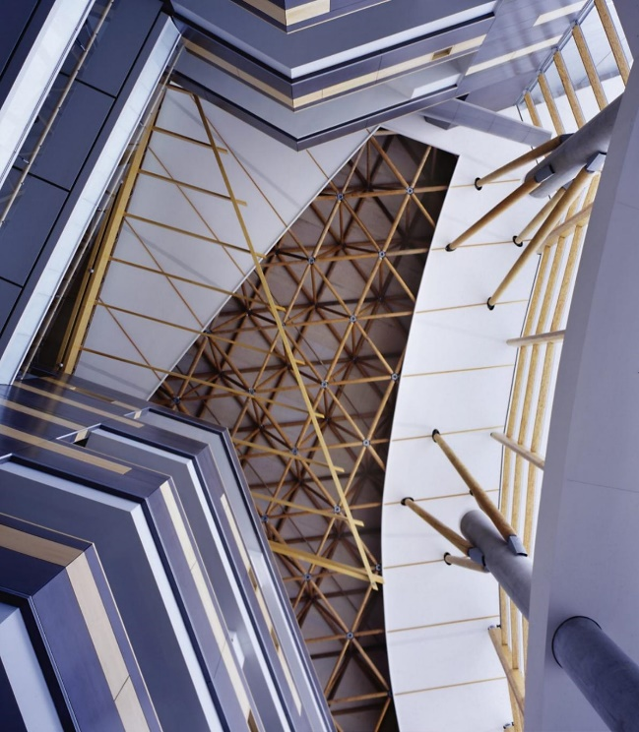
Fig 7. Central City, Surrey, Canada (Photo courtesy: Nic Lehoux [6] and Okanagan College Jim Pattison Centre of Excellence, Penticton, Canada (Photo courtesy, Cei Architecture [6]).
In the years to come, engineered wood will form a much bigger part of the construction sector in India as well as around the globe. The above-said hybrid timber systems will redefine the possibilities of using timber with steel, concrete and others materials. Using engineered wood combines the potential for prefabrication and rapid construction with lower embodied energy and the potential to delay the carbon emissions for buildings during construction and service cycle. Research and technical reports suggest that timber can be best used in combination with other conventional materials, taking advantage and attributes of individual materials. Buildings and the construction sector can be optimized towards sustainability, matching the aesthetic, acoustic, dynamic, safety and the fire performance of occupants. It is concluded that in order to promote the development of timber construction industries in India, it is necessary to progress on regulatory, cultural, and material availability issues, where international experience, demonstrative buildings, and the implementation of public policies are crucial.
Conclusion
The emissions from conventional building materials and construction processes must be sincerely addressed to ensure that the buildings which are being built in future are to be optimized for low-carbon solutions across the full-life cycle. This involves maximizing the refurbishment of existing buildings, evaluating each design choice using a whole life-cycle approach and seeking to minimize upfront carbon impacts (e.g., lean construction, low-carbon materials and construction processes, etc.), as well as taking steps to avoid future embodied carbon during and at the end of life (viz. maximize the potential for renovation, future adaptation and circularity). With the recent acceptance of timber in the building code, environmental commitments of the country and increasing environmental awareness, the concept of green building in India is gaining attention and expected to get momentum in coming years. Production and utilization of mass timber products in construction is a way for the building and construction industry to contribute toward sustainable development goals. Policymakers, the forest products industry, and resource management organizations need to initiate a science-based approach to outlining the benefits of using wood and wood-based products in green buildings in India. A multi-disciplinary approach is needed to further develop scientific knowledge and provide technology transfer and education relevant to evaluating and advancing these benefits. It must be noted that the inherent benefits of using wood go beyond economic, social and environmental gains in a long run. Focussing and implementing the initiatives such as research, development, and industrialization for mass timber products in India, outreach and education on the perception of wood and wood-based products, development of standards, codes and certification programmes on the footprint of wood building materials may contribute to achieving sustainable development goals.

References
- Abrahamsen R. (2017) “Mjøstårnet-Construction of an 81 M Tall Timber Building,” in Internationals Holzbau-Forum IHF, 1–12.
- https://cenamad.cl/investigadores-cenamad-integran-adjudicaciones-fondecyt-regular-2023/
- https://sustain.ubc.ca/sites/default/files/brockcommons_designpreconstructionoverview_web%20(1).pdf
- https://wood-rise-congress.org/wp-content/uploads/sites/34/2017/09/2016-07-08-structural-system-compressed.pdf
- https://www.entuitive.com/ensight-trend-home/timber-concrete-composite-systems-lighter-weight-and-lower-carbon/
- https://www.naturallywood.com/topics/hybrid-timber-construction/
- Araya R., Guillaumet A. do Valle, Â., Duque M.d.P., Gonzalez G., Cabrero, J.M., De León, E., Castro, F., Gutierrez, C., Negrão, J., Moya, L., Guindos, P. Development of Sustainable Timber Construction in Ibero-America: State of the Art in the Region and Identification of Current International Gaps in the Construction Industry Sustainability 2022, 14, 1170. https://doi.org/10.3390/su14031170
- Poirier, E., Moudgil, M., Fallahi, A., Staub-French, S., and Tannert, T. (2016) Design and Construction of a 53-Meter-Tall Timber Building at the university of British Columbia. Vienna, Austria Proceedings of WCTE.
- Xiaoyue Zhang, Lu Xuan, Wanru Huang, Lin Yuan and Pengcheng Li (2022) “Structural Design and Analysis for a Timber-Concrete Hybrid Building”,Front. Mater. 9:844398
- Zhang, X., Pan, Y., and Tannert, T. (2021) The Influence of Connection Stiffness on the Dynamic Properties and Seismic Performance of Tall Cross-Laminated Timber Buildings. Eng. Structures 238, 112261. doi:10.1016/j.engstruct.2021.112261. doi: 10.3389/fmats.2022.844398.

