An Assistive System for Physically Disabled People using Nose and Eye Movements

Prof. Sunil B. Hebbale  Assoc. Prof,, CSE Dept.  KLE College of Engineering ang Technology  Chikodi, Dist – Belagavi, Karnataka, India  sunilkbh2@gmail.com | Prof. Ashwini V. Gavali  Asst. Prof., CSE Dept.  KLE College of Engineering ang Technology  Chikodi, Dist – Belagavi, Karnataka, India  ashwini_gavali@yahoo.com

ABSTRACT
The system introduces a new algorithm for moving the cursor on the computer screen using nose and eye movements. By precisely detecting the position of the iris and mapping it to a specific position on the computer screen, this algorithm allows physically disabled people to control the left, right, up, and down movement of the cursor on the computer screen. The algorithm also allows people to open and close folders or files or applications using a click mechanism. The world's growing population with disabilities must be accompanied by increasing research and development of tools that assist these users in basic computing activities. Our project focuses on developing a system that enables the use of personal computers using nose and eye movements.
To develop this system, the most effective techniques from previous works have been collected, studied and analyzed, and new ones have been developed to build a high-performance and accurate system that will ensure that physically disabled people can communicate effectively with a computer. The system described here represents a hands-free human-computer interface. In general, the physical mouse that people use is replaced by a new way, which is a virtual mouse that uses nose and eye movements for mouse operations.
Keywords: Human Computer Interaction (HCI), Haar-Cascade (line detection) algorithm, Dlib (Kaggle) algorithm, grayscale, OpenCV.
I. INTRODUCTION

Initially, word processing and mathematical calculations were performed on personal computers. But in later years, computers have become essential in all aspects of our daily life. These activities include both work applications and more private applications such as shopping, chatting with friends and browsing the internet. Computers are easily accessible to common people. Still, using a computer can be difficult for people with severe physical disabilities, such as cerebral palsy or amyotrophic lateral sclerosis.
In order to improve the user's contact with the computer system, numerous research studies have been conducted on Human Computer Interface (HCI). Most of them only apply to average people. These interfaces include touch screen, speech recognition technology and many other approaches. Despite the success of these approaches, people with physical disabilities could not use them. Several researchers have attempted to develop techniques to allow disabled people to communicate with computers using brain signals such as electroencephalography (EEG), electromyography (EMG), and electrooculography (EOG). Other techniques include the use of contact lenses, limbus, pupil and eye/eyelid tracking, corneal, pupil reflection coupling, and head motion measurements. These techniques are impractical because they require the application of attachments and electrodes to the head. Some state-of-the-art approaches to computer control, which rely on infrared tracking of eye and nose movements, are extremely expensive and out of reach for people who need them.
People with disabilities can now use computing devices thanks to nose motion detection and eye tracking. This is important because it ensures that they are not left out of this new technology. Many organizations interested in related topics have looked into using the eye mouse as a basic eye-tracking tool to enable computer use by people with disabilities. A well-designed virtual mouse works by allowing the user's eyes to control the computer. It was created using a computer and a webcam that produced amazing effects. It is possible to create a system for assisted locomotion using the electrooculography (EOG) based vision control technique. Some EOG-based human-machine interfaces (HMIs) are commented on by the study of guiding and controlling a wheelchair for the disabled, where the control is actually influenced by eye movements.

II. Literature Survey

The creation of assistive technologies for people with disabilities and advances in conventional systems have increased significantly in the last few years. The growing use of computers for business and entertainment has also spurred the creation of PC manipulation applications, most of which use graphical user interfaces. Conventional means of human-machine interaction (joystick, mouse or keyboard), which are dependent on specific control motors from users, are thus complemented by alternatives that enable their use even by people with severe disabilities.
Among these new techniques, voice recognition and visual data should be mentioned. For example, voice recognition is used in "speech and spelling" applications to type text or control various devices, or is programmed using simple voice commands.
Other methods include using an electrooculography mouse to move a pointer on the screen, video oculography or infrared oculography to detect gestures or eye movements, an infrared head-operated joystick to detect head movements, or even retina-based infrared oculography. The constant corneal-retinal potential that results from the hyperpolarization and depolarization that exist between the cornea and retina is what gives EOG its name, which stands for electrooculogram. EOG uses a variety of guidance approaches, including eye guidance, automated or semi-automated scanning procedures, and direct access guidance. The systems have been built using ideas and methods that have proven to be effective and offer high processing power, improving the user experience.

Methodology

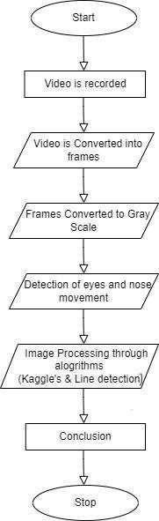

Image processing operations carried out in the system include,
• Video is initially recorded using a web camera.
• Frames are extracted from recorded video.
The frame is converted to a grayscale image and further processed.
• After processing, it takes the face image which is already converted to gray scale image and to detect the edges of the image.
• Processing the values, converting the image to gray scale and detecting the edges of the face is done with the help of line detection algorithm.
• From the edges, it detects the eyes and nose in the frame. As a result we also find the aspect ratio of the eye.
• Finally, eye blinks and nose movements are detected by Kaggle's algorithm.

A. Line Search Algorithm:
The work of this algorithm is to collect the pixel values ​​from the image, convert it to a gray scale image and detect the edges of the face.
Face detection is a key element of the proposed system, and it greatly affects the performance of the system. The OpenCV library searches for the user's face. Here an entire image is converted to a grayscale image and image faces are detected based on the various shadow values ​​within. This process is shown in the figures below.

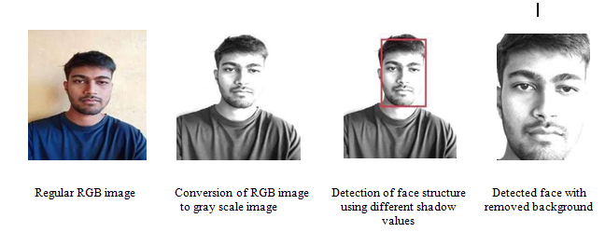
B. Kaggle's dataset and Dlib libraries algorithm:
It accepts the output produced by the line detection algorithm (grayscale image with edges), which is fed to Kaggle's algorithm to detect the nose and eyes. And it is used for forward click, scroll, right, left, up and down movements. This dataset contains about 7198 face images for image processing.

C. Coping with checking landmarks using the Dlib library algorithm:
The system needs more information than just the location of the face to perform operating system commands. Therefore, it is important to find additional components that enable the system to recognize the location of the face and other facial features such as eyes, mouth and nose. The proposed approach estimates the face position using facial landmarks. These details also reveal information regarding their status outside the arm.
The Dlib package, which provides an algorithm for facial landmark detection based on the algorithm presented by Kazemi and Sullivan, 2014, was used to implement this feature. This algorithm uses regression trees to estimate the positions of facial landmarks. This algorithm searches for the 68 facial landmarks proposed by Saonas et al.(2013) where faces have been identified, as shown below.
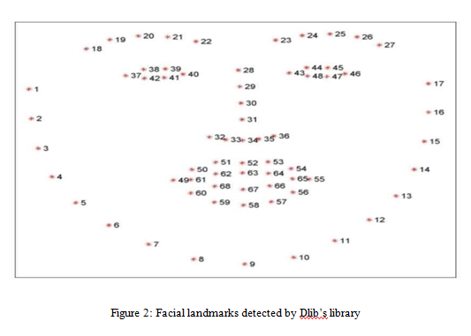

IV. Experimental results
Our project involves recognizing elements of nose and eye movements and projecting them onto a computer cursor, our primary goal is to create a user-friendly human-computer interaction to turn on the webcam and start recording video. The real process begins as soon as the webcam is turned on, where we extract each frame from the recorded video. The frames go through a number of processes, such as converting each frame to a grayscale image and detecting face edges. After processing the frame, facial landmarks are detected from the image and these facial landmarks are used to detect facial features such as nose shape, eye ratio and many other features.

V. Conclusion

We have developed an HCI (Human Computer Interface) that uses machine learning algorithms to interpret eye and nose movements to navigate and perform click operations, a unique and innovative way of interacting with a computer. The main goal of developing this system is to provide a hands-free cursor, which reduces the dependence on a physical mouse. The developed system uses computer vision techniques to track nose and eye movements in real time and then maps these movements to specific commands. To achieve this, we used a combination of facial landmark detection, feature extraction and classification algorithms to accurately identify and interpret eye and nose movements.
This design has the potential to be useful for individuals who have limited mobility or poor motor control in their arms or hands. By using noses and eyes that are less affected by certain disabilities or injuries, this mouse design can provide a new level of accessibility and facilitate interaction. This design can provide a more natural and intuitive interface for interacting with the computer. Additionally, this system has the potential to be adapted and used in other applications such as virtual reality or augmented reality environments.
Our project shows the possibilities of combining technological progress in terms of accessibility, which requires the creation of new and innovative solutions. This mouse design will inspire further research into alternative input methods for computers and other devices. This system will be very useful for physically disabled people to access and operate the mouse.

REFERENCES

[1] May Phu Paing, Aniwat Juhong, and Chuchart Pintavirooj "Design and Development of an Eye-Tracking-Based Assistive System" (2022).
[2] International Research Journal of Engineering and Technology (IRJET) by Pavithra S, Rakshitha K, RamyaV, Vikas Reddy S. (2021).
[3] International Journal of Trend in Scientific Research and Development (IJTSRD) by K. Vijith, P Narendra Babu and D. Suneeth “Implementaion of Eye-Controlled Mouse Cursor for Physically Disabled Individual” (2020).
[4] S. Shriram, B. Nagaraj, J. Jaya, S. Shankar and P. Ajay “Deep Learning-Based Real-Time AI Virtual Mouse System Using Computer Vision to Avoid Spreading COVID-19”, (2021).
[5] Cagdas Esiyok, Ayhan Askin, Aliye Tosun, Sahin Albayrak, "New hands-free interaction techniques based on a software switch approach for computer access using head movements", (2020).
[6] K. H. Shibly, S. KumarDey, M. A. Islam and S. Iftekhar Showrav, “Design and Development of Hand Gesture Based Virtual Mouse”, 2019 1st International Conference on Advances in Science, Engineering and Robotics Technology (ICASERT), Dhaka, Bangladesh , 2019, pp. 1-5, doi:10.1109/ICASERT,2019.8934612.
[7] International Journal of Innovative Technology and Exploring Engineering (IJITEE) by Arathi Boyanapalli and Rohini Patil, "Assistive Technologies Using IoT for Physically Disabled People" (2019).
[8] S. Ram Kumar, K. Sathesh Kumar, T. Dhiliphan Raj Kumar, M. Ilayaraja and K. Shankar “A Review-Classification of Electrooculogram Based Human Computer Interfaces” (2018).
[9] Mohamed Nasor, K. Mujeeb Rahman, Maryam Mohamed Zubair, Haya Ansari, Farida Mohamed “Eye-Controlled Mouse Cursor for Physically Disabled Individuals”, 2018
[10] XuebaiZhang, XiolongLiu, Shyna-MingYuanandShu-FanLin, "An eye-tracking-based control system for natural human-computer interaction" (2017).
[11] Čechand Soukupová, "Eye Blink Detection in Real Time Using Facial Landmarks", Center for Machine Perception, February (2016).
[12] Andréia Sias Rodrigues, Vinicius da Costa, Márcio Bender Machado, Angélica Lacerda Rocha, Joana Marini de Oliveira, Marcelo Bender Machado, Rafael Cunha Cardoso, Cleber Quadros & Tatiana Aires Tavares “Evaluation of the use of eye and head movements for
Mouse-like functionality using IOM devices' (2016).
[13] International Journal of Computer Science and Mobile Computing by Snehal Dongre and Sachin Patil, “Face asa Mouse for Disabled Person” (2015).
[14] International Journal of Engineering Research and Technology (IJERT) by Anandhi. P
and Mrs. V. Gayathri. M.E "New Technology Input Device by Eyes and Nose Expressions using Ensemble Method" (2013).
[15] Frederic Maire, Frank Loewenich "Hands-free mouse and pointer manipulation using motion tracking and speech recognition" (2007).
[16] Margrit Betke, James Gips and Peter Fleming "The Camera Mouse: Visual Tracking of Body Functions to Provide Computing Access for People with Severe Disabilities" (2002).
[17] Book by Wilhelm Burger and Mark J. Burge, "Principles of Digital Image Processing".
[18] Allen B Downey, “Think Python: How to Think Like a Computer Scientist”, 2nd edition (O’Reilly, 2015).
[19] Sommerville "Software-Engineering-9th-Edition-by-Ian".
[20] RichKnightNair "Artificial Intelligence" published by McGrawHillEducationpublications. Rafael C. Gonzalez and Richard E. Woods, "Digital Image Processing", published by Pearson.
[21] https://youtu.be/k3PcVruvZCs
[22] https://youtu.be/e0OCfVuHsgg
[23] https://youtu.be/ot6LWpZjTXo
[24] https://stackoverflow.com/questions/72211167/how-to-label-eyes-detected-using-media

