A comparative study of Working trends and best practices Followed in the kitchens of five-star hotels on good health and well-being for Customer satisfaction & employee Performance post-COVID-19: A Review

Mr. Srajan Kohli

Student, B.Sc Hotel Management, 3rd Year
GalgotiasUniversity
Greater Noida

Prof. (Dr.) Vikas Singh
Professor, School of Hospitality and Tourism
Galgotias University, Greater Noida

Prof. (Dr.) Rajiv Mishra
Dean, School of Hospitality and Tourism
Galgotias University, Greater Noida

Abstract

Purpose:
This study aims to examine the working styles and best practices used in the kitchens of star-rated hotels, as well as how they affect guest pleasure, employee productivity, and general health and well-being, both before and after Covid-19. The comparative analysis will shed light on the adjustments made to the hospitality sector as a result of the epidemic and how it has changed the working conditions in the kitchen. The study will also look at the steps hotels have made, such as implementing new technologies and protocols, to protect the security and well-being of their staff and guests. The results of this study will aid hotel management in making decisions on how to enhance culinary operations and give customers a better experience. Data will be gathered for the project through surveys, interviews, and observations of culinary operations in star-rated hotels across various geographic regions. The study will concentrate on a number of topics, including menu planning, food preparation, sanitary standards, teamwork, communication, and training and development. The study will also look at how technology, like automation and digitization, affects kitchen operations and worker productivity. The research results will be examined statistically and provided in a thorough report with suggestions for enhancing culinary operations in star-rated hotels. This research aims to further knowledge of best practices and emerging trends in kitchen operations and how they affect client happiness, employee performance, and general health and well-being.

KEYWORDS – Health, well-being, COVID-19 pandemic; customer satisfaction, employees’ satisfaction, Best practices

Introduction

The COVID-19 epidemic has had a significant negative effect on the hospitality sector, especially the hotel industry. The industry has seen a large decline in revenue and jobs as a result of hotels and restaurants closing. Hotels are reopening with new safety rules and health safeguards to ensure the well-being of their customers and employees, nevertheless, as the world begins to slowly recover from the pandemic. The kitchen, where food Is made and provided to guests, is one of the most important parts of a hotel. The kitchen crew is crucial in ensuring that the cuisine is wholesome, safe, and up to par with guests’ expectations. Understanding the working styles and recommended procedures used in the kitchens of star-rated hotels. The kitchen is a busy space that calls for collaboration, coordination, and teamwork. Food is made hygienically, quickly, and precisely when the kitchen is well-run. Prior to COVID-19, there was a major emphasis on local sourcing, sustainability, and healthier cuisine. In order to adapt to shifting consumer expectations, hotels concentrated on decreasing food waste, employing organic ingredients, and providing vegan and vegetarian options. After COVID-19, however, the focus has switched to safety and cleanliness. The use of masks and gloves when handling food, frequent hand washing, sanitizing of surfaces and utensils, and maintaining social distancing are just a few of the tight regulations hotels are putting in place to make sure their kitchen staff adheres to basic hygiene standards. More technology has been used to minimize physical contact, including touchless faucets, automated temperature sensors, and contactless payment methods. The evolution of best practices and working patterns has had a big impact on customer satisfaction. Nowadays, customers are more worried about the cleanliness and safety of the food they eat. According to a poll by Oracle Hospitality, 40% of visitors desire contactless payment options, while 80% of guests want hotels to enforce high sanitary standards. Customers’ pleasure and loyalty have increased at hotels that have used these methods. Changes in working patterns and best practices have also had an impact on employee performance. Strict sanitary regulations must now be followed by the culinary staff, which can be time-consuming and difficult. Employee morale and productivity have increased for hotels that have made the investment in training their workers on these practices. The introduction of technology has also eased the workload for the kitchen crew, lowering physical labour requirements and boosting productivity. In conclusion, customer happiness and employee performance are significantly impacted by the working trends and best practices used in the kitchens of star category hotels.

Objective

1. To compare the working trends and best practices followed in the kitchens of five-star hotel post covid-19.
2. To examine the impact of these working trends and best practices on the health and well-being of customers.
3. To assess the impact of these working trends and best practices on employee performance.
4. To determine the level of customer satisfaction with the quality of food and service provided by five-star hotels.

Literature Review:

(Berchoux, et al ,2015) states that to ascertain whether luxury hotel management and patrons have the same views on the value and satisfaction of customer service and whether there is a disconnect between the services provided by these establishments and how patrons actually perceive them.

Shattered But Smiling: Human Resource Management And The Wellbeing Of Hotel Employees During COVID-19.(International Journal Of Hospitality Management 93, 102765, 2021). This paper’s goals are To Investigate The Human management Strategies Used during the pandemic and Use Qualitative Thematic Analysis To Assess How COVID-19 Affected The Happiness Of Hotel Staff Members.

The authors of the study "Understanding the psycho-environmental potential functions of a green building to promote employee health, well-being and productivity: A theoretical perspective" suggest that previous research on the effects of environmentally friendly office buildings on worker health, happiness, and productivity has produced inconsistent results are being to explain these discrepancies.

"The Impact of transformational leadership on the job satisfaction of internal employees and outsourced workers" published in Business& service management in 2020, the study examines transformational how affects the job satisfaction of both internal employees and outsourced workers. This study’s main goal is to examine the connection between job happiness and leadership, as well as any distinctions between internal and external workforces.

The impact of risk factors for the occupational good health of employee satisfaction in the hotel industry.( Murat SelimSelvi, Gonca Kilic.2009, Ege Academic Review, 9 (3), 903-921)

In the service industry and other industries, risk factors for health and safety may have a direct or indirect impact on employees’ levels of organisational commitment, and productivity. This study examined how risk factors for safety and health that are prevalent in the hotel industry’s physical, biological, chemical, and sociopsychological aspects affected job satisfaction.

Aesthetic evaluations of workplace well-being and design made by hotel staff. (KseniaKirillova, Xiaoxiao Fu, and DenizKucukusta. 2020) This quantitative study examined the connections between workplace design aesthetics, hotel employees' subjective well-being, and the role of contrast between back-of-the-house and front-of-the-house environments using conceptual insights from organisational aesthetics and the theory of subjective well-being.

The role of kitchen design effectiveness in improving hotel employees’ performance: the case of Minia city’’(Ali, 2016 )

The layout and design of a kitchen should make it possible for the personnel to work comfortably, promptly, and safely. The primary goal of this research is to evaluate the layout and design of hotel kitchens in Minia. Second, determine the function of well-designed kitchens and coordinated kitchens in lowering hazards and enhancing worker performance

( Melanie Smith and László Puczkó's) book "Health, Tourism and Hospitality: (Spas, Wellness and Medical Travel" published by Routledge in 2014 ) offers a comprehensive and detailed analysis of the growing global industries of health and medical tourism in its second edition.

A phenomenological examination of the ideas, types, and causes of food production failure: Chefs’ perspectives of failures in foodservice kitchens, ( JJ Healy, Máirtn Mac Con Iomaire, and Mohamed Fawzi Afifi )

In the Foodservice Business Research, volume 24, the objective of this paper is to explore the varieties, and reasons for food production failure (FPF) in restaurant kitchens, as perceived by chefs. A qualitative approach utilizing a phenomenological epistemology was adopted to investigate FPF. A literature conducted, followed by purposeful sampling and an emic stance to conduct semi-structured interviews with 15 experienced chefs from hotels and restaurants until data saturation was achieved. The interview transcripts were thoroughly analyzed using the QDA Miner Lite qualitative analysis software, and interrater reliability was evaluated.

In the Health Promotion Practice journal article published in 2015 by Nour Fakhoury, Mary L. Marzec, Karen S. Harlow-Rosentraub, and Kristi Rahrig Jenkins) the objective is to demonstrate the potential value of open to ended survey data that reflects the perceptions of professors and staff towards a better tailor communicate and programs. Such data can be useful for supporting the creation, perpetuation, and preservation of a CoH within an organization. The study involved distributing an online anonymous survey to 10,000 employees, and the grounded theory approach was employed to analyze the open-ended responses obtained from the survey.

Methodology:

Primary Data Collection: The following sources were used to gather primary data:
a well-designed questionnaire was created and distributed to hotel HR managers.
In Delhi,a well-designed questionnaire was created and distributed to those working in the kitchens of five-star hotels.
Interviews and conversations with hotel staff members and managers of five-star hotels were carried out to comprehend the causes and effects of personnel turnover in the kitchen.
Secondary Data Collection: Research papers and articles on the same issue were used to gather secondary data. Additionally, data on employee turnover was acquired from a variety of journals, newsletters, and articles. Primary Data Collection: The following sources were used to gather primary data.

VI.Results

The hospitality business has undergone a tremendous transformation as a result of the COVID-19 epidemic, especially in the food and beverage industry. In order to promote optimal health and well-being for customer satisfaction and employee performance post-COVID-19, this study intends to investigate and compare the working trends and best practices used in the kitchens of five-star hotels. Interviews and surveys with chefs, kitchen workers, and management staff from five-star hotels in various locations will be used in the research's qualitative methodology. The study will concentrate on identifying the steps taken by these hotels to uphold safety and sanitary standards, encourage wholesome eating, and improve employee well-being. The results of this study will offer insightful information about the state of the food business today following COVID-19 and assist in identifying

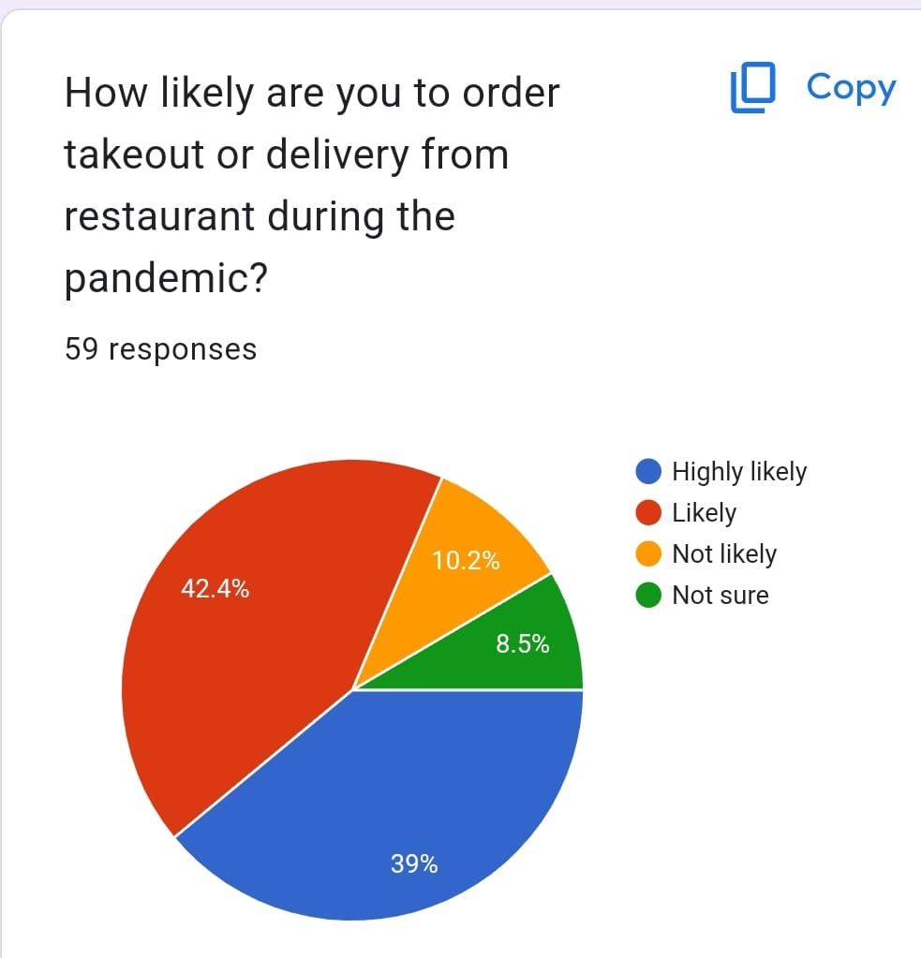

Graphic patients that the order-taking or delivery process which is being done by the five-star restaurant during the pandemic is a good practice for the customers 42% of people have been like the service provided by the restaurant.

The graphical representation indicates that the portion size of the food which is being served in the restaurant is noticed by the people who visit the restaurants since the pandemic and 50% of people say yes about the portion size of their food in 5-star hotel restaurants.

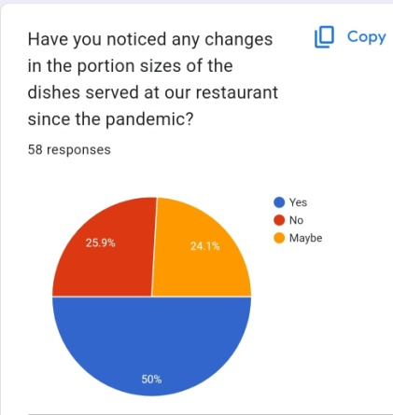

. VII. Ethical Consideration

Ethical factors were taken into account in this comprehensive literature evaluation to guarantee responsible and ethical study conduct. We considered the following ethical concepts in particular:
Informed consent: We did not get informed permission from any participants since this study entailed a review of published literature.

Confidentiality and anonymity

We did not acquire any personal data from the selected studies, and we guaranteed the authors’ and participants’ confidentiality and anonymity by not releasing their names or other identifying information in this work.

Conflict of interest

We reported any potential conflicts of interest that may have impacted the selection and interpretation of the literature in this evaluation.

Suggestions and recommendations

Many comments and recommendations for future studies on the influence of green technology adoption on employee satisfaction and retention in the hospitality sector can be made based on the findings of this systematic literature review. These include:

Conducting longitudinal studies

The majority of previous research on the influence of green technology adoption on employee happiness and retention in the hospitality sector has been cross-sectional or has been based on a short-term examination. Longitudinal studies examining the long-term consequences of green technology adoption on employee outcomes should be the focus of future studies.

Addressing the general ability of the findings

The bulk of the research in this study concentrated on certain technologies or components of the hospitality business, such as hotels or restaurants. Future studies should seek to give a more thorough examination of the impact of green technology adoption throughout the whole industry, as well as to address the findings’ generalizability.

Examining the role of organizational culture

The literature emphasizes the significance of corporate culture in the adoption and deployment of green technologies in the hotel sector. Future studies should investigate the effect of corporate culture in determining employee attitudes and actions regarding the adoption of green technologies.

Incorporating a multi-stakeholder perspective

Employees, management, customers, and local communities are all involved in the adoption and implementation of green technology in the hotel business. Future studies should use a multi-stakeholder approach and investigate the effects of green technology adoption on all relevant stakeholders.

Limitations

1. Limited sample size: The study will only focus on five-star hotels, which may not be representative of the entire hospitality industry.

2. Limited generalizability: The findings of this study may not be applicable to smaller hotels and restaurants that do not have the same resources and capabilities as five-star hotels.

3. Self-report bias: The data collected through interviews and surveys may be subject to self-report bias, where participants may provide socially desirable responses rather than their actual practices.

4. Lack of control group: The study will not have a control group to compare the practices and outcomes of the five-star hotels to those of other types of hotels or restaurants.

5. Difficulty in measuring health and well-being: Measuring the impact of working trends and best practices on health and well-being may be difficult, as these concepts are subjective and can vary from person to person.
.

Conclusion
The food service business has undergone a major transformation as a result of the COVID-19 pandemic, particularly in the kitchens of hotels with star ratings. In order to ensure customer happiness and employee performance, hotel kitchens have had to adapt to new working trends and best practices with the installation of safety measures including social distancing, sanitization standards, and contactless delivery. This study compares the working styles and best practices used in the kitchens of star-rated hotels to examine how they affect employee morale, customer happiness, and kitchen operations before and after COVID-19. The study will look at how COVID-19 has impacted working trends and best practices in hotel kitchens as well as how it has affected the food service industry as a whole.

The food service sector was already undergoing changes In consumer preferences and expectations prior to COVID-19, with a greater emphasis on health and well-being. The pandemic, however, has hastened these shifts, with patrons now giving safety and cleanliness priority while dining out. As a result, additional safety precautions, including the use of PPE, frequent sanitization, and contactless delivery, have been implemented in hotel kitchens. The study will also look at how these safety precautions affect staff and customer performance. Customer satisfaction is a crucial component of any food service company’s performance, so it’s crucial to comprehend how these safety precautions have changed how guests view hotel kitchens. The performance of employees is important since it has a big impact on the standard of the hotel’s meals and services. After COVID-19, it’s anticipated that the food service sector would undergo significant changes that endure a long time, with a sustained emphasis on safety and hygiene. This study will offer information on how hotel kitchens can adjust to these changes and put best practices into place to ensure client happiness and staff productivity.

A mixed-methods approach will be used for the study, mixing quantitative surveys and qualitative interviews. While the interviews will offer information on working patterns and best practices in hotel kitchens, the surveys will be used to collect information on employee performance and customer happiness. To sum up, the COVID-19 epidemic has significantly altered the food service sector, especially in the kitchens of star-rated hotels. To ensure customer pleasure and employee performance, hotel kitchens had to adjust to new working trends and best practices as a result of the installation of safety measures. The purpose of this study is to compare the working styles and best practices used in the kitchens of star-rated hotels with regard to customer satisfaction, employee performance, and overall health and well-being. Insights from the study’s findings will help hotel kitchens adjust to new working trends and best practices to maintain client happiness and staff productivity in the post-COVID-19 environment.

References:

Agarwal, P. (2021). Shattered but smiling: Human resource management and the wellbeing of hotel employees during COVID-19. International Journal of Hospitality Management, 93, 102765.

Ali, A. (2016). ’The role of kitchen design effectiveness in improving hotel employees’ performance: case of Minia city’’. Journal of Faculty of Tourism and Hotels, 253-269.

Escortell, R., Baquero, A., & Delgado, B. (2020). The impact of transformational leadership on the job satisfaction of internal employees and outsourced workers. Cogent Business & Management, 7(1), 1837460.

Jenkins, K. R., Fakhoury, N., Marzec, M. L., & Harlow-Rosentraub, K. S. (2015). Perceptions of a culture of health: implications for communications and programming. Health promotion practice, 16(6), 796-804.

Kilic, G., &Selvi, M. S. (2009). The effects of occupational health and safety risk factors on job satisfaction in hotel enterprises. Ege Academic Review, 9(3), 903-921.

Kirillova, K., Fu, X., &Kucukusta, D. (2020). Workplace design and well-being: Aesthetic perceptions of hotel employees. The Service Industries Journal, 40(1-2), 27-49.

Lu, C., Berchoux, C., Marek, M. W., & Chen, B. (2015). Service quality and customer satisfaction: qualitative research implications for luxury hotels. International Journal of Culture, Tourism and Hospitality Research, 9(2), 168-182.

Mac Con Iomaire, M., Afifi, M. F., & Healy, J. J. (2021). Chefs’ perspectives of failures in foodservice kitchens, part 1: A phenomenological exploration of the concepts, types, and causes of food production failure. Journal of Foodservice Business Research, 24(2), 177-214.

Smith, M., &Puczkó, L. (2014). Health, tourism and hospitality: Spas, wellness and medical travel. Routledge.

Zitars, J., Spadafore, B., Coulombe, S., Riemer, M., Dreyer, B. C., & Whitney, S. (2021). Understanding the psycho-environmental potential functions of a green building to promote employee health, wellbeing and productivity: A theoretical perspective. Building and Environment, 205, 108268

