\***Molecular Docking: A Highly efficient Method for Structure-Based Drug Designing**\*

**Malhari Nagtilakab\***

aDepartment of Chemistry and Research Centre, S. M. Joshi College,

Hadapsar, Pune, Maharashtra 411028, India.

bDepartment of Chemistry, DBNP Arts, SSGG Commerce, and SSAM Science College,

Lonavala, Maharashtra 410403, India.

malhari.nagtilak22@gmail.com

**ABSTRACT**

With the introduction of innovative approaches in drug discovery, numerous techniques to structure-driven drug development have been employed. Molecular docking is one of the most crucial methods. Today, molecular docking is turning into a crucial tool for drug discovery and molecular modeling purposes. Molecular docking is a type of computational modeling of complexes that are generated by the intermolecular interaction of two or more molecules, such as lipids, nucleic acids, proteins, and ligands. By optimizing the geometry and relative location of the ligand and protein, molecular docking aims to truncate the free energy of the whole framework. Based on the binding characteristics of the involved ligands and molecule of interest, it guesses the three-dimensional geometry of adducts. Molecular docking provides many alternative candidate structures, which are scored and clustered together employing the scoring function in the molecular docking program software. Docking simulations figure out the optimal conformer based on the overall energy of the system. Molecular docking research is important for predicting possible disease targets and generating successful medications for the pharmaceutical sector.

In this section, we provide an in-depth description of various computational features associated with molecular docking, such as fundamental docking steps, docking types and interactions, software programs and their algorithms, scoring functions, and the available molecular docking methods, as well as their development and utilization in drug discovery. The mechanism of binding and compatibility of the complex generated are assessed via Molecular Docking, which avails in the molecular detection process docking towards the invention of innovative leads for medicines.

**Keywords**— Molecular Docking, Receptor, Ligand, AutoDock Vina, PDB

# INTRODUCTION

Computational chemistry is the utilization of computer calculations to tackle chemical problems. It employs theoretical chemistry methods, which are integrated in sophisticated computer programs for determining the structure and characteristics of molecules. Computational techniques are indispensable in the drug revelation process, categorically in taking use of the growing number of solved NMR and X-ray protein ligand structures [1].

Several experimental as well as high throughput screening approaches have been employed in medication revelation throughout the last few decades. Traditional ways of discovering innovative therapeutic medications were prohibitively costly, time-consuming, and inefficient. To address the limitations of old approaches, new effective and reasonable methods based on virtual screening have been devised. The virtual screening approach may be divided into ligand-based and structure-based drug developing strategies based on the accessibility of structural data. The structure-based drug synthesis technique focuses on molecular docking, whereas ligand-based approaches emphasize on quantitative structure-activity correlations and pharmacophore models.

1. **Theoretical foundations of molecular docking (MD)**

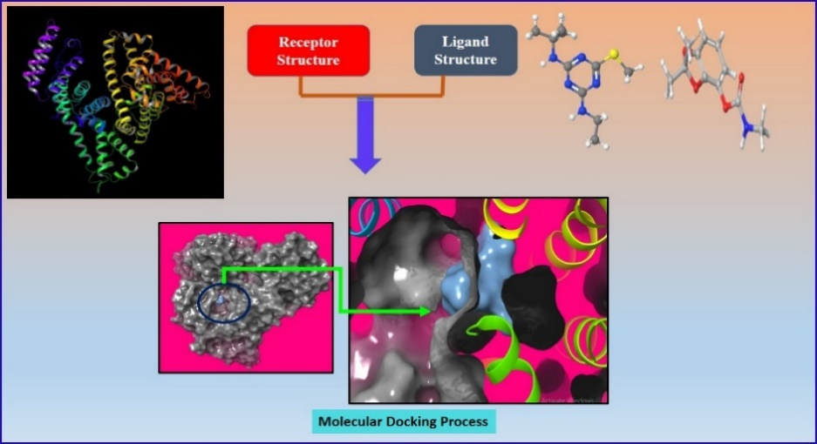

**Fig.1 Molecular docking flow chart.**

Since the molecular docking (MD) approach has been widely employed in recent years, it has substantially improved efficiency and reduced research costs. It has evolved into an important tool in computer-assisted drug design [2]. MD is a kind of computational model that makes simpler to determine the preferred binding relation of a particular molecule (such as a ligand) to another one (such as a receptor) when the two connect to form a stable complex and aids in the selection of potent compounds as part of virtual screening of massive databases. It is possible to forecast a complex's energy profile using knowledge of the preferred orientation of the bound compounds. This information includes the binding free energy, force, and stability (such as the binding capacity and binding constant). This is possible using the MD scoring function. It is critical to detect the optimum ligand poses and properly rate the relative docking propensity of multiple ligands [3,4].

It has been routinely and effectively utilized in pharmaceutical and medical research for the design, manufacturing, and discovery of therapeutically significant medicines and dyes. MD is used to investigate protein-ligand interactions and validate experimental interpretations in silico (Fig.1). MD is a promising approach that uses experimental information to theoretically anticipate the ideal position of a tiny compound (ligand) in a macromolecule (target) such as DNA and protein to generate a stable complex; the interaction of ligand receptor demonstrates that the receptor and ligand have particular complimentary geometric forms that merge perfectly into each other. Prior to wet-lab investigations, MD studies might be performed to anticipate how a ligand would interact with a macromolecule. It can assist to confirm the outcomes of wet-lab investigations and to better understand the process of binding [5].

Automated software is used to do MD studies, which aids in predicting the mechanism of binding, the effectiveness of binding, and the creation of an energetically advantageous conformation between a macromolecule and ligand. Additionally, it offers insightful information on how various ligands interact, including those that are therapeutically active [6].

# Primary stages associated in the MD mechanism

MD is an in-silico approach for investigating how two molecules interact with one another. The macromolecule involved in this particular process is either the enzyme, protein or DNA receptor. The Ligand compound is a tiny compound that has the ability to function as an inhibitor. Consequently, the docking technique encompasses distinct steps, which are illustrated in Figure 2.

1. **Stage I –Macromolecule preparation (Protein/DNA):**

A 3D Protein data bank (PDB) structure of a macromolecule ought to be downloaded from the RCSB protein directory or another repository, and then pre-processed. Based on the specified settings, this approach is expected to facilitate the removal of water molecules from the cavity, the maintenance of charges, the completion of deficient residues, the generation of side chains, and other related processes.

1. **Stage II – Active site Identification:**

The active site of the macromolecule (Protein/DNA) should be anticipated once it has been prepared. A receptor might possess multiple active locations; however, only the relevant one should be selected. In the majority of cases, molecules of water and hetero atoms are eliminated [7].

1. **Stage III –Ligand preparation:**

A variety of databases, including ZINC, Pub Chem, and ChemSpider, may be used to access ligands. They may additionally be sketched with the Chem sketch tool.

1. **Stage IV- Docking Process:**

Analysis of the interactions occurs when the ligand is docked against the protein. The best-chosen bound ligand complex is used by the scoring algorithm to determine a score.

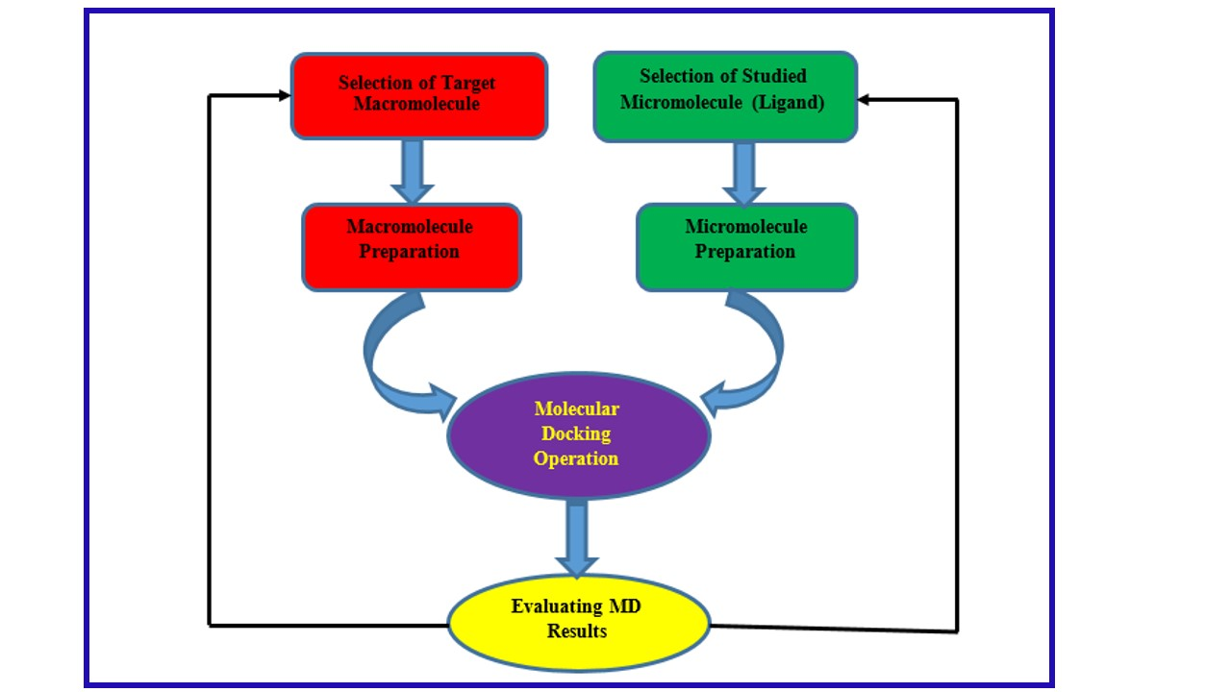

**Fig. 2. A flow plan for analyzing docking**

1. **Molecular docking software classification / Types of molecular docking**

There are three forms of molecular docking, as seen in Fig.3.



**Fig.3 Categorization of Molecular Docking Software [2]**

1. **Rigid Docking/ Lock and Key:**

According to Lock and key hypothesis, both the ligand and the receptor are stiff and exhibit tight binding. It establishes the fundamental idea of three-dimensional complementarity. It only calculates six transitional degrees of freedom and rotational freedom. ZDOCK [8] and RDOCK [9] is an outstanding example of a stiff docking approach that employs superimposing the ligand at the appropriate binding groove.

1. **Flexible-rigid docking/Semi-flexible Docking:**

In the semi-flexible technique, one of the molecules (the ligand) is regarded flexible, while the target is deemed stiff. Only one of two molecules (usually the ligand) is exposed to the theoretical process, while the protein is rigid. Docking procedures are used to stabilize the protein conformation that may correlate with the ligands to be docked. Flexible-rigid docking is commonly utilized. Flex X [10], AutoDock [11], and AutoDock Vina [12] are outstanding examples of flexible-rigid docking methods.

1. **Flexible Docking/ Induced fit Docking:**

Receptor and ligand both have some flexibility. To increase the bonding forces between the ligand and receptor, it binds flexibly at their active site. It carries forth the idea of complementarity between ligands and proteins or DNA.

Flexible docking computational approaches are commonly used to investigate the intermolecular interaction of superposition between a flexible macromolecule (receptor) and a tiny molecule (ligand). To optimize bonding forces between both, the ligand connects flexibly at the active place of the receptor. It enacts the idea of protein-ligand complementarity. Docking software such as Gold [13], and Glide [14], is commonly utilized in the automated process between a flexible ligand and an ensemble of flexible receptor conformations generated using experimental or particular computational techniques. Fischer [15] presented a locking-and-key explanation for the ligand-receptor interaction mechanism, wherein the ligand inserts into the surface of the receptor like a lock and key. The earliest known docking operations centered on this notion, and as a result, both the receptor and the ligand were perceived as immovable entities [16]. The "induced-fit" hypothesis [17] put forth by Koshland expands the lock-and-key model by proposing that interactions with ligands continually modify the "active" portion of the protein as the ligands connect with the target protein. This theory recommends that the receptor and the ligand be seen as adaptable during docking. As a consequence, it may be capable of representing binding instances more accurately than the stiff treatment.

The most prevalent docking algorithms utilize GA (genetic algorithm), LGA (Lamarckian genetic algorithm), and the flexible-ligand/rigid-receptor model to visualize the interaction between ligands and proteins/DNAs [2]. BSP SLIM online, AutoDock vina, AutoDock 4.2, and more tools are freely accessible to do docking between target protein and ligand. AutoDock is the most often used docking software.

1. **Methods of MD**

Based on the prediction of probable targets, MD may be separated into two methods: general docking and reverse docking.

1. **Reverse Docking Method**:

A tiny ligand of interest is inserted into the binding region of several protein/DNA (many receptors) structures, which may be downloaded from the protein database to obtain a suitable protein, in the reverse docking approach. Thus, prospective ligand/drug targets can be anticipated.

1. **General Docking methods:**

To get an appropriate ligand, a protein/DNA (receptor) of interest is docked into several tiny ligand structures retrieved from the chemical library. Figure 1 depicts a comparison of these two paradigms.

1. **MD Databases**

One of the most popular resources for studying protein structures is the Protein Data Bank (PDB). Moreover, publicly accessible databases including PubChem Compound Database and ZINC are available without cost [2].

# Various Forms of Interactions

Interaction forces are divided into four distinct groups:

(1) Van der Waals interaction - forces of electrodynamics.

(2) Steric forces - As an outcome of entropy.

(3) Forces of electrostatic attraction - charge-charge, dipole-dipole, and charge-dipole

(4) Solvent-cognate forces - Hydrophobic Interactions and Hydrogen bond [4].

# Scoring Function

The function of scoring offers an option to prioritize the positioning of ligands relative to each other. The ranking is intended to accurately reflect the ligand's binding capacity for the DNA/protein, ensuring that the ligands with the highest scores also exhibit the strongest binding capabilities. Score functions can be categorized as either tangible, knowledge-driven, or centered on molecular mechanics. The process of scoring encompasses three distinct interpretations that are pertinent to the fields of docking and ligand development. [4].

A docking analysis is carried out on the most energetically beneficial conformer, that is, the path with the lowest energy of binding. This technique permits flexibility inside the ligand to be docked as well as the incorporation of advanced molecular mechanics techniques to compute the ligand's energy in the context of the of the ostensibly active region. After docking, a 2D plot may be created, which can offer a graphical depiction of the various forces and amino acids molecules participate in the mechanism of binding by utilizing software such as LigPlot, Discovery Studio, and so on. It also includes details on the amino acid residues and forces associated in the binding process [18].

The collected data, alone or in combination with molecular modeling tools, might be used to investigate the toxicity of manufactured drugs and aid in the clarification of the molecular processes of in vivo toxicity.

# Advantages of MD Techniques

MD approach offers numerous benefits over other drug discovery strategies such as High-Throughput Screening (HTS).

1. It is significantly quicker and less expensive for assessing binding capability of ligands from a vast chemical repository.
2. This shortens the analysing time required for examining the intricacy of ligand-protein interactions.
3. Accurate scoring functions with little computational cost
4. Computational techniques (In Silico methods) should be fast and resilient.

# Applications of molecular docking

MD research is particularly important in an extensive variety of applications in computer-aided drug development. It is essential in modern research. If performed before to the testing portion of an investigation, it may demonstrate the practicability of any operation. There are various domains where MD has transformed research. Interaction studies between tiny molecules (ligands) and target proteins (which may be enzymes) in particular can predict enzyme activation or inhibition. Such information could potentially be utilized as a commencement point for reasonable design of pharmaceuticals. In computational chemistry research, MD is an essential technique. The importance of MD is well acknowledged and established in the pharmaceutical industry. Docking is mostly utilized in drugs design. The majority of medicines are tiny organic compounds, and docking may be used on them:

1. Hit Recognition (Virtual Screening)
2. Lead Optimization (Drug Development)
3. Bioremediation
4. Blind docking, which predicts the binding location
5. Protein de-orphanization
6. Interactions between nucleic acids and proteins
7. Seeking out prominent compounds for proteins of interest
8. Mechanisms of reactions involving enzymes
9. Protein engineering
10. Bioremediation: Ligand Protein docking may additionally be employed to presage contaminants that enzymes can breakdown.
11. Research on Drug-DNA Interactions: Identification of drug binding characteristics to nucleic acid.
12. By creating and discovering innovative medications, this technique may be utilized to treat a wide range of chronic conditions.
13. This approach was used to anticipate effective therapeutic compounds that would limit the proliferation of cancer stem cells. It might demonstrate the viability of any role or feature of the investigated substances before they are employed in the experimental phase of any inquiry. The accuracy forecast of molecular docking yields great results, especially when analyzing the interaction between ligand and a macromolecule, which delivers a wealth of knowledge about its vital function (activation or inhibition). Obtaining this sort of details prior to doing any experimental investigation may assist researchers in designing novel medications with different properties.
14. Its involvement in intriguing new approaches such as computation enzymology, genome research, and proteomic search engines continues to grow [4,19].

# Conclusions

Simple molecular visualization along with straightforward accessibility to structural resources have grown to be indispensable elements of the pharmacological chemist's workspace. MD shares an abundance of utilizable methods for drug engenderment and research. In particular, for protein-ligand docking, induced-fit movements and protein flexibility will be used in the next years to find and create novel chemotherapeutic drugs. Computational docking simulations are now widely used at various phases of drug development and rational drug design processes. As the area of virtual examining founded on molecular interaction grows, its visibility will increase tremendously. Multiple software programs that analyze ligand binding abilities against various receptors are being released. Despite this, more advancements are required to incorporate thermodynamic characteristics including as desolvation energies, actual time energy fluctuations owing to conformational alterations in both the ligand and receptor, i.e. dynamic simulations. The application of MD methods may be utilized to cure a number of chronic diseases through synthesizing, designing, optimizing, discovering, and developing new therapeutic medicines, as well as studying the molecular interactions of various enzyme activities. Accurate and low-cost scoring functions may propel docking applications to new heights. In conclusion, we expect that MD will become a trustworthy drug-design tool by refining the scoring system and updating the relevant search algorithms.

# References

[1] K.M. Elokely, R.J. Doerksen, Docking Challenge: Protein Sampling and Molecular Docking Performance, J. Chem. Inf. Model. 53 (2013) 1934–1945. https://doi.org/10.1021/ci400040d.

[2] J. Fan, A. Fu, L. Zhang, Progress in molecular docking, Quant. Biol. 7 (2019) 83–89. https://doi.org/10.1007/s40484-019-0172-y.

[3] S. Agarwal, R. Mehrotra, An overview of molecular docking, JSM Chem. 4 (2016) 1024–1028.

[4] K.K. Chaudhary, N. Mishra, A review on molecular docking: novel tool for drug discovery, Databases. 3 (2016) 1029.

[5] S. Afrin, Y. Rahman, T. Sarwar, M.A. Husain, A. Ali, Shamsuzzaman, M. Tabish, Molecular spectroscopic and thermodynamic studies on the interaction of anti-platelet drug ticlopidine with calf thymus DNA, Spectrochim. Acta Part A Mol. Biomol. Spectrosc. 186 (2017) 66–75. https://doi.org/https://doi.org/10.1016/j.saa.2017.05.073.

[6] L.G. Ferreira, R.N. Dos Santos, G. Oliva, A.D. Andricopulo, Molecular Docking and Structure-Based Drug Design Strategies, Molecules. 20 (2015) 13384–13421. https://doi.org/10.3390/molecules200713384.

[7] O.K. Vasant, M.A. Chandrakant, K.V. Chandrashekhar, G.V. Babasaheb, K.M. Dnyandev, A review on molecular docking, Int. Res. J. Pure Appl. Chem. 22 (2021) 60–68.

[8] R. Chen, L. Li, Z. Weng, ZDOCK: An initial-stage protein-docking algorithm, Proteins Struct. Funct. Bioinforma. 52 (2003) 80–87. https://doi.org/https://doi.org/10.1002/prot.10389.

[9] L. Li, R. Chen, Z. Weng, RDOCK: Refinement of rigid-body protein docking predictions, Proteins Struct. Funct. Bioinforma. 53 (2003) 693–707. https://doi.org/https://doi.org/10.1002/prot.10460.

[10] B. Kramer, M. Rarey, T. Lengauer, Evaluation of the FLEXX incremental construction algorithm for protein–ligand docking, Proteins Struct. Funct. Bioinforma. 37 (1999) 228–241. https://doi.org/https://doi.org/10.1002/(SICI)1097-0134(19991101)37:2<228::AID-PROT8>3.0.CO;2-8.

[11] G.M. Morris, R. Huey, W. Lindstrom, M.F. Sanner, R.K. Belew, D.S. Goodsell, A.J. Olson, AutoDock4 and AutoDockTools4: Automated docking with selective receptor flexibility., J. Comput. Chem. 30 (2009) 2785–2791. https://doi.org/10.1002/jcc.21256.

[12] O. Trott, A.J. Olson, AutoDock Vina: Improving the speed and accuracy of docking with a new scoring function, efficient optimization, and multithreading, J. Comput. Chem. 31 (2010) 455–461. https://doi.org/https://doi.org/10.1002/jcc.21334.

[13] M.L. Verdonk, J.C. Cole, M.J. Hartshorn, C.W. Murray, R.D. Taylor, Improved protein–ligand docking using GOLD, Proteins Struct. Funct. Bioinforma. 52 (2003) 609–623. https://doi.org/https://doi.org/10.1002/prot.10465.

[14] T.A. Halgren, R.B. Murphy, R.A. Friesner, H.S. Beard, L.L. Frye, W.T. Pollard, J.L. Banks, Glide:  A New Approach for Rapid, Accurate Docking and Scoring. 2. Enrichment Factors in Database Screening, J. Med. Chem. 47 (2004) 1750–1759. https://doi.org/10.1021/jm030644s.

[15] E. Fischer, Einfluss der Configuration auf die Wirkung der Enzyme, Berichte Der Dtsch. Chem. Gesellschaft. 27 (1894) 2985–2993.

[16] X.-Y. Meng, H.-X. Zhang, M. Mezei, M. Cui, Molecular docking: a powerful approach for structure-based drug discovery, Curr. Comput. Aided. Drug Des. 7 (2011) 146–157.

[17] D.E. Koshland Jr, Correlation of Structure and Function in Enzyme Action: Theoretical and experimental tools are leading to correlations between enzyme structure and function., Science (80-. ). 142 (1963) 1533–1541.

[18] S. Siddiqui, F. Ameen, S. ur Rehman, T. Sarwar, M. Tabish, Studying the interaction of drug/ligand with serum albumin, J. Mol. Liq. 336 (2021) 116200. https://doi.org/https://doi.org/10.1016/j.molliq.2021.116200.

[19] A. Tripathi, K. Misra, Molecular docking: A structure-based drug designing approach, JSM Chem. 5 (2017) 1042–1047.