Advances in Drug Development Process using AI

Dr. Seema Kohli  HOD, Pharmacy  K.N.Polytechnic College,  Jabalpur, (M.P.), India  seemankohli@gmail.com | Dr. Ankita Alice Singh  Faculty, Pharmacy  K.N.Polytechnic College,  Jabalpur, (M.P.), India  Dr. Kaminee Sahu  Professor, Pharmacy  Gyan Ganaga Instt. Of Science and Technology  Jabalpur, (M.P.), India  Dr. B.K.Jain  Faculty, Pharmacy  K.N.Polytechnic College,  Jabalpur, (M.P.), India

Abstract
Drug discovery and development is essentially concerned with newfangled chemical moiety with biological activity. It works on enhancing the properties of drugs used in the treatment of different medical conditions. The development and launching of a new drug is a highly time consuming, tedious and expensive process. In order to speed up research and estimate the risk and cost of clinical trials, Artificial Intelligence(AI) learning tools and techniques are used throughout all stages of drug development. Through diverse applications like QSAR analysis, hit discoveries, and de novo drug designs, AI approaches enhance decision-making in the pharmaceutical industry to retrieve correct results. This chapter focuses on the various aspects of drug discovery using traditional approaches and the artificial intelligence based digital techniques.
Key words : Artificial Intelligence , Drug Discovery , Machine Learning, Drug Target, Drug Lead
I. Introduction
Drug discovery and development are exciting important new drug segments. He is working on improving the properties of drugs used in the treatment of different diseases. The development and launch of new drugs is a time-consuming, tedious and expensive process.A powerful and effective way to create drug videos, drug discovery is an important task for scientists. In fact, experts complete this task by converting screen clicks into suitable drug candidates. The process of introducing a new drug to the market is quite long and requires approximately 10-15 years of research. Therefore, new methods should be developed not only to speed up the process, but also to ensure the safety of the drug and more effective drugs [1].

II. Conventional Approach to Drug discovery
Classically, the drug discovery involves under mentioned defined stages:
- Identification of cause of Disease and Search for target site
- Search and Optimisation of active compound i.e. the Drug Lead
- Testing of Drug in Animals (pre-clinical phase) .
- Clinical Trials
- Approval of New Drug by Competent authority and availability in market.
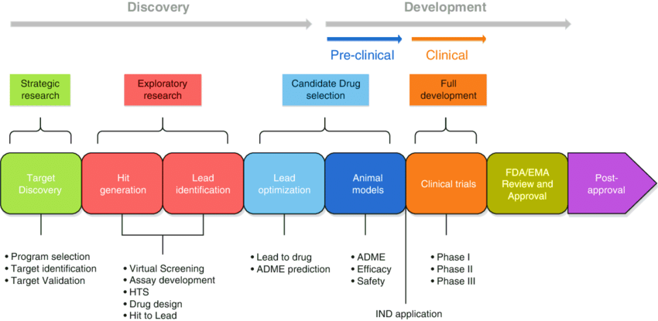
Figure 1: Drug Discovery Process

A. Step I
Typically, researchers discover new drugs through:
- New insights into a disease process that allow researchers to design a product to stop or reverse the effects of the disease.
- Many tests of molecular compounds to find possible beneficial effects against any of a large number of diseases.
- Existing treatments that have unanticipated effects.
- New technologies, such as those that provide new ways to target medical products to specific sites within the body or to manipulate genetic material.
Once researchers identify a promising compound for development, they conduct experiments to gather information on:
- How it is absorbed, distributed, metabolized, and excreted.
- Its potential benefits and mechanisms of action.
- The best dosage.
- The best way to give the drug (such as by mouth or injection).
- Side effects or adverse events that can often be referred to as toxicity.
- How it affects different groups of people (such as by gender, race, or ethnicity) differently.
- How it interacts with other drugs and treatments.
- Its effectiveness as compared with similar drugs.
  - Target Discovery
- In the first phase, called target discovery, in vitro studies are conducted to identify targets related to a disease. Targets are usually molecules such as nucleic acid sequences or proteins that are important for the regulation of genes or intracellular signals. To determine what target research efforts should focus on, it is necessary to ensure that the molecule is "medicinable"; its activity can be altered by exogenous compounds.

    - Target Validation
After selecting a potential target, researchers must demonstrate that it is relevant to a particular disease and that its activity can be modified. Careful and well-targeted validation experiments are critical to the success of development drug in the following stages.

Lead Compound Identification
Finding or making a compound that can interact with the chosen target is the process of lead compound identification. Researchers can do screening trials to find potential naturally occurring substances that can be converted into medicines. As an alternative, synthetic substances can be created that will both target the expected target and not affect other cellular functions. Initial safety tests are carried out in cell culture along with examining the drug's mode of action. The medicine is also examined for its pharmacokinetics and pharmacodynamics, or, more specifically, for how it impacts certain biological processes.
- Lead Optimization
A lead (or leads) must be improved for performance and security once they have been found.Electronic components can be designed differently to avoid interfering with the goal, decreasing the likelihood that they will interact with molecules other than their targets. On 2D and 3D cell culture platforms, the ideal dose and method of administration (oral, injection) were also tested. Prior to using different in vivo animal models in the following stage of preclinical development, this phase also includes safety assessment. At this point, animal models like mice and rats can be used, but first, certain in vitro safety experiments will be carried out. A scaffold created to evaluate brand-new glaucoma medications is one particular instance of a three-dimensional platform..Glaucoma can result from high intraocular pressure that directly affects the outflow of intraocular fluid from the trabecular meshwork.

Figure 2: Steps in Stage I of Drug Discovery

B. Stage II
Before testing a drug in people, researchers must find out whether it has the potential to cause serious harm, also called toxicity. The two types of preclinical research are:
- In Vitro
- In Vivo
FDA requires researchers to use good laboratory practices (GLP), defined in medical product development regulations, for preclinical laboratory studies. . These regulations set the minimum basic requirements for:
- study conduct
- personnel
- facilities
- equipment
- written protocols
- operating procedures
- study reports
- and a system of quality assurance oversight for each study to help assure the safety of FDA-regulated product
Usually, preclinical studies are not very large. However, these studies must provide detailed information on dosing and toxicity levels. After preclinical testing, researchers review their findings and decide whether the drug should be tested in people.

Advancing to Clinical Trials

Investigational New Drug (IND) Application
A New Investigational Drug (IND) Application must be submitted to the FDA before clinical trials can begin. Required documentation includes:
- Animal studies and toxicity data
- Production data Clinical procedures for human trials
- Data from a past human study
- Information about principal investigator
Next, the FDA performs a comprehensive review of the IND, and thirty days later. It can respond in two ways: Approval of IND and initiation of clinical trial On hold or trial halted until further data are available

C. Stage III - Clinical Trials

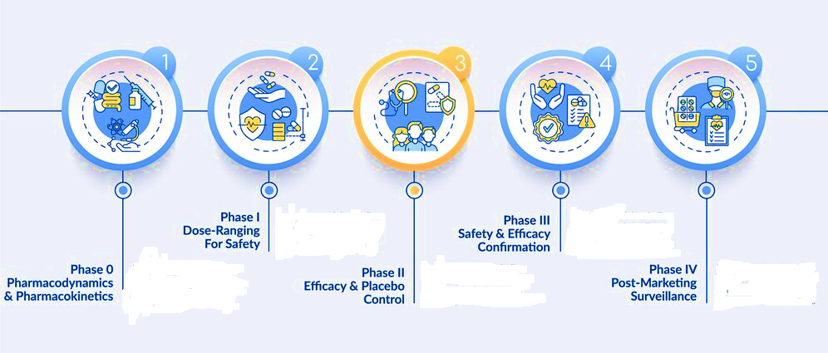

Figure 3: Phases in Clinical Trials

Phase I Clinical Trials
During phase I of clinical trials, the new drug is tested on 100 or less healthy patients to determine the the drug's safety. This level also makes the use of mouse carcinogenicity test model, specifically " TgrasH2 mouse for estimating the potential of oncogenic drugs. This mouse model carries human c-Ha-ras in addition to the endogenous mouse Ha-ras oncogene. Significant effect of this model is on tumorigenesis
- Phase II Clinical Trials
In phase II, the patient population doubles to between 100 and 500, and the drug's efficacy is investigated. These patients have the illness that the new medication is attempting to treat. Efficacy, adverse events, and side effects are all examined in this phase..

Phase III Clinical Trials
In Phase III studies, scientists examine the medication on 1,000–5,000 individuals to gather important information. This stage, which only 12 percent of medications make it through, is crucial for assessing the new drug's general safety and effectiveness.Future prescriptions will be based on data from bigger patient populations if a medicine can pass this stage.
D. Stage IV

FDA Review and Approval
A New Drug Application (NDA) is submitted to the FDA for assessment and potential approval following the completion of clinical trials. This report's goal is to confirm that the medicine is fit for commercial usage and that clinical trials have shown its efficacy and safety. For this, a lot of information is required, including details on all stages of studies, treatment outcomes, safety precautions, and the potential for drug interactions.Between six and 10 months may pass during the review procedure. The registration procedure starts by establishing a prescription file that is included with all pharmaceuticals in the United States if a drug is approved at this point.
E. Stage V

FDA Post-Market Drug Safety Monitoring
Even while clinical trials provide essential information about a drug's effectiveness and safety, it is challenging to fully understand a drug's safety prior to its approval. There are still certain limitations despite the stringent standards in the pharmaceutical development process. The genuine perception of a product's safety actually changes over time because a product's lifecycle on the market can endure for months or even years. In circumstances where the issues are more serious than those reported, FDA may decide to take additional actions in addition to adding warnings to dose or usage instructions. FDA examines reports of concerns with prescription and over-the-counter medications.. [2].
III. Challenges in Traditional Drug Discovery Process
- Drug development is a lengthy, complex, and costly process, entrenched with a high degree of uncertainty that a drug will actually succeed.
- The unknown pathophysiology for many nervous system disorders makes target identification challenging.
- Animal models often cannot recapitulate an entire disorder or disease.
- Challenges related to heterogeneity of the patient population might be alleviated with increased clinical phenotyping and endo-typing.
- Greater emphasis on human data might lead to improved target identification and validation.
- There is a lack of validated diagnostic and therapeutic biomarkers to objectively detect and measure biological states.
- Unfamiliarity with current regulatory processes for investigational new drug (IND) applications can be resolved through pre-IND meetings.[3][4]
IV. Novel approaches in Drug Development using AI
Throughout all phases of drug development, machine learning technologies and techniques are utilised to expedite research and predict the risk and expense of clinical trials. Machine learning techniques improve decision-making in the pharmaceutical business to produce accurate outcomes through a variety of applications, including QSAR analysis, hit discoveries, and de novo drug designs. In order to use any type of information effectively, machine learning must be updated; therefore, a specific model and its parameters must first be defined. 'omics' and'smart' automation techniques were being used to accurately mine and estimate the medical data. The pharmaceutical sector has new potential as well as obstacles as a result of expanding these approaches into the biological field.
In computer science, machine learning (ML) is an area of artificial intelligence (AI). A machine learning algorithm in this context refers to any computing technique that uses the outcomes of past actions, decisions, or observations to enhance forecasts or future decision-making. Nowadays, ML methods are widely used in the pharmaceutical industry.

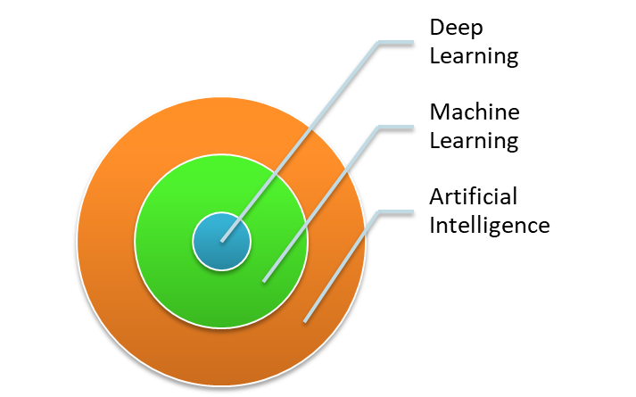
Figure 4: Relatioship betwwn AI, ML and DL
In drug discovery, computational intelligence provides various techniques for analyzing, learning and furthermore clarifies how such pharmaceutical was identified with AI for finding numerous medications in a programmed and integrated format. Therefore, many pharmaceutical industries have shown greater enthusiasm for contributing to technologies, resources for retrieving accurate results in drug discovery.
V. AI potential to transform the drug development process
- The medication development process typically takes 15 years, costs over $1 billion, and has a very low success record for pharmaceutical companies.
- The conventional drug development approach is unable to effectively treat many medical problems.
- Only around 1 in 10 small molecule ideas are predicted to be approved for clinical trials, and of those, only 1 in 10 will ultimately be successful.
- Obstacles include the inability to develop a molecule that targets the desired target only when administered, as well as the lack of significant financial incentives based on the size of the addressable market.
- AI has the potential to significantly improve the efficiency and effectiveness of the drug development process, benefiting everyone involved, from the corporations creating novel medications to the patients in need of effective therapies.

.

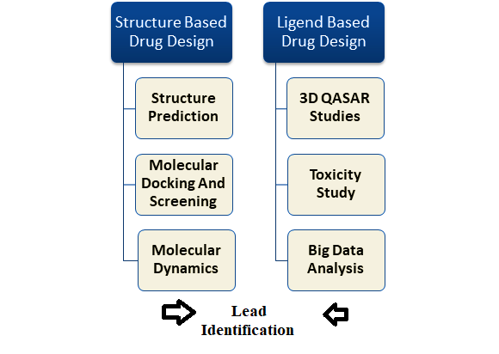
Figure 5: Recent Trends In Drug Discovery
Machine learning tasks are grouped l broadly into three categories.

  - The first one is supervised learning, in which the goal is to predict the label of new observations given a large database of labelled examples. Several supervised learning algorithms have been applied in a biological context, such as Support Vector Machines or (Deep) Neural Networks.
  - The second task is unsupervised learning, and it aims at detecting underlying relationships or patterns in unlabeled data.
  - The third type of task is sequential learning, where algorithms rely on trial-and error, and iteratively use external observations in order to find the best.[5]
VI. AI use in drug discovery
- A known target is utilised to screen for small compounds that either interact with it or impact its function in cells in traditional drug discovery approaches.
- These strategies are effective for targets that are simple to drug, have a known structure, and whose interactions inside cells are thoroughly understood.Due to the intricate structure of cellular connections and the lack of understanding of complex cellular pathways, these methods are, nevertheless, severely constrained.
By spotting unique interconnections and determining the relative importance of various parts of a cellular pathway, AI can get around these problems.
- AI uses sophisticated algorithms and machine learning to glean useful data from a huge dataset, e.g., a dataset of RNA sequencing can be used to identify genes whose expression correlates with a given cellular condition.
- AI can also be used to find substances that might bind to proteins known as "undruggable targets," or proteins whose structures are unknown. A predicted set of compounds can be quickly identified through iterative simulations of interactions of various compounds with tiny fragments of a protein..

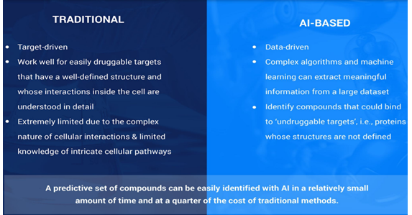
Figure 6: Traditional Vs AI based Drug Development Process

VII. Benefits of applying AI to drug discovery
The application of AI to drug discovery has the potential to revolutionize the current time scale and scope of drug discovery.
- Drug discovery using AI doesn't rely on predetermined targets. As a result, objective bias and prior knowledge are not taken into account during the medication development process.
- AI develops cutting-edge algorithms for drug discovery by combining the most recent advances in biology and computation. Due to the rapid increase in processing power and decrease in processing costs, AI has the potential to level the playing field in drug research..
- AI has a higher prognostic power to define significant interactions in a drug screen. Therefore, the possibility for false positives can be reduced by prudently crafting the factors of the assay in question.
• Most importantly, AI has the power to change drug screening from a bench to a virtual lab, allowing for faster retrieval of screening results and the selection of interesting targets without a lot of labor-intensive experimentation.
VIII. Downsides of AI in drug discovery
- AI forecasts are as accurate as the algorithms used to analyse a dataset, but AI still cannot completely replace a human scientist in the drug discovery process.
- When the findings are in the "grey zone" of interpretation, the algorithm should explicitly state the criteria that should be applied to separate out useful information.
- AI is susceptible to algorithm bias, in which the creators' own biases are reflected in the way data is analysed to provide predictions. As a result, the procedure is not totally impartial.
- Although supercomputing and high-throughput screening have become significantly less expensive over the past ten years, building these pipelines still demands a considerable investment.
- In the end, a scientist must confirm computer forecasts to ensure they are accurate.[6][7]
IX. AI based Tools Employed in Drug Discovery
The various toolsempolyed in AI based drug discovery are presented in Table 1. [5]
Table 1 Examples of AI Tools
Tools | Details | Website URL
Neural graph fingerprint | To evaluate properties of novel molecules | https://github.com/HIPS/neural-fingerprint
DeepChem | Used to find out suitable drug candidate | https://github.com/deepchem/deepchem
DeepTox | Prediction of drug toxicity | www.bioinf.jku.at/research/DeepTox
Hit Dexter | To identify molecules that may react to biochemical tests. | http://hitdexter2.zbh.uni-hamburg.de
DeepNeuralNetQSAR | Detection of the molecular activity of compounds | https://github.com/Merck/DeepNeuralNet-QSAR
ORGANIC | Helps to create molecules with desired properties | https://github.com/aspuru-guzik-group/ORGANIC
PotentialNet | Employs Neural networks to envisage binding affinity of ligands | https://pubs.acs.org/doi/full/10.1021/acscentsci.8b00507
Chemputer | Assist in procedure for chemical synthesis | https://zenodo.org/record/1481731
DeltaVina | To know drug–ligand binding affinity | https://github.com/chengwang88/deltavina

X. Success Stories in AI Driven Drug Discovery
AI has revolutionized the drug discovery process. The AI based tool uses technology that copies the human intelligence in solving complex clinical problems. Here are certain examples that denotes the milestones in drug discovery process. [9]
- In 2020, the company Exscientia proclaimed the discovery of first AI drug molecule to be submitted for human clinical trials.
- In July 2021, AlphaFold, an artificial intelligence (AI) system developed by DeepMind, predicted the structure of 330,000 proteins. That’s more than 20 times the number of proteins in the entire human genome.
- In February 2022 Insilico Medicine named company announced the initiation of Phase I clinical studies for the world’s first AI-based molecule based on a novel AI-discovered target in comparatively less time and cost than traditional preclinical programs.
- In January 2023, AbSci company became the first “to create and validate de novo antibodies in silico” using AI technology.
- FDA granted its first Orphan Drug Designation in February 2023 to a drug discovered and designed by using AI approaches that was then initiated for Phase II Clinical trials.

XI. Conclusion
The path of drug discovery from a small molecule ligand to a clinically useful drug is a long and strenuous process. The presented basic concept and application of artificial intelligence in drug design and development will facilitate this process. In particular, machine learning and deep learning, which have shown great utility in many areas of computer-aided drug development, such as new drug development, QSAR analysis and chemical state imaging. Artificial intelligence-integrated drug discovery and development has accelerated the growth of the pharmaceutical sector, leading to a revolutionary change in the pharma industry. This chapter attempts to discuss basic concept of AI in drug discovery.

References
1 S Kohli, Integrated Approach to Nature as Source of New Drug Lead in Molecular Insight of Drug Design,Edited by Arli Aditya ,Intech open ,2017
2. https://www.fda.gov/patients/learn-about-drug-and-device-approvals/drug-development-process
3. JP Hughes, S Rees, SB Kalindjian, KL Philpott. Principles of early drug discovery. Br J Pharmacol. 2011 Mar;162(6):1239-49. doi: 10.1111/j.1476-5381.2010.01127.x. PMID: 21091654; PMCID: PMC3058157.
4. Forum on Neuroscience and Nervous System Disorders; Board on Health Sciences Policy; Institute of Medicine. Improving and Accelerating Therapeutic Development for Nervous System Disorders: Workshop Summary. Washington (DC): National Academies Press (US); 2014 Feb 6. 2, Drug Development Challenges. Available from: https://www.ncbi.nlm.nih.gov/books/NBK195047/
5. D Paul, G Sanap, S,Shenoy D Kalyane, K Kalia, RK Tekade. Artificial intelligence in drug discovery and development. Drug Discov Today. 2021 Jan;26(1):80-93. doi: 10.1016/j.drudis.2020.10.010. Epub 2020 Oct 21. PMID: 33099022; PMCID: PMC7577280.
6. M Elbadawi , S Gaisford, and A W. Basit, Advanced machine-learning techniques in drug discovery, Drug Discovery Today Volume 26, Number 3 March 2021,769-777
7. S Dara1 · S Dhamercherla · S S Jadav · CH Madhu Babu · M J Ahsan, Machine Learning in Drug Discovery: A Review, Artifcial Intelligence Review https://doi.org/10.1007/s10462-021-10058-4
8 . https://blog.petrieflom.law.harvard.edu/2023/03/20/how-artificial-intelligence-is-revolutionizing-drug-discovery

