Hazards and Toxic effects on the different Living organism of Cadmium and its related safety Assessment.
Om Singh*¹ Vinod Kumar Singh¹, Rajendra Yadav ² and Bijender Kumar ³
¹Department of Chemistry COER University Roorkee Haridwar, Uttarakhand, India
²Assistant Professor, Department of Pharmaceutical Sciences, Gurukula Kangri University Haridwar, India
³ Postdoctoral Fellow, Department of Chemistry, Inha University, Incheon, South Korea
Abstract
Cadmium element is harmful, non-essential and dangerous for human health, Soil and aquatic life. Cd play negative role for soil organisms and soil ecology, other impacts of Cd like low grade of bone mineralization, high rate of fractures, increased rate of osteoporosis, and intense bone associated pain. Cd has good corrosive resistance properties, and working as stabilizers for PVC. Cd exposure cause pathophysiological damages as well as growth rate reduction in fish and long-term exposure can include larval mortality and temporary reduction in growth, fluid replacement, supplemental oxygen, and mechanical ventilation may effective if Cd poisoning occur and gastric lavage also beneficial soon after exposure.
Key words: Cd effects, Sources of Cd, Toxicity, Uses
*Corresponding author: Om Singh
*Corresponding author Email: - omchemist.singh@gmail.com
Introduction
Cd is a by-product of zinc, or lead refining and easily to recyclable. It can be found in soil because insecticides, fungicides, sludge, and commercial fertilizers that use Cd in agriculture Baby, J., et al. 2010. Cd play negative role for soil organisms and soil ecology, Cd element is harmful, non-essential and dangerous for human health Magrath, S.P. 1999 it has good corrosive resistance properties, especially in high stress environments like as marine and aerospace applications for high safety or reliability is required; the coating is preferentially corroded if damaged. Cd is also used as pigments, and stabilizers for PVC.
Routes of Cd exposure
Cd is used in industrial purpose for a long time period and its toxicity focused in the middle of the last century. As discussed in introductory part Cd found in ores of zinc, copper and lead. Volcanic activity is also one of the natural reasons for a temporary increase of Cd concentration in environment. Excessive accumulation of Cd in the body should be regarded as potentially toxic.
By the Natural Environment
Groundwater rarely contains high levels of Cd, till the mining or industrial wastewater, or seepage from hazardous waste sites are not involved. Cd dissolved from water lines in presence of Soft or acidic water, Cd levels are also increased in water decaying in household pipes. But these sources not reported as clinical Cd poisoning, Cd exists as small particles in air as Cd oxide which fume are the result of soldering, smelting, or other high-temperature industrial processes.
By the Food Chain
Certain plants such as tobacco, rice, other cereal grains, potatoes, and other vegetables take up Cd from the soil. Cd is also found in meat, especially liver and kidney. Some areas, Cd concentrations are raised in shellfish and mushrooms.
Chemical Properties
Cd is transition metal which contain 1 mmHg pressure at 394ºC. Cd is odorless and corrosive resistant. its oxides and Cd metal are insoluble in water. The oxidation state of Cd is (+2). Solid Cd is not flammable but powdered of Cd will burn and produce corrosive and toxic fumes National Toxicology Program 2004 & Schaefer, H. R., et al 2020. But some salts of Cd are water soluble as Cd chloride, Cd sulfate and Cd nitrate; But some other salts of Cd which is insoluble in water as they interact with acids, light or oxygen then more soluble. The melting point of Cd is 321۫ ⁰C.
Cd Half-Life
Cd half-life in the kidney is between 6 to 38 years; and in the liver is between 4 - and 19 -years Schaefer, H. R., et al 2020.
Hazardous of Cd
Cd dust or fumes damage the fertility, and organs of the unborn child and cause long-lasting harmful effects on aquatic life so a precautionary system is necessary.
Effects on the environment
After a threshold level of heavy metal concentration, could be dangerous to aquatic and human health and also affect the ecological balance. When heavy metals are not metabolized by the body, they become toxic and accumulate in the soft tissues. The aquatic organism takes heavy metals through three ways: the body surface, gills and food Baby, J., et al.2010 Human exposure like as combustion of fossil fuel, phosphate fertilizers, production of iron and steel, cement production and related activities, and municipal solid waste also Morrow, H. 2010
Effect on human health
Heavy metals may enter the human body via food, water, air, or absorption through the skin when they come in contact with humans in agriculture and in manufacturing, pharmaceutical, industrial, or residential settings. Cd considers as a carcinogen and cause lung cancer Liu, W. 2010 If Cd is inhalation of fine dust and fumes, or ingestion of highly soluble Cd compounds Morrow, H. 2010 And after inhalation of metal fume and cause pneumonitis, pulmonary edema, and death Hayes A.W. 2008 Cd is an endocrine disruptor and some experimental studies show that it can interact with different hormonal signaling pathways. For example, Cd can bind to the estrogen receptor alpha, Fechner, P.; et al. 2011 & Stoica, A.; et al. 2000 and affect signal transduction along the estrogen and MAPK signaling pathways at low doses. Ali, I.; et al. 2010, Ali, I.; et al. 2012 & Johnson, M. D.; et al. 2003
Effects of Cd in reproductive biology
Cd affects the ovarian steroidogenic pathway in rats. Piasek et al. evaluated the direct effects of in vitro Cd exposure on steroidogenesis in rat ovaries. Mostly Cd affect the productions of progesterone and testosterone Piasek M, et al. 1999 Using of low dosage of Cd stimulate the ovarian progesterone biosynthesis, in spite of high dosages inhibit it Henson MC et al. 2004 after some study find out Cd is a potent nonsteroidal estrogen in vivo and in vitro. Cd precipitation increased uterine wight in rat and enhanced mammary development also Johnson MD, et al. 2003
Respiratory Effects
Pulmonary disease can result inhalation exposure to high concentrations of Cd compounds;
Production of Cd alloy, Cd coated steel welding, smelting and refining of Cd. The Initial symptoms of Cd poisoning, flu-like illness- chills, fever, and myalgias. Later symptoms like chest pain, cough, and dyspnea Davison, A. G, et al.1988
Gastrointestinal Effects
Take the acidic food or beverages, cigrates and improper stored contains food with Cd coating Bowers, N., et al. 1997 Cause irritates the gastric epithelium and show the symptoms of gastrointestinal effect nausea, vomiting, abdominal cramps and pain, diarrhea, and tenesmus Schaefer, H. R., et al. 2020 & Saini, S., et al. 2020 Cd ingested in high doses irritates the gastric epithelium. Nordberg GF 2004
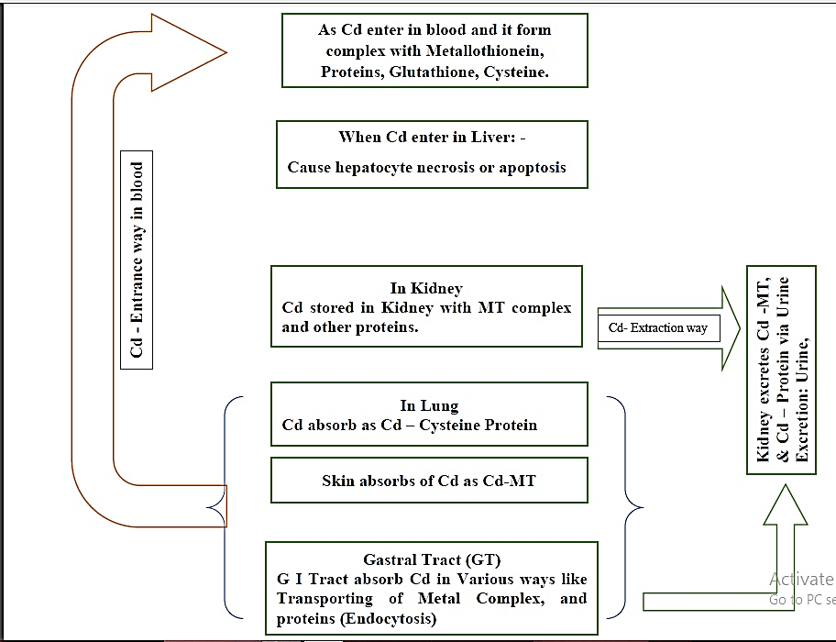
Fig. 1 Effect on Human Health by Cd
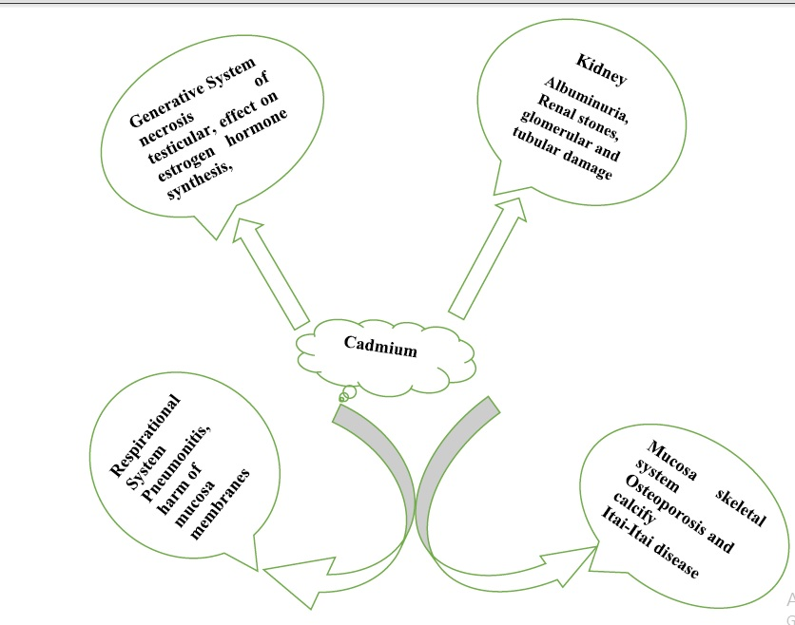
Fig. 2 Effected organs by Cd
Effect on Aquatic Ecosystem
When Cd enter in freshwaters, bulk of the metal is precipitate and be located in the bottom of sediments. so, sediment is main source of Cd for aquatic environment WHO, 2000. Cd effected the aquatic organisms directly or indirectly lethal and can influence populations and ecosystems. Cd consider as a pollutant and so can alter the trophic levels for centuries and freshwater organisms such as fish Sorensen, E.M.B. 1991 Cd uptake from sediment bottom and feeding by fauna and sediment-rooted flora and then circulate the food chain to fish, with the specific pathways which dependent upon the present species Irwin, R.J. et al 1997
Toxicity of Cd in freshwater fish
As Cd is a toxic element and act as tensioning agent for fish Annabi, A., et al. 2013 the results Cd exposure causes pathophysiological damages as well as growth rate reduction in fish Hansen, J.A., et al.2002 in mammals and fish Cd cause hepatic and renal injuries with the probable to induce oxidative stress Kim, J.H., et al.2010
Cd causes hypocalcemia when interacts with the calcium and during its metabolism process. The higher concentrations of calcium in water protect fish from Cd uptake. After exposed over a long period of time the lower concentration of Cd would be chronically toxic. when the animal is Effects of long-term exposure can include larval mortality and temporary reduction in growth. Cd would be acute toxic but animal may die high concentration over a short period of time AMAP., 1998. After above discussion the impact of Cd on aquatic organisms depends on chemical forms of Cd which contain different toxicities and bio-concentration factors. This form binds with metallothionein and decreases its toxicity normally takes place in the liver of fish. However, higher concentration of Cd produces toxic effects. Bradl, H., 2005 & Wright, D.A. et al. 2002
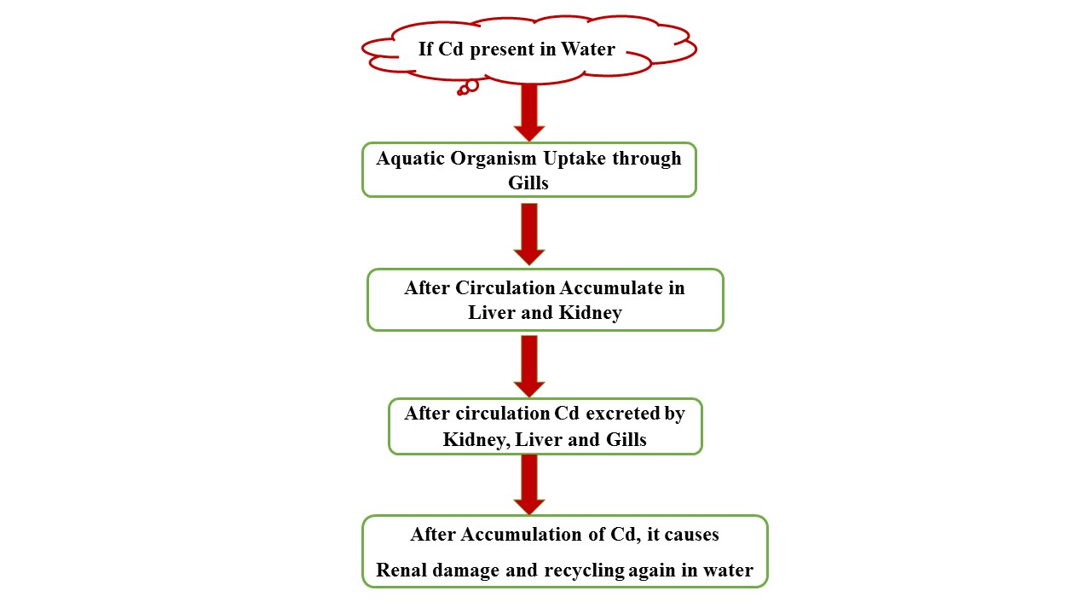
Fig. 3 Effect of Cd on Aquatic Life
Safety Assessment: -
if the dust/fumes of Cd Oxide are inhaled it may cause cancer. Cd dust or fumes damage the fertility, and organs of the unborn child and cause long-lasting harmful effects on aquatic life so a precautionary system is necessary. Not only Cd but also any chemical species before handling first we understand the handling procedure and safety measures and then use it Soni, R. K., et al. 2021& Singh, O. 2021 Before handling the Cd First read and understand the safety precaution. Chose a well-ventilated area for Cd-related work. wear always respiratory safety mask for breathing, when using this product wash your hands properly before eating, drinking or smoking. as Cd get moisture should be explosively so avoid moisture or another surface because it may leave traces and can accumulate, so ensure that any effluent or solid waste disposal, and consider dry covered area.
Substance like polyphenolic compounds mostly present in plants prevents the harmful effect of Cd, polyphenolic compound involves in biological activity and has antioxidant properties. Such compound has at least one aromatic ring with active phenolic group. Some relevant substance which contains polyphenolic group examples are given below.
Cloves, Plums, Cocoa Powder, Apples, Walnuts, Almond, Green olives, Spinach, Red Onion, Red Wine, Green Tea, Black Tea, Coffee, Black Chokeberry and Peppermint etc.
Applications/ Uses
Normally Cd is used as electric batteries, pigments, Buxbaum, Gunter; et al 2005. Cd used as coating agents, Smith C.J.E.; et al. 1999
Another use of Cd is electroplating. In Nuclear fission work as Neutron absorber Scoullos, Michael J.; et al. 2001
Batteries; Nickel-Cd, Krishnamurthy, N. et al. 2013
In Television technology, as QLED TVs, Maynard, Andrew.2017
In medical field cd used as Anticancer drugs, Abyar, Selda; et al. 2019
In past years Cd oxide used in black and white television Lee, Ching-Hwa; et al. 2002
photoconductive surface used CdS coating for photocopier drums. Miller, L. S.; et al. 1991
Cd was used as heat, light, and weathering stabilizers in PVC Jennings, Thomas C. 2005
FUTURE DIRECTIONS
Cd toxicity relation in plants is a key source for future research direction and how to mitigate this toxicity-related problem. Understand the interaction of water quality conditions and Cd in fish as well as the occurrence of the others metal interaction, protection, future threats, and the genetic influence of Cd bioaccumulation. Invents new agricultural tools for mitigating Cd identification, genetic reasons which improve more resistant species in the future.
Conclusion
The nonbiodegradable toxic nature of Cd is a very serious problem for rising countries. it effects on photosynthesis process in plants, and crops productivity also not only in the harvest but is also harmful to human health major known reason is Cigarette smoking, which cause lung or kidney disease. use new methods for mitigating Cd-related problems like microbial remediation, and phytodegradation, implement Cd counter agricultural tools. The European Commission has proposed much stricter limits transitioning from 60 to 20 mg Cd/kg. Fluid replacement, supplemental oxygen, and mechanical ventilation may effective. And In cases of ingestion, gastric decontamination by emesis or gastric lavage may be beneficial soon after exposure.
Acknowledgement: Authors are thankful to COER University Roorkee Haridwar 247667 provide the necessary facilities.
Declaration of Conflict of Interest: Authors are no conflict of interest about this manuscript all authors agree to proceed with this.
Funding details: Authors did not get any fund for this manuscript.

References:
- Baby, J., Raj, J. S., Biby, E. T., Sankarganesh, P., Jeevitha, M. V., Ajisha, S. U., & Rajan, S. S. (2010). Toxic effect of heavy metals on aquatic environment. International Journal of Biological and Chemical Sciences, 4(4).
- Magrath, S.P. (1999). Adverse effects of Cd on soil microflora and fauna. In B.R. Singh (eds), Cd in Soils and Plants. Kluwer Academic Publishers, Dordrecht. pp. 199-218.
- National Toxicology Program (2004). NTP classifies Cd as known to be a human carcinogen.
- Schaefer, H. R., Dennis, S., & Fitzpatrick, S. (2020). Cd: Mitigation strategies to reduce dietary exposure. Journal of food science, 85(2), 260-267.
- Morrow, H. (2010). Cd and Cd Alloys, Kirk-Othmer Encyclopedia of Chemical Technology.
- Liu, W., Zhou, Q., An, J., Sun, Y., & Liu, R. (2010). Variations in Cd accumulation among Chinese cabbage cultivars and screening for Cd-safe cultivars. Journal of Hazardous Materials, 173(1-3), 737-743.
- Hayes, A. W. (2008). Principles and Methods of. Toxicology.
- Fechner, P.; Damdimopoulou, P.; Gauglitz, G. (2011). "Biosensors paving the way to understanding the interaction between Cd and the estrogen receptor alpha".
- Stoica, A.; Katzenellenbogen, B. S.; Martin, M. B. (2000). "Activation of estrogen receptor-alpha by the heavy metal Cd". Molecular Endocrinology (Baltimore, Md.)
- Ali, I.; Penttinen-Damdimopoulou, P. E.; Mäkelä, S. I.; Berglund, M.; Stenius, U.; Akesson, A.; Håkansson, H.; Halldin, K. (2010). "Estrogen-like effects of Cd in vivo do not appear to be mediated via the classical estrogen receptor transcriptional pathway". Environmental Health Perspectives.
- Ali, I.; Damdimopoulou, P.; Stenius, U.; Adamsson, A.; Mäkelä, S. I.; Åkesson, A.; Berglund, M.; Håkansson, H.; Halldin, K. (2012). "Cd-induced effects on cellular signaling pathways in the liver of transgenic estrogen reporter mice". Toxicological Sciences.
- Johnson, M. D.; Kenney, N.; Stoica, A.; Hilakivi-Clarke, L.; Singh, B.; Chepko, G.; Clarke, R.; Sholler, P. F.; Lirio, A. A.; Foss, C.; Reiter, R.; Trock, B.; Paik, S.; Martin, M. B. (2003). "Cd mimics the in vivo effects of estrogen in the uterus and mammary gland". Nature Medicine.
- Piasek M, Laskey JW. (1999). Effects of in vitro Cd exposure on ovarian steroidogenesis in rats. J Appl Toxicol. 19:211–217
- Henson MC, Chedrese PJ. (2004). Endocrine disruption by Cd, a common environmental toxicant with paradoxical effects on reproduction. Exp Biol Med (Maywood). 229:383–392.
- Davison, A. G., Taylor, A. N., Darbyshire, J., Chettle, D. R., Guthrie, C. J. G., O'Malley, D., & Gompertz, D. (1988). Cd fume inhalation and emphysema. The Lancet, 331(8587), 663-667.
- Bowers, N., Pratt, J. R., Beeson, D., & Lewis, M. (1997). Comparative evaluation of soil toxicity using lettuce seeds and soil ciliates. Environmental Toxicology and Chemistry: An International Journal, 16(2), 207-213.
- Saini, S., & Dhania, G. (2020). Cd as an environmental pollutant: ecotoxicological effects, health hazards, and bioremediation approaches for its detoxification from contaminated sites. Bioremediation of industrial waste for environmental safety: Volume II: biological agents and methods for industrial waste management, 357-387.
- Nordberg GF. (2004) Cd and health in the 21st century--historical remarks and trends for the future. Biometals.; 17:485–489.
- WHO., (2000). Cd. In: Air Quality Guidelines for Europe, WHO (Ed.). Chapter 6.3, World Health Organization, Regional Office for Europe, Copenhagen, Denmark, ISBN-13: 9789289013581, pp: 136-138.
- Sorensen, E.M.B., (1991). Metal Poisoning in Fish. CRC Press, Boston, MA., USA.,
- Irwin, R.J., M. van Mouwerik, L. Stevens, M.D. Seese and W. Bashaw, (1997). Environmental contaminants encyclopedia: Copper entry. National Park Service, Water Resources Divisions, Water Operations Branch, Fort Collins, CO., USA., July 1, 1997, pp: 1-99.
- Annabi, A., K. Said and I. Messaoudi, (2013). Cd: Bioaccumulation, histopathology and detoxifying mechanisms in fish. Am. J. Res. Commun., 1: 60-79
- Hansen, J.A., P.G. Welsh, J. Lipton and M.J. Suedkamp, (2002). The effects of long‐term Cd exposure on the growth and survival of juvenile bull trout (Salvelinus confleuentus). Aquat. Toxicol., 58: 165-174.
- Kim, J.H., J.S. Rhee, J.S. Lee, H.U. Dahms, J. Lee, K.N. Han and J.S. Lee, (2010). Effect of Cd exposure on expression of antioxidant gene transcripts in the river pufferfish, Takifugu obscurus (Tetraodontiformes). Comp. Biochem. Physiol. C: Toxicol. Pharmacol., 152: 473-479
- AMAP., (1998). AMAP assessment report: Arctic pollution issues. Arctic Monitoring and Assessment Programme (AMAP), Oslo, Norway
- Bradl, H., (2005). Heavy Metals in the Environment: Origin, Interaction and Remediation. 1st Edn., Academic Press, New York, USA., ISBN-13: 9780120883813, Pages: 282.
- Wright, D.A. and P. Welbourn, (2002). Environmental Toxicology. Cambridge University Press, Cambridge, UK., ISBN-13: 9780521588607, Pages: 630.
- Soni, R. K., & Singh, O. (2021). Arsine: Risk assessment, environmental, and health hazard. In Hazardous Gases (pp. 11-21). Academic Press.)
- Singh, O. (2021). Arsenic pentafluoride: Risk assessment, environmental, and health hazard. In Hazardous Gases (pp. 1-9). Academic Press.
- Buxbaum, Gunter; Pfaff, Gerhard (2005). "Cd Pigments". Industrial inorganic pigments. Wiley-VCH. pp. 121–123. ISBN 978-3-527-30363-2.
- Smith C.J.E.; Higgs M.S.; Baldwin K.R. (20 April 1999). "Advances to Protective Coatings and their Application to Ageing Aircraft". RTO MP-25. Archived from the original (PDF) on 17 May 2011. Retrieved 29 May 2011.
- Scoullos, Michael J.; Vonkeman, Gerrit H.; Thornton, Iain; Makuch, Zen (2001). Mercury, Cd, Lead: Handbook for Sustainable Heavy Metals Policy and Regulation. Springer. ISBN 978-1-4020-0224-3.
- Krishnamurthy, N. (2 July 2013). Engg. Chemistry, 2/e. New York: PHI Learning Private Limited. pp. 82–83. ISBN 978-81-203-3666-7.
- Maynard, Andrew. (2017). "Are quantum dot TVs – and their toxic ingredients – actually better for the environment?". The Conversation. Retrieved 23 July 2017.
- Abyar, Selda; Khandar, Ali Akbar; Salehi, Roya; Abolfazl Hosseini-Yazdi, Seyed; Alizadeh, Effat; Mahkam, Mehrdad; Jamalpoor, Amer; White, Jonathan M.; Shojaei, Motahhareh; Aizpurua-Olaizola, O.; Masereeuw, Rosalinde (December 2019). "In vitro nephrotoxicity and anticancer potency of newly synthesized Cd complexes". Scientific Reports. 9 (1): 14686.
- Lee, Ching-Hwa; Hsi, C. S. (2002). "Recycling of Scrap Cathode Ray Tubes". Environmental Science & Technology. 36 (1): 69–75.
- Miller, L. S.; Mullin, J. B. (1991). "Crystalline Cd Sulfide". Electronic materials: from silicon to organics. Springer. p. 273. ISBN 978-0-306-43655-0.
- Jennings, Thomas C. (2005). "Cd Environmental Concerns". PVC handbook. Hanser Verlag. p. 149. ISBN 978-1-56990-379-7.

