ANALYSIS OF HIGH-RISE BUILDING WITH DIAGRID STRUCTURE SUBJECTED TO LATERAL LOADING

Parvez Patel
Department of Civil Engineering (Str)
Khaja Bandanawaz University
Kalaburagi, India
parvezpatel2419@gmail.com

Professor Nadeem Pasha
Department of Civil Engineering
Khaja Bandanawaz University
Kalaburagi, India
nadeem@kbn.university

ABSTRACT
Around the world, there is a substantial increase in the construction of tall structures, and these buildings are affected by lateral loads due to wind or earthquake. There are several construction techniques available to withstand these lateral stresses. Among them, the diagrid structural system has gained popularity for tall buildings due to its unique geometric configuration, offering both structural efficiency and aesthetic appeal. Currently, the latest trend in diagrid structures involves using diagonal grids at specific angles around the building's perimeter and across its height in modules. Unlike traditional orthogonal structures, diagrids employ triangulated grids in place of vertical columns at the periphery, making them more efficient in providing stiffness against lateral loads. As a result, these systems are increasingly favoured for the design of tall buildings.
In this work, we analyze a G+15-story RCC building with a regular floor plan of 30mx30m situated in seismic zones IV & V. With the objective to investigate a G+15 storey, 10 models were made, of which 1 is a bare frame, 4 are diagrid angles that are analyzed in zone 4, and the same 5 models are analyzed in zone 5. We employ the Etabs 2020 software for structural simulation and analysis, considering wind loads based on IS 875 part 3 and seismic factors according to IS 1893(Part 1): 2002. Through a comparative assessment of the results from both the diagrid and conventional building analyses, we evaluate story displacement, storey drift, base shear, and time period. This study provides insights into the performance of diagrid structures compared to traditional methods in the context of lateral load resistance and overall structural stability.

Keywords- Bare Frame, Diagrid Structural System, optimal angle, Storey Displacement, Storey Drift Ratio, Base Shear, Time Period, ETABS

I.INTRODUCTION.

The global expansion of tall buildings in densely populated cities is on the rise, driven by ongoing urban expansion, increased availability of rentable spaces with minimized environmental impact, cost-effective construction, and the imperative to safeguard agricultural land. Among the innovative concepts for designing these tall structures, the Diagrid – characterized by diagonalized grid structures – has gained prominence. Along with increasing stiffness, the Diagrid also uses axial action to successfully offset lateral forces (such wind and seismic loads) and gravity loads. This architectural style makes use of a unique type of space truss that has a perimeter grid made of triangle-shaped pieces, sometimes adopting diamond-shaped modules. The term "Diagrid" itself stems from the fusion of "diagonal" and "grid," signifying a pioneering approach. A pivotal consideration for the success of the diagrid structural system lies in the judicious selection of appropriate materials for its construction.

  - Diagrid structural system.
The word ‘diagrid’ is derived from ‘diagonal-grid’. It is a structural system with triangular modules and without vertical columns. In this system, a triangular module is formed by connecting two braces with one beam. These braces resist lateral loads through axial action, handling compression and tension alternatively and simultaneously, similar to trusses. By adjusting the beam span and the angle between braces, various configurations of triangular modules can be achieved, allowing for the construction of free-form shaped buildings using different node angles and shapes.

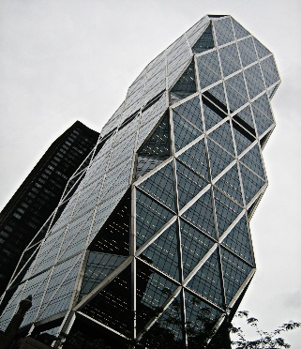
Figure 1 - Example of Diagrid Structural System
Diagrids are commonly positioned along the perimeter of a building to resist most of the lateral forces acting on the structure. This strategic placement helps the diagrids efficiently handle all lateral forces coming from the building's periphery. Shear forces and overturning moments in diagrids are resisted by the axial action of the slanted columns, compared to conventional constructions that depend on the bending of vertical columns. As a result, there is no need for a separate shear rigidity core in diagrid structures.
Moreover, diagrids can effectively counteract gravitational forces acting on the structure through axial action. They can be constructed using various materials such as steel, reinforced concrete, timber, or composite materials, but steel diagrids are commonly used due to their strength and flexibility

1.2 Diagrid Structural System Module Geometry.
1. Diagrid Optimal Angle.
The diagrid's diagonal elements are designed to handle both shear and moment forces. The most suitable angle for positioning these diagonals depends on the height of the building. In a typical building, columns are optimally placed at a 90-degree angle to maximize bending rigidity, while diagonals, set at around 35 degrees to optimize shear rigidity. The ideal diagrid angle usually falls within the range of 60 to 70 degrees, striking a balance between these two angles. Additionally, as the building height grows, the optimal diagrid angle tends to increase accordingly
2. Diagrid Module Dimensions
There are primarily two module dimensions:
- Height: The number of floors built within a single diagrid module, which normally ranges from 2 to 6 levels, affects the diagrid's vertical height.
- Base of the Module: The diagrid's formation is normally determined by its elevation and the best angle it can take.

II. LITERATURE SURVEY

1. Ravi Sorathiya(2017): They studied on “diagrid structure of multistorey building” This literature study proposes an innovative approach for utilizing diagrid structures to improve the design of tall buildings. The study explores structures with different heights—G+24, G+36, G+48, and G+60 stories—while keeping a constant 18 m 18 m plan size. This is done by using stiffness-based approaches. implementing STAAD Pro. With the aid of advanced software, precise structural models are built, and analysis is carried out in line with RCC standards (IS 456:2000) and seismic load combinations (IS 1893(Part 1):2002). The study compares diagrid structures' performances to those of conventional designs by examining factors such storey displacement, drift, and bending moments. The ideal diagrid angles (63° and 69°) that increase structural stiffness and decrease displacement, drift, and bending moments are identified through wind and seismic analyses. Importantly, the study, which can offer an aesthetically pleasing substitute for high-rise constructions, also recognizes the aesthetic attractiveness of diagrid systems, which is significant. In conclusion, the results highlight the structural and financial benefits of stiffness-based diagrid designs. The study suggests using diagrid structures because they have the ability to improve lateral and gravitational load resistance while providing an appealing design option for modern tall buildings.

2. Sahil.M.Kaspate (2022): They studied on “Comparative Analysis between Diagrid and Normal Frame Structure with Contrasting Parameters” The study compares a standard concrete building to a steel diagrid structure that is situated at a 60-degree angle along the building's exterior and has an inner core made of R.C.C. columns, beams, and slabs. The diagrid's diagonal members effectively transfer lateral loads through axial action, as opposed to the conventional system's vertical columns, which bend when under lateral loads. An eleven-story RCC building with a 16 m 16 m plan dimension that is located in seismic zones V and III is taken into account in the analysis. STAAD.Pro software is used for structural modeling and analysis, and IS 1893(Part 1): 2002 seismic concerns are taken into account. Comparing several characteristics, such as node displacement, bending moment, storey drift, shear pressures, reinforcement area, and economic factors, results are provided. Notably, the study shows that, in seismic zone V's soft soil conditions, the composite diagrid frame is noticeably more cost-effective than the bare frame construction, with cost savings ascribed to improved steel and concrete sections. Zone III exhibits comparable trends in a variety of soil types, highlighting the diagrid system's financial benefits.

3. Deepak P Hittalmani (2019): They studied on “Wind Analysis and Comparative Study of High-Rise Building Having Diagrid and Outrigger Structural System by Gust Factor Approach” This examination of the literature offers a thorough investigation of the analysis and design of a 30-story diagrid steel structure, taking into account a typical floor plan of 18 m by 18 m. The study analyzes structural performance under dynamic wind loads along wind and across wind directions using ETABS software. Each structural member complies with IS 800:2007 requirements, and load combinations are carefully taken into account. The goal of the study is to introduce an outrigger that combines a perimeter diagrid system with a belt truss system to increase structural stiffness and lateral load resistance while minimizing lateral displacement. In comparison to structures with outriggers, study results show that adding a perimeter diagrid system resulted in a 10% decrease in top storey displacement. With the use of outriggers, there is a noticeable reduction in stress in the columns, resulting in a more uniform force distribution. Economically, the diagrid structural system performs well since it uses 17% less steel than the outrigger system. Improved performance is shown by the diagonal members' optimal inclination for diagrid constructions (67.38°) and the clever positioning of the outriggers at 0.33 and 0.66 heights. Due to the perimeter diagonal elements' increased rigidity, diagrid systems have shorter time scales. In addition to highlighting their stiffness, load-resisting capacities, and economic viability, this research offers valuable insights into the efficiency and effectiveness of diagrid and outrigger structural systems in multi-story high-rise buildings.

III. OBJECTIVES
- To analyse a (G+15) storey diagrid structure for Wind and seismic forces by equivalent static method.
- To compare the wind and seismic performance for conventional building and Diagrid structure in different zones.
- To determine the various optimum angle of inclination of diagrid system at which the building performs its best under the influence of wind and seismic forces imposed on it.
- To investigate the building response in terms of base shear, displacement, story drift and time period.
- To compare the results for base shear displacement, story drift and time period and to check which structural system is efficient.
IV. METHODOLOGY
This study commences by creating a three-dimensional model of a reinforced concrete building structure. The assessment and design of the structure take into account Dead Load (DL), Live Load (LL), Wind Load and Earthquake Load (EL) as per Indian standard codes. Utilizing the Etabs software, all the relevant loads are considered. The square shape of a high-rise building for the diagrid and conventional building is compared with the Etabs software.
- In this thesis the work is done to know the behavior of wind & seismic forces on bare frame building and building with different angle of diagrid.
- G+15story building is selected for the wind &seismic analysis with the Etabs software.
- Total 10 models are prepared, out of which one is bare frame and others are 4 different models with different angle of diagrid which is analyzed in zone 4 and 5
- The loading is applied as per IS codes.
- Equivalent static analysis is performed using Etabs software.
- The results obtained in terms of storey drift, displacement, time period and base shear is discussed.
Ⅴ. DESCRIPTION OF MODELS
5.1 In this project total ten models are prepared
- Model-01: Regular G+15 storey conventional RC framed building (i.e bare frame) in seismic zone Ⅳ.
- Model-02: G+15 storey RC framed structure in seismic zone IV with no columns at the outer edges using concrete sections with diagrid angles of 52°.
- Model-03: G+15 storey RC framed structure in seismic zone IV with no columns at the outer edges using concrete sections with diagrid angles of 62.48°.
- Model-04: G+15 storey RC framed structure in seismic zone IV with no columns at the outer edges using concrete sections with diagrid angles of 68.66°.
- Model-05: G+15 storey RC framed structure in seismic zone IV with no columns at the outer edges using concrete sections with diagrid angles of 72.64°.
- Model-06: Regular G+15 storey conventional RC framed building (i.e., bare frame) in seismic zone Ⅴ.
- Model-07: G+15 storey RC framed structure in seismic zone IV with no columns at the outer edges using concrete sections with diagrid angles of 52°.
- Model-08: G+15 storey RC framed structure in seismic zone IV with no columns at the outer edges using concrete sections with diagrid angles of 62.48°.
- Model-09: G+15 storey RC framed structure in seismic zone IV with no columns at the outer edges using concrete sections with diagrid angles of 68.66°.
- Model-10: G+15 storey RC framed structure in seismic zone IV with no columns at the outer edges using concrete sections with diagrid angles of 72.64°.

5.2 Model Geometry and Structural Data

Sl.No | Description | Values
01 | Plan Dimension | 30mx30m
02 | Total number of storey | 16
03 | Each storey height | 3.2m
04 | Footing end condition | Fixed support
06 | Span between two successive columns | 5m
07 | Number of bays in x & y direction | 7
08 | Depth of Slab | 150mm
09 | Size of RCC Column | 600x600mm
10 | Size of RCC Beam | 300x550mm
11 | Concrete grade used | M40
12 | Rebar grade used | Fe500
13 | Diagrid member | 300x550mm
14 | Diagrid angle considered | 52⁰,62.48⁰, 68.66⁰and 72.64⁰

5.3 Details of load applied, Wind and Seismic parameters:

5.3.1 LOAD DETAILS
Dead Load = Self Weight of Structure
Live Load on Floor = 3.5kN/m²From (IS 875 PART-2)
Floor Finish on Roof and Floors = 1kn/m²
Wall Load = 12kN/m (for 230mm wall).

5.3.2 Wind and Seismic Load Detail:

A.) For Seismic Zone Ⅳ model:
- Wind Load Details: - From (IS 875 PART-3)
Basic Wind Speed (V_{b}) = 44m/s
Risk Co-efficient = 1
Terrain Category = 3
Topography Factor = 1
Importance Factor = 1

- Seismic Data: - From (IS 1893 PART-1 2016)
Type of Structure = Special RC Moment Resisting Frame
Zone Factor = 0.24
Type of soil = Medium
Response Reduction Factor = 5
Importance Factor = 1.2

B.) For Seismic Zone V model:
- Wind Load Details: - From (IS 875 PART-3)
Basic Wind Speed (V_{b}) = 50m/s
Risk Co-efficient = 1
Terrain Category = 2
Topography Factor = 1
Importance Factor = 1

- Seismic Data: -From (IS 1893 PART-1 2016)
Type of Structure = Special RC Moment Resisting Frame
Zone Factor = 0.36
Type of soil = Medium
Response Reduction Factor = 5
Importance Factor = 1.2

5.4 MODEL GENERATION

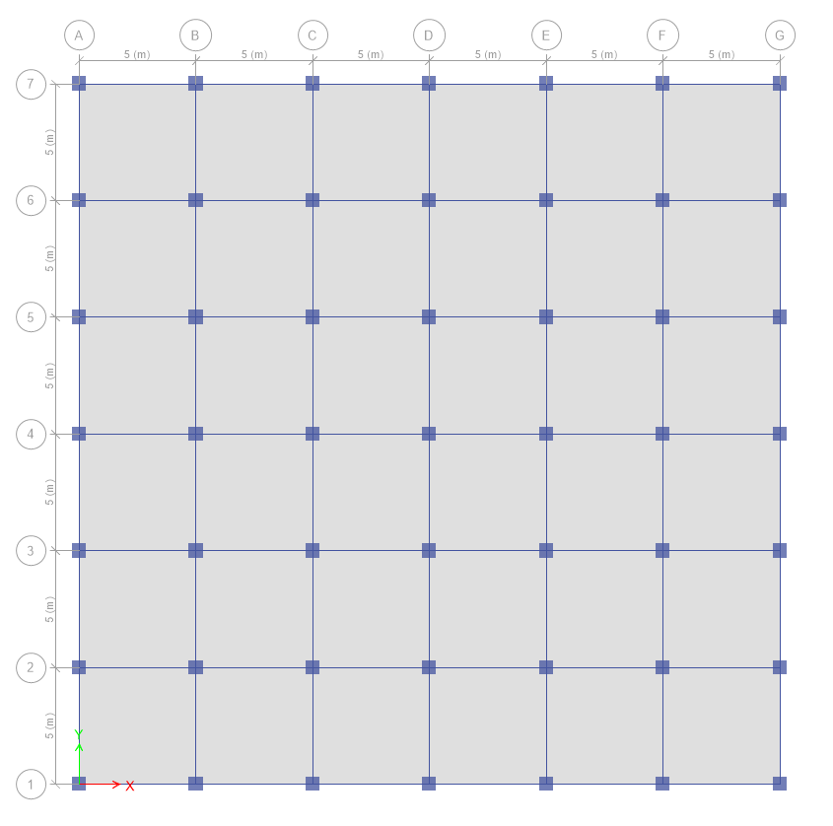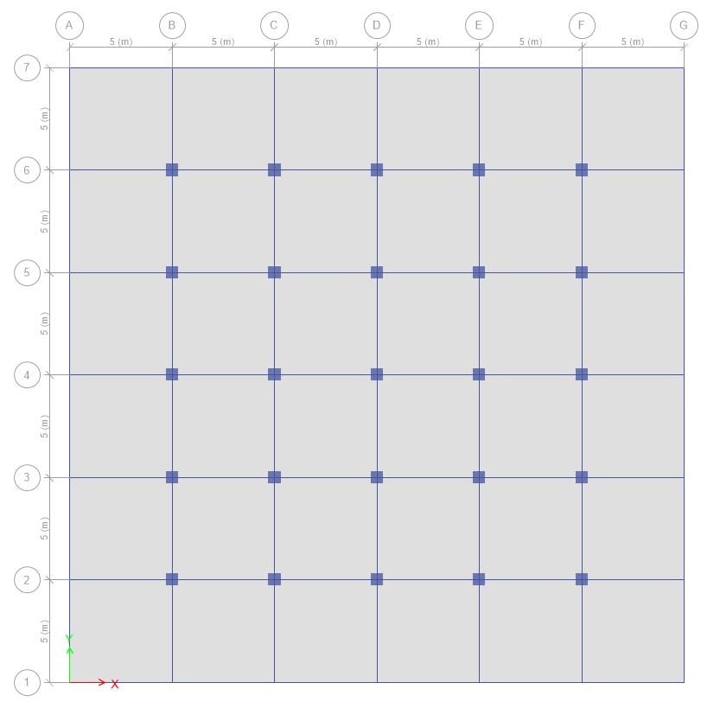
Fig 2: Plan of multi-storeyed RC Bare frame building Fig:3 Plan of multi-storyed diagrid building
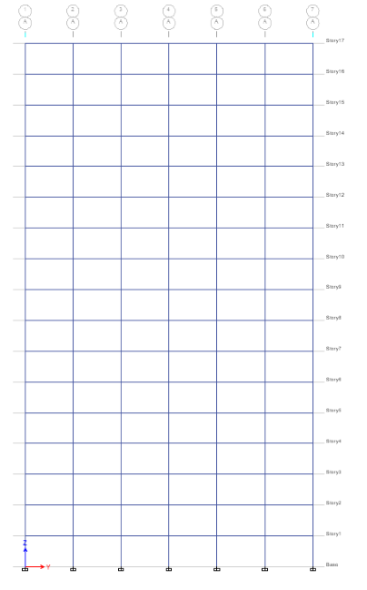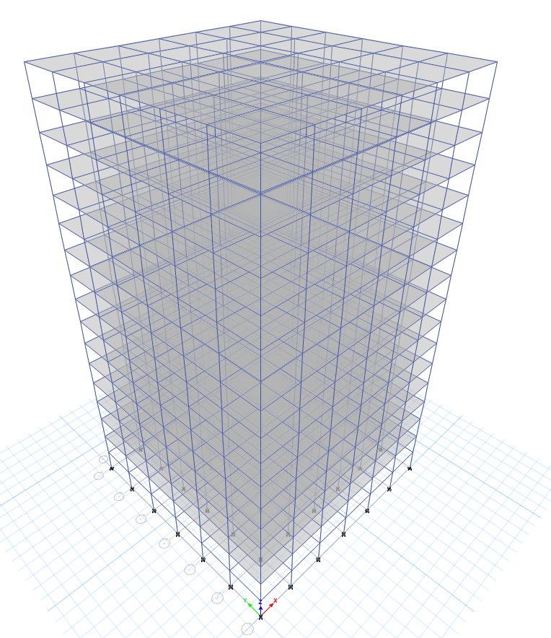
Fig4: Elevation of and 3D view of RC bare frame building

a). 2 STOREY MODEL
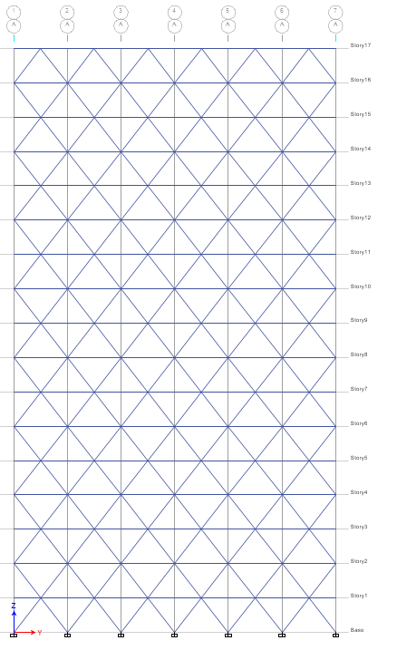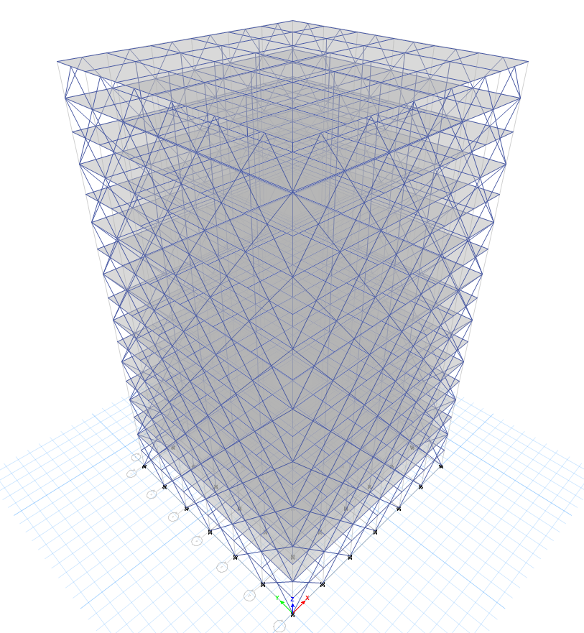
Fig:5 Elevation and 3D view of diagrid building with diagrid angle 52°.

b).3 STOREY MODEL
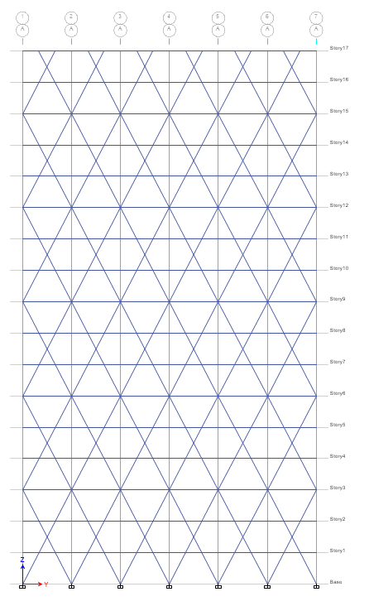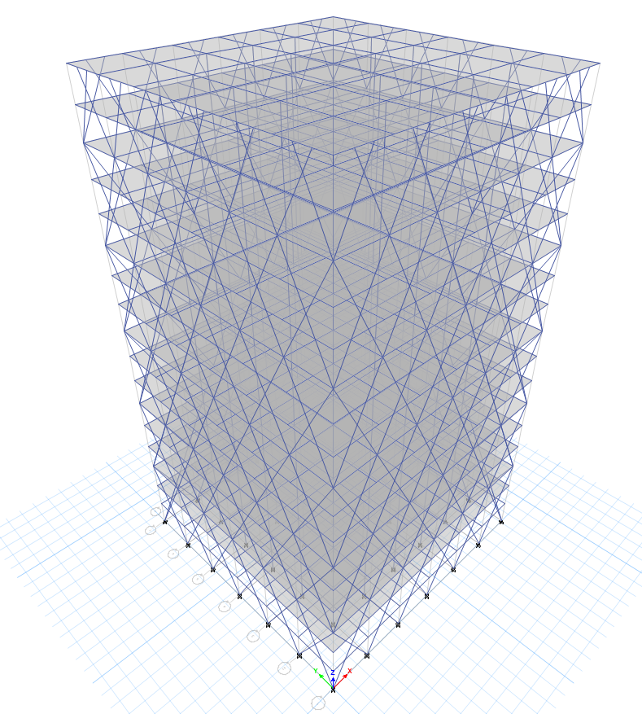
Fig:6 Elevation of diagrid building and 3D view of diagrid building with diagrid angle 62.48°.
c). 4 STOREY MODEL
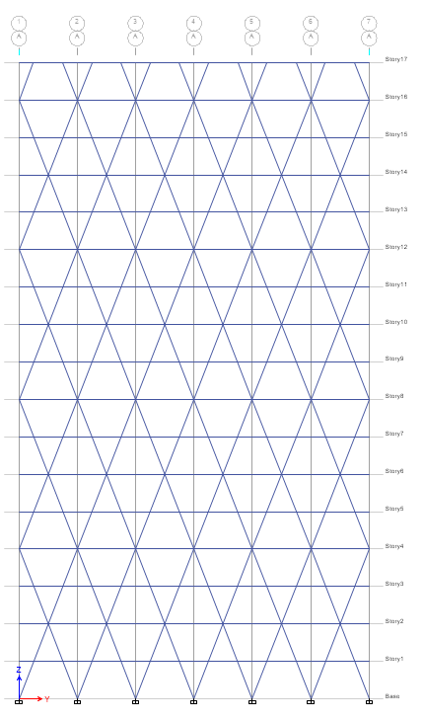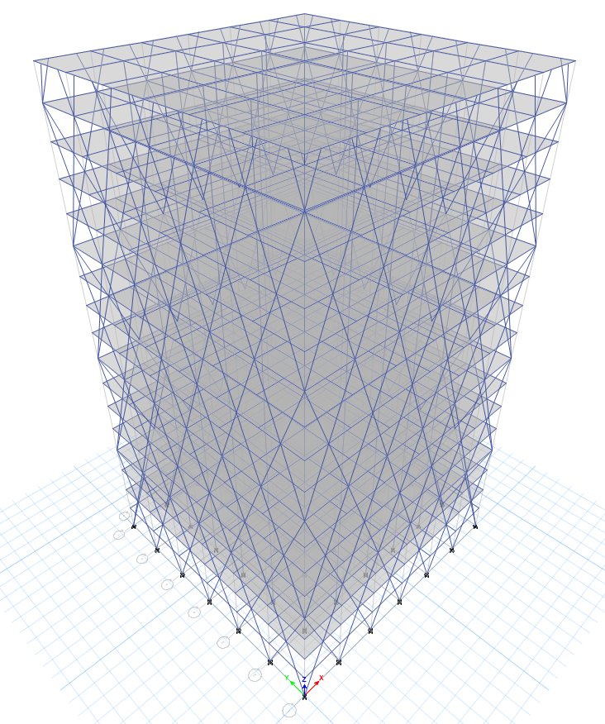
Fig:7 Elevation of diagrid building and 3D view of diagrid building with diagrid angle 68.66°.

d). 5 STOREY MODEL
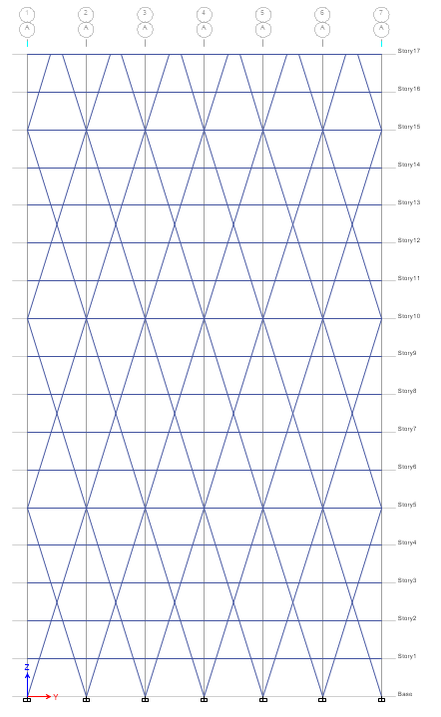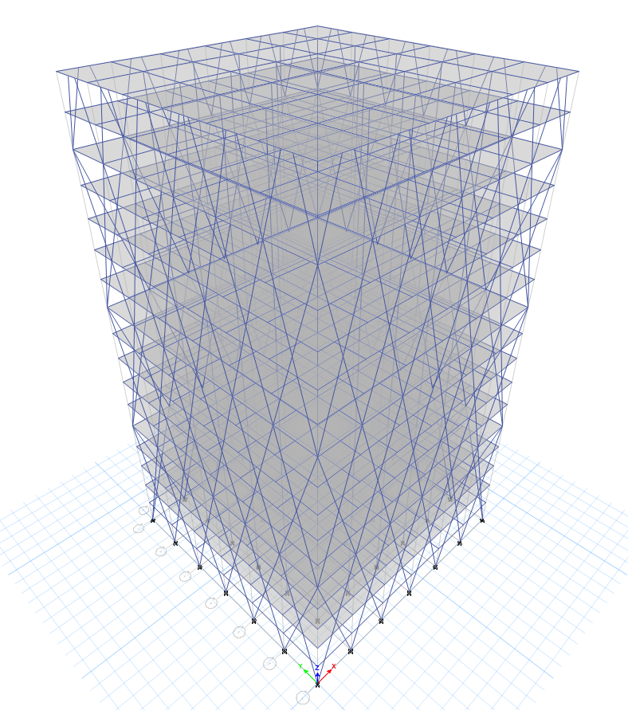
Fig:8 Elevation of diagrid building and 3D view of diagrid building with diagrid angle 72.64°.
Ⅵ ANALYSIS RESULT AND DISCUSSION

For the investigation of every one of the ten structure models seismic and wind loads are applied. The Evaluation of the all the ten structure models is finished by utilizing ETABs 2020 programming. The evaluation effects along with displacements, storey drifts, time period and base shear of all constructing models are supplied and as compared.

6.1Wind load in Zone Ⅳ and Zone Ⅴ
6.1.1 Displacement:
Storey displacement is defined as it is the displacement of considered floor with reference to the base of a structure, usually the base of a building being aground.
Deflection limit is H/500 where H-is height of structure as per clause 5.6.l Indian standard -800:2007
Allowable deflection is 54.4/500 = 0.108m = 108mm

Graph-1: Storey Displacement in mm for model 1 to 5 due to wind load along x& y- Dir in Zone Ⅳ

The graph represents displacement relative to each storey for all models.The graph indicates that model M1 displays the largest displacement compared to all model and is equal to 23.507 at story 17. The diagrid structural system was implemented in models M2, M3, M4, and M5. As a result, in M2, the displacement decreased by 79% compared to M1. From the above observation in the diagrid models the model M2 with 52°angle is having the least displacement when compared to other diagrid models IN Zone Ⅳ

Graph-2: Storey Displacement in mm for model 6 to 10 due to wind load along x& y- Dir in Zone Ⅴ

The graph represents displacement relative to each storey for all models. The graph indicates that model M6displays the largest displacement compared to all model and is equal to 33.653 at story 17. The diagrid structural system was implemented in models M7, M8, M9, and M10. As a result, in M2, the displacement decreased by 80% compared to M1. From the above observation in the diagrid models the model M7 is having the least displacement when compared to other diagrid models IN Zone Ⅴ

6.1.2 Storey Drifts: It is outlined because the quantitative relation of movement of two successive floors to height of that floor. The drift ratio is shown below for bare frame, and diagrid structure using the wind load. The drift values shall not exceed 0.004timestorey height, as per I.S. 1893:2016.

Graph-3: Drift ratio for model 1 to 5 due to wind load along X & Y-Dir in Zone Ⅳ

According to graph the story drift is maximum for model M1 when compared to all other models. The highest value of storey drift was observed in model M1 at 3rd storey.and is equal to 0.001018. Since the diagrid structural system was implemented for the model M2 M3, M4, & M5. Hence storey drift values go on decreasing. Among diagrid structural systems the model M4 with 68.66° angle is performing least against drift ratio values, due to the presence of diagonal members around the periphery of the structure which increases strength, durability and stiffness of the structure. From the above observation we came to know that the diagrid structural model M4 with 68.66° angle shows least results against drift, when compared with all other models for wind load in zone Ⅳ.
.

Graph-4: Drift ratio for model 6 to 10 due to wind load along X & Y-Dir in Zone Ⅴ

From the chart it is observed that:
The story drift is maximum for model M6 when compared to all other models. The highest value of storey drift was observed in model M6 at 3rd storey. Since the diagrid structural system was implemented for the model M7 M8, M9, & M10. Hence storey drift values go on decreasing. Among diagrid structural systems the model M9 with 68.66° angle is performing least against drift ratio values, due to the presence of diagonal members around the periphery of the structure which increases strength, durability and stiffness of the structure. From the above observation we came to know that the diagrid structural systemM9with 68.66° angle shows least results against drift, when compared with all other models for wind load in zone Ⅴ.

6.2 SEISMIC ANALYSIS RESULTS IN ZONE Ⅳ&Ⅴ.
6.2.1 DISPLACEMENT:

Graph-5: Storey Displacement in mm for model 1 to 5 due to Seismic load along x& y- Dir in Zone Ⅳ

From the chart it is observed that:
The graph represents displacement relative to each storey for all models. The graph indicates that model M1 displays the largest displacement compared to all model and is equal to 48.122 at story 17. The diagrid structural system was implemented in models M2, M3, M4, and M5. As a result, in M3 with Diagrid angle 62.48°, the displacement decreased by 52.17% compared to M1. From the above observation in the diagrid models the model M3 with 62.48°angle is having the least displacement when compared to other diagrid models.

Graph-6: Storey Displacement in mm for model 6 to 10 due to Seismic load along x& y- Dir in Zone Ⅴ

From the chart it is observed that:
The graph represents displacement relative to each storey for all models. The graph indicates that model M6 displays the largest displacement compared to all model and is equal to 72.183 at story 17. The diagrid structural system was implemented in models M7, M8, M9, and M10. As a result, in M8 with Diagrid angle 62.48°, the displacement decreased by 53% compared to M6. From the above observation in the diagrid models the model M8 with 62.48° angle is having the least displacement when compared to other diagrid models.
6.2.2 STOREY DRIFT RESULTS FOR SEISMIC ANALYSIS IN ZONE Ⅳ& Ⅴ

Graph-7 Drift ratio for model 1 to5 due to Seismic load along X & Y-Dir in zone Ⅳ.

From the chart it is observed that
The story drift is maximum for model M1 when compared to all other models. The highest value of storey drift was observed in model M1 at 5th storey. Since the diagrid structural system was implemented for the model M2 M3, M4, & M5. Hence storey drift values goes on decreasing. Among diagrid structural systems the model M3 with 62.48° angle is performing least against drift ratio values, due to the presence of diagonal members around the periphery of the structure which increases strength, durability and stiffness of the structure. From the above observation we came to know that the diagrid structural systemM3 with 62.48° angle shows least results against drift, when compared with all other models for seismic load in zone Ⅳ.

Graph-8: Drift ratio for model 6 to10 due to Seismic load along X & Y-Dir in zone Ⅴ

From the chart it is observed that:
The story drift is maximum for model M6 when compared to all other models. The highest value of storey drift was observed in model M6 at 5th storey. Since the diagrid structural system was implemented for the model M7 M8, M9, & M10. Hence storey drift values goes on decreasing. Among diagrid structural systems the model M8 with 62.48° angle is performing least against drift ratio values, due to the presence of diagonal members around the periphery of the structure which increases strength, durability and stiffness of the structure. From the above observation we came to know that the diagrid structural systemM8with 62.48° angle shows least results against drift, when compared with all other models for seismic load in zone Ⅴ.

6.2.3 Base shear: Base shear is the force that is generated at the base of the structure especially due to seismic forces. The base shear is the function of mass and stiffness of the structure therefore, base shear increases as structural stiffness and mass increases.

Graph-9: Base shear in kN for model 1 to 5 due to Seismic load along x and y-direction in zone Ⅳ

From the above chart it is observed that:
The graphical representation indicates that model M1 has the lowest base shear compared to all the other models and is equal to 3655.2404 Kn. In model M2, M3, M4, & M5 due to the presence of diagonal members around the periphery of the structure the base shear is increased compare to bare frame structure.
Among these diagrid models M5 demonstrates the lowest base shear and is equal to 6258.98KN because as the angle of inclination of diagonal member is increased then the base shear is goes on decreased. In model M5 the base shear has been increased by 40% compare to the bare frame model.

Graph-10: Base shear in kN for model 6 to 10 due to Seismic load along x and y-direction in zone Ⅴ

From the above chart it is observed that:
The graphical representation indicates that model M6 has the lowest base shear compared to all the other models and is equal to 5482.8606 Kn. In model M7, M8, M9, & M10 due to the presence of diagonal members around the periphery of the structure the base shear is increased compare to bare frame structure. Among these diagrid models M10 demonstrates the lowest base shear and is equal to 9388.4766kN because as the angle of inclination of diagonal member is increased then the base shear is goes on decreased. In model M10 the base shear has been increased by 41.66% compare to the bare frame model.

6.2.4 Time Period: The time taken (in seconds) by the structure to complete one cycle of oscillation in its natural mode of oscillation is known as its time period. In the seismic risk assessment and mitigation, the estimation of fundamental period of buildings is an important aspect both for design of new buildings and performance assessment of existing ones. Depending on mass and stiffness, the fundamental period is a global characteristic describing the behavior of building under seismic loads. In order to estimate the lateral loads acting on a structure, it is first necessary to determine the period of vibration.

Graph-11: Time Period in Sec for model 1 to 5 using Seismic load in zone Ⅳ.

From the above chart it is observed that:
The time period for model M1 is highest and is equal to 2.57 sec and M2 and is equal to 1.0878 least compare to the all models. From the diagrid structural models, the M2 is performing the least fundamental time period as the base shear is high for this model hence the stiffness increases it may lead to reduces the fundamental time period. From the above observation we can say that the time period for M2 has been decreased by 57.63% when compare to M1 bare frame model. As per the above results we came to know that the M2 has the least fundamental time period hence this model is performing best against all models in zone Ⅳ.

Graph-12: Time Period in Sec for Model 6 to 10 using Seismic load in zone Ⅴ

From the above chart it is observed that:
The time period for model M6 is highest and is equal to 2.567 sec and M7 and is equal to 1.109 least compare to the all models. From the diagrid structural models, the M7 is performing the least fundamental time period as the base shear is high for this model hence the stiffness increases it may lead to reduces the fundamental time period.From the above observation we can say that the time period for M7 has been decreased by 57% when compare to M6 bare frame model. As per the above results we came to know that the M7 has the least fundamental time period hence this model is performing best against all models in zone Ⅴ.

VII. CONCLUSION

- All ten models in the investigation showed storey displacement and storey drift values that stayed within permitted limitations.
- In response to wind and seismic study, using diagrid angles of 62.48° and 68.66° at all levels gives the diagrid structural system more stiffness, which reflects less storey displacement, less storey drift, and shorter time periods.
- If the seismic zone shifts from IV to V, the displacement rises by more than 33%. With an expanding seismic zone, building model displacement rises. At the roof, displacement is quite high, while at the base, it is very low.
- From a wind speed of 44 m/s to 50 m/s, the displacement increases by more than 30%. With an expanding seismic zone, building model displacement rises. The displacement is very high at roof and very low at base.
- When comparing zone IV to zone V, the storey drift increases by more than 35%. The storey drift goes up as the seismic zone factor rises. and zone V indicates the greatest amount of story drift.
- There is an increase of more than 31% in the storey drift. With a rise in wind speed, the storey drift increases. and zone V indicates the greatest amount of story drift.
- Effective resistance against lateral loads: Diagrid displays better resistance to lateral loads because of the diagonal columns on its periphery. As a result, inner columns relax and only support gravity loads. whereas the inner and outer columns of a conventional building are both designed for lateral and gravity loads.
- Aesthetic appeal: Diagrid buildings have a more appealing appearance than conventional ones, which is significant for high-rise structures.
As a result, one can use diagrid construction for higher lateral load resistance and this becomes important for seismic zone IV or V based on results and comparison with conventional buildings.

FUTURE SCOPE OF WORK
- For diagrid construction, higher level buildings can be explored in R.C.C symmetrical buildings.
- Different angel studies for an asymmetrical tall building with a diagrid structure.
- Analysis of the diagrid structure with and without the outer column’
- Diagrid structures can also be studied in steel buildings.
REFERENCES
- Ravi Sorathiya (2017) “Study on Diagrid Structure of Multistorey Building” International Journal of Advance Engineering and Research Development (IJAERD), Volume: 04 Issue: 04 e-ISSN (O): 2348-4470 p-ISSN (P): 2348-6406.
- Sindhuja G J (2017) “Performance Study of High Rise Building with Diagrid System Under Dynamic Loading” International Research Journal of Engineering and Technology (IRJET) Volume: 04 Issue: 06 e-ISSN: 2395 -0056 p-ISSN: 2395-0072.
- Harshita Tripathi (2016) “Diagrid Structural System for R.C. Framed Multistoreyed Buildings” International Journal of Scientific & Engineering Research (IJSER), Volume 7, Issue 6, ISSN 2229-5518.
- Snehal S. Mali (2017) “Response of High Rise Building with Different Diagrid Structural System” - International Journal of Science Technology & Engineering (IJSTE) Volume 4 Issue 5, ISSN: 2349-784X.
- ROHIT KUMAR SINGH (2014) “Analysis and Design of Concrete Diagrid Building and Its Comparison with Conventional Frame Building” International Journal of Science, Engineering and Technology (IJSET) VOLUME 2 ISSUE 6, ISSN: 2348-4098
- Deepak P Hittalmani (2019) “Wind Analysis and Comparative Study of High-Rise Building Having Diagrid and Outrigger Structural System by Gust Factor Approach” Internatinal Journal of Science and Advance Research in Technology (IJSART) Volume 5 Issue 8, ISSN: 2395-1052
- IS. 456: 2000, Indian Standard Plain and Reinforced Concrete - Code of Practice, Bureau of Indian Standards, New Delhi.
- IS: 875 (Part 1) - 1987, Indian Standard Code of Practice for Design Loads (Other than Earthquake) (Dead load) for Buildings and Structures, Bureau of Indian Standards, New Delhi.
- IS: 875 (Part 2) - 1987, Indian Standard Code of Practice for Design Loads (Other than Earthquake) (Imposed Loads) for Buildings and Structures, Bureau of Indian Standards, New Delhi.
- IS: 875 (Part 3) - 1987, Indian Standard Code of practice for design loads (other than earthquake) (Wind Loads) for buildings and structures, Bureau of Indian Standards, New Delhi.
- IS 1893 (Part1):2016, Indian Standard Criteria for Earthquake Resistant Design of Structures, Bureau of Indian Standards, New Delhi

