DEFINITION OF BLOCKCHAIN AND HOW TO IMPLEMENT IN GOVERNMENT ACCOUNTING SYSTEMS

Iskandar Muda¹, Gioia Amone², Normah Omar³, Noor Marini Haji Abdullah⁴, Irene Martin ⁵, Devina ⁶, Fauziah Kumalasari ⁷, Dio Agung Herubawa ⁸

^{1,5,6,7, 8}Universitas Sumatera Utara, Faculty Economic and Business, TM Hanafiah Address 12, Medan, Indonesia
¹Corresponding Author : iskandar1@usu.ac.id
²University of Naples “Parthenope”, Napoli, Italy
³Universiti Teknologi MARA, Accounting Research Institute, Level 12, Menara Sultan Abdul Aziz Shah, Shah Alam, Selangor, Malaysia
⁴Universiti Teknologi MARA Cawangan Kelantan, Malaysia

Abstract
Blockchain, has been perceived as a revolutionary innovation. Due to its rapid development, blockchain has the capabilities to influence many domains, including accounting. Besides improving the efficiency and effectiveness of a business, blockchain has several features that ensure any information's reliability. This research aims to identify what is blockchain and analyze the potential of blockchain technology for the accounting field in Indonesia and how to implement in government accounting systems. This research uses qualitative methods with the case study approach and analysis of making explanation strategies. The result of this study indicates that blockchain is applicable in Indonesia without having to use cryptocurrency as a payment tool. The result finds that blockchain can be used as a technology for Accounting Information System. One of the reasons is that all accounting transactions have the potential to be traceable with the blockchain. The data in this technology can be considered as relevant information due to the nature of blockchain as a technology that records and stores data that cannot be changed and manipulated. Blockchain will be used as a database and data procession will still be carried out by using the Accounting Information System. Blockchain is unable to automatically process data into information that may be needed in accounting. This research is expected to strengthen the theory related to blockchain as one of the accounting technologies, also to be an initial step in improving the concept of triple-entry accounting that is usable in Indonesia by using Blockchain which is supported by other platforms such as ERP and uses Token as the representative of assets or financial in recording transactions.
Keywords: blockchain, revolutionary innovation, recording transactions, Accounting Information System

- INTRODUCTION

Blockchain technology development has predicted to disrupt an established business process and business model. It is expected to help the organization in increasing their operational effectiveness and efficiency, as well as in increasing their system security.

Nowadays, several industries have started to implement and conduct various research on blockchain implementation in their areas. A survey to 2,965 C-suite executives has shown that one-third of organizations have actively engaged or considered blockchain technology to be a value-added organization (Lim and Kamaruddin, 2023).

Many kinds of research described blockchain as a technology capable of open collaboration and exchanging any information (Brender et al., 2023). It can improve business value in altering inter-organizational relationships and enabling trusted information flows. Recent research focuses on revealing and improving the limitations of blockchain from privacy and security perspectives.

Blockchain technology can be used to provide formal guarantees and capture the transaction details like the state of the product, product ownership, product origin, and footprint. It is useful for the supply chain management process to increase their transparency with customers. It is also helpful to make transactions trustworthy without the need to trust anyone. This feature is usually referred to as trustless trust (Yavaprabhas,, 2022).

The government sector is used to maintain several processes like taxes, passports, land registries, and other public services. Specific industries that are also involved in using blockchain technology are financial sectors, real estate, legal services, e-commerce, and digital platforms

As in other industries, the use of blockchain technology in the accounting sectors can connect stakeholders to the distributed data. Data is the most potent resource in accounting because all of the activity and decisions should be supported with reliable financial and non-financial data.

The implementation of blockchain is estimated to provide essential benefits for accounting and assurance services in order to protect data integrity, share appropriate information, make reliable and automatic control mechanisms, and provide the foundation for automatic assurance and enabling a more agile and precise audit model (Abdennadher et al., 2022). The benefits will be beneficial in adding accounting cycles' essential function such as generating an invoice, processing automatic payment, contracts, and document index in significant implications..

Because it is believed will give some benefits for the future digital era of accounting and assurance domains, especially to increase its effectivity, efficiency, and security processes through some reliable and distributed mechanisms, Through this research, we intend to answer the question as to blockchain technology that could potentially be useful in the accounting and government. It is provided by studying the best practices from other sectors, which are published in academic and professional publications.

- LITERATURE REVIEW

- WHAT IS A BLOCKCHAIN?

A blockchain is a distributed database shared among the nodes of a computer network. As a database, a blockchain stores information electronically in digital format. Blockchains are best known for their crucial role in cryptocurrency systems, such as Bitcoin, for maintaining a secure and decentralized record of transactions (Ahamad et al., 2022). The innovation with a blockchain is that it guarantees the fidelity and security of a record of data and generates trust without the need for a trusted third party. Blockchain system record information in a way that makes it difficult or impossible to change, hack, or cheat system.

Each block in the chain contains a number of transactions, and every time a new transaction occurs on the blockchain, a record of that transaction is added to every participant’s ledger. The decentralized database managed by multiple participats is known as Distributed Ledger Technology (DLT).

Blockchain is a type of DLT in which transactions are recorded with an immutable cryptographic signature called a hash. This means if one block in one chain was changed, it would be immediately apparent it had been tampered with. If hackers wanted to corrupt a blockchain system , they would have to change every block in the chain, across all of the distributed version of the chain

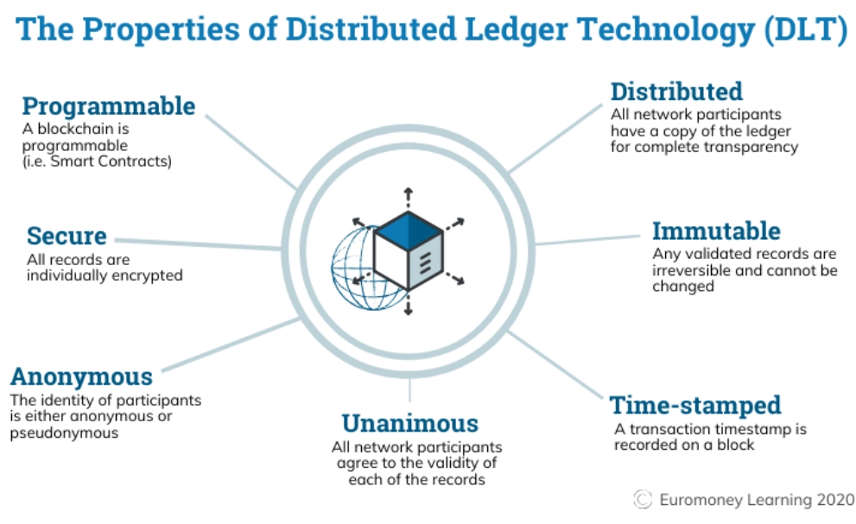

As the summary, Blockchain is:
- A Blockchain is a type of shared database that differs from a typical database in the way that it stores information; blockchains store data in blocks that are then linked together via cryptography.
- As new data comes in, it is entered into a fresh block. Once the block is filled with data, it is chained onto the previous block, which makes the data chained together in chronological order.
- Digital assets are distributed instead of copied or transferred, creating an immutable record of an asset.
- The asset is decentralized, allowing full real-time access and transparency to the public.
- Different types of information can be stored on a blockchain, but the most common use so far has been as a ledger for transactions.
- A transparent ledger of changes preserves integrity of the document, which creates trust in the asset.
- Blockchain’s inherent security measures and public ledger make it a prime technology for almost every single sector.

Blockchain is an especially promising and revolutionary technology because it helps reduce risk, stamps out fraud and brings transparency in a scalable way for myriad uses.

- HOW DOES BLOCKCHAIN WORK?
The whole point of using a blockchain is to let people in particular, people who don't trust one another to share valuable data in a secure, tamper proof way.
Blockchain consists of three important concepts: blocks, miners and nodes.
- Blocks
Every chain consists of multiple blocks and each block has three basic elements:
- The data in the block.
- A 32-bit whole number called a nonce. The nonce is randomly generated when a block is created, which then generates a block header hash.
- The hash is a 256-bit number wedded to the nonce. It must start with a huge number of zeroes (i.e., be extremely small).

When the first block of a chain is created, a nonce generates the cryptographic hash. The data in the block is considered signed and forever tied to the nonce and hash unless it is mined.
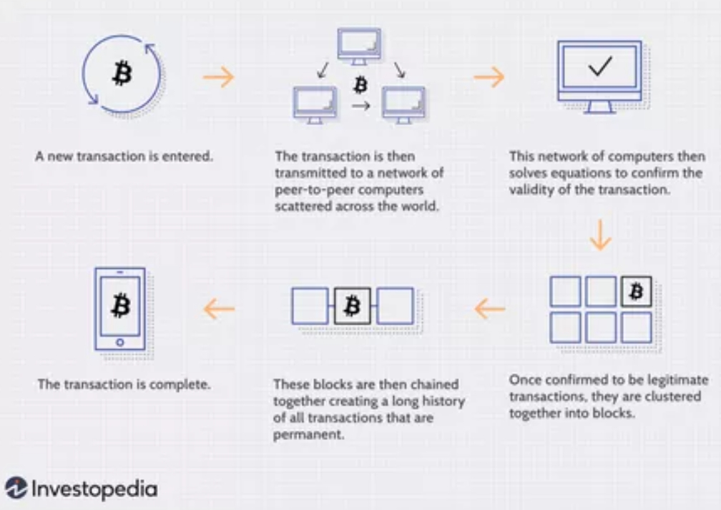
- Miners
Miners create new blocks on the chain through a process called mining. In a blockchain every block has its own unique nonce and hash, but also references the hash of the previous block in the chain, so mining a block isn't easy, especially on large chains.

Miners use special software to solve the incredibly complex math problem of finding a nonce that generates an accepted hash. Because the nonce is only 32 bits and the hash is 256, there are roughly four billion possible nonce-hash combinations that must be mined before the right one is found. When that happens miners are said to have found the "golden nonce" and their block is added to the chain.
Making a change to any block earlier in the chain requires re-mining not just the block with the change, but all of the blocks that come after. This is why it's extremely difficult to manipulate blockchain technology. Think of it as "safety in math" since finding golden nonces requires an enormous amount of time and computing power. When a block is successfully mined, the change is accepted by all of the nodes on the network and the miner is rewarded financially.
- Nodes
One of the most important concepts in blockchain technology is decentralization. No one computer or organization can own the chain. Instead, it is a distributed ledger via the nodes connected to the chain. Nodes can be any kind of electronic device that maintains copies of the blockchain and keeps the network functioning.
Every node has its own copy of the blockchain and the network must algorithmically approve any newly mined block for the chain to be updated, trusted and verified. Since blockchains are transparent, every action in the ledger can be easily checked and viewed. Each participant is given a unique alphanumeric identification number that shows their transactions.
Combining public information with a system of checks-and-balances helps the blockchain maintain integrity and creates trust among users. Essentially, blockchains can be thought of as the scalability of trust via technology.
- USES OF BLOCKCHAIN -- CRYPTOCURRENCIES: THE BEGINNING OF BLOCKCHAIN’S TECHNOLOGICAL RISE
Blockchain’s most well-known use (and maybe most controversial) is in cryptocurrencies. Cryptocurrencies are digital currencies (or tokens), like Bitcoin, Ethereum or Litecoin, that can be used to buy goods and services. Just like a digital form of cash, crypto can be used to buy everything from your lunch to your next home. Unlike cash, crypto uses blockchain to act as both a public ledger and an enhanced cryptographic security system, so online transactions are always recorded and secured.
Cryptocurrencies are digital currencies that use blockchain technology to record and secure every transaction. A cryptocurrency (for example, Bitcoin) can be used as a digital form of cash to pay for everything from everyday items to larger purchases like cars and homes. It can be bought using one of several digital wallets or trading platforms, then digitally transferred upon purchase of an item, with the blockchain recording the transaction and the new owner. The appeal of cryptocurrencies is that everything is recorded in a public ledger and secured using cryptography, making an irrefutable, timestamped and secure record of every payment.
III. ETHEREUM BLOCKCHAIN
Originally created as the ultra-transparent ledger system for Bitcoin to operate on, blockchain has long been associated with cryptocurrency, but the technology's transparency and security has seen growing adoption in a number of areas, much of which can be traced back to the development of the Ethereum blockchain.

In late 2013, Russian-Canadian developer Vitalik Buterin published a white paper that proposed a platform combining traditional blockchain functionality with one key difference: the execution of computer code. Thus, the Ethereum Project was born. Ethereum blockchain lets developers create sophisticated programs that can communicate with one another on the blockchain.

Tokens
Ethereum programmers can create tokens to represent any kind of digital asset, track its ownership and execute its functionality according to a set of programming instructions.
Newfound uses for blockchain have broadened the potential of the ledger technology to permeate other sectors like media, government and identity security. Thousands of companies are currently researching and developing products and ecosystems that run entirely on the burgeoning technology.
Blockchain is challenging the current status quo of innovation by letting companies experiment with groundbreaking technology like peer-to-peer energy distribution or decentralized forms for news media. Much like the definition of blockchain, the uses for the ledger system will only evolve as technology evolves.
IV. FINANCIAL TOOL
Cryptocurrency is a digital currency that is used in blockchain, this raises an opinion that using blockchain means the payment tool must be cryptocurrency. The advantage of blockchain is that it is not limited by cryptocurrency.
There are a lot of blockchains that do not even need cryptocurrency such as Hyperledger Fabric. Indonesia has a regulation that prohibits cryptocurrency as a payment tool. Based on Informant 1, there are two ways to improve the accounting system based on the blockchain without using cryptocurrency as the payment tool;
(1) transaction recording using the token as the representative of Indonesian Rupiah. The token that is used in blockchain as a payment tool to record transactions is not a cryptocurrency but particularly as a representative of physical or financial assets;
(2) using blockchain more like a database, this method does not need cryptocurrency or token.
V. USES OF BLOCKCHAIN – GOVERNMENT ACCOUNTING INFORMATION SYSTEMS
Blockchain is an accounting technology that concerned with the transfer of ownership of assets, and maintaining a ledger of accurate financial information. The accounting profession is broadly concerned with the measurement and communication of financial information, and the analysis of said information. Much of the profession is concerned with ascertaining or measuring rights and obligations over property, or planning how to best allocate financial resources. For accountants, using blockchain provides clarity over ownership of assets and existence of obligations, and could dramatically improve efficiency.

Blockchain has the potential to enhance the accounting profession by reducing the costs of maintaining and reconciling ledgers, and providing absolute certainty over the ownership and history of assets. Blockchain could help accountants gain clarity over the available resources and obligations of their organisations, and also free up resources to concentrate on planning and valuation, rather than recordkeeping.
Alongside other automation trends such as machine learning, blockchain will lead to more and more transactional-level accounting being done – but not by accountants. Instead, successful accountants will be those that work on assessing the real economic interpretation of blockchain records, marrying the record to economic reality and valuation. For example, in due diligence in mergers and acquisitions, distributed consensus over key figures allows more time to be spent on judgemental areas and advice, and an overall faster process.
By eliminating reconciliations and providing certainty over transaction history, blockchain could also allow for increases in the scope of accounting, bringing more areas into consideration that are presently deemed too difficult or unreliable to measure, such as the value of the data that a government holds.
VI. IMPLEMENT IN GOVERNMENT ACCOUNTING SYSTEMS
Because of its useful , The development of Blockchain in Indonesia attracts the government’s interest to use this technology as well.
Public procurement is a business that has significant values, which covered infrastucture business, such as bridge project, roads, buildings, hospitals, universities, and also the procurement of goods and services. Based on Report from The Organization of Economic Developed Countries (OECD, 2016) , the amount of public procurement budget amongst countries member of OECD, on average reaching 15% of Gross National Product (GDP) .
This indicates the large portion of the funds that must be provided for. In Indonesia, the amount of public procurement budget accounts for approximately 30% of The State Budget (APBN), the amount of APBN 2017 of Rp.2.080 trillion (Ministry of Finance, 2017). It is estimated that 60% of foreign aid is allocated to this post (Transparency International, 2017). Based on OECD Report (2016), the public procurement management in Indonesia is inefficient, less accountable and less transparent, which resulting loss of approximately US $ 15 billion per year. Data collected by the Corruption Eradication Commission (KPK) shows that between 2015 July 1st to December 31st , corruption in public procurement budget is the most commonly corruption case in Indonesia. Corruption is the enemy of economic development, which caused Indonesia had financial crisis in 1997 (Yayan Nuryana & Dwi Asih, 2019) The Government has been done many ways to combat corruption in public procurement, including the adoption of electronic procurement system. But, the adoption process is running slower than expected because only 30% of total public procurement budget, managed through eprocurement system (Transparency International, 2017) .To overcome the slow adoption, the Government of Indonesia established an e-catalog system launched in 2013.
The e-cataloque system is used for ordering electronically. To date there are more than 66,000 (sixty six thousand) types of items that have been registered on a system basis. Unfortunately, the e-cataloque system which prepared by the government, still has some disadvantages. According to Transparency International Report (2017), the advantages of e-catalogue system consisting several items:

(a) can not access some important documents for procurement, such as bidding documents, contract documents and details,
(b) the data is not presented in detail until the transaction level, and presented only to the account level only, such as data on tax revenues, budget allocations per organization, budget title, and rural budget transfers,
(c) data presented in different formats and not always readable by machine (machine readable),
(d) the government is not active in promoting the openness of data on public procurement, which is published online to the public,
(e) there is no standardized data format for publication purposes,
(f) unavailability of information that may explain the origin of the data (metadata), as well as
(g) data presented online, does not provide sufficient documentary evidence.

Furthermore, Transparency International (2017 reported, there is no formal mechanism, which can provide official feedback on government-published data. This research is conducted base on the argument that Indonesia, as one of the member countries that support the Sustainable Development Goals (SDGs), is having an interest in creating efficiency of government budget utilization, especially in public procurement funds. Corruption due to in-efficiency public budget procurement funds has significant values which approximately USD 15 Billion per year (Transparency International, 2017). The misuse of the public procurement budget is counterproductive compared to the cost of development required to achieve the goal of SDGs 2030, such as poverty alleviation programs, food security, health, education, climate change mitigation, and other socio-economic and environmental sustainability. It is estimated that developing countries like Indonesia need investment funds to build basic infrastructure, such as roads, railway stations, ports, water, sanitation, electricity, food, health and education facilities, $ 3.3 trillion - $ US 4, 5 trillion per year (United Nations) Conference on Trade and Development/ UNCTAD, 2014a)(4). The role of the Public Sector is crucial to achieve the objectives of SDGs, so implementation of good governance becomes very important. Slow implementation of good governance, weaknesses in rule and law enforcement and judicial systems, as well, is the main cause of corruption in Indonesia (Martini, 2012),(World Bank,2010). Based on the reports of Transparency International (2018), Indonesian corruption ranks on 2017 is 96 from 176 countries with a score of 37 on a scale of 100
Yermack considered that blockchain technology can replace it as a tool to fight corruption. The important point from the benefit of the blockchain is to minimize the chance of fraud. As said, In blockchain it is very difficult to create fictitious assets, transactions can not be backdated, can not capitalize operating costs illegally, and so on. Blockchain technology makes accounting transactions "real time", the data generated through blockchain technology is well-maintained, so auditing or financial reporting standards is not important any more.
For this reason, if Blockchain is implemented in the area of financial accounting it can solve the problems of trust with stakeholder, avoid communication errors or avoid the problems of asymmetric accounting information, which is one of the most common errors when summarising and interpreting the economic-financial information of the government performance. Another recent theoretical study (Demirkan, Demirkan & McKee, 2020) about the importance of Blockchain and its usefulness in accounting, he pointed out that through this system, not only can transactions be recorded, but transactions can be measured, verified and classified without the need for intermediaries. This will mean cost savings for government in the future and will of course provide the greatest transparency for their stakeholders. In addition, implementing the Blockchain system in accounting is directly related to the trust of the information presented of government and involves a continuous audit every time there is a transaction
OJK allows banks or other financial institutions to utilize blockchain since it can improve the working mechanism of internal banks with a low operational cost which makes it more efficient. Furthermore, the use of blockchain technology in OnlinePajak has been announced in 2018.It is expected to support tax transparency and make it easier for the taxpayers to pay. With the implementation of the OnlinePajak blockchain, it will be possible for interested parties to have a record for every transaction of tax payment.
VII. HOW TO IMPLEMENT BLOCKCHAIN IN GOVERNMENT ACCOUNTING SYSTEM
To implement blockchain in Government accounting system, we use Third-Entry system. Modern accounting is therefore based on a Double-Entry system (Sangster & Scataglinibelghitar, 2010). But we cannot speak of an unfailing system, because there is not really any connection between government’ ledgers, so one of them, or both, can manipulate the data. With the development of government and their activities, they were expected to share the data with external users there is no guarantee that its content is real, which makes the presence of the auditors necessary
Auditor should consider the time and work required for all of this, as well as the cost. This is not to say that Double-Entry bookkeeping is obsolete. On the contrary, we are aware of its transcendence and its full validity. Users must reflect the actual data.
And as we have pointed out before, Double-Entry method has not only experienced the recent economic and financial crisis, but also various reforms, as well as the emergence and development of new technologies.
From the current paradigm we should point out the great importance of entity’s cash flow, as reflected in the shift in bookkeeping from Cash Flows Statement (CFS) to Annual Account. It reflects how an entity's cash (cash and demand deposits) and cash equivalents vary over time. “Cash equivalents” means a type of current asset that is highly liquid and can be converted into cash very easily.
Such is their importance that Lev, Siyi and Sugiannis (2010) stated in a comprehensive empirical study that cash flows predict corporate performance better than accounting profit itself. CFS aims at collecting all transactions related to the government 's cash flow. Therefore, it provides information on the origin and use of current assets, in particular, cash and cash equivalents movements classified by activities and indicating changes in net assets in the accounting year (Pascual, 2017).It highlights the changes in cash produced by the inflows and outflows from operating, investing and financing activities during a particular period. CFS is useful since it provides the economic entity and the person in charge of financial reporting with a basis for assessing an entity's ability to generate cash and its equivalents and the needs to use it in the administration and top management (Rivero, 2015). However, given that there are many methodologies developed on the basis of the standards and norms included in the General Accounting Plan, we do not currently have a general framework that unifies the preparation of Cash Flow Statement.
Having said that, Triple-Entry Method or Triangular Accounting consists of supporting the recording of cash flows and adding a record to each entry. Apart from the debit and credit entries, a third item will be recorded for the flows, giving rise to three items instead of two. In the words of Arjona (2012) it is not intended to be a new accounting system or a different form of accounting, but rather a logical evolution, an addition to the current accounting.
Ibanez (2018) adds that cash flow included in the journal entries reflects changes in cash, which do not necessarily correspond to cash movements, and may be investment or financing flows. This provides triple information and the preparation of CFS, which supposes an improvement of the dual accounting. Thus, Triple-Entry bookkeeping is in accord with Double-Entry bookkeeping as a systemic improvement, as if it were the development of the third accounting dimension, which makes it possible to codify a third, apart from the two dimensions that we have been using for more than six centuries (Debit and Credit): the movement of flow (Arjona, 2015).
When carrying out the transaction, a receipt is signed through the digital signatures of the users, so we are assuming that throughout Blockchain each user has a unique and nontransferable digital signature. Thus, we can affirm that this is an improvement on the current accounting system, as the accounting entries made by government / state-owned enterprises are visible to the parties involved and are cryptographically sealed by a “third entry”, made by the network itself. The final receipt has the digital signatures of all the parties, and becomes a very valuable proof of transaction: that is the “third entry”.
In the words of Ibanez (2018), triple bookkeeping means direct connection between two operators (P2P) and the proof record given by the network of nodes. Operations are automatically reconciled and recorded, without the involvement of third parties, so that in decentralized registries everyone becomes simultaneously aware of the operations.
The consequence is that internal accountants, auditors or external experts are not required to issue documentary supports (delivery notes, invoices), and verify the concordance between supports and accounting entries system. Let us consider the following example. During a transaction, in the traditional system subject A records in his or her Journal that he has sold a given quantity of goods; subject B notes a purchase in his or her Journal. However, if we use Blockchain, both parties will digitally sign a receipt, in which they confirm that the goods have been delivered in exchange for the stipulated price. The issued receipts A and B become an encrypted and unmodifiable proof of the transaction through Blockchain. Since the entries are distributed and cryptographically sealed, their manipulation seems practically impossible. See a complete study by Preneel (2010) on the evolution of cryptographic functions.
Similarly, Gonzalez (2018) states that if transactions are recorded in the ledger of both parties, a third party, that is the chain of blocks, will emerge in the future, generating a Triple-Entry system that will make audit routines simpler and more automated. Triangular Accounting, cryptography and Blockchain are a way of agreeing on an objective reality: they are two parts outlining a version of past events thanks to an exportable system, individually verifiable and more manageable by computers. The mere adoption by government of the Triple-Entry bookkeeping method could immediately provide two noteworthy benefits. First, this would extraordinarily facilitate the work of auditors, since they would be able to verify the majority of the data contained in the financial statements easily and quickly, resulting in significant economic and time savings. This would help them to focus their efforts on the parts that have the highest control risk, e.g. internal control. And secondly, the financial statements prepared by government on an annual basis and the information presented in them would be more secure and reliable. Keep in mind that transactions carried out could not be falsified, since they would require the encrypted signature of the counterpart in order to be accepted as valid.
Benefits that could be produced in each government’s internal accounting must also be taken into account. Since entries are made directly on the blockchain, recorded transactions will be more reliable as they can be easily verified and will be identical for each party linked to the transaction
Ibanez (2018) reports that in automated Triple-Entry bookkeeping, accounting entries of three groups of subjects are synchronized: one part of the transaction, the second part and the nodal network, which simultaneously records the same data on the blockchain. This is very important, as it permits corporate savings on the numerous conciliation costs and internal audit that might be incurred by legal contract to carry out the ordinary activity. It also makes it possible to avoid those associated with external advertising and evidence of transactions.
Therefore, it is not necessary to issue proof of receipt of the parties' consideration for final mutual evaluation and proof of final knowledge of the reality of the assets exchange. This is an important advantage, since the validity of accounting entries is no longer guaranteed by mutual control between parties, or their internal or external auditors, but by the information contained in the network itself.
We understand that the aforementioned Triple-Entry bookkeeping expression is graphic and expressive. The new third entry corresponds to Blockchain and consists of a proof that a transaction occurred between two interested parties, and of course it will be more reliable than a transaction made in the DoubleEntry system.
However, we understand that it would be equally correct to refer to a verified (or qualified) Double-Entry bookkeeping in which the Double-Entry corresponds to both parties, and the verification of the transaction to Blockchain.
Either name, it seems clear to us the superiority of the DLT environment over conventional accounting. On the one hand, by the immediacy of authorized nodes access to the content of accounting information dumped in distributed records. And on the other hand, by the use of Blockchain-based smart contracts as programs that trigger transaction orders, when these have economic content requiring to be legally recorded (Tan & Low, 2019). The execution of the program itself is recorded in the Blockchain, serving as support, receipt and proof of the exchange simultaneously in all the computers of the involved parties and of all third parties enabled to share information in the network.
In the light of all this, we can say that the advantages of the Triple-Entry bookkeeping system are several; among them one could distinguish reconciliation, transparency, trust and ease of auditing. Such a system will allow accountants or persons involved in it to reconcile the account balance, transaction and reporting process so that government / state-owned enterprises can have full confidence in their own Journal books. Triple-Entry bookkeeping in Blockchain reduces such current risks by maintaining an unbiased record. Triple-Entry system would strengthen smaller state-owned enterprises and could favor their growth opportunities, as it would offer them a very economical way of demonstrating business activity to external stakeholders.
3. Methods
This research has done by conceptual analysis through deep digging scientific literature approach from eight references which have known for accounting, technology, and information system areas and government. All of the secondary data gathered from manuscripts had been through the process of collection, extraction, classification, interpretation by systematic and scientific methodologies.The research was conducted within the period of Desember 20,2021 until Desember 23,2021. All of the research did by desk research proceed toward varieties of discussion and synthesis between researchers. Researchers conducted this work with a Systematic Literature Review (SLR). There are at least two reasons why we used the SLR approach to maximize the quality of evidence and minimize the risk of bias (Kodja, 2010). Building on previous studies (Beecham et al. 2008; González et al. 2010; Kitchenham et al. 2007), there is at least five foremost steps of SLR which we applied:
1) Research identification. In this phase, we developed a research goal and research method. Our research goal is to provide about blockchain. This paper's research question is: What is block chaind and how to implemented blockchain in government accounting system
2) Search strategy/study selection.
This phase includes developing a research protocol, determining a database journal or another additional resource, and searching logic for each database. We developed some inclusion and exclusion criteria for the research protocol, as well as word variants, synonyms, spelling variants, and plural-singular forms.
. The media of its resources consist of the magazine, white paper, and other professional publications.
3) Data extraction/quality assessment.
We were determining the minimum standard for further analysis and comprehension. Based on the searching strategy above, we performed the two-step of data extraction. In the first step, we extract the paper collected by its paper title and abstract. When it is below the predetermined standard, we then eliminate the paper, whereas the second extraction step is continued when the paper is considered to be above the predetermined standard. In this final extraction, we read the full content of the paper. In this phase, we also developed the reading material based on what we found in primary manuscripts, which have been set.
4) Data analysis.
We were performing an internal peer review process to decide the criteria that have been specified. We checked each paper to one another and discussed several issues within the paper.
5) Research synthesis and report preparation.
Synthesizing the data collection and adjusting it into the research report structure. In this process, we create the research synthesis and produce a report written in this paper.
4. Result and Discussion
4.1. Result
The result provides the theory which states that blockchain is an accounting technology that can be applied in Indonesia without having to use cryptocurrency as a tool of payment.
Blockchain can be a database engine for accounting information system applications because an accounting information system is a computer-based method that tracks the accounting and business activity of a company.
Blockchain is only used for data security while processing the data into information will still be carried out by the accounting information system. Blockchain cannot automatically process data into information that may be needed in accounting. The other implication of this study is a practical implication.
The triple-entry accounting concept which can be used in Indonesia is a concept that merges blockchain with other applications or platforms such as ERP. This allows the triple-entry accounting model to use tokens as an asset or financial representation in recording the transactions.
This uses the private type of blockchain that requires permission to participate in the network. Thus, it will be possible for every company that wants to use this technology to design its blockchain model according to its needs. All accounting transactions have the potential to be traceable with the blockchain.
The data in this technology can be considered as relevant information due to the nature of blockchain as a technology that records and stores data that cannot be changed and manipulated. Blockchain will be used as a database and data procession will still be carried out by using the Accounting Information System.
This research is expected to strengthen the theory related to blockchain as one of the accounting technologies, also to be an initial step in improving the concept of triple-entry accounting that is usable in Indonesia by using Blockchain which is supported by other platforms such as ERP and uses Token as the representative of assets
4.2. Discussion
Financial frauds have been, are and continue to be crimes of intelligence that negatively affect investors, society, damage the government’s reputation and deteriorate the economic and financial situation of the country in which they operate. While in happen the sme thing in government that Corruption due to in-efficiency public budget procurement funds has significant values which approximately USD 15 Billion per year (Transparency International, 2017).
Based on the reports of Transparency International (2018), Indonesian Government corruption ranks on 2017 is 96 from 176 countries with a score of 37 on a scale of 100 so Blockchain is a good choice to eminently countable, because the data are not only archived, but also dynamically settled and ordered. They also can be visualized and endowed with economic content. It lowers operational costs (Catalini & Gans, 2016; Iansiti & Lakhani, 2017), and once a transaction is done, the record is visible to all users. This implies that transactions are transparent and cannot be altered or manipulated later (Dolader. Bel & Muñoz, 2017).
In this sense, González (2018) indicates that certainty and transparency on accounting data opens up new possibilities for cooperative compliance, at national and international levels (Kwilinski, 2019). Blockchain ledger aims at updating and storing all transactions occurring within and outside the company with various counterparties. But that is going to be done only in the case that if the transaction input is the transaction itself, that means that all transactions must be done in the form of “token” transfers (understood as a digital representation of the company's FIAT money) within the blockchain, this is only possible if all parties involved in the transaction have implemented the blockchain system in advance. Despite these advantages, it should be noted that in isolation, the system can write and store transactions purely within the company and can sometimes be difficult to find.
Without prejudice to the multiple utilities that Blockchain has, we can affirm that it is an eminently accounting technology, since data are not only archived, but also dynamically settled and ordered, they can be visualized and endowed with economic content.
Its application to accounting will follow a trajectory similar to other technologies, which have evolved from their beginning until to be adopted. Blockchain is a type of DLT with special features, but not all DLTs are Blockchain. A DLT is simply a decentralized database that is managed by various participants, and we feel that, because of its broad and wide purpose, it would better adapt than Blockchain to accounting, the subject matter of our study.
Similarly, we have shown that Blockchain used by the cryptocurrency Bitcoin is not the most suitable application to accounting. There are other types, such as Quorum, which permits private transactions and the creation of a semi-permissioned network, in which it is necessary to request access in order to participate, but with free access to public data consumption. In addition, by replacing the mining with another system executing actions and transactions, we achieve greater agility. In the revised literature we have found some terminological confusion that we have sought to clarify, in what we consider to be one of the contributions of this study.
We are referring to the confusion between Blockchain and DLT, mentioned above. Also, the concepts of double and Triple Entry were revised, as well as the concepts of Double-Entry bookkeeping and Triple-Entry bookkeeping. And, especially the equating of Blockchain with the ledger. All of the above is one of the factors that have led us to advocate the need for academic accounting research to go hand in hand with programmers and technicians in the study of current and future uses of Blockchain in companies. It would be desirable a continuous dialogue between accountancy, to which we belong, and technology. We advocate the need for retraining for the accountant that helps understand and know how to use technology, collaborating in the development of Blockchain solutions. His or her advisory function is essential for companies to adapt to new technology (avoiding the invoice between small and large companies), facing accounting, not from the perspective of data and transaction, but from the perspective of the value it can generate in the organization. In our opinion, accountants will cease to be mere bookkeepers and move closer to financial advisors in their role.
Triple-Entry bookkeeping consisting of recording, in addition to debit and credit entries, a third entry for cash flows, giving rise to three entries instead of two. In addition, the identity between accounting entries made by stakeholders is guaranteed. Thus, it is not necessary to issue proof of receipt of the parties' consideration for final mutual verification of the asset exchange reality. Therefore, the validity of accounting entries is no longer guaranteed by mutual control between parties, or their internal or external auditors (Schmitz & Leoni, 2019), but by the information contained in the network itself. Accounting information may not be modified, which will act as a mechanism to minimize conflicts and will mean an important increase in trust level for society, investors and stakeholders.
Therefore, we believe that this study contributed to forecasting the early arrival of Blockchain in accounting, based on transparency, which would lead to trust in the authenticity of records. To this should be added the enjoyment of accounting information in real time, as well as the reduction of costs, not forgetting the improvement of analysis techniques and the fight against fraud and corruption. Such advantages would not only apply to large companies, but to all companies, irrespective of their size. Among the limitations, it is worth noting that research on the topic is limited, as well as the lack of detailed mechanisms on what the practical application of blockchain on accounting and auditing would look like.
Having done so, we believe that consensus between government, regulators, accountants and auditors would be paramount. As for future lines of research, we look forward with great anticipation to the beginning of the application of blockchain in accounting and auditing in organisations, carrying out a case study and testing the improvements achieved with its use. Blockchain technology will continue to advance, undergoing a process of improvement and technical change until it reaches maturity (Fullana & Ruiz, 2021). Undoubtedly, it will continue to connect with other technologies, such as artificial intelligence or cloud services, as well as promoting research in those areas in which it can generate greater benefits, among which, bookkeeping.
5. Conclusion
Blockchain has numerous benefits such as decentralisation, persistency, anonymity and auditability. There is a wide spectrum of blockchain applications ranging from cryptocurrency, financial services, risk management, internet of things (IoT) to public and social services.
Block chain is a comprehensive information technology with tiered technical levels and multiple classes of applications for any form of asset registry, inventory, and exchange, including every area of finance, economics, and money: hard assets (physical property, home and cars) and intangible assets (votes, ideas, reputation, intention, health data, information, etc.). But the blockchain concept is even more,it is a new organizing paradigm for the discovery , valuation, and transfer of all quanta (discrete units) of anything and potentially for the coordination of all human activity at a much larger scale than has been possible before..
Blockchain provides advantages for accounting, particularly for Accounting Information Systems. The recording of transaction data that is previously validated by nodes in the network before the data is dropped into the blockchain is a form of future improvement of the Accounting Information System. Blockchain database facilitates Accounting Information System to browse the relevant data and the data can be used as a reference in organizing financial reports.
Even though blockchain is a system of data structure that is used in technology and it can automate transaction records by using smart contracts, the accounting job is still needed to analyze and organize financial reports based on the data taken from the blockchain. The triple-entry accounting concept can be used in Indonesia later by utilizing blockchain as an system to record transactions in other platforms such as ERP. The use of blockchain here aims to give a timestamp to every transaction to avoid data manipulation

Reference

Abdennadher, S., Grassa, R., Abdulla, H., & Alfalasi, A. (2022). The effects of blockchain technology on the accounting and assurance profession in the UAE: an exploratory study. Journal of Financial Reporting and Accounting, 20(1), 53-71.
Agustin, R., Susilowati., D. (2019, September) Preventing Corruption With Blockchain Technology Case Study Of Indonesian Public Procurement. International journal of scientific & Technology Research, 8 , 1-7 http://www.ijstr.org/final-print/sep2019/Preventing-Corruption-With-Blockchain-Technology-case-Study-Of-Indonesian-Public-Procurement-.pdf
Ahamad, S., Gupta, P., Acharjee, P. B., Kiran, K. P., Khan, Z., & Hasan, M. F. (2022). The role of block chain technology and Internet of Things (IoT) to protect financial transactions in crypto currency market. Materials Today: Proceedings, 56, 2070-2074.
Alfian, A., Adrianto, Zaldy., Ritchi, H., Setiono, Kharisma ., Sugianto, Larasati., (2021, Januari) Construct Indentification on Blockchain implementation in emerging accounting and assurance domain. Indonesian Journal of Business and Entrepreneurship, 7 (1), 1-9 http://dx.doi.org/10.17358/IJBE.7.1.82
Blockchain and the future of accountancy (n.d). ICAEW. https://www.icaew.com/technical/technology/blockchain-and-cryptocurrency/blockchain-articles/blockchain-and-the-accounting-perspective
Blockchain Explained (n.d.). Investopedia. https://www.investopedia.com/terms/b/blockchain.asp
Brender, N., Gauthier, M., Morin, J. H., & Salihi, A. (2023). Three lines model paradigm shift: a blockchain-based control framework. Journal of Applied Accounting Research.
Gelashvili, V, Nebreda, L. P., & Pedreno, E. P. (2019, September). Blockchain and its application to accounting. 17(1), 1-16 https;//doi.org/10.3926/ic.1522
Hartoyo, A., Prihatiningtyas, Y. W., &Sukoharsono, E. G. (2021, November). Analysing the Potential of Blockchain for the Accounting Field in Indonesia. Jurnal Akuntansi dan Keuangan, 23(2), 1 - 11, DOI: 10.9744/jak.23.2.51-61
Lim, W. J., & Kamaruddin, N. K. (2023). A Foresight Study on Adoption of Blockchain Technology among Logistics Industry. Research in Management of Technology and Business, 4(1), 282-297.
What Is Blockchain Technology? How Does It Work? (n.d.). Builtin Beta https://builtin.com/blockchain
What is Blockchain? (n.d) Euromoney learning https://www.euromoney.com/learning/blockchain-explained/what-is-blockchain
Yavaprabhas, K., Pournader, M., & Seuring, S. (2022). Blockchain as the “trust-building machine” for supply chain management. Annals of operations research, 1-40.

