Role of Plant Virus and Virus like particles in Biotechnology
1. INTRODUCTION
Viruses are microscopic infectious agents that are solely intracellular organisms that multiply in animal, plant, or bacterial cells. All viruses contain one nucleic acid, either RNA or DNA, which is encased in a protein coat that protects the viral genes [1]. Viruses are simple biological systems that can evolve highly effective strategies for infecting cells, expressing their genomes, and replicating themselves. Most known viral classes can be genetically manipulated to make recombinant viruses that express foreign proteins. Many viruses also have a viral envelope that protects the nucleocapsids by including host cell membrane lipids and proteins as well as viral glycoproteins that shield viruses from degradation outside the cell and aid in virus attachment to host cell membranes. Over 5000 viruses have been thoroughly described. Nonetheless, considerable progress in viral identification and propagation was not possible until the 1950s, when cell culture technology was developed. [2],[3] Animal viruses, because of their impact on animal and human health, and bacterial viruses, which are typically used as a model to explore the fundamental ideas of biology and virology, have received a lot of attention. Plant viruses and algal viruses, despite their agricultural importance, are a less-studied class of viruses.
Plant Viruses
Plant viruses, like all other viruses, are obligatory intracellular parasites that are unable to multiply on their own. The fact that many plant viruses affect both crop and ornamental plants makes them of significant economic significance. They all include ribonucleic acid (RNA), but the bulk of them do not have the fatty membrane that is present in many animal viruses. RNA viruses are considered to move from one cell to another through specialised mechanisms that plants have for transferring mRNAs through plasmodesmata. The most significant method of spreading plant viruses is by insect bites, particularly those caused by aphids and plant hoppers. Tobacco mosaic virus (TMV), one of the most thoroughly researched viruses, is mechanically propagated by contact with infected sap. Martinus Beijerinck first discovered tobacco mosaic virus in 1898. [4] Plant viruses have gained prominence in recent years for a variety of biotechnological applications. Plant viruses are ideal for vaccine manufacturing because they are recognised by the innate immune system via pathogen associated molecular pattern (PAMP) receptors [5] while being non-pathogenic to mammals. Plant viruses can elicit both cell-mediated immunity [6], [17] furthermore, when given through mucosal surfaces, a humoral immune response [8] or parenteral [9] routes. In gene therapy, recombinant viruses have been employed to deliver specific genes into higher organisms. Advances in virology and molecular biology have lately enabled the development of platforms for the synthesis of virus-like particles (VLPs) as vaccinations against emerging diseases and viral vectors for gene therapy.
Virus-like particles (VLPs)
Virus-like particles (VLPs) are multiprotein complexes that look and behave like true natural viruses but lack the viral DNA. VLPs are made up of viral structural proteins that self-assemble in recombinant systems. They have been used as medication and gene delivery vehicles and, more recently, as tools in Nanobiotechnology. VLPs have so far mimicked a variety of viruses, including those with single or multiple capsid proteins and with or without lipid envelopes (Table 1)
VLPs are being developed for preventive vaccinations
VIRUS | FAMILY | RECOMBINANT  PROTEINS | ENVELOPE | PRODUCT | REFERENCE
Adeno-associated virus (AAV) | Parvoviridae | VP1, VP2, VP3 | NO | NONE | [10]
Ebola Virus | Filoviridae | Glycoprotein and VP40 | Yes , two proteins | Preclinical | [11]
Goose haemorrhagic polyomavirus | Polyomaviridae | VP1, VP2 | NO | NONE | [12]

2. Applications of Plant Virus in Biotechnology
2.1 Role of Plant Virus-Based Nanoparticles in Biotechnology
Plant virus-based nanoparticles (PVNPs) have emerged as potential biotechnology tools due to their distinct features and wide range of uses. PVNPs are nanoparticles generated from plant viruses, which are naturally occurring nanoscale entities capable of self-assembling into well-defined shapes. These nanoparticles have several benefits that make them appealing for a variety of biotechnological applications: PVNPs are non-toxic and biocompatible in general, making them appropriate for application in a wide range of biological systems, including plants, animals, and people. Plant viruses have well-defined and homogeneous structures, as do bacteria. Tobacco mosaic virus (TMV) and potato virus X (PVX) are attractive drug delivery platforms due to their high aspect ratios. TMV and PVX are both rod-shaped viruses with single-stranded RNA genomes encapsidated by capsid proteins that have showed significant promise as drug delivery systems. Cowpea mosaic virus (CPMV) has an icosahedral form, which provides distinct advantages as a nanoparticle [13]. The genomes of plant viruses have been modified to express heterologous open reading frames. Deciphered virus vectors, for example, were created first using TMV [14] and PVX [15] (Fig.1)
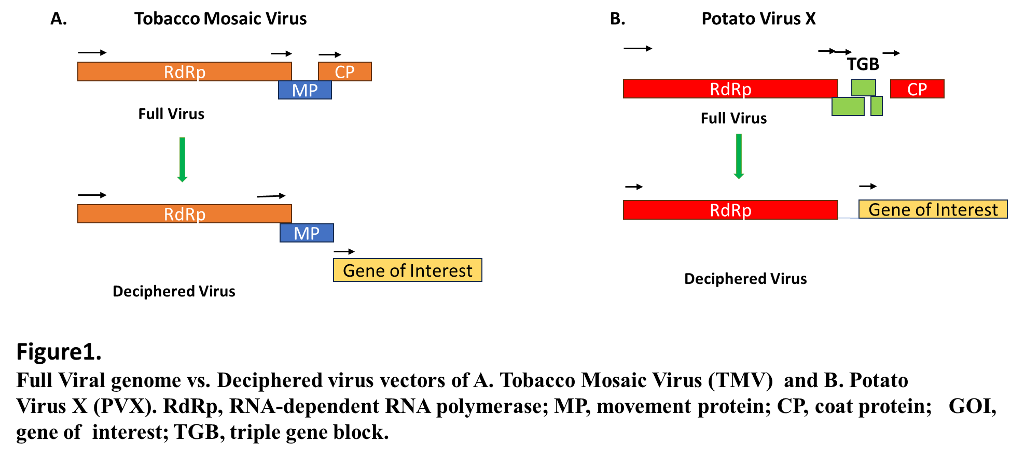
Plant viruses have also been created as VLPs and VNPs in order to employ them as epitope display systems for vaccine manufacturing and scaffolds for the conjugation of medicines or compounds used in diagnostics (Fig 2) VNPs and VLPs based on plant viruses are advantageous since they are non-pathogenic to humans and hence avoid any undesired side effects/contamination.
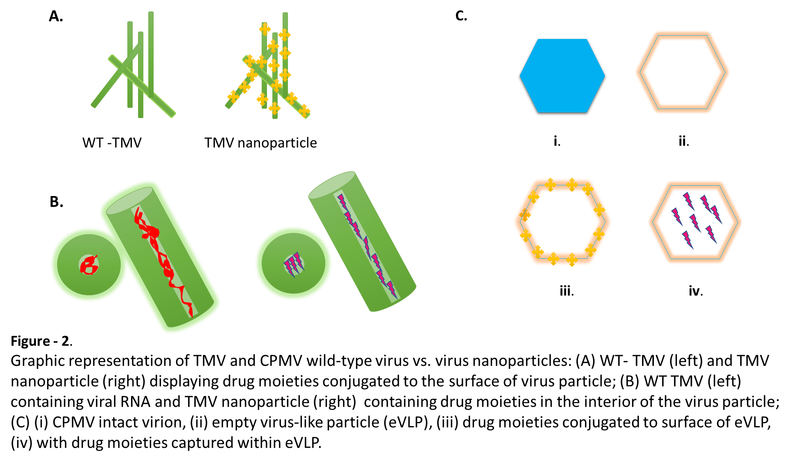
VNPs are virus-based nanoparticle formulations that can be used as building blocks for innovative nanomaterials with a variety of molecular properties [16]. VNPs are highly symmetrical self-assembling systems. They are advantageous due to factors such as their durability and capacity to be manufactured in a short amount of time. Several self-assembly methods have been used to encapsulate ligands such as tiny chemical modifiers, peptides, proteins, or even extra nanoparticles within VNPs, which have been conjugated using a variety of chemistries [17, 18].
2.2Virus-Like Particles in Plant-Based Vaccine Development
Virus-like particles (VLPs) are non-infectious, self-assembled entities that resemble viruses but do not multiply or cause disease. They are a necessary component in the creation of plant-based vaccines, which have various advantages over traditional vaccine techniques. Because of its potential to revolutionise vaccine manufacture and dissemination, plant-based vaccine are used extensively. Plant-based vaccine production using VLPs is a cost-effective and scalable approach because plants can be grown in controlled environments, providing a stable and reproducible system for VLP production. Additionally, plant-based production eliminates the need for specialised cell culture facilities required for traditional vaccine production methods, which can be costly and limited in capacity. VLPs provide significant advantages in terms of safety, immunogenicity, antigen stability, and production over vaccines based on whole pathogen preparations or subunit antigens, and have thus acquired tremendous traction as a premier vaccine platform.[19] While inactivated or killed pathogens continue to elicit powerful immune responses and are the principal source of protection for many infectious illnesses, possible reversion of attenuated pathogens or inadequate inactivation of killed pathogen vaccines remain serious safety concerns. VLPs are non-infectious and lack viral nucleic acid, making them a safer vaccine alternative than attenuated or inactivated viruses. VLPs derived from edible plants represent a unique and cost-effective method of developing gut mucosal immunity by oral administration [20, 21]. Influenza A H1N1 HA enveloped VLP and VLP NVCP non-enveloped VLPs are one of the examples of Plant –produced VLP-based vaccines that have reached human clinical trial stage and FDA-approved plant – derived human pharmaceuticals.
2.3 Plant Viruses: First Generation Vectors
Using plant viruses as transient expression vectors had numerous benefits over transgenic systems, including the ability to be used with different plant species [22] The first viral-based vector to be described was a gene-replacement model in which the GOI replaced the CP of the brome mosaic virus (BMV) [23] However, the recombinant virus was only able to infect injected cells because it was lacking the CP, which prevented it from spreading. The GOI was introduced upstream of the intrinsic CP gene and was regulated by an extra sub genomic RNA promoter in subsequent attempts utilising TMV-based vectors. Nevertheless, the structure was unstable, and homologous recombination led to the loss of the inserted sequence and return to the wild-type virus [24].
Plant Viruses in Second-Generation Vectors and Recombinant Expression Technology
Constructs with extensive inserts showed instability and minimal systemic distribution, despite viral vectors based on a whole genome demonstrating success in creating recombinant proteins [25, 26]. These drawbacks prompted the creation of second-generation vectors, in which the virus genome was dissected into a replicon containing the required genomic elements for gene expression and replication, with plant infection started exogenously. Recombinant GOI was used in this method to replace the viral MP and/or CP genes, and the vector was introduced into plants as part of T-DNA delivered by Agrobacterium [27] biolistic bombardment [28]. Among the monopartite RNA viruses, potato virus X (PVX) [28] and TMV [29] were first to be adopted as a deconstructed-virus.
2.4 The Delivery of CRISPR Reagents by Plant Viruses
Since the early days of genetic engineering, plant viruses have been utilised as vectors for heterologous gene expression. The ability to manipulate the viral genome to express heterologous proteins and RNAs in plants has been made possible by the development of molecular biology and high-throughput sequencing technology. The potential use of plant viral vectors as temporary delivery systems for CRISPR-Cas reagents in plants has been emphasised in a number of recent research [24]. Plant viruses are currently the most effective alternate method for introducing CRISPR-Cas reagents into plant cells. Recent advancements in GE technology have compelled researchers to use viral vectors for the effective delivery of GE reagents in plant cells.
2.3.1 Geminiviruses and Genome Editing: What Role Can They Play?
The largest viral family, Geminiviridae, is made up of circular, single-stranded (ss) DNA viruses that infect a wide range of hosts, including staple and fibre crops around the world including cotton, maize, wheat cucurbits, tomato, and various ornamental and weed species[25,26,27] and currently pose a serious threat to the global food security. Vectors produced from geminiviruses have been widely employed to produce proteins, vaccines, and to silence genes using functional genomic techniques [28]. According to GE, geminivirus-based replicons have garnered a lot of attention and successfully applied genome-editing techniques[29] Geminiviruses are exceptional in the ways listed below, making them attractive vectors for plant genome editing: (1) being able to simultaneously infect a large variety of plants from different kinds; (2) beginning of replication inside hosts requires a relatively small amount of proteins; (3) The intergenic region's native promoter and any user-specific inducible or constitutive promoters control its expression [29] (4) autonomously reproduce inside the host through replication that is based on homologous recombination (HR)[30] Geminiviruses have been modified to serve as vectors for the production of heterologous proteins in plants [31].
Challenges and Limitations in using Plant Virus and Virus-Like Particle in Biotechnology
Biotechnology based on plant viruses and virus-like particles (VLPs) has showed considerable potential in a number of applications, but it also has a number of drawbacks. Plant viruses and VLPs' stability is a significant problem. The activity and integrity of these particles may be impacted by environmental factors as temperature, humidity, and pH. For practical applications, stability during storage and delivery is essential. It can be challenging to obtain substantial yields of plant viruses and VLPs. These particles are frequently produced in plants using a temporary expression technique, which may produce lower yields than conventional recombinant protein expression systems. Also plant viruses and VLPs can be difficult to purify. There is a possibility of recombination with wild-type plant viruses when employing plant viruses for biotechnology, which could result in the development of novel viruses with unknown features and possibly unforeseen environmental effects.

REFERENCES
- Roldão A, Silva AC, Mellado MCM, Alves PM, Carrondo MJT. Viruses and Virus-Like Particles in Biotechnology: Fundamentals and Applications. Comprehensive Biotechnology. 2011:625–49. doi: 10.1016/B978-0-08-088504-9.00072-6.
- Enders J.F., Weller T.H., Robbins F.C. Cultivation of the lansing strain of poliomyelitis virus in cultures of various human embryonic tissues. Science. 1949;109(2822):85–87
- Kretzmer G. Industrial processes with animal cells. Applied Microbiology and Biotechnology. 2002;59(2–3):135–142.
- Bos L. Beijerinck’s work on tobacco mosaic virus: Historical context and legacy. Philosophical Transactions of the Royal Society B: Biological Sciences. 1999;354(1383):675–685
- Ruffing M., Zentgraf H., Kleinschmidt J.A. Assembly of viruslike particles by recombinant structural proteins of adeno-associated virus type 2 in insect cells. Journal of Virology. 1992;66(12):6922–6930.
- Yusibov V., Mett V., Davidson C., Musiychuk K., Gilliam S., Farese A., MacVittie T., Mann D. Peptide-based candidate vaccine against respiratory syncytial virus. Vaccine. 2005;23:2261–2265. doi: 10.1016/j.vaccine.2005.01.039.
- Kemnade J.O., Seethammagari M., Collinson-Pautz M., Kaur H., Spencer D.M., McCormick A.A. Tobacco mosaic virus efficiently targets DC uptake, activation and antigen-specific T cell responses in vivo. Vaccine. 2014;32:4228–4233. doi: 10.1016/j.vaccine.2014.04.051.
- Brennan F.R., Bellaby T., Helliwell S.M., Jones T.D., Kamstrup S., Dalsgaard K., Flock J.-I., Hamilton W.D.O. Chimeric plant virus particles administered nasally or orally induce systemic and mucosal immune responses in mice. J. Virol. 1999;73:930–938. doi: 10.1128/JVI.73.2.930-938.1999
- Brennan F., Jones T., Longstaff M., Chapman S., Bellaby T., Smith H., Xu F., Hamilton W., Flock J.-I. Immunogenicity of peptides derived from a fibronectin-binding protein of S. aureus expressed on two different plant viruses. Vaccine. 1999;17:1846–1857. doi: 10.1016/S0264-410X(98)00485-X
- Melito P.L., Qiu X., Fernando L.M. The creation of stable cell lines expressing Ebola virus glycoproteins and the matrix protein VP40 and generating Ebola virus-like particles utilizing an ecdysone inducible mammalian expression system. Journal of Virological Methods. 2008;148(1–2):237–243.
- Zielonka A., Gedvilaite A., Ulrich R. Generation of virus-like particles consisting of the major capsid protein VP1 of goose hemorrhagic polyomavirus and their application in serological tests. Virus Research. 2006;120(1–2):128–137
- Venkataraman S, Hefferon K. Application of Plant Viruses in Biotechnology, Medicine, and Human Health. Viruses. 2021 Aug 26;13(9):1697. doi: 10.3390/v13091697
- Gleba Y., Klimyuk V., Marillonnet S. Magnifection—A new platform for expressing recombinant vaccines in plants. Vaccine. 2005;23:2042–2048.
- Lindbo J.A. TRBO: A High-Efficiency Tobacco Mosaic Virus RNA-Based Overexpression Vector. Plant Physiol. 2007;145:1232–1240. doi: 10.1104/pp.107.106377.
- Steinmetz N.F. Viral nanoparticles as platforms for next-generation therapeutics and imaging devices. Nanomedicine. 2010;6:634–641. doi: 10.1016/j.nano.2010.04.005.
- Young M., Debbie W., Uchida M., Douglas T. Plant Viruses as Biotemplates for Materials and Their Use in Nanotechnology. Annu. Rev. Phytopathol. 2008;46:361–384. doi: 10.1146/annurev.phyto.032508.131939.
- Steinmetz N.F., Evans D.J. Utilisation of plant viruses in bionanotechnology. Org. Biomol. Chem. 2007;5:2891–2902. doi: 10.1039/b708175h.
- Roldão A, Mellado MC, Castilho LR, Carrondo MJ, Alves PM. Virus-like particles in vaccine development. Expert Rev Vaccines. 2010;9:1149–76. doi: 10.1586/erv.10.115
- Tacket CO, Pasetti MF, Edelman R, Howard JA, Streatfield S. Immunogenicity of recombinant LT-B delivered orally to humans in transgenic corn. Vaccine. 2004;22:4385–9. doi: 10.1016/j.vaccine.2004.01.073.
- Yusibov V, Hooper DC, Spitsin SV, Fleysh N, Kean RB, Mikheeva T, et al. Expression in plants and immunogenicity of plant virus-based experimental rabies vaccine. Vaccine. 2002;20:3155–64. doi: 10.1016/S0264-410X(02)00260-8.
- Hamamoto, H., Sugiyama, Y., Nakagawa, N., Hashida, E., Matsunaga, Y., Takemoto, S., et al. (1993). A new tobacco mosaic-virus vector and its use for the systemic production of angiotensin-I-converting enzyme-inhibitor in transgenic tobacco and tomato. Biotechnology 11, 930–932. doi: 10.1038/nbt0893-930
- 23French, R., Janda, M., and Ahlquist, P. (1986). Bacterial gene inserted in an engineered RNA virus: efficient expression in monocotyledonous plant cells. Science 231, 1294–1298.
- .
- Dawson, W., Lewandowski, D., Hilf, M., Bubrick, P., Raffo, A., Shaw, J., et al. (1989). A tobacco mosaic virus-hybrid expresses and loses an added gene. Virology 172, 285–292.
- Shivprasad, S., Pogue, G. P., Lewandowski, D. J., Hidalgo, J., Donson, J., Grill, L. K., et al. (1999). Heterologous sequences greatly affect foreign gene expression in tobacco mosaic virus-based vectors. Virology 255, 312–323.
- Avesani, L., Marconi, G., Morandini, F., Albertini, E., Bruschetta, M., Bortesi, L., et al. (2007). Stability of Potato virus X expression vectors is related to insert size: implications for replication models and risk assessment. Transgenic Res. 16, 587–597.
- Gleba, Y., Marillonnet, S., and Klimyuk, V. (2004). Engineering viral expression vectors for plants: the ‘full virus’ and the ‘deconstructed virus’ strategies. Curr. Opin. Plant Biol. 7, 182–188.
- Komarova, T., Skulachev, M., Zvereva, A., Schwartz, A., Dorokhov, Y. L., and Atabekov, J. (2006). New viral vector for efficient production of target proteins in plants. Biochemistry 71, 846–850.
- Lindbo, J. A. (2007). TRBO: a high-efficiency tobacco mosaic virus RNA-based overexpression vector. Plant Physiol. 145, 1232–1240.
- Xu C.L., Ruan M.Z., Mahajan V.B., Tsang S.H. Viral delivery systems for CRISPR. Viruses. 2019;11:28. doi: 10.3390/v11010028.
- Mahmood M., Naqvi R., Irfan N., Amin I., Mansoor S. First report of Cotton leaf curl Multan virus infecting Millettia pinnata in Pakistan. New Dis. Rep. 2022;46:e12116. doi: 10.1002/ndr2.12116.
- Mahmood M.A., Ahmed N., Hussain S., Muntaha S.T., Amin I., Mansoor S. Dominance of Asia II 1 species of Bemisia tabaci in Pakistan and beyond. Sci. Rep. 2022;12:1528. doi: 10.1038/s41598-022-05612-1.
- Nawaz-ul-Rehman M.S., Fauquet C.M. Evolution of geminiviruses and their satellites. FEBS Lett. 2009;583:1825–1832. doi: 10.1016/j.febslet.2009.05.045.
- Lozano-Durán R. Geminiviruses for biotechnology: The art of parasite taming. N. Phytol. 2016;210:58–64. doi: 10.1111/nph.13564
- Baltes N.J., Gil-Humanes J., Cermak T., Atkins P.A., Voytas D.F. DNA replicons for plant genome engineering. Plant Cell. 2014;26:151–163. doi: 10.1105/tpc.113.119792
- Richter K.S., Serra H., White C.I., Jeske H. The recombination mediator RAD51D promotes geminiviral infection. Virology. 2016;493:113–127. doi: 10.1016/j.virol.2016.03.014.
- Lozano-Durán R. Geminiviruses for biotechnology: The art of parasite taming. N. Phytol. 2016;210:58–64. doi: 10.1111/nph.13564.

